Visual impairment

**Lesson focus**

|  |  |  |
| --- | --- | --- |
| **Skills** | **Terminology** | **Functional language** |
| Note taking | Visual impairment | Participating in a discussion |
| Synthesising information from two sources |  |  |
| Mediating information |  |  |

**Lead-in.** Work in groups of three.Do you know who the three people below are? If not, search online to find out key information about them (in English!) and share it with your group.

[**Erik Weihenmayer**](http://en.wikipedia.org/wiki/Erik_Weihenmayer) [**Marla Runyan**](http://en.wikipedia.org/wiki/Marla_Runyan) [**Tony Giles**](https://www.tonythetraveller.com/)

**1 Notetaking and synthesising information from two sources.** You are going to write a short text based on information from a video and an article.

a) Notetaking.

* What strategies do you use for note taking during a lecture? (Jamboard)
* Look at [this](https://docs.google.com/document/d/1lJVsTnrqU4xBDX-oN-7ddjKcs4zV5qJdqr1zk7y875g/edit?usp=sharing) set of abbreviations. Can you guess their meaning?

b) You are going to watch a [video](https://www.youtube.com/watch?v=GBDMn7hE2YM) about Tony Giles.

* First, just watch and listen. What do you think about Tony and his travels?
* Work in pairs. Decide who is going to be Student A and who’s going to be Student B. Watch and listen again. Take notes to answer the following questions.

|  |  |
| --- | --- |
| **Student A** | **Student B** |
| What does Tony do? | What are his impairments? |
| What does he say about the background of his condition? | Where does he come from? |
| Why does he take photos of the places he’s been to (two reasons)? | Where did he go when he was 16 and how did he feel about it? Why? |
| What is he interested in seeing when he visits a place? | How does he learn about each country he travels to? |
| How do people help him to get around? | Why does he travel? |

* Put it all together. Based on your answers, summarise Tony’s story.

|  |
| --- |
|  |

c) Now read [this](https://www.simplemost.com/this-man-became-the-first-blind-person-to-run-the-nyc-half-marathon-with-the-help-of-3-guide-dogs/) text. First, **skim** it to answer question 1. Then **scan** it for answers to questions 2 and 3. You can also use [this Google document](https://docs.google.com/document/d/1TemXFvwAKFqLvpruoPGM_65SsqSzgkPM/edit?usp=sharing&ouid=107336564483047275338&rtpof=true&sd=true) to read the text (no pictures).

1. What’s Thomas’ achievement? What’s your opinion about it?
2. Why did he do it?
3. Who did he get help from?

* Write down the key points of Thomas’s story in the box below.

|  |
| --- |
|  |

* Did you come across any new expressions in the text? If so, what are they and what’s their meaning? Share with the person sitting next to you.
* Do you personally know anyone with limited or no vision who has managed to overcome their challenges and achieve personal or career success?

d) If you were to give a talk or write an article based on these two stories, what would it be about? Work in small groups and consider the following:

* What’s the common theme?
* What main points would you choose to include and why?
* Write a short text of at least 100 words combining the main points from the two sources. If you belong to the xxx group, go to this Google Document. If you´re the xxx group student, go to this Google Document.

**2 Terminology, note taking & describing.** Watch a short [video](https://www.youtube.com/watch?v=i3_n3Ibfn1c) on how vision works. Take notes to be able to briefly describe how vision works. Here are some useful words you might hear. Do you know their meaning?

**TO DETECT PATTERNS OF LIGHT LIGHT RAYS BOUNCE OFF (sth.)**

**BRIGHT LIGHT DIM LIGHT TO FLATTEN TO BEND**

**ROUGH IMAGE UPSIDE DOWN RIGHT SIDE UP**

|  |
| --- |
| Your notes: |

a) This image might help you describe the eye. Which parts of the eye are mentioned in the video?

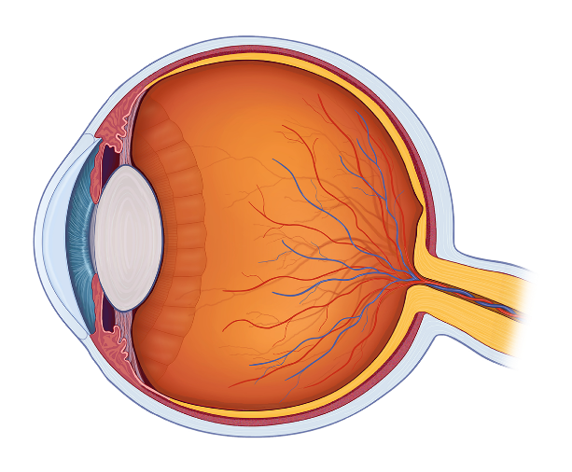

<http://vsp.postclickmarketing.com/EyeAnatomyQuizBuild/eye-anatomy-knowledge-200WM-3155W1.html>

b) Find a person you haven’t worked with so far in today’s class and share your description with them. Take turns. Listen carefully! Is your description the same or different? How?

**3 Terminology & mediating.** What causes vision loss? There are several short texts around the classroom about conditions leading to vision loss. Your teacher will give you a table with the names of these conditions. Work in teams. Each of you will read about 2-3 conditions, take notes and then come back to share what you’ve learnt. Make sure you also find out the **correct pronunciation**. Make notes while listening to your partners.

|  |
| --- |
|  |

**4 Optional.** Find a video on low vision, e.g., multiple field loss, distortion, tunnel vision, central field loss, contrast loss and glare problems and blurred vision. Share the link in the discussion forum and give a summary of the content. 

**5 Listening, terminology and discussing.** You are going to watch a [video](https://www.youtube.com/watch?v=nILU4BmexTc) about London and what challenges getting around London poses for people with limited vision or total blindness.

a) First work in pairs and put yourselves into the shoes of a blind person. Discuss…

* what aids, devices or strategies would help you get around Brno?

|  |
| --- |
|  |

* what dangers you might encounter when getting around Brno?

|  |
| --- |
|  |

b) Now watch the video and answer the following questions:

|  |
| --- |
| What things help visually impaired people get around? |
| What are the dangers? |

c) Play quizlet live to practise/learn new vocabulary about aids for people with vision loss.

d) Think about your hometown.

* Are there any elements that help visually impaired people to get around? If so, what are they?

|  |
| --- |
|  |

* What are the dangers?

|  |
| --- |
|  |

e) You are now going to discuss how to make your town more accessible to people with visual impairment.

* First, revise some language that you can use to express your opinion, show agreement/disagreement, initiate a discussion, invite turn taking or give advice. Post your ideas on Google Jamboard. Pick a few phrases that you would like to be able to use more actively and write them down. Make a conscious effort to use them in the discussion.
* Now, with your partner, imagine you are members of your town’s council. One of your goals is to make your town more accessible to people with vision loss. Think of a dangerous situation for a blind person in your town and come up with a solution.
* Report back on your discussion to another pair. Use some phrases from the box below. Make sure that you describe the dangerous situation briefly and then explain your solution. Also, mention what the situation could result in if it wasn’t handled by the town’s council. Finish by summarising your report. (What’s the key take-away?)

|  |
| --- |
| We believe that the most dangerous situation…  Our view is that…  My colleague proposed that…/-ing…  I recommended that…/-ing…; however, my colleague believes that… We would like to suggest that…/-ing… We argue that installing tactile pavement is…because…  We interviewed XX citizens with visual impairment and found out that…  Some/several/The majority of…seem to think/believe/consider/  If this situation isn’t handled promptly/appropriately, it might lead to/result in/cause…  To sum up/In conclusion, we agreed that…  Unfortunately, we haven’t managed to arrive at a solution as we believe that further analysis would be necessary. |

* Comment on the other team’s solution. Do you agree or disagree? Why? Why not? Use some phrases from the box below. Make an effort to be polite and respectful!

|  |
| --- |
| Thank you for sharing…/describing… The situation you described seems to be…  If I understood it correctly, you would like to make the public transport in your town more inclusive.  I am afraid I didn’t understand the gist of your project. Do you think you could go over it again?  I agree with your solution because/as/since it…  On the whole, I agree with your solution; However, there’s one thing I would do differently…  Have you thought about…  How about using…  If I were you, I would…  What I believe would work more effectively would be…  I appreciate the effort…/ I think it’s great that you’d like to…; however, I don’t think your solution would work. |

**6 Reflection.** Take a minute to think about what you’ve learnt this week. Write down a few points and share them with your partner.

|  |
| --- |
| * Skills: * Language functions: * Vocabulary: * Grammar: * Other: * What went well? * What needs more work? * What was useful/useless? * What was fun/boring? |

Sources:

<https://chicagolighthouse.org/sandys-view/getting-around/>

<https://chicagolighthouse.org/technology/magnilink-zip/>

<https://www.bath.ac.uk/case-studies/how-blind-people-see-the-world/>

<http://www.blindcanadians.ca/publications/cbm/10/challenges-and-opportunities-facing-visually-impaired-persons>

<https://www.youtube.com/watch?v=5EyRPexVI_8>

<https://www.tonythetraveller.com/>

<https://www.journalism.co.uk/news-freelance/through-the-eyes-of-a-visually-impaired-journalist/s12/a533323/>

<https://www.youtube.com/watch?v=dp2cYYkeWWM>

<https://www.youtube.com/watch?v=nILU4BmexTc>

<https://www.youtube.com/watch?v=s0B_CiOEXSI>

<https://www.youtube.com/watch?v=gvozcv8pS3c>