**Exercise for appropriate speed**

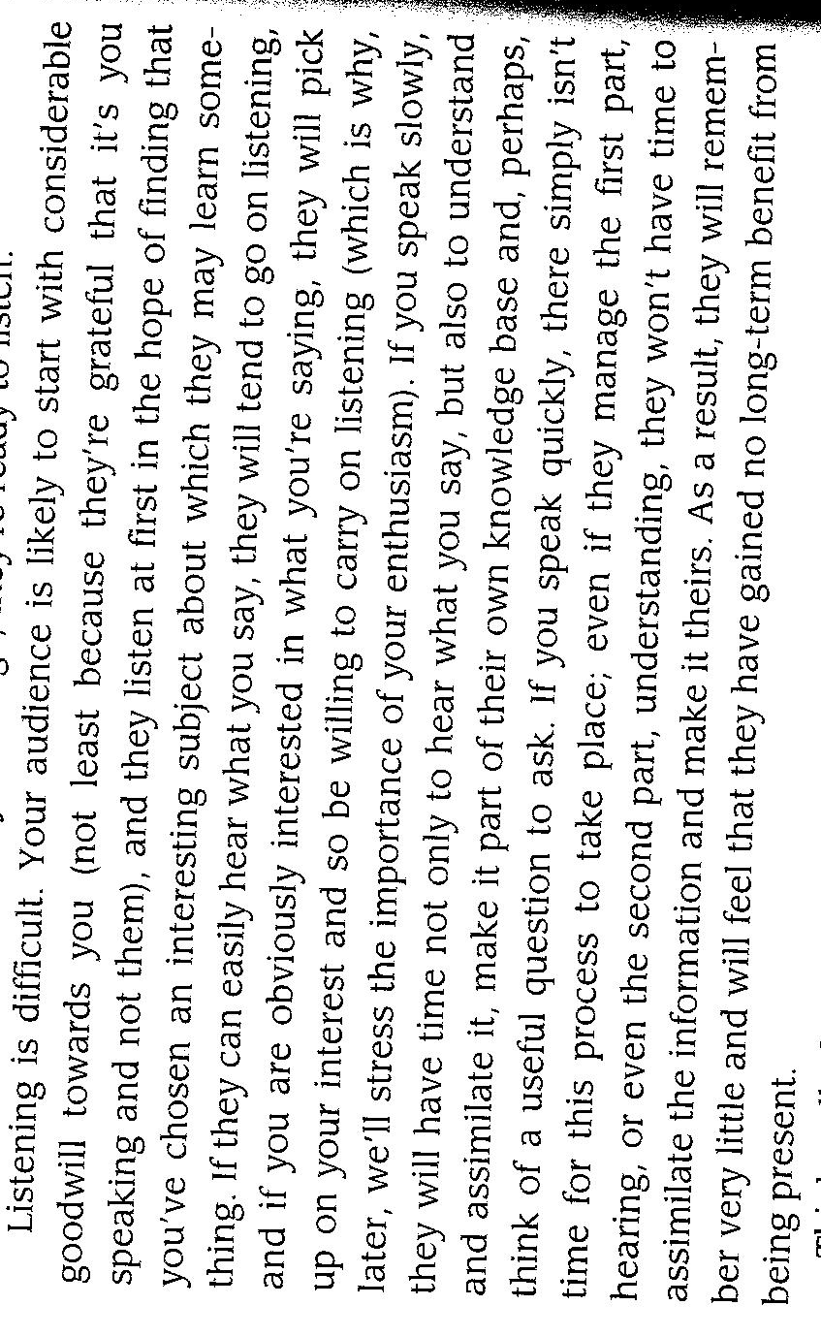

The paragraph above contains 198 words, which is ideal for the purposes of practice. Read paragraph aloud and time yourself, and try again until you manage to take about a minute and a half to read it. Depending on the size of the audience, that’s just about the speed you need when you talk in public.