Influence of N and P on compounds content in Browallia sp.
min
6
7
8
9
10
11
12
Norm.
0
10
20
30
40
50
60
70
80
DAD1 A, Sig=254,4 Ref=450,50 (MAR120419 2012-04-20 07-28-20\BRO120419000002.D)
6.421
6.886
7.493
DAD1 A, Sig=254,4 Ref=450,50 (MAR120419 2012-04-20 07-28-20\BRO120419000005.D)
6.436
6.889
7.259
7.450
7.744
9.084
9.597
9.787
10.174
10.547
10.733
11.718
DAD1 A, Sig=254,4 Ref=450,50 (MAR120419 2012-04-20 07-28-20\BRO120419000010.D)
6.440
6.894
7.264
7.463
7.754
8.941
9.093
9.334
9.588
10.170
11.729
Eriksson
Heller
water
Acteoside-detector 254 nm
nm
250
300
350
400
450
500
550
600
650
mAU
0
20
40
60
80
100
120
140
160
*DAD1, 6.923 (161 mAU, - ) Ref=6.777 & 7.936 of BRO120419000005.D
Spectrum of acteoside
medium | acteoside-peak areas-fresh material
Eriksson | 57.2
heller | 608.8
Voda | 600

Relative concentration of acteoside in fresh material
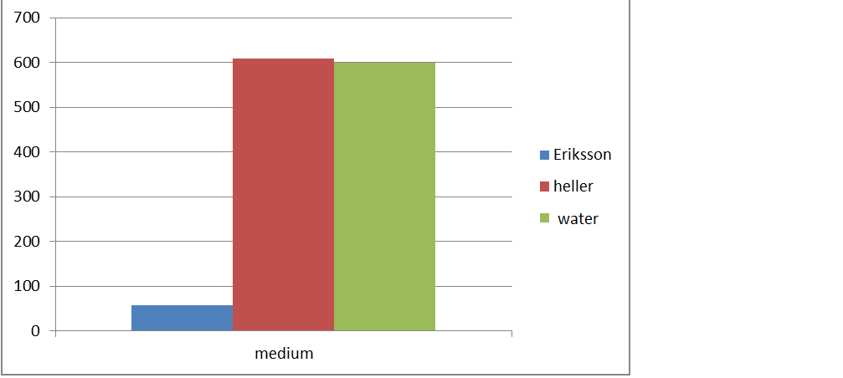

Summary: Stress, caused by a lack of nitrogen and phosphorus in plants can stimulate the production of secondary metabolites. Increased dosage of nitrogen can caused generally greater formation of green mass, but the content of glycosides decreases.

Task: Calculate the relative concentration of acteoside in dry mass and expressed it graphically.

