Iresine herbstii – influence of light
Detector 254 nm
min
6
7
8
9
10
Norm.
-6
-4
-2
0
2
4
6
8
10
DAD1 A, Sig=254,4 Ref=450,50 (ERG120420 2012-04-20 18-58-24\ERG120420000004.D)
5.902
6.245
7.371
7.530
8.012
8.542
9.612
DAD1 A, Sig=254,4 Ref=450,50 (ERG120420 2012-04-20 18-58-24\ERG120420000008.D)
Kaempferol glycoside – is only in lighted plant
light
dark
Chlorophyll – detector 450 nm
nm
250
300
350
400
450
500
550
600
650
mAU
0
2.5
5
7.5
10
12.5
15
17.5
20
*DAD1, 8.569 (20.4 mAU, - ) Ref=7.849 & 8.849 of ERG120420000004.D
Spectrum of kaempferol glycoside
min
41.5
42
42.5
43
43.5
44
44.5
45
45.5
Norm.
-2
0
2
4
6
8
DAD1 C, Sig=450,4 Ref=500,50 (ERG120420 2012-04-20 18-58-24\ERG120420000008.D)
41.824
43.641
DAD1 C, Sig=450,4 Ref=500,50 (ERG120420 2012-04-20 18-58-24\ERG120420000004.D)
dark
light
Chlorophyll
nm
250
300
350
400
450
500
550
600
650
mAU
0
2
4
6
8
10
*DAD1, 43.662 (11.4 mAU, - ) Ref=43.435 & 44.062 of ERG120420000008.D
Spectrum of chlorophyll
cultivation | kaempferol-peak areas-fresh material
light | 115.5
dark | 0

cultivation | chlorophyll- peak areas-fresh material
light | 30.1
dark | 148.5
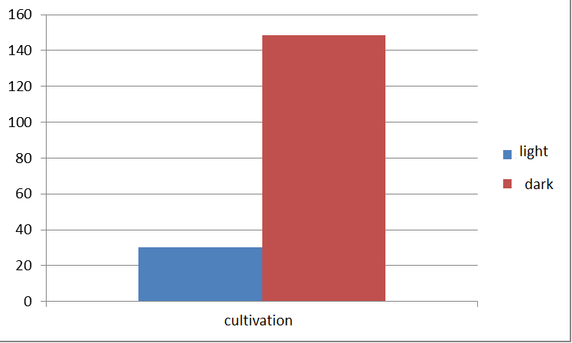

Summary: On the first and second chromatogram we can see big differences in content of substances. In the area of 10 minutes there are several substances in Iresine grown in light conditions. One of them is kaempferol glycoside. Iresine grown in darkness completely lacks these substances. Lack of light causes at heliophilous plants reduced production of secondary metabolites.

Task: Calculate the relative concentration of kaempferol glycoside and chlorophyll in dry mass and expressed it graphically.

