Tradescantia pallida – influence of light
Anthocyanines – detector 535nm
min
8.5
9
9.5
10
10.5
11
Norm.
0.5
0.75
1
1.25
1.5
1.75
2
2.25
2.5
DAD1 E, Sig=535,20 Ref=600,52 (ERG120420 2012-04-20 18-58-24\ERG120420000011.D)
Area: 43.7006
9.092
DAD1 E, Sig=535,20 Ref=600,52 (ERG120420 2012-04-20 18-58-24\ERG120420000016.D)
Area: 9.99261
9.118
Anthocyanine
dark – peak area 9,9
light – peak area 44,7

nm
250
300
350
400
450
500
550
600
650
mAU
0
1
2
3
4
*DAD1, 9.118 (4.7 mAU, - ) Ref=8.891 & 9.438 of ERG120420000011.D
Spectrum of anthocyanine

Chlorophyll – detector 450 nm
min
41.5
42
42.5
43
43.5
44
Norm.
-1
0
1
2
3
4
5
DAD1 C, Sig=450,4 Ref=500,50 (ERG120420 2012-04-20 18-58-24\ERG120420000011.D)
43.668
DAD1 C, Sig=450,4 Ref=500,50 (ERG120420 2012-04-20 18-58-24\ERG120420000016.D)
43.651
Chlorophyll
dark – peak area 102,5
light – peak area 92,6
nm
250
300
350
400
450
500
550
600
650
mAU
0
1
2
3
4
*DAD1, 43.718 (4.6 mAU, - ) Ref=43.278 & 44.158 of ERG120420000011.D
Spectrum of chlorophyll

cultivation | anthocyanine-peak areas – fresh material
light | 44.7
dark | 9.9
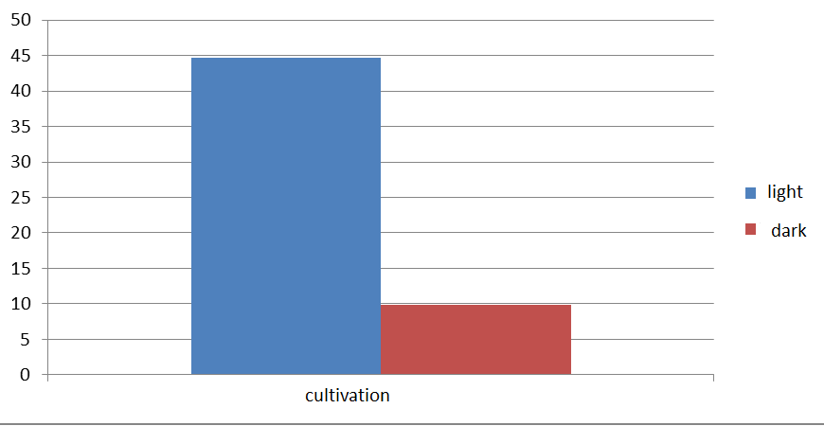
cultivation | chlorophyll- peak areas – fresh material
light | 92.6
dark | 102.5

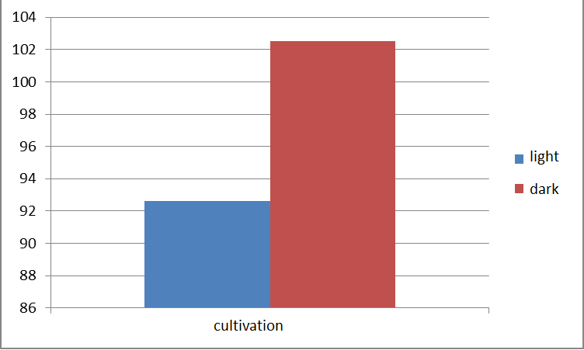
Summary: The content of anthocyanins increases together with increasing intensity of light.

Task: Calculate the relative concentration of anthocyanins and chlorophyll in dry mass and expressed it graphically.

