Phenakistoscope

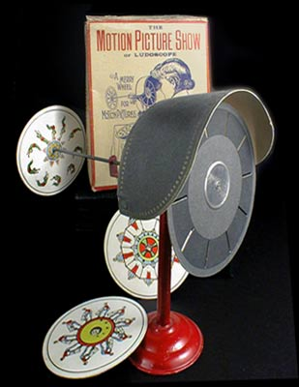
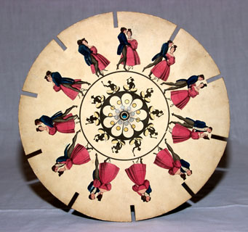

Joseph Plateau, 1832

History | How it works | What became of it | Animations
Video Demonstrations | Sources | Back to Optical Toys
History:

In 1832, Belgian physicist Joseph Plateau and his sons introduced the phenakistoscope ("spindle viewer"). It was also invented independently in the same year by Simon von Stampfer of Vienna, Austria, who called his invention a stroboscope. Plateau's inspiration had come primarily from the work of Michael Faraday and Peter Mark Roget (the compiler of Roget's Thesaurus). Faraday had invented a device he called "Michael Faraday's Wheel," that consisted of two discs that spun in opposite directions from each other. From this, Plateau took another step, adapting Faraday's wheel into a toy he later named the phenakistoscope.

How it works:

The phenakistoscope uses the persistence of motion principle to create an illusion of motion. Although this principle had been recognized by the Greek mathematician Euclid and later in experiments by Newton, it was not until 1829 that this principle became firmly established by Joseph Plateau.

The phenakistoscope consisted of two discs mounted on the same axis. The first disc had slots around the edge, and the second contained drawings of successive action, drawn around the disc in concentric circles. Unlike Faraday's Wheel, whose pair of discs spun in opposite directions, a phenakistoscope's discs spin together in the same direction. When viewed in a mirror through the first disc's slots, the pictures on the second disc will appear to move.

What became of it:

After going to market, the phenakistoscope received other names, including Phantasmascope and Fantoscope (and phenakistiscope in Britain and many other countries). It was quite successful for two years until William George Horner invented the zoetrope, which offered two improvements on the phenakistoscope. First, the zoetrope did not require a viewing mirror. The second and most influential improvement was that more than one person could view the moving pictures at the same time.

Sources:

Origin of the phenakistoscope's name:
http://web.inter.nl.net/users/anima/optical/phena/index.htm

Zoetrope

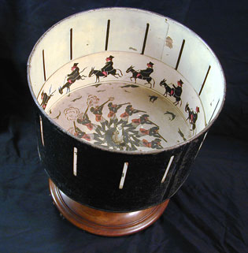

William George Horner, 1834

History | How it works | What became of it | Video Demonstrations
Sources | Side View | Back to Optical Toys

History:

The zoetrope was invented in 1834 by William Horner, who originally called it a Daedalum ("wheel of the Devil"). It was based on Plateau's phenakistoscope, but was more convenient since it did not require a viewing mirror and allowed more than one person to use it at the same time. Horner's invention strangely became forgotten for nearly thirty years until 1867, when it became patented in England by M. Bradley, and in America by William F. Lincoln. Lincoln renamed the Daedalum, giving it the name of "zoetrope," or "wheel of life."

How it works:

The zoetrope is the third major optical toy, after the thaumatrope and phenakistoscope, that uses the persistence of motion principle to create an illusion of motion. It consists of a simple drum with an open top, supported on a central axis. A sequence of hand-drawn pictures on strips of paper are placed around the inner bottom of the drum. Slots are cut at equal distances around the outer surface of the drum, just above where the picture strips were to be positioned.

To create an illusion of motion, the drum is spun; the faster the rate of spin, the smoother the progression of images. A viewer can look through the wall of the zoetrope from any point around it, and see a rapid progression of images. Because of its design, more than one person could use the zoetrope at the same time. top

What became of it:
When the praxinoscope was invented by Emile Reynaud in 1877, interest in the zoetrope declined. The praxinoscope offered a clearer, brighter image to viewers than the zoetrope could. In 1889, George Eastman invented flexible photographic film, which allowed a lot of film to be held on one reel. Whereas zoetrope picture strips were limited to about 15 pictures per strip, devices using reels of the new flexible film could present longer animations to viewers. Finally, in 1895, modern cinema was born. Once moving pictures could be projected on a large screen, optical toys such as the zoetrope became used less and less frequently.

Sources:

Biographical information for William G. Horner:
http://www-groups.dcs.st-and.ac.uk/~history/Mathematicians/Horner.html

How to build your own zoetrope (downloadable PDF manual)
http://www.groeg.de/zoetrope.html

Praxinoscope

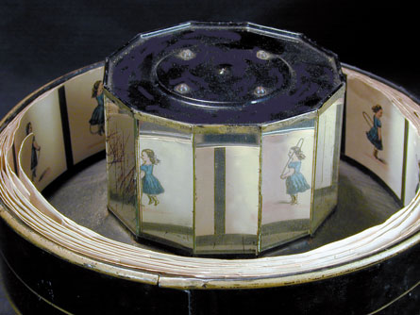

Charles Reynaud, 1877

History | How it works | What became of it | Video Demonstrations
Sources | Side View | Back to Optical Toys

History:

The praxinoscope, invented in 1877 by the Frenchman Charles Reynaud, was the first device to overcome the picture distortion caused by viewing through moving slots. The image produced is more brilliant than with any previous devices. Because of this advance, it quickly replaced the zoetrope in popularity.

How it works:

A band of pictures is placed inside a shallow outer cylinder, so that each picture is reflected by the inner set of mirrors. The number of mirrors is equal to the number of pictures, and the images of the pictures are viewed in the mirrors. When the outer cylinder rotates, the quick succession of reflected pictures gives the illusion of a moving picture.

What became of it:

Using this principle, Reynaud found a way to project the series of pictures onto a screen. He called this the "Theatre Optique." A standard praxinoscope, like the one above, can only accomodate a second or two of animation because of the limited number of pictures it contains. Reynaud's "Theatre Optique" used a long roll of paper to increase the number of pictures, and was therefore able to create a much longer show for an audience. top

Sources:

Background information:
http://www-personal.umich.edu/~natsinas/REYNAUD.html

How it works:
http://www.imag-n-that.com/prax/howdoes.html

How to make your own praxinoscope kit:
http://www.imag-n-that.com/prax/praxin.html

