ACADEMIC ORACY’S CONFERENCE SKIT
at CREATIVITY NIGHT
WHEN: Wednesday, May 2, 2012 at 8:15pm
WHERE: The Tro3jka, Dominikánská 9, Brno
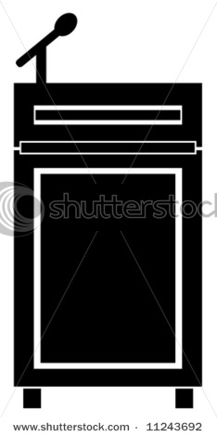
Don’t miss papers presented by LaFree Genderziel
Annalaura Usai-Coccone
Jan Chamonikolas, Kidia Ryzlink
Katka Prize-Nerova
Stephen Hardly and others
at an EACANZSAJP Studies Conference!

