Cambridge oral test Part 2
- label
- similarities
- differences
- details

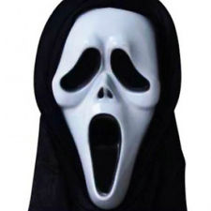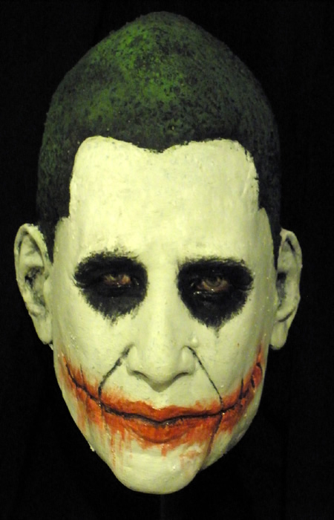

Cambridge oral test Part 3
You have about 3 minutes to reach an agreement. A picture for inspiration:

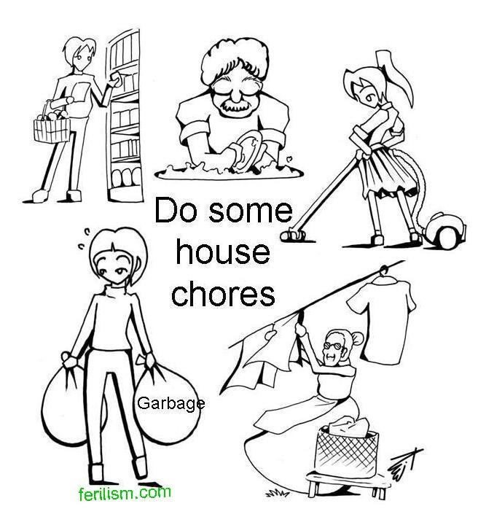

A hypothetical bachelor’s project
Title The impact of Halloween masks
on attractiveness perception
Hypothesis People wearing scary masks will be found less attractive than those wearing neutral/pretty ones
Method Half a dozen masks tipped out at a Halloween party, two dozen respondents (12 males - 9 hetero, 3 homosexual, 12 females - 11 hetero, 1 self-pronounced lesbian) filling out a questionnaire assessing the degree of the mask wearer’s attractiveness
Results Hypothesis disproved, respondents not influenced much by the masks, assessed the wearers‘ natural attractiveness

You investigated the attractiveness of people depending on masks they put on for a Halloween party. The hypothesis was that

