1st YEAR PHONETICS AND PHONOLOGY, Spring 2015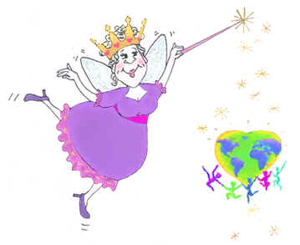

Teacher
Lectures in practical English Phonetics, Phonology and Pronunciation given by Kateřina Tomková (2060@mail.muni.cz) of the Dept. of English and American Studies. Office hours: Tuesdays 1100-1200, Wed 15-16, Thu 13-14, combined studies Fridays 0800-0900. Office: Gorkého 7, 2nd floor, facing the steps.
Assessment
Your final mark in Phonetics and Phonology depends on the result in your final test (60%) on May 20 and subsequent pronunciation interview (40%). Students are recommended to talk to K.Tomková and have their pronunciation assessed now while there is still time to eliminate incorrect speaking habits.
Exam dates
May 20 – EXAM TEST followed by interviews with K. Tomková
June 24 – EXAM TEST second regular date and resits + interviews
September 9 – EXAM TEST resits + interviews

Sources
- Regular attendance at lectures + full understanding of SYLLABUS
- Gimson’s Pronunciation of English, first 7 chapters; bookshop/SAC/IS
- Professor Krčmová’s Obecná fonetika a fonologie in the IS (student-stud.materiály-kód předmětu)
- Rudiments of Linguistics, chapter on Phonetics by Ludmila Urbanová
- A practical course in English pronunciation, xeroxed copy and tape (SAC), relevant chapters in the IS
- www.bbc.co.uk/worldservice/learningenglish/grammar/pron www.photransedit.com/Online/Text2Phonetics.aspx
- www.typeit.org www.howjsay.com

Syllabus

Date | Event; Accent | 1 Organization; 2 Hints for pronunciation; 3 Theory; 4 Listening; 5 Transcription and/or description of accent spoken | Reading assignment
Feb 26 | American  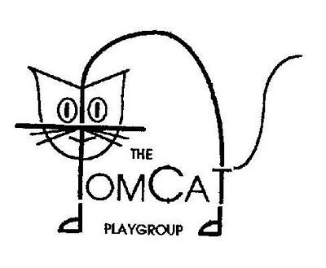 | 1 Introduction of subject and its facilitator; dates. The use of www.typeit.org.  2 Suprasegmental features (stress, rhythm and intonation) as opposed to segments, sounds (vowels, diphthongs and consonants) diagnoses and FORM. Common mistakes, collection of errors. SINGING THE HALLELLUYAH P+P SONG. To illustrate the universality of reductions: karaoke singing of “Have You Ever Seen The Rain” by CCR.  3 Delimitation of Phonetics (concrete, discreet sounds) and Phonology (works with phonemes and their functions in the system of a language). The succession of phoneticians at UCL: Henry Sweet, Daniel Jones, A.C. Gimson, J.C. Wells.  4 The English Language in 24 Accents (youtube).  A Tour of the British Isles in Accents (British)  A fun tour of American accents by Amy Walker  5 American accent is RHOTIC, NASAL, with certain vowels more open such as /ɔː/ and /ɒ/, FLAPS of intervocalic /t/ (atom=Adam) and YOD DROPPING (duty). On the suprasegmental level, it associates STRESS and DURATION in some positions. Compare RP and GenAm pronunciations of words such as Veronica, economy, economist, economics and economical.
March 11 | Standards;  RP | 2 Synthesis of skills. Standard versus accents. Perceptions. Speech models. Dictionaries.  3 Spoken versus written communication. Redundancy.  4 Educating Rita Part 1 starring Julie Walters and Michael Caine.  5 New trends in RP: INTRUSIVE R, SMOOTHING: [ˈtɑʊə] becomes [ˈtɑːə] and [ˈʃaɪə] becomes [ˈʃaːə]. Diphthong /ʊə/ merges with long / ɔː/. [æ] more open than ever before.  GLOTTALIZATIONS: still not acceptable in RP but dominant in most other accents of the UK. An accent bearing elements of RP, a continuum of Cockney: Estuary English.  Practice “Put it in the bottom of a bottle” pronounced as  ˈpʰʊʔɪʔɪnðəˈbɒʔəməvəˈbɒʔɫ | Gimson 1 Communication  up to p. 7
 | 3 days after International Women´s Day; Southern US accent introduced | 2 Hints for pronunciation training, interview statistics.  2+3 Articulatory settings in English and Czech.  3 Physiology of speech. Vocal nodules and how the voice works (youtube).  4 The 21 accents by Amy Walker, Deep southern American accent tip of the day, Forrest Gump 1994 high definition 1080p Part 1, note Sally Field (youtube).  5 Introducing the International Phonetic Alphabet (IPA). | Gimson 2 Physiology of Speech pp. 8-17
April 8   | After Easter; the “Celtic” accents - Irish and Scottish    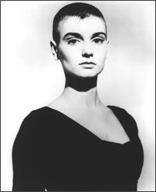  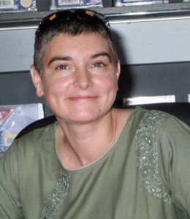 | 1 Find out who (what) a leprechaun is. Song: White Orange And Green.  2 and 4 Famine by Sinéad O’Connor (word stress).  Word stress exercise.  Song lyrics:  OK, I want to talk about Ireland  Specifically I want to talk about the "famine"  About the fact that there never really was one  There was no "famine"  See Irish people were only allowed to eat potatoes  All of the other food  Meat fish vegetables  Were shipped out of the country under armed guard  To England while the Irish people starved  And then in the middle of all this  They gave us money not to teach our children Irish  And so we lost our history  And this is what I think is still hurting me  See we're like a child that's been battered  Has to drive itself out of it's head because it's frightened  Still feels all the painful feelings  But they lose contact with the memory  And this leads to massive self-destruction  alcoholism, drug addiction  All desperate attempts at running  And in it's worst form  Becomes actual killing  And if there ever is gonna be healing  There has to be remembering  And then grieving  So that there then can be forgiving  There has to be knowledge and understanding  All the lonely people  where do they all come from  An American army regulation  Says you mustn't kill more than 10% of a nation  'Cos to do so causes permanent "psychological damage"  It's not permanent but they didn't know that  Anyway during the supposed "famine"  We lost a lot more than 10% of our nation  Through deaths on land or on ships of emigration  But what finally broke us was not starvation  but its use in the controlling of our education  School go on about "Black 47"  On and on about "The terrible famine"  But what they don't say is in truth  There really never was one  (Excuse me)  All the lonely people  (I'm sorry, excuse me)  Where do they all come from  (that I can tell you in one word)  All the lonely people  where do they all belong  So let's take a look shall we  The highest statistics of child abuse in the EEC  And we say we're a Christian country  But we've lost contact with our history  See we used to worship God as a mother  We're suffering from post traumatic stress disorder  Look at all our old men in the pubs  Look at all our young people on drugs  We used to worship God as a mother  Now look at what we're doing to each other  We've even made killers of ourselves  The most child-like trusting people in the Universe  And this is what's wrong with us  Our history books the parent figures lied to us  I see the Irish  As a race like a child  That got itself bashed in the face  And if there ever is gonna be healing  There has to be remembering  And then grieving  So that there then can be forgiving  There has to be knowledge and understanding  All the lonely people  Where do they all come from  All the lonely people  Where do they all come from  We stand on the brink of a great achievement  In this Ireland there is no solution  to be found to our disagreements  by shooting each other  There is no real invader here  We are all Irish in all our  different kinds of ways  We must not, now or ever in the future,  show anything to each other  except tolerance, forbearance  and neighbourly love  because of our tradition everyone here  knows who he is and what God expects him to do.  5 Irish accent: rhotic, dark r’s, clear l’s, t-opening, th-stopping, /ɒ / becomes / /ʌ/ and vice-versa. | Gimson 3 Acoustic and Auditory Aspects of Speech pp. 18-26
 |  | 2 and 3 Classification of sounds in relation to commonest mistakes made by Czechs  Vowels. Criteria – openness (open, mid, closed), frontness (front, mid, back).  Diphthongs: centring, /ɪ/ and /ʊ/ dipththongs. Mod. tendencies in BrE: /ʊə/ becomes /ɔː/ (sure, pure, endure); smoothing of triphthongs (shire x shower).  Consonants.  Manner of articulation: plosives, affricates, fricatives, nasals, approximants (liquids), semi-vowels.  Place of articulation: bilabial, alveolar, velar, labio-dental, dental, palato-alveolar, lateral, palatal.  Sonority: voiced, voiceless.  Articulatory energy: lenis, fortis.  Aspiration: voiceless plosives /p/, /t/, /k/ under stress, unless they are preceded by /s/.  The biggest problem with Czech segmental pronunciation is final-consonant devoicing.  Exercise:  /b/ bib and brace trousers  /v/ for the love of English  /g/ a big dog at home  /d/ time and tide wait for no man  /z/ because I, is another, was nowhere, trees and other plants, buzz and hussle  /ʒ/ massage and bath  /dʒ/ message and letter, his age was advanced, lunge not lunch  5 Scottish accents range from educated Scottish standard different from RP to the broadest referred to as Lallans. The Scots refer to themselves as the Mediterraneans of the North and Edinburgh as Athens of the North. Patron: St. Andrew (see left). Plant: the Scottish thistle (see above left). Pattern: tartans of the various clans in the Scottish Highlands. Scottish accent in films: Traispotting, Lord of the Rings.  The Scottish accent has a velar setting, frequent monophthongizations; rhotic accent with a diversity of r realizations, /ʊ/=/u/, whales x Wales. Expressions: a wee bairn = a little baby, bonnie – beautiful, lad = boy, lass = girl, aye = yes, haggis = traditional dish. | Gimson 4 Phonetics of Sounds pp. 27-39
April 22 | Southern England | 3 Classification of sounds practiced on a grid.  Segmental Phonology, but also revision of physiology of speech, acoustic and auditory aspects of speech in Gimson’s Pronunciation of English.  4 Transcriptions in John Trim’s “English Pronunciation Illustrated”. | Gimson 5 Phonology of Sounds pp. 40-53
 | Northern England  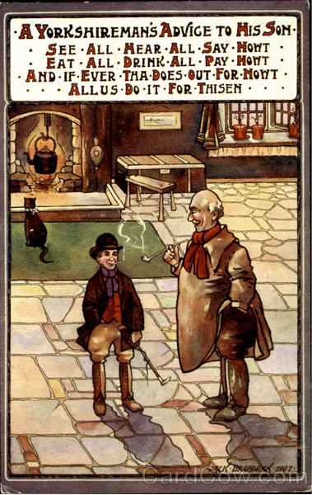 | 3 History of phonetic research up to Prague School and present-day scholars  4 Youtube videos:  Yorkshire Airlines (2:11)  John Tams & Barry Coope. Hear all, see all, say nowt (3:36)  Coming home Newcastle (with lyrics) (3:24)  Cheryl Cole Too British for Simon Cowell (1:52)  3 History and influences upon English (home study)  Present-day pronunciation of English as a result of historical development  Beowulf Intro (Benjamin Bagby) https://www.youtube.com/watch?v=PzmmPRG4smU  Today´s Frisian very much like Old English  Mongrel nation – Brown Cow (2:42)  Canterbury Tales on youtube: male performance (https://www.youtube.com/watch?v=QE0MtENfOMU)  and female performance (https://www.youtube.com/watch?v=vkAfDsjYaWM  The Story of English in 7 parts on youtube.  The English Language in 24 Accents on youtube. | Gimson 6 History pp. 57-63  Gimson 6 Sound Change pp. 63-72  Gimson 6 OE, ME, EmE pp. 72-76
May 6 |  | 2 Practising stress, rhythm and intonation – the 3 rules  - You only stress words which you wouldn´t leave out in a text message.  B) Stressed syllables are at constant distances from each  other.  C) Any unstressed syllables at the beginning of a stress  group are said very quickly.  Exercise 1:  A: I’ve ‘broken my ‘glasses  B: ‘How did you ‘do it?  A: I ‘dropped them on the ‘floor  B: You must ‘get them re’paired.  Exercise 2:  A: ‘I saw ‘John last ‘night / ‘Over at his ‘mother’s  B: ‘When I last ‘saw him he was ‘terribly ‘worried  C: When ‘I last saw him he was ‘terribly worried, ‘too.  Suprasegmental practice. Intonation; intronation centres.  Jazz Chants by Carolyn Graham, hiphop music.  J.D.O’Connor tunes.  H.J. high jump. →↓Tune used for statements, imperatives, information and wh-questions.  G.U. glide-up. ↑↓↑Tune used for asking yes-no questions and in speaking to little children, people who are afraid (e.g. at the dentist’s) and idiots. Caution: a patronizing tune!  H.D. high dive -↑_/ A tune used to express incompleteness or doubt.  T.O. take-off _______↑ A tune used to express extreme distress and annoyance.  Intonation is often symptomatic of accents, e.g. of Northern Ireland.  Intonation centre is the last important word in the sentence. Caution: in English it is often the noun:  - The ↓baby’s crying.  - The ↓kettle’s boiling.  - The ↓postman’s coming up the path.  - I’m afraid my ↓father’s very ill. (CZ Ale mám nemocnýho taťku.)  - He’s very ↓rich, I’ve been told.  3 Phonologically relevant stress
 | Mock test. | A sample (mock) test taken and corrected. | Gimson 7 Accents pp. 77-87

