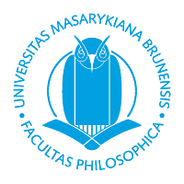
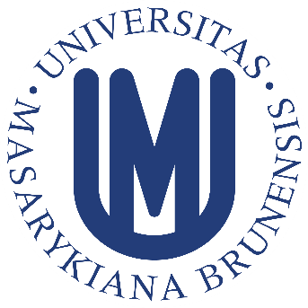
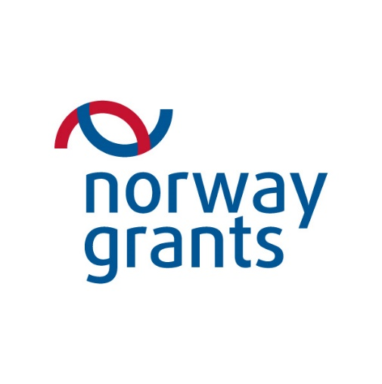
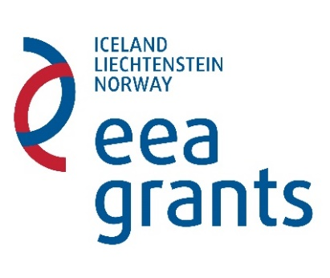

Invitation

Under the auspices of:

Excellency the Ambassador of Norway in Prague, Czech Republic, Siri Ellen Sletner;

the Dean of the Faculty of Arts at Masaryk University, prof. PhDr. Milan Pol, CSc.;

The Department of German, Scandinavian and Dutch Studies - Faculty of Arts,
Masaryk University

together with the Norwegian partner institution – University College of Southeast Norway

will hold a ceremony to celebrate the culmination of the following projects, supported by

participants in Norway and EEA Grants:

Language acquisition in the context of traditional and contemporary culture in Norway
(NF-CZ07-ICP-4-330-2016)

Norwegian Literature: Location experience and European perspectives
(NF-CZ07-MOP-4-329-2016)

Programme:
Presentation of results and overview of the implementation of the projects
Press conference
The event will be accompanied by a performance by the Gideon String Trio
(Pavel Wallinger, Karel Plocek, Jan Škrdlík)

Thursday 15th of September 2016
12:00 – 13:15
Brno University of Technology, Antonínská 1, Brno, Czech Republic

