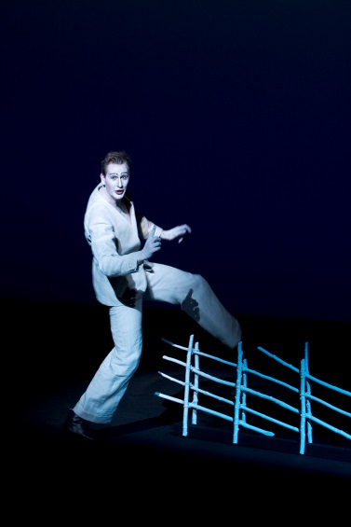

Henrik Rafaelsen jako Peer Gynt, režie Robert Wilson, Det Norske Teatret Oslo a Den Nationale Scene i Bergen, 2005.

The Norwegian Ibsen tradition and Peer Gynt
Two guest lectures by PhD. Keld Hyldig
Associate Professor in Theatre Studies
Department of Linguistic, Literary and Aesthetic Studies
University of Bergen, Norway
27 April 2017, Department of Theatre Studies, MU, room G01 (Gorkého 7)
  - – 10.40 and 10.50 – 12.20

The first lecture will give a historical overview of the development of modern theatre in Norway and the influence of Ibsen’s plays on that.Through repeated productions of Ibsen’s plays an Ibsen tradition developed to become the most essential feature of Norwegian theatre. This tradition implies a specific acting style, a certain kind of stage scenery, specific ideas of dramaturgy and perception of theatre. “Realism” or “psychological realism” is the main stylistic characteristic of the Norwegian Ibsen tradition – in a historical perspective. However, the Ibsen tradition is complex, consisting of different lines of traditions that can be linked to the different categories of Ibsen’s plays: National historical plays (written in the 1850s and 60s.), idea-plays or allegorical plays (with Peer Gynt as the most important) and the corpus of contemporary plays. During the 20th century the Ibsen tradition got influenced and regulated by modern and postmodern theatricalism, whereby Ibsen’s plays entered into the repertoire of contemporary directors theatre.
In the second lecture we shall take a closer look on three examples of recent Peer Gynt-productions: Robert Wilson’s staging at Det norske Teatret 2005, the outdoor production at Lake Gålå 1989-2016 and Alexander Mørk-Eidem’s staging at Nationaltheatret in Oslo 2014.

Keld Hyldig is Associate Professor in Theatre Studies at the University of Bergen. He teaches among others, Norwegian and European theatre history, dramaturgy and aesthetics of theatre. Hyldig holds a PhD with a thesis about the Ibsen-tradition at the National Theatre in Oslo. He has published several articles and essays about the Ibsen tradition in Norwegian theatre and other topics within the field of theatre studies. Main fields of scholarly interest are Ibsen in the theatre, aesthetic theory, dramaturgy in theory and practice, classical and contemporary tragedy. He is currently working on a larger monography about Ibsen and Norwegian theatre.

