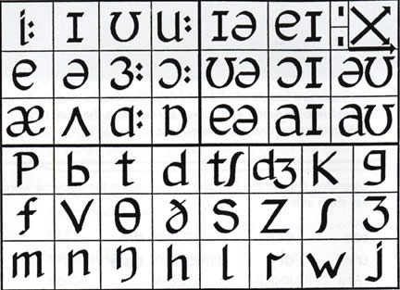
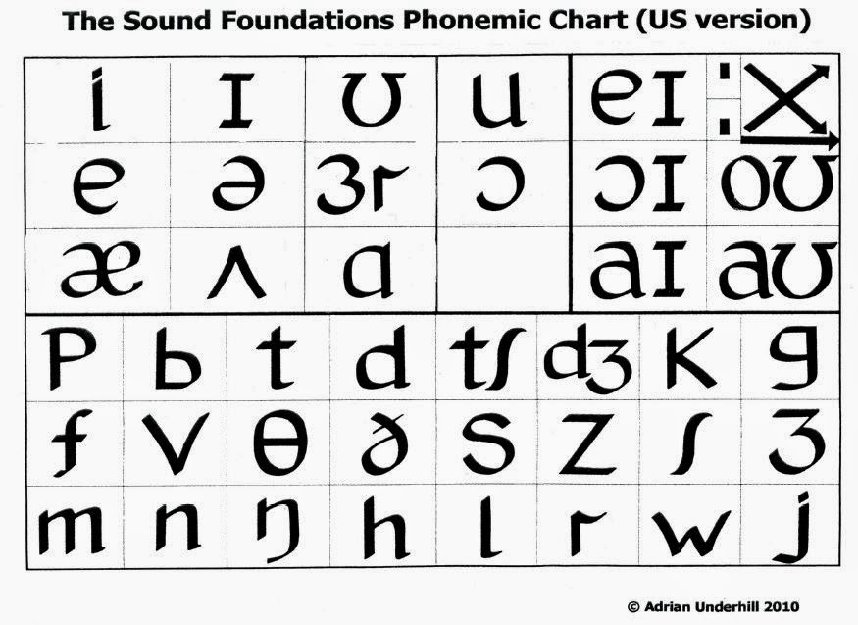
Sounds which are not phonemes, just allophones/replacements of certain phonemes:
[ɾ] = alveolar tap (flap), replacing /t/ in AmE
[ʔ] = glottal stop (=plosive], replacing [t] and sometimes even [p] and /k/ in substandard accents of British English; originated in Scotland
[ts] = affricated /t/ in initial positions in SE accents
[dz] = affricated /d/ in initial positions in SE accents

The Cockney diphthong shift:
[iː] > [eɪ] > [aɪ] > [ɔɪ]

Consequences of misplaced stresses:
Camden Town (Roger Kingdon)
unique (Jan Werich)
event (a student)
dessert, Pompei (myself)

Yod dropping and Yod Coalescence - what is the difference?
These two are mutually exclusive - if you get Yod Dropping you don't get Yod Coalescence, and vice-versa.
Yod Dropping REMOVES the j after t and d before u:
becomes
becomes
Yod Coalescence happens when the j has NOT dropped, but AFFRICATES the preceding t or d -
becomes
becomes
- so dew and Jew become homophones (=pronounced the same), and Tuesday is pronounced Choose-day.
Yod Dropping is common in North America, Yod Co in Britain.
Note that in older Cockney (up to the last third of the 20th century) Yod Dropping was common in Cockney; since then it has disappeared and Yod Coalescence has replaced it.
Source: Pétur Knútsson´s page

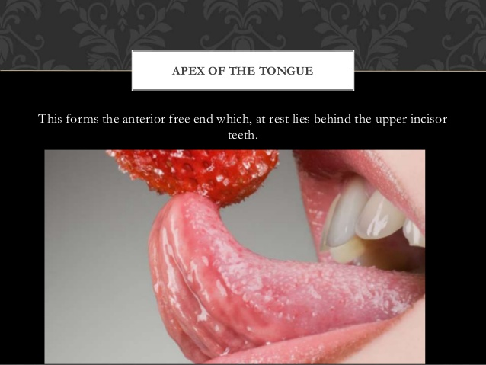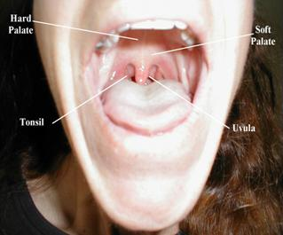

St. Patrick class, March 15
- Song: a listening comprehension exercise
https://www.youtube.com/watch?v=jdblgoXNiL8
Questions: a) the 3 colours on the Irish flag
b) the girl´s age
c) the expressions for flag and car
d) the young man´s identity
e) two expressions for what the girl
would rather do than have the flag
taken away
- Description of Irish accent
- Song: Famine by Sinéad O´Connor
https://www.youtube.com/watch?v=Z0K2kaG3VhM
&
Exercise in word stresses
IPA stress symbol: ˈ
beˈfore the ˈstressed ˈsyllable

