Important Dates in Ringo Starr’s Post-Beatles Career
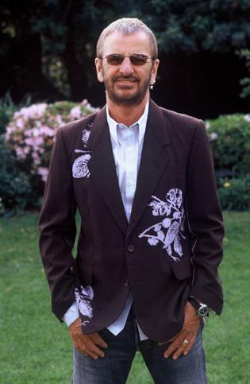

1970-Releases “It Don’t Come Easy,” a #1 hit produced by George Harrison. Also writes a song called “Early 1970” about the troubles befalling the Beatles.

1973-Releases the album Ringo, which had four top ten hits, and featured songs and performances by John, Paul, and George.

1974-Hangs out with John in L.A., and releases a follow-up to Ringo called Goodnight Vienna with contributions from the other Beatles.

1975-80- Records several albums that go nowhere and tries to figure out what to do.

1981-Marries the actress Barbara Bach.

1987-present: Released many albums, played in many concerts, has formed a band called the “All Starr Band,” that has existed in different incarnations and played all around the world. Ringo’s son Zak has played drums for The Who for many years.

2010- Ringo is the first Beatle to turn 70 years old! He’s still on tour today…

www.ringostarr.com

