COT
Strategies in preparation for
Cambridge-style oral tests
It is a common misconception that there is no way of preparing for the kind of oral test taken in couples, lasting 15 minutes, which most of you took as part of your Comprehensive Exam last year. In fact, with anything you read, listen to or practice (such as the pronunciation of the ‘adjective re’ciprocal), you develop mechanical skills and confidence continuously for occasions such as this one. There are, however, ways of putting oneself in the right disposition a few days before, or even the morning of the exam – not by cramming more knowledge but working on one’s behaviour and psychological disposition.
The exam’s structure:
- The first 5 minutes – introductions of the Interlocutor, Assessor and the Examinees, an informal chat between the two to a certain general topic suggested by the Interlocutor.
- Another 2 minutes each – comparing and contrasting pictures.
- The last 3-5 minutes – joint task - interaction over a set of pictures.
Each examinee’s assessment: max. 25pts (5pts pronunciation, 5pts grammar & vocabulary, 5pts sophistication, 5pts discourse management, 5pts overall effectiveness). The pass/fail line is 16.25pts.
THE INITIAL INTERACTION. Walking to the exam, one must put oneself in an interactive, friendly mood, no matter who their partner will be. The worst thing to do, once the Interlocutor has suggested a topic such as “Discuss with your partner where you see yourselves in 10 years‘ time“ (the least popular topic ever), is to say “Shall I start or will you?“, clearly showing that you’re not in the mood to interact and are only willing to give a separate, uninterrupted monologue. The very purpose of this first task is to see how you can interact and react to your partner’s opinions, politely agree or disagree, take turns, give turns., all in a language better than just casual, using terms such as “I can see your point, but don’t you rather think…“ and showing (faking) interest in your partner, kicking the ball into their field by asking questions. Honesty and truthfulness do not matter much in this initial, warm-up discipline, and if you (as most do) dislike being asked such intimate questions as above in public, you can turn the conversation to the (in)appropriateness of being asked like that, or you can joke in your answer saying you’d like to travel round the world and have ten children afterward. Everyone will appreciate if you make others laugh. This is a chance to show your sophistication in grammar, width of vocabulary and friendly, cooperative attitude.
THE PICTURES. This discipline is individual. You know beforehand that you shall be shown a sheet with 4-6 pictures on it, asked to pick just 2 of them for a more detailed description, comparison and contrasting. The Interlocutor then asks a very specific question. The commonest mistake here is that once the Examinee is confronted with the sheet, they stop listening to the Interlocutor and start fretting over which pix to choose and what the objects/people/animals in them are called, and then, in the middle of this discipline, ask “What was I supposed to do?“. Again, walking to the exam, one must be determined to calmly listen to the Interlocutor’s instructions and act accordingly without panicking. Besides not following the instructions, there are further pitfalls in this discipline which can be avoided:
- While choosing two out of a handful of pictures, most students, instead of localising them on the sheet in a civilised way, just point their fingers like two-year-olds saying “this one and this one“ (often “dis one and dis one“, much to the phonetician’s delight). Walking to the exam, one can practice expressions such as TOP-BOTTOM (UPPER-LOWER), LEFT, RIGHT and mid(le). These are technical expressions and must be practiced. Try this straight away:

- Everyone knows that the correct preposition is IN the picture. 30 per ‘cent people get it wrong, thinking ahead. Walking to the exam, one can practice this phrase indefinitely to make sure that muscle memory works and nothing but correct production is ensured.
- Time management. One needs to know how much can be fitted into two minutes, not to be done in one minute and then just stare at the Interlocutor (who is not supposed to help you out, but often does) nor only get the knack toward the end, being interrupted at the best moment, never having proceeded to the other picture (a much better expression than “the second picture“, implying you’ll be describing another images). It pays to compare and contrast similar, though not identical images, set 2 minutes on one’s device to experience what can be done /said in 120 seconds.
THE LAST, COOPERATIVE TASK. The couple are asked to discuss something between themselves, but loud enough for the Assessor to hear them. The discussion is based on a set of pictures on a larger-scale sheet. The wrong way: for each Examinee to pick their favourite picture, speak about it at length, and then agree those are the two most important/interesting/harmful items on the list. The right way: to take turns labelling each item briefly (which is often a concrete representation of a more abstract concept), showing off your vocabulary, and only then narrowing it down to the most important/interesting/harmful. Your practice in localising objects on a sheet from the individual task will come in handy. A lively and polite exchange of opinions is expected, again offering two separate monologues is wrong here.

NOW FOR TEST 6. MAKE A RECORDING SUMMING UP THE ABOVE INSTRUCTIONS IN ONE MINUTE AND THEN CHOOSE ONE OF THE FOUR TASKS:
- COMPARE AND CONTRAST THE Halloween masks BELOW TAKING EXACTLY 2 MINUTES, GIVING THE TWO IMAGES A LABEL THAT WOULD SUIT THEM BOTH, STATING THE SIMILARITIES AND DIFFERENCES BETWEEN THEM, NAMING SOME DETAILS IN THE PIX IF YOU HAVE TIME.
- or
- THE SAME WITH the witches BELOW BELOW.
- or
- IMAGINE YOU’D BE MOVING IN WITH SOMEONE. BASED ON THE CARTOON, MAKE A 2-MINUTE MONOLOGUE ABOUT WHICH CHORES YOU’D VOLUNTEER TO DO, WHICH YOU WOULDN’T AND WHY. ADD SOME OTHERS WHICH NEED TO BE DONE BUT AREN’T IN THE CARTOON.
- or
- IMAGINE YOU’RE DEFENDING A BACHELOR’S THESIS ON HOW THE ATTRACTIVENESS OF PEOPLE DEPENDS ON HALLOWEEN MASKS THEY’RE WEARING. USE THE BULLET POINTS AT THE BOTTOM OF THIS MATERIAL.

Download in the respective Homework Vault, deadline: March 31.

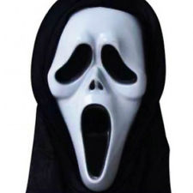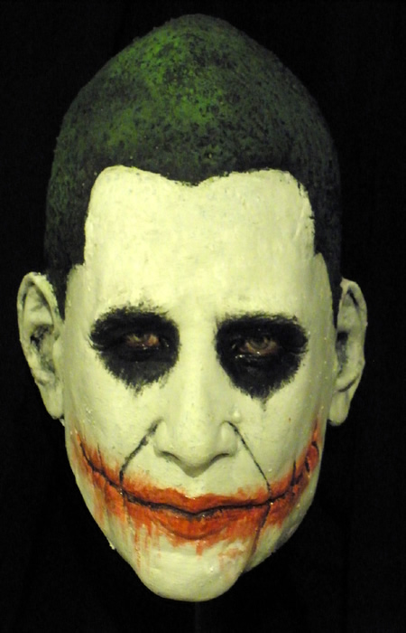
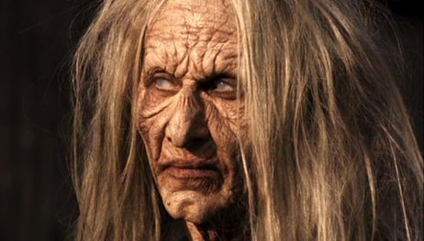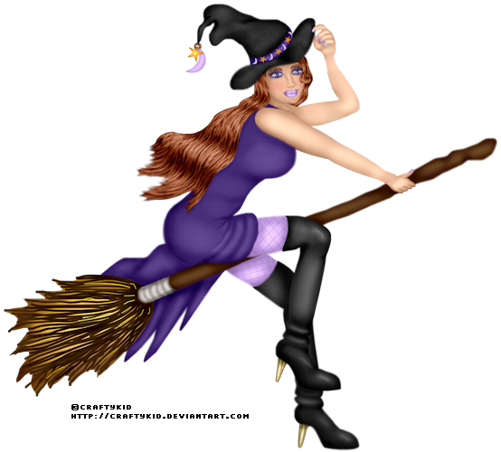

Cambridge oral test Part 3

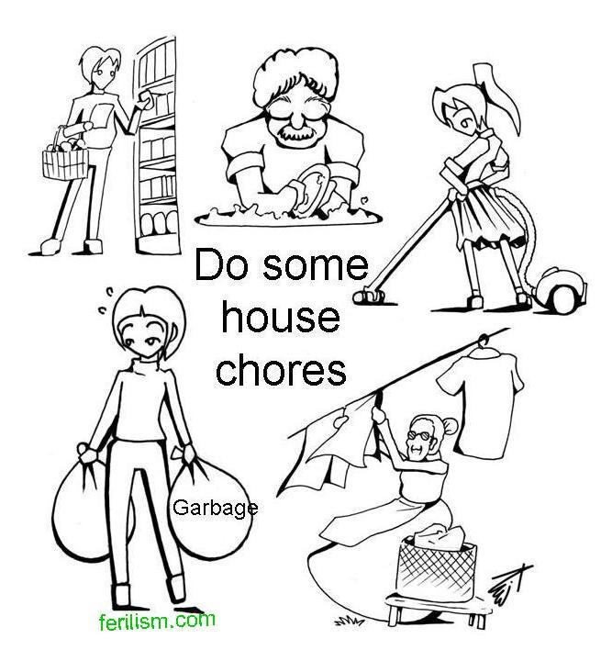

A hypothetical bachelor’s project
Title The impact of Halloween masks
on attractiveness perception
Hypothesis People wearing scary masks will be found less attractive than those wearing neutral/pretty ones
Method Half a dozen masks tipped out at a Halloween party, two dozen respondents (12 males - 9 hetero, 3 homosexual, 12 females - 11 hetero, 1 self-pronounced lesbian) filling out a questionnaire assessing the degree of the mask wearer’s attractiveness
Results Hypothesis disproved, respondents not influenced much by the masks, assessed the wearers‘ natural attractiveness

You investigated the attractiveness of people depending on masks they put on for a Halloween party. The hypothesis was that

