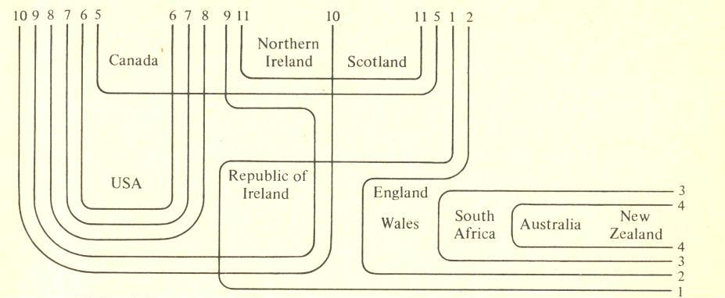
The variables as delimited here are
1 /αː/rather than /æ/ in path etc., 2 absence of non-prevocalic /r/,
3 close vowels for /æ/ and /e/, monophthongization of /aɪ/ and /ɑʊ/,
4 front /aː/ for /ɑː/ in part etc., 5 absence of contrast of /ɒ/ and /ɔː/ in cot and caught,
6 /æ/ rather than /ɑː/ in can’t etc.,
7 absence of contrast of /ɒ/ and /ɑː/ as in bother and father,
8 consistent voicing of intervocalic /t/, 9 unrounded /ɑ/ in pot, 10 syllabic /r/ in bird,
11 absence of contrast of /ʊ/ and /uː/ as in pull and pool.

