C+ CHARLIE PARKER 23/79:59

1. Billie’s Bounce (Charlie Parker) = based on 12-BAR BLUES chords 3:12
Charlie Parker’s Reboppers: Dizzy Gillespie-tp; Parker-as; Sadik Hakim-p; Curley Russell-b; Max Roach-dr.
New York City, November 26, 1945.
78: Savoy 573 / matrix number S 5850-5. CD: Giants of Jazz 53051.
On youtube: https://www.youtube.com/watch?v=S4mRaEzwTYo (klikni na ZOBRAZIT VÍCE)
https://www.youtube.com/watch?v=s2vYzelRycY (etiketa desky, fotografie)

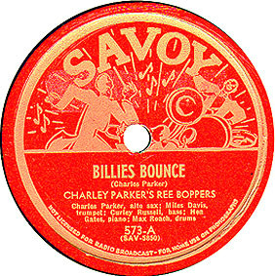

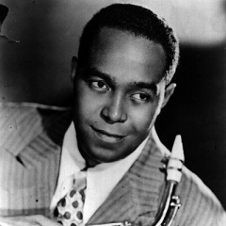

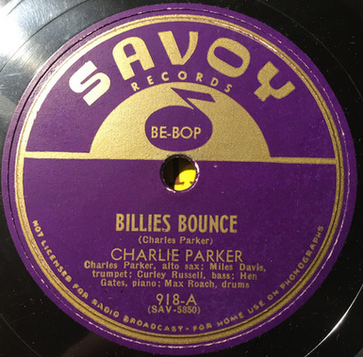

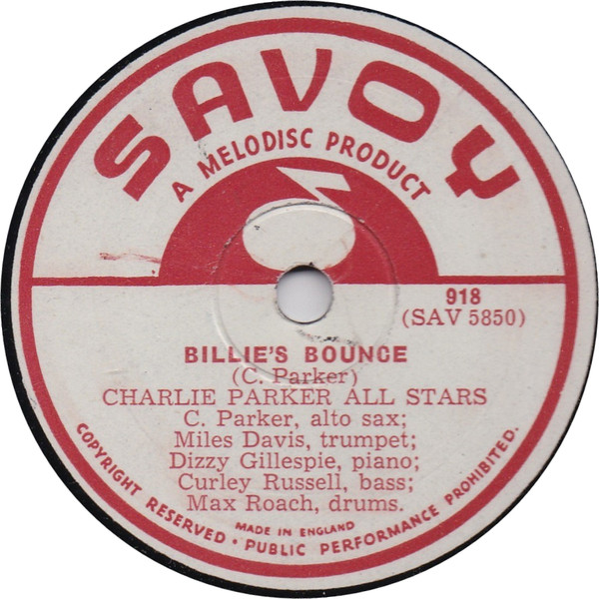

2. Ko Ko (Charlie Parker) = based on CHEROKEE chords 2:55
Charlie Parker’s Reboppers: Parker-as; Dizzy Gillespie-tp, p; Curley Russell-b; Max Roach-dr.
New York City, November 26, 1945.
Savoy 597 / S 5853-2. CD: Giants of Jazz 53051.
https://www.youtube.com/watch?v=8wGJpbPKbz8
https://www.youtube.com/watch?v=4rMiD8UUcd0 (s foto)

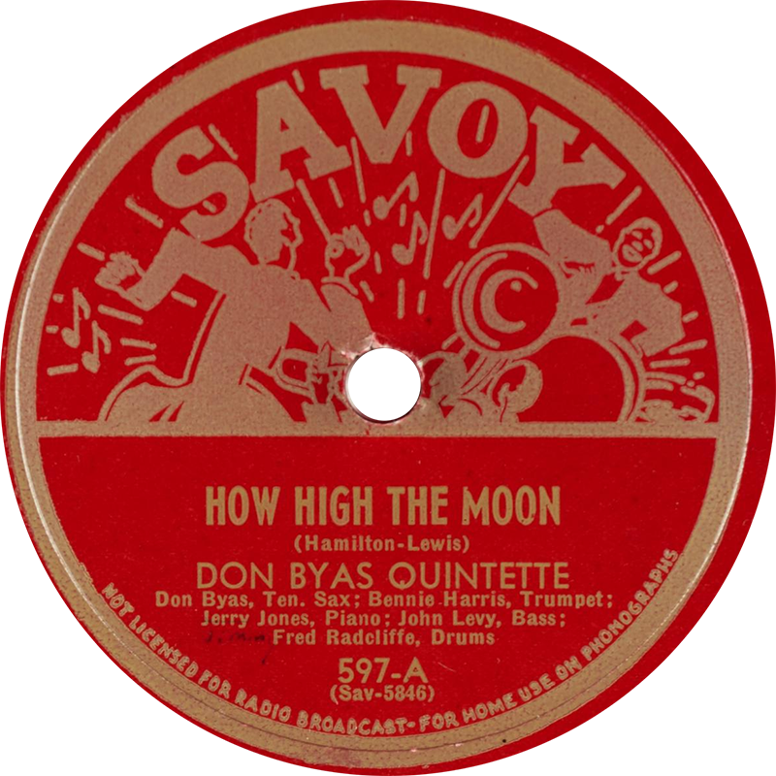

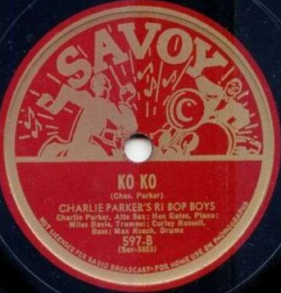

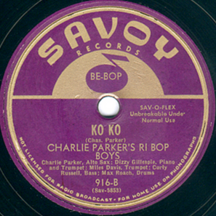

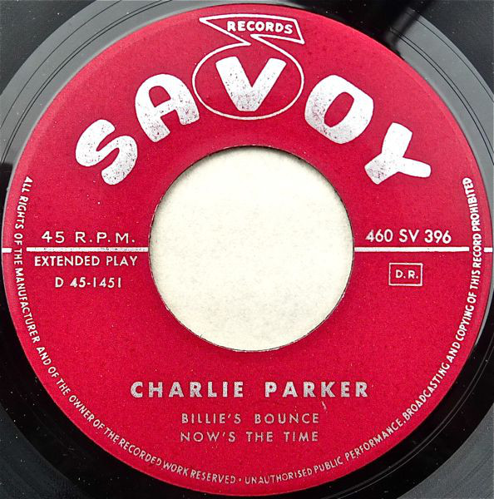

Ko-ko in Tom Lord’s Jazz Discography

Ko-ko
[P701-14] Charlie Parker
Charlie Parker's Reboppers:
Miles Davis (tp-1) Dizzy Gillespie (tp-2,p-3) Charlie Parker (as) Argonne Thornton (p-4) [aka Sadik Hakim (p) ] Curly Russell (b) Max Roach (d)
New York, November 26, 1945

S5849-1 Warming up a riff (3,*) Savoy 945
S5850-1 Billie's bounce (1,3) Savoy (F)460SV396
S5850-2 Billie's bounce (1,3) (incomplete) Byg (F)529121
S5850-3 Billie's bounce (1,3) Savoy (F)255SV121
S5850-4 Billie's bounce (1,3) (incomplete) Savoy MG12079
S5850-5 Billie's bounce (1,3,*) Savoy 573
S5851-1 Now's the time (1,3) (incomplete) Savoy MG12079
S5851-2 Now's the time (1,3) (incomplete) Savoy MG12079
S5851-3 Now's the time (1,3) Savoy (F)460SV396
S5851-4 Now's the time (1,3,*) Savoy 573, 918
S5852-1 Thriving from a riff (1,4) Savoy (F)460SV402
S5852-2 Thriving from a riff (1,4) (incomplete) (cp out) Savoy MG12079
S5852-3 Thriving from a riff (1,4,*) Savoy 903, 945
tk 1 Meandering (3) (incomplete) Savoy (F)460SV399
S5853-1 Ko-ko (2,3) (incomplete) Savoy (F)300SV058, CBS/Sony (Jap)SOPJ134-5SY
S5853-2 Ko-ko (2,3,*) Savoy 597, 916, 45-311, 4508, XP8001, XP8097,
MG9000, MG9034, MG12014, MG12126, (E)916, F)916, 460SV399, 300SV058, Byg (F)529605, Monkey (F)MY40031, Byg (F)58005 (set of 5 LP's, LP2), Byg (It)LP5, Savoy SJL2201, (E)ZL71854, Franklin Mint GJR043, Giants of Jazz (It)LPJT31, Smithsonian P11891, London (E)LTZ-C15107 Musidisc (F)30SA6031, London (E)LTZ-C15062, Realm (E)RM187, Savoy/Musidisc (F)30SA6017, BYG (F)529148, Official (E)3011-2, Giants of Jazz (It)CD53051 [CD], 2nd St. SSP1204 [CD],
Vogue (F)VG655650107 [CD], Rhino R2-72260 [CD], Savoy ZD70737 [CD], Definitive (And)DRCD44420 [CD]

Note: "Ko-ko" Mx S5853-2 issued as "Co-coa" on Savoy XP8097 and MG9034.
Savoy 903 and 945 issued as by The Bebop Boys, all other issues under Parker's name if not exactly under the same heading (eg Charley Parker's Ri-Bop Boys).
Savoy SJL1107 titled "Encores"; see various flwg sessions to September 18, 1948 for more titles; rest of LP by Tiny Grimes, Miles Davis.
Savoy SJL1129 titled "Bird encores Vol. 2"; see various flwg sessions to September 24, 1948 for more titles.
Savoy SJL2201 titled "Bird - The Savoy Recordings : Master takes"; see various flwg sessions to September 24, 1948 for more titles.
Savoy MG12104 titled "The genius, 4".
Franklin Mint 043 is part of a 4 LP box set titled "Bebop legends"; further titles by others artists.
Savoy (E)ZL71854 titled "The original Bird"; see various flwg sessions to January 15, 1949 for more titles; rest of LP by Miles Davis.
Giants of Jazz (It)LPJT31 titled "Birth of Bebop"; see various flwg sessions to May 8, 1947 for more titles; rest of LP by Dizzy Gillespie, Red Norvo, Tiny Grimes and Sir Charles Thompson.
Smithsonian P11891 titled "Smithsonian Collection of Classic Jazz".
Official (E)3011-2 titled "Boss Bird"; see various flwg sessions to August 4, 1953 for more titles; rest of this 2 LP set by Jay McShann, Tiny Grimes, Dizzy Gillespie, JATP, Slim Gaillard.
2nd St. SSP1204 [CD] titled "Bob Yanelli Jazz Saxophone Classics, Volume One"; see August 1950 & March 28, 1946 for 2 more titles; rest of CD by others.
Giants of Jazz (It)LPJT24 titled "The early years Vol. 1" and is issued under Miles Davis' name.
Giants of Jazz (It)CD53051 [CD] titled "Charlie Parker 1945-53".
Rhino R2-72260 [CD] titled "Yardbird Suite"; see various flwg sessions to July 30, 1953 for more titles; rest of this 2 CD set by Dizzy Gillespie.
Savoy ZD70737 [CD] titled "Bird - The Savoy Recordings master takes"; see various flwg sessions to September 24, 1948 for more titles; rest of CD by Tiny Grimes, September 15, 1944 & Miles Davis, August 14, 1947.
Definitive (And)DRCD44420 [CD] titled "Charlie Parker - The Complete Savoy Sessions Master Takes"; see various flwg sessions to Spetember 24, 1948 for more titles; rest of this 2 CD set by Dizzy Gillespie, Tiny Grimes, Slim Gaillard, Miles Davis.
American Jazz Classics (Sp)99033 [CD] titled "Charlie Parker & Miles Davis - Blue Bird: Legendary Savoy Sessions".
All titles from Definitive (And)DRCD4420 [CD] also on Classics (F)980 [CD] titled "Charlie Parker 1945-1947"; see flwg sessions to May 4,1947 for rest of CD.
One take of each of "Billie's bounce", "Now's the time" and "Meandering" also on Definitive (And)DRCD44418 [CD] titled "Charlie Parker and Miles Davis - Blue Bird - Legendary Savoy Sessions".
One take of Mx. S5850 also on Frequenz (It)044-004 [CD].
Above titles from Savoy MG12009 also on Savoy (Jap)SV-0103 [CD].
Above titles from Savoy MG12014 also on Savoy (Jap)SV-0104 [CD].
First 12 titles on CBS/Sony (Jap)SOPU-21, SOPL-64.
Last 3 titles on CBS/Sony (Jap)SOPU-22, SOPL-65.
(1) These titles also on Masters of Jazz (F)MJCD131 [CD].
All titles from Savoy SJL2201 also on Savoy (F)2C162-99010/011, Savoy (G)1C148-99010/011.
All titles, except (*), also on Neatwork (Au)RP2008 [CD] titled "Charlie Parker volume 1,1945-1947, The Alternate Takes"; see flwg sessions to February 19,1947 for rest of CD.
All above titles also on Savoy MG12079 (titled "The greatest recording session"), London (E)LTZ-C15108, Eros (E)ERL50048, Realm (E)RM120, 52120, Byg (F)529129, LP58011 (set 58011/15, LP3), Savoy SJL SSJ5500, CD6131 [CD], CD9012 [CD], Savoy (Jap)SV-0105 [CD](titled "The Charlie Parker story").
All above titles also on Savoy ZDS5500 [CD] titled "Charlie Parker - The Complete Studio Sessions"; this is a 3 CD set.
All above titles also on Definitive (And)DRCD44402 [CD], Definitive (And)DRCD1148 [CD].

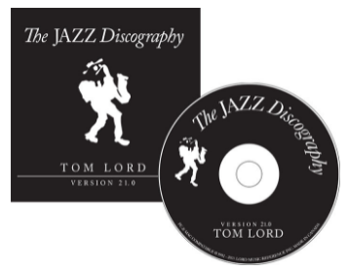

3. Shaw ‘Nuff (Dizzy Gillespie) = I GOT RHYTHM („Rhythm changes“) 4:20
Dizzy Gillespie and his Rebop Six: Gillespie-tp; Parker-as; Al Haig-p; Ray Brown-b;
Stan Levey-dr.
Broadcast AFRS Jubilee, Hollywood, CA, December 29, 1945.
Spotlite SPJ 123 / no matrix #. CD: Musica Jazz MJCD 1102.
https://www.youtube.com/watch?v=DGrZpTWSkh4
https://www.youtube.com/watch?v=5DCY8o6IPjg (s etiketou, z archivního gramofonu)
Original recording, May 11, 1945:
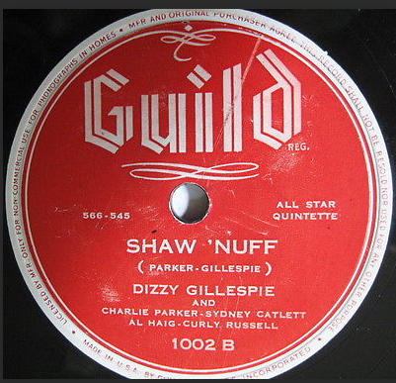

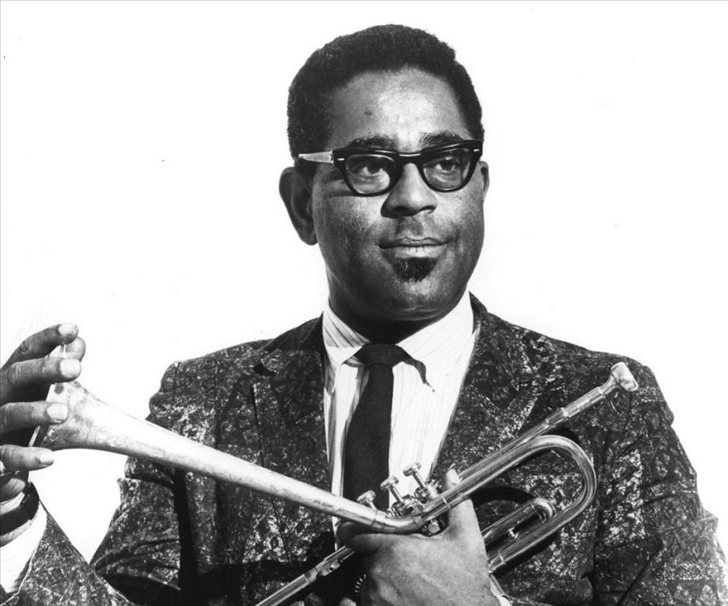

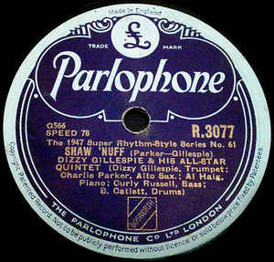

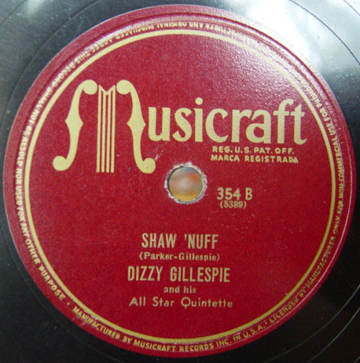

4. Donna Lee (Charlie Parker) = INDIANA 2:34
Charlie Parker All Stars: Miles Davis-tp; Parker-as; Bud Powell-p; Tommy Potter-b;
Max Roach-dr.
New York City, May 8, 1947.
Savoy 652 / S 3420-5. CD: Giants of Jazz 53051.
Although credited to Charlie Parker, some sources claim this tune was in fact written by Miles Davis (including Davis himself in his autobiography). If true, this would be Davis' first composition to have been recorded.
https://www.youtube.com/watch?v=bF0W4fHiVUc
https://www.youtube.com/watch?v=D_iZPUCMgow

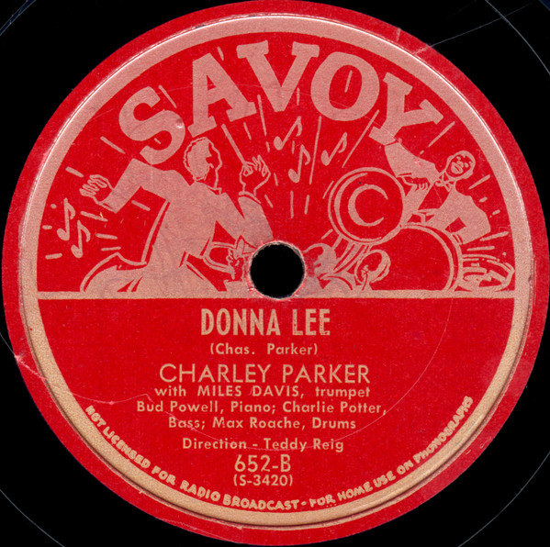

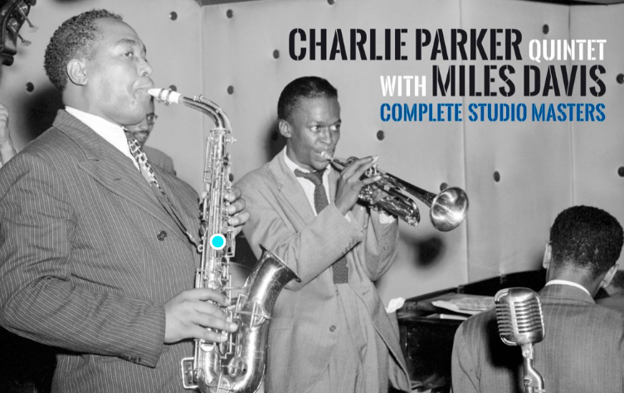
5. Chasin’ the Bird (Charlie Parker) = RHYTHM CHANGES 2:48
Charlie Parker All Stars: Miles Davis-tp; Parker-as; Bud Powell-p; Tommy Potter-b;
Max Roach-dr.
New York City, May 8, 1947.
Savoy MG 12001 / S 3421-1. CD: Giants of Jazz 53051.
https://www.youtube.com/watch?v=BwWL0Eyi8I4 (ZOBRAZIT VÍCE)
https://www.youtube.com/watch?v=q97xzziKqOI (foto)

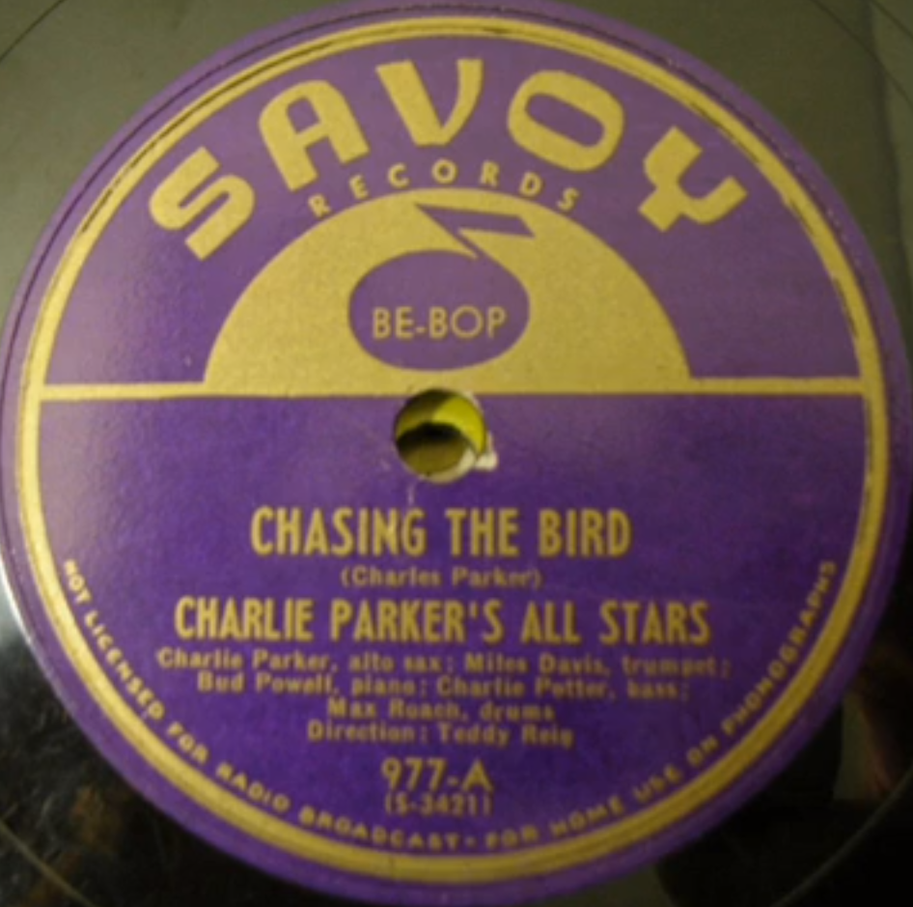

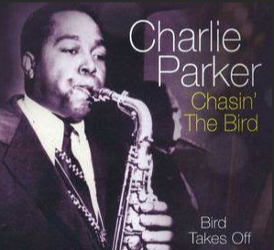

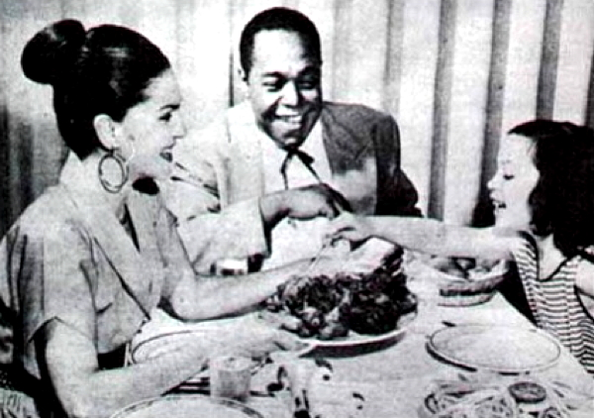

6. Parker’s Mood (Charlie Parker) = BLUES 3:05
Charlie Parker All Stars: Parker-as; John Lewis-p; Curley Russell-b; Max Roach-dr.
New York City, September 18, 1948.
Savoy 936 / B 903-5. CD: Giants of Jazz 53051.
https://www.youtube.com/watch?v=6Wa7El-k3jQ (ZOBRAZIT VÍCE)
https://www.youtube.com/watch?v=yxKPe0WDAAg

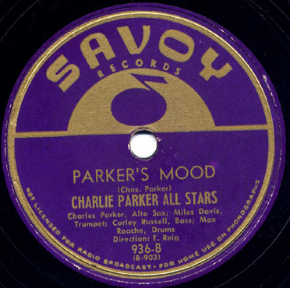

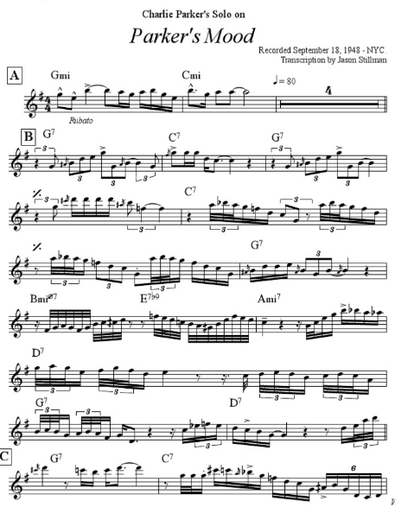

7. Overtime (Pete Rugolo) 4:33
Metronome All Stars: Dizzy Gillespie, Miles Davis, Fats Navarro-tp; Kai Winding,
Jay Jay Johnson-tb; Buddy DeFranco-cl; Charlie Parker-as; Charlie Ventura-ts; Ernie
Caceres-bs; Lennie Tristano-p; Billy Bauer-g; Eddie Safranski-b; Shelly Manne-dr.
New York, January 3, 1949.
Victor LPT-3046 / D9VC-1000-1. CD RCA 07863 66528 2.
https://www.youtube.com/watch?v=o9NNaebOUyU (ZOBRAZIT VÍCE, etiketa desky)
https://www.youtube.com/watch?v=eZo0Oy9QEwA (FOTO SÓLISTŮ!!!)

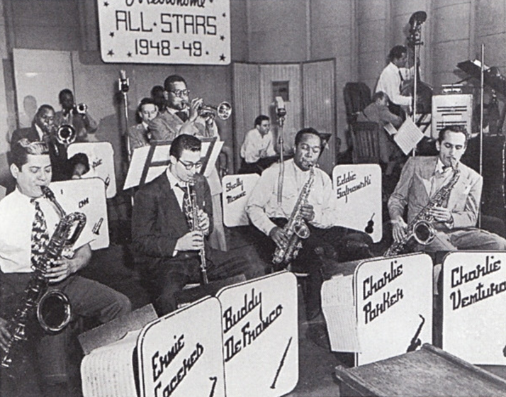

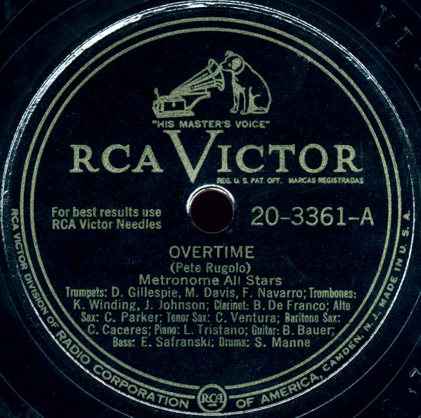
Alternate take label

8. Cardboard (Charlie Parker) 3:10
Charlie Parker Septet: Kenny Dorham-tp; Tommy Turk-tb; Parker-as; Al Haig-p;
Tommy Potter-b; Carlos Vidal-cga; Max Roach-dr.
New York City, April 1949.
Norgran MGN 1035 / C292-3. CD: Verve 527 815-2.
https://www.youtube.com/watch?v=CrLHwJiLofA
https://www.youtube.com/results?search_query=charlie+parker+cardboard

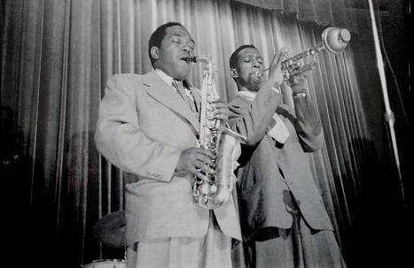

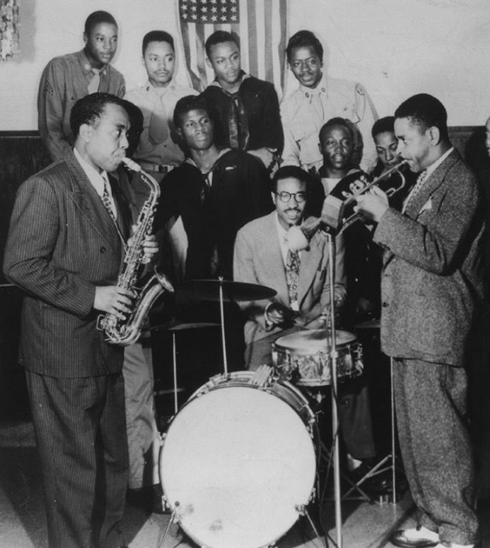

9. Just Friends (John Klenner-Sam Lewis) 3:33
Charlie Parker Quartet with Jimmy Carroll Orchestra: Parker-as; Mitch Miller-ob, Eh; Bronislaw Gimpel, Max Hollander, Milt Lomask-vio; Frank Brieff-vla; Frank Miller-vcl; Myor Rosen-harp; Stan Freeman-p; Ray Brown-b; Max Roach-dr; Jimmy Carroll-arr, cond.
New York City, November 30, 1949.
Mercury/Clef 11036 / C319-5 | 62VK204. CD: Verve 527 815-2.
https://www.youtube.com/watch?v=IwMjxAEnPwE (ZOBRAZIT VÍCE; foto, etiketa šelakové desky)
https://www.youtube.com/watch?v=4fPPkRI2vfk (obal vinylové desky)

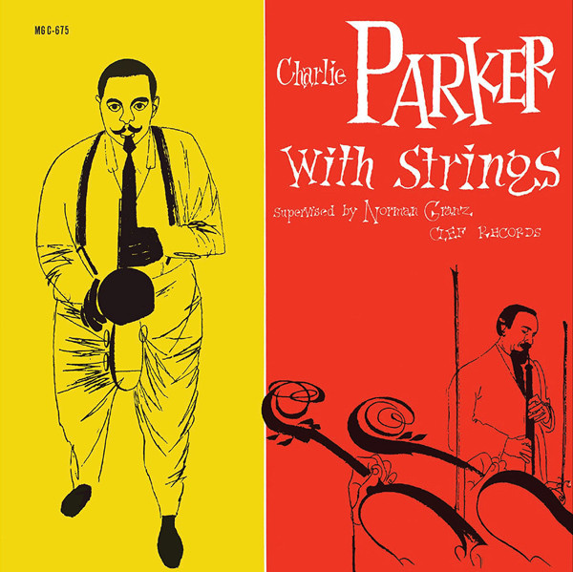

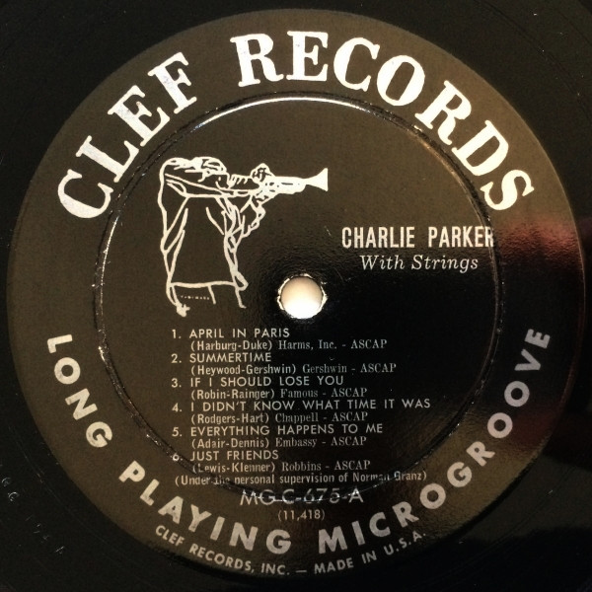

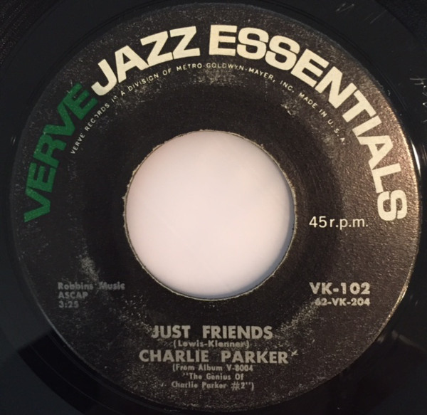

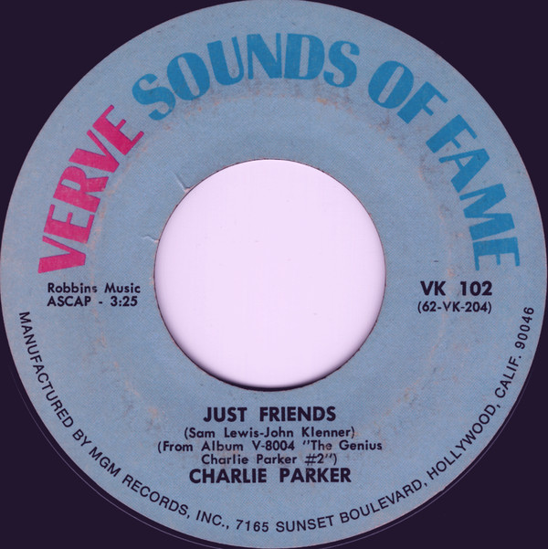

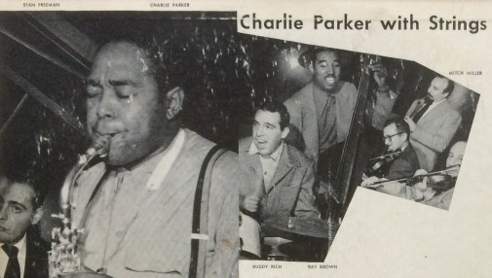

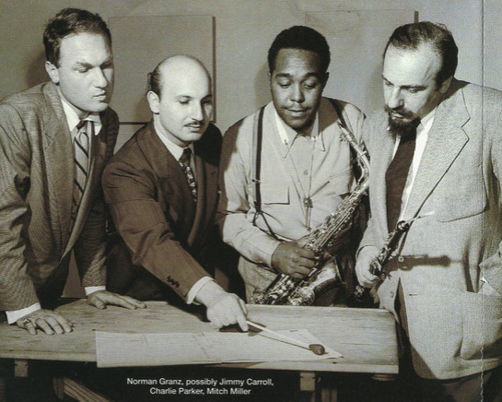
Norman Granz, possibly Jimmy Carroll, Charlie Parker, Mitch Miller

10. Bloomdido (Charlie Parker) = BLUES 3:28
Dizzy Gillespie-Charlie Parker Quintet: Gillespie-tp; Parker-as; Thelonious Monk-p;
Curly Russell-b; Buddy Rich-dr.
New York City, June 6, 1950.
Mercury/Clef 11058 / C 410-4. CD: Verve 527 815-2.
https://www.youtube.com/watch?v=fzzE73QK_Kk (ZOBRAZIT VÍCE; obal vinylu)
https://www.youtube.com/watch?v=1MCGweQ8Oso (foto, i odjinud)

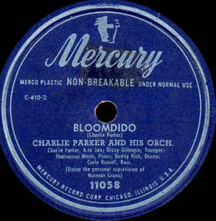
shellac record 1952

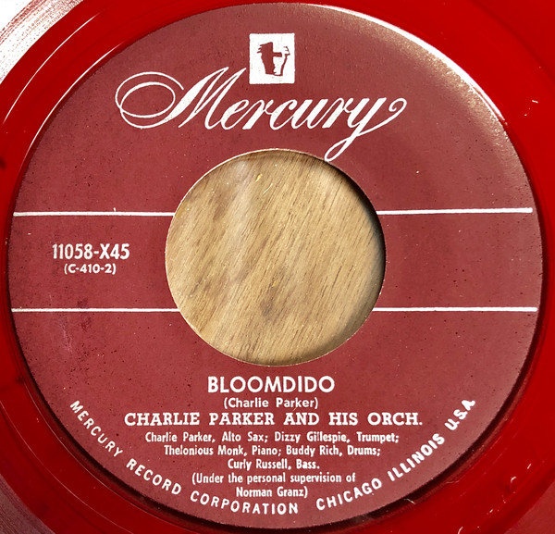
SP record
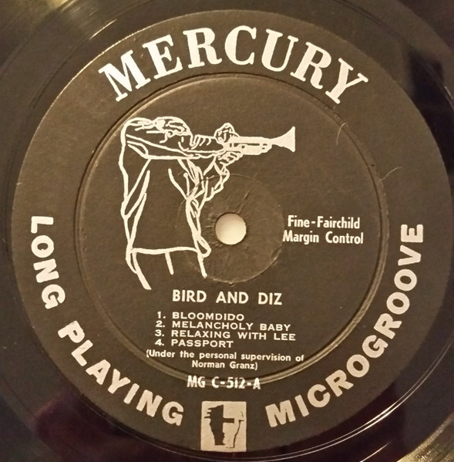
10” LP record 1952

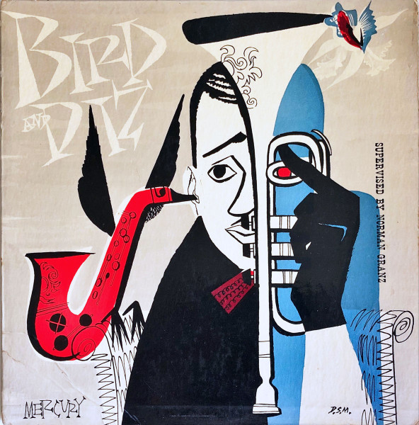
1952 Mercury LP cover

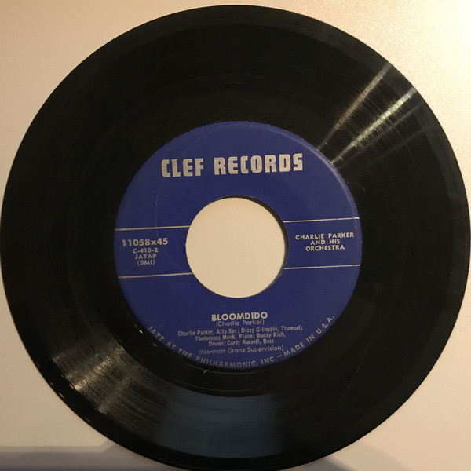
Clef SP record 1954

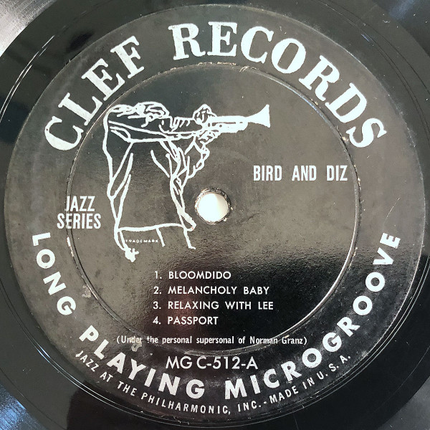
Clef LP record

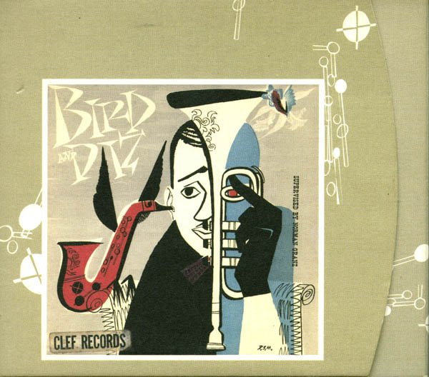
1954 Clef LP cover

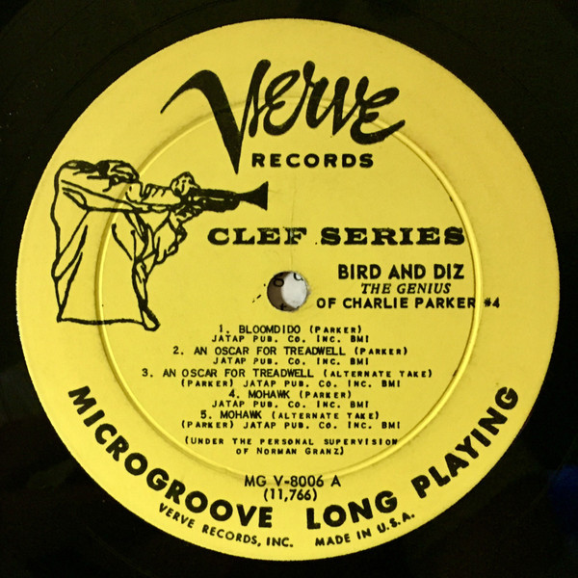
Verve LP record 1956

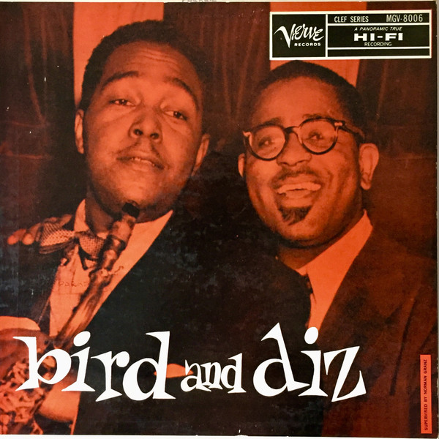

1997 CD release with alternate takes
1 |  |  | Bloomdido |  | 3:25
2 |  |  | My Melancholy Baby |  | 3:24
3 |  |  | Relaxin' With Lee |  | 2:47
4 |  |  | Leap Frog |  | 2:47
5 |  |  | An Oscar For Treadwell |  | 2:29
6 |  |  | Mohawk |  | 3:23
7 |  |  | My Melancholy Baby |  | 3:17
8 |  |  | Relaxin' With Lee |  | 3:56
9 |  |  | Leap Frog |  | 2:34
10 |  |  | Leap Frog |  | 2:02
11 |  |  | Leap Frog |  | 2:06
12 |  |  | An Oscar For Treadwell |  | 3:21
13 |  |  | Mohawk |  | 3:48
14 |  |  | Relaxin' With Lee |  | 0:17
15 |  |  | Relaxin' With Lee |  | 1:08
16 |  |  | Relaxin' With Lee |  | 0:04
17 |  |  | Relaxin' With Lee |  | 0:24
18 |  |  | Leap Frog |  | 0:26
19 |  |  | Leap Frog |  | 0:14
20 |  |  | Leap Frog |  | 0:40
21 |  |  | Leap Frog |  | 0:18
22 |  |  | Leap Frog |  | 0:20
23 |  |  | Leap Frog |  | 0:13
24 |  |  | Leap Frog |  | 0:41

11. Au Privave (Charlie Parker) = BLUES (výslovnost: o priváv) 2:41
Charlie Parker Quintet: Miles Davis-tp; Parker-as; Walter Bishop-p; Teddy Kotick-b;
Max Roach-dr.
New York City, January 17, 1951.
Verve MGV 8409 / C 489-2. CD: Verve 527 815-2.
https://www.youtube.com/watch?v=dvdQYSWOobc (foto, obaly)
https://www.youtube.com/watch?v=AQD3V1ExdDY (obal vinylu s foto ze Stockholmu)

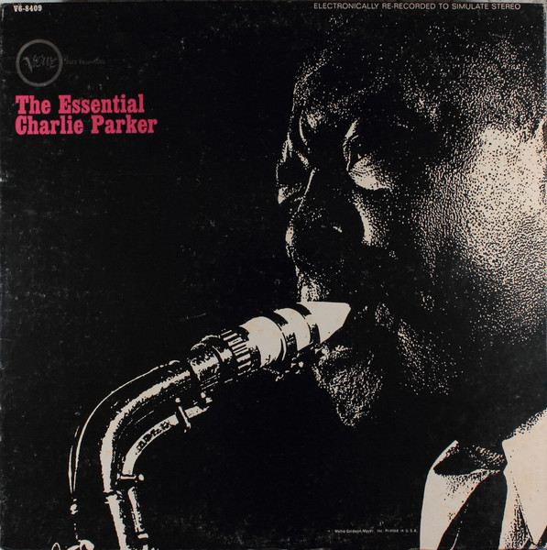

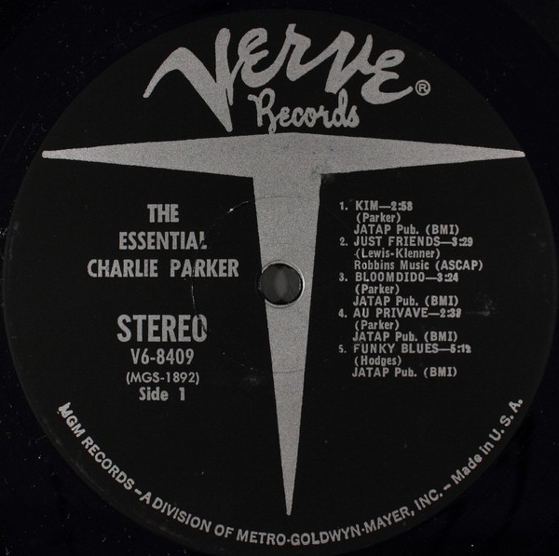

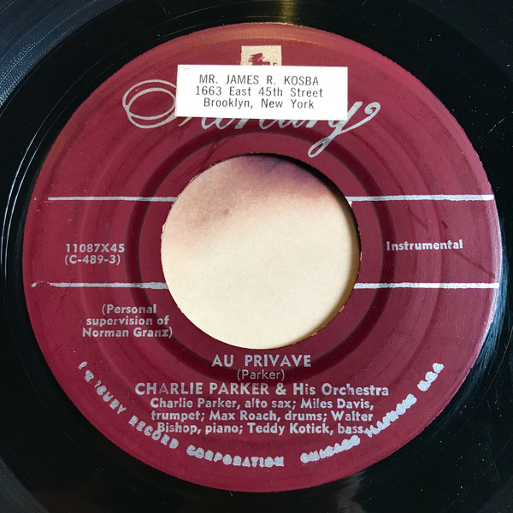

Austroton Austria 1952
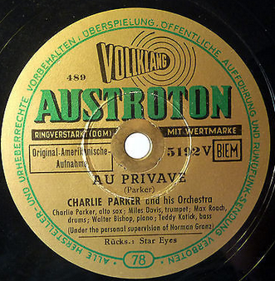

12. My Little Suede Shoes (Charlie Parker) 3:05
Charlie Parker’s Jazzers: Parker-as; Walter Bishop, Jr.-p; Teddy Kotick-b; Roy Haynes-dr;
José Mangual-bgo; Luis Miranda-cga.
New York City, March 12, 1951.
Mercury/Clef 11093 / C 540-6. CD: Verve 527 815-2.
https://www.youtube.com/watch?v=-JKDFD1PZ8Y (ZOBRAZIT VÍCE)
https://www.youtube.com/watch?v=2TghfhihKd8 (foto)

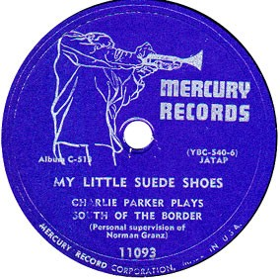

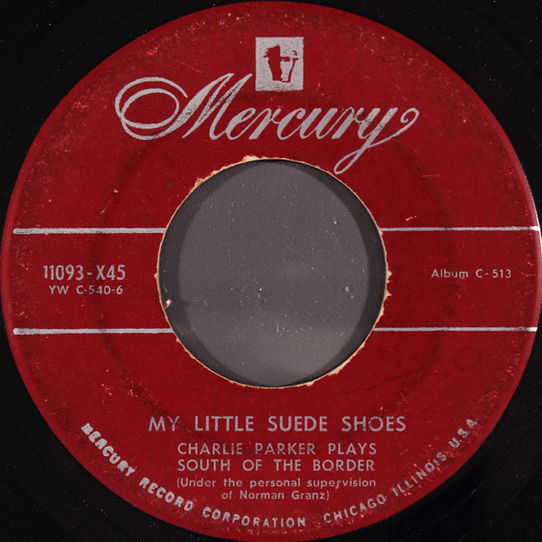

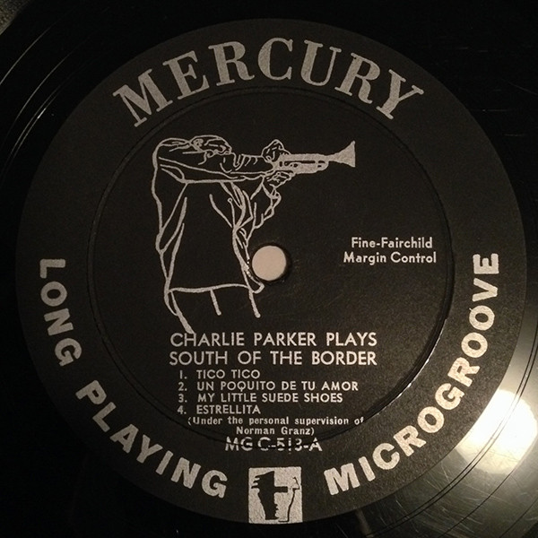

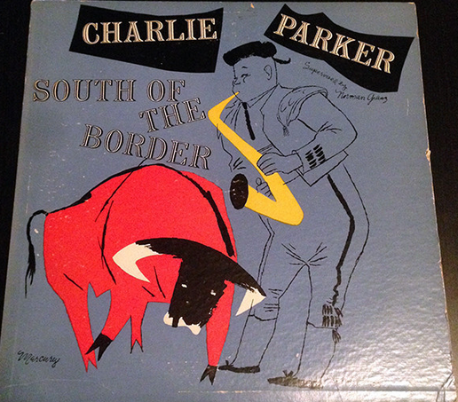

13. Swedish Schnapps (Charlie Parker) RHYTHM CHANGES 3:19
Charlie Parker Quintet: Red Rodney-tp; Parker-as; John Lewis-p; Ray Brown-b; Kenny Clarke-dr.
New York City, August 8, 1951.
Verve MGV 8409 / C 611-3. CD: Verve 527 815-2.
https://www.youtube.com/watch?v=x4zv051Pks0 (obal)
https://www.youtube.com/watch?v=0fjLwKIP7Hw (ZOBRAZIT VÍCE)

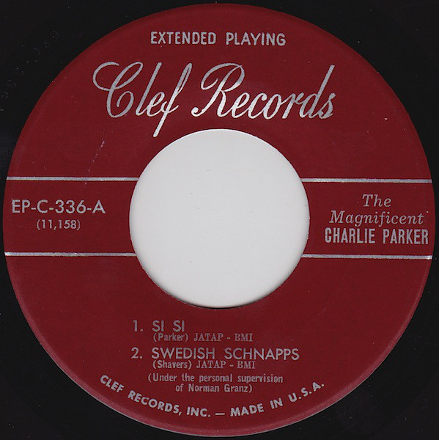

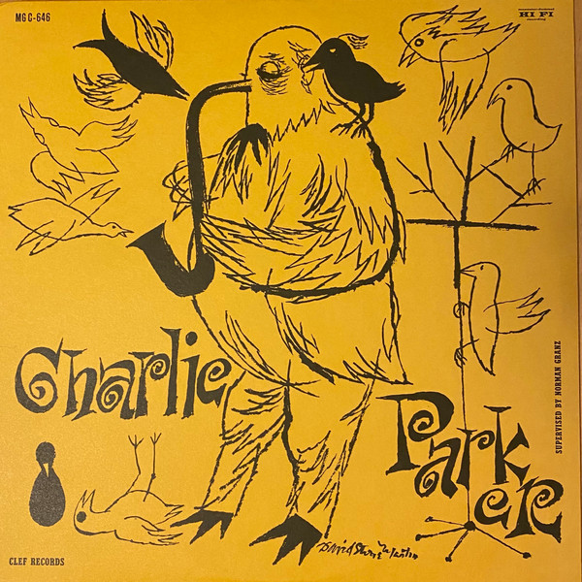

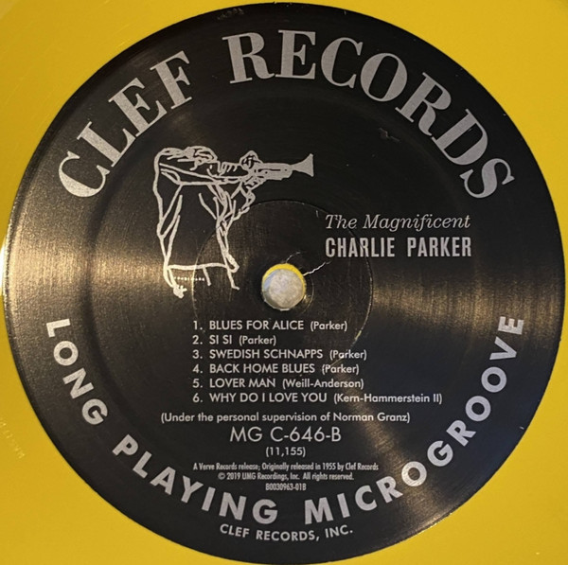

Columbia UK 1955 – Clef Series
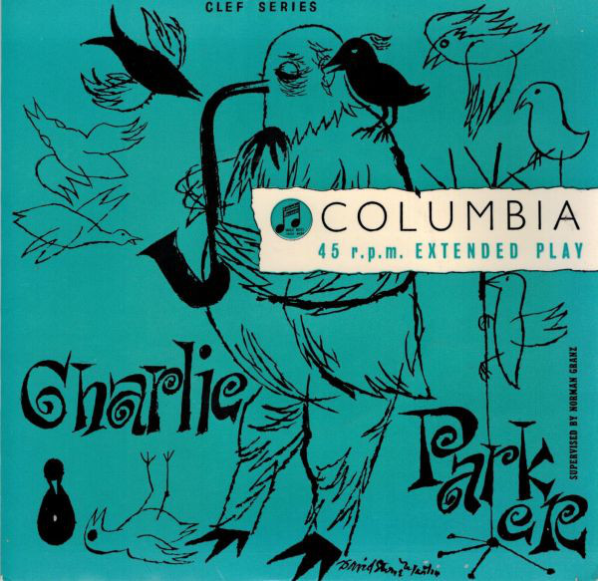

14. In the Still of the Night (Cole Porter) 3:26
Charlie Parker Quartet with Gil Evans Orchestra: Parker-as; Junior Collins-h; Hal McKusick-cl; Tommy Mace-ob; Manny Thaler-bsn; Tony Aless-p; Charles Mingus-b; Max Roach-dr; Dave Lambert Singers: Lambert (arr), Butch Birdsall, Jerry Parker, Annie Ross, two unknown-voc;
Gil Evans-arr, cond.
New York City, May 25, 1953.
Clef 11100 / C 1238-7. CD: Verve 527 815-2.
https://www.youtube.com/watch?v=YxtomSATLNM
https://www.youtube.com/watch?v=AY89gcVgTxI (ZOBRAZIT VÍCE)

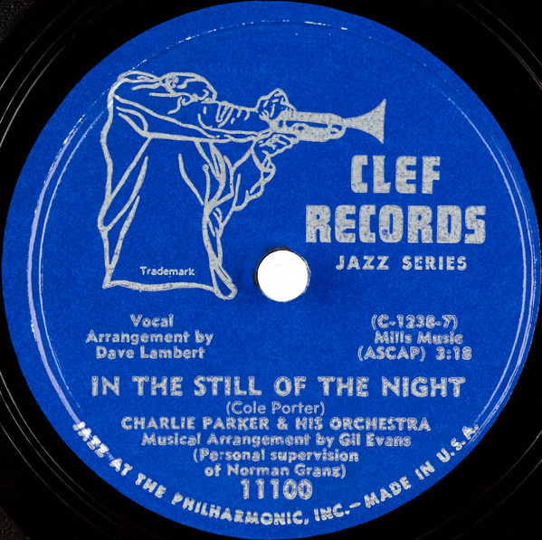

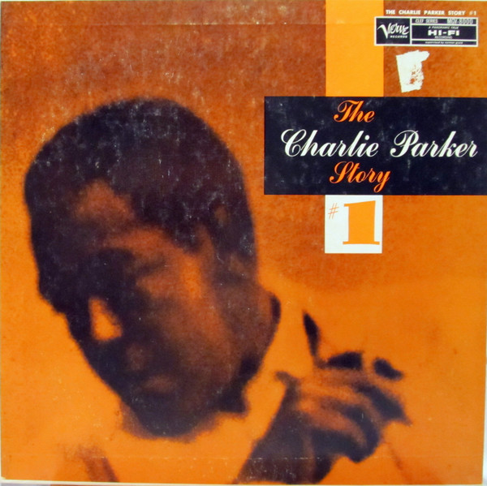

Columbia UK – Clef Series
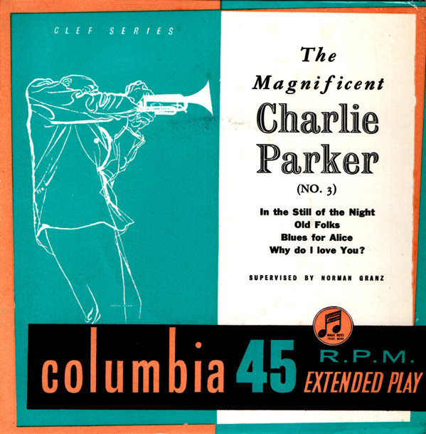

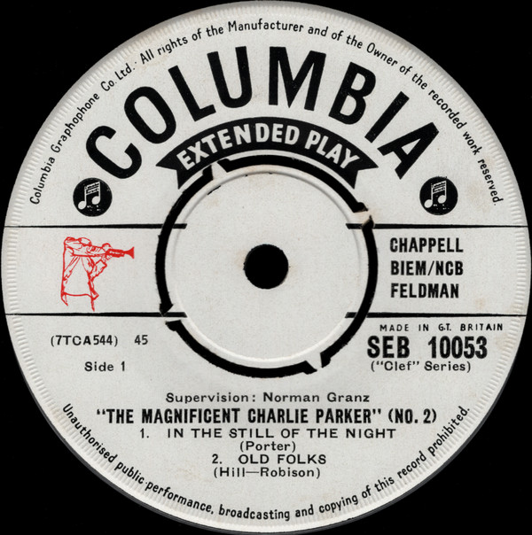

15. Now’s the Time (Charlie Parker) BLUES 3:03
Charlie Parker Quartet: Parker-as; Al Haig-p; Percy Heath-b; Max Roach-dr.
New York City, July 30, 1953.
Clef MGC 517/C 1248-1. CD: Verve 527 815-2.
https://www.youtube.com/watch?v=ryNtmkfeJk4
https://www.youtube.com/watch?v=qG2RzlLJUNo

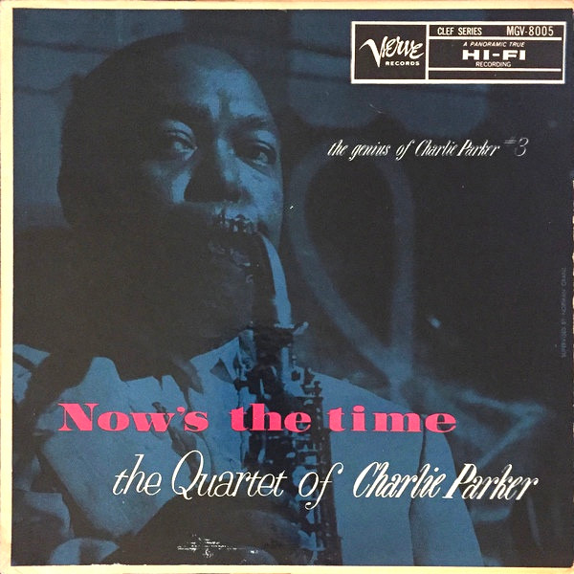

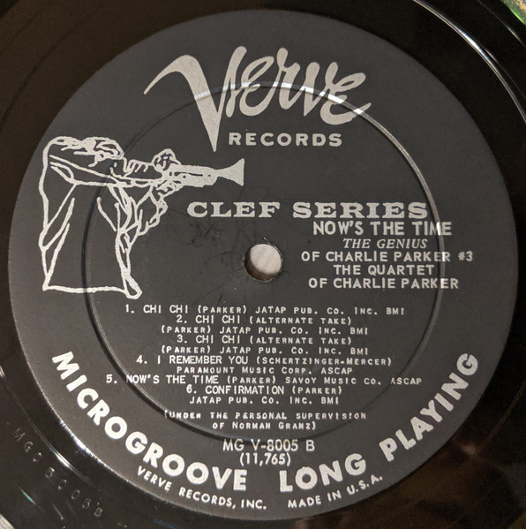

16. Confirmation (Charlie Parker) [take 1-false start, take 2-false start, take 3-master take] 3:27
same personnel & date.
Clef MGC 517/1249-3. CD: Verve 837 154-2.
https://www.youtube.com/watch?v=yXK0pZx92MU (s foto)
https://www.jazziz.com/song-of-the-day-charlie-parker-confirmation/ (s komentářem)

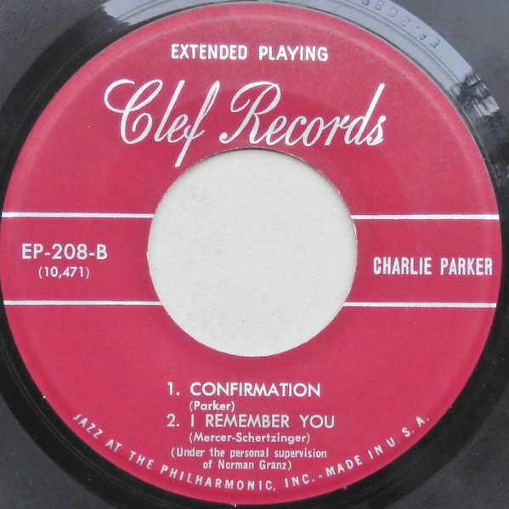

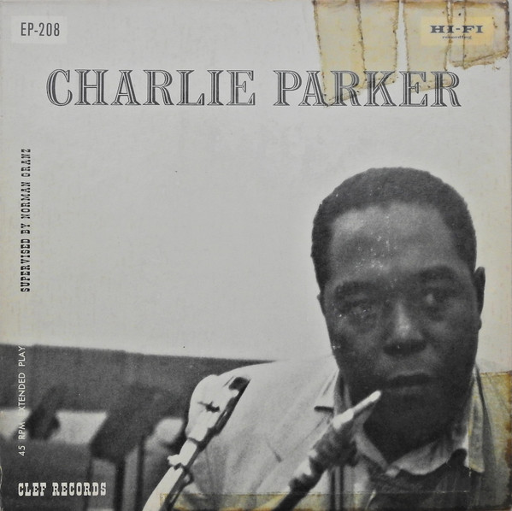

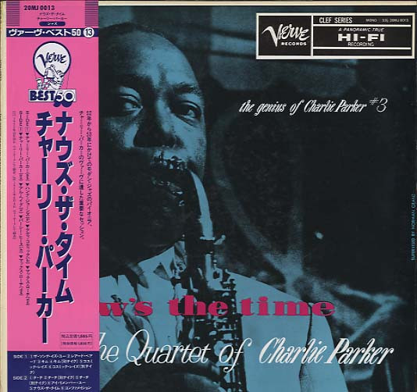

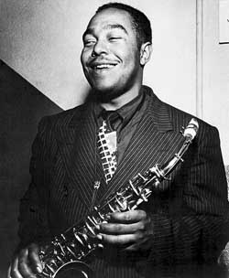

17. Repetition (Neal Hefti) 3:02
Charlie Parker overdubbed on Neal Hefti’s Orchestra: Parker-as; Doug Mettome, Al Porcino,
Ray Wetzel-tp; Bill Harris-tb; Bart Varsalona-btb; Vinnie Jacobs-h; John LaPorta-cl; Sonny Salad, Murray Williams-as; Pete Mondello, Flip Phillips-ts; Manny Albam-bs; Gene Orloff, Sam Caplan, Manny Fiddler, Sid Harris, Harry Katzman, Zelly Smirnoff-vio; Nat Nathanson, Fred Ruzilla-vla; Joe Benaventi-vcl; Tony Aless-p; Curly Russell-b; Shelly Manne-dr; Diego Iborra-perc;
Neal Hefti-arr, cond.
Carnegie Hall, New York City, December 1947.
Clef EPC 4007/2071-5 | 62VK205. CD: Verve 527 815-2.
https://www.youtube.com/watch?v=EtqNW7iEVWk (ZOBRAZIT VÍCE)
https://www.youtube.com/watch?v=E5fbRPLQt98 (obal)

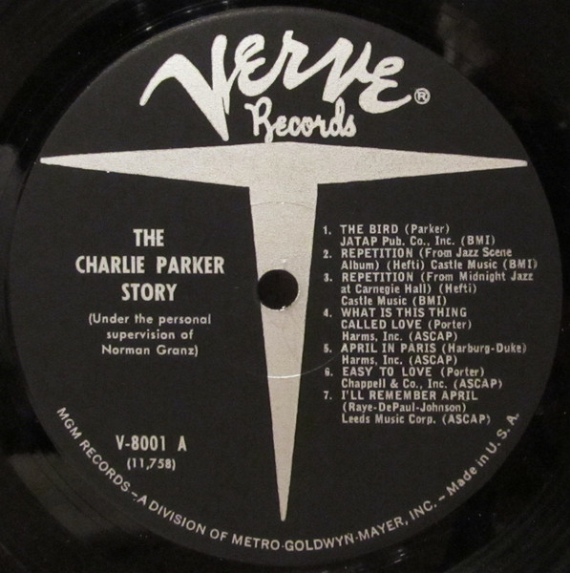

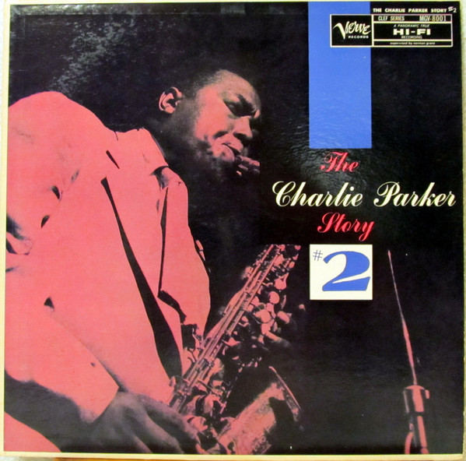

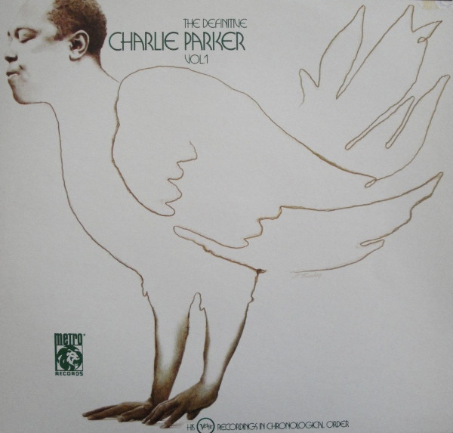

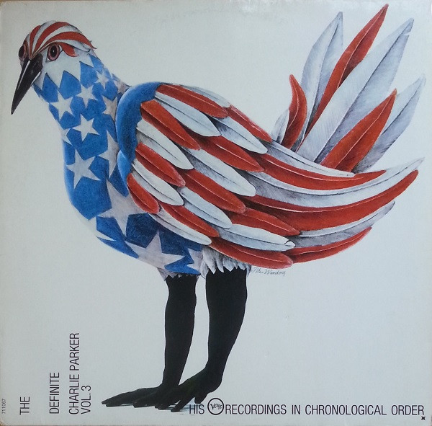

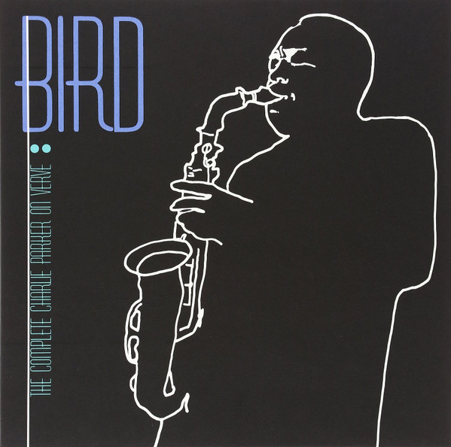

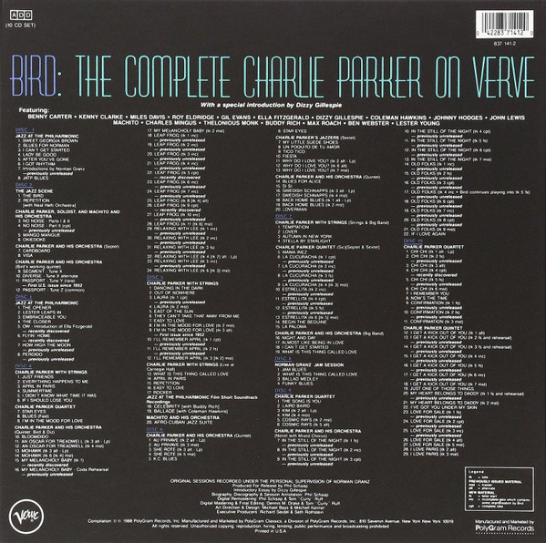

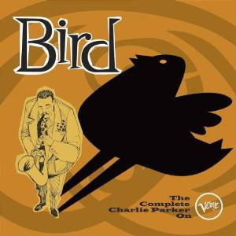
Europe 2013

18. Ko-Ko (Charlie Parker) CHEROKEE 4:17
Charlie Parker Quintet: Dizzy Gillespie-tp; Parker-as; John Lewis-p; Al McKibbon-b;
Joe Harris-dr.
Broadcast from Carnegie Hall, September 29, 1947.
Jazz America Marketing JAM 5006/no matrix. CD Roost CDP 7243 8 57061 2 7.
https://www.youtube.com/watch?v=E5fbRPLQt98
https://www.youtube.com/watch?v=7m4weFJlT58 (foto, i odjinud)

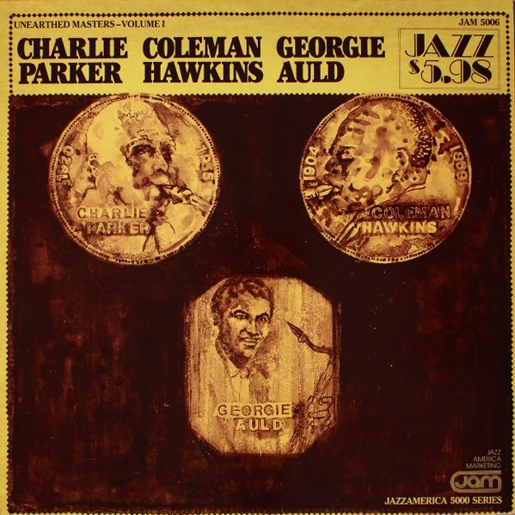

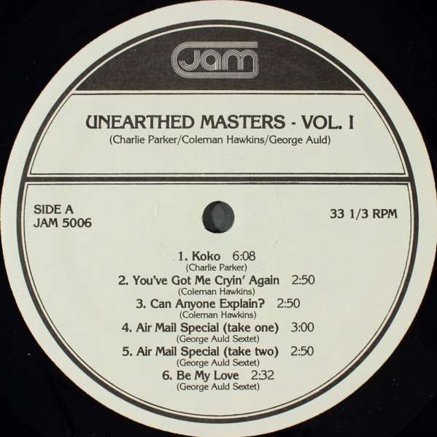

19. Ko-Ko (Charlie Parker) 3:26
Supersax: Med Flory, Joe Lopes-as; Warne Marsh, Jay Migliori-ts; Jack Nimitz-bs;
Conti Candoli-tp; Ronnell Bright-p; Buddy Clark-b; Jake Hanna-dr.
Los Angeles, 1972.
LP: Capitol ST 11177.
https://www.youtube.com/watch?v=3VxS_CUhFgg (obal alba)
https://www.youtube.com/watch?v=7OqyWW1cois (foto Supersax)

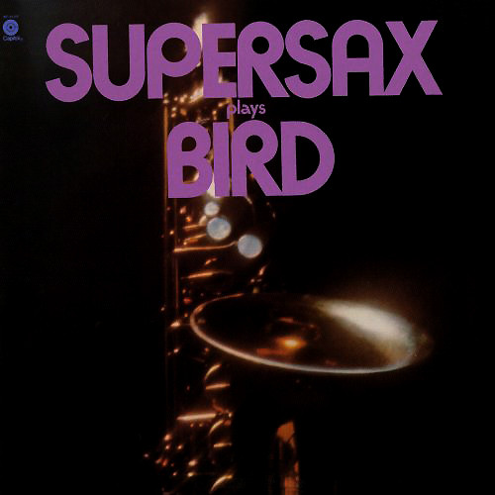

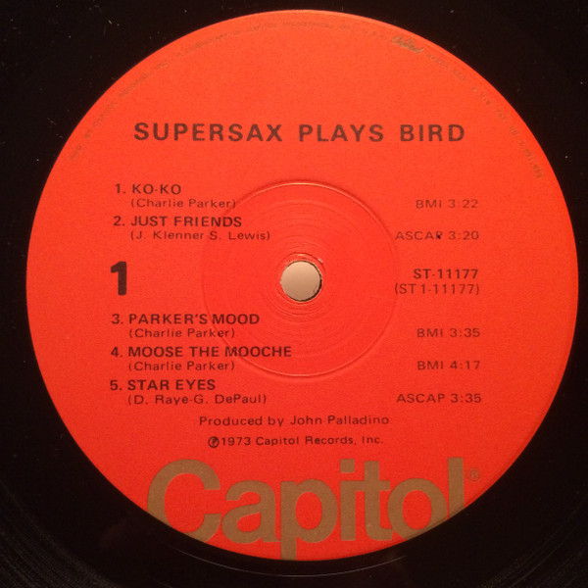

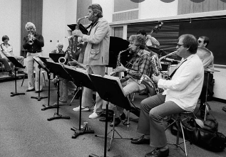

Med Flory, Lanny Morgan, Jay Migliori, Don Menza, Jack Nimitz
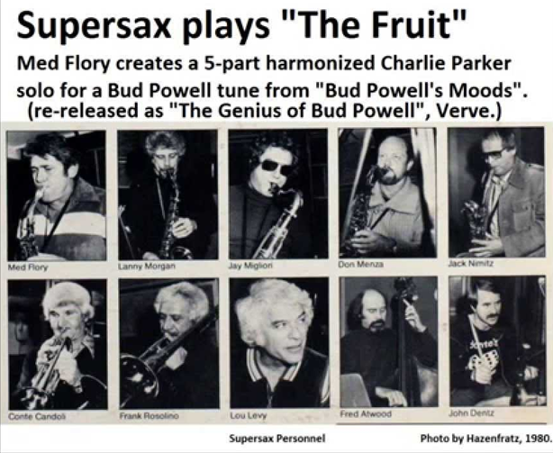
Conte Candoli, Frank Rosolino, Lou Levy, Fred Atwood, John Dentz

20. Ornithology (Charlie Parker) HOW HIGH THE MOON 4:49
Charlie Parker, Charles McPherson-as; Jon Faddis-tp; Walter Davis, Jr.-p; Ron Carter-b;
John Guerin-dr; Charlie Shoemake-vib.
Movie soundtrack, 1988.
LP Columbia SC 44299. CD CBS 461002 2.
https://www.youtube.com/watch?v=toWY4j4jOOw (ZOBRAZIT VÍCE; obal soundtracku)
https://www.youtube.com/watch?v=e2qHFmdojy8 (scéna z filmu “Bird”)

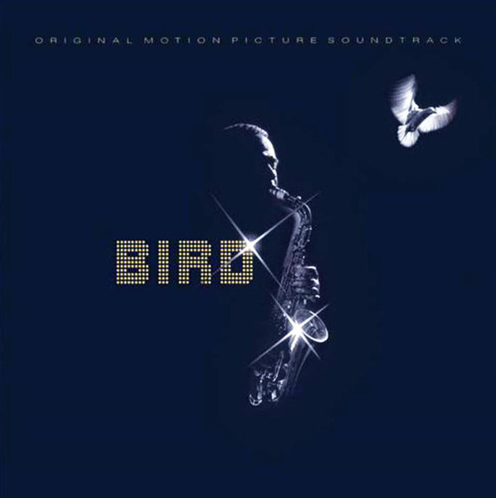

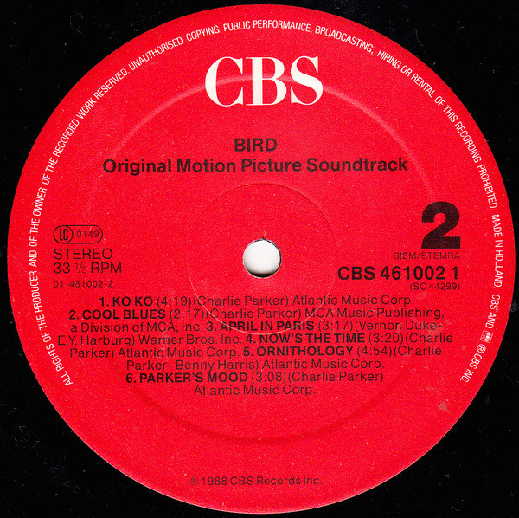

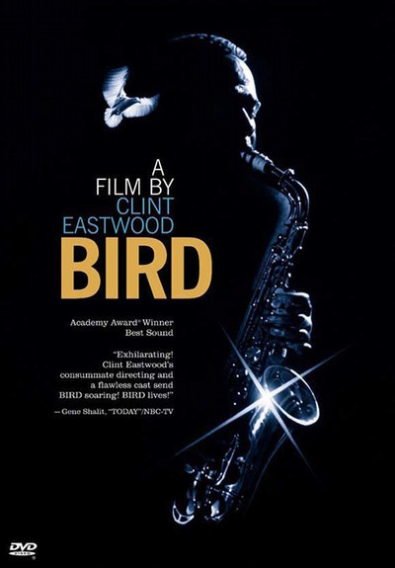

https://www.youtube.com/watch?v=Z2tvlp7RnlM (předloha Charlieho Parkera:)
Miles Davis-tp; Charlie Parker-as; Lucky Thompson-ts; Dodo Marmarosa-p; Arvin Garrison-g;
Vic McMillan-b; Roy Porter-dr.
Los Angeles, CA, March 28, 1946
Dial 1002 / D 1012-4.

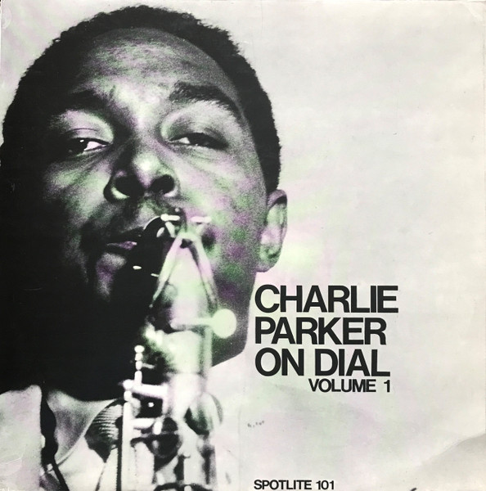

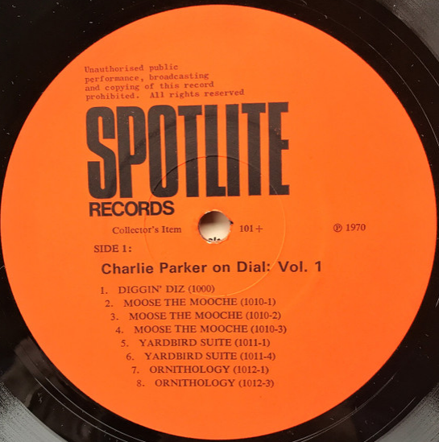

Tom Lord Jazz Discography, Hollywood, March 28, 1946:
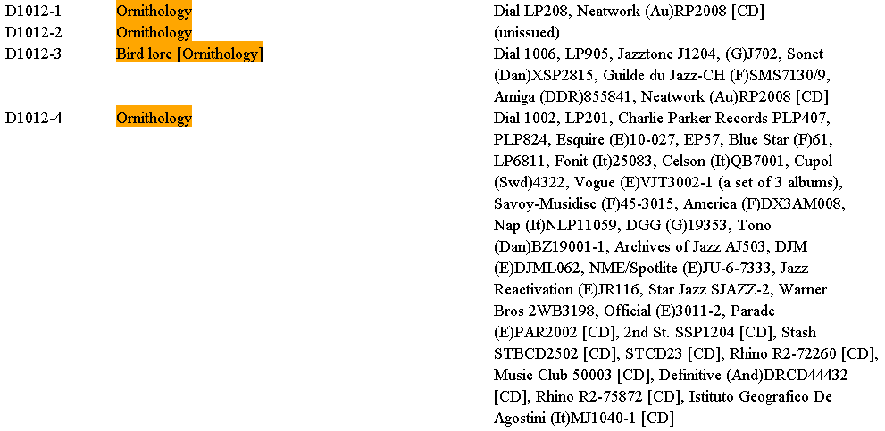

21. Yardbird Suite (Charlie Parker) 3:54
Roy Hargrove-tp; Stephen Scott-p.
New York City, April 12-14, 1995.
CD: Verve 527 907-2.
https://www.youtube.com/watch?v=g-baE6aDgoE (obal alba)
https://www.youtube.com/watch?v=GnHyQa2pfe8 (solo Roye Hargrova s transkripcí!)

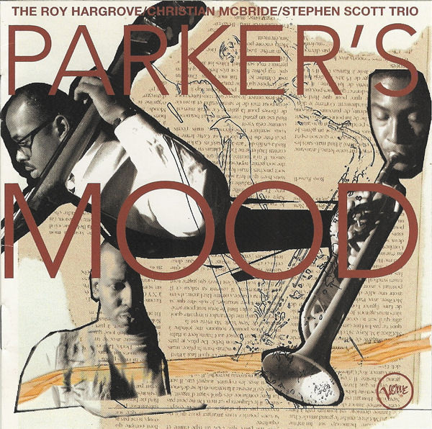

https://www.youtube.com/watch?v=K5sMapsiqyM (předloha Charlieho Parkera:)
Miles Davis-tp; Charlie Parker-as; Lucky Thompson-ts; Dodo Marmarosa-p; Arvin Garrison-g;
Vic McMillan-b; Roy Porter-dr.
Los Angeles, CA, March 28, 1946
Dial 1003 / D 1011-4.

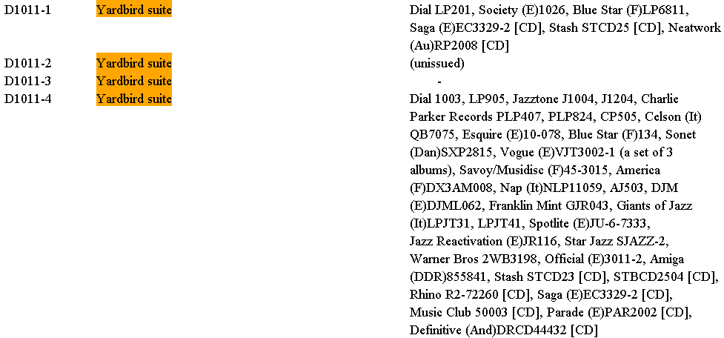

22. Red Cross (Charlie Parker) RHYTHM CHANGES 2:06
Christian McBride-b.
New York City, April 12-14, 1995.
CD: Verve 527 907-2.
https://www.youtube.com/watch?v=xGnlYnqfi5k (obal alba)

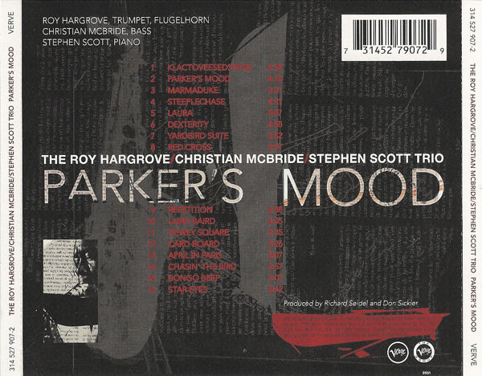

https://www.youtube.com/watch?v=Hiere4cgZ5M (předloha Charlieho Parkera:)
https://www.youtube.com/watch?v=B8FnKvyXRVk (předloha Charlieho Parkera:)
Tiny Grimes Quintette: Charlie Parker-as; Clyde Hart-p; Tiny Grimes-g; Jimmy Butts-b;
Doc West-dr.
WOR Studios, Broadway, NYC, September 15, 1944
Savoy MG 12001 / S 5713-1.

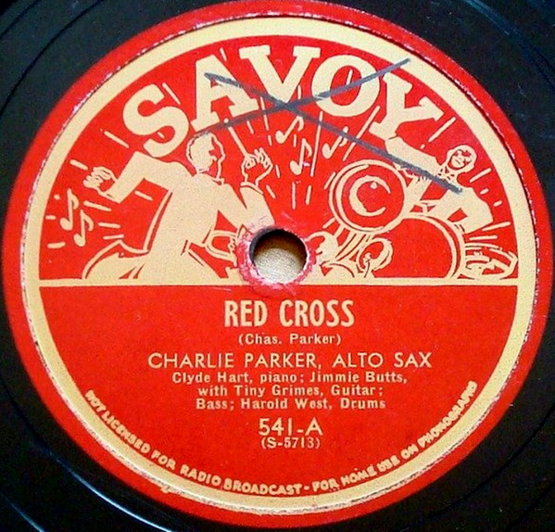

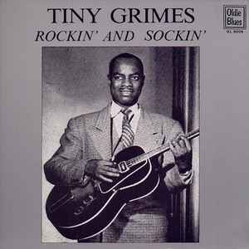

23. Moose the Mooche (Charlie Parker) RHYTHM CHANGES 5:43
Roy Hargrove-tp; Kenny Garrett-as; Dave Kikoski-p; Dave Holland-b; Roy Haynes-dr.
March 26-27, 2001.
CD: Dreyfus Jazz FDM 36625-2.
https://www.youtube.com/watch?v=EomfsWmGY2Y (obal alba Roye Haynese *1925)

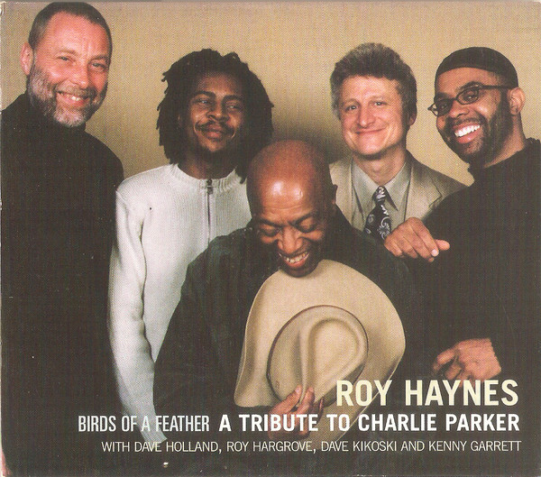

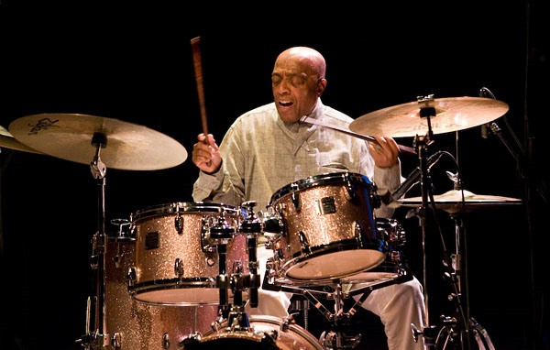

https://www.youtube.com/watch?v=HOoZ6zo8HAQ (předloha Charlieho Parkera:)
Miles Davis-tp; Charlie Parker-as; Lucky Thompson-ts; Dodo Marmarosa-p; Arvin Garrison-g;
Vic McMillan-b; Roy Porter-dr.
Los Angeles, CA, March 28, 1946
Dial 1004 / D 1010-2.

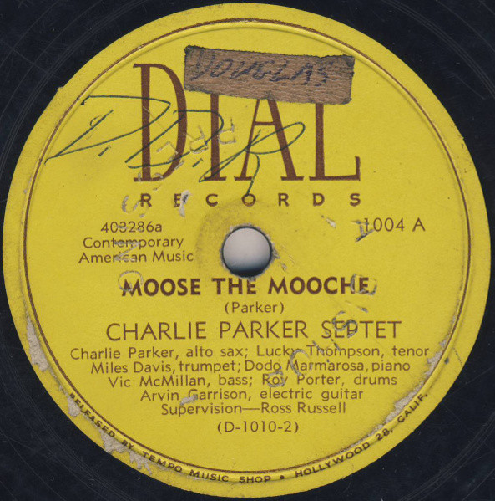

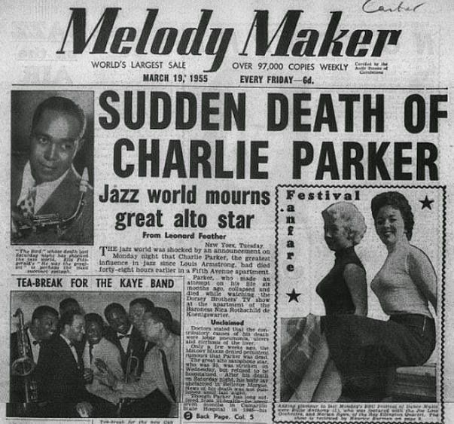

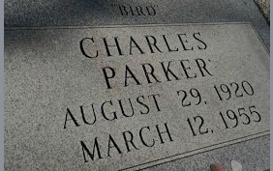

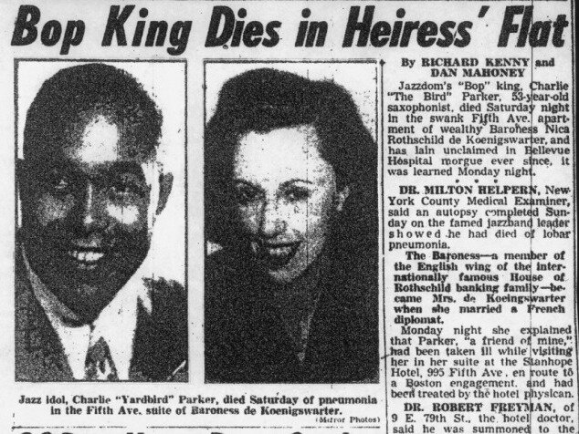

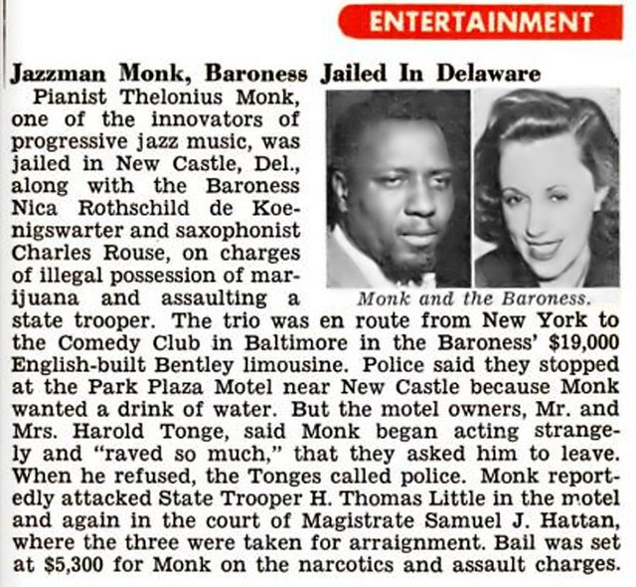

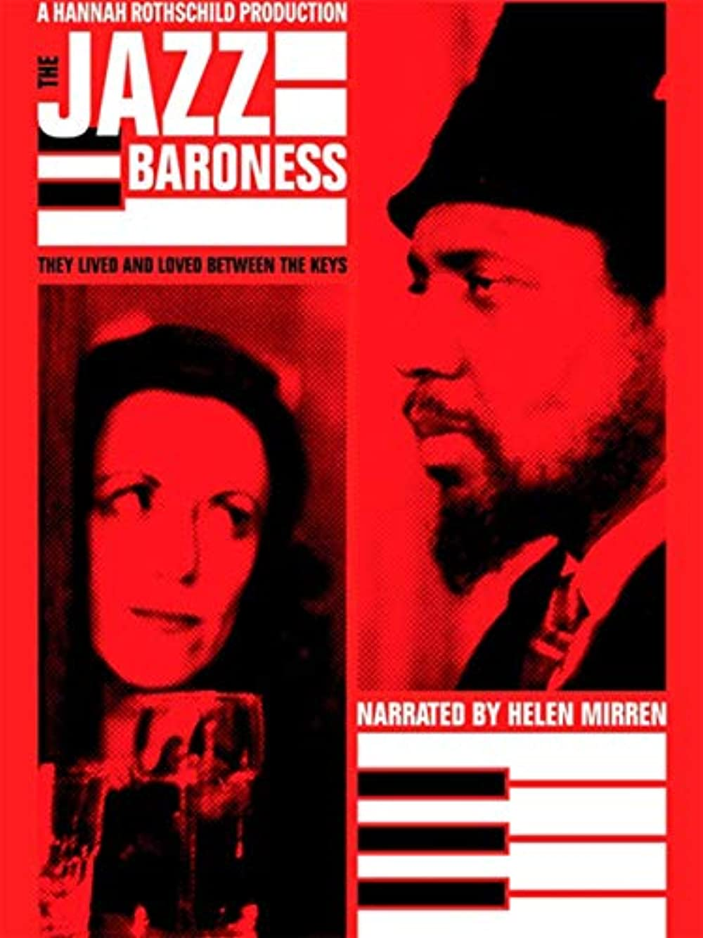

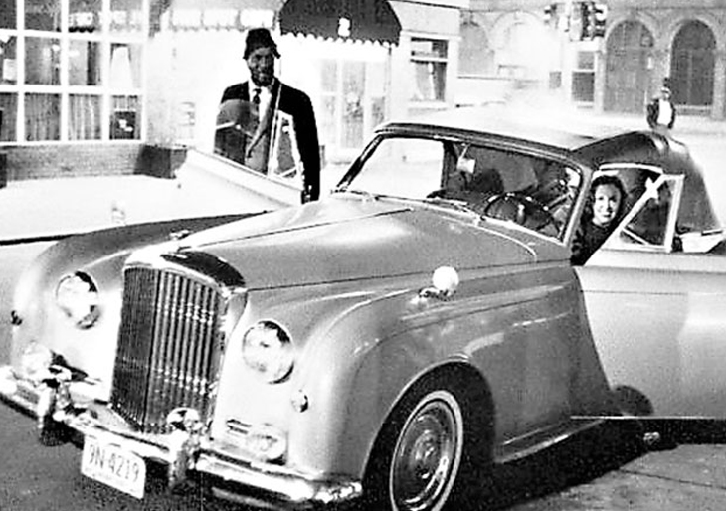

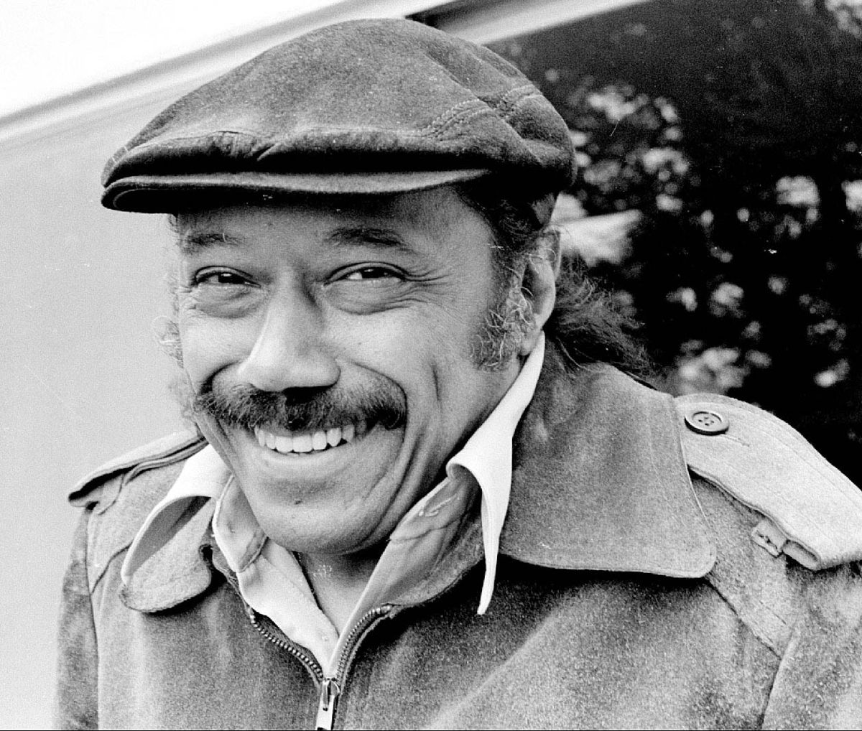

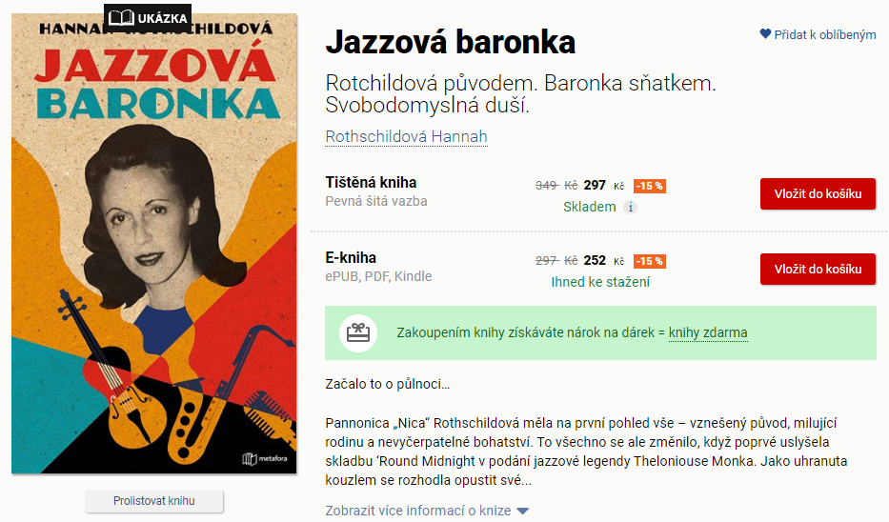

Začalo to o půlnoci…
Pannonica „Nica“ Rothschildová měla na první pohled vše – vznešený původ, milující rodinu a nevyčerpatelné bohatství. To všechno se ale změnilo, když poprvé uslyšela skladbu ‘Round Midnight v podání jazzové legendy Theloniouse Monka. Jako uhranuta kouzlem se rozhodla opustit své nejbližší i jistotu rodinného zázemí Rothschildů a vydala se do Spojených států geniálního jazzmana vyhledat.
Newyorská společnost živelnou Evropanku mezi sebe nepřijala, ale hudebníci ano. Nalezla u nich otevřenost a přátelství a oni v ní inspiraci a podporu. Její kabriolet běžně zdobil parkoviště jazzových klubů, kde trávila veškerý čas, zatímco popíjela whiskey z placatky maskované jako bible. Největší ranou pro její už tak pošramocenou pověst byla smrt drogově závislého saxofonisty Charlieho Parkera v jejím bytě. To se ale nijak nepodepsalo na její vzpurné povaze. Ani na lásce, s jakou pečovala o Monka až do jeho smrti v roce 1982.
Jazzová baronka je nejen úžasný portrét Niky Rothschildové, ale také doby, ve které žila, a generace Rothschildů, která opustila rodinnou tradici v bankovnictví. Je to fascinující vhled do dějin jejich rodu – od pronásledování nacisty, přes století financování vlád a válek. Vše na pozadí strhujícího života svobodomyslné ženy.

