ALMS ENGLISH NEEDS ANALYSIS

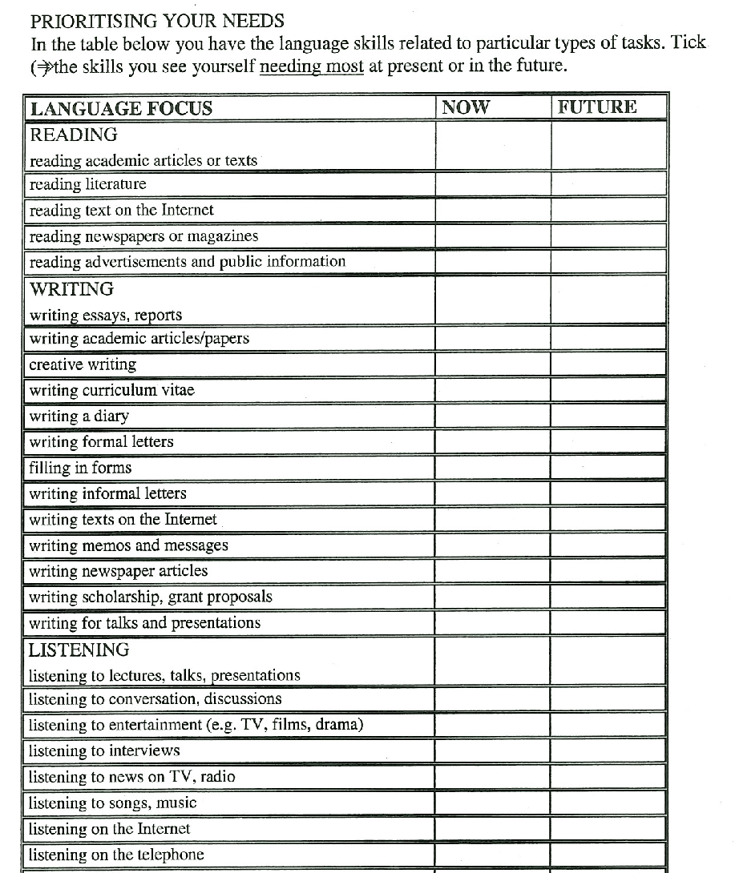

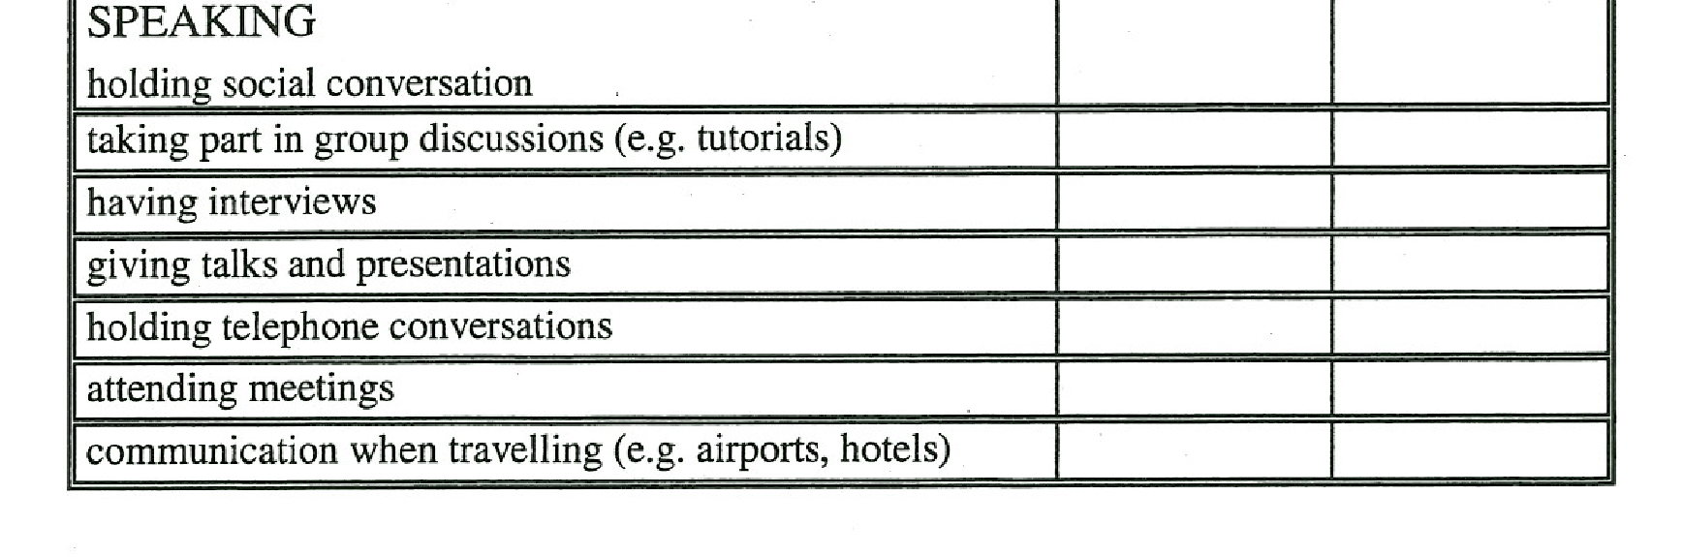
OTHER NEEDS

