MUNI 2023-1 Kurt Weill a pár dalších: Joseph Kosma, Bronislaw Kaper a Ann Ronell

076 | September Song | 1938 | Weill,Kurt | Anderson,Maxwell
110 | Mack the Knife | 1928 | Weill,Kurt | Brecht,Bertolt/Blitzstein,Marc
120 | Speak Low | 1943 | Weill,Kurt | Nash, Ogden
292 | My Ship | 1941 | Weill,Kurt | Gershwin,Ira

Postavení Kurta Weilla v Top 300 Jazz Standards na první pohled neohromuje, ale ta krása jeho melodií! Ostatně ta první se na Broadwayi dočkala 467 provedení!
Co můžeme zjistit z kvalitního zdroje JazzStandards.com dál?
Nejprve životopis:

Kurt Weill
Kurt Julian Weill
Composer
(1900 - 1950)

Kurt Weill was a musical prodigy from a family of distinguished rabbis. He studied in Berlin, presented his first opera in 1926, and was acclaimed as a leading modernist composer. With left-wing poet Bertolt Brecht he developed a distinctive style of opera, integrating political material through popular song. In 1928 The Three Penny Opera, rife with jazz and blues and starring Weill’s wife, Lotte Lenya, was a sensation. Weill’s strident melodies captured the nihilism and corruption of 1920’s Germany. A 1933 U.S. production flopped, but a successful revival (1954), with new lyrics by Marc Blitzstein, made a hit of “Mack the Knife” which won Grammies for Bobby Darin (1959) and Ella Fitzgerald (1960). Happy End (1929) produced “The Bilbao Song,” a later hit with Johnny Mercer’s lyrics. Mahagonny, their satire of capitalism set in a mythical American city, premiered in 1930 but was not seen in the U.S. until 1970. Its “Alabama Song” is full of ribald humor.
In 1933 Weill and Lenya fled to Paris and then America in 1935, the same year that Nazis closed Weill’s last German production. In the U.S. Weill worked on a film history of the Jews and on an anti-war satire with the influential Group Theatre. 1938’s Knickerbocker Holiday established Weill as a new force in American theater and captivated audiences with “September Song.” Lady in the Dark (1941, lyrics by Ira Gershwin) produced “My Ship,” and the musical comedy, One Touch of Venus (1943, lyrics by Ogden Nash), gave us “Speak Low.” Weill’s last work dealt with racial intolerance. Lost in the Stars (1949) with its touching title song, was adapted by Maxwell Anderson from Alan Paton’s book on South Africa, Cry, the Beloved Country.
Lenya, who collaborated on Weill’s work, remained involved with theater and played in U.S. films, winning a Best Supporting Actress nomination for The Roman Spring of Mrs. Stone (1961).
- Sandra Burlingame

MY SHIP

https://secondhandsongs.com/work/12795
https://www.jazzstandards.com/compositions-2/myship.htm

Writer Moss Hart was working on a play about psychoanalysis which he called I Am Listening when he was approached by composer Kurt Weill who asked him to work on a project called The Funnies. Instead Hart proposed that Weill work with him on transforming his play into a musical, and they decided on Ira Gershwin as the lyricist for their “play with music” which was now to be titled Lady in the Dark.
Lady in the Dark premiered at New York’s Alvin Theatre on January 23, 1941, to critical acclaim and ran for 467 performances. Gertrude Lawrence introduced “My Ship,” a song which was not only well integrated into the plot but essential to it.
Lawrence starred as Liza, a successful but unhappy magazine editor. She is undergoing analysis and must not only recall a song which she knew in childhood but remember what happened when she last sang it. The scenes move from her office to the office of the psychoanalyst where her recollections are presented in dream sequences.
Ira Gershwin emphasizes the importance of “My Ship” in Lyrics on Several Occasions. “Although the lyric itself was a mental block to her until well into the second act, the haunting tune--orchestrated by Kurt to sound sweet and simple at times, mysterious and menacing at other--heightened the suspense of many moments in the play.”
According to David Ewen in the Complete Book of the American Musical Theater, “Hart recognized that his play would require dream sequences, and with an equally sure instinct he felt that music was indispensable in pointing up such sequences and intensifying their moods.... A consummate writing technique was required to keep the play moving fluidly from the reality of Liza’s actual business and love life, to the confused world of her subconscious; from her everyday problems and frustrations to the nebulous world of her dreams and the misty memories of her past. Hart possessed that skill. But he also profited from one of the most remarkable virtuoso performances of our contemporary musical stage, that of Gertrude Lawrence.” As a measure of her stardom Lawrence was portrayed by Julie Andrews in Star! a 1968 film of her life.
The collaboration of Hart, Weill and Gershwin was made in heaven. As Philip Furia says in his book Ira Gershwin: The Art of the Lyricist the score, according to Gershwin, combined ...“light opera, musical comedy, and choral pieces--something which had never been done in this country before.” And Furia points out that “the composer was even willing to let Ira’s words come first for much of the score, and that freedom gave Ira license for poetic flights greater than he had ever taken.”
Lawrence dazzled Broadway audiences but was nearly upstaged by Danny Kaye (in his first Broadway role) as gay fashion photographer Russell Paxton. Kaye sang a song which became one of his trademarks, “Tschaikowsky and Other Russians,” in which he rapidly recited the names of 49 Russian composers. At the preview, he received a standing ovation, and the authors worried that their star, about to sing “The Saga of Jenny,” would be overshadowed. But Lawrence rose to the challenge, extemporizing a “bump and grind” that delighted the audience.
“My Ship” was key to the plot, for as Furia says, the arrival of the ship represented Liza’s new found self-awareness, and it is her singing of the song that brings the ship in. And since this was a song from Liza’s past, Weill sought to give the melody a turn-of-the-century feeling. Surprisingly, when Hollywood filmed Lady in the Dark in 1943 with Ginger Rogers and Ray Milland, the song, which is mentioned frequently in the movie, appears only as an instrumental without its very important lyric, much to the dismay of Gershwin and the confusion of audiences and critics.
In The Poets of Tin Pan Alley: A History of America’s Great Lyricists, also by Furia, the author says, “The lyric...exudes a sentimentality, unrelieved by wit or insouciance, that Ira seldom fell into with his brother. Its uninventive catalog of images...culminates in a cloyingly repeated plea for the ship to bring ‘My own true love to me.’ So tangled does Gershwin get in the extended image he weaves that he commits unheard-of poetic inversions....” Furia implies that Hollywood’s dissatisfaction with the lyrics is why only the melody was retained in the film.
Even so, Furia finds much to like about the song in his biography of Gershwin. “The song has no verse,” says Furia, “only a straightforward chorus that opens with a perfectly singable phrase of billowing sibilant and liquid consonants and open vowels that soar to the highest notes of the melody: ‘My ship has sails that are made of silk.’
“For ‘memorability’ Ira created faceted repetitions, barely heard, such as the il of ‘silk’ that recurs in:

My ship’s aglow
With a million pearls
And rubies fill
Each bin.

“Even fainter, but still subtly memorable, is the rhyme between ‘million’ and ‘bin.’”
Gershwin tells an amusing story of an aural ambiguity, somehow missed by both composer and lyricist but brought to their attention during rehearsals by Lawrence when she sang the original lines:

I can wait for years
Till it appears,
One fine day in spring.

One day she stopped and asked Gershwin, “Why four years, why not five or six?” Gershwin says, “She was quite right,” and he changed the line to “the years.” “Somehow neither Kurt nor I had noticed that the preposition ‘for’ received the same musical value as ‘wait’ and ‘years’,” he says.
Lady in the Dark was presented in a 1954 TV production starring Ann Southern and Carleton Carpenter. In 1963 Rise Stevens made a studio recording of the stage show which includes some of Danny Kaye’s 1941 recordings. The show opened at London’s Royal National Theater in 1997 and ran from March to August. Although the production resulted in a cast recording, the play, a difficult one to stage, was panned by critics.
“My Ship” continues to be popular with jazz musicians. Recent recordings include those by drummer Cindy Blackman and vocalists Janis Siegel and Sheila Jordan (1999); vocalist Dee Dee Bridgewater (2000); pianist Herbie Hancock’s quintet featuring saxophonist Michael Brecker and trumpeter Roy Hargrove (2001); vocalists Mark Murphy (2004) and Greta Matassa and Flora Purim (2001); pianist Travis Shook in his 2005 tribute to Weill; and the Gary Urwin Jazz Orchestra featuring trombonist Bill Watrous and saxophonist Pete Christlieb (2006). Pianist Gerald Wiggins, who first recorded the song in 1990, reprised it at his 80th birthday celebration recorded at the Jazz Bakery in 2002.
Miles Davis’ seminal 1957 big band recording of this tune was preceded by two fine vocal versions from 1956, Jeri Southern’s and Sarah Vaughan’s. Yet it is Davis’ recording that insured the tune’s standard status. A monumental CD collection from 1996 includes not only this track (plus alternate takes) but all of Davis’ recordings in collaboration with arranger Gil Evans from the Columbia Records’ vaults.
Rahsaan Roland Kirk, a saxophonist/flautist who also played such obscure instruments as the manzello and stritch, was able to play three saxophones at the same time (in a musical fashion). His recording of “My Ship” from 1964 features his flute playing, where he roams from classical sweetness to breathy, blues-tinged, “hummed” tonalities.
Vocalist Johnny Hartman, whose work was featured in the 1995 motion picture The Bridges of Madison County and who recorded with tenor saxophonist John Coltrane, performed a fine “My Ship” in 1964 backed by guitarist Barry Galbraith.
Statistika: Pozice v JazzStandards (v tisícovce nejnahrávanějších skladeb): 292. místo.
Výskyt v SecondHandSongs: 299 verzí, roku 1941 hit č. 13.
V Jazz Discography Toma Lorda: 281 různých nahrávek.

JazzStandards videos zde: https://www.jazzstandards.com/compositions-2/myship.htm
Herbie Hancock-Michael Brecker-Roy Hargrove, Kenny Burrell, Tierney Sutton, Miles Davis

https://secondhandsongs.com/performance/536906
My Ship by Hildegarde with Orchestra directed by Harry Sosnik
February 2, 1941

Jedna z nejpůsobivějších úprav pro velký orchestr všech dob
https://secondhandsongs.com/performance/313220
My Ship by Miles Davis + 19 with Orchestra under the direction of Gil Evans
May 10, 1957

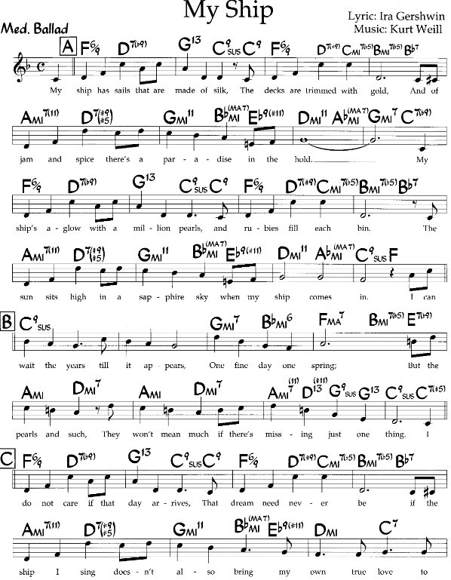
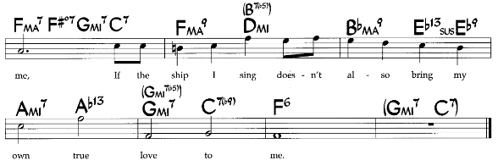

A ještě dvě pozoruhodná pojetí, hrané a zpívané:
https://secondhandsongs.com/performance/114378
My Ship by Sonny Rollins & Co.
June 24, 1964

https://secondhandsongs.com/performance/183615
My Ship by Sheila Jordan with Steve Kuhn Trio
April 1 – 2, 1998

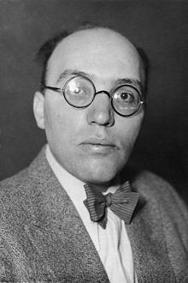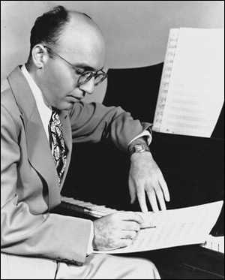

Kurt Weill (1900 – 1950)

MACK THE KNIFE

https://secondhandsongs.com/work/9118
https://www.jazzstandards.com/compositions-1/macktheknife.htm

Louis Armstrong generally gets credit for the first jazz version of this tune, recorded in 1955. But his old rival from New Orleans, clarinetist/soprano saxophonist Sidney Bechet, beat him to the punch a year earlier, recording the tune in France, sans vocal, as “La Complainte de Mackie” (LP: Le Double Disque D’Or De Sidney Bechet, LDA 16001, 1976.) (It’s possible Bechet first heard the tune in Berlin in 1929.) Nevertheless, Armstrong had been coerced to record it by producer George Avakian and enlisted the arranging talents of friend and trombonist/bandleader Turk Murphy. Murphy, an expert in early jazz, was offered a cut on the royalties, but neither he nor Armstrong thought much of the song, and Turk chose to take a flat fee. “The biggest mistake of my life,” he was known to say in later years after Armstrong’s version sold one million plus.
This ballad was part of composer Kurt Weill’s The Threepenny Opera which was an adaptation of The Beggar’s Opera (1728) by John Gay, English playwright and societal satirist (1685-1732). The lead character of Gay’s opera is named Captain MacHeath, a gentleman who prefers the company of cutthroats and whores. The central theme of The Beggar’s Opera, the most popular play of the 18th century, is that the same characters inhabit prisons and governmental positions.
In the 1920’s Europe was recovering from World War I and Kurt Weill was interested in the Music for the People movement. He teamed with Marxist poet Bertolt Brecht to translate into German, adapt, and update The Beggar’s Opera with MacHeath becoming a gangster named Mackie Messier or Mack the Knife. “The Ballad of Mack the Knife” was originally entitled “Moritat,” meaning “murder song” (“mord” meaning murder and “tat” meaning deed), and it was positioned just after the Overture so as to establish Mack’s evil nature early on in the production. It was sung by a street singer who pointed to images of the crimes Mackie has committed such as arson, rape and murder.
Like The Beggar’s Opera, The Threepenny Opera or Die Dreigroschenoper, as it was originally titled, dealt with corruption in modern government, contributing to its immense success when it opened in 1928. “Moritat” became a big hit in Berlin in the 1930s. After running for thousands of performances in Germany and other countries, The Threepenny Opera failed on Broadway in 1933. However, it was performed at Brandeis University in 1952 under the baton of Leonard Bernstein with new English lyrics by Marc Blitzstein. It moved off-Broadway in 1954, ran for 94 performances, reopened in 1955 and ran for 2611 more with Weill’s wife Lotte Lenya as prostitute Jenny Diver. MGM pressed the cast recording, the first for an off-Broadway production, but somewhat sanitized the “Mack” lyrics for family fare.
In his book Stardust Melodies Will Friedwald tells the story of how and why the song entered the jazz repertoire and became such a hit in America. An executive at Columbia Records, George Avakian, thought “Mack the Knife” would make a great jazz instrumental. After being turned down by several noted musicians, he convinced trad jazz bandleader and trombonist Turk Murphy of its potential. Turk arranged the song and, in turn, recommended Louis Armstrong as the vocalist. When MGM heard that Armstrong was going to record “Mack,” they rushed Dick Hyman into the studio to record it on his “harpsichord piano.” Avakian recorded Murphy’s instrumental version, Lotte Lenya singing it in German for the European market, and the Armstrong version. Both the Hyman and Armstrong recordings were released in 1955, but Armstrong’s jazzier version is the one that has endured. A few months after these two releases Chappell Music officially changed the name of the song to “Mack the Knife.”
Both Bing Crosby and the Les Paul/Mary Ford duo jumped on the bandwagon and successfully recorded the song. But it was Vegas showman Bobby Darin who brought “attitude” and swing to the Richard Wess arrangement and won a Grammy in 1959. Ella Fitzgerald’s 1960 rendition also won a Grammy.
Some liberties have been taken with Blitzstein’s lyrics, and Blitzstein himself made some changes in the process of translating. “Whenever he translated a line and came up a beat short, he threw in the word ‘dear,’ mostly just to take up the space,” according to Friedwald. “Dear,” of course, became “Babe” in the slangier Darin version.
Vocalists Frank Sinatra and Anita O’Day recorded “Mack” as did a variety of jazz musicians, among them saxophonist Sonny Rollins, vibist Lionel Hampton, trumpeter Kenny Dorham, and violinist Stephane Grappelli . Friedwald takes particular note in his book of Eartha Kitt’s menacing version and mentions other stage revivals of the production and the use of “Mack the Knife” in several films. Dee Dee Bridgewater included it in her tribute to Ella in 1997, and most recently pianist Roger Kellaway, who was Darin’s musical director for two years, featured it on his Grammy-nominated 2005 CD Remembering Bobby Darin.

Statistika: Pozice v JazzStandards (v tisícovce nejnahrávanějších skladeb): 110. místo.
Výskyt v SecondHandSongs: 624 verzí, roku 1928 hit č. 3.
V Jazz Discography Toma Lorda: 487 různých nahrávek.

JazzStandards videos zde: https://www.jazzstandards.com/compositions-1/macktheknife.htm
Louis Armstrong – Bobby Darin – Scott Hamilton – Clark Terry & Oscar Peterson

Ještě s původním interpretem
https://secondhandsongs.com/performance/9118
Moritat von Mackie Messer by Kurt Gerron
Premiered August 31, 1928

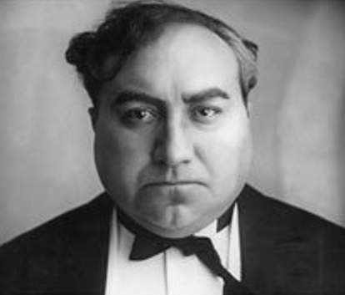
Kurt Gerron
Real name Kurt Gerson
Born May 11, 1897
Died October 28, 1944

Jewish actor and film director born in Berlin, whose popular cinema breakthrough came with The Blue Angel (Der Blaue Engel, 1930) opposite Marlene Dietrich. Previously he played the character "Moritatensänger" in the world premiere of Die Dreigroschenoper in 1928. He was killed in the concentration camp Auschwitz in 1944.

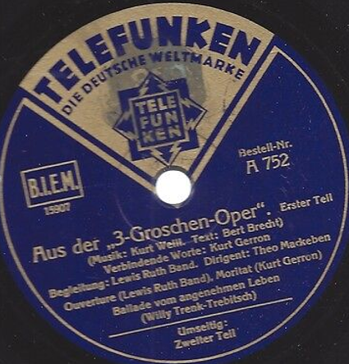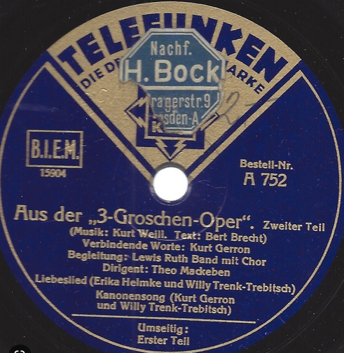

Původní vydání po světové premiéře v Německu

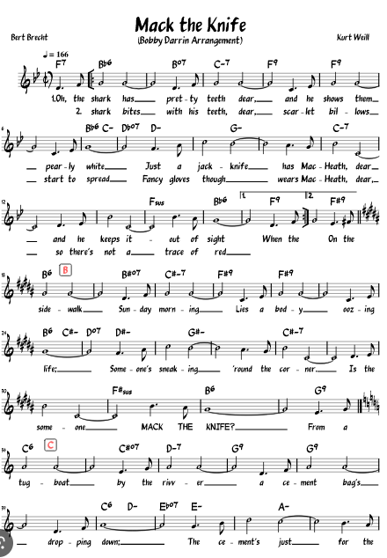

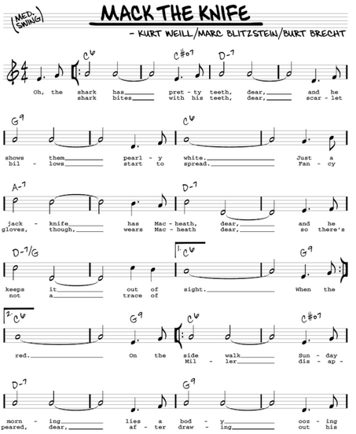

Autor textu jako zpěvák? Ale že si dává záležet na těch německých „rrr“!
https://secondhandsongs.com/performance/360711
Die Moritat vom Mackie-Messer by Bertolt Brecht mit Orchester
1929

Zpěvák, který se držel na 1. místě hitparády po neuvěřitelných 9 týdnů!!!
https://secondhandsongs.com/performance/9121
Mack the Knife by Bobby Darin V I D E O
December 19, 1958
Grammy Award winner for Best New Artist 1959
and Record of the Year 1959 with "Mack the Knife"

https://secondhandsongs.com/performance/481372
Mack the Knife by Wayne Shorter
November 10, 1959
Shorter-ts, Lee Morgan-tp, Wynton Kelly-p, Paul Chambers-b, Jimmy Cobb-dr

https://secondhandsongs.com/performance/578731
Mackie Messer by Milan Chladil - Karel Vlach se svým orchestrem
April 9, 1960

https://secondhandsongs.com/performance/967812
Mackie Messer by Gabriela Vermelho & GaRe
Released December 8, 2014

Hebrejsky (Avraham Shlonsky)
https://secondhandsongs.com/performance/1380028
מקי סכינאי {Mack hasakinay} by אריק לביא (Arik Lavie)
Released 1974

Anglicky (3 verze), finsky, francouzsky (2), německy (2), řecky, hebrejsky, islandsky, italsky (2), norsky, polsky, portugalsky, srbsky, španělsky (3), švédsky (3) welšsky, chipmunk, chorvatsky,
česky (Chladil, Suchý, Kolář, Gott, Gabriela Plíšková)

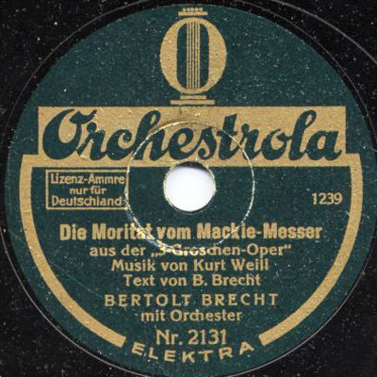

…a další standardy z vysokých pozic, o kterých bychom měli vědět

AUTUMN LEAVES

https://secondhandsongs.com/work/11555
https://www.jazzstandards.com/compositions-0/autumnleaves.htm

Statistika: Pozice v JazzStandards (v tisícovce nejnahrávanějších skladeb): 11. místo.
Výskyt v SecondHandSongs: 1.508 verzí, roku 1950 hit č. 3.
V Jazz Discography Toma Lorda: 1.420 různých nahrávek.

JazzStandards videos zde: https://www.jazzstandards.com/compositions-0/autumnleaves.htm
Nat King Cole – Manhattan Jazz Quintet – Chet Baker & Paul Desmond – Leslie Odom Jr. – Chick
Corea & Bobby Mc Ferrin – Bill Evans Trio

Nejúspěšnější standard neamerického původu, od maďarského skladatele ve Francii

Joseph Kosma
Composer
(1905 - 1969)

Joseph Kosma became primarily known as a film composer although he was educated in Hungary at the Budapest Conservatory. His scholarship to the Berlin Opera introduced him to Bertolt Brecht. He joined Brecht’s touring company in 1929 where he met Kurt Weill and Hanns Eisler whose influence on his work was apparent in the film scores he would later write. In 1933 he moved to Paris to work with director Jean Renoir. Their first collaboration was 1936’s Le Crime de Monsieur Lange, and in 1937 they produced La Grande Illusion, considered one of the top films of all times.
When Kosma scored the 1945 Marcel Carne classic Les Enfants du Paradis, he met the film’s screenwriter, Jacques Prevert. During their partnership they produced the ballet Rendezvous and several songs, including a Prevert poem set to music, “Les Feuilles Mortes,” which would become “Autumn Leaves” in English. Kosma returned to his classical roots, composing several operettas during the ‘60s.
- Sandra Burlingame

Composer Joseph Kosma and Jacques Prevert created one of the songs for Les Portes De La Nuit by setting a Prevert poem to music, “Les Feuilles Mortes.” In 1949 Johnny Mercer wrote English lyrics for the tune changing the original French title to “Autumn Leaves.” Not surprisingly, Jo Stafford was the first to record “Autumn Leaves.” From 1943 until 1950 she was under contract with Capitol Records, a company founded and co-owned by Mercer. Following Stafford’s recording were a number of covers including renditions by Bing Crosby, Edith Piaf, Artie Shaw, and Jo Stafford’s husband, Paul Weston.
The Italian born, French singing idol Yves Montand introduced the song “Les Feuilles Mortes” in the 1946 film Les Portes De La Nuit, a gloomy urban drama set in post World War II Paris. Scriptwriter and poet Jacques Prevert and director Marcel Carne (1909-1996) had been responsible for a string of films spawning the French “poetic realism,” a genre upon which the American film noir movement was based. Although Les Portes De La Nuit was a commercial failure it fared much better when released in the United States several years later under the title Gates of the Night.
Initially the public showed little interest in “Autumn Leaves.” In 1955 that changed, however, as pianist Roger Williams (1925-) (renowned for the instrumental hits “Near You” (1958), and “Born Free” (1966)) recorded a million-seller, number-one hit rendition of the song that stayed on the charts for 6 months. Williams’ success opened the door for a second spate of covers by Steve Allen, Mitch Miller, the Ray Charles Singers, Jackie Gleason, and Victor Young. These would be followed by hundreds of renditions in subsequent decades.
As the 1940’s waned so too did the public’s appetite for the Tin Pan Alley style ballad. With decreasing demand for his sophisticated talents, lyricist Johnny Mercer found himself penning words for instrumentals. In the case of “Les Feuilles Mortes,” Mercer would not have thought twice about renaming what was literally “The Dead Leaves” to “Autumn Leaves.” “The Dead Leaves” may have been an appropriate song title for the somber Les Portes De La Nuit, but it would not do for an American popular song.
In 1956 Columbia Pictures produced a film entitled Autumn Leaves starring Joan Crawford and Cliff Robertson. It is a generally well-reviewed tale of a spinster marrying a young man who has mental problems as a result of his ex-wife’s (Vera Miles) affair with his father (Lorne Green). Nat King Cole sang his hit version of “Autumn Leaves” during the credits.
This 1947 tune took almost ten years to catch on as a jazz number, and 1957 saw three excellent recordings. There were versions by Coleman Hawkins, Dizzy Gillespie and Duke Ellington.
Ellington’s version, taken at a very slow tempo, features Ray Nance on violin. Nance’s violin playing represented almost the total opposite of his trumpet playing, and he’s at his soulful best on “Autumn Leaves,” where he plays an exquisite, emotional solo; he then fills along with vocalist Ozzie Bailey. The album, Ellington Indigos, offered a different, more sentimental side of the Ellington ensemble and has rarely been out-of-print since it was released.

“Autumn Leaves (Les Feuilles Mortes)” was included in these films:

- Les Portes De La Nuit (1946, Yves Montand)
- Autumn Leaves (1956, Nat King Cole)
- Hey Boy! Hey Girl! (1959, Keely Smith)
- Addicted to Love (1997, Stephane Grappelli)
- Midnight In The Garden Of Good And Evil (1997, Paula Cole)
- Sidewalks of New York (2001, Stan Getz)
https://secondhandsongs.com/performance/11552
Les feuilles mortes by Yves Montand – harmonica version
Premiered December 3, 1946
In the movie, there awas also a version of the song performed by Orchestre de la Société des Concerts des Conservatoires, a version by Natalie Nattier, another one by Aimé Barelli and a harmonica version by a Parisian bum.

https://secondhandsongs.com/performance/336104
Les feuilles mortes by Yves Montand - Accomp. d'orchestre dir. Bob Castella
May 9, 1949

https://secondhandsongs.com/performance/534724
Autumn Leaves by Edith Piaf – in English-French-English
Released 1951

https://secondhandsongs.com/performance/1256526
Podzimní by Světlana Nálepková
Released April 2, 2003
Lyrics by Jiří Dědeček

Česky, holandsky (3 verze), švédsky (3), anglicky (3), estonsky, finsky (2), německy (2), maďarsky, islandsky, italsky, rumunsky, rusky, slovinsky, španělsky, hebrejsky, welšsky

https://secondhandsongs.com/performance/68117
Autumn Leaves by Cannonball Adderley
March 9, 1958
Miles Davis-tp, Cannonball-as, Hank Jones-p, Sam Jones-b, Art Blakey-dr

https://secondhandsongs.com/performance/151615
Autumn Leaves by Bill Evans Trio
December 28, 1959

https://secondhandsongs.com/performance/442413
Autumn Leaves by Jim Hall-Ron Carter Duo
August 4, 1972

https://secondhandsongs.com/performance/902510
Autumn Leaves by (Jeremy Steig), James Moody, (Sahib Shihab, Chris Hinze
October 20 – 21, 1973
Joachim Kuhn_p, John Lee-b, Aldo Romano-dr

https://secondhandsongs.com/performance/559796
Autumn Leaves by Chet Baker
July – November, 1974
Paul Desmond-as, Bob James-p, Ron Carter-b, Steve Gadd-dr

https://secondhandsongs.com/performance/159137
Autumn Leaves by The Thad Jones Mel Lewis Quartet
September 24, 1977 live in Miami, Florida

https://secondhandsongs.com/performance/823314
Autumn Leaves by Didier Lockwood
February 20 – 22, 1979

https://secondhandsongs.com/performance/149043
Autumn Leaves by Biréli Lagrène & Roy Haynes V I D E O
Ca. 1982

https://www.youtube.com/watch?v=1rsGjeYwMrE
Autumn Leaves by Larry Coryell, Larry Carlton. John Abercrombie, John Scofield, Tal Farlow-g,
John Patitucci-b, Billy Hart-dr V I D E O
Date & place unlisted

https://secondhandsongs.com/performance/1398077
Autumn Leaves by Jiří Stivín & Rudolf Dašek
Released 1991

https://secondhandsongs.com/performance/663644
Autumn Leaves by Martial Solal & Robert Kaddouch
October 15, 1998

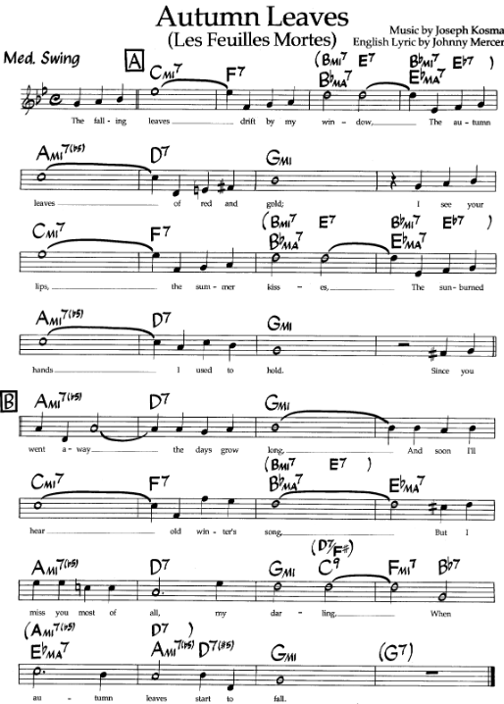

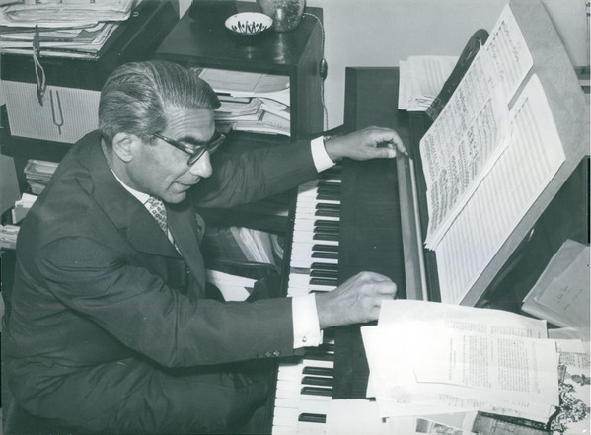

Joseph Kosma [József Kozma] (1905 – 1969)

ON GREEN DOLPHIN STREET

https://secondhandsongs.com/work/20710
https://www.jazzstandards.com/compositions-0/ongreendolphinstreet.htm

Statistika: Pozice v JazzStandards (v tisícovce nejnahrávanějších skladeb): 25. místo.
Výskyt v SecondHandSongs: 600 verzí, roku 1947 hit č. 5.
V Jazz Discography Toma Lorda: 912 různých nahrávek.

JazzStandards videos zde: https://www.jazzstandards.com/compositions-0/ongreendolphinstreet.htm
Count Basie – Ella Fitzgerald & Joe Pass – Keith Jarrett Trio – Sarah Vaughan – Stan Getz Quartet – Wayne Shorter Quartet

Další francouzský skladatel, tentokrát z Polska

Bronislau Kaper
Bronislaw or Bronislav Kaper
Composer, Arranger, Conductor, Music Director, Pianist
(1902 - 1983)
Bronislau Kaper was a musical prodigy who studied law and music in his native Poland before moving to Berlin to pursue music. He composed for German films, but as anti-Semitism increased he moved to Paris in 1933. There he was discovered by Louis B. Mayer who signed him to MGM.
From 1936 to 1940 he wrote songs for films: “Tomorrow Is Another Day,” “Cosi Cosa,” and “All God’s Chillun Got Rhythm” (now considered politically incorrect) for the Marx Brothers’ A Day at the Races (1937). By 1940 he was assigned complete scores. During a career that spanned over 30 years in Hollywood he scored an incredible variety of films from Gaslight (1944), a suspense drama, to Them! (1954), a horror film about giant ants, to Somebody Up There Likes Me (1956), a boxing film. With Herbert Stothart he served as music director for the operetta, The Chocolate Soldier (1941), which featured his song, “While My Lady Sleeps” with Gus Khan’s lyrics.
In 1947 Kaper’s score for Green Dolphin Street produced a jazz classic, “On Green Dolphin Street.” He won an Oscar for Lili (1953), which contained the song “Hi-Lili Hi-Lo,” and was nominated in 1962 for the Mutiny on the Bounty score and its love song, “Follow Me” with Paul Francis Webster’s lyrics. Mutiny... did win a Golden Globe for best score as did A Life of Her Own (1950). With Webster, Kaper also wrote the haunting “Invitation” (1952), which would become an oft-recorded jazz standard.
Milestones for Kaper in 1958 include the “Overture” for Auntie Mame and the score for The Brothers Karamazov, where his intimate knowledge of Russian ethnic music added to the score’s authenticity. But large-scale scores such as Lord Jim’s (1965) were losing favor, so Kaper produced his last one in 1967 for The Way West.
- Sandra Burlingame

“...this definitive version, courtesy of Davis on muted trumpet, John Coltrane on sax, and Bill Evans at the piano ... unfolds at a leisurely pace.”

“On Green Dolphin Street” was introduced as the main theme of the 1947 MGM film Green Dolphin Street. The movie was based on British novelist Elizabeth Goudge’s 1944 book Green Dolphin Country, published that same year in the United States as Green Dolphin Street.
Elizabeth Goudge (1900-1984) enjoyed a prolific career writing both fiction and nonfiction, including seventeen novels for adults and children. Green Dolphin Street was her sixth effort and told the story of a young man in 1800’s New Zealand who sends to the British Isles for the woman he loves. In an act of carelessness, he addresses his letter to her sister with whom he also shares a past. The story centers on the trials of the young man and his bride as they attempt to make the marriage work. Critics routinely praise Goudge for her ability to graphically portray characters and landscapes, but, as a New York Times reviewer said, Green Dolphin Street lacked “the sterner virtues of good literature.”
Those “sterner virtues” were not at the top of the motion picture company’s list when MGM awarded Goudge $200,000 as the winner of its annual Novel Award. It was the only such winner, however, to find its way onto the silver screen.
At a lengthy two hours and twenty minutes, Green Dolphin Street starred Lana Turner, Van Heflin, Donna Reed, Richard Hart, and Frank Morgan. In his book, The MGM Story, John Douglas Eames says of the film,
It had everything, i.e. too much for a single movie: a glorious wallow in family conflict, triangle romance, Maori uprising in old New Zealand, earthquake, tidal wave, pathos and bathos.
The movie is generally panned by today’s critics, but war-weary audiences were ready for an extravaganza. It was the top box office draw of 1947 and won Academy Awards for visual and sound effects.
In 1947, with a string of successful songs and movie scores behind him, Bronislau Kaper was enlisted to write the soundtrack for the production. Suprisingly, the theme was not a hit, even with Ned Washington’s lyrics. It would be a decade before Miles Davis’ recording would establish the composition as a jazz classic.
On Green Dolphin Street is also the title of a 2003 novel by Sebastian Faulks, in which the heroine hears Miles Davis playing the song in the background when she moves to New York’s Greenwich Village in 1960.
Although Miles Davis’ 1958 recording is considered by many to be the best of the earlier versions of the tune, several recordings prior to Miles’ are worthy of consideration. An interesting version by trombonist Urbie Green from 1955, taken at a ballad tempo, features his silken-toned trombone with pianist Jimmy Lyon on the seldom-heard-in-jazz instrument, the celeste.
The 1957 recording by the Poll Winners (named because each musician placed first in Downbeat magazine’s readers’ poll in 1956) with guitarist Barney Kessel, bassist Ray Brown, and drummer Shelly Manne, is almost the template version for the tune, taken at a medium tempo with a Latin feel.
“On Green Dolphin Street” was included in these films:

- Green Dolphin Street (1947, Mel Torme)
- The Prize (1963)
- Zigzag (1970, Anita O’Day)
- The Score (2001, Cassandra Wilson)
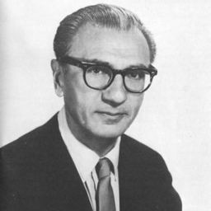
Bronislaw Kaper (1902 – 1983)
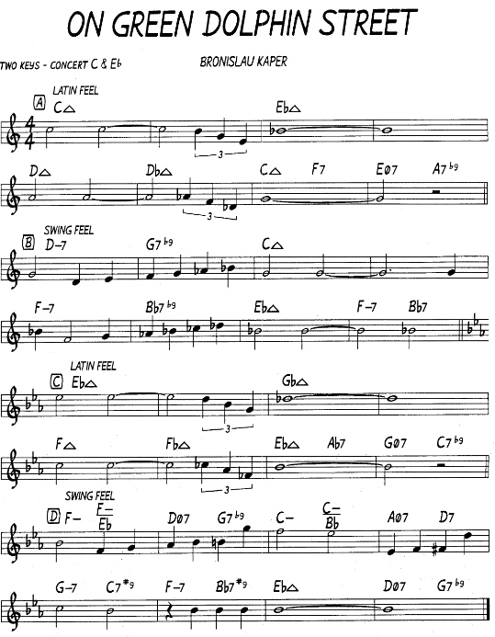

Nejstarší dostupná nahrávka se sametovým trombonem, připomínajícím legendárního bratra dirigenta tohoto orchestru, Tommyho Dorseye
https://secondhandsongs.com/performance/20710
On Green Dolphin Street by Jimmy Dorsey and His Orchestra
Movie premiered October 15, 1947

Legendární zpěvák, zvaný Velvet Fog
https://secondhandsongs.com/performance/53378
On Green Dolphin Street by Mel Tormé and Shorty Rogers Orchestra
July 11, 1962

Snad nejpomalejší tempo ke slyšení; také start jazzového zpěváka, který usedal opakovaně na trůn vokalistů až na přelomu tisíciletí
https://secondhandsongs.com/performance/201323
Green Dolphin Street by Mark Murphy and Ernie Wilkins Orchestra
October 19, 1961

Nestor pánského zpěvu, narozený roku 1926, volí jen o něco rychlejší = pomalé tempo
https://secondhandsongs.com/performance/129070
On Green Dolphin Street by Tony Bennett
March 26, 1964

A ještě naše patronka, Ella Fitzgerald, která zařadila naši píseň na začátek jedné z medleys – směsí, jaké byly kdysi módou. Příjemné tempo medium.
https://secondhandsongs.com/performance/345656
On Green Dolphin Street- How Am I to Know - Just Friends - I Cried for You - Seems Like Old Times - You Stepped Out of a Dream by Ella Fitzgerald with Benny Carter's Music
May 28, 1968

Báječný jazzový bard Joe Williams s kapelou trumpetisty Nata Adderleye
https://secondhandsongs.com/performance/952390
On Green Dolphin Street by Joe Williams
August 7, 1973

Nejsem sám, koho kdykoliv potěší nedostižní The Singers Unlimited mnohohlasým zpěvem a svižným aranžmá jejich dlouholetého partnera Clare Fischera
https://secondhandsongs.com/performance/296091
Green Dolphin Street by The Singers Unlimited - Orchestra arranged and conducted by Pat Williams
May 26 – 31, 1975

Tato báječná Francouzka, hostující před lety v našem Janáčkově divadle (ale jazzovým koncertem, ne v opeře), se pouští za hranice formy a harmonie
https://secondhandsongs.com/performance/451837
Green Dolphin Street by Anne Ducros
September 3, 2007

Vítané osvěžení Coreova tria (John Patitucci-b, Dave Weckl-dr) z koncertu na Floridě
https://secondhandsongs.com/submission/158653
On Green Dolphin Street by Chick Corea Akoustic Band
January 13, 2018

O generaci mladší trombonista Urbie Green navazuje na pověstný lahodný tón Tommyho Dorseye
https://secondhandsongs.com/performance/289344
Green Dolphin Street by Urbie Green
January 12, 1955

Jedno z prvních svrchovaně jazzových uchopení té podmanivé písně v komorním duchu tria, které dal dohromady kalifornský producent Lester Koenig, zakladatel významné gramofonové značky Contemporary, na základě ankety čtenářů časopisu Down Beat. Pět let po sobě vítězili ve svých nástrojových kategoriích kytarista Barney Kessel, bubeník Shelly Manne (oba z židovských rodin, stejně jako Koenig) a basista Ray Brown, Afroameričan. Taková shoda se hned tak nevidí a Koenig ji každým rokem zachytil na speciálním albu The Poll Winners.
https://secondhandsongs.com/performance/351810
On Green Dolphin Street by Barney Kessel, Shelly Manne & Ray Brown
March 18 – 19, 1957

Míříme do nejvyššího patra jazzových osobností, do sexteta trumpetisty Milese Davise. Dalšími melodiky v něm byli altsaxofonista Julian „Cannonball“ Adderley a tenorsaxofonista John Coltrane, rytmika byla stejně hvězdná: Bill Evans-klavír, Paul Chambers-basa a Jimmy Cobb-bicí. Jen pozor,
pokud shlédnete obrazový doprovod. Druhé sólo po Davisově trubce hraje Coltrane a my vidíme Cannonballa, a potom naopak. Ještěže klavírista je jen jeden…
https://secondhandsongs.com/performance/129046
On Green Dolphin Street by Miles Davis
May 26, 1958

Jednou jedinkrát se nechal klavírista Bill Evans, považovaný za hlavního tvůrce moderního jazzového způsobu hry, zmanipulovat zlověstným producentem Creedem Taylorem k nahrávce bohapustě komerčního alba. Jeho pád do hlubin hudebního smogu se naštěstí neopakoval… https://secondhandsongs.com/performance/602120
On Green Dolphin Street by Bill Evans
September 6, 1963

Těsně před svým rozpadem bylo kvarteto nejmelodičtějšího tenorsaxofonisty Stana Getze dvakrát zachyceno na evropském turné, v Berlíně a Paříži: Gary Burton-vibrafon, Steve Swallow-kontrabas, Roy Haynes-bicí. Ti tři „ostatní“ vzápětí přibrali rockového kytaristu Larryho Coryella a vynalezli fúzi dvou do té doby separátních stylů, jazz-rock.
https://secondhandsongs.com/submission/179042
On Green Dolphin Street by Stan Getz
November 13, 1966 Paris

Na závěr nezpívaných podob klavírní sólo z alba této i dalších filmových melodií v podání autora
https://secondhandsongs.com/performance/540946
Green Dolphin Street by Bronislaw Kaper
Released 1975

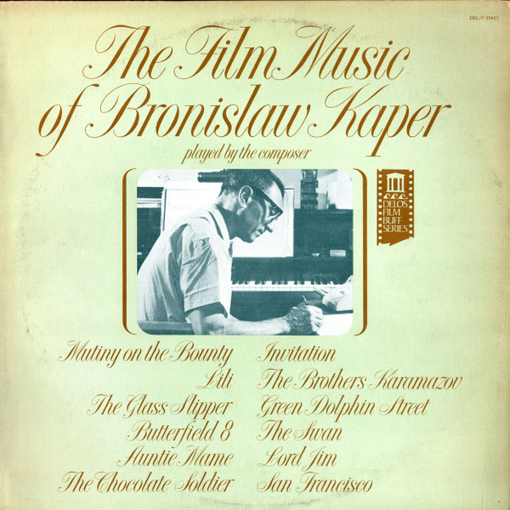

A přece! Úplně na konci přehlídky 600 různých verzí nalezeno pozoruhodné album dlouholetého šampióna jazzového kontrabasu, Christiana McBridea. Jeho spoluhráči 1. března 2021 byli
saxofonista Marcus Strickland, kytarista Mike Stern a bubeník Eric Harland. Hudebníci se nijak neomezovali časově – tuto podobu standardu natáhli téměř do čtvrthodiny nekončících nápadů – ani po technické stránce – odmítli jakékoliv digitální úpravy zvuku. Taková je nepřikrášlená současnost jazzu.

https://secondhandsongs.com/performance/1345612
On Green Dolphin Street by Christian McBride
March 1, 2021

