Jazz Standards
Počty standardů v jednotlivých dekádách 20. století ve sledované tisícovce nejvíce nahrávaných:
pre-1910 | 24
1910s | 36
1920s | 164
1930s | 312
1940s | 267
1950s | 131
1960s | 58
1970s | 7
1980s | 1

32 solitérů v Jazz Standards 0 – 300
011 | Autumn Leaves (Les Feuilles Mortes) | 1947 | Kosma,Joseph | Prévert,Jacques/Mercer,Johnny
013 | Willow Weep for Me | 1932 | Ronell,Ann | -
014 | What's New? | 1939 | Haggart,Bob | Burke,Johnny
016 | Sweet Georgia Brown | 1925 | Bernie-Pinkard-Casey | Ben-Maceo-Ken
021 | How High the Moon | 1940 | Lewis,Morgan | Hamilton, Nancy
026 | Tenderly | 1946 | Gross,Walter | Lawrence,Jack
037 | Sweet Lorraine | 1928 | Burwell,Cliff | Parish,Mitchell
041 | Indiana (Back Home Again in Indiana) | 1917 | Hanley,James | MacDonald,Ballard
056 | Misty | 1954 | Garner,Erroll | Burke,Johnny
071 | All of Me | 1931 | Marks,Gerald-Simons,Seymour | -
085 | Just Friends | 1931 | Klenner,John | Lewis,Sam M.
090 | Just You, Just Me | 1929 | Greer,Jesse | Klages,Raymond
109 | Avalon | 1920 | Jolson-DeSylva-Rose | Al-Buddy G.-Vincent
115 | Nature Boy | 1948 | Ahbez,Eden | -
146 | Flamingo | 1941 | Grouya,Ted | Anderson,Edmund
164 | My Melancholy Baby | 1911 | Burnett,Ernie | Norton,George A.
174 | Limehouse Blues | 1922 | Braham,Philip | Furber,Douglas
176 | I'm Getting Sentimental Over You | 1933 | Bassman,George | Washington,Ned
196 | Poor Butterfly | 1916 | Hubbell,Raymond | Golden,John L.
197 | Since I Fell for You | 1948 | Johnson,Woodrow Wilson | -
199 | Rose Room | 1917 | Hickman,Art-Williams,Harry | -
225 | When You‘re Smiling | 1928 | Fisher,Mark-Shay,Larry | Goodwin,Joe
226 | I'm Coming Virginia | 1927 | Heywood,Donald | Cook,Will Marion
227 | I Hear a Rhapsody | 1940 | Fragos-Baker-Gasparre | George-Jack-Dick
240 | Someday My Prince Will Come | 1937 | Churchill,Frank E. | Morey,Larry
260 | Crazy Rhythm | 1928 | Kahn,Roger Wolfe-Meyer,Joseph | Caesar,Irving
261 | That's All | 1952 | Haymes,Bob-Brandt,Alan | -
266 | As Time Goes By | 1931 | Hupfeld,Herman | -
267 | Indian Summer | 1919 | Herbert,Victor | Dubin,Al
273 | The Night Has a Thousand Eyes | 1948 | Brainin,Jerry | Bernier,Buddy
288 | China Boy | 1922 | Boutelje,Phil | Winfree,Richard A.
294 | Besame Mucho | 1941 | Velazquez,Consuelo | Skylar,Sunny
A mimo soutěž nejúspěšnější píseň Leonarda Bernsteina:
591 | Maria | 1957 | Bernstein,Leonard | Sondheim,Stephen

Co je to solitér? Standard, jehož skladatel je v první tisícovce zastoupen pouze jedenkrát.
Dejme šanci ještě těm, kteří mají v Top 300 dva standardy – toto jsou ty výše umístěné.

2 standardy téhož autora
034 | After You've Gone | 1918 | Layton,Turner | Creamer,Henry
083 | Memories of You | 1930 | Blake,Eubie | Razaf,Andy
135 | Days of Wine and Roses | 1962 | Mancini,Henry | Mercer,Johnny
155 | If I Could Be with You (One Hour Tonight) | 1926 | Johnson,James P. | Creamer,Henry
167 | Stairway to the Stars (Park Avenue Fantasy) | 1935 | Malneck,Matt-Signorelli,Frank | Parish,Mitchell
170 | God Bless the Child | 1941 | Herzog,Arthur-Holiday,Billie | -
203 | Rosetta | 1933 | Hines,Earl-Woode,Henri | -
210 | I'll Never Be the Same | 1932 | Malneck,Matt-Signorelli,Frank | Kahn,Gus
211 | Django | 1955 | Lewis,John | bez rozšířeného textu
253 | Don't Explain | 1946 | Holiday,Billie-Herzog,Arthur | -
255 | It's the Talk of the Town | 1933 | Livingston,Jerry | Symes,Marty-Neiburg,Al J
291 | Li'l Darlin' | 1957 | Hefti,Neal | -

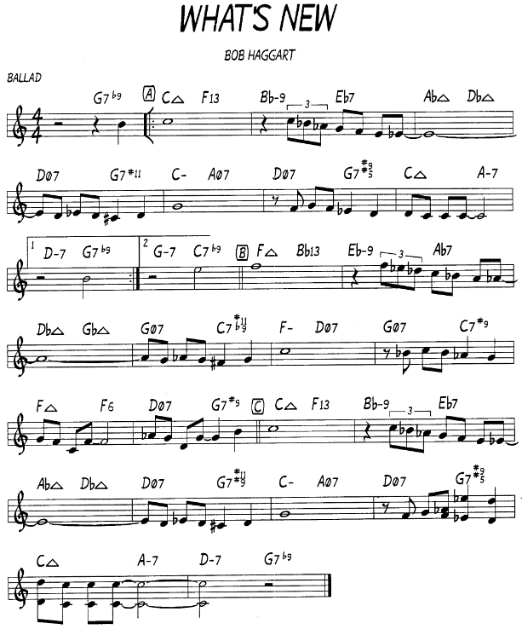

Jazz Standards 14. místo
SecondHandSongs 484 verzí roku 1939 hit č. 33
Tom Lord Jazz Discography 783 verzí

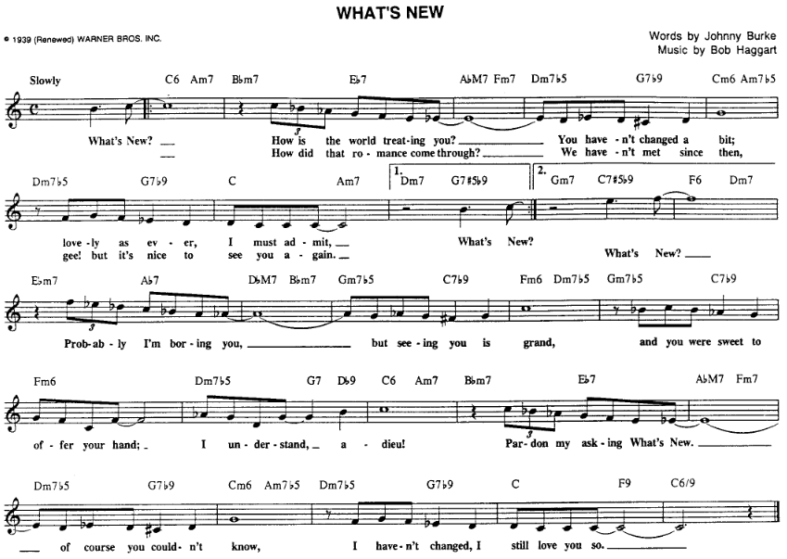

Stan Kenton ještě v dobách stratosférického Maynarda Fergusona, zde „jen“ s 19 hudebníky
https://secondhandsongs.com/submission/204956
May 31, 1951

Clifford Brown, trumpetista normálního rozsahu, ale jaký! Dodnes největší vzor
https://secondhandsongs.com/performance/388969
January 18, 1955

Zpěvačka jazzmanů, doprovází skupina…Clifforda Browna – zahraje si sólo
https://secondhandsongs.com/performance/40647
December 24, 1954

Klavírista Oscar Peterson doprovází miláčka milionů – Louise Armstronga
https://secondhandsongs.com/performance/64399
October 14, 1957

Nenapodobitelná Betty Carter
https://secondhandsongs.com/performance/415534
December 6, 1969

Když se setkají dvě z nejoriginálnějších zpěvaček, Carmen McRae & Betty Carter
https://secondhandsongs.com/performance/129846
January 30, 1987

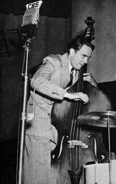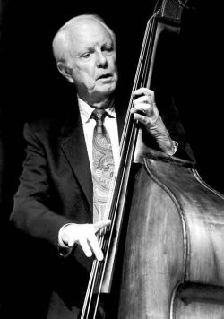

Bob Haggart (1914 – 1998)

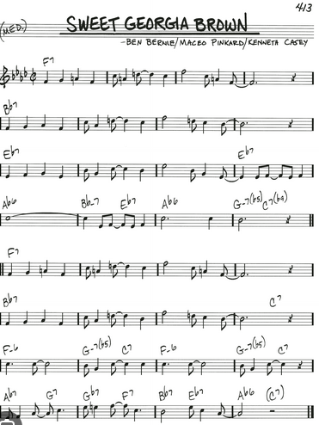

Jazz Standards 16. místo
SecondHandSongs 968 verzí roku 1925 hit č. 1
Tom Lord Jazz Discography 1606 verzí

Slavná Afroameričanka, Ethel Waters v roce vzniku písně, v neworleánském stylu
https://secondhandsongs.com/performance/67614
May 13, 1925

Do ještě vzdálenější minulosti nás dostane Original Washboard Band
https://secondhandsongs.com/performance/435830
1959

Naše patronka, tetička Ella Fitzgerald
https://secondhandsongs.com/performance/185824
July 20, 1966

Zážitky poskytuje obvykle i Mr. Velvet Fog, vlastním jménem Mel Tormé, zde scat songem
https://secondhandsongs.com/performance/552187
August 1988

Jedinečné vokální sexteto Take 6 si s písničkou hraje jako kočka s myší
https://secondhandsongs.com/performance/476335
released 2008

Nejstarší instrumentální deska je ovšem s orchestrem autora, Bena Bernieho
https://secondhandsongs.com/performance/67609
March 19, 1925

Když poctivě stylově po staru, tak od bílých Dukes of Dixieland
https://secondhandsongs.com/performance/1409265
October 1951

Mistrovství světa v nekonečném proudu nápadů a jejich střelhbité realizaci – Oscar Peterson
https://secondhandsongs.com/performance/677287
March 17, 1975 Paris

Petersona překoná jedině Peterson se dvěma basisty, Rayem Brownem a Nielsem H. Ø. Pedersenem.
Uvěří jen ten, kdo uvidí - - - - - - - - - - - - - - - - - - - - - - V I D E O
https://www.youtube.com/watch?v=Ypd1YGW5Huw

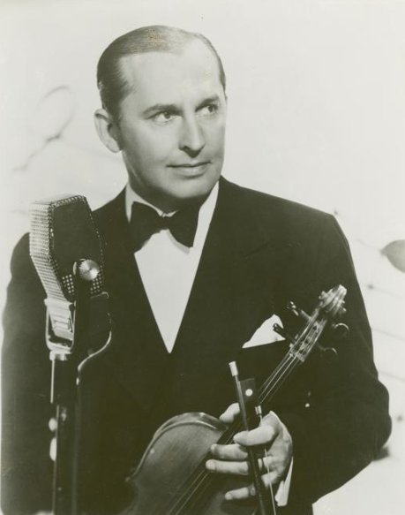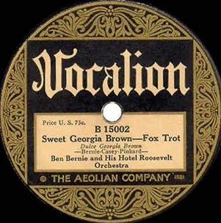
Ben Bernie (1891 – 1943)

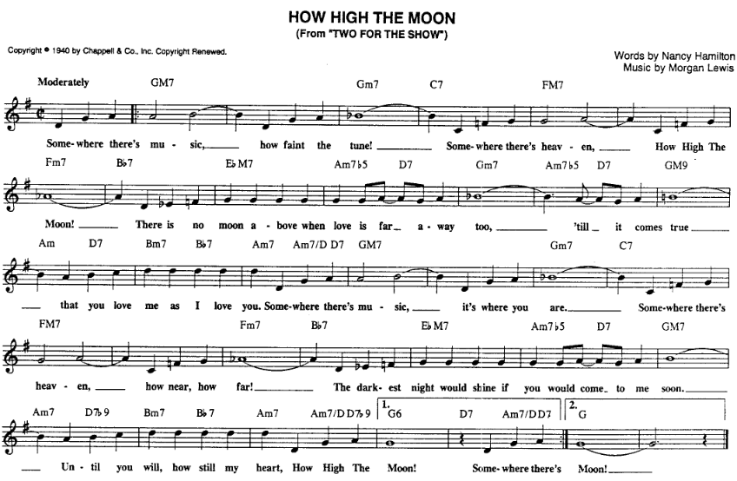

Jazz Standards 21. místo
SecondHandSongs 476 verzí roku 1940 hit č. 4
Tom Lord Jazz Discography 860 verzí

King of Swing, klarinetista Benny Goodman s orchestrem a zpěvačkou Helen Forrest
https://secondhandsongs.com/performance/167358
February 7, 1940

Kytarový experimentátor Les Paul na trikové nahrávce se svojí ženou, Mary Ford
https://secondhandsongs.com/performance/61308
released March 1951

Hodně uvolněné uchopení tématu zpívajícím kytaristou Slimem Gaillardem, známým vtipálkem
https://secondhandsongs.com/performance/721282
November 1958

O r n i t h o l o g y
Vtipná melodická parafráze na harmonickou kostru How High the Moon od Charlieho Parkera,
hrají saxofonista Joshua Redman a klavírista Brad Mehldau
https://secondhandsongs.com/performance/623192
released 2016

Málokterou píseň natočila Ella Fitzgerald víckrát. Po úvodní volnější sloce přijde double-time a parádní ukázka scat songu, včetně melodické parafráze Charlieho Parkera, Ornithology
https://secondhandsongs.com/submission/158169
November 4 – 8, 1953 Tokyo

Trochu méně kvalitní video, ovšem od Manhattan Transfer z koncertu
https://secondhandsongs.com/performance/106308
November 1983

Významný tenorsaxofonista Sonny Rollins na výletě v Kalifornii
https://secondhandsongs.com/performance/360855
October 20 – 22, 1958

Veterán barytonsaxofonu Ronnie Cuber (1941 – 2022) zralý jako dobré víno
https://secondhandsongs.com/performance/936172
released November 2019

Návrat domů s krasobruslící Helenou Vondráčkovou na český text Zdeňka Borovce
https://secondhandsongs.com/performance/1198118
released 1976

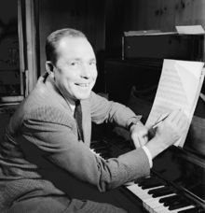

Morgan Lewis (1906 – 1968)
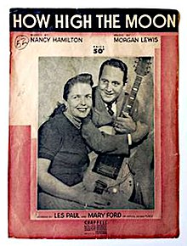

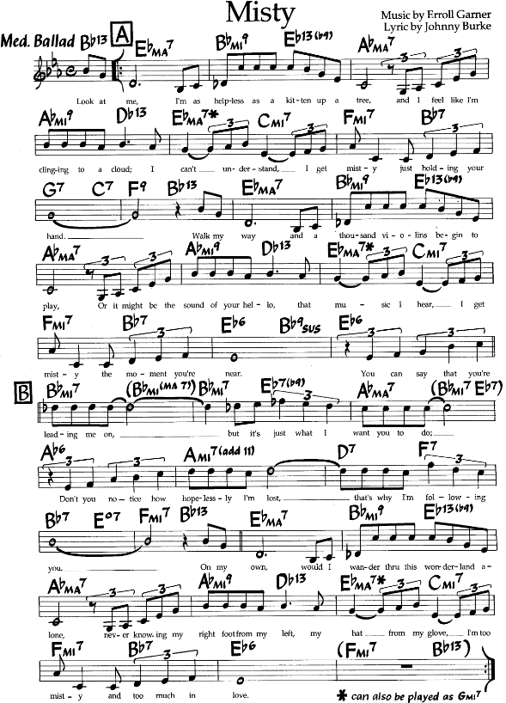

Jazz Standards 56. místo
SecondHandSongs 740 verzí roku 1954 hit č. 2
Tom Lord Jazz Discography 800 verzí

Nejen skladatel, ale hlavně přední jazzový pianista Erroll Garner přichází se svou autorskou verzí
https://secondhandsongs.com/performance/46271
July 27, 1954

Jedna z raných orchestrálních podob je od Richarda Haymana, foukačkáře a dirigenta
https://secondhandsongs.com/performance/670198
released 1956

Za ryze jazzové provedení lze považovat to od legendárního swingového orchestru Counta Basieho, aranžmá Frank Foster, sólový barytonsaxofon Charlie Fowlkes
https://secondhandsongs.com/performance/409215
December 31, 1959

Ještě měkčí zvuk má hollywoodský studiový orchestr pod taktovkou a v aranžmá velkého sběratele cen, Henryho Manciniho (20 trofejí Grammy, 4 Oscary); trombonistou je Dick Nash
https://secondhandsongs.com/performance/273325
February 22 – 29, 1960

Prvotřídní jazzovou partu reprezentuje prvních 8 taktů nejmelodičtější tenorsaxofonista Stan Getz, ale leaderem nahrávání byl pístový trombonista Bob Brookmeyer. Oba bílé melodiky podbarvuje Gary Burton na vibrafon a tři špičkoví Afroameričané, Herbie Hancock, Ron Carter a Elvin Jones.
https://secondhandsongs.com/performance/764036
May 27, 1964

Naprosto unikátní je sólová harfa Afroameričanky Dorothy Ashby, jediné jazzové hráčky na královský nástroj. Jen známý komik Harpo Marx překvapoval svými autodidaktickými kreacemi.
V nabídce je ovšem celé její album, skladba Misty začíná v čase 28:00
https://secondhandsongs.com/performance/631513
1984

V malebném aranžmá pro Orchestr Radia a Televize Lublaň nahrál tu podmanivou melodii dávný host brněnského rozhlasového studia, vibrafonista Boško Petrovič
https://secondhandsongs.com/performance/1411593
April 2002

Z doby nedávné je video mladých jazzmanů z Barcelony pod vedením Joana Chamorra (bass) a nečekaně s dosud neznámou houslistkou jménem Élia Bastida, jinak saxofonistkou orchestru
https://secondhandsongs.com/performance/742427 V I D E O
released October 5, 2017

Kuriozitou, kterou zahájíme malý výběr vokálních verzí, zůstáváme v téže zeměpisné oblasti a vyslechneme verše v katalánštině pod názvem Tot és gris, jak je zpívá Núria Feliu za doprovodu nevidomého pianisty Tete Montolia
https://secondhandsongs.com/performance/1441194
November 12, 1965

Když zvláštnosti, neodpustím si českou verzi od Nezmarů, s textem Petra Jánského, a v tempu
https://secondhandsongs.com/performance/1117695
released 2007

A teď už do země vzniku a za velkými umělkyněmi. Nejdříve Sarah Vaughan
https://secondhandsongs.com/performance/114690
July 7, 1958

Její starší kolegyně a rivalka, garantka obou semestrů Ella Fitzgerald
https://secondhandsongs.com/performance/217773
February 13, 1960

Svým zpěvem pečetí kvalitu předchozích Frank Sinatra, zvaný The Voice
https://secondhandsongs.com/performance/38531
November 21, 1961

V naší zemi nikoli neznámá švédská vokální skupina The Real Group, někdy nazývaná díky svým kvalitám „švédští Manhattan Transfer“
https://secondhandsongs.com/performance/471804
released 1987

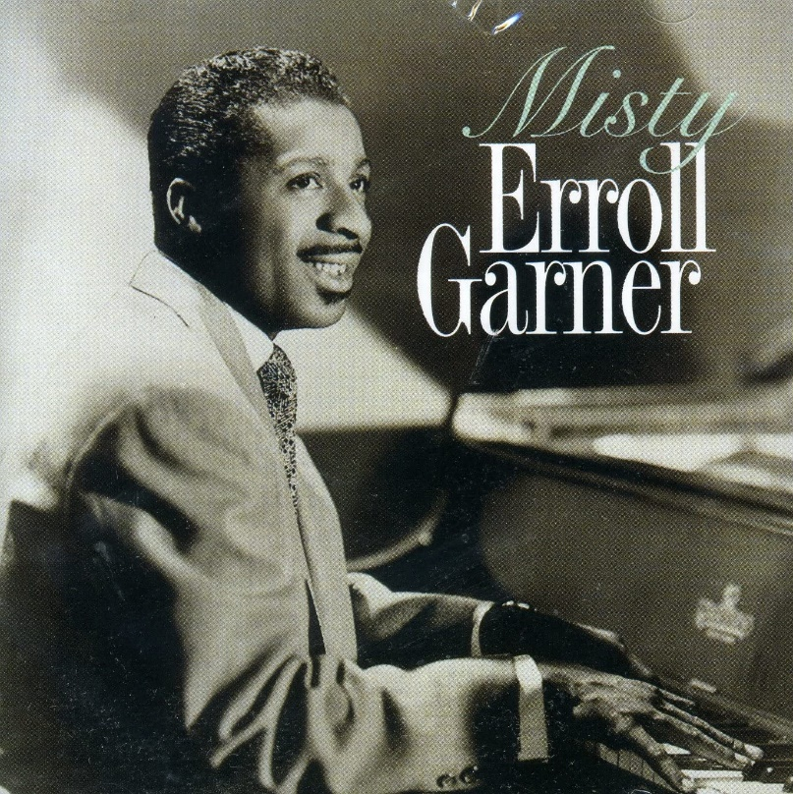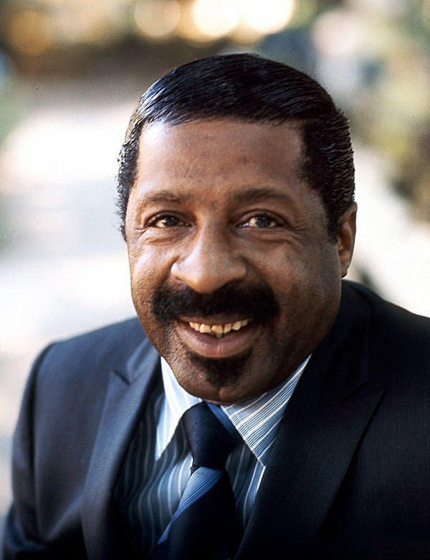

Erroll Garner (1921 – 1977)

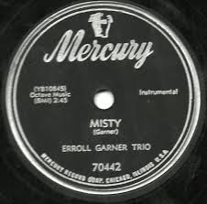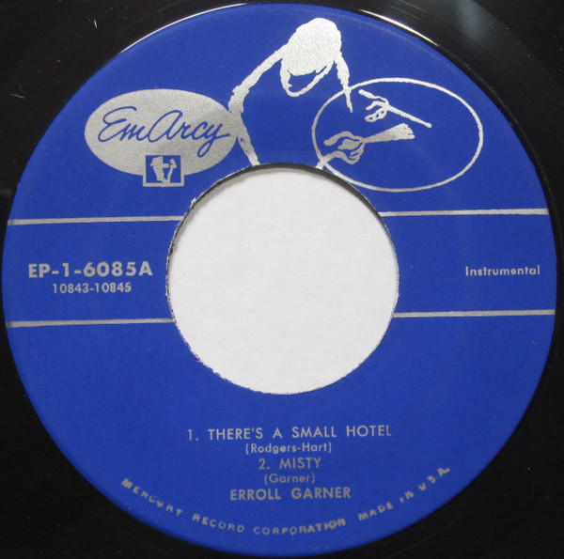
Shellac disc EP vinyl

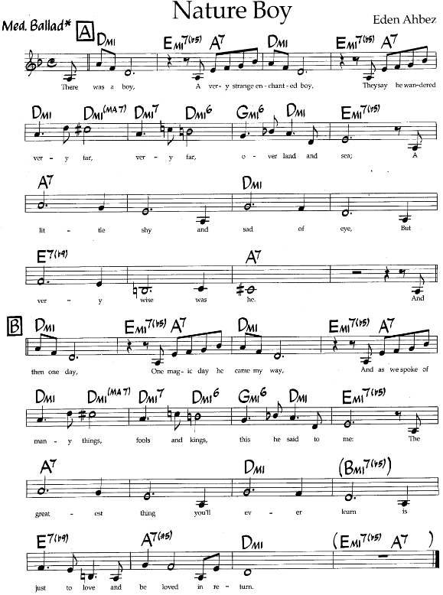

Jazz Standards 115. místo
SecondHandSongs 700 verzí roku 1947 hit č. 1
Tom Lord Jazz Discography 498 verzí

První nahrávka a hned bomba. První místo po dobu 7 týdnů v hitparádě a prodej více než milionu desek. Interpretem, jemuž autor píseň věnoval, se stal zpívající klavírista Nat King Cole.
https://secondhandsongs.com/performance/1378
August 22, 1947

Brzy se píseň dostala i do repertoáru Franka Sinatry. V době stávky hudebníků jej mohl doprovázet jedině pěvecký sbor – naprostá rarita v dějinách populární hudby
https://secondhandsongs.com/performance/1379
April 26, 1948

Do doby stávky spadá i první ženská nahrávka, tedy se sborem místo orchestru: Sarah Vaughan
https://secondhandsongs.com/performance/108286
April 8, 1948

Vokální skupina jako byly The King Sisters s doprovodem orchestru, to už byla normální situace
https://secondhandsongs.com/performance/530281 V I D E O
released 1966

Hybným rytmem překvapil jindy zádumčivý Johnny Hartman, zde s japonskou rytmikou
https://secondhandsongs.com/performance/228833
November 25, 1972

Mezi mnohohlasými sbory rozhodně vedou The Singers Unlimited, aranžmá Gene Puerling
https://secondhandsongs.com/performance/452293
released 1975

Královna Ella Fitzgerald ve zralém věku a ideálním partnerství s kytaristou Joem Passem
https://secondhandsongs.com/performance/68936
February 8, 1976

Natalie Cole, dcera prvního interpreta, nemůže v této minipřehlídce chybět, zde na albu, které získalo 7 cen Grammy
https://secondhandsongs.com/performance/46464
released June 11, 1991

Ovšem mým vítězem se už dávno stal největší z jazzových zpěváků, Kurt Elling. Ta gradace!
https://secondhandsongs.com/performance/55152
September 14, 1996

Swingující dánský houslista Svend Asmussen (1916-2017!) na jedné z prvních nezpívaných nahrávek
https://secondhandsongs.com/performance/449794
August 10, 1948

Génius poválečného jazzu, trumpetista Miles Davis v podivuhodné sestavě: Britt Woodman-trombon, Teddy Charles-vibrafon, Charles Mingus-kontrabas, Elvin Jones-bicí nástroje. Klasika.
https://secondhandsongs.com/performance/161224
July 9, 1955

Největší z melodiků mezi tenoráky, Stan Getz, ke všemu s harfou a smyčci
https://secondhandsongs.com/performance/449861
March 1960 Baden-Baden

Nature Boy jakoby přitahoval všechny tenorsaxofonisty, dalším je Ike Quebec
https://secondhandsongs.com/performance/429117
November 26, 1961

Nebo Getzův dávný spoluhráč, Zoot Sims, ten v rytmu tehdy nové bossa-novy
https://secondhandsongs.com/performance/950905
November 1962

Ani John Coltrane neodolal ďábelským svodům té nádherné písně
https://secondhandsongs.com/performance/142110
February 18, 1965

Až kdesi z kosmu přinesl svůj názor na tento standard tajemný kouzelník Sun Ra
https://secondhandsongs.com/performance/449993
October 14, 1977

Jako osvěžení působí novým pohledem na staré dobré téma trombonista John Fedchock se svým sextetem. Melodický trojhlas je nepředvídatelný, ale moc chytný
https://secondhandsongs.com/performance/1070741
released July 3, 2020

A český příspěvek na závěr? Pavel Bobek zpívá český text Zdeňka Rytíře: Kluk s tváří mou
https://secondhandsongs.com/performance/1182631
released March 2005

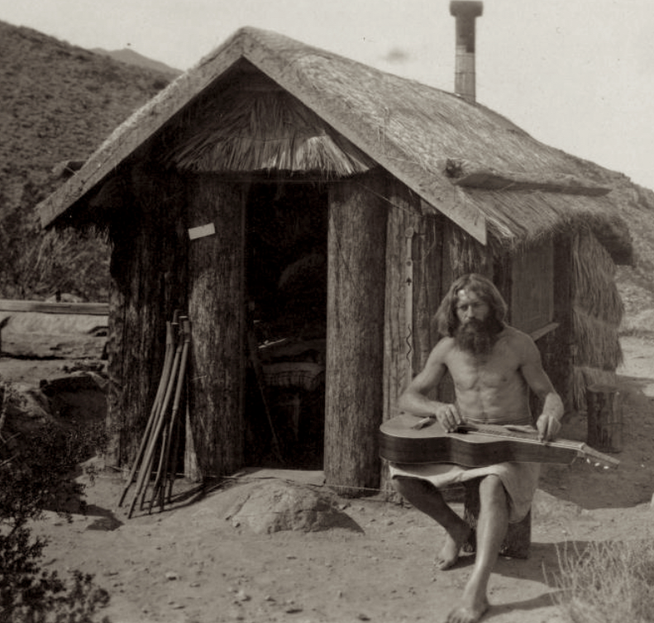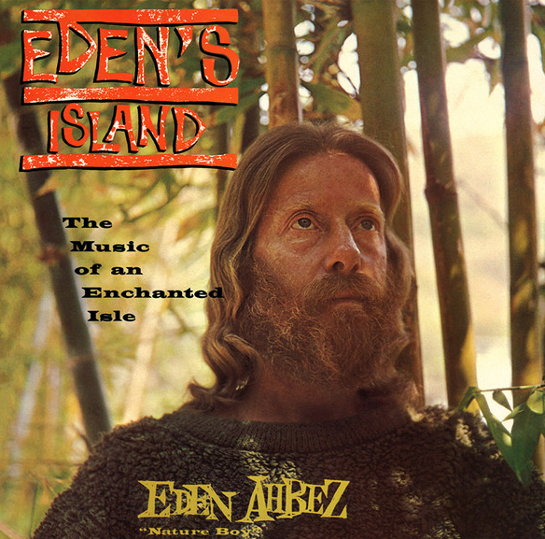

William Pester (1885 – 1963) eden ahbez (1908 – 1995)

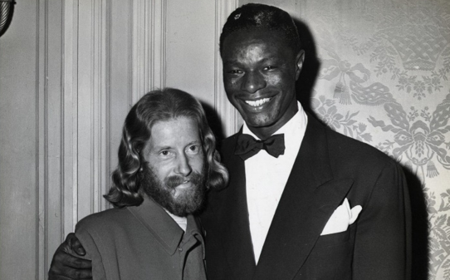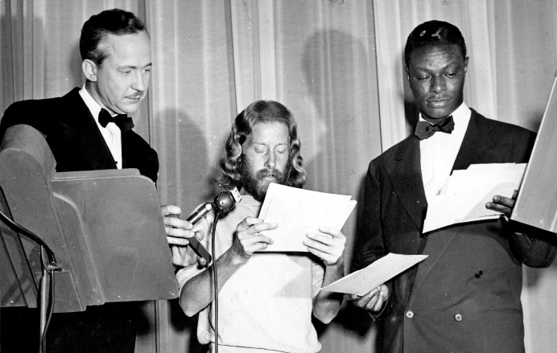

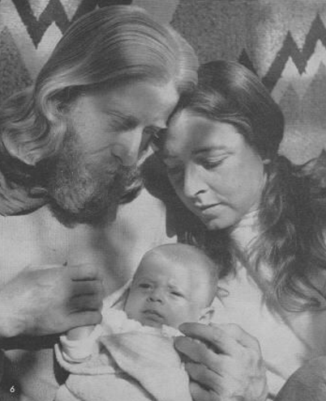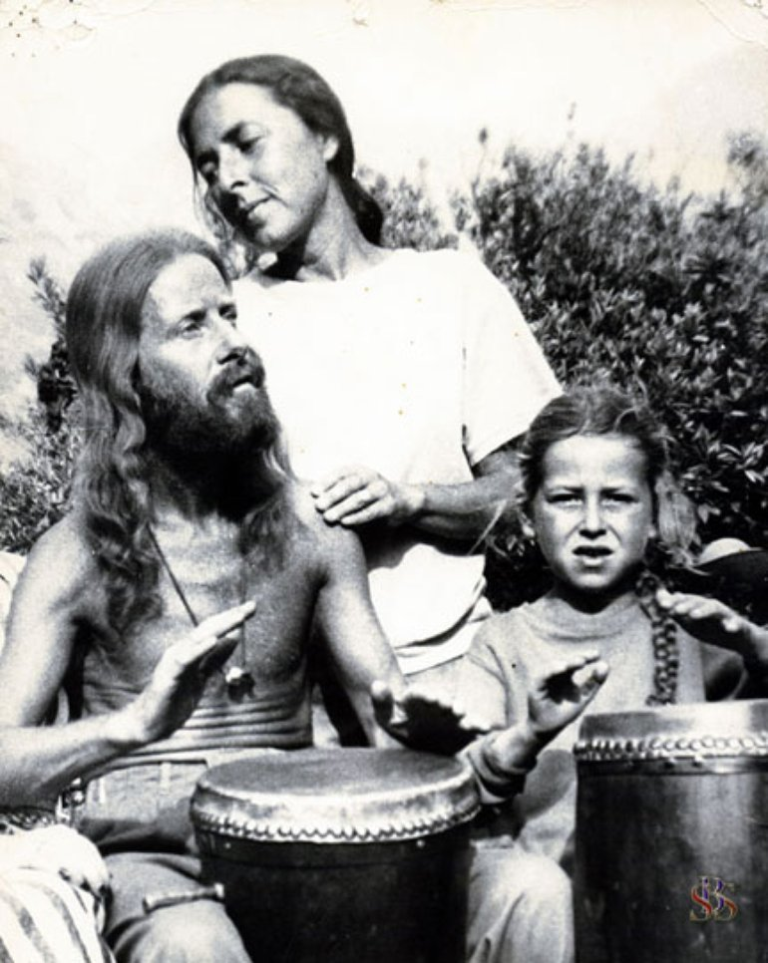

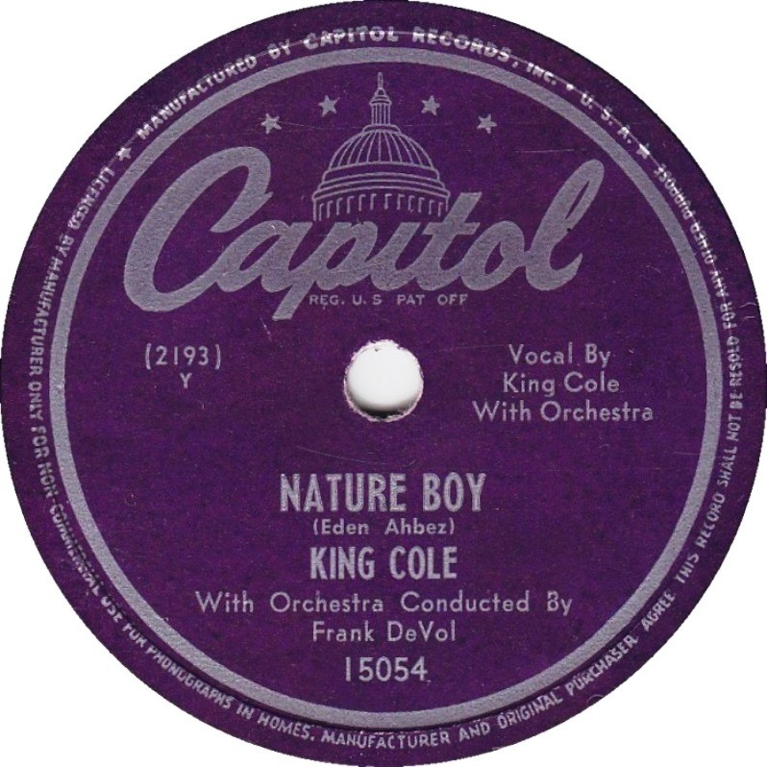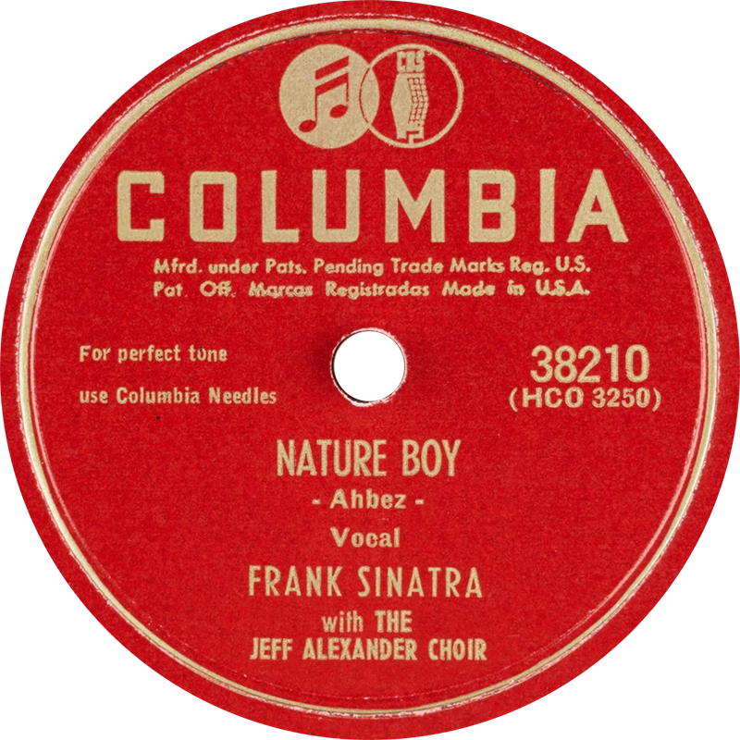
Capitol versus Columbia

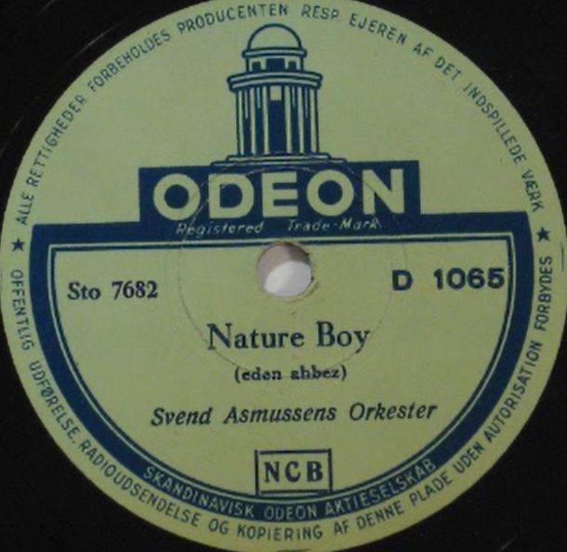
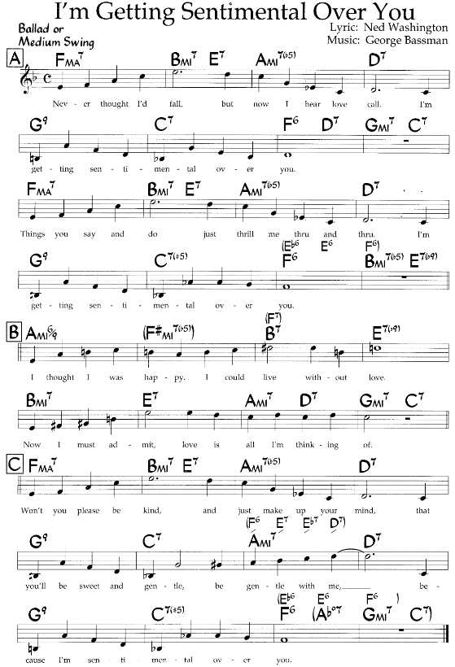

Jazz Standards 176. místo
SecondHandSongs 399 verzí roku 1933 hit č. 8
Tom Lord Jazz Discography 604 verzí

První nahrávka patří orchestru bratří Dorseyů a zpěvačce Jean Bowes, s trombonem Tommyho D.
https://secondhandsongs.com/performance/61207
September 24, 1932

Mezi vokálními skupinami té doby se rozhodně neztráceli The Ink Spots
https://secondhandsongs.com/performance/61217
October 11, 1939

Ella Fitzgerald v hodně komorním vydání…
https://secondhandsongs.com/performance/872266
April 19, 1960

…a s pořádným orchestrálním doprovodem Counta Basieho
https://secondhandsongs.com/performance/996009
February 15, 1979

Neodolatelní Four Freshmen, o nějakých 9 let později na československém turné – nezapomínáme
https://secondhandsongs.com/performance/107170
July 19, 1960

Velekněz moderního jazzu Thelonious Monk se neobracel zády k tradiční hudbě, sám u klavíru
https://secondhandsongs.com/performance/61214
April 12, 1957

Hodně profláknutý popíkář Billy Vaughn a jeho vlezlý mečivý altsaxofon měl taky své vyznavače
https://secondhandsongs.com/performance/593508
released 1958

Není altka jako altka. Modernista Lee Konitz to vzal úplně jinak. To je jazz.
https://secondhandsongs.com/performance/817438
October 29, 1959

Ještě nesmlouvavější inovátor, basista Charles Mingus u klavíru, perlí a reharmonizuje
https://secondhandsongs.com/performance/61215
June 30, 1963

Jeden z největších moderních pianistů Bill Evans s triem (Eddie Gomez-bass, Shelly Manne-bicí)
https://secondhandsongs.com/performance/130912
October 4, 1966

A co avantgardisté? I jim se hodí starodávné téma. Ran Blake-klavír, Anthony Braxton-saxofon
https://secondhandsongs.com/performance/133074
November 19, 1988

Elegantní pojetí dua Andy LaVerne-klavír a John Abercrombie-kytara (kdysi i v Brně)
https://secondhandsongs.com/performance/615227
September 2002

Mladá krev jazzové kytary, Julian Lage
https://secondhandsongs.com/performance/916038
released February 2019

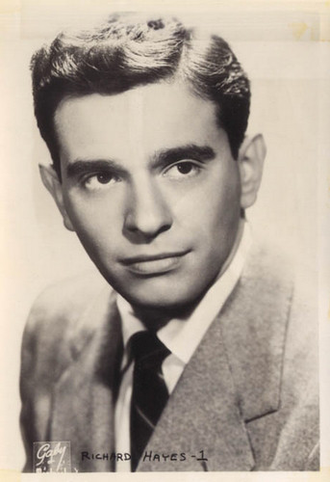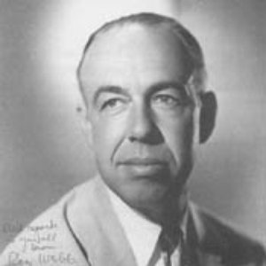

George Bassman (1914 – 1997)

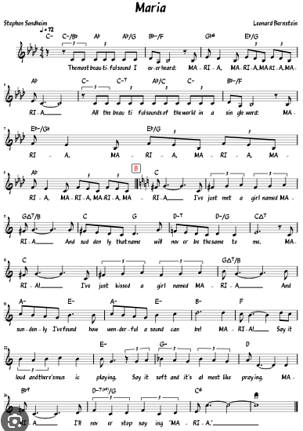

SecondHandSongs 241 verzí roku 1957 hit č. 12
Jazz Standards 591. místo
Tom Lord Jazz Discography 147 verzí

První představitel Tonyho, Larry Kert (1930-1991)
https://secondhandsongs.com/performance/1290426
September 29, 1957

Velkolepý zvuk orchestru Stana Kentona s mellofony – 27 hudebníků, Johnny Richards-aranžmá
https://secondhandsongs.com/performance/111635
March 15, 1961

Z Kentonova orchestru vyšel i famózní kanadský trumpetový výškař Maynard Ferguson
https://secondhandsongs.com/performance/1312767
December 1961

Něco pro trpělivé – vláčné pojetí dnes zapomenutého zpěváka Andyho Williamse
https://secondhandsongs.com/performance/96713
released 1962

O čtyři roky později přispěl do pokladnice West Side Story i Karel Gott-anglicky. Návrat domů.
https://secondhandsongs.com/performance/733911
released 1966

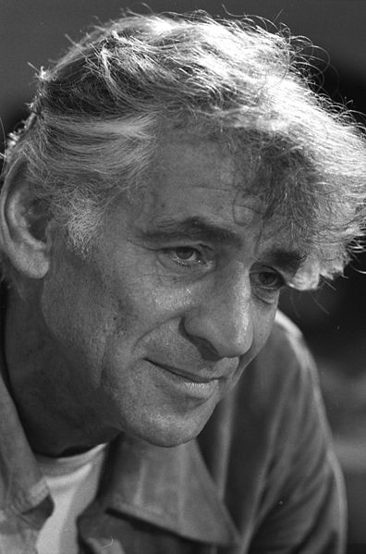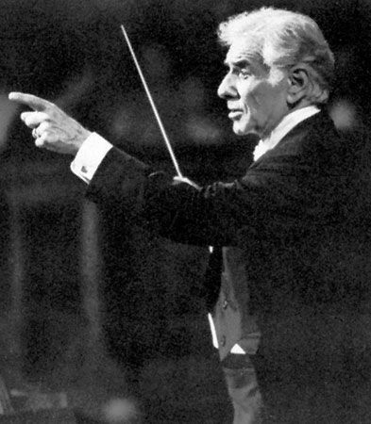

Leonard Bernstein (1918 – 1990)

eden ahbez

Nat “King” Cole introduced this unusual tune, based on a Yiddish song “Schwieg Mein Hertz” (Be Still My Heart), in 1948, when it leaped to number one in the charts for 18 weeks:
- Nat “King” Cole (1948, vocal, #1)
- Frank Sinatra (1948, vocal, #7)
- Sarah Vaughan (1948, vocal, #9)
- Dick Haymes (1948, vocal, #11)
George Alexander Aberle (April 15, 1908 – March 4, 1995), known as eden ahbez, was an American songwriter and recording artist of the 1940s to 1960s, whose lifestyle in California was influential in the hippie movement. He was known to friends simply as ahbe.
Ahbez composed the song "Nature Boy", which became a No. 1 hit for eight weeks in 1948 for Nat "King" Cole. Living a bucolic life from at least the 1940s, he traveled in sandals and wore shoulder-length hair and beard, and white robes. He camped out below the first L in the Hollywood Sign above Los Angeles and studied Oriental mysticism. He slept outdoors with his family and ate vegetables, fruit, and nuts. He claimed to live on three dollars per week.
Ahbez was born in Brooklyn, New York, to a Jewish father and a Scottish-English mother, and spent his early years in the Brooklyn Hebrew Orphan Asylum of New York, which branched off from the Hebrew Orphan Asylum. (and his 12 siblings!) He then traveled in an Orphan Train and was adopted, in 1917, by a family in Chanute, Kansas, and raised under the name George McGrew.
During the 1930s, McGrew lived in Kansas City, where he performed as a pianist and dance band leader. In 1941, he arrived in Los Angeles and began playing piano in the Eutropheon, a small health food store and raw food restaurant on Laurel Canyon Boulevard. The cafe was owned by John and Vera Richter, who followed a Naturmensch and Lebensreform philosophy influenced by the Wandervogel movement in Germany. He was a vegetarian. He recalled once telling a policeman: "I look crazy but I'm not. And the funny thing is that other people don't look crazy but they are."
Their followers, known as "Nature Boys" and who included "Gypsy Boots" (né Robert Bootzin), wore long hair and beards and ate only raw fruits and vegetables. During this period, he adopted the name "eden ahbez", choosing to spell his name with lower-case letters, claiming that only the words God and Infinity were worthy of capitalization.
Some time in 1947, he married Anna Jacobson a month after they met; the couple had a son, Tatha Om Ahbez, on October 9, 1948.
n 1947, ahbez approached Nat "King" Cole's manager backstage at the Lincoln Theater in Los Angeles and handed him the music for his song, "Nature Boy". Cole began playing the song for live audiences to much acclaim, but needed to track down its author before releasing his recording of it. Publicity material for Cole's single instead makes the claim that Johnny Mercer recommended ahbez to Cole on behalf of Capitol Records. Jack Patton, in turn, is said to have advised ahbez to bring "Nature Boy" to Capitol after befriending him at the restaurant where ahbez worked.
Ahbez was discovered living under the Hollywood Sign and became the focus of a media frenzy when Cole's version of "Nature Boy" shot to No. 1 on the Billboard charts and remained there for eight consecutive weeks during the summer of 1948. In early 1948, RKO Radio Pictures paid ahbez $10,000 for the rights to "Nature Boy" to use as the theme song for their film The Boy with Green Hair, and he was credited as the song's composer on the film's opening titles.
Ahbez was covered simultaneously in Life, Time, and Newsweek magazines. Frank Sinatra and Sarah Vaughan later released versions of the song. Ahbez faced legal action from a Yiddish music composer, Herman Yablokoff, who claimed that the melody to "Nature Boy" came from one of his songs, "Shvayg mayn harts" ("Be Still My Heart"). Ahbez claimed to have "heard the tune in the mist of the California mountains". However, legal proceedings resulted in a payment to Yablokoff of $25,000 in an out-of-court settlement.
Ahbez continued to supply Cole with songs, including "Land of Love (Come My Love and Live with Me)", which was also covered by Doris Day and The Ink Spots. In 1949, he gave Burl Ives the idea to cover Stan Jones' "Ghost Riders in the Sky" after overhearing Jones recording his own version of the song. He worked closely with jazz musician Herb Jeffries, and, in 1954, the pair collaborated on an album, The Singing Prophet, which included the only recording of Ahbez's four-part "Nature Boy Suite". The album was later reissued as Echoes of Eternity on Jeffries' United National label. In the mid 1950s, he wrote songs for Eartha Kitt, Frankie Laine, and others, as well as writing some rock-and-roll novelty songs. In 1957, his song "Lonely Island" was recorded by Sam Cooke, becoming the second and final Ahbez composition to hit the Top 40.
In 1959, he began recording instrumental music, which combined his signature somber tones with exotic arrangements and (according to the record sleeve) "primitive rhythms". He often performed bongo, flute, and poetry gigs at beat coffeehouses in the Los Angeles area. In 1960, he recorded his only solo LP, Eden's Island, for Del-Fi Records. This mixed beatnik poetry with exotica arrangements. Ahbez promoted the album through a coast-to-coast walking tour making personal appearances, but it sold poorly.
During the 1960s, ahbez released five singles. Grace Slick's band, the Great Society, recorded a version of "Nature Boy" in 1966 and ahbez was photographed in the studio with Brian Wilson during a session for the Smile album in early 1967. Later that year, British singer Donovan sought out ahbez in Palm Springs, and the two wanderers shared a reportedly "near-telepathic" conversation. In the 1970s, Big Star's Alex Chilton recorded a version of "Nature Boy" with the photographer William Eggleston on piano. The song was finally released as a bonus track on the 1992 Rykodisc re-release of the album Third/Sister Lovers.

Personal life
His wife Anna (née Annette Jacobson; October 16, 1915 – August 9, 1963) died, aged 47, of leukemia, and his son Zoma (né Tatha Om Ahbez), drowned in 1971 at age 22. In 1974, ahbez was reported to be living in the Los Angeles suburb of Sunland, and he owned a record label named Sunland Records, for which he was recording under the name "Eden Abba". From the late 1980s until his death, ahbez worked closely with Joe Romersa, an engineer/drummer in Los Angeles. The master tapes, photos, and final works of ahbez are in Romersa's possession.

Death
Ahbez died on March 4, 1995, of injuries sustained in a car accident, at the age of 86. Another album, Echoes from Nature Boy, was released posthumously.

Real name George Alexander Aberle
Born April 15, 1908
Died March 4, 1995
Songwriter and performer active from the 1940s into the 1960s. Ahbez spent his early years in a Brooklyn orphanage and was adopted in 1917, moving to Kansas and growing up under the name George McGrew. Ahbez was an inspiration to the California hippie movement as since at least the 1940s, Ahbez had shoulder length hair and a beard, dressed unconventionally and lived outdoors.
``Ahbez's most famous song was "Nature Boy" over which Herman Yablokoff sued, claiming an infringement of his song called "Schweig Mein Hartz" ("Be Still My Heart"), written and published in 1935. The suit was settled with Yablokoff receiving $25,000 and waiving rights to Nature Boy.

Bob Haggart - Robert Sherwood Haggart (March 13, 1914 – December 2, 1998) was an American dixieland jazz double bass player, composer, and arranger. Although he is associated with dixieland, he was one of the finest rhythm bassists of the Swing Era.
In 1935, Haggart became a member of the Bob Crosby Band. He arranged and composed "Big Noise from Winnetka", "My Inspiration", "What's New?", and "South Rampart Street Parade". He remained with the band until it dissolved in 1942, then began working as session musician, with much of his time spent at Decca Records. He recorded with Billie Holiday, Duke Ellington, Benny Goodman, and Ella Fitzgerald; his arrangements can be heard on Fitzgerald's album Lullabies of Birdland. Haggart also starred in several commercials for L&M cigarettes on the radio program "Gunsmoke", including the March 4, 1956 episode, "The Hunter".
He and Yank Lawson formed the Lawson-Haggart Band, and they also led the World's Greatest Jazz Band from 1968 until 1978. He appeared at jazz festivals until his death on December 2, 1998 in Venice, Florida.

Benjamin Anzelwitz, known professionally as Ben Bernie (May 30, 1891 – October 23, 1943), was an American jazz violinist, bandleader, and radio personality, often introduced as "The Old Maestro". He was noted for his showmanship and memorable bits of snappy dialogue, being part of the first generation of "stars" of American popular music, alongside other artists such as Paul Whiteman (a fellow violinist and bandleader), Ted Lewis and Al Jolson.
Bernie was born Bernard Anzelevitz (another source says Benjamin Anzelevitz) in Bayonne, New Jersey. He attended Columbia University and the New York College of Music. By the age of 15 he was teaching violin, but this experience apparently diminished his interest in the violin for a time.
Bernie performed in vaudeville, appearing with Charles Klass as The Fiddle Up Boys in 1912 and with Phil Baker as Baker and Bernie, but he met with little success until 1922 when he joined his first orchestra. Later, he had his own band, The Lads, seen in the early DeForest Phonofilm sound short, Ben Bernie and All the Lads (1924–25), featuring pianist Oscar Levant. He toured with Maurice Chevalier in Europe.

William Morgan "Buddy" Lewis, Jr. (26 December 1906 – 8 December 1968) was a writer of jazz songs, some of which were also recorded in the pop music genre.
Lewis was born in Rockville, Connecticut and died in New York City. He wrote songs and Broadway theatre scores with lyricist Nancy Hamilton including "How High the Moon" and "The Old Soft Shoe".

Erroll Louis Garner (June 15, 1921 – January 2, 1977) was an American jazz pianist and composer known for his swing playing and ballads. His instrumental ballad "Misty", his best-known composition, has become a jazz standard. It was first recorded in 1956 with Mitch Miller and his orchestra, and played a prominent part in the 1971 motion picture Play Misty for Me.
Scott Yanow of Allmusic calls him "one of the most distinctive of all pianists" and a "brilliant virtuoso". Garner received a star on the Hollywood Walk of Fame at 6363 Hollywood Boulevard. His live album Concert by the Sea first released in 1955, sold more than 1 million copies by 1958, and Yanow's opinion on the album is that it "made such a strong impression that Garner was considered immortal from then on."
Garner was born, along with twin brother Ernest in Pittsburgh, Pennsylvania on June 15, 1921, the youngest of six children. He attended George Westinghouse High School (as did fellow pianists Billy Strayhorn and Ahmad Jamal). Interviews with his family, music teachers, other musicians, and a detailed family tree can be found in Erroll Garner: The Most Happy Piano by James M. Doran.
Garner began playing piano at the age of three. His elder siblings were taught piano by a "Miss Bowman." From an early age, Erroll would sit down and play anything she had demonstrated, "just like Miss Bowman", his eldest sister Martha said. Garner was self-taught and remained an "ear player" all his life, never learning to read music. At age 7, he began appearing on the radio station KDKA in Pittsburgh with a group named the Candy Kids. By age 11, he was playing on the Allegheny riverboats. In 1937 he joined local saxophonist Leroy Brown.
He played locally in the shadow of Linton Garner, his older brother, also a pianist.
Garner moved to New York City in 1944. He briefly worked with the bassist Slam Stewart, and although not a bebop musician per se, in 1947 played with Charlie Parker on the "Cool Blues" session. Although his admission to the Pittsburgh music union initially was refused because of his inability to read music, the union relented in 1956 and made him an honorary member. Garner is credited with a superb musical memory. After attending a concert by Russian classical pianist Emil Gilels, Garner returned to his apartment and was able to play a large portion of the performed music by memory.

eden ahbez

George Bassman (February 7, 1914 – June 26, 1997) was an American composer and arranger.
Born in New York City to a Ukrainian- and Lithuanian-Jewish émigré couple, Bassman was later raised in Boston and began studying music at the Boston Conservatory while still a boy.
He studied orchestration and composition formally, but in his teens he left home against his father's wishes to play piano in an itinerant jazz group, and subsequently worked as an arranger for Fletcher Henderson in New York.
Through that gig, he became part of the burgeoning swing/big band scene and was soon writing songs as well. Bassman peaked in that career when he and Ned Washington wrote "I'm Getting Sentimental Over You" for the bandleader Tommy Dorsey. Bassman also worked in radio as an arranger for Andre Kostelanetz, and made the move to Hollywood in the mid 1930s.
Among his earliest film jobs was orchestrating the Gershwin songs in the Fred Astaire movie A Damsel in Distress at RKO. He later went to work at MGM, where he composed music for the Marx Brothers vehicles A Day at the Races, Go West, and The Big Store, as well as writing or arranging music for such musicals as Lady Be Good and Cabin in the Sky. He also worked on Metro-Goldwyn-Mayer's 1939 musical The Wizard of Oz (for which he orchestrated the background music used in the tornado scene, poppy-field scene and many of the Emerald City sequences), Babes in Arms, and For Me and My Gal. During his work at MGM, he returned to RKO to supervise the adaptation of the Richard Rodgers/Lorenz Hart musical Too Many Girls to the big screen. He also worked on dramas, including Vincente Minnelli's The Clock and Tay Garnett's The Postman Always Rings Twice.

Leonard Bernstein (25. srpna 1918, Lawrence, Massachusetts, USA – 14. října 1990, New York) byl americký dirigent, hudební skladatel, klavírista, pedagog, hudební popularizátor a televizní hvězda. Patřil mezi nejvýznamnější dirigenty své doby a byl také prvním americkým dirigentem, který získal mezinárodní uznání. Podle hudebního kritika Donala Henahana byl „jedním z nejzáhadněji talentovaných a nejúspěšnějších hudebníků v americké historii“.
Bernstein byl prvním v Americe narozeným dirigentem, který vedl americký orchestr. Byl hudebním ředitelem Newyorské filharmonie, dirigoval přední světové orchestry a vytvořil významné dědictví zvukových a obrazových záznamů. Byl také klíčovou postavou v moderním oživení hudby Gustava Mahlera, skladatele, o jehož hudbu se nejvíce zajímal. Jako zručný klavírista často dirigoval klavírní koncerty od klaviatury.

Narodil se jako Louis Bernstein v Lawrence ve státě Massachusetts do rodiny ukrajinských Židů původem z města Rovno. Nebyl příbuzný filmového skladatele Elmera Bernsteina, ale byli přáteli a dokonce sdíleli určitou fyzickou podobnost. Jako malý chlapec bral lekce na piano a navštěvoval Posádkovou a Bostonskou latinskou školu. Na Harvardově univerzitě studoval s Walterem Pistonem, Edwardem Burlingame-Hillem a A. Tillmanem Merrittem a mnoha dalšími. Absolvoval studium hudebních oborů na Harvardu (1939), poté studoval hru na klavír, dirigování a orchestraci na Curtisově institutu ve Filadelfii (1942), kde byl nejnadanějším žákem Fritze Reinera. V roce 1940 studoval pod vedením dirigenta Sergeje Kusevického v Tanglewoodu, berkshisrském letním středisku Bostonského symfonického orchestru, posléze se stal Kusevického asistentem.
Dne 14. listopadu 1943 „zaskočil“ za nemocného Bruna Waltera u Newyorské filharmonie, kde působil od září 1943 jako asistent. Tento záskok odstartoval jeho profesionální kariéru. V letech 1945-1947 byl hudebním ředitelem Newyorského Symfonického orchestru. Po smrti Sergeje Kusevického v roce 1951 se stal na mnoho let vedoucím třídy dirigování v Tanglewoodu. Na počátku roku 1947 Bernstein přijal pozvání Palestinského orchestru a přijel do Jeruzaléma v tehdejší britské mandátní Palestině (dnešní Izrael), aby dirigoval několik koncertů.

Muzikál West Side Story (česky též: Příběh ze západní čtvrti) autorů Leonarda Bernsteina (hudba), Stephena Sondheima (text), Arthura Laurentse (libreto), koncepce a režie Jerome Robbins, inspirovaný Shakespearovým příběhem Romea a Julie, se od roku 1957 hraje na jevištích celého světa. Divadelní inscenace West Side Story měla světovou premiéru 26. září 1957 ve Winter Garden Theater na Broadwayi v New Yorku.
West Side Story je považována za jeden z vrcholů ve svém žánru. Dominantními složkami tohoto, na svou dobu převratně, moderního muzikálu jsou dynamika, rychlost, rytmičnost – hudba, tanec, pohyb, zvuky, dialogy, kamera. Je znám též díky zlidovělým melodiím jako jsou Somewhere, Maria, Tonight či America.

Českou premiéru měl v roce 1970 v Národním divadle v Brně, krátce poté ji uvedlo i Hudební divadlo v Karlíně. Přes pokročilé politické tání byla předmětem „dozoru“ („skryté“ a/nebo „dobrovolné“ cenzury), překlad byl bedlivě upravován ve snaze úředníků zamezit šíření amerického způsobu života, z propagačních materiálů musely být odstraněny rusko-finské hvězdy (sice pěticípé, ale stříbrné a tak ideologicky „podezřelé“) těsně před vyvěšením plakátů po celé Praze (plakáty musely být znovu vytištěny).
Od roku 1989 se hrál v Městském divadle Brno. Režie se ujal Stanislav Moša. S tímto zpracováním slavilo Městské divadlo Brno mnoho úspěchů i na jevištích v Německu, Rakousku, Itálii či Belgii.[1] Nyní je uváděno na Soudobé hudební scéně Městského divadla Brno. V hlavních rolích září brněnské muzikálové hvězdy Petr Gazdík, Alena Antalová, Markéta Sedláčková, Roman Vojtek (ten byl za roli Tonyho nominován v roce 1997 na prestižní Cenu Thálie), Petra Jungmanová, Igor Ondříček.

