**Příloha 7.6 (přepis B)**

**Moteto Salve virgo rubens/Ave lux luminum/Neuma (Codex Montpelier H 196, fol.93r)**

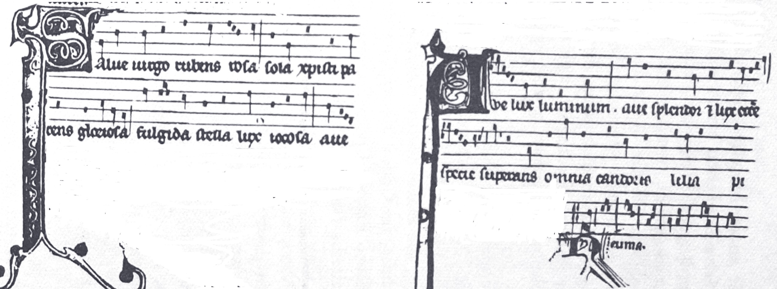

Triplum: Salve virgo rubens rosa/ sola Christi parens gloriosa/ fulgida stella lux iocosa/Ave ….

Motetus: Ave lux luminum/Ave splendor et lux eclesiae/ specie superans omnia andor calelia pi…