09 SYMPHONIC & PROGRESSIVE JAZZ / FREE JAZZ / THIRD STREAM 14/79:47

1 We Named It Justice (Thelonious Monk) 6:41
Art Blakey’s Jazz Messengers: Lee Morgan-tp; Benny Golson-ts; Bobby Timmons-p; Jimmy
Merritt-b; Art Blakey-dr.
Live at Club St. Germain, Paris, December 21, 1958.
LP RCA Victor 60001 / no matrix number.

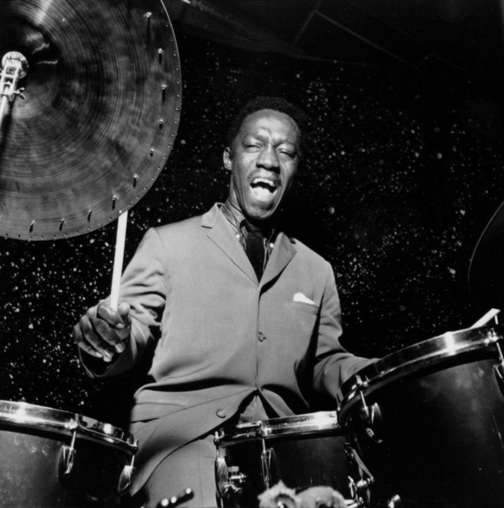

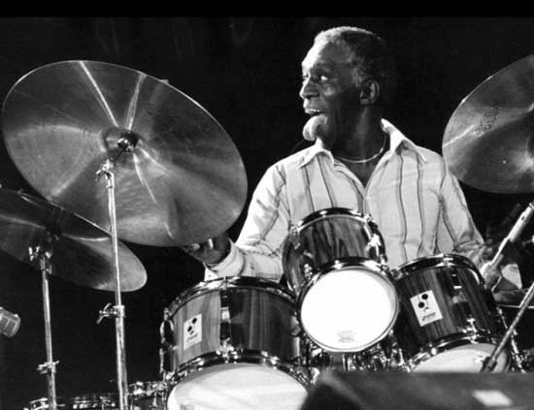

2 Blue in Green (Miles Davis-Bill Evans) 5:37
Miles Davis Quintet: Miles Davis-tp; John Coltrane-ts; Bill Evans-p; Paul Chambers-b;
Jimmy Cobb-dr.
New York, March 2, 1959.
LP Columbia CL 1355/CS 8163 / CO 62292-5.

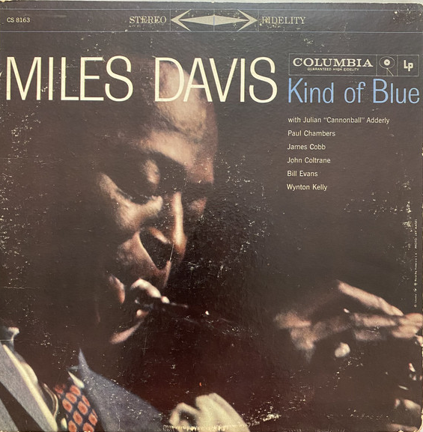

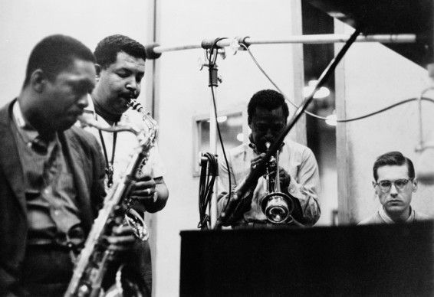
John Coltrane-Cannonball Adderley-Miles Davis-Bill Evans

3 Rhapsody in Blue (George Gershwin/arr. Ferde Grofé) 9:14
George Gershwin-p; Paul Whiteman Orchestra [possible
personnel]:Henry Busse, Ted Bartell, Red Nichols-tp; Vincent Grande, Wilbur Hall, another-
tb; Max Farley, Hal McLean, Chester Hazlett, Charles Strickfaden-cl,as,bs; 2 French horns;
Kurt Dieterle, Mischa Russell, Mario Perry, Matt Malneck, another-vio; 2 violas; 1 cello;
Mike Pingitore-bjo; John Sperzel-tu; Harry Perrella-celeste; Al Armer-b; George Marsh-dr;
Nat Shilkret-cond.
New York, April 21, 1927.
Victor 35822 / 30173-8 & 30174-6.
(First recording June 10, 1924, Victor 55225 / 30173-2 & 30174-1.)

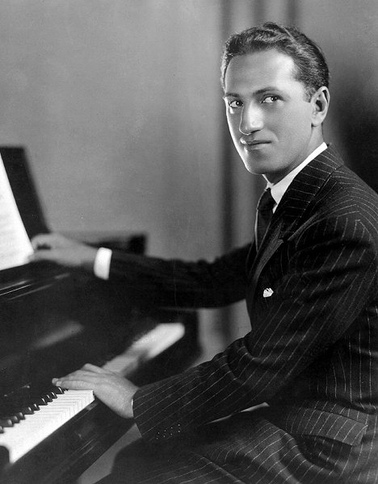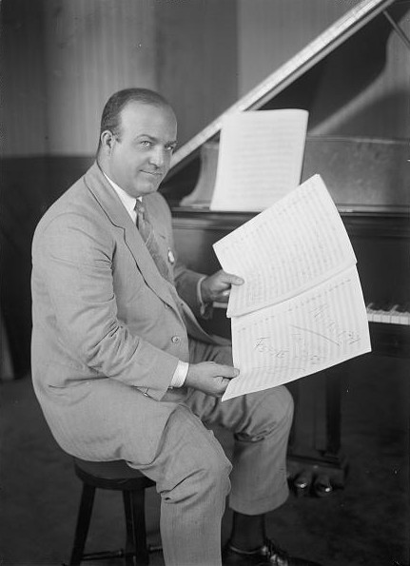
George Gershwin (1898 – 1937) Ferde Grofé (1892 – 1972)

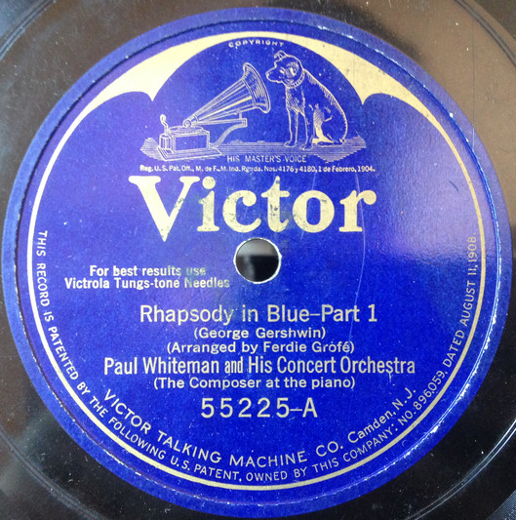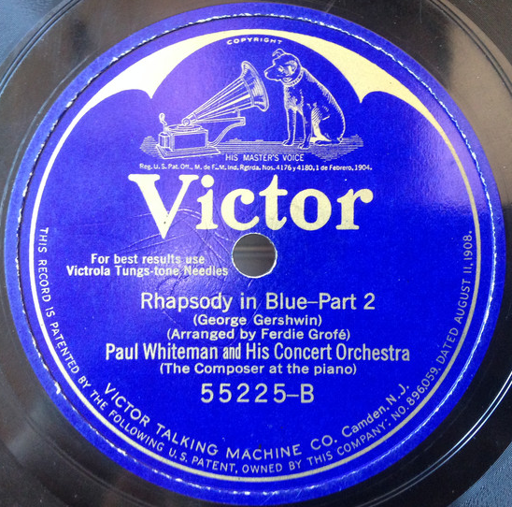

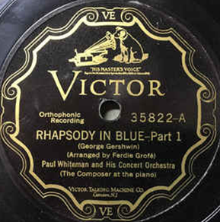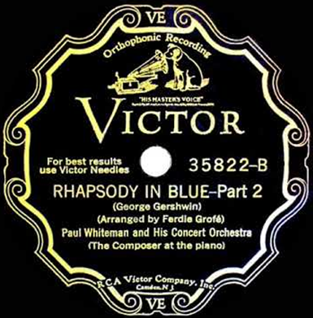

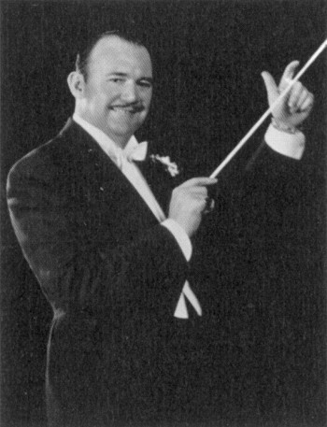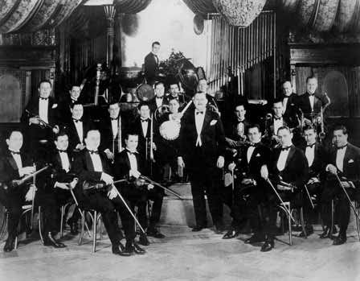

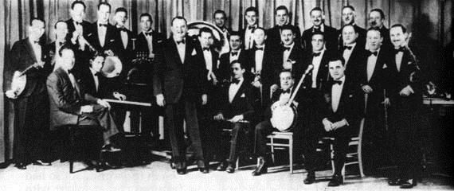
4 Ebony Concerto – Part 1 (Igor Stravinsky) 3:07
Woody Herman First Herd: Sonny Berman, Shorty Rogers, Cappy Lewis, Conrad Gozzo,
Carol Lewis-tp; Bill Harris, Ralph Pfiffner, Ed Kiefer-tb; Woody Herman-cl; Sam
Rubinowitch, Sam Marowitz, John LaPorta-as; Mickey Folus, Flip Phillips-ts; John Cave-h;
Stanley Chaloupka-harp; Jimmy Rowles-p; Chuck Wayne-g; Joe Mondragon-b; Don
Lamond-dr; Igor Stravinsky-cond.
Los Angeles, August 19, 1946.
78rpm Columbia 7479M / XCO 36778-1 & XCO 36779-1.

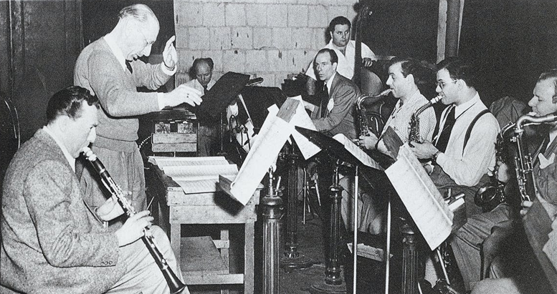
Woody Herman (1913 – 1987) & Igor Stravinskij (1882 – 1971)

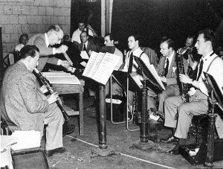

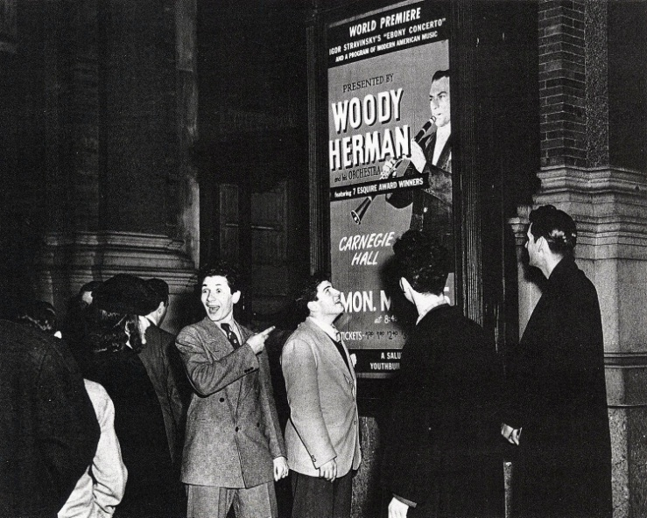

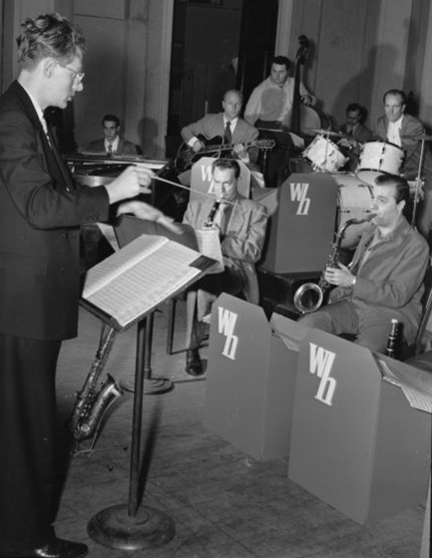
Walter Hendl on rehearsal, March 1946

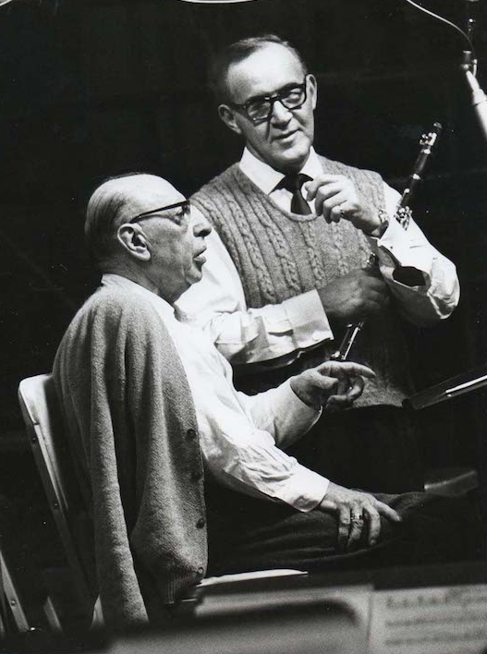
April 27, 1965 with Benny Goodman

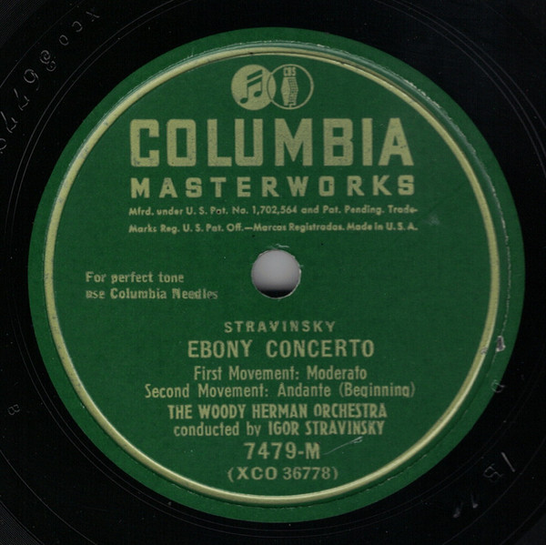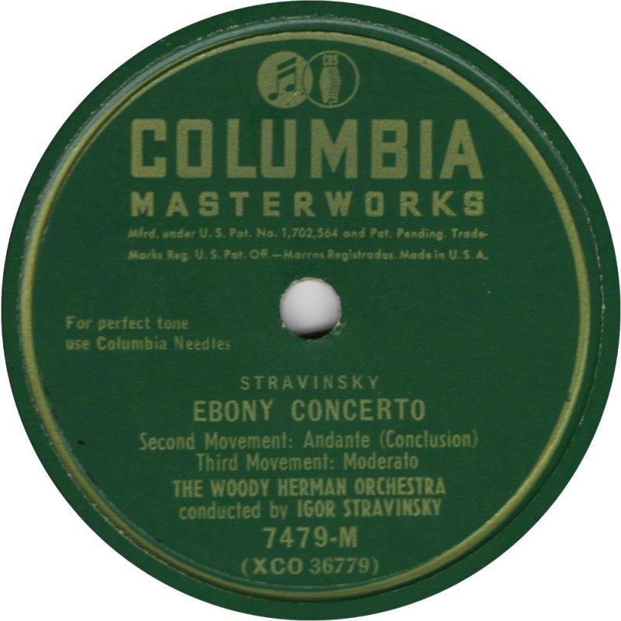

5 A Bird in Igor’s Yard (George Russell) 2:54
Buddy DeFranco Orchestra: Bernie Glow, Paul Cohen, James Pupa, Jack Eagle-tp; Ollie
Wilson, Earl Swope, Bart Varsalona-tb; Buddy DeFranco-cl; Lee Konitz, Frank Socolow-
as; Al Cohn, Jerry Sanfino-ts; Serge Chaloff-bs; Gene DiNovi-p; Oscar Pettiford-b; Irv
Kluger-dr; George Russell-arr.
New York, April 23, 1949.
78rpm Capitol M1 1060 / 3769.

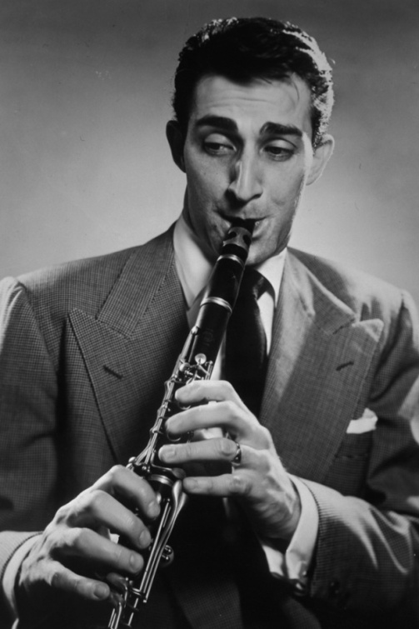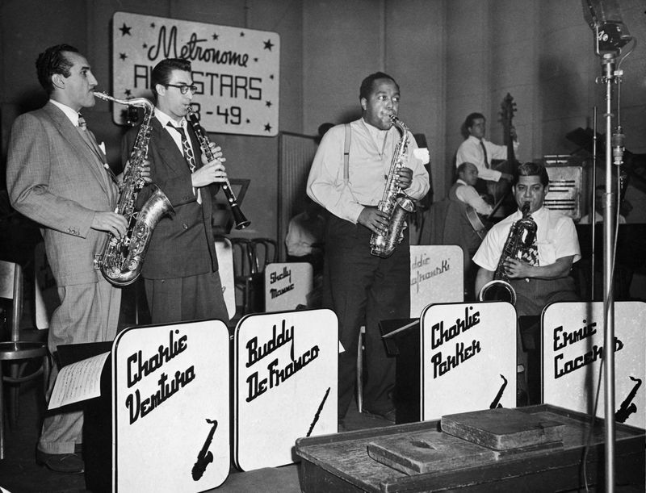
Buddy DeFranco
(1923 – 2014)

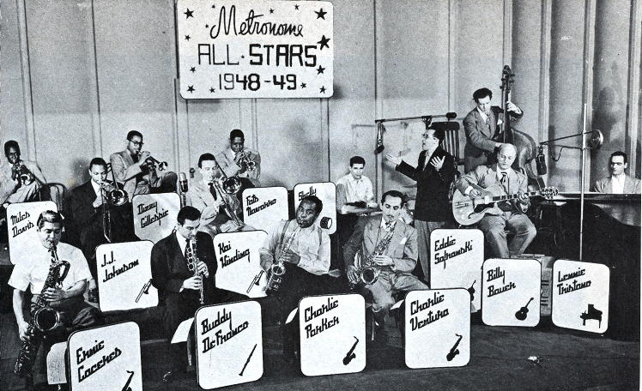

6 Solitaire (Bill Russo) 4:14
Stan Kenton Orchestra: Buddy Childers, Maynard Ferguson, Shorty Rogers, Chico Alvarez,
Don Paladino-tp; Milt Bernhart (solo), Harry Betts, Bob Fitzpatrick, Bill Russo-tb; John
Graas, Lloyd Otto-h; Gene Englund-tu; Bud Shank-as,fl; Art Pepper-as,cl; Bob Cooper-
ts,ob,Eh; Bart Caldarell-ts,bsn; Bob Gioga-bs,bcl; George Kast, Lew Elias, Jim Cathcart,
Earl Cornwell, Anthony Doria, Jim Holmes, Alex Law, Herbert Offner, Dave Schackne, Carl Ottobrino-vio; Stan Harris, Leonard Selie, Sam Singer-vla; Gregory Bemko, Zachary Bock, Jack Wulfe-vcl; Stan Kenton-p; Laurindo Almeida-g; Don Bagley-b; Shelly Manne-dr;
Carlos Vidal-conga,bongo; Bill Russo-arr.
Los Angeles, February 3, 1950.
78rpm Capitol 28001 / 5478-7.

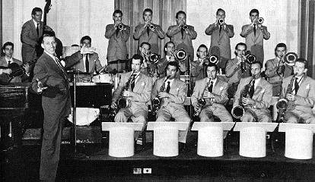

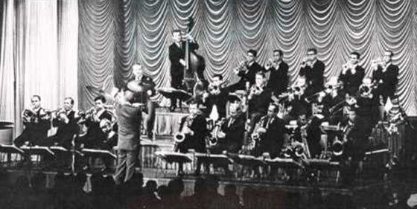

7 Pithecanthropus Erectus (Charles Mingus) 3:29
Charles Mingus Quintet: Jackie McLean-as; J. R. Monterose-ts; Mal Waldron-p; Charles
Mingus-b; Willie Jones-dr.
New York, January 30, 1956.
LP Atlantic 1237 / 1865.

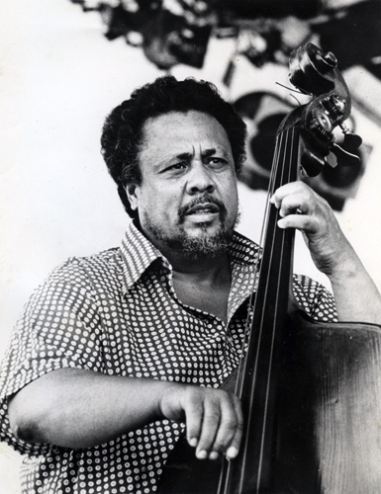
Charles Mingus (1922 – 1979)

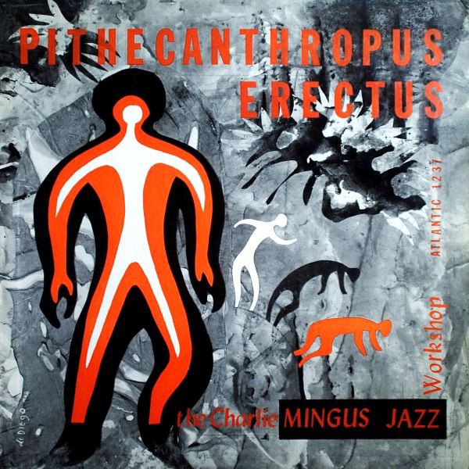
Atlantic debut (1956)

8 Lydian Lullaby (George Russell) 4:56
The RCA Victor Jazz Workshop: Hal McKusick-as, cond;
Art Farmer-tp; Jimmy Cleveland-tb; Bill Barber-tu; Gene Allen-bs; Barry Galbraith, Jimmy
Raney-g; Milt Hinton-b; Osie Johnson-dr; George Russell-arr.
New York, March 3, 1956.
RCA LPM 1366 / G2JB2704.

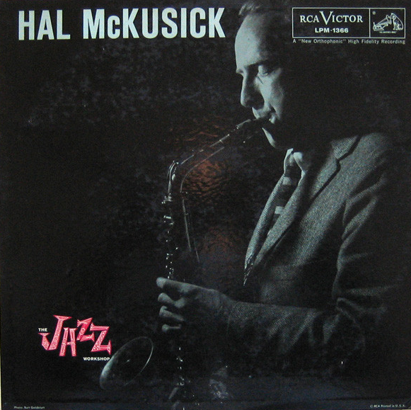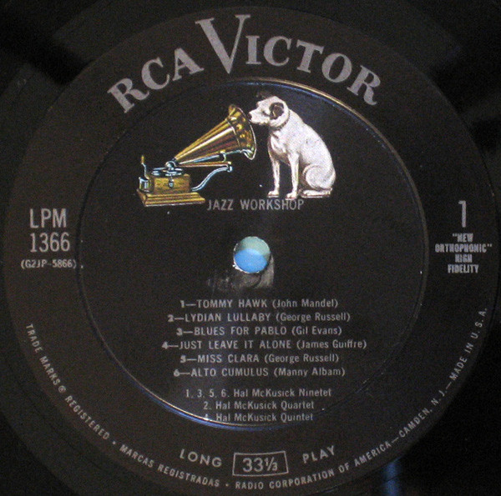
Hal McKusick (1924 – 2012) original LP

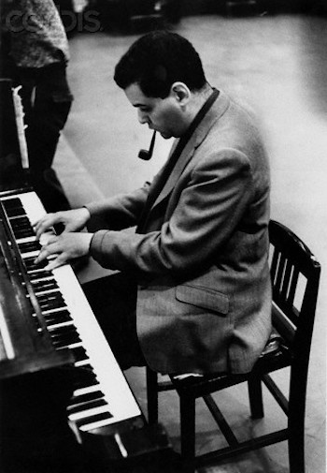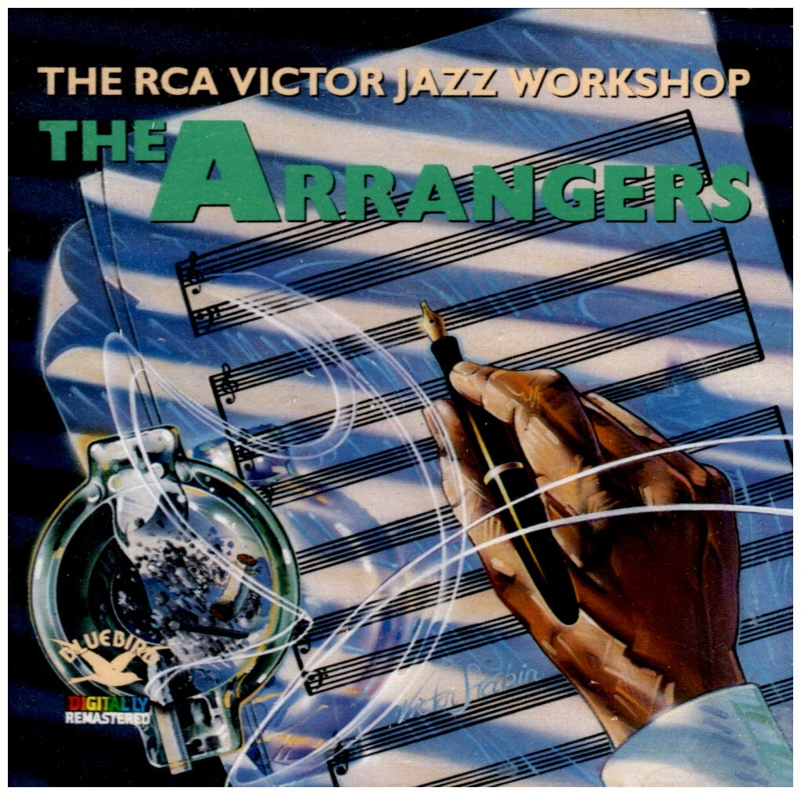
George Russell (1923 – 2009) CD reissue (1987)

9 Invisible (Ornette Coleman) 4:17
Ornette Coleman Quintet: Don Cherry-tp; Ornette Coleman-as; Walter Norris-p; Don Payne-
b; Billy Higgins-dr.
Los Angeles, February 10, 1958.
LP Contemporary C 3551/S 7551 / matrix number unknown.

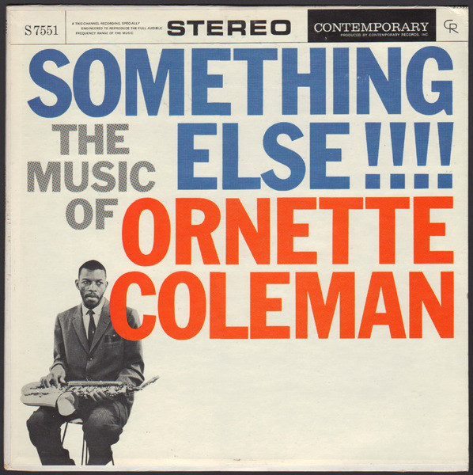

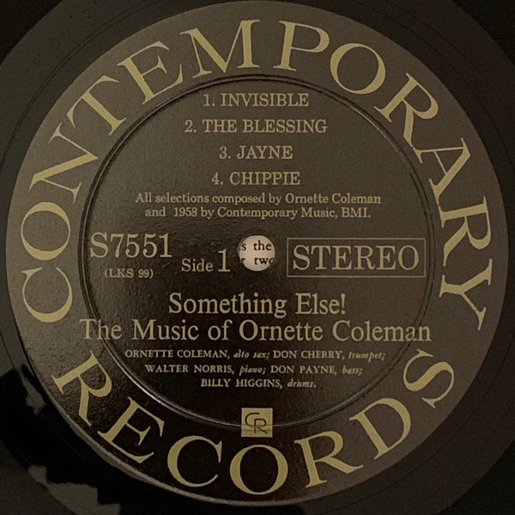

10 Monk and the Nun (Ornette Coleman) 5:54
Ornette Coleman Quartet: Don Cherry-co; Ornette Coleman-as; Charlie Haden-b; Billy
Higgins-dr.
Hollywood, May 22, 1959. (Released 1971)
LP Atlantic SD 1588 / 3512.

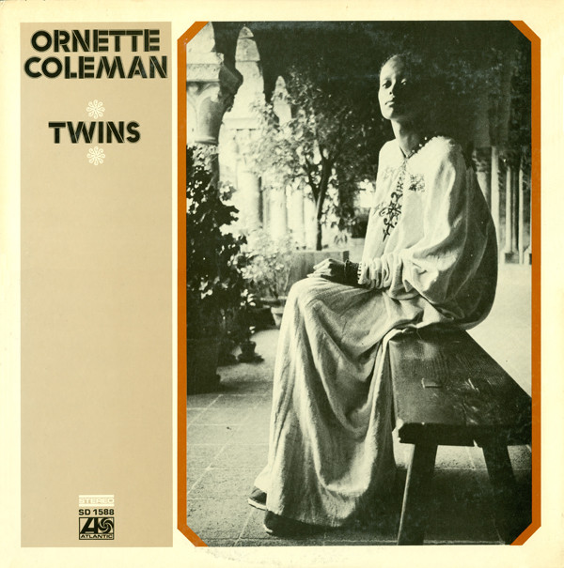

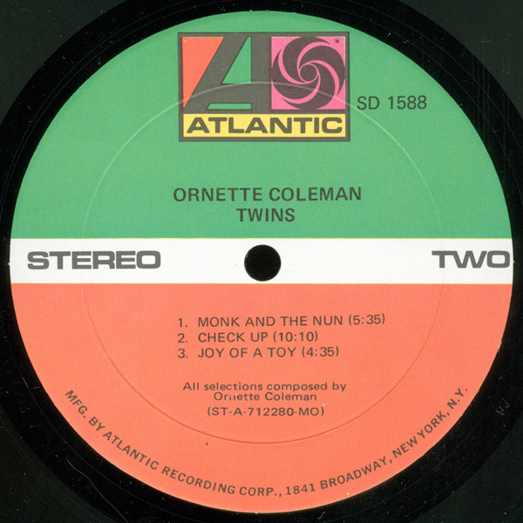

11 First Take (Ornette Coleman) 17:06
Ornette Coleman Double Quartet:
Left channel: Don Cherry-pocket tp; Ornette Coleman-as; Scott LaFaro-b; Billy Higgins-dr.
Right channel: Freddie Hubbard-tp; Eric Dolphy-bcl; Charlie Haden-b; Ed Blackwell-dr.
New York, December 21, 1960. (Released 1971)
LP Atlantic SD 1588 / 5247-1.

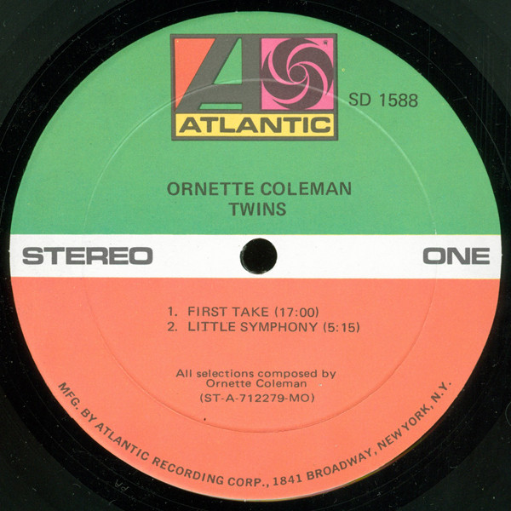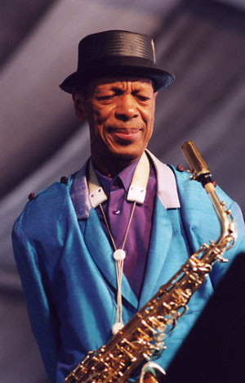
Ornette Coleman (1930 – 2015)

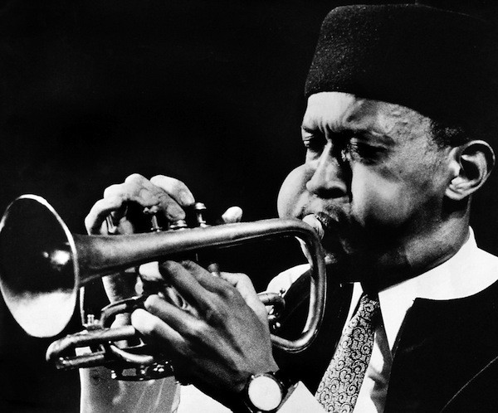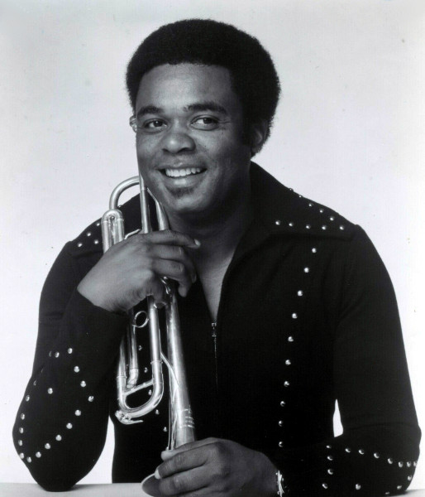
Don Cherry (1936 – 1995) Freddie Hubbard (1938 – 2008)

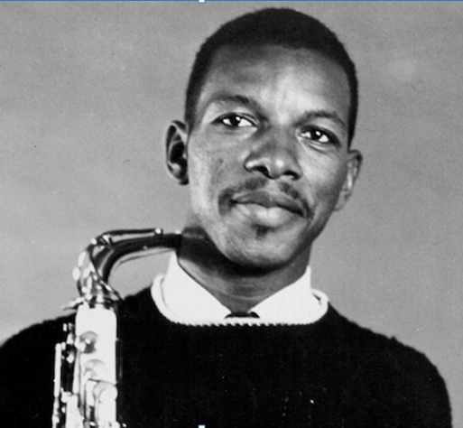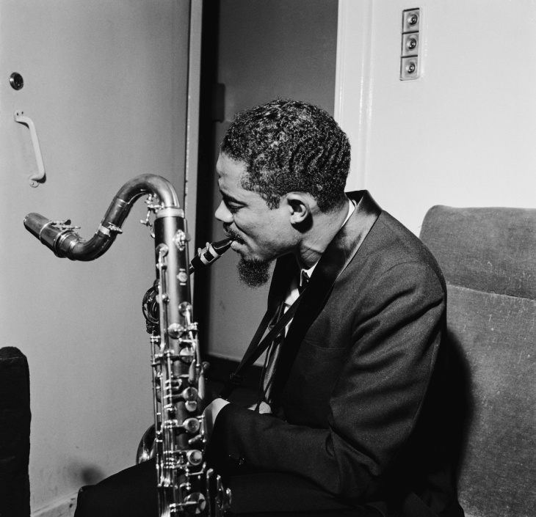
Ornette Coleman (1930 – 2015) Eric Dolphy (1928 – 1964)

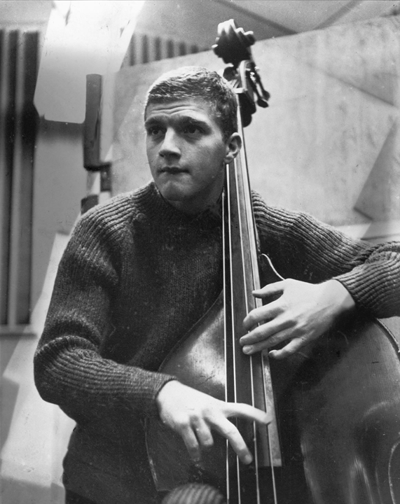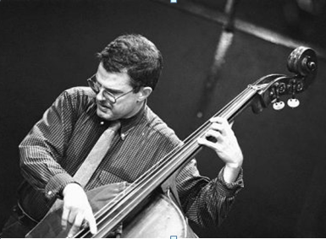
Scott LaFaro (1936 – 1961) Charlie Haden (1937 – 2014)

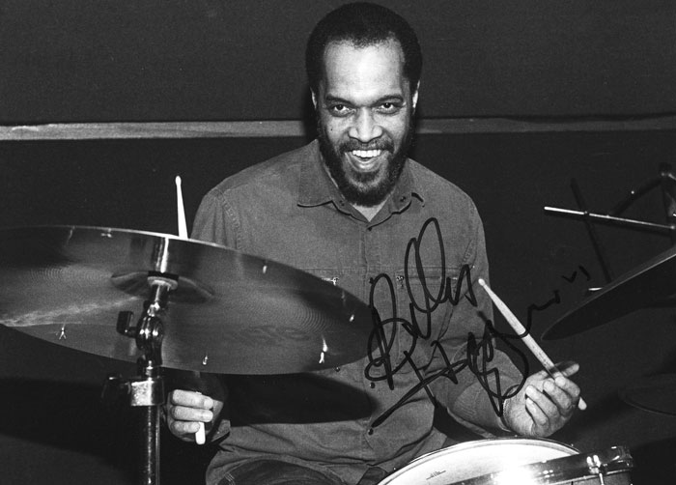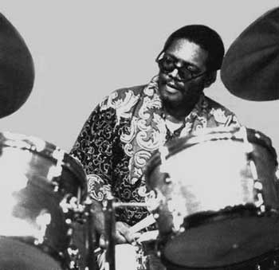
Billy Higgins (1936 – 2001) Ed Blackwell (1929 – 1992)

12 Abstraction (Gunther Schuller) 4:12
Gunther Schuller Ensemble: Ornette Coleman-as; Jim Hall-g; Scott LaFaro, Alvin Brehm-b;
Sticks Evans-dr; The Contemporary String Quartet: Charles Libove, Roland Vamos-vio;
Harry Zaratzian-vla; Joseph Tekula-vcl.
New York, December 19-20, 1960.
LP Atlantic SD 1365 / 5232.

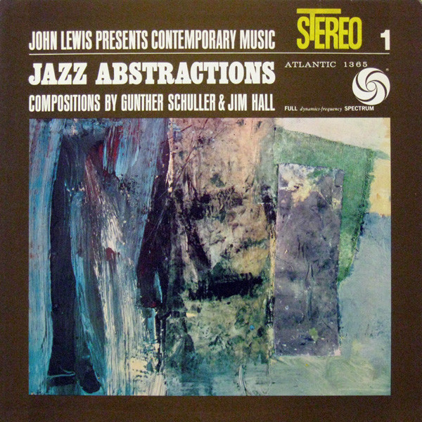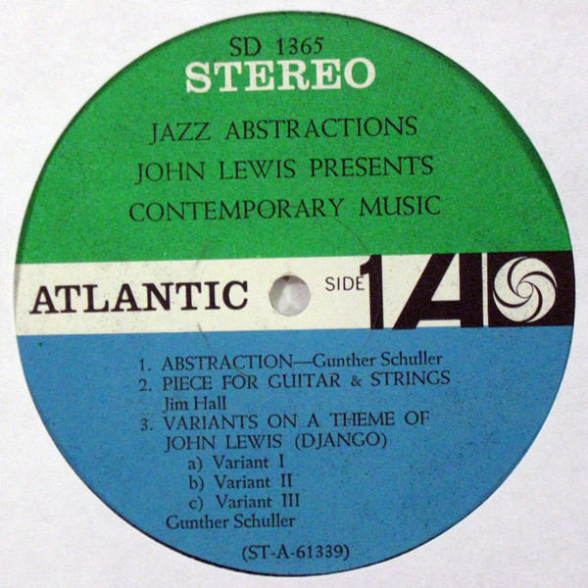

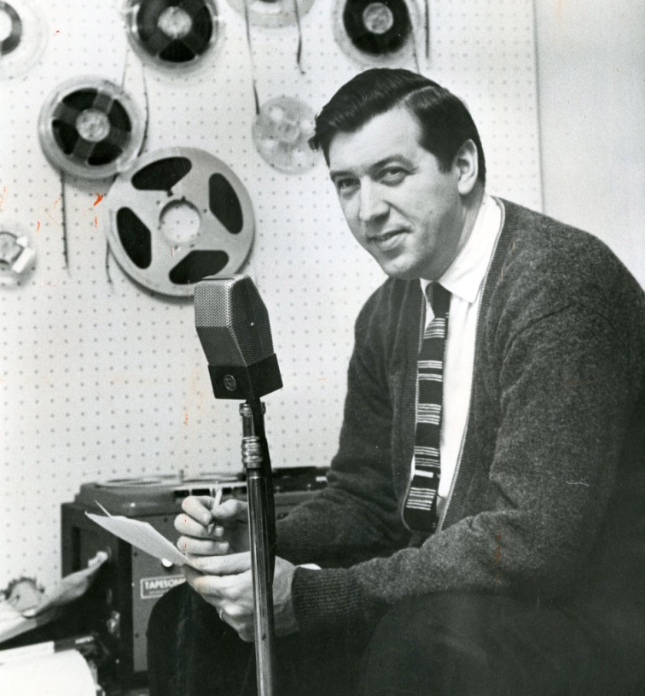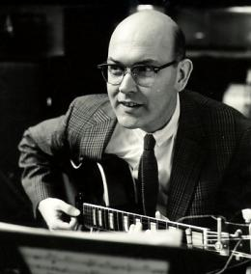
Gunther Schuller (1925 – 2015) Jim Hall (1930 – 2013)

13 Threewe (Jimmy Giuffre) 4:12
Jimmy Giuffre-cl; Paul Bley-p; Steve Swallow-b.
New York, October 10, 1962.
LP Columbia CS 8764 / C076815.

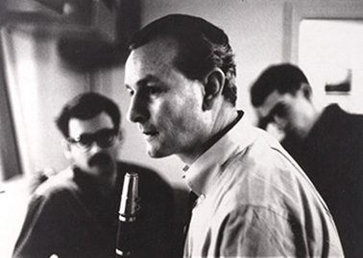

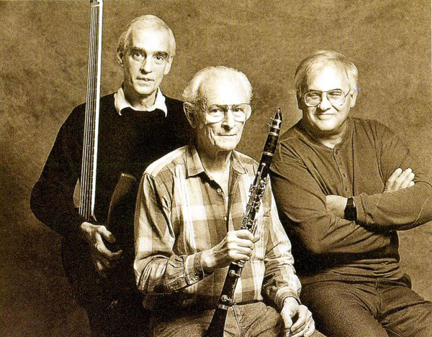
Steve Swallow (*1940) Jimmy Giuffre (1921 – 2008) Paul Bley (1932 – 2016)

