10 BOSSA NOVA - Antonio Carlos Jobim (25. 1. 1927 Rio de Janeiro – 8. 12. 1994 NY)
https://cs.wikipedia.org/wiki/Antonio_Carlos_Jobim

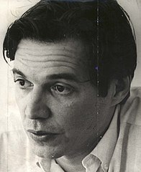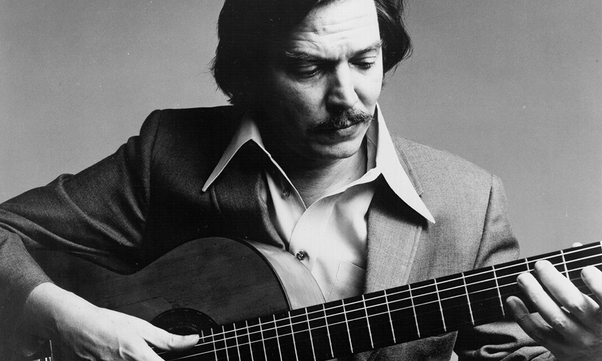

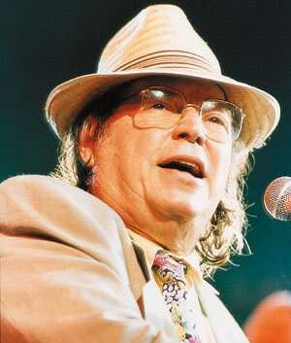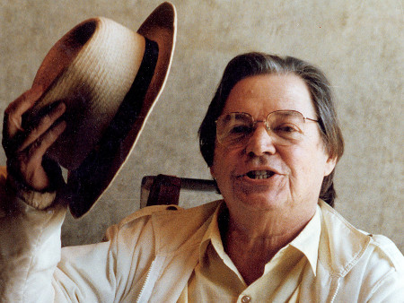

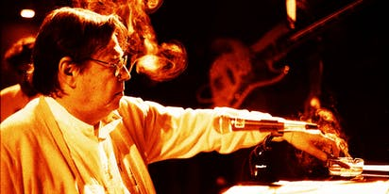

01 Desafinado 1:58

Joao Gilberto-voc; unlisted orchestra, Antonio Carlos Jobim-cond.
November 10, 1958.
78 Odeon 13059 / CD World Pacific CDP 7 93891 2.
https://secondhandsongs.com/performance/21528

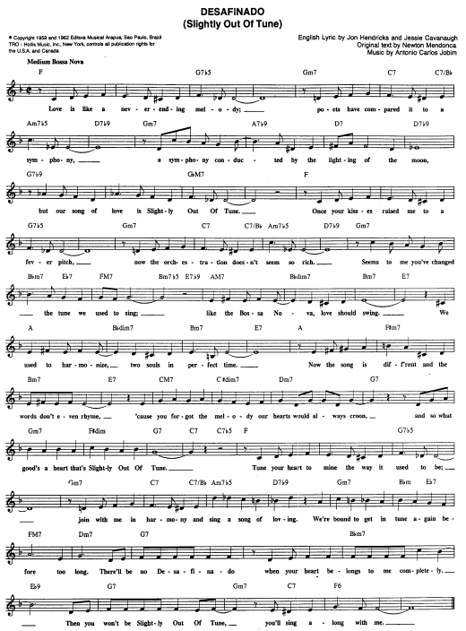

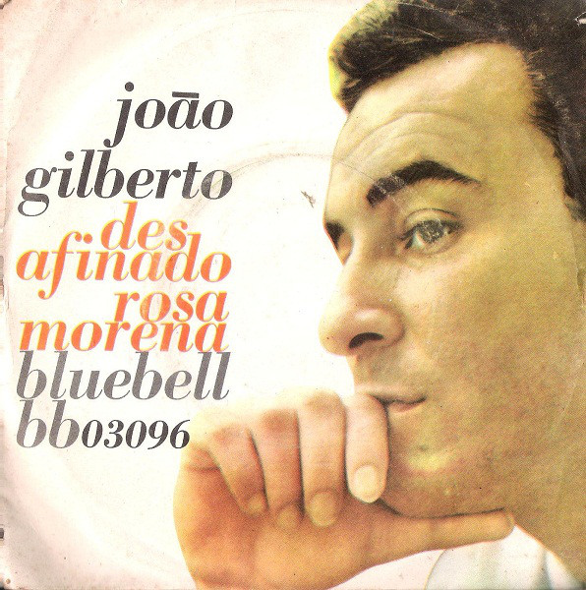

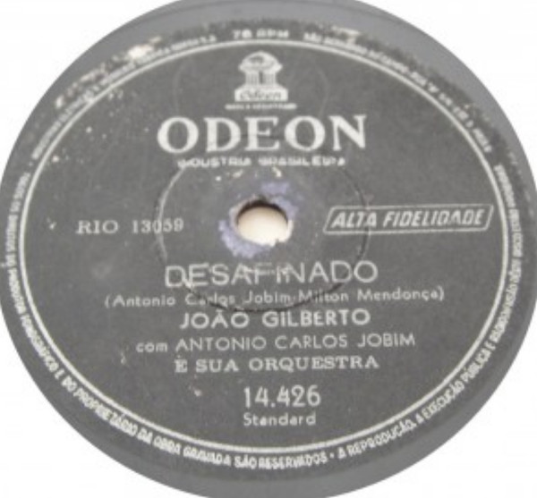

…A MIMO PROGRAM
https://secondhandsongs.com/performance/21528
Joao Gilberto – Desafinado V I D E O
02 Desafinado 5:53
Stan Getz-ts; Charlie Byrd-g; Keter Betts-b; Gene Byrd-b, g; Buddy Deppenschmidt-dr; Bill
Erichenbach-dr.
All Souls Unitarian Church, Washington, DC, February 13, 1962.
LP Verve V6-8432 / CD 823 611-2.
https://secondhandsongs.com/performance/262600

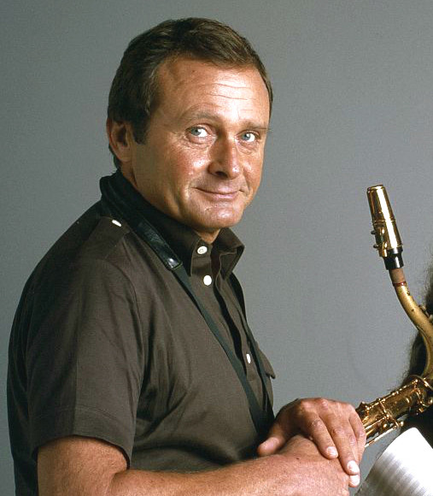

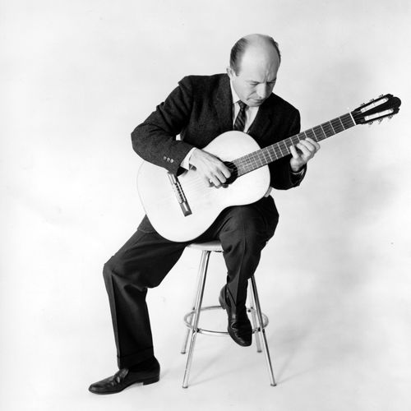
Charlie Byrd (1925 – 1999)

03 Desafinado 4:12
Stan Getz-ts; Antonio Carlos Jobim-p; Joao Gilberto-g, voc; Tommy Williams-b; Milton
Banana-dr.
New York, March 18-19, 1963.
LP Verve V6-8545 / CD 823 611-2.
https://secondhandsongs.com/performance/64630

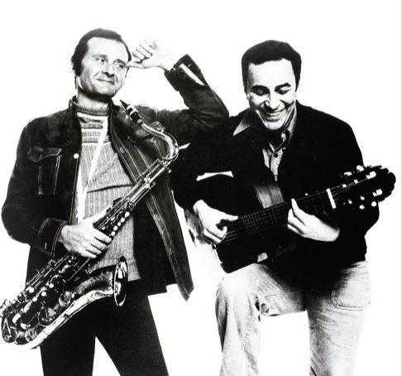
Stan Getz (1927 – 1991) & Joao Gilberto (1931 – 2019)

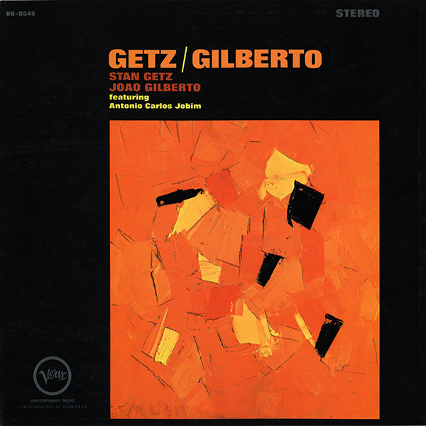

04 Desafinado (Off Key) 2:46
Antonio Carlos Jobim-p, g; Claus Ogerman Orchestra, including Jimmy Cleveland-tb; Leo
Wright-fl, as; George Duvivier-b; Edson Machado-dr; unlisted strings; Claus Ogerman-arr,
cond.
New York, May 9-10, 1963.
LP Verve V6-8547 / CD 516 409-2.
https://secondhandsongs.com/performance/62791

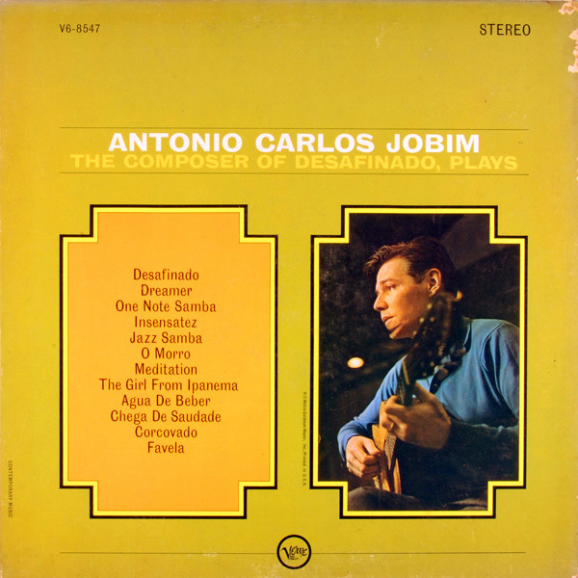

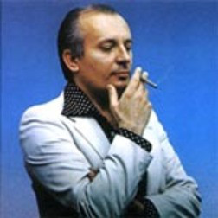
Claus Ogerman (1930 – 2016)
Born in Ratibor, Upper Silesia, Germany [today Racibórz, Poland]

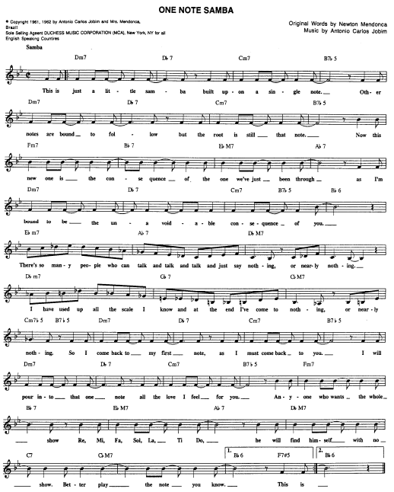

05 Samba de uma nota so 1:37

Joao Gilberto-voc; unlisted orchestra, Antonio Carlos Jobim-cond.
April 4, 1960.
LP Odeon MOFB 3151 / CD World Pacific CDP 7 93891 2.
https://secondhandsongs.com/performance/9724

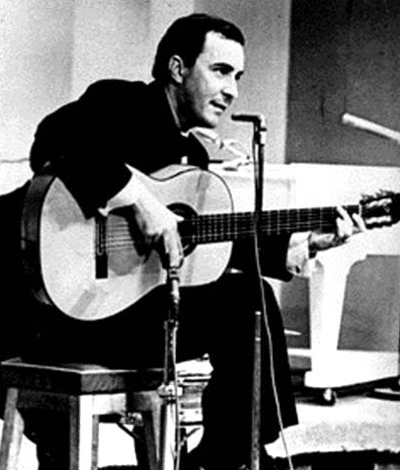
Joao

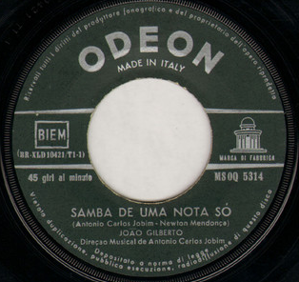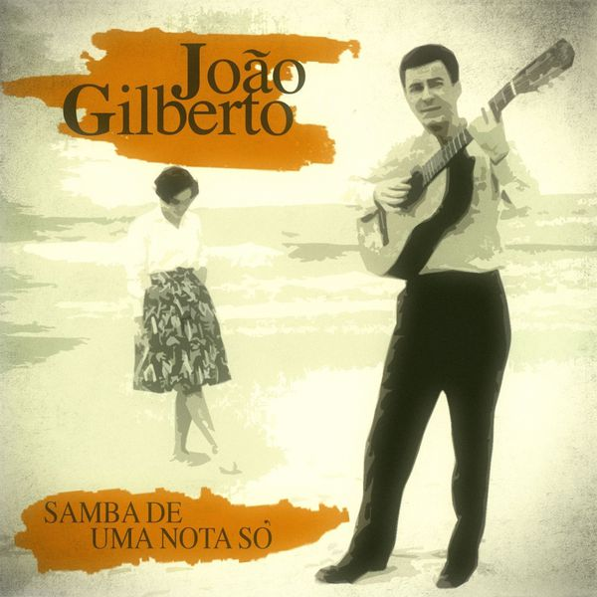

A MIMO PROGRAM
https://www.youtube.com/watch?v=H_V1qYB2D_A
50 bossa nov za 2 hodiny 40 minut – Joao Gilberto – Track 1 Chega de saudade…

06 Samba de uma nota so (One Note Samba) 6:12
Stan Getz-ts; Charlie Byrd-g; Keter Betts-b; Gene Byrd-b, g; Buddy Deppenschmidt-dr; Bill
Erichenbach-dr.
All Souls Unitarian Church, Washington, DC, February 13, 1962.
LP Verve V6-8432 / CD 823 611-2.
https://secondhandsongs.com/performance/269562

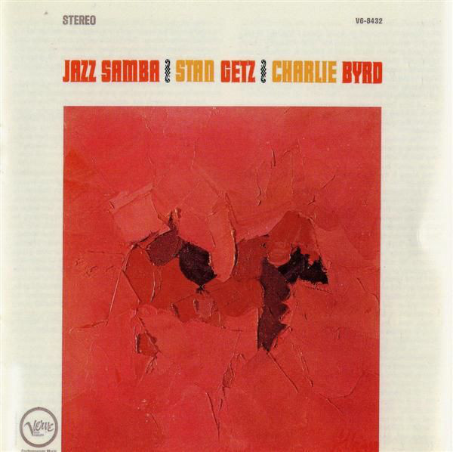

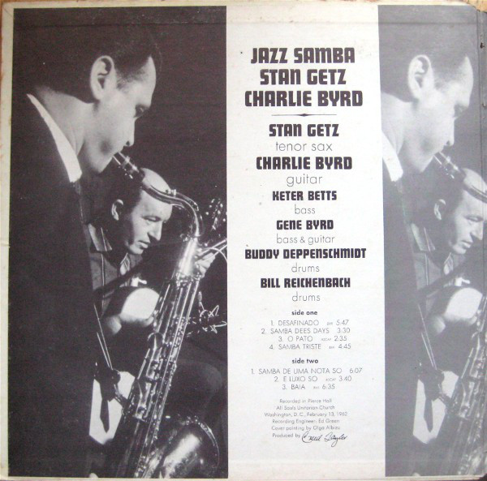

07 Samba de uma nota so 3:28
Stan Getz-ts; Gary McFarland Orchestra: Doc Severinsen, Bernie Glow or Joe Ferrante,
Clark Terry or Nick Travis-tp; Ray Alonge-h; Tony Studd, Bob Brookmeyer or Willie Dennis-
tb; Gerald Sanfino or Ray Beckenstein-fl; Eddie Caine-afl; Ray Beckenstein and/or Babe Clark
and/or Walt Levinsky-cl; Romeo Penque-bcl; Jim Hall-g; Hank Jones-p; Tommy Williams-b;
Johnny Rae-dr; Jose Paulo-tamb; Carmen Costa-cabassa; Gary McFarland-arr, cond.
New York, August 27-28, 1962.
LP Verve V6-8494 / CD 823 611-2.
https://www.youtube.com/watch?v=xlipkpBM12U

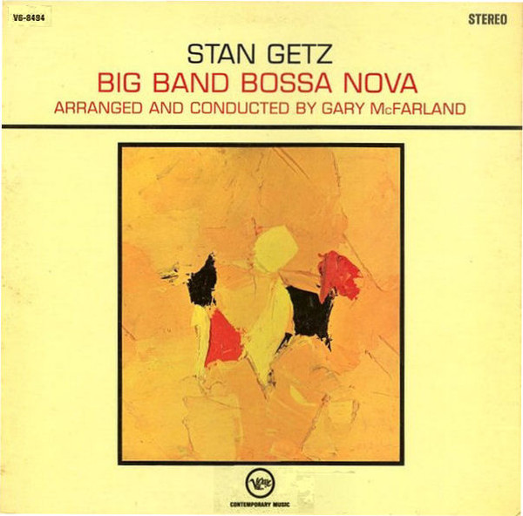

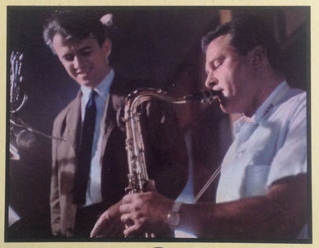
Gary McFarland (1933 – 1971)

08 Samba de uma nota so 3:16
Stan Getz-ts; Astrud Gilberto-voc; Gary Burton-vib; Gene Cherico-b; Helcio Milito-dr;
Kenny Burrell-g.
New York, May 22, 1964.
LP Verve V6-8600 / CD 823 611-2.
https://secondhandsongs.com/performance/235604

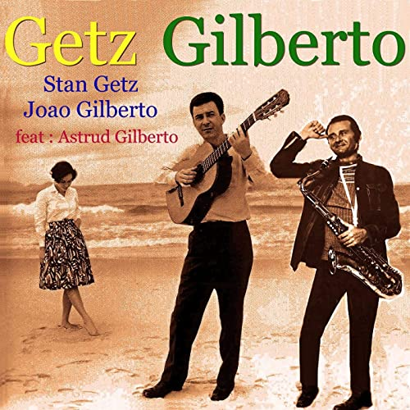

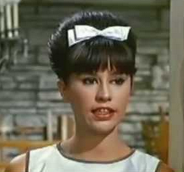
Astrud Gilberto (*1940)

RARITA – VERZE V HEBREJŠTINĚ
https://secondhandsongs.com/performance/850966
סמבה של תו אחד by אלי דג'יברי / אבישי כהן / יונתן אבישי / עופר שניידר / שי זלמן / אלון אולארצ'יק
written by Alon Oleartchik

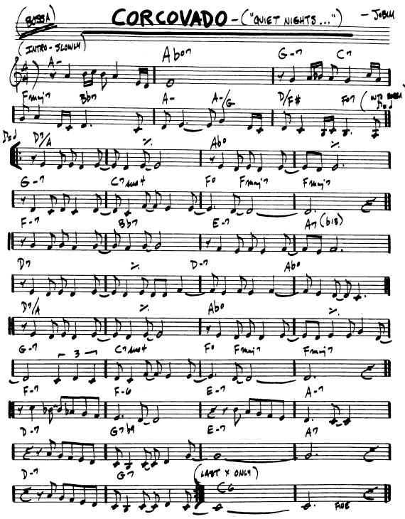

09 Corcovado 1:57
Joao Gilberto-voc; unlisted orchestra.
March 30, 1960.
LP Odeon MOFB 3151 / CD World Pacific CDP 7 93891 2.
https://secondhandsongs.com/performance/64513

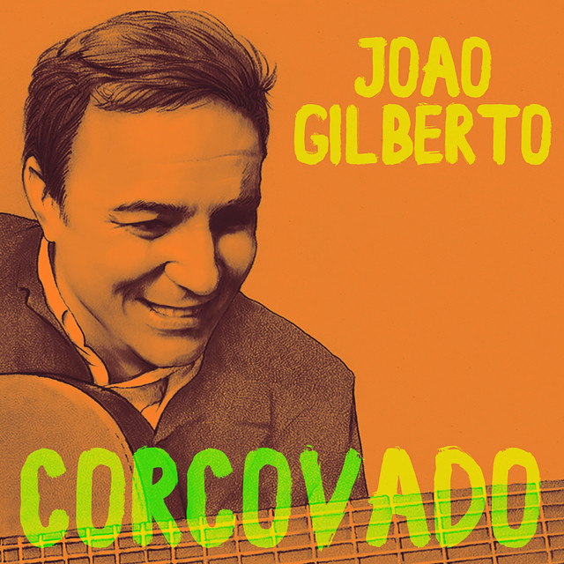

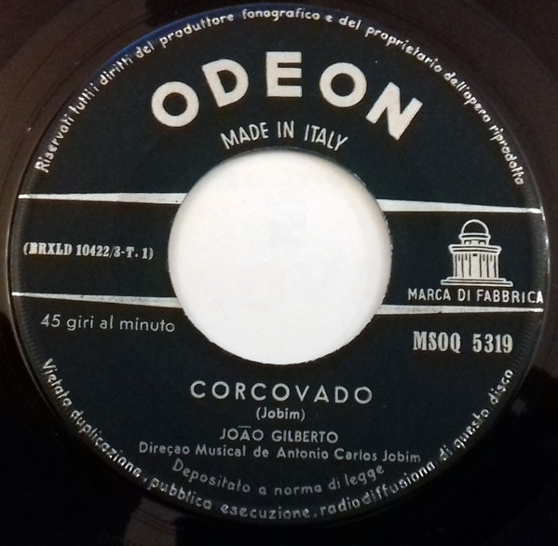

Corcovado (česky Hrbáč) je 710 m vysoký vrchol nad městem Rio de Janeiro. Na vrcholu se nachází socha Krista Vykupitele (Cristo Redentor) s rozepjatýma rukama, která se stala symbolem Rio de Janeira. V roce 2007 jeden z nových sedmi divů světa. Tuto sochu si roku 1921 objednala arcidiecéze Rio de Janeiro. Je dílem francouzského sochaře Maximiliena Paula Landowského. Socha je v noci osvětlena, s podstavcem je vysoká 39.6 metrů, váží 1145 tun. Socha, která byla odhalena 12. října 1931 jako památník brazilské nezávislosti na Portugalsku (1822), v roce 1931 byla též vysvěcena.

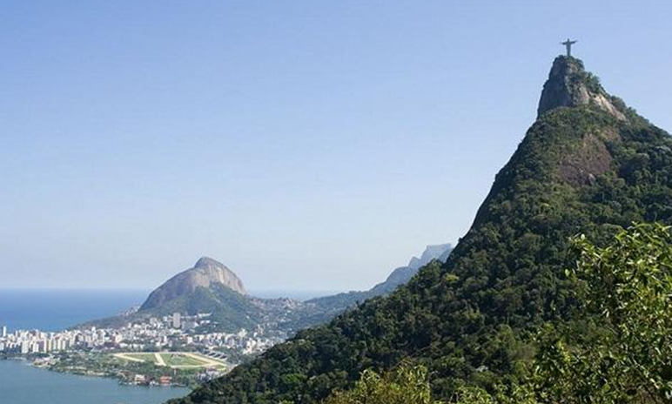

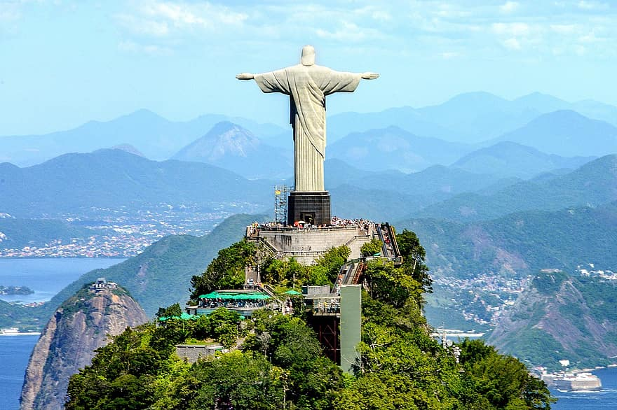

10 Corcovado 4:15
Stan Getz-ts; Antonio Carlos Jobim-p; Joao Gilberto-g, voc; Tommy Williams-b; Milton
Banana-dr; Astrud Gilberto-voc.
New York, March 18-19, 1963.
LP Verve V6-8545 / CD 823 611-2.
https://secondhandsongs.com/performance/64516

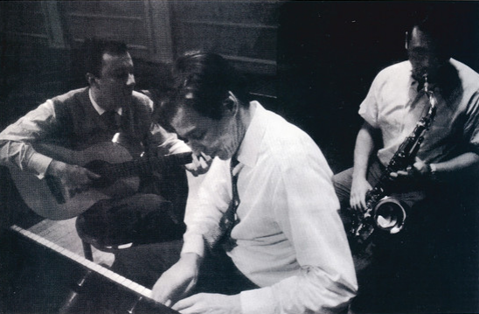
João Gilberto Antonio Carlos Jobim Stan Getz

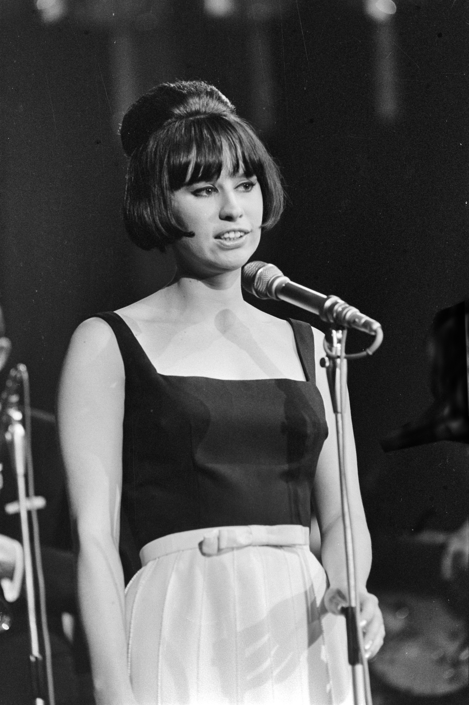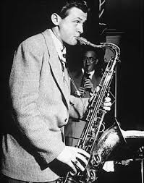

11 Corcovado 5:13
Stan Getz-ts; Steve Kuhn-p; Laurindo Almeida-g; George Duvivier-b; Dave Bailey-dr;
Edison Machado, Jose Soorez, Luis Parga, Jose Paulo-perc.
New York, March 21, 1963.
CD Verve 823 611-2.
https://www.youtube.com/watch?v=fKugq3m2oxc

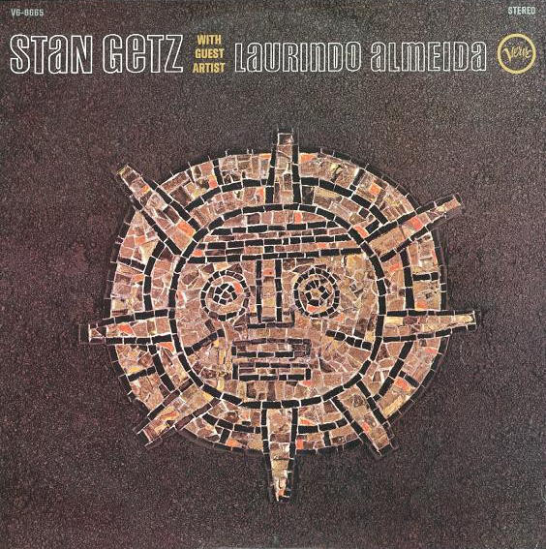

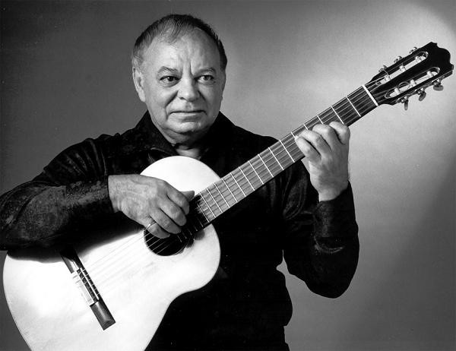
Laurindo Almeida (1917 – 1995)

MIMO POŘADÍ
https://secondhandsongs.com/performance/64516
Antonio Carlos Jobim – Composer of Desafinado Plays (May 1963).

https://www.youtube.com/watch?v=9srw5FRm5eA
Astrud Gilberto – Corcovado V I D E O

12 Corcovado (Quiet Nights of Quiet Stars) 2:32
Stan Getz-ts; Astrud Gilberto-voc; Gary Burton-vib; Gene Cherico-b; Helcio Milito-dr;
Kenny Burrell-g.
New York, May 22, 1964.
LP Verve V6-8600 / CD 823 611-2.

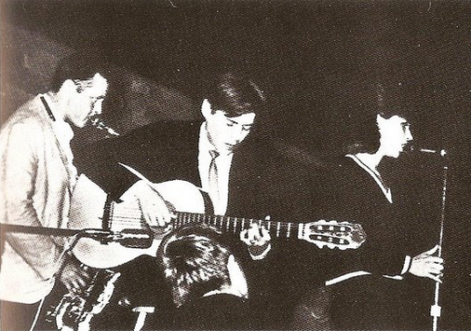

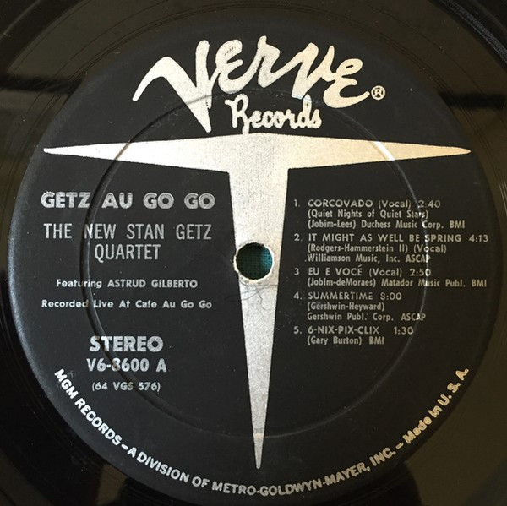

13 Corcovado 5:39
Stan Getz-ts; Joao Gilberto-g, voc; Gary Burton-vib; Gene Cherico-b; Joe Hunt-dr; Astrud
Gilberto-voc.
Live at Carnegie Hall, New York, October 9, 1964.
CD Verve 823611.
https://www.youtube.com/watch?v=2CwEdwipynU&list=OLAK5uy_n9g_RNfTla_vFXXAO0JSoqHqx6jYfCgbY&index=13

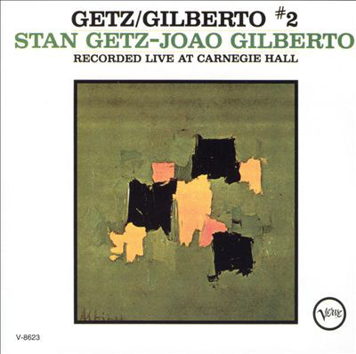

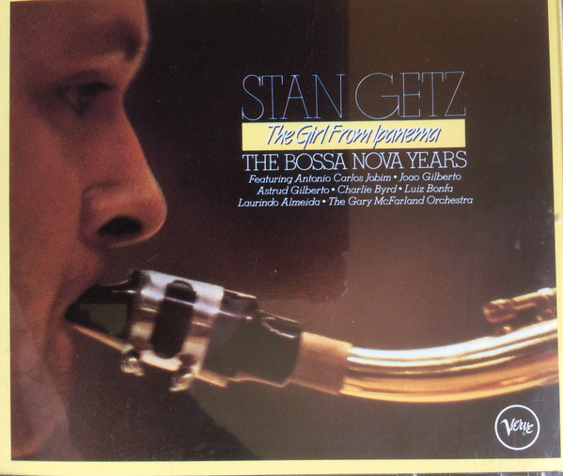

14 Quiet Nights of Quiet Stars (Corcovado) 2:06>
Oscar Peterson-p; Ray Brown-b; Ed Thigpen-dr.
New York City, October 19, 1964.
LP Verve V6-8606 / CD 810 047-2.
https://secondhandsongs.com/performance/483995

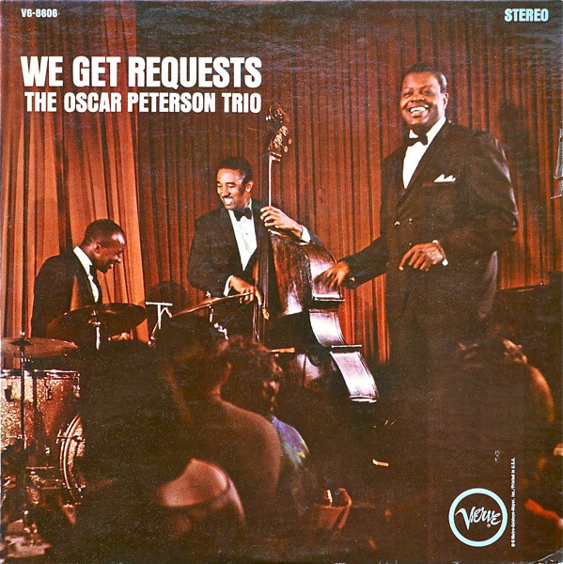

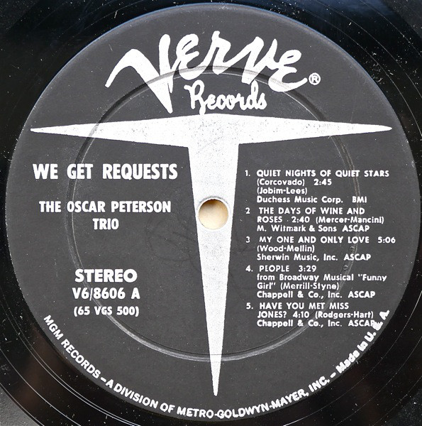

15 Corcovado 2:40
Miles Davis-tp; Gil Evans Orchestra: Ernie Royal, Bernie Glow, Louis Mucci, Harold Shorty
Baker-tp; J. J. Johnson, Frank Rehak-tb; Ray Alonge, Julius Watkins, ?Don Corrado-h; Bill
Barber-tu; Steve Lacy-ss; Al Block-fl; Jerome Richardson, ?Ray Beckenstein-fl, reeds;
unknown-reeds, ww; Bob Tricarico-bsn; Garvin Bushell-bsn, contra bsn; ?Janet Putnam-harp;
Paul Chambers-b; Jimmy Cobb-dr; Willie Bobo-bgos; Elvin Jones-perc; Gil Evans-arr, cond.
New York, July 27, 1962.
CD Columbia 67397.
(Corcovado is followed by Aos pes da cruz, M.Pinto-P.Goncalves)
https://secondhandsongs.com/performance/67706

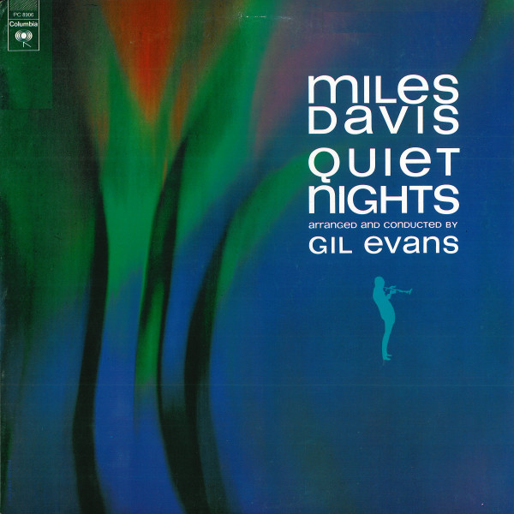

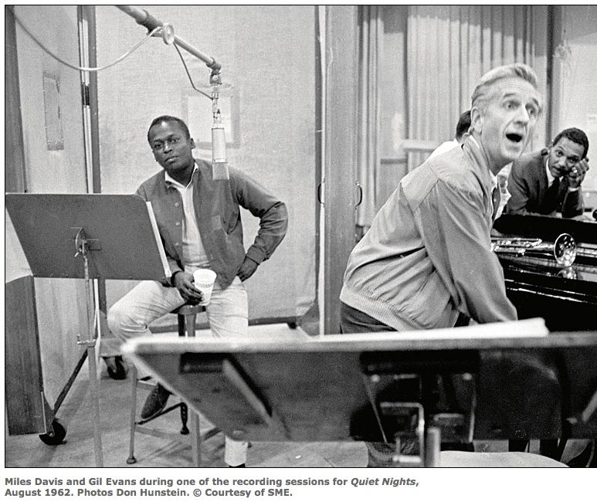

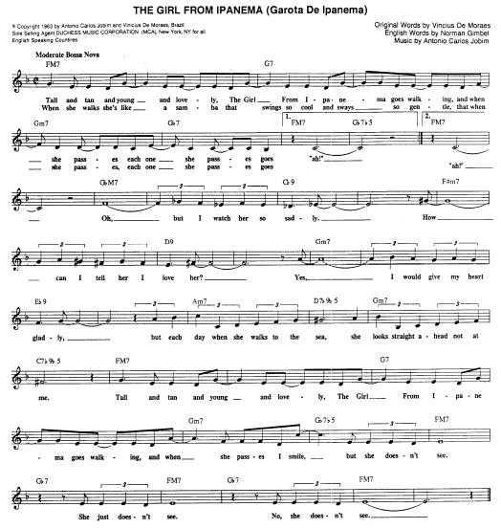

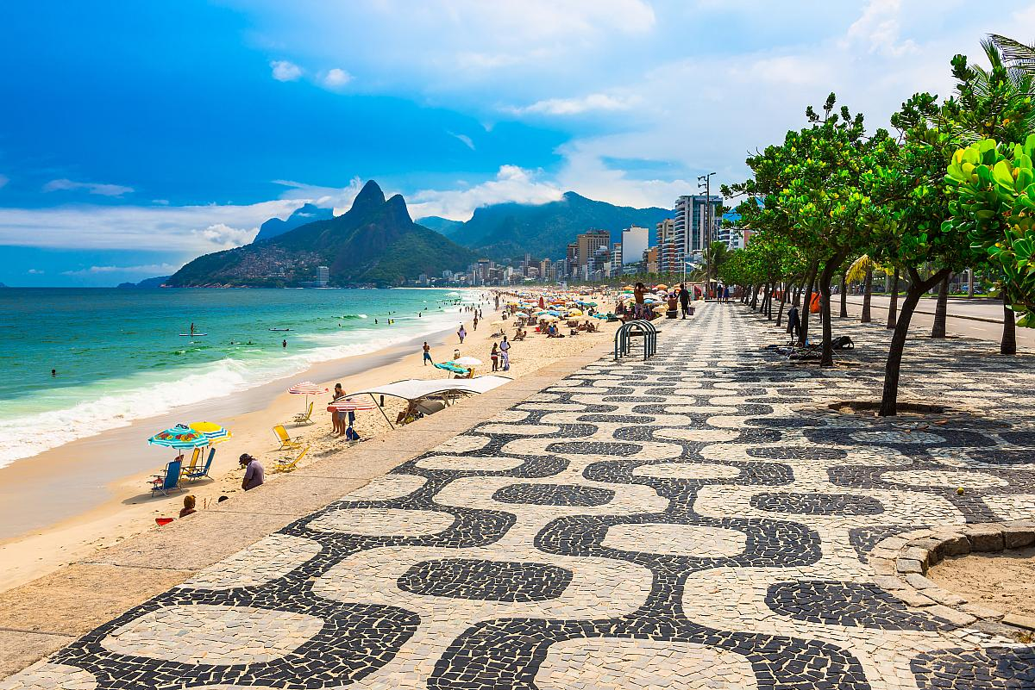

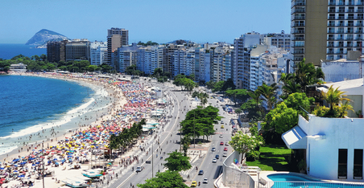

16 The Girl from Ipanema 5:24

Stan Getz-ts; Antonio Carlos Jobim-p; Joao Gilberto-g, voc; Tommy Williams-b; Milton
Banana-dr; Astrud Gilberto-voc.
New York, March 18-19, 1963.
LP Verve V6-8545 / CD 823 611-2.
https://secondhandsongs.com/artist/3058

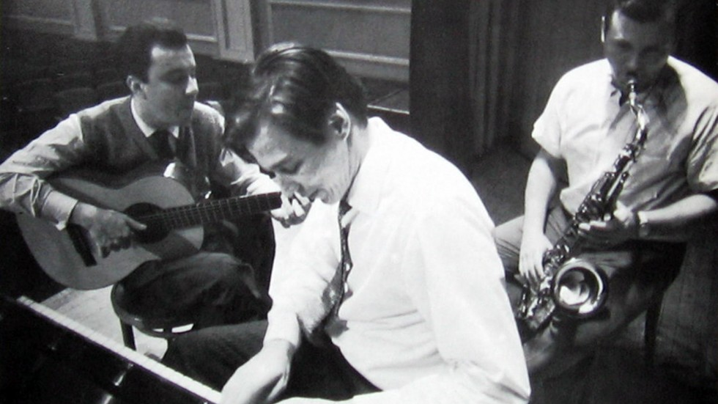

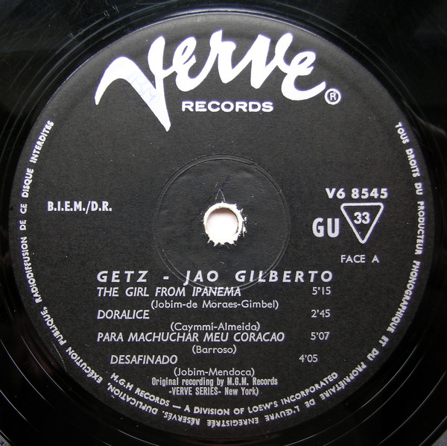

17 Garota de Ipanema (Girl from Ipanema) 2:39
Antonio Carlos Jobim-p, g; Claus Ogerman Orchestra, including Jimmy Cleveland-tb;
Leo Wright-fl, as; George Duvivier-b; Edson Machado-dr; unlisted strings; Claus Ogerman-
arr, cond.
New York, May 9-10, 1963.
LP Verve V6-8547 / CD 516 409-2.
https://secondhandsongs.com/performance/62787

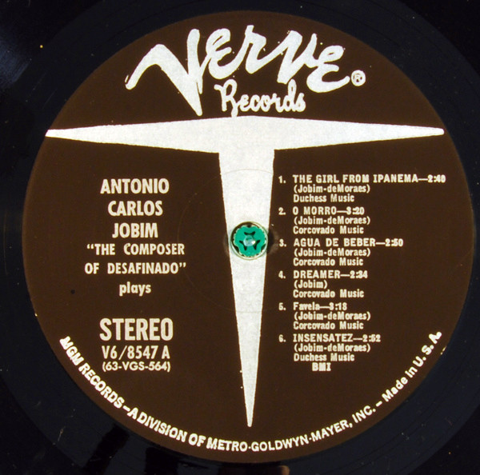

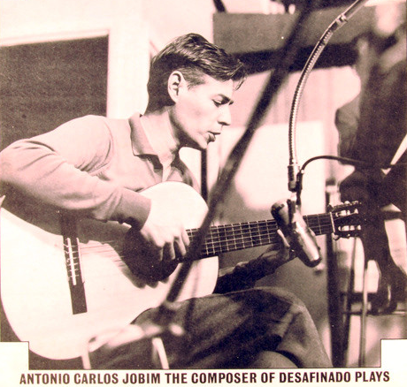

18 The Girl from Ipanema 6:34
Stan Getz-ts; Joao Gilberto-g, voc; Gary Burton-vib; Gene Cherico-b; Joe Hunt-dr; Astrud
Gilberto-voc.
Live at Carnegie Hall, New York, October 9, 1964.
CD Verve 823 611-2, 519 800-2.
https://secondhandsongs.com/performance/4652

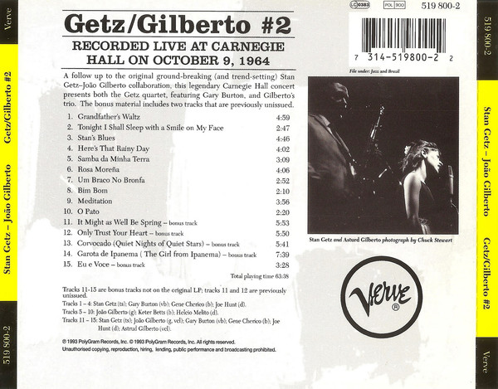

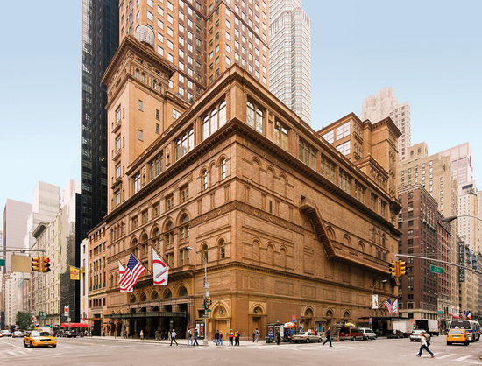
Carnegie Hall

19 The Boy from Ipanema 2:30
Sarah Vaughan-voc; Frank Foster Orchestra: Wayne Andre, Billy Byers, Benny Powell,
Britt Woodman-tb; Richard Hixson-btb; Jerome Richardson-fl; Bernard Eichen, Lewis Eley,
Emmanuel Green, Leo Kruczek, Charles Libove, Gene Orloff, Tosha Samaroff-vio; Harry
Lookofsky-tenor vio; Bob James-p; Barry Galbraith-g; George Duvivier-b; Bobby
Donaldson-dr; Willie Rodriguez-perc; Frank Foster-arr, cond.
New York, August 13, 1964.
CD Mercury/Verve 549 374-2.
https://secondhandsongs.com/performance/483728

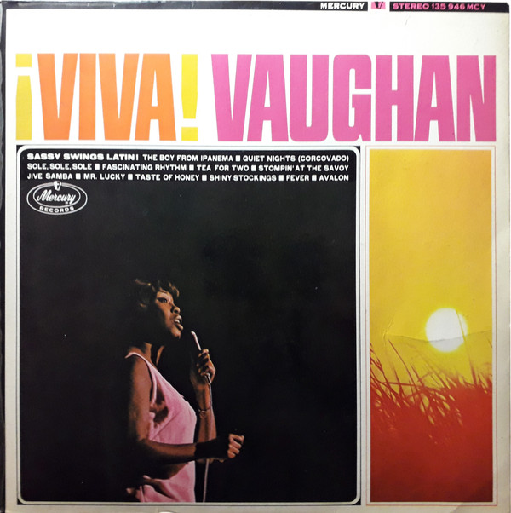

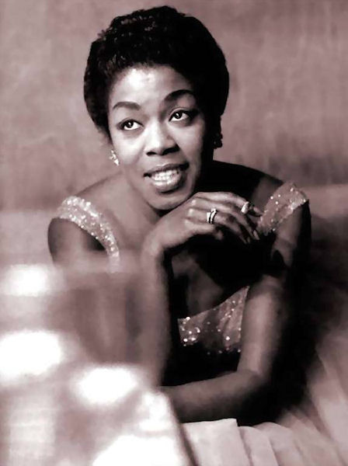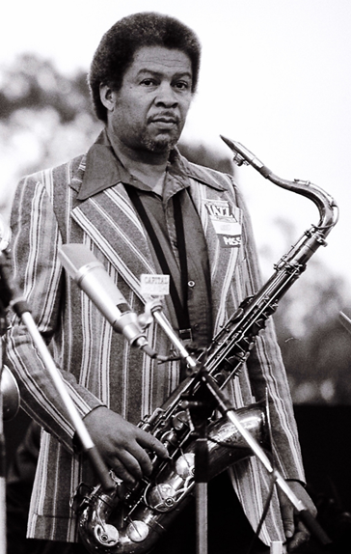
Sarah Vaughan (1924 – 1990) Frank Foster (1928 – 2011)

20 The Girl from Ipanema 8:37
Archie Shepp-ts; Ted Curson-tp; Joseph Orange-tb; Marion Brown-as; Reggie Johnson-b; Joe
Chambers-dr.
Englewood Cliffs, NJ, February 16, 1965.
CD Impulse! 11582.
https://secondhandsongs.com/performance/405869

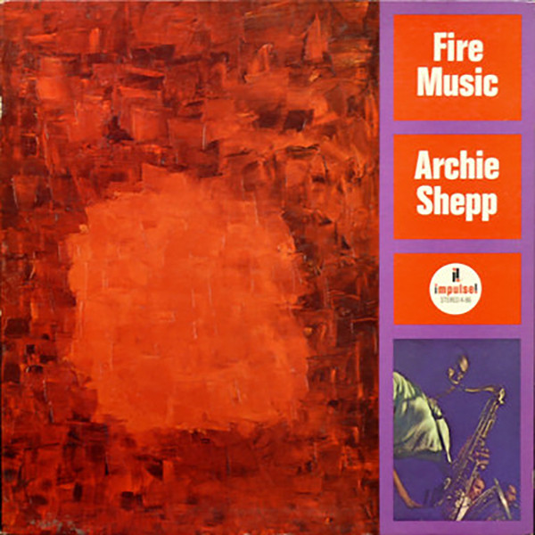

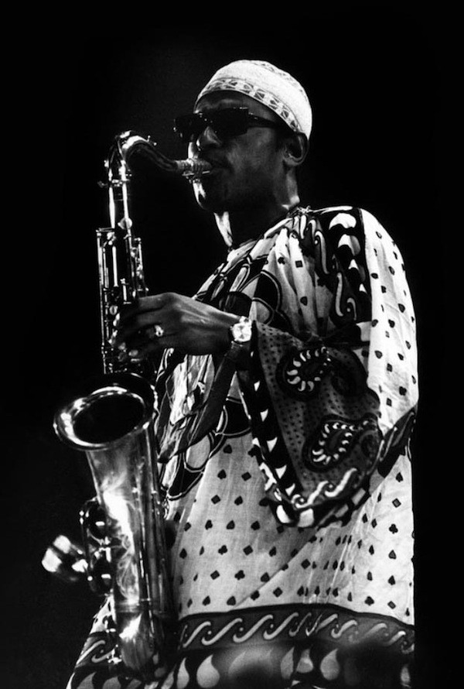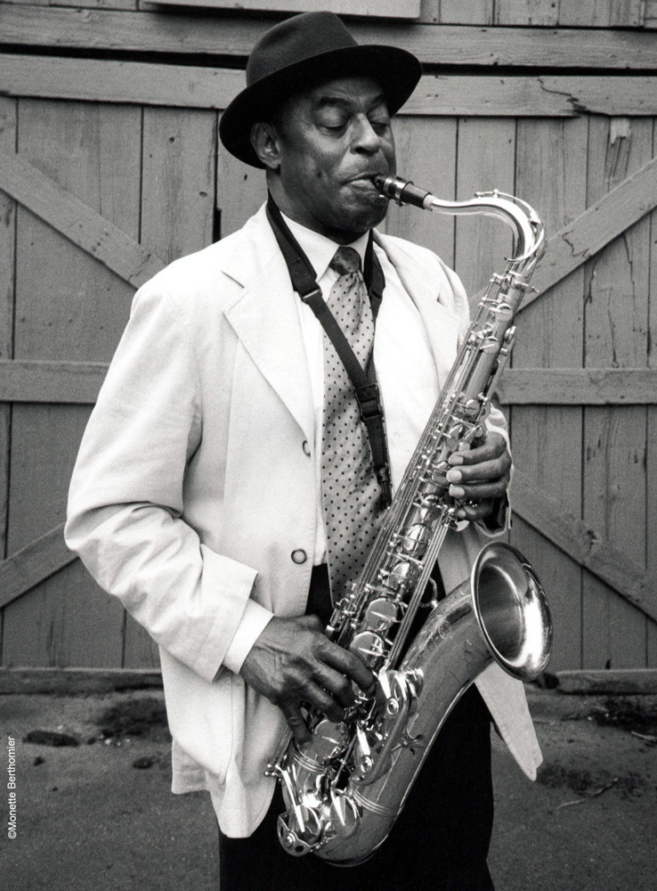
Archie Shepp (*1937)

https://larryappelbaum.wordpress.com/2014/09/01/interview-with-archie-shepp-1982/
(moc dobrý zdroj rozhovorů se zajímavými jazzmany!)

Interview with Archie Shepp (1982) (excerpt)

Sep1 by Larry Appelbaum

Let me ask you about one of your plays. Thumbing through the Black Drama Anthology, we find your jazz allegory Junebug Graduates Tonight…
Incidentally, I never called that a jazz allegory. That was the idea of the people who produced the play. In fact, the play was originally titled The Communist. We did it under the auspices of a Rockefeller grant and they thought that for cosmetic purposes we ought to push more the jazz angle and change the title of the play to Junebug Graduates Tonight. That wasn’t really my idea. In fact, I never liked the term jazz allegory. That was one of the things the critics used against us because they said the play didn’t have enough jazz in it. It was never my intention to make it a jazz play. I don’t even like the word.
The script indicates music and song…
Yes music, but not so-called jazz music. I don’t like this because right away when you say jazz people expect screaming trumpets and drums playing four-to-the-bar, and like that. See, I didn’t want to be stereotyped because that’s not my notion of so-called jazz either. That’s how other people see it.
I’d like to talk with you further about your notion of jazz, but first let me straighten this out. Since I’ve never seen this play staged, I have no idea what the music sounded like. Why don’t you tell me a little bit about that?
At that time, to tell you the truth, I was rather influenced by the work of Weill and Brecht. In fact the play itself, from a dramaturgical point-of-view, has elements of Brecht in terms of its political implications and the way the characters are used allegorically. Subsequently, I was very interested in the way Kurt Weill used music for The Three-Penny Opera and I attempted to do, from my own Black perspective, what they had been able to do from a European perspective.
So, stylistically, where would these “songs” lie?
Stylistically they would probably, I wouldn’t call myself influenced by German lieder, but stylistically I would say the songs had political import, meaning beyond a beat or the attempt to merely communicate a nice aesthetic feeling.

https://jazztimes.com/features/interviews/archie-shepp-memoirs-of-a-gunfighter/

Archie Shepp: Memoirs of a Gunfighter
The saxophonist reminisces about auditioning for Lee Morgan, John Coltrane’s dislike of socks, and a Wild West-style confrontation with Miles Davis
Published May 18, 2020 – By Ashley Kahn

Yeah. Then I had a play that I wrote Off-Broadway in the ’60s [The Communist] and a couple of the one-act plays I did, one that was presented at Brooklyn College with Maurice Watkins directing—Maurice was the guy who taught Laurence Fishburne. So literature has also been very important for me, particularly playwriting. I wrote plays after I got out of college, but I realized that somehow music is calling me, and then I had the chance to perform on recordings—with Cecil Taylor.
In 1960.
Yeah, and so I haven’t stopped since. Actually, I’ve been playing music for about 60 years. And I used to be able to get up the stairs without having to be helped, but it’s come to that.

http://www.theamiagency.com/archie-shepp

Archie Shepp
“Archie Shepp, “ One of the greatest interprets of the babelian memory of jazz “”

Saxophone player, composer, pianist, singer, politically committed poet, playwright, Archie Shepp is a legend.
Archie Shepp was born in 1937 in Fort Lauderdale in Florida. He grew up in Philadelphia, studied piano and saxophone and attended high school in Germantown ; he went to college, became involved with theatre , met writers and poets, among them, Leroy Jones and wrote : « The Communist », an allegorical play about the situation of black Americans . In the late fifties, Archie Shepp also met the most radical musicians of the time : Lee Morgan, Bobby Timmons, Jimmy Garrisson, Ted Curson, Beaver Harris… his political consciousness found an expression in plays and theatrical productions which barely allowed him to make a living. In the beginning sixties he met Cecil Taylor and did two recordings with him which were determining. In 1962 he signed his first record with Bill Dixon as co-leader. During the following year, he created the New York Contemporary Five with John Tchichai, made four records for Fontana, Storyville and Savoy and travelled to Europe with this group.
Starting in August 1964, he worked with Impulse and made 17 records among which, Four For Trane, Fire Music, and Mama Too Tight, some of the classics of Free Music. His collaboration with John Coltrane materialized further with Ascension in 1965, a real turning point in Avant-Garde music. His militancy was evidenced by his participation in the creation of the Composers Guild with Paul and Carla Bley , Sun RA, Roswell Rudd and Cecil Taylor.
In July 1969 he went for the first time to Africa for the Pan African Festival in Algiers where many black American militants were living. On this occasion he recorded Live for Byg the first of six albums in the Actual series.
In 1969 he began teaching Ethnomusicology at the University of Amherst, Massachusetts; at the same time he continued to travel around the world while continuing to express his identity as an African American musician.
The dictionary of Jazz (Robert Laffont, Bouquins) defines him in the following way : « A first rate artist and intellectual, Archie Shepp has been at the head of the Avant- Garde Free Jazz movement and has been able to join the mainstream of Jazz, while remaining true to his esthetic . He has developed a true poli-instrumentality: an alto player, he also plays soprano since 1969, piano since 1975 and more recently occasionally sings blues and standards. »
He populates his musical world with themes and stylistic elements provided by the greatest voices of jazz: from Ellington to Monk and Mingus, from Parker to Siver and Taylor. His technical and emotional capacity enables him to integrate the varied elements inherited by the Masters of Tenor from Webster to Coltrane into his own playing but according to his very own combination : the wild raspiness of his attacks, his massive sound sculpted by a vibrato mastered in all ranges, his phrases carried to breathlessness, his abrupt level changes , the intensity of his tempos but also the velvety tenderness woven into a ballad. His play consistently deepens the spirit of the two faces of the original black American music: blues and spirituals. His work with classics and with his own compositions (Bessie Smith’s Black Water Blues or Mama Rose) contributes to maintaining alive the power of strangeness of these two musics in relationship to European music and expresses itself in a unique mix of wounded violence and age-old nostalgia.
The scope of his work which registered in the eighties a certain urgency (at the cost of a few discrepancies) is a witness to the fact that in 1988 Archie Shepp was with Sonny Rollins one of the best interpreters in the babelian history of jazz.
With his freedom loving sensitivity Archie Shepp has made an inestimable contribution to the gathering, the publicizing and the inventing of jazz.
info@theamiagency.com

