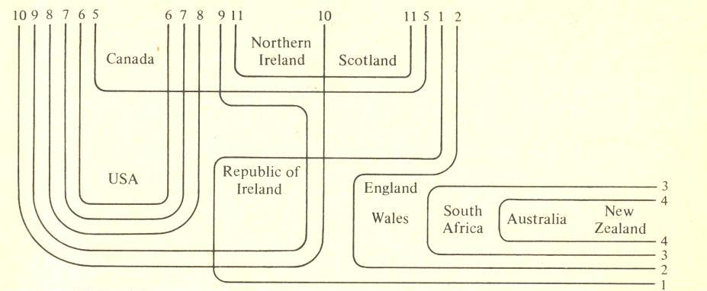
The variables as delimited here are 1 /α/ rather than // in path etc., 2 absence of non-prevocalic //, 3 close vowels for // and //, monophthongization of // and //, 4 front // for // in part etc., 5 absence of contrast of // and // in cot and caught, 6 // rather than /α/ in can’t etc., 7 absence of contrast of // and /α/ as in bother and father, 8 consistent voicing of intervocalic //, 9 unrounded /α/ in pot, 10 syllabic // in bird, 11 absence of contrast of // and // as in pull and pool.

