A summary of
“The Social Stratification of (r)
in New York City Department Stores”

This study was carried out by William Labov, who is an American Linguist known for his attention to dialects.

Gathering data:
Generally, the primary means for collecting data is tape-recorded interviews. However, interview speech is formal speech in the sense that it is different from everyday language.
One alternative for this is to interview the subject in his own natural social context. Another way is to gather data by observing the subjects’ use of language in daily life without any interview situation. This is the way that is adopted in this study.

Preliminary investigations:
Before this study was carried out, Labov conducted a series of preliminary investigations which included individual interviews in addition to anonymous observations in public places.
As a result of these observations, Labov noticed that the variable [r] in postvocalic position as in car, four, etc. is sensitive to measures of social stratification. Labov was also able to make two assumptions: one of them is that the linguistic variable (r) is a social differentiator in all level of New York City speech. The other is that rapid and anonymous speech events could be used as the basis for a systematic study of language. And the study of (r) in New York City department stores is a test of these ideas.

The hypothesis
Based on these notions, Labov was able to state the hypothesis to be tested as follows:
“If any two subgroups in New York City speakers are ranked in a scale of social stratification, then they will be marked in the same order by their differential use of (r).”
In order to show that the hypothesis is so general, and that the differential use of (r) pervades New York City so thoroughly, it seemed best to find a case of stratification within a single occupational group: in this case, the sales people of large department stores in Manhattan.
Labov selects three large department stores from the top, middle, and bottom of the price and fashion scale. This means that the customers should be socially stratified. The question is whether the sales people will show comparable stratification. According to C. Wright Mills, salesgirls tend to borrow prestige form their customers.
The hypothesis predicts that salespeople in highest-ranked store will have the highest value of (r), those in the middle-ranked store will have the intermediate value of (r), and those in the lowest-ranked store will show the lowest value.
The stores are Saks Fifth Avenue, Macy’s, and S. Klein: the highest-ranked store is Saks, the middle-ranked store is Macy’s, and the lowest-ranked store is S. Klein. Labov presents evidence that these stores are differentiated in a fixed order, and that jobs in these stores are evaluated by employees in that order. The differential ranking of the stores is based on a number of factors, such as: location, advertising, price policies, and the physical plant of the stores. However, the stratification of the employees depends on the prestige of the stores and the working conditions, regardless of the wages. Those two factors stratify the employees in the order: Saks, Macy’s, and S. Klein.

The Method
The application of the study is simple. The interviewer, who is Labov, took the role of a customer. He asked the sales person for directions to a particular department which is located on the fourth floor. The interviewer would say: “Excuse me, where are the women’s shoes?” and the sales person would answer, “Fourth floor.” Then the interviewer leaned forward and said, “Excuse me?” and the sales person repeats his answer: “Fourth floor” spoken under emphatic stress.
Then the interviewer makes a written note of the data. He included the following independent variables: the store, floor within the store, sex, age, occupation, race, and foreign or regional accent. The dependent variable is the use of (r) in four occurrences:
Casual: fourth floor
Emphatic: fourth floor
The interviewer would then write (r-1) for each plainly constricted value of the variable, and (r-0) for unconstructed schwa, lengthened vowel, or no representation. He wrote d for doubtful cases or partial constriction.
He applied this method on each aisle of the floor and on all floors as many times as possible. On the fourth floor the form of the question was different: “Excuse me, what floor is this?”
He interviewed 264 subjects, 68 in Saks, 125 in Macy’s and 71 in S. Klein.

Overall stratification of (r)
The following bar graph shows the use of (r) by employees of Saks, Macy’s and S. Klein. The informants are divided into three categories:
all (r-1): those whose records show only (r-1) and no (r-0)
some (r-1): those whose records show at least one (r-1) and one (r-0)
no (r-1): those whose records showed only (r-0)
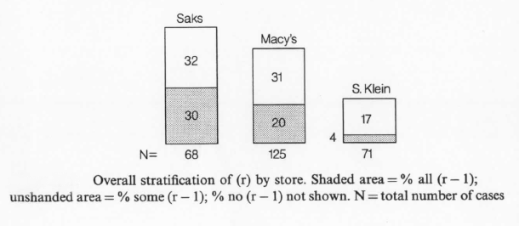
The graph shows that there is a clear stratification of (r) in the three stores: 62 percent of Saks employees, 51 percent of Macy’s, and 20 percent of S. Klein used all or some (r-1). This proves that the three groups are ranked by their differential use of (r) in the same order they were stratified by social factors. And this is what the hypothesis predicted.
Regarding the distribution of (r) in each of the four standard positions, the following figure shows the results:
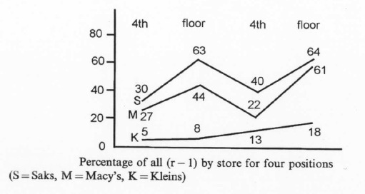
This figure shows how the stores are differentiated for each position. The difference between Macy’s and S. Klein at each position is significant. However, the difference between Macy’s and Saks varies. When it comes to the emphatic pronunciation of the final (r), Macy’s employees show a similar result to that of Saks. The explanation is that, for the majority of Macy’s employees, the norm they aim to is to pronounce (r), but they do not use it most often. This shows that Saks employees have more “linguistic security.”

