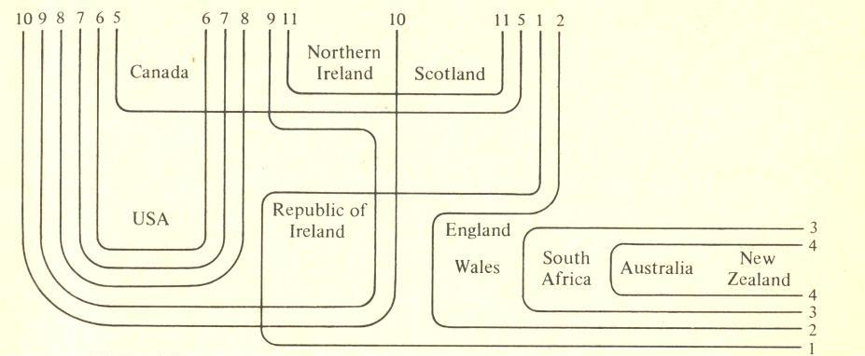
The variables as delimited here are
1 /α:/ rather than /æ / in path etc.,
2 absence of non-prevocalic /r/,
3 close vowels for /æ/, monophthongization of /aɪ/ and /ɑʊ/,
4 front /a:/ for /ɑ:/ in part etc.,
5 absence of contrast of /ɒ/ and /ɔː/ in cot and caught,
6 /æ/ rather than /α:/ in can’t etc.,
7 absence of contrast of /ɒ/ and /α:/ as in bother and father,
8 consistent voicing of intervocalic /t/,
9 unrounded /α/ in pot,
10 syllabic /r/ in bird,
11 absence of contrast of /ʊ/ and /u:/ as in pull and pool.

