[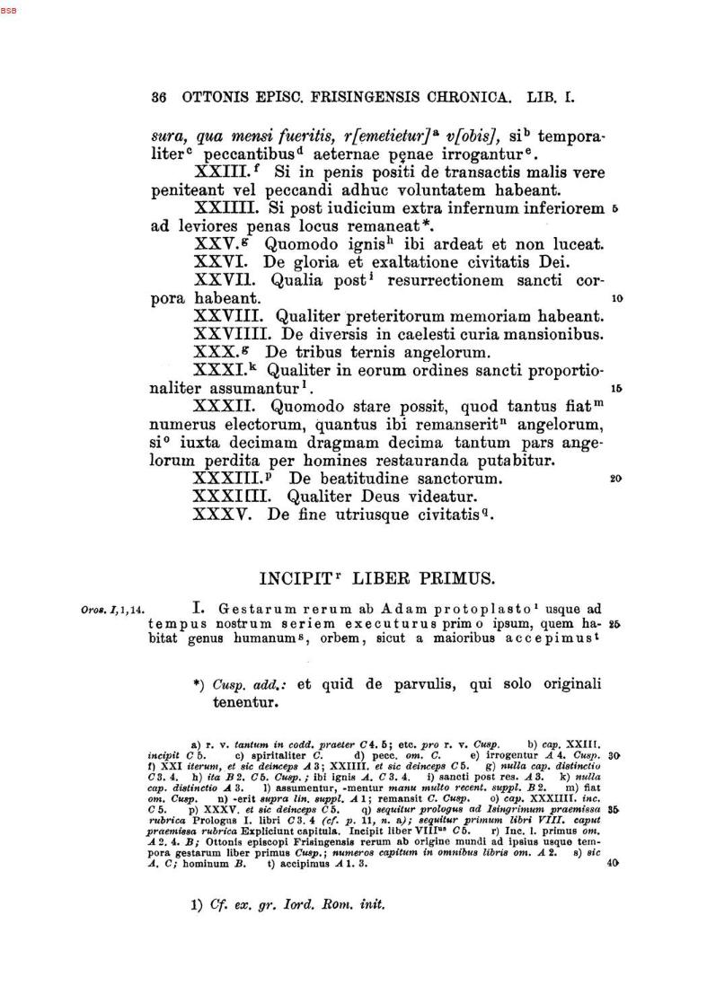](http://www.dmgh.de/de/fs1/object/display/bsb00000746_00151.html?sortIndex=010%3A070%3A0045%3A010%3A00%3A00&zoom=0.75)[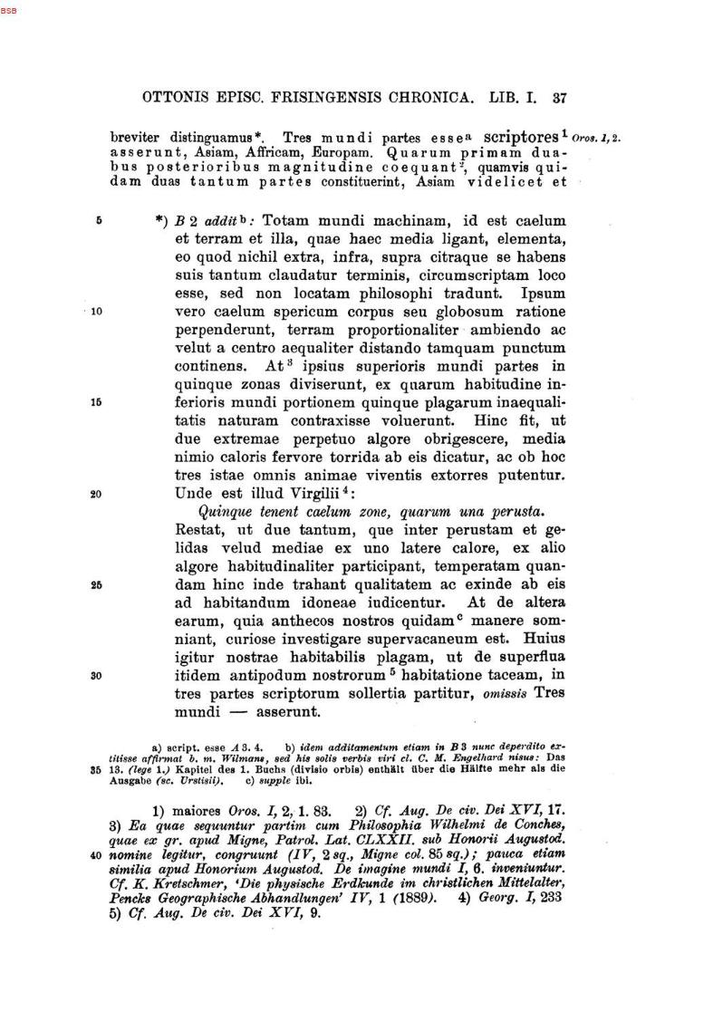](http://www.dmgh.de/de/fs1/object/display/bsb00000746_00152.html?sortIndex=010%3A070%3A0045%3A010%3A00%3A00&zoom=0.75)[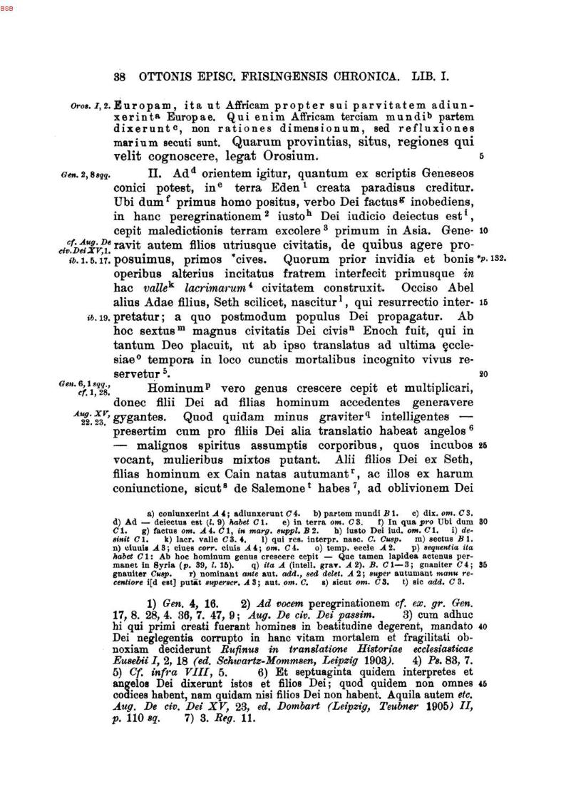](http://www.dmgh.de/de/fs1/object/display/bsb00000746_00153.html?sortIndex=010%3A070%3A0045%3A010%3A00%3A00&zoom=0.75)[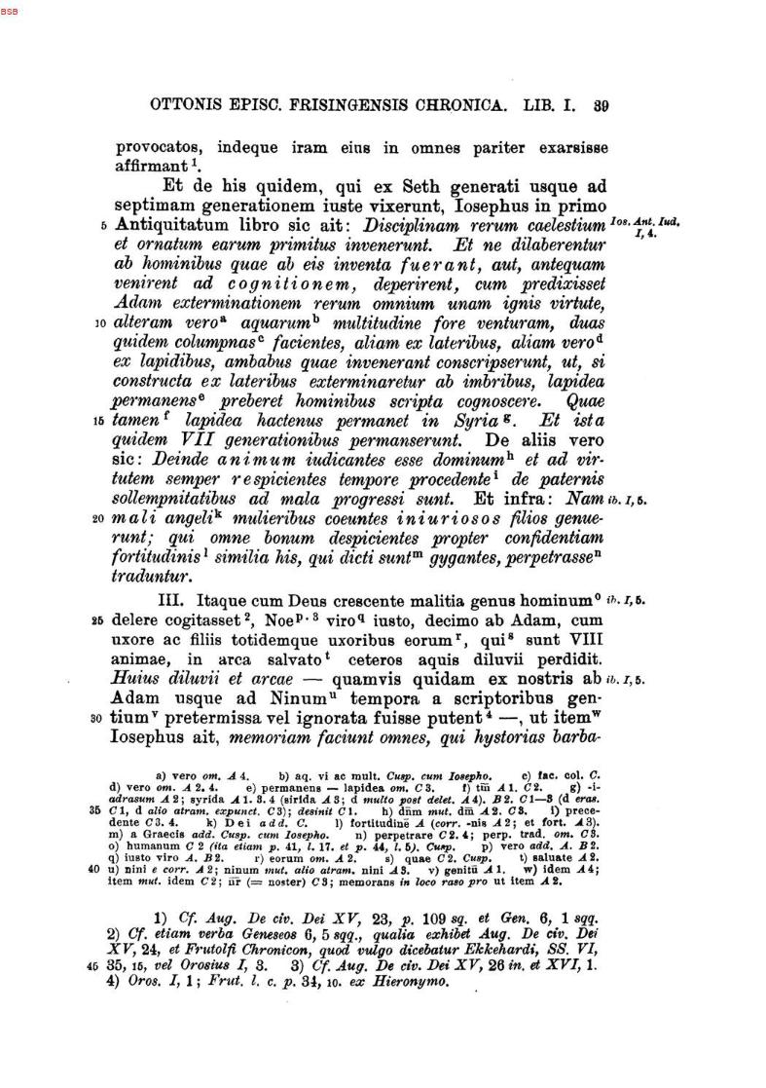](http://www.dmgh.de/de/fs1/object/display/bsb00000746_00154.html?sortIndex=010%3A070%3A0045%3A010%3A00%3A00&zoom=0.75)[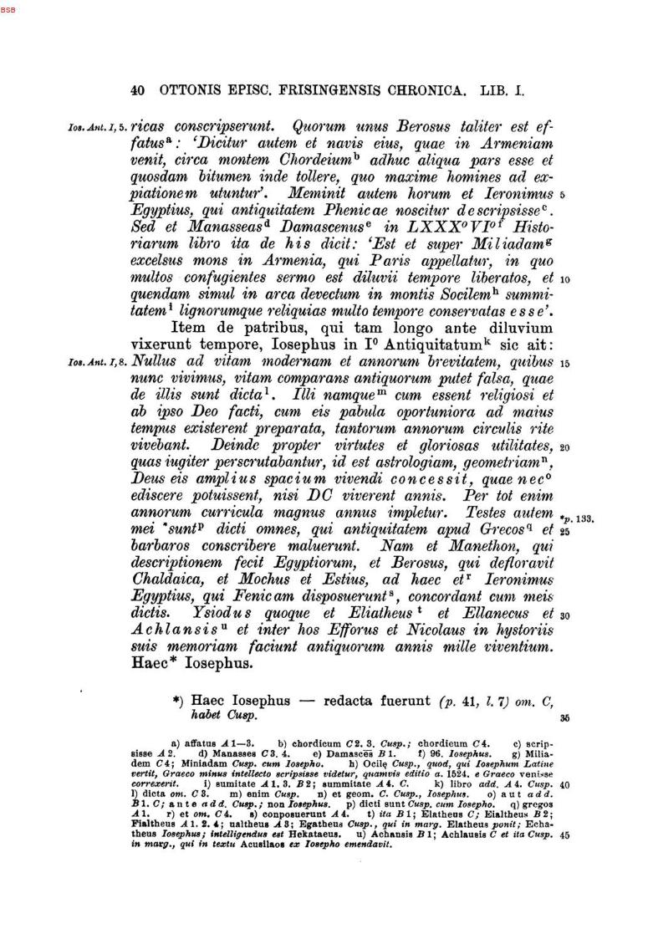](http://www.dmgh.de/de/fs1/object/display/bsb00000746_00155.html?sortIndex=010%3A070%3A0045%3A010%3A00%3A00&zoom=0.75)