AJ22066 PRONUNCIATION VARIETIES, Autumn 2017
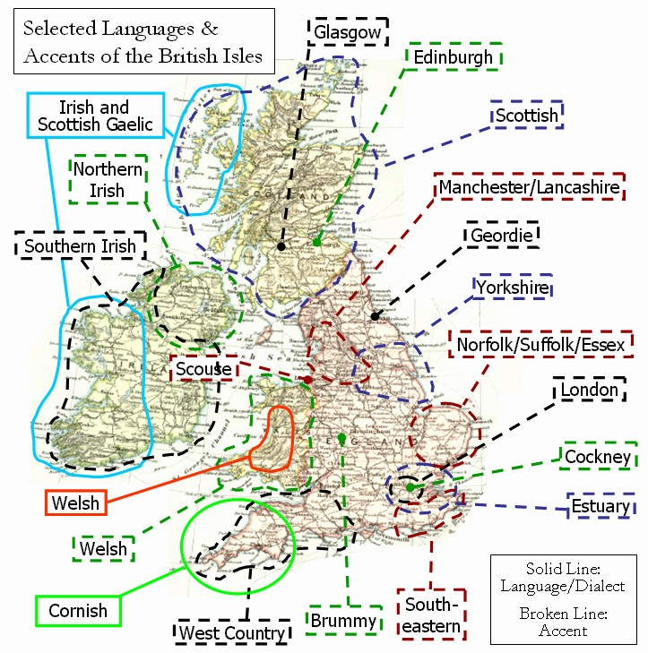

Sessions: Room B2.34, 0730-0900,
Thursdays Oct. 12 and 26, Nov. 9 and 23, Dec. 7 and 14 (with AmE V).

Facilitator: K. Tomková, 2060@mail.muni.cz,
office hours Tue 9:15-10:15, Wed 9:15-10:45.
Compulsory listening:
J.C.Wells – Accents of English in IS Study Materials
Collins and Mees – Practical Phonetics and Phonology in IS Study
Materials, with tapecscipts
Youtube: - ‘The English Language in 24 Accents’
‘A Tour of the British Isles in Accents’
‘One Woman, 17 British Accents’
‘Educating Rita for educational purposes only
‘Christopher Cazenove in Three Men and a Little Woman’ (=Lady)
Online sources: Sounds Familiar langlit; Accents Archive browse

Literature:
Phonetic and sociolinguistic terminology
Accents of English by J.C.Wells, chapters presented in class
International English by Trudgill / Hannah, chapters presented in class
Accents and dialects for stage and screen by Paul Meier

Requirements:
- Attendance, 5pts a session
- Final test max. 50pts
- Contributions, up to 20pts

Syllabus
Oct. 12
The secrets of a posh accent: http://www.theguardian.com/lifeandstyle/video/2014/sep/22/secrets-posh-accent-video-riot-club-vowels
Introduction. Literature. Terminology. Web sources.
Wells’ triangle and Trudgill’s chart.
Sources of recordings and tapescripts.
2 social varieties in Educating Rita.
Anglican vicar stereotype in The Three Men and a Little Lady.
Creating one’s own accent. Collections of errors.
(Having native speakers of different accents in class.)

Oct. 26
Phonetic terminology from Meier
The sociolinguistics of accents from Wells
RP, R.I.P. by David Abercrombie and Sociophonology by John Honey
Upton’s model of RP by Miroslav Ježek
Sum-up recordings: - A tour of the British Isles in Accents
https://www.youtube.com/watch?v=-8mzWkuOxz8
- One woman, 17 British accents https://www.youtube.com/watch?v=FyyT2jmVPAk
Cockney, Estuary English and SE England
Recommended by Matěj Otruba: https://www.youtube.com/watch?v=-IJsSsK7doQ&list=PLI2RcSLPnGzsc1FrAv6urHmxH_oiKVePv&index=6
The rhotic SW: Bristol, Hampshire
Welsh
Midlans
Yorkshire
Scouse
Geordie

Nov. 9
Revision with reference to Guy Fawkes Day in the U.K.
EE accents overseas: - Australia and New Zealand
recommended by Hana Kovačičová: www.radionz.co.nz/collections/kiwi-accent
Flight of the Conchords – Racism
“Brit“ (aka Bret) – The New Zealand Accent

- South Africa
- India
- Africa
- European second language varieties
Nov. 23
- Scottish
HW: watch Trainspotting.
-Irish
-Northern Irish
HW: watch In the Name of the Father.
Mock test.

Dec. 7
Revision of Mock Test, additional hints, presentations and remarks.
Credit test in theory, accent classification and recognition.

Dec. 14 (joining AmE Varieties to meet a visitor)
Debate with a visitor
Revision of Credit Test, assessments.

Exam colloquium: Tuesday 23 January, 2018, at 10a.m.

Relevant tapescripts in Collins and Mees, Practical Phonetics and Phonology:
1 – Traditional RP
2 – Modern RP
41 – Cockney (Greater London)
42 – West Country (Bristol)
43 – Midlans (Birmingham)
44 – North (Lancashire)
45 – Geordie (Newcastle)
45 – Scottish (Edinburgh)
47 – Irish Republic (Greater Dublin)
48 – Northern Ireland (Belfast)
49 – South Wales
50 – Scouse (Liverpool)
51 – Southern USA (Texas)
52 – Kentucky
53 – Canadian
54 – Australian
55 – New Zealand
56 – South African
57 – Indian English
58 – Singapore
59 – Caribbean (West Indian)

