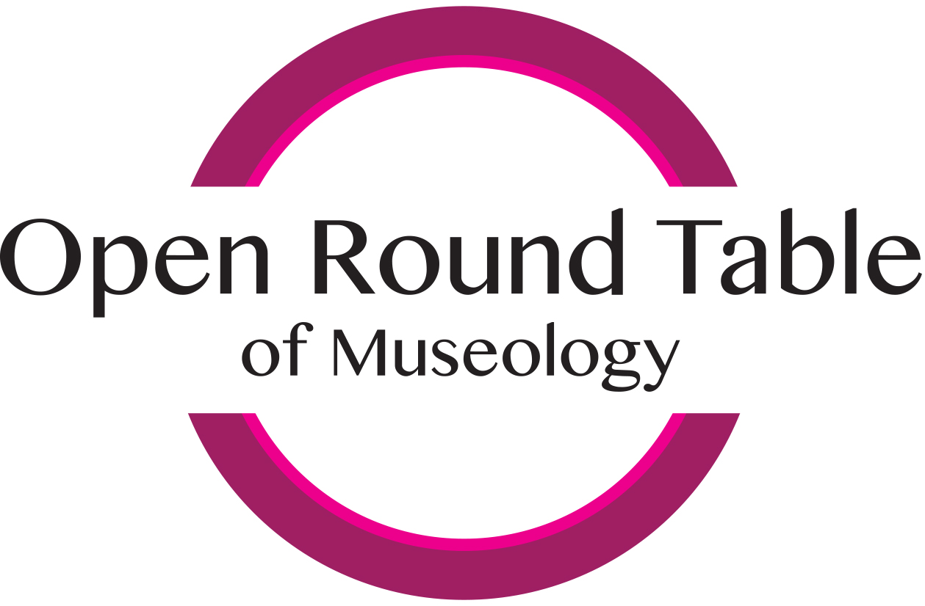

Invitation to the Workshop
„open round table of museology no. 2 – interpretation in museology and museum work“

Coordinators:
Lenka Mrázová and Bernadette Biedermann

Topics of group work

1. Advantages and disadvantages of oral history in the interpretation of topics on controversial history of the 20th century in the museums

2. The issue of suitable interpretation in the work of museums to the untrained museum staff

3. Interpretation in the museums as a tool for strengthening the social community

4. Interpretation in connection with the use of new information technologies

5. Interpretation in the public space

