Ludwig Wittgenstein: Philosophical Investigations
- Published posthumously in 1953

Style and method

Style
  - A collection of 693 numbered remarks (from one sentence up to one page, usually one paragraph long).
  - These remarks are extracted by Wittgenstein from larger manuscripts (written from 1929 till 1951). We possess 20 000 pages of these (handwritten or typed) manuscripts.
  - There are many chains of remarks elaborating upon a certain topic. There are several breaks where the topic is changed without any explicit notice.
  - Many remarks have the form of a fictional dialogues between two (and occasionally three) partners or “voices”. Sometimes it is not clear which voice is Wittgenstein’s.
  - Many remarks end with analogies or open questions (that are left unexplained or unanswered).
  - Wittgenstein uses often examples (real as well as imaginary). There are only a few generalizations (like “meaning is use”).
  - These intricate characteristics of Wittgenstein’s style are related to his philosophical method.

Philosophical method
  - Philosophy is no doctrine (theory, a structured set philosophical theses).
  - There are no (deductive) arguments leading to certain conclusions. No explanations.
  - Philosophy is an activity.
    - What kind of activity? “Philosophy is a battle against the bewitchment of our intelligence by means of language.” (§109) “A philosophical problem has the form: ‘I don’t know my way about.’” (§123)
    - What is its goal? A clear grammar of our language, a clear overview of the use of our words (a perspicuous presentation, §122). (Cf. Wittgenstein said allegedly: “Meaning is use.”)
  - As soon as the goal (the perspicuous presentation) is achieved, there will be no need for philosophy. In other words, as soon as the philosophical problem completely disappears (§133), there is no need for philosophy.
  - The bewitchment is a kind of confusion or obstacle that Wittgenstein compares to an illness.
  - Philosophy is (analogous to) a therapy.
  - Philosophical theories are, at best, “objects of comparison” (§131). We compare them with the actual praxis, with reality.

Critique of the Augustinian conception of language
- The Philosophical Investigations begin with a long quotation from Augustine’s Confessions, which is subsequently summed up as:

These words, it seems to me, give us a particular picture of the essence of human language. It is this: the words in language name objects a sentences are combinations of such names. —– In this picture of language we find the roots of the following idea: Every word has a meaning. This meaning is correlated with the word. It is the object for which the word stands. (§1)

- Subsequently Wittgenstein (together with the reader) starts asking this theory: Are there any differences between kinds of words? His asking has the form of an example:

Now think of the following use of language: I send someone shopping. I give him a slip of paper marked “five red apples”. He takes the slip to the shopkeeper, who opens the drawer marked “apples”; then he looks up the word “red” in a chart and finds a colour sample next to it; then he says the series of elementary number-words – I assume that he knows them by heart – up to the word “five”, and for each number-word he takes an apple of the same colour as the sample out of the drawer.

- Now the voice changes several times. Wittgenstein marks this by dashes.

—– It is in this and similar ways that one operates with words.
—– “But how does he know where and how he is to look up the word ‘red’ and what he is to do with the word ‘five’?”
—– Well, I assume that he acts as I have described. Explanations come to an end somewhere.
– But what is the meaning of the word “five”?
– No such thing was in question here, only how the word “five” is used. (§1)

- If there is any critique of Augustin’s conception of language, then it is only implicit. Neither Wittgenstein, nor any of the voices claims that this conception of language is absolutely hopeless.
- Any conclusion is up to the reader.
- What follows: Wittgenstein introduces various extensions or improvements of this language (which are called language-games) and applies his method again and again.
- Some of these games work akin the theory of names from his Tractatus.
- These languages-games and their implicit conceptions of meaning are objects of comparison.

Rule-following
- What is alluded in the language-game from §1 is that we connect with certain words rather rules than objects.
- The question is now how can we grasp a rule (that governs the use of a word)?
  - In particular, can we grasp a rule / the meaning of a word at a stroke? If so, then how can grasp potentially unlimited applications of this rule / uses of the word?
  - What is the relations between meaning (something delimited) and use (something unlimited)?
  - How can I apply a certain rule / word (e.g. “cube”) in a novel unforeseen situation?
- The tractarian answer: We possess a method of projection (e.g. we are able to project our mental representation of a cube onto a real object).
  - But: The method of projection is a rule for applying other rules. Applying a rule requires another rule.
- The same point can be made without invoking any mental representations: How do we grasp the rule of the series: 1 4 9 16 25 …? The must be a moment when I can say: “Now I can go on”’ (PI 151) It seems that I can indeed grasp this rule at a stroke when realizing that this is the series of second powers of natural numbers.
  - But: To understand what second power is we need a rule for it.
- This is Wittgenstein’s (or some of his voices’) tentative conclusion:

This was our paradox: no course of action could be determined by a rule, because every course of action can be made out to accord with the rule. The answer was: if everything can be made out to accord with the rule, then it can also be made out to conflict with it. And so there would be neither accord nor conflict here. (§201)

- There must be an end in invoking additional rules. Sometimes the only possible answer is “I do what I do”. “When I obey a rule, I do not choose. I obey it blindly.” (§219) No other interpretation is needed.
- To use a rule blindly means that there is an established practice of following this rule.
- Following a rule is analogous to obeying an order or following a signpost.
- There must be some regularity and interpersonal harmony in obeying rules blindly, i.e. in established practices. Wittgenstein calls this harmony a form of life.

Private language
- What about rules governing the application of psychological concepts (i.e. concepts for sensations like pain, joy, anger, fear, love, hate)?
- How do we learn these rules? By directing our attention at instances of these experiences, naming and remembering them.
- But consider the following thought-experiment:
  - Suppose I have a new sensation worth remembering.
  - I write down the sign “S” and concentrate my attention on the sensation every time I am experiencing this sensation.

– But what is this ceremony for? For that is all it seems to be! A definition serves to lay down the meaning of a sign, doesn’t it?
– Well, that is done precisely by concentrating my attention; for in this way I commit to memory the connection between the sign and the sensation.
– But “I commit it to memory” can only mean: this process brings it about that I remember the connection correctly in the future. But in the present case, I have no criterion of correctness. One would like to say: whatever is going to seem correct to me is correct. And that only means that here we can’t talk about ‘correct’. (§258)

- The structure of this “argument” is the same as that of rule-following: There are some instances, but nothing guarantees a future correct application in a novel situation.
- Tentative conclusion (there are only tentative conclusions in Wittgenstein): This method of giving meaning doesn’t work. There must be something else what guarantees future correct applications. – A public practice, a form of life. But what does it mean “public”?
- What does this argument amount to?
  - Refutation of the basic tenets of Descartes’ philosophy, of classical empiricism, of phenomenalism, of sense-date theories of perception?
  - It is a kind of verificationist theory of meaning? A defense of logical behaviorism?

Inner and outer
- If we accept Wittgenstein’s conclusion of the private language argument, what would remain of philosophy of psychology? Could we speak about our inner states at all? Are we committed to behaviorism?
- Behaviorism takes psychological concepts like “S” to mean “S”-behavior.
- Wittgenstein insists that there is a (grammatical!) distinction between the concepts of pain and pain-behavior (or between “pain” and crying). I can pretend pain-behavior without actually being in pain.
- The main question is: What is the nature of the connection between psychological concepts and characteristic form of behavior?
  - The grammar of our language can mislead us: If “I have pain” is meaningful, then “Others have pain” too? Maybe “Stones have pain”? Maybe numbers?
  - Is this an object at all that can have pain? Can my hand have pain? Or only I can have pain?
  - There is, however, characteristic pain-behavior which we are taught to replace by the expression “pain”. E.g. “Stop crying and tell me where do you feel pain!”
- Tentative conclusion: “pain” is the (inner) object of crying (outward manifestation).
- The following beetle in the box parable seeks to show that this is not so:

Suppose everyone had a box with something in it: we call it a “beetle”. No one can look into anyone else’s box, and everyone says he knows what a beetle is only by looking at his beetle. — Here it would be quite possible for everyone to have something different in his box. One might even imagine such a thing constantly changing. —But suppose the word “beetle” had a use in these people’s language? —If so it would not be used as the name of a thing. The thing in the box has no place in the language-game at all; not even as a something: for the box might even be empty. —No, one can ‘divide through’ by the thing in the box; it cancels out, whatever it is. (§293)

- There is a language-game with the words “beetle” and “box”. But is there any connection between the beetle and the box at all?
- There is no independent meaning of “beetle” apart from “anything inside the box”. But the pronoun “anything” suggests that “beetle” refers to a thing, to an object. Once again, the grammar of English/German can mislead us.
- A positive picture: The relation between psychological concepts and characteristic behavior is akin to psych. concepts and facial expressions. E.g. “I read timidity in his face” (§573) or “a smiling face” (§539). These kinds of expressions are a part of our form of life.

Aspect seeing
- This topic comes from the second part of the Philosophical Investigations (today labeled “Philosophy of Psychology – A Fragment”). The form is different: There are 14 sections more less corresponding the original manuscripts. Wittgenstein didn’t manage to incorporate them in the main body of the Philosophical Investigations.
- How do we recognize smile/fear/timidity in a facial expression?
  - We can say: I see this face as smiling/frowning/threatening.
  - These aren’t any features or properties of a face.
- How can we see or recognize something as or in something else?
- There is the difference between seeing something and seeing something as something else. That is: ‘There are two uses of the word “see”: The one: “What do you see there?” — “I see this” (and then a description, a drawing, a copy). The other: “I see a likeness between these two faces”.’ (PIF, §111)
- Look at the following picture:
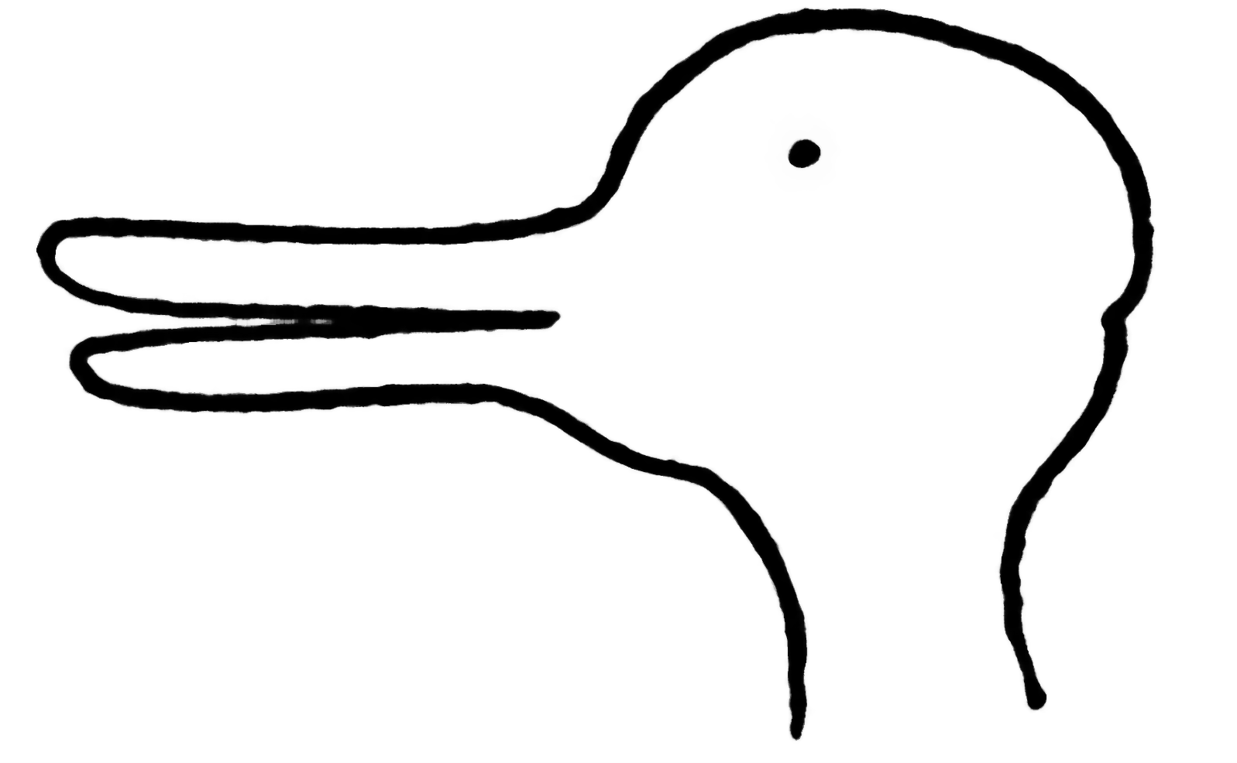
The picture is ambiguous. It can be seen as a duck or as a rabbit.
- Pay attention at the moment when you realized that the picture is ambiguous, i.e. when you see the other aspect. This is the experience of the change of aspect. But the picture is still the same.
- This is a kind of paradox: “The expression of a change of aspect is an expression of a new perception and, at the same time, an expression of an unchanged perception.” (PIF, §130)
- Wittgenstein says that “what I perceive in the lighting up of an aspect is not a property of the object, but an internal relation between it and other objects.” (PIF, §247)
- An internal relation is a grammatical relation between two concepts (of a duck-shape and of a rabbit-shape).
- The sentence “I see this picture as a rabbit” doesn’t express any property of the picture, but rather an internal relation between the two involved concepts.

Further reading
- Ludwig Wittgenstein, Philosophical Investigations, The German text, with an English translation by G. E. M. Anscombe, P. M. S. Hacker and Joachim Schulte, revised 4th edition by P. M. S. Hacker and Joachim Schulte, Wiley-Blackwell, 2009. [Use this translation/edition.]

- Marie McGinn, Wittgenstein and the Philosophical Investigations, Routledge, 1997. [Good as the first introduction for students]
- David Stern, Wittgenstein’s Philosophical Investigations: An Introduction, Cambridge University Press, 2004. [More demanding than McGinn’s introduction]
- Stephen Mulhall, Wittgenstein’s Private Language: Grammar, Nonsense, and Imagination in Philosophical Investigations §§243–315, Oxford University Press, 2006. [An innovative, but somehow controversial reading of the private language argument]

