FUN CLASS NOVEMBER 22, 2018

- Tabboo game
- Karaoke song 1
- Adverb game
- Da Da language
- ‘What would they be’ game
- Karaoke song 2

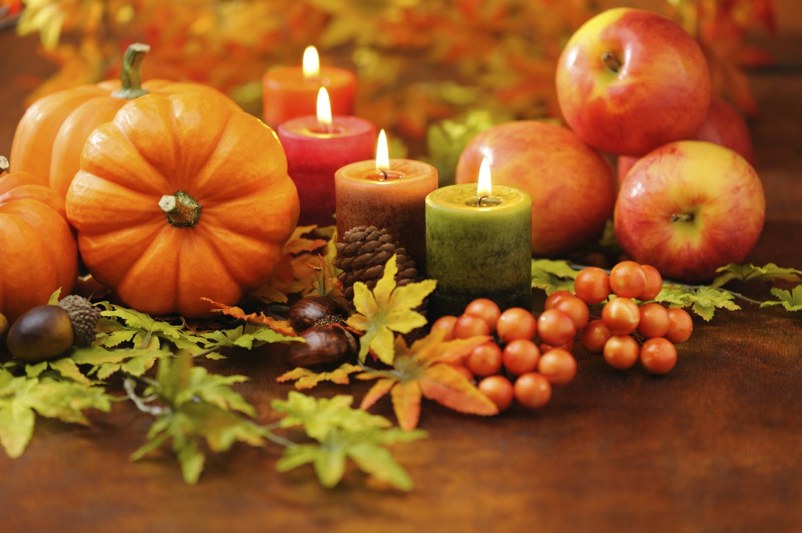
THANKSGIVING

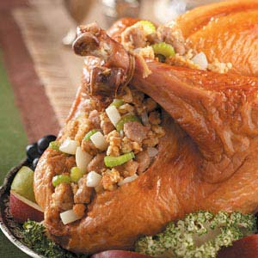 STUFFING

CREATION

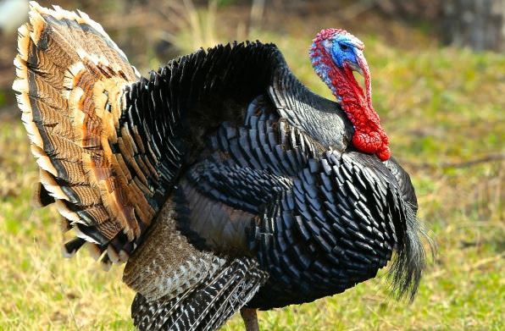
TURKEY

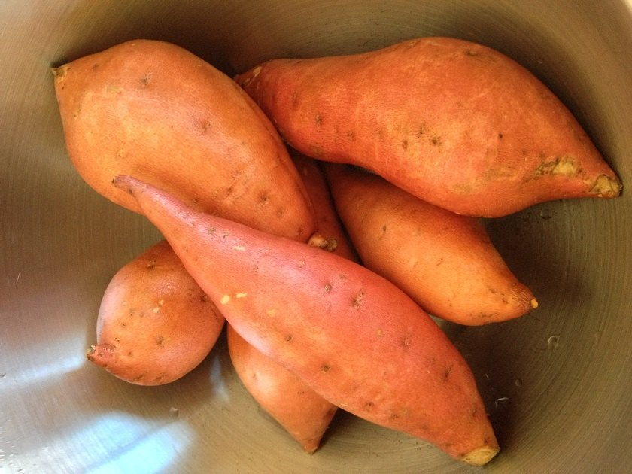 YAMS
TO TEAR
