FROM ENGLISH TO AMERICAN ACCENTS
“Downton Abbey with American accents is bizarre“ 2:25
“British actors doing American accents“ 13:00
“British English vs. American English: Pronunciation 4:34
“5 American words that are rude in Britain 3:48
PRACTISING (AMERICAN) ENGLISH
Everything by Amy Walker, particularly:
“American accent essentials – speak the way Americans REALLY do / Amy Walker“
OVERVIEW AND MAP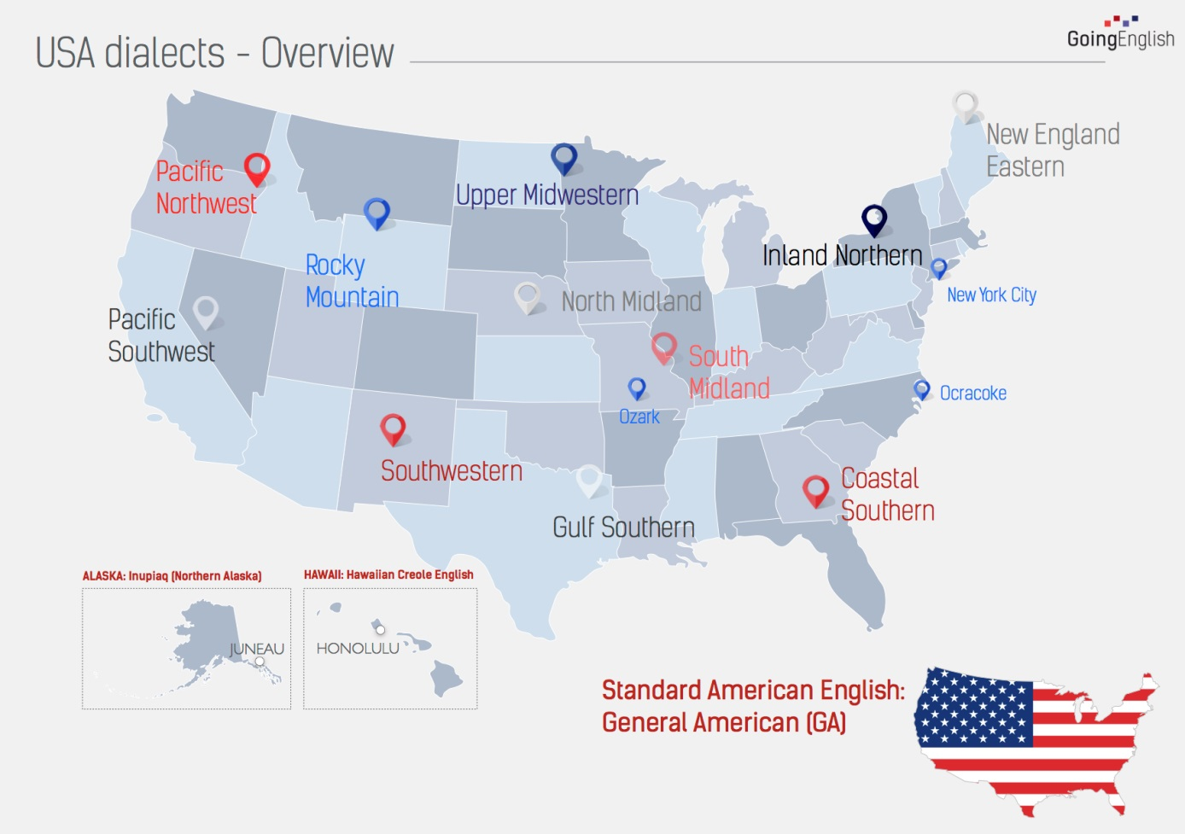
Listen to youtube video “Why Do American Accents Sound That Way?“ (2:49): https://www.seeker.com/why-do-american-accents-sound-that-way-1501524466.html
and localize the accents mentioned on the map in writing.

“Fred Armison can do any Southern accent“ 2:17

