Vowels

Monophthongs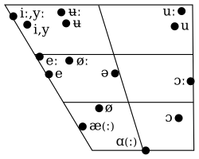
Monophthongs of Urban East Norwegian on an auditory vowel chart, from Vanvik (1979:13). Note that modern sources tend to describe /ɑ, ɑː/ as back [ɑ, ɑː], rather than central [ɑ̈, ɑ̈ː].
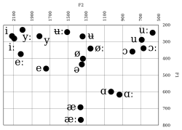
Monophthongs of Urban East Norwegian on a formant vowel chart, from Kristoffersen (2000:16–17)
Monophthong phonemes^{[17]}
 | Front |  |  |  | Central |  | Back
 | unrounded |  | rounded
 | short | long | short | long | short | long | short | long
Close | i | iː | y | yː | ʉ | ʉː | u | uː
Mid | e | eː | ø | øː |  |  | ɔ | ɔː
Open | æ | æː |  |  |  |  | ɑ | ɑː
- Unless preceding another vowel within the same word, all unstressed vowels are short.^{[18]}
- /eː, øː/ are frequently realized as centering diphthongs [eə, øə]. /iː, yː, uː, ɔː/can also be realized as [iə, yə, uə, ɔə], yet /ʉː, æː, ɑː/ are always monophthongal.^{[19][20]} However, according to Kvifte & Gude-Husken (2005), the diphthongal variants of /eː, øː, ɔː/ are opening [eːɛ̯, øːœ̯, ɔːɑ̯], not centering.^{[21]}

