AJ22066 & AJL22066 PRONUNCIATION VARIETIES, Autumn 2019
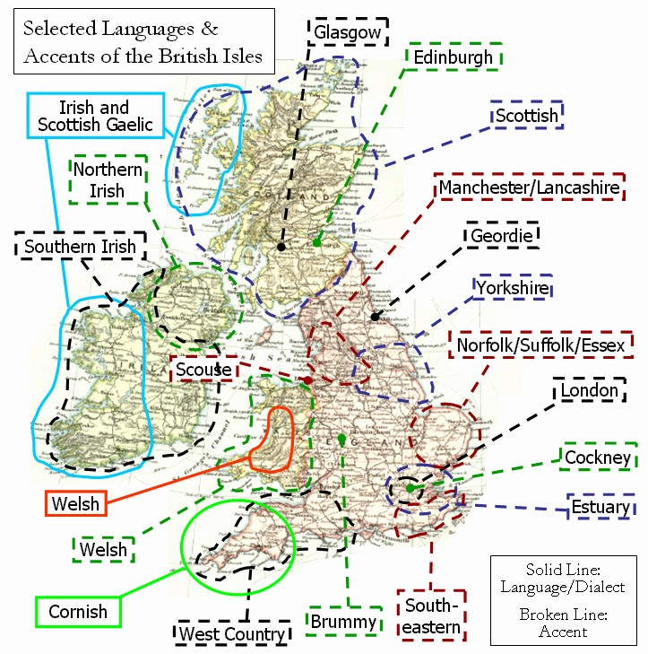

Sessions: Room G32, Mondays 1200-1330,

Facilitator: K. Tomková, 2060@mail.muni.cz,
office hours Mon 11/1130, Tue & Wed 0830-0930, Thu 1400-1500.

Compulsory listening:
J.C.Wells – Accents of English in IS Study Materials
Collins and Mees – Practical Phonetics and Phonology in IS Study
Materials, with tapecscipts
Youtube: - ‘The English Language in 24 Accents’
‘A Tour of the British Isles in Accents’
‘One Woman, 17 British Accents’
‘Educating Rita for educational purposes only
‘Christopher Cazenove in Three Men and a Little Woman’ (=Lady)
Online sources: Sounds Familiar langlit; Accents Archive browse

Literature:
Phonetic and sociolinguistic terminology
Accents of English by J.C.Wells, chapters presented in class
International English by Trudgill / Hannah, chapters presented in class
Accents and dialects for stage and screen by Paul Meier

Requirements:
- Progress tests 10 x max. 4pts = max. 40pts
- Final test max. 50pts
- Contributions, up to 10pts

Syllabus
Sep. 23
The secrets of a posh accent: http://www.theguardian.com/lifeandstyle/video/2014/sep/22/secrets-posh-accent-video-riot-club-vowels
Introduction. Literature. Terminology. Web sources.
Wells’ triangle and Trudgill’s chart.
HW: listening to J.K. Rowling commencement speech of 2008, link and tapescript in SM. TEST 1.

Sep. 30
Sources of recordings and tapescripts. Identification of an accent with a speaker.
2 social varieties in Educating Rita, Anglican vicar stereotype in The Three Men and a Little Lady. J.K. Rowling’s speech.
The standard – role and changes (RP, GB].
Creating one’s own accent (goals in pronunciation training).
Collections of errors. TEST 2.

Oct. 07
Phonetic terminology from Meier – game
Suggested presentation topics:
- The historical development of English
- The sociolinguistics of accents from Wells
- RP, R.I.P. by David Abercrombie
- Sociophonology by John Honey
- Upton’s model of RP by Miroslav Ježek. TEST 3.

Oct. 14
Sum-up recordings: - A tour of the British Isles in Accents
https://www.youtube.com/watch?v=-8mzWkuOxz8
- One woman, 17 British accents https://www.youtube.com/watch?v=FyyT2jmVPAk
Cockney, Estuary English and SE England
The rhotic SW: Bristol, Hampshire. TEST 4.

Oct. 21
South and North Wales
Midlans. TEST 5.
Oct. 28 – no class, Reading Week

Nov. 04
Yorkshire
Scouse
Geordie
Revision with reference to Halloween and Guy Fawkes Night in the U.K. TEST 6.

Nov. 11
EE accents overseas: - Australia
- New Zealand
recommended by Hana Kovačičová: www.radionz.co.nz/collections/kiwi-accent

- South Africa. TEST 7.
Nov. 18
First and second-language varieties in: - India
- Africa
- Europe. TEST 8.

Nov. 25
Celtic accents: - Scottish. HW: watch Trainspotting.
- Irish
- Northern Irish. HW: watch In the Name of the Father. TEST 9.

Dec. 02
Revision activities, students’ presentations. TEST 10.

Dec. 09
Revision activities, students’ presentations. MOCK TEST.

Dec. 16
Feedback of MOCK TEST, CREDIT TEST.

Results in the IS by December 24.

Exam colloquium: Monday 27 January, 2020, at 10a.m.

