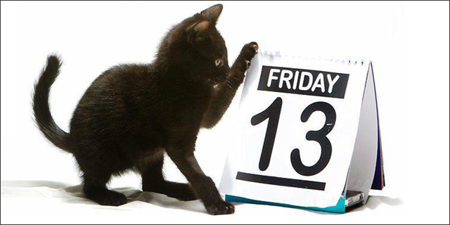
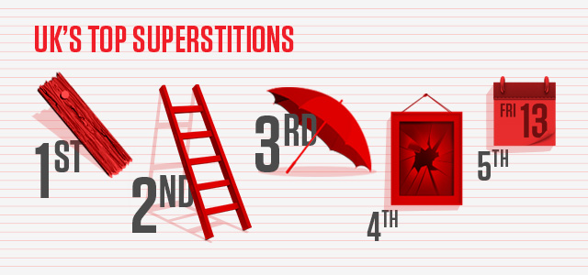
6 Meeting a black cat means good luck in the U.K.
7 If you spill salt on the table you must throw it over
your left shoulder into the eyes of the devil.
8 If thirteen people meet to sit at a table, one will die.
9 If your ears turn red it means someone is gossipping
about you.
10 An unmarried person should not sit in the corner.
9 