IMMIGRATION TO AUSTRALIA AFTER WWII/ after 1990
Vietnamese boat people (Vietnamese: Thuyền nhân Việt Nam), also known simply as boat people, refers to the refugees who fled Vietnam by boat and ship following the end of the Vietnam War in 1975. This migration and humanitarian crisis was at its highest in 1978 and 1979, but continued through the early 1990s.
Until very recently, people were arriving in Australia by boat from Indonesia by the hundreds per week.

Most of these people had no passports or identification at all, despite having crossed many national borders to get to Indonesia.

The Australian government, originally, was housing these people in Detention Centres in Australia until their documentary evidence showing that a person is what they claim to be, i.e. credentials.
could be established and a decision made as to whether they could stay or not.

But the people kept arriving anyway.

The current Australian Liberal government, in an attempt to dissuade these immigrants, decided that they would be housed on the soil of other countries, such a New Guinea, until their identities and bona fides could be corroborated. The arrivals have basically stopped.

And why wouldn't they? New Guinea doesn't have the overly generous Welfare System that Australia has, it provides no real employment potential, and the presence of the immigrants is creating tensions with the local tribes.

New Guinea, by Australian standards is impoverished, lacks law and order, health, housing and educational support.

Why would the immigrants want to go there?
Migration after 2000

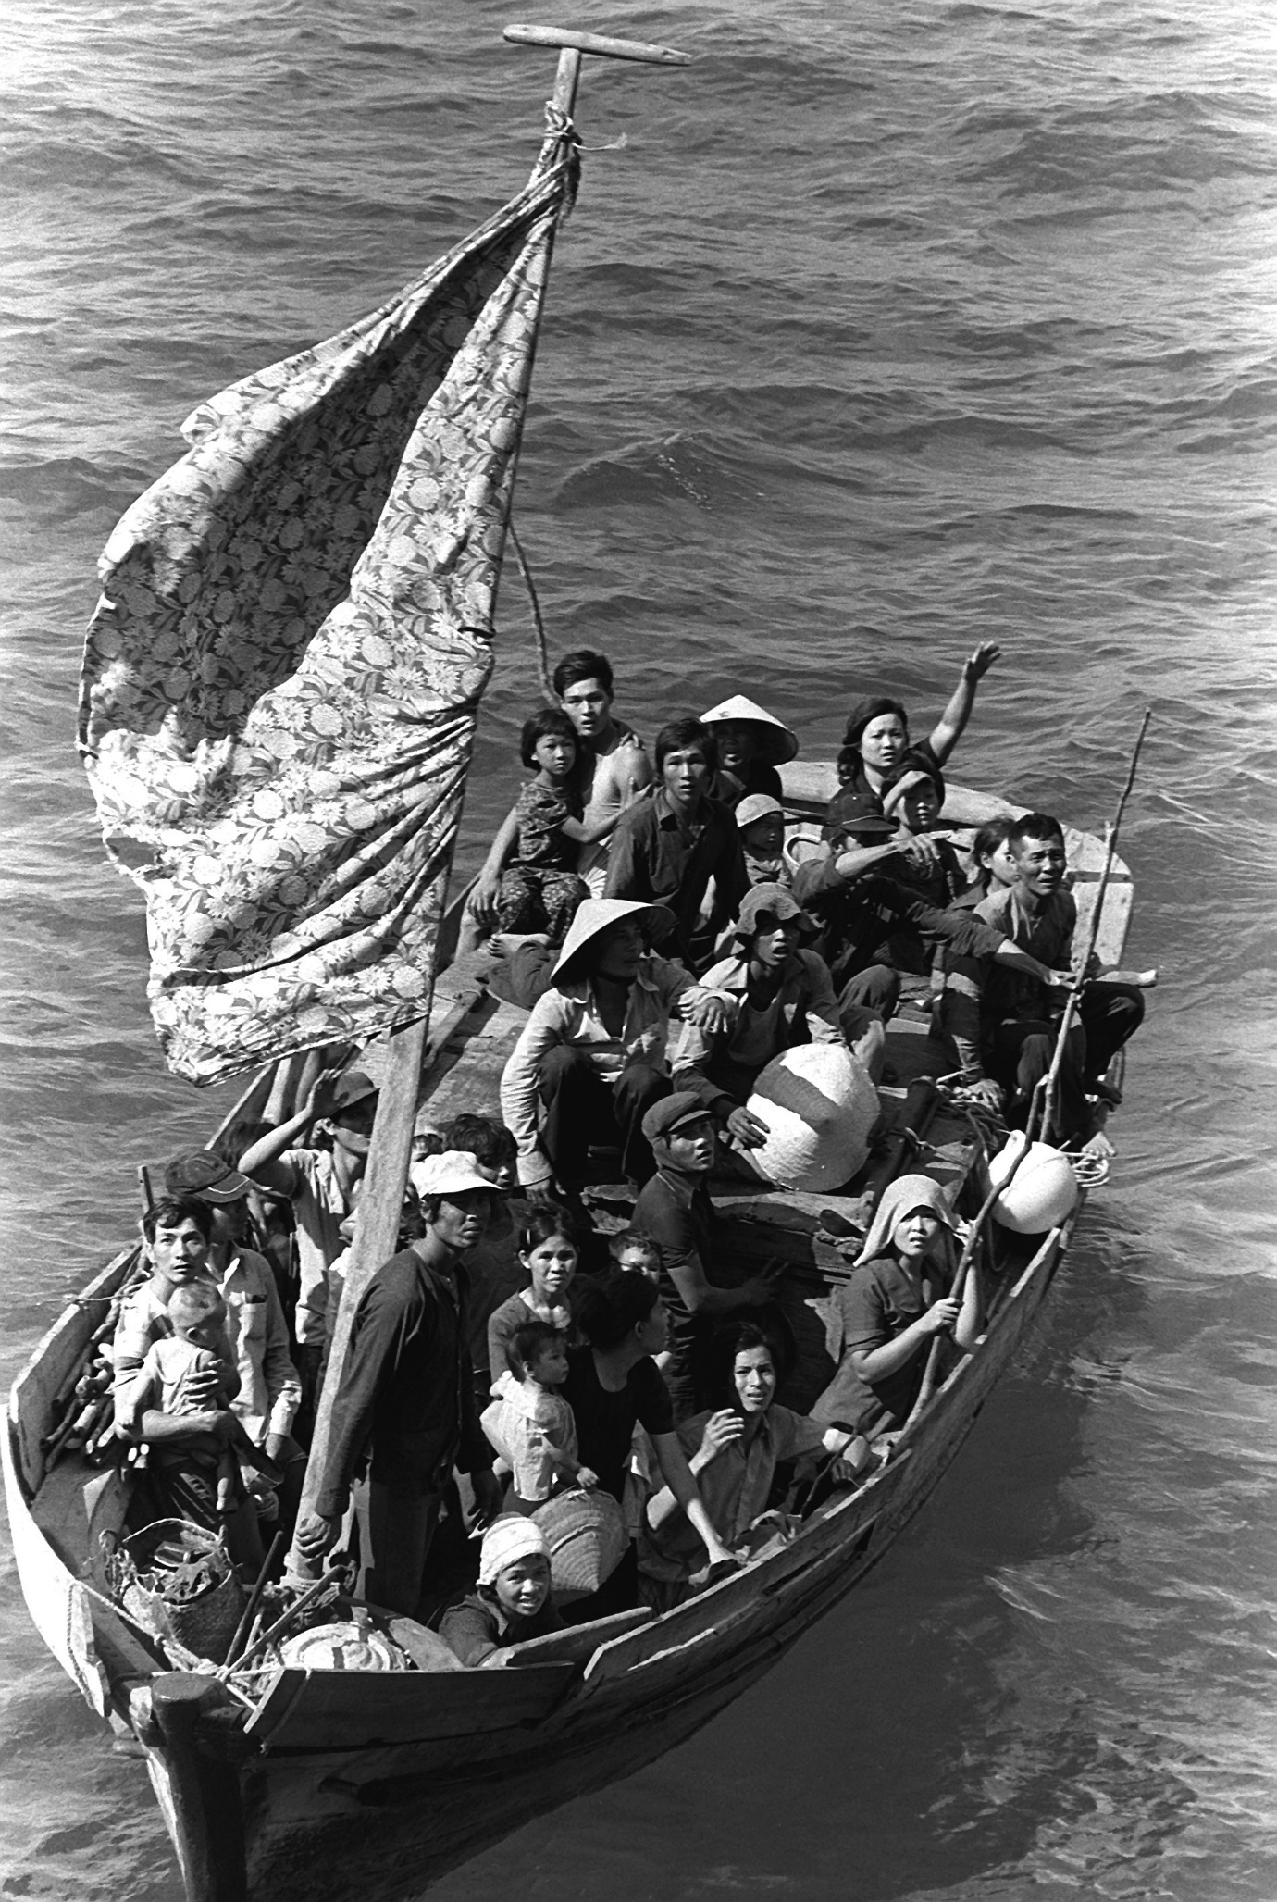
boat people awaiting rescue.
35 Vietnamese refugees wait to be taken aboard the amphibious command ship USS BLUE RIDGE (LCC-19). They are being rescued from a 35 foot fishing boat 350 miles northeast of Cam Ranh Bay, Vietnam, after spending eight days at sea.
- Public Domain
- Created: 15 May 19

Australia’s Migration Program

Skilled Migration
Four main categories exist under the skilled component of the Migration Program:
- General skilled migration, for skilled workers who do not have an employer sponsoring them. Migrants are selected on the basis of their nominated occupation, age, skills, qualifications, English language ability and employability
- Employer nomination, for those who have an employer willing to sponsor them
- Business skills migration, which encourages successful business people to settle in Australia and develop new business opportunities, and
- Distinguished talent, a small category for ‘distinguished individuals with special or unique talents of benefit to Australia’ such as sports people, musicians, artists and designers, who are internationally recognised as outstanding in their field.[15]

On 1 July 2010 a new Skilled Occupation List (SOL) came into effect. It contains 181 occupations identified as being in demand, to ensure that the Skilled Migration Program is demand-driven rather than supply-driven. In order to be eligible for independent skilled migration applicants must hold relevant qualifications in occupations listed on the SOL. Occupations which have been identified as no longer being in demand, such as cooks and hairdressers, were removed from the list.

Family stream (child, parent, spouse..)

Source countries
Figure 1: Top ten countries of citizenship for migrants, 2008–09
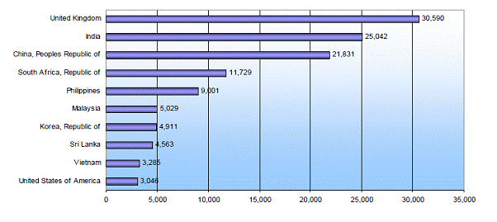
The Australian government has a policy and practice of detaining in immigration detention facilities non-citizens not holding a valid visa, suspected of visa violations, illegal entry or unauthorised arrival, and those subject to deportation and removal in immigration detention until a decision is made by the immigration authorities to grant a visa and release them into the community, or to repatriate them to their country of origin/passport.
Muslims in Australia
CANBERRA AUSTRALIA: Muslims who want to live under Islamic Sharia law were told on Wednesday to get out of Australia, as the government targeted radicals in a bid to head off potential terror attacks. A day after a group of mainstream Muslim leaders pledged loyalty to Australia at a special meeting with Prime Minister John Howard, he and his ministers made it clear that extremists would face a crackdown.
Education Minister Brendan Nelson later told reporters that Muslims who did not want to accept local values should “clear off”. “Basically, people who don’t want to be Australians, and they don’t want to live by Australian values and understand them, well then they can basically clear off,” he said. Separately, Howard angered some Australian Muslims on Wednesday by saying he supported spy agencies monitoring the nation’s mosques.
The Australian government has a policy and practice of detaining in immigration detention facilities non-citizens not holding a valid visa, suspected of visa violations, illegal entry or unauthorised arrival, and those subject to deportation and removal in immigration detention until a decision is made by the immigration authorities to grant a visa and release them into the community, or to repatriate them to their country of origin/passport.

Christmas Island Immigration Reception and Processing Centre or commonly just Christmas Island Immigration Detention Centre, is an Australian immigration detention facility located on Christmas Island in the Indian Ocean. The centre closed in 2018.
• 12/17/2020 · The average length of detention in Australia is more than 500 days — vastly more than the UK, where 87 per cent of detainees have been in detention for less than six months, and Canada, where the average stay in 2019 was 12.3 days. As of November 2020, the Australian government held 1500 people in immigration detention.
•

