The Treaty of Versailles was the primary treaty produced by the Paris Peace Conference at the end of World War I. It was signed on June 28, 1919, by the Allied and associated powers and by Germany in the Hall of Mirrors in the Palace of Versailles and went into effect on January 10, 1920. The treaty gave some German territories to neighbouring countries and placed other German territories under international supervision. In addition, Germany was stripped of its overseas colonies, its military capabilities were severely restricted, and it was required to pay war reparations to the Allied countries. The treaty also created the League of Nations.
- After the Treaty was signed (reluctantly) by the German government, terrorists assassinated several government officials they held responsible for it.
- The other treaties signed with the losing Central Powers were also harsh, ending their empires.
- The extreme effects of the Treaty on Germany led to the Dolchstosslegende (stab-in-the-back legend) which worked in favor of the Nazi Party.
- The Treaty's required reparations amplified the state of Europe's economy in Germany, causing hyperinflation.
- The French insisted on the Treaty being harsh out of fear of Germany instigating another war.

Gallipoli Campaign
World War I

Gallipoli Campaign, also called Dardanelles Campaign, (February 1915–January 1916), in World War I, an Anglo-French operation against Turkey, intended to force the 38-mile- (61-km-) long Dardanelles channel and to occupy Constantinople. Plans for such a venture were considered by the British authorities between 1904 and 1911, but military and naval opinion was against it. When war between the Allies and Turkey began early in November 1914, the matter was reexamined and classed as a hazardous, but possible, operation.
- 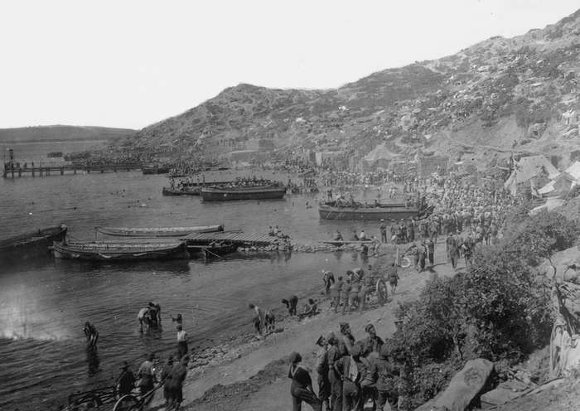
- 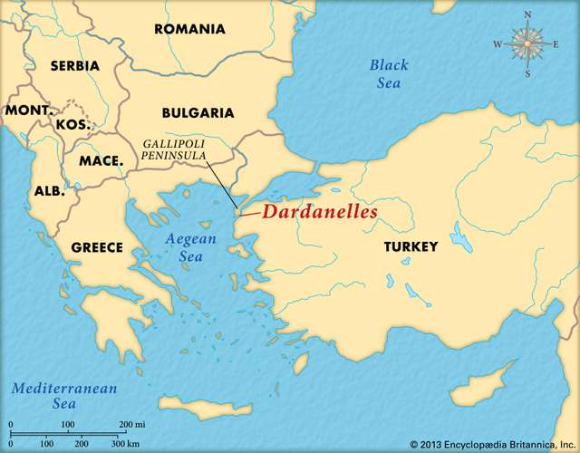
World War I: Allied troops on the Gallipoli Peninsula
Allied troops lining the shore at "ANZAC Cove" on the Gallipoli Peninsula. The cove was named after the ANZAC (Australian and New Zealand Army Corps) troops that were part of the Allied forces. The Dardanelles Campaign against the Turks was a bloody defeat for the Allies.
Hulton Archive/Getty Images
DardanellesEncyclopædia Britannica, Inc.
GALLIPOLI CAMPAIGN EVENTS

Battle of Gallipoli
1915

February 19, 1915 - March 18, 1915

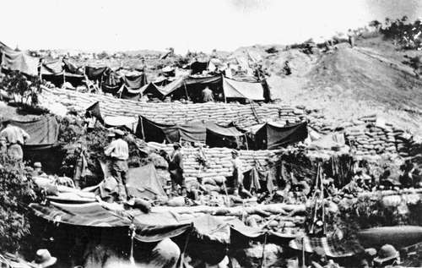
Battle of Lone Pine
August 6, 1915 - August 10, 1915

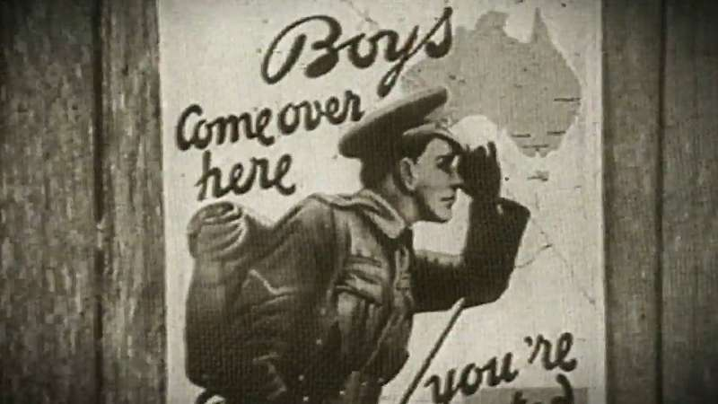
Know about the significance of the disastrous Gallipoli Campaign of World War I, with a focus on the ANZAC troops
An overview of the 1915–16 Gallipoli Campaign of World War I, with a focus on ANZAC troops.
© Behind the News (A Britannica Publishing Partner)See all videos for this article
On January 2, 1915, in response to an appeal by Grand Duke Nicholas, commanding the Russian armies, the British government agreed to stage a demonstration against Turkey to relieve pressure on the Russians on the Caucasus front. The Dardanelles was selected as the place, a combined naval and military operation being strongly supported by Winston Churchill, who was then the first lord of the Admiralty. On January 28 the Dardanelles committee decided on an attempt to force the straits by naval action alone, using mostly obsolete warships too old for fleet action. On February 16 that decision was modified, as it was agreed that the shores of the Dardanelles would have to be held if the fleet passed through. For that purpose a large military force under Gen. Sir Ian Hamilton was assembled in Egypt, the French authorities also providing a small contingent.

Gallipoli Campaign
A collection of significant facts about the Gallipoli Campaign.
Encyclopædia Britannica, Inc./Kenny Chmielewski
The naval bombardment began on February 19 but was halted by bad weather and not resumed until February 25. Demolition parties of marines landed almost unopposed, but bad weather again intervened. On March 18 the bombardment was continued. However, after three battleships had been sunk and three others damaged, the navy abandoned its attack, concluding that the fleet could not succeed without military help.
Troop transports assembled off the island of Lemnos, and landings began on the Gallipoli Peninsula at two places early on April 25, 1915, at Cape Helles (29th British and Royal Naval divisions) and at ANZAC (Australian and New Zealand Army Corps) beaches. A French brigade landed on the Anatolian coast opposite, at Kum Kale, but was later withdrawn. Small beachheads were secured with difficulty, the troops at ANZAC being held up by Turkish reinforcements under the redoubtable Mustafa Kemal, who later became famous as Atatürk. Large British and Dominion reinforcements followed, yet little progress was made. On August 6 another landing on the west coast, at Suvla Bay, took place; after some initial progress the assault was halted.
- 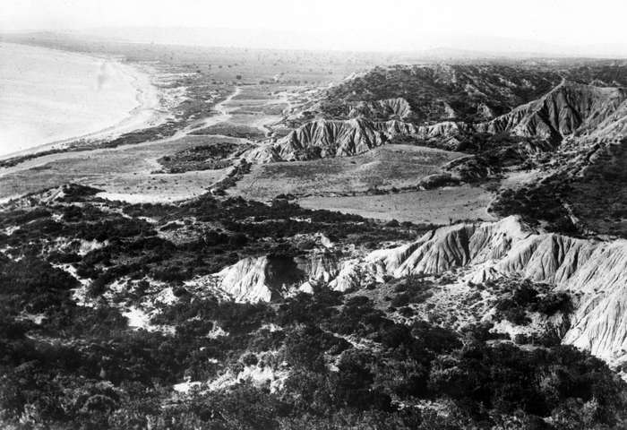
- 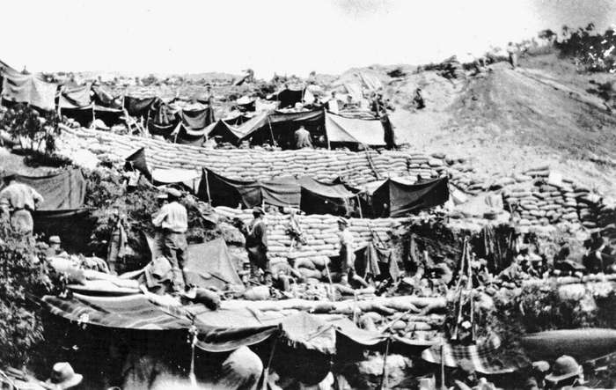
- 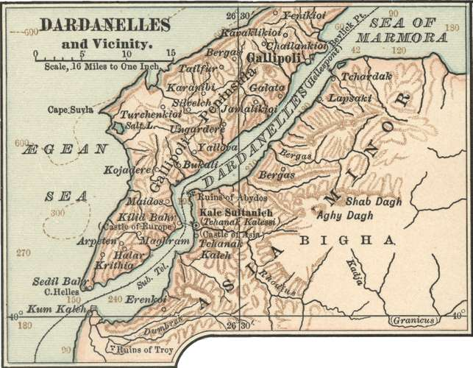
Gallipoli Campaign
The view from “Anzac Cove,” looking north across Suvla Bay, August 8, 1915.
Encyclopædia Britannica, Inc.
Australia and New Zealand Army Corps troops
Australia and New Zealand Army Corps (ANZAC) troops setting up camps on the Gallipoli Peninsula during World War I.
GrahamBould
Dardanelles, c. 1900
Map of the Dardanelles (c. 1900), from the 10th edition of Encyclopædia Britannica.
Encyclopædia Britannica, Inc.
Get exclusive access to content from our 1768 First Edition with your subscription.Subscribe today
In May 1915 the first sea lord, Adm. Lord Fisher, had resigned because of differences of opinion over the operation. By September 1915 it was clear that without further large reinforcements there was no hope of decisive results, and the authorities at home decided to recall Hamilton to replace him by Lieut. Gen. Sir Charles Monro. The latter recommended the withdrawal of the military forces and abandonment of the enterprise, advice that was confirmed in November by the secretary of state for war, Lord Kitchener, when he visited the peninsula. That difficult operation was carried out by stages and was successfully completed early on January 9, 1916.
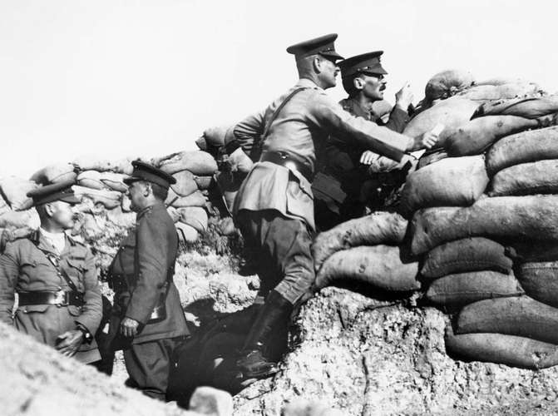
Gallipoli Campaign: “ANZAC Cove”
British army officers in a trench at “ANZAC Cove” during the Gallipoli Campaign of World War I.
© Mary Evans Picture Library Ltd/age fotostock
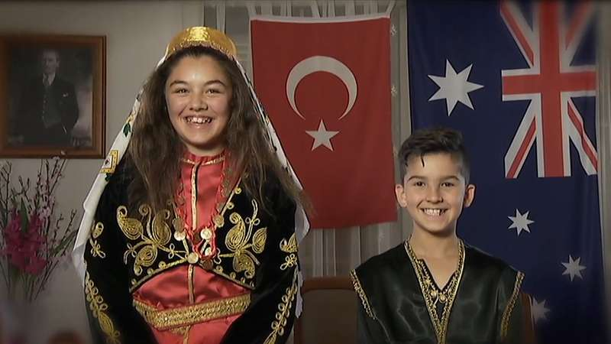
Listen to a Turkish perspective on the Gallipoli Campaign, known to Turkish people as the Battle of Cannakkale, 1915-16
A Turkish perspective on the Gallipoli Campaign (1915–16), widely known among Turks as the Battle of Çanakkale.
© Behind the News (A Britannica Publishing Partner)See all videos for this article
Altogether, the equivalent of some 16 British, Australian, New Zealand, Indian, and French divisions took part in the campaign. British Commonwealth casualties, apart from heavy losses among old naval ships, were 213,980. The campaign was a success only insofar as it attracted large Turkish forces away from the Russians. The plan failed to produce decisive results because of poor military leadership in some cases, faulty tactics including complete lack of surprise, the inexperience of the troops, inadequate equipment, and an acute shortage of shells.
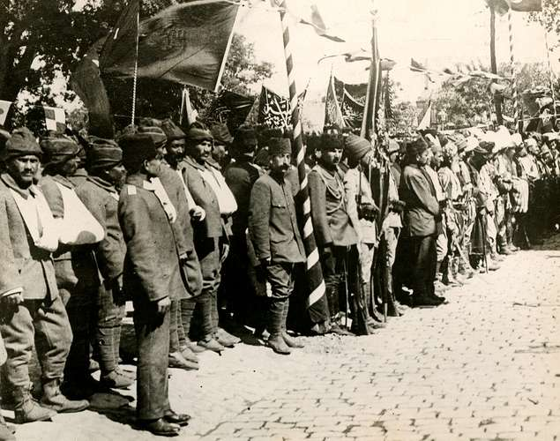
Gallipoli Campaign
Wounded Turkish troops at an assembly during the Gallipoli Campaign.
Encyclopædia Britannica, Inc.

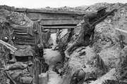
World War I: Rival strategies and the Dardanelles campaign, 1915–16
By late 1914 the state of deadlock on the Western Front had become clear to the governments of the warring countries and even to many members of their general staffs. Each side sought a solution to this deadlock, and the solutions varied…

