- 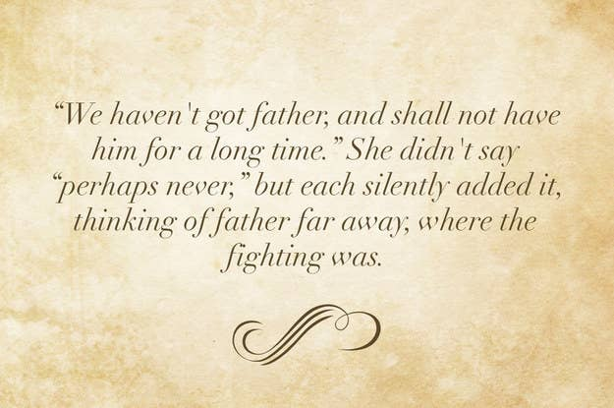

The Railway Children

Little Women

Pride and Prejudice

  - 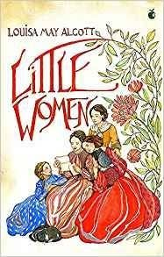
- 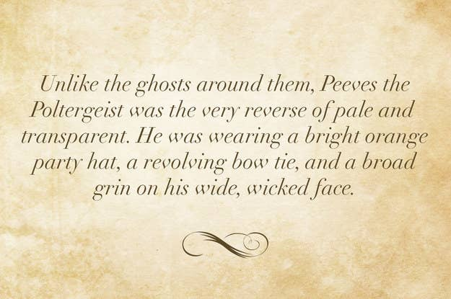
  - Turn of the Screw
  - The Woman in Black
  - Harry Potter and the Chamber of Secrets
- 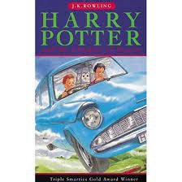

- 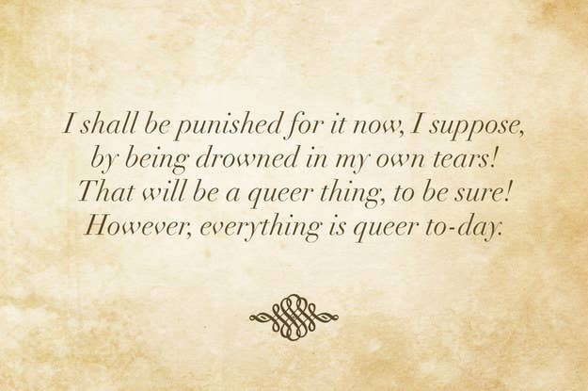

  - The Lion, the Witch, and the Wardrobe
  - Alice's Adventures in Wonderland
  - The Hobbit

- 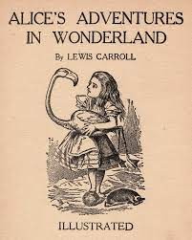

- 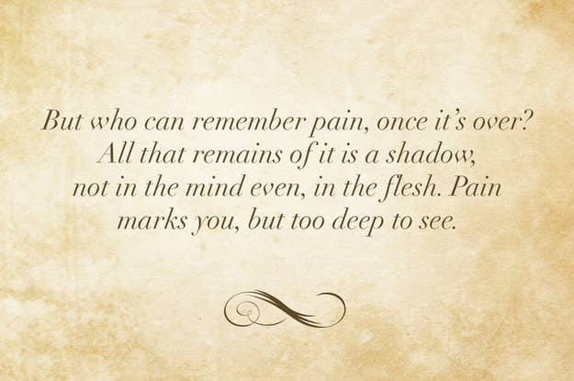

  - The Handmaid's Tale
  - 1984
  - One Hundred Years of Solitude
- 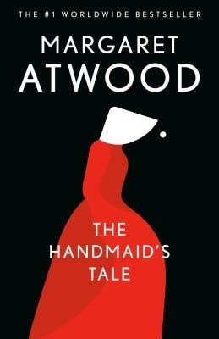

- 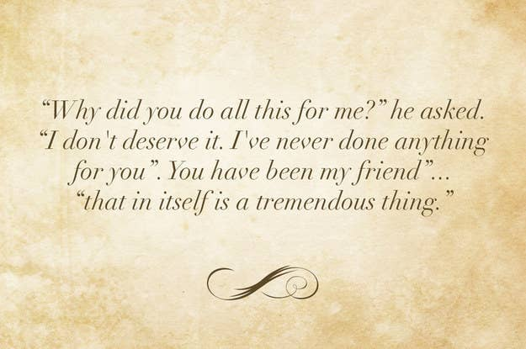
  - Harry Potter and the Deathly Hallows
  - Charlie and the Chocolate Factory
  - Charlotte's Web

- 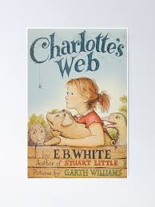
- 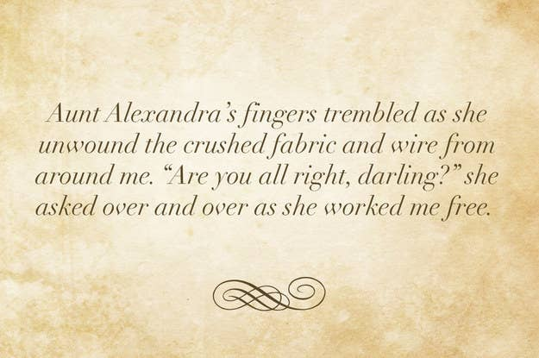
  - To Kill a Mockingbird
  - A Series of Unfortunate Events
  - I Capture the Castle

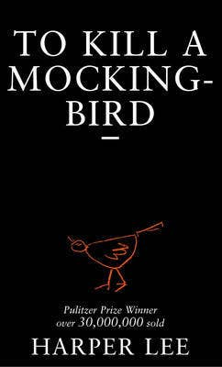
- 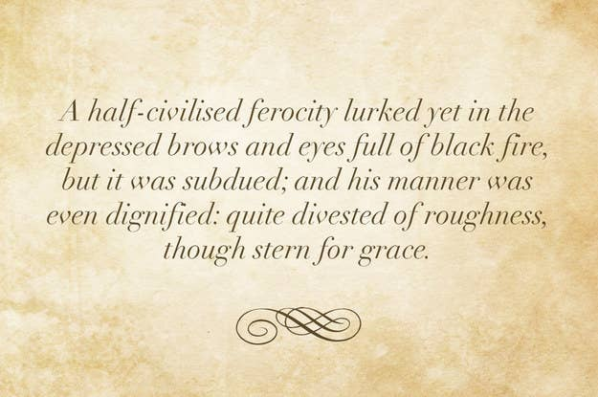
  - Great Expectations
  - Wuthering Heights
  - Fifty Shades of Grey

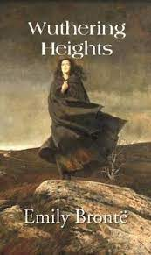
- 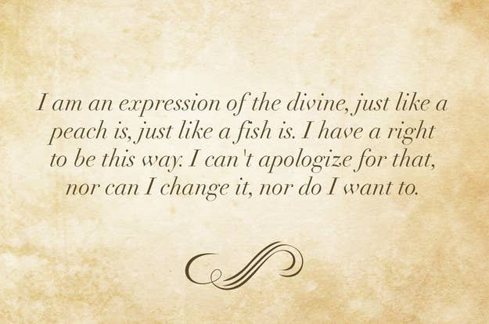
  - Beloved
  - Frankenstein; or, The Modern Prometheus
  - The Color Purple

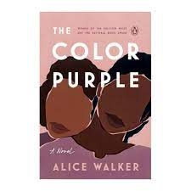
- 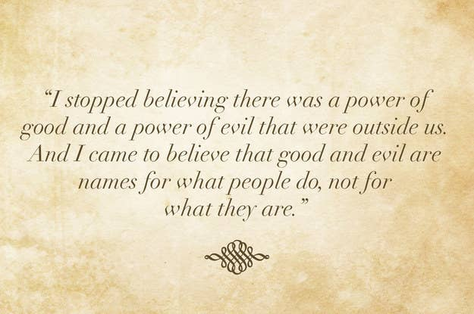
  - Noughts and Crosses
  - The Amber Spyglass
  - A Game of Thrones

