Biomechanics
Meyerhold, V. M. Bebutov and I. A. Aksyonov,
Emploi aktyora, Moscow, 1922, pp. 3–4
In the past the actor has always conformed with the society for which his art was intended. In future the actor must go even further in relating his technique to the industrial situation. For he will be working in a society where labour is no longer regarded as a curse but as a joyful, vital necessity. In these conditions of ideal labour art clearly requires a new foundation.
We are accustomed to the rigid division of a man’s time into labour and rest. Every worker used to try to expend as few hours as possible on labour and as many as possible on rest. Whereas such a desire is quite normal under the conditions of a capitalist society, it is totally incompatible with the proper development of a socialist society. The cardinal problem is that of fatigue, and it is on the correct solution of this problem that the art of the future depends.
In America at the present time much research is being devoted to the possible methods of incorporating rest in the work process instead of regarding it as a separate unit.
The whole question boils down to the regulation of rest periods. Under ideal conditions (taking account of hygiene, physiology and comfort) a rest of as little as ten minutes is capable of completely restoring a man’s energy.
Work should be made easy, congenial and uninterrupted, whilst art should be utilized by the new class not only as a means of relaxation but as something organically vital to the labour pattern of the worker. We need to change not only the forms of our art but our methods too. An actor working for the new class needs to re-examine all the canons of the past. The very craft of the actor must be completely reorganized.
The work of the actor in an industrial society will be regarded as a means of production vital to the proper organization of the labour of every citizen of that society.
However, apart from the correct utilization of rest periods, it is equally essential to discover those movements in work which facilitate the maximum use of work time. If we observe a skilled worker in action, we notice the following in his movements: (1) an absence of superfluous, unproductive movements; (2) rhythm; (3) the correct positioning of the body’s centre of gravity; (4) stability. Movements based on these principles are distinguished by their dance-like quality; a skilled worker at work invariably reminds one of a dancer; thus work borders on art. The spectacle of a man working efficiently affords positive pleasure. This applies equally to the work of the actor of the future.
In art our constant concern is the organization of raw material. Constructivism has forced the artist to become both artist and engineer. Art should be based on scientific principles; the entire creative act should be a conscious process. The art of the actor consists in organizing his material; that is, in his capacity to utilize correctly his body’s means of expression.
The actor embodies in himself both the organizer and that which is organized (i.e. the artist and his material). The formula for acting may be expressed as follows:
N = A₁ + A₂ (where N = the actor; A₁ = the artist who conceives the idea and issues the instructions necessary for its execution; A₂ = the executant who executes the conception of A₁).
The actor must train his material (the body), so that it is capable of executing instantaneously those tasks which are dictated externally (by the actor, the director).
In so far as the task of the actor is the realization of a specific objective, his means of expression must be economical in order to ensure that precision of movement which will facilite the quickest possible realization of the objective.
The methods of Taylorism¹ may be applied to the work of the actor in the same way as they are to any form of work with the aim of maximum productivity.
The conditions (1) that rest is embodied in the work process in the form of pauses, and (2) that art has a specific, vital function and does not serve merely as a means of relaxation, make it obligatory for the actor to utilize his time as economically as possible. Art is allocated a specific number of time units in the worker’s timetable which must be utilized to the maximum effect. This means that one must not fritter away hours in making up and putting on one’s costume.
The actor of the future will work without make-up and wear an overall, that is, a costume designed to serve as everyday clothing yet equally suited to the movements and concepts which the actor realizes on the stage.
The Taylorization of the theatre will make it possible to perform in one hour that which requires four at present.
For this the actor must possess: (1) the innate capacity for reflex excitability,¹ which will enable him to cope with any emploi within the limits of his physical characteristics; (2) ‘physical competence’, consisting of a true eye, a sense of balance, and the ability to sense at any given moment the location of his centre of gravity.
Since the art of the actor is the art of plastic forms in space, he must study the mechanics of his body. This is essential because any manifestation of a force (including the living organism) is subject to constant laws of mechanics (and obviously the creation by the actor of plastic forms in the space of the stage is a manifestation of the force of the human organism).
The fundamental deficiency of the modern actor is his absolute ignorance of the laws of biomechanics.
It is quite natural that with the acting methods which have prevailed up to now, the ‘inspirational’ method and the method of ‘authentic emotions’ (essentially they are one and the same, differing only in their means of realization: the first employs narcotic stimulation, the second – hypnosis), the actor has always been so overwhelmed by his emotions that he has been unable to answer either for his movements or for his voice. He has had no control over himself and hence been in no state to ensure success or failure. Only a few exceptionally great actors have succeeded instinctively in finding the correct method, that is, the method of building the role not from inside outwards, but vice versa. By approaching their role from the outside, they succeeded in developing stupendous technical mastery. I am speaking of artists like Duse, Sarah Bernhardt, Grasso, Chaliapin, Coquelin.
There is a whole range of questions to which psychology is incapable of supplying the answers. A theatre built on psychological foundations is as certain to collapse as a house built on sand. On the other hand, a theatre which relies on physical elements is at very least assured of clarity. All psychological states are determined by specific physiological processes. By correctly resolving the nature of his state physically, the actor reaches the point where he experiences the excitation which communicates itself to the spectator and induces him to share in the actor’s performance: what we used to call ‘gripping’ the spectator. It is this excitation which is the very essence of the actor’s art. From a sequence of physical positions and situations there arise those ‘points of excitation’ which are informed with some particular emotion.
Throughout this process of ‘rousing the emotions’ the actor observes a rigid framework of physical prerequisites.
Physical culture, acrobatics, dance, rhythmics, boxing and fencing are all useful activities, but they are of use only so long as they constitute auxiliary exercises in a course of ‘biomechanics’, the essential basis of every actor’s training.
[‘The Actor of the Future and Biomechanics’,
a report of Meyerhold’s lecture in the
Little Hall of the Moscow Conservatoire, 12 June 1922;
in Ermitazh, Moscow, 1922, no 6, pp. 10–11.]
… When Jaques-Dalcroze invented his system of eurhythmies he was concerned primarily with the musical aspect, but the question of rhythm has proved vital for everybody. If we cannot handle a saw, if we are clumsy with a knife and fork, if we walk badly on the stage, we can learn from Dalcroze. Every craftsman – the blacksmith, the foundry-worker, the actor – must have rhythm, must be familiar with the laws of balance. An actor ignorant of the laws of balance is less than an apprentice. For instance, the Kamerny Theatre director’s¹ ignorance of biomechanics has had the most dismal consequences. Neither fencing nor acrobatics have helped him; he has succeeded merely in making a cult out of the dexterity of tailors and cobblers.
How do we set about moulding the new actor? It is quite simple I think. When we admire a child’s movements we are admiring his biomechanical skill. If we place him in an environment in which gymnastics and all forms of sport are both available and compulsory, we shall achieve the new man who is capable of any form of labour. Only via the sports arena can we approach the theatrical arena.
Every movement is a hieroglyph with its own peculiar meaning. The theatre should employ only those movements which are immediately decipherable; everything else is superfluous …
Consider Pushkin: ‘Inspiration is as necessary in geometry as in poetry, but ecstasy is not necessary.’ Ecstasy is the notorious inner experience, the ‘authentic emotion’; it is the system of my teacher Konstantin Stanislavsky, who, by the way, will probably abandon it very shortly. We need not ecstasy but excitation, based firmly on the physical premise.
[From a report of the same lecture in Teatralnaya Moskva,
Moscow, 1922, no 45, pp. 9–10.]
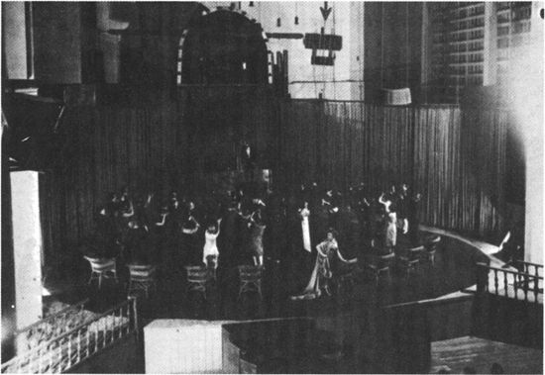
Bubus, the Teacher, 1925.
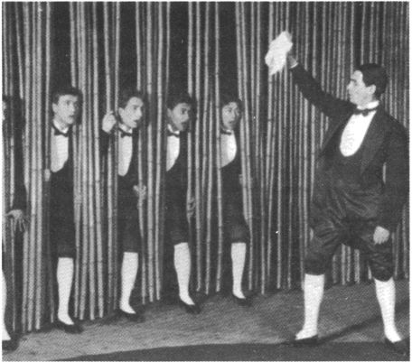
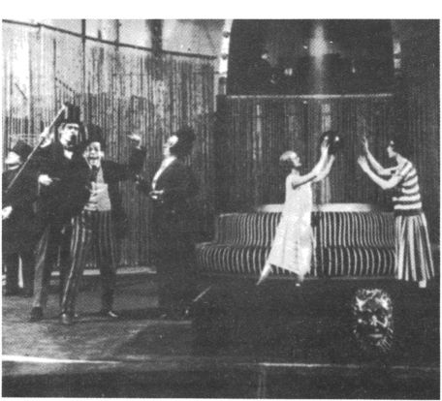
Bubus, the Teacher, 1925.
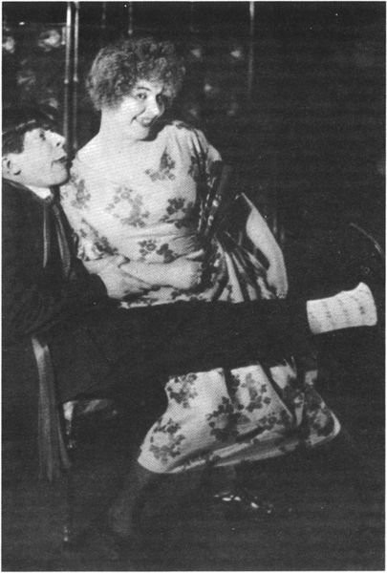
The Warrant, 1925. Sergei Martinson and Zinaida Raikh.
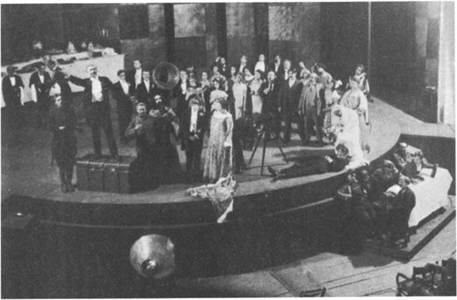
The Warrant, 1925. (Meyerhold seated bottom right.)
An actor must possess the capacity for Reflex Excitability. Nobody can become an actor without it.
Excitability
Excitability is the ability to realize in feelings,¹ movements and words a task which is prescribed externally.
The manifestation of excitability
The co-ordinated manifestations of excitability together constitute the actor’s performance. Each separate manifestation comprises an acting cycle.²
Each acting cycle comprises three invariable stages:
1. INTENTION.
2. REALIZATION.
3. REACTION.
The intention is the intellectual assimilation of a task prescribed externally by the dramatist, the director, or the initiative of the performer.
The realization is the cycle of volitional, mimetic³ and vocal reflexes.
The reaction is the attenuation of the volitional reflex as it is realized mimetically and vocally in preparation for the reception of a new intention (the transition to a new acting cycle).…
[Meyerhold, V. M. Bebutov and I. A. Aksyonov,
Emploi aktyora, Moscow, 1922, pp. 3–4.]

NOTE Apart from the two reports of Meyerhold’s lecture in Ermitazh and Teatralnaya Moskva, his only substantial published pronouncement on biomechanics is contained in his review⁴ of Tairov’s book, Zapiski Rezhissyora (‘A Director’s Notes’), which largely reiterates what is printed above and furthers his polemic against what he saw as the studied balleticism of the Kamerny Theatre.
Meyerhold delivered a second public lecture on biomechanics in October 1922 which, like the first, was followed by a display of exercises by his pupils. Shortly afterwards, in an article entitled ‘Biomechanics according to Meyerhold’,¹ Ippolit Sokolov dismissed Meyerhold’s claim to the invention of biomechanics, referring to ‘over 100 major works on the subject’, most notably Jules Amar’s Le Moteur humain et les bases scientifiques du travail professionnel (Paris, 1914). Furthermore, he claimed that Meyerhold’s exercises were either physiologically unsound and ‘downright anti-Taylorist’ or simply rehashed circus clowning.
Meyerhold answered his critic in a lecture entitled ‘Tartuffes of Communism and Cuckolds of Morality’. Judging from the one brief résumé published,² he made little attempt to refute Sokolov’s charges, saying that his system had no scientific basis and that its underlying theory rested on ‘one brochure by Coquelin’. He must have meant Constant-Benoît Coquelin’s L’art et le comédien (1880) or L’art du comédien (1886),³ in which the remarks on the dual personality of the actor are strikingly similar to Meyerhold’s formulation N = A₁ + A₂.
Meyerhold’s own writings show that as early as 1905 his production methods were shaped by a preoccupation with mime and movement. With the opening of his Studio in 1913 came the opportunity to explore the formal discipline of the commedia dell’ arte, as well as the conventions of the Oriental theatres. It was at this time that he laid the basis for what later became called ‘biomechanics’. One of the Studio’s ‘comédiens’ recalls:
… from the exercise ‘Shooting a bow’ there developed the étude, ‘The Hunt’, and then a whole pantomime which was used to train every ‘generation’ in the Studio. A whole series of exercises and études became ‘classics’ and were used later in the teaching of biomechanics.⁴
Similarly, Valery Bebutov says that Meyerhold based the exercise ‘The Leap on to the Chest’ on his observations of the Sicilian actor, Giovanni Grasso, who visited Petersburg before the First World War.⁵
Thus Meyerhold derived his exercises from various sources, refining them and adding new ones during his first year at the State Theatre Workshop until they numbered about twenty. As he said to Harold Clurman in 1955, ‘each exercise is a melodrama. Each movement gives the actor a sense of performing on the stage.’⁶
Erast Garin, one of Meyerhold’s pupils in 1922, describes the exercise ‘Shooting a bow’:
An imaginary bow is held in the left hand. The student advances with the left shoulder forward. When he spots the target he stops, balanced equally on both feet. The right hand describes an arc in order to reach an arrow in an imaginary belt behind his back. The movement of the hand affects the whole body, causing the balance to shift to the back foot.
The hand draws the arrow and loads the bow. The balance is transferred to the front foot. He aims. The bow is drawn with the balance shifting again to the back foot. The arrow is fired and the exercise completed with a leap and a cry.
Through this, one of the earliest exercises, the pupil begins to comprehend himself in spatial terms, acquires physical self-control, develops elasticity and balance, realizes that the merest gesture – say with the hand – resounds throughout the entire body, and gains practice in the so-called ‘refusal’. Thus, in this exercise the ‘pre-gesture’, the ‘refusal’, is the hand reaching back for the arrow. The étude is an example of the ‘acting sequence’ which comprises intention, realization and reaction.¹
Emploi aktyora (‘The Actor’s Emploi’) was published by the State Higher Theatre Workshop, and is an attempt to define seventeen male and seventeen female types according to their physical characteristics and vocal ranges. Each emploi is accompanied by examples of suitable roles drawn from a wide range of dramatic literature: classical and modern, Russian and foreign.²
Whilst honouring the traditional notion of emploi, Meyerhold reserved the right to interpret it freely. For instance, in the 1930s he said:
It is not true that the modern director has no need to take account of the actor’s emploi. The question is what use he makes of it. Here’s a paradox for you: I need to know who is the juvenile lead in my theatre so as never to cast him as a juvenile lead. I have often noticed that an actor blossoms out quite unexpectedly in a part where he has to struggle to subdue his natural characteristics. They are still there, but they act as a kind of accompaniment to the character he has created. There is nothing more tedious than a provincial heroine playing Katerina.³ The fascination of Komissarzhevskaya lay in her playing of heroines without being at all the heroine type. Unfortunately, the nature of actors is such that when they are type-cast they usually stop working and assume that their voice and appearance will see them through. In order to spur an actor into action you sometimes need to set him a paradoxical task which he can manage only by discarding his normal criteria. In my experience this method of casting nearly always justifies itself.…¹
¹ Term derived from the name of Frederick Winslow Taylor (see p. 183 above).
¹ See p. 201 below.
¹ Tairov.
¹ The term ‘feelings’ is used in the strictly technical sense with no loose, sentimental connotation.
The same applies to ‘volitional’. The word is used to exclude on the one hand the ‘inspirational’ method of acting (and the systematic use of narcotic stimulants), and on the other the method of ‘authentic emotions’ (the hypnotic conditioning of the imagination) … [Meyerhold’s note.]
² Literally ‘element of acting’. [Translator.]
³ ‘Mimetic reflexes’ comprise all the movements performed by the separate parts of the actor’s body and the movements of the entire body in space. [Meyerhold’s note.]
⁴ Published in Pechat i revolyutsia, Moscow, 1922, no 1, pp. 305–9.
¹ Teatr, Moscow, 1922, no 5, pp. 149–51.
² Teatr i Musyka, Moscow, 1922, no 7, 23–24.
³ For an English translation of Coquelin see Actors on Acting (editors: T. Cole and H. K. Chinoy), New York, 1949, pp. 195–206.
⁴ Alexei Gripich, ‘Uchitel stseny’ in Vstrechi s Meyerholdom, cit., p. 125.
⁵ V. Bebutov, ‘Neutomimy novator’ in Vstrechi s Meyerholdom, cit., p. 76. (For an illustration of this exercise see the photograph facing p. 160.)
⁶ Harold Clurman, ‘Conversation with Two Masters’ in Theatre Arts Monthly, New York, 1935, November, p. 874.
¹ Erast Garin, ‘O Mandate i o drugom’ in Vstrechi c Meyerholdom, cit., pp. 322–3. For a detailed exposition of Meyerhold’s biomechanical ‘études’ see Mel Gordon, ‘Meyerhold’s Biomechanics’, The Drama Review, Vol. 18, No. 3 (T–63), pp. 73–88.
² For a translation of Emploi aktyora see Marjorie Hoover, Meyerhold – The Art of Conscious Theatre, University of Massachusetts, 1974.
³ In Ostrovsky’s Storm.
¹ Recalled by Alexander Gladkov in ‘Meyerhold govorit’, Novy mir, Moscow, 1961, no 8, p. 232.

