00b - JAZZ LEGENDS – NEW ORLEANS 26 / 78:31

FOLKWAYS - LP 3 – NEW ORLEANS (FJ 2803, 1951)

1. Perdido Street Blues (Louis Armstrong) 3:03
A1 The New Orleans Wanderers: George Mitchell-co; Kid Ory-tb; Johnny Dodds-cl;
Stomp Evans-as?; Lil Armstrong-p; Johnny St. Cyr-bjo; Baby Dodds-dr.
Chicago, July 13, 1926.
78rpm Columbia 689-D/142426-1. LP Folkways FJ 2803 (1951).

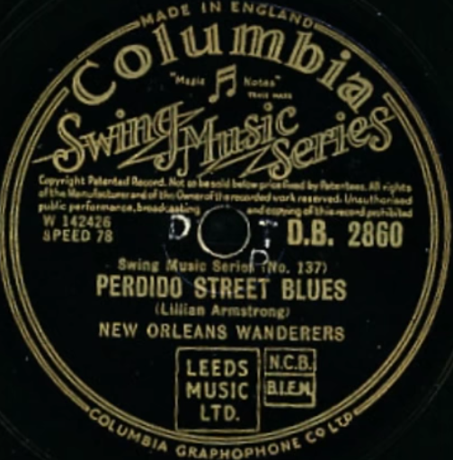

Name of the band under which Lil Hardin recorded with members of Louis Armstrong's Hot Five on a 1926 session for Columbia Records.
Louis Armstrong himself was unable to appear since he was under contract to Okeh, although he collaborated with Hardin on three of the four songs.
His place was taken by George Mitchell. Four further songs were released by the same musicians under the name New Orleans Bootblacks.

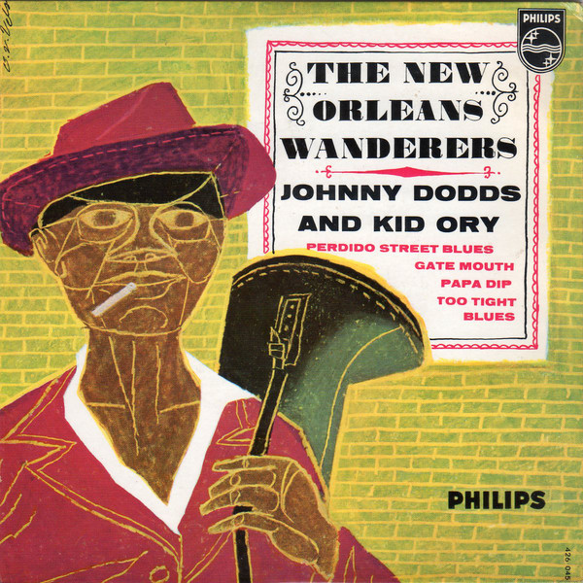

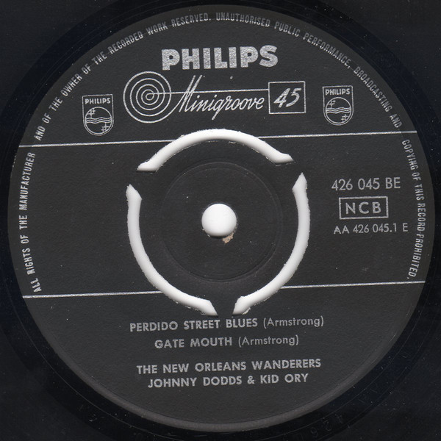

2. Oh, Didn’t He Ramble (traditional) 2:55
A2 Bunk Johnson Brass Band: Bunk Johnson, Kid Shots Madison-co; Jim Robinson-tb;
Joseph Clark-tu; Isidore Barbarin-alto horn; Adolphe Alexander-baritone horn; George
Lewis-Eb cl; Baby Dodds-snare drum; Lawrence Marrero-bass drum.
New Orleans, July 1944.
78rpm American Music 103/matrix unknown. LP Folkways FJ 2803 (1951).

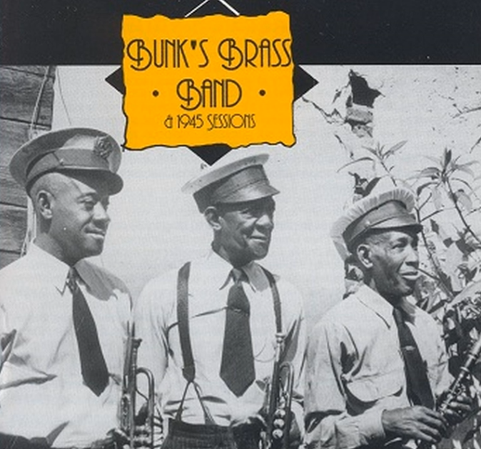

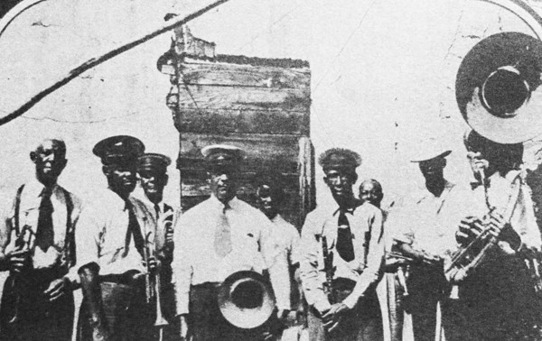

3. Bottle It Up and Go (traditional) 2:27
A3 Dallas Jug Band: Will Shade-hca; Jab Jones-jug; Charlie Burse-voc, g; Vol
Stevens-voc, mandolin; Otto Gilmore-perc; unknown-female backing vocals.
Richmond, IN. Wednesday, August 3, 1932.
78rpm Varsity 6025/matrix unknown. LP Folkways FJ 2803 (1951).

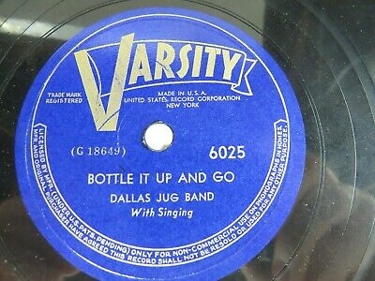

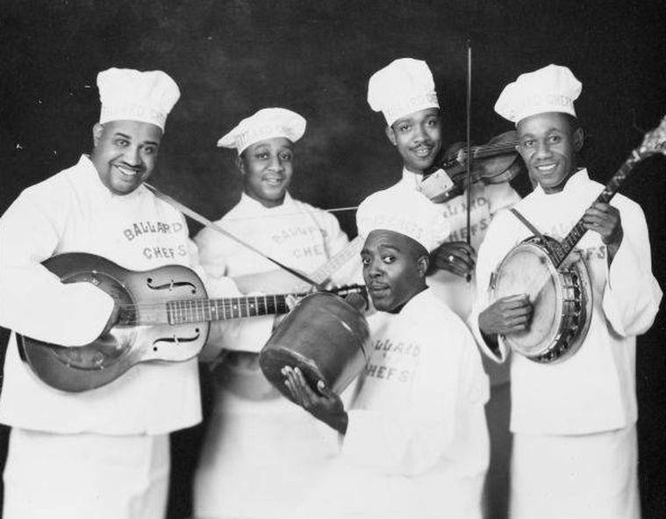
unknown jug band

4. I’ll See You in the Spring, When the Birds Begin to Sing 3:03
xyz Memphis Jug Band: Will Shade-hca, g, voc; Ben Ramey-kazoo, voc; Vol Stevens-bjo,
mandolin, g, voc; Will Weldon-g, voc; Charlie Polk-jug.
Atlanta, October 20, 1927.
78rpm Victor 21066/40321-1.

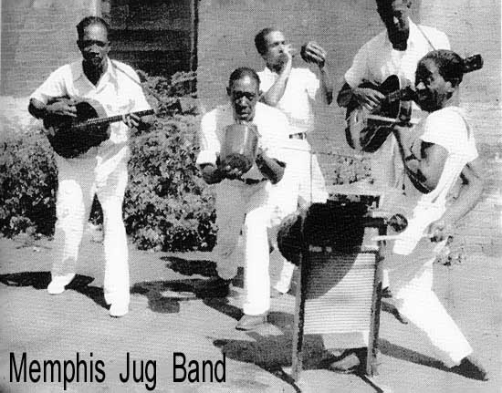

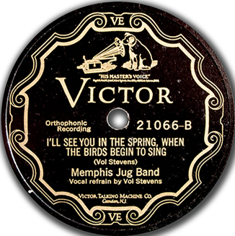

5. Snake Rag (King Oliver) 2:58
A4 King Oliver’s Creole Jazz Band: King Oliver, Louis Armstrong-co; Honore Dutrey-tb;
Johnny Dodds-cl; Lil Hardin-p; Bill Johnson-bjo; Baby Dodds-dr.
Richmond, IN, April 6, 1923.
78rpm Gennett 5184/11391. LP Folkways FJ 2803 (1951).

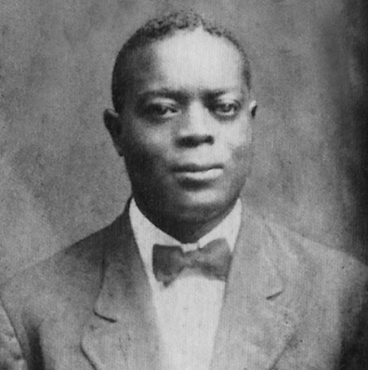
Joe “King” Oliver

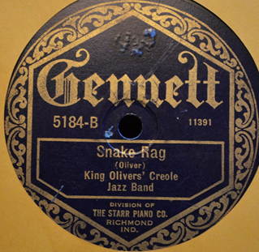

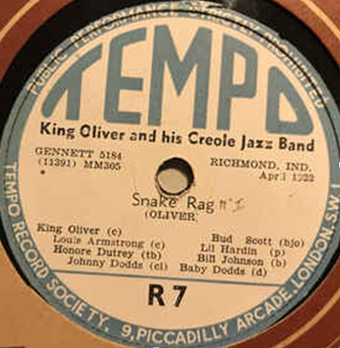

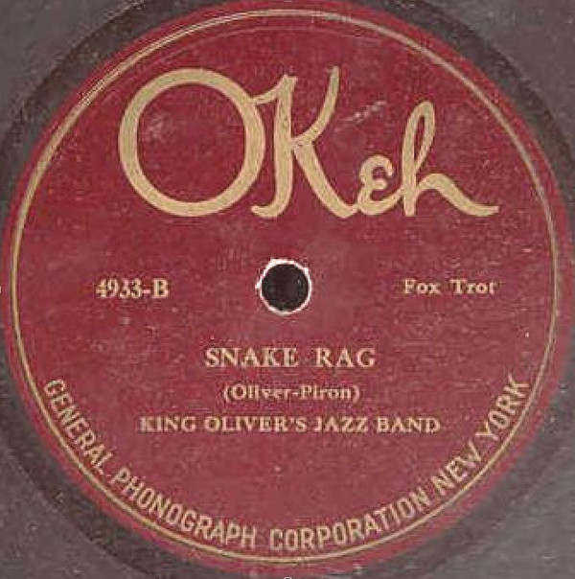

Brian Rust Discography
Richmond, IN, April 6, 1923
KING OLIVER'S CREOLE JAZZ BAND: King Oliver, Louis Armstrong, c / Honore Dutrey, tb / Johnny Dodds, cl / Lil Hardin, p / Bill Johnson, bj, v break / Baby Dodds, d.
11391 Snake Rag Gennet 5184, UHCA 76, JI 5, JC L-4, Tem R-7, AF A-03,
Sto KB, 104, XX 3

Tom Lord Discography
Richmond, Indiana, April 6, 1923
11391 Snake rag Gen 5184, Riv 1029, 12-122, (Du)RM8805, Herwin H106, London (E)AL3504, VJM (E)VLP49, Byg (F)529070, Folkways FP57, FJ2803, Time-Life STL-J26, Olympic OL7133

6. New Orleans Blues (Joys) (Jelly Roll Morton) 2:38
A5 Jelly Roll Morton-piano solo.
Washington, DC, June 8, 1938.
78rpm Circle 27/1681. LP Folkways FJ 2803 (1951).

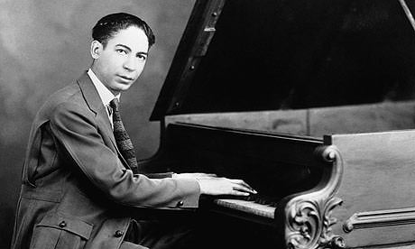

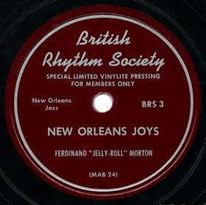

7. Down by the Riverside (traditional) 2:52
A6 Bunk Johnson Original Superior Band: Bunk Johnson-tp; Jim Robinson-tb; George
Lewis-cl; Walter Decou-p; Lawrence Marrero-bjo; Austin Young-b; Ernest Rogers-dr.
New Orleans, June 11, 1942.
78rpm Jazz Man 8/matrix unknown. LP Folkways FJ 2803 (1951).

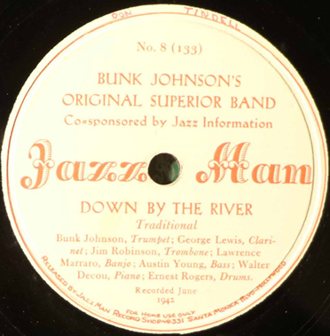

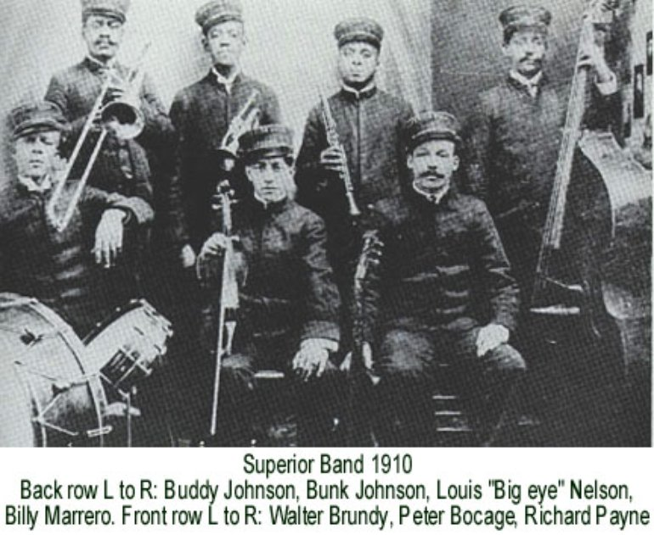

8. Keyhole Blues (W. Wilson) 3:22
A7 Louis Armstrong and His Hot Seven: Louis Armstrong-co, voc; John Thomas-tb;
Johnny Dodds-cl; Lil Armstrong-p; Johnny St.Cyr-bjo, g; Pete Briggs-tu; Baby Dodds-dr.
Chicago, May 13, 1927.
78rpm OKeh 8496/80876-B. LP Folkways FJ 2803 (1951).

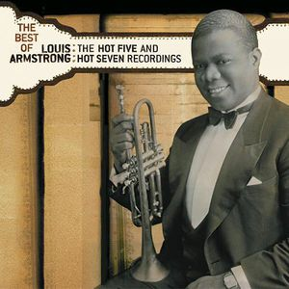

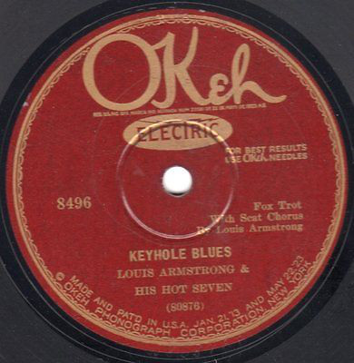

9. Dippermouth Blues (King Oliver) 2:33
B1 King Oliver’s Creole Jazz Band: King Oliver, Louis Armstrong-co; Honore Dutrey-tb;
Johnny Dodds-cl; Lil Hardin-p; Bill Johnson-bjo; Baby Dodds-dr.
Richmond, IN, April 6, 1923.
Gennett 5132/11389-B. LP Folkways FJ 2803 (1951).

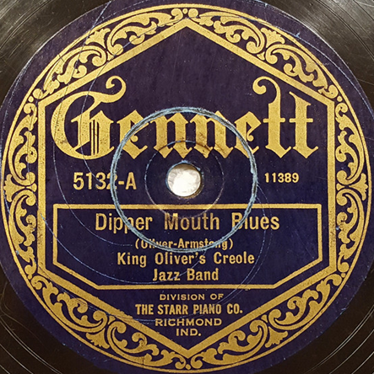

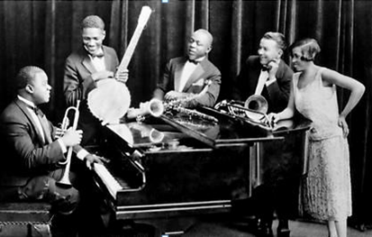

10. High Society (Porter Steele) 2:55
B2 King Oliver’s Creole Jazz Band: King Oliver, Louis Armstrong-co; Honore Dutrey-tb;
Johnny Dodds-cl; Lil Hardin-p; Bud Scott-bjo; Baby Dodds-dr.
Chicago, June 22, 1923.
78rpm OKeh 4933/8393-B. LP Folkways FJ 2803 (1951).

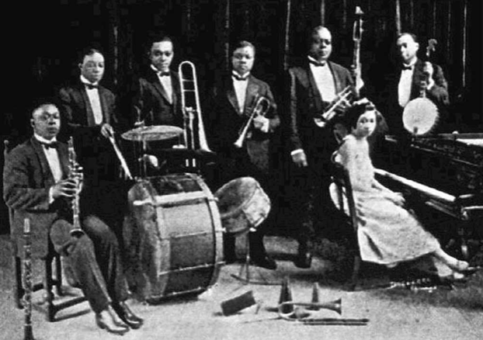

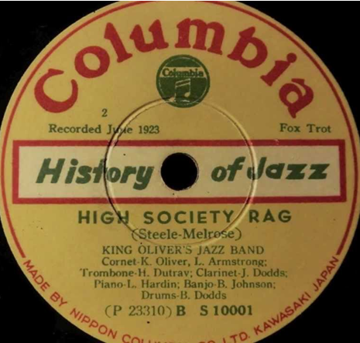

11. Milenberg Joys (Rappolo-Mares-Morton) 2:45
B3 The New Orleans Rhythm Kings: Paul Mares-co; George Brunies-tb; Leon Roppolo-cl;
Jack Pettis-Cmel; Glenn Scoville-as, ts; Don Murray-cl, ts; Jelly Roll Morton-p; Bob
Gillette-bjo; Chink Martin-tu; Ben Pollack-dr.
Richmond, IN, July 18, 1923.
78rpm Gennett 5217/11551-A. LP Folkways FJ 2803 (1951).

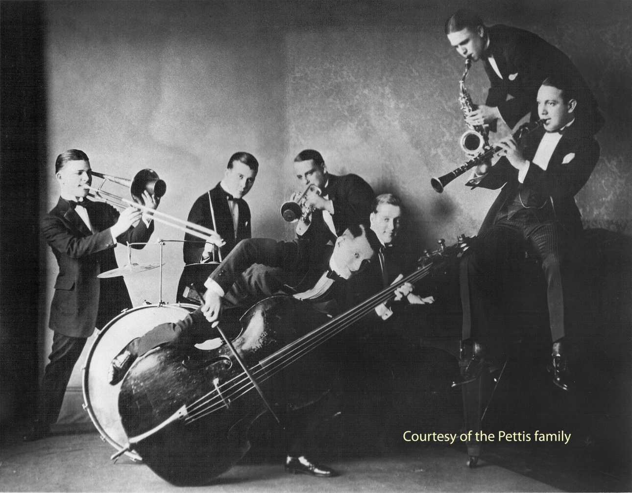

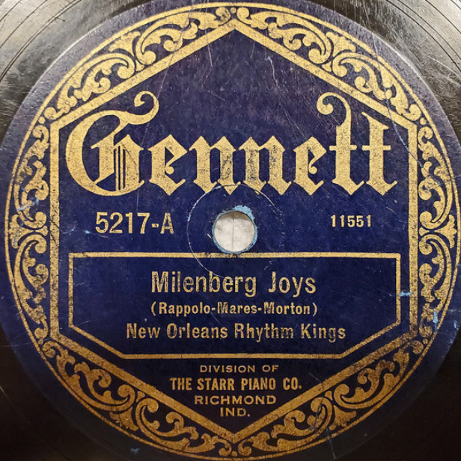

12. Tiger Rag (Original Dixieland Jazz Band) 2:21
B4 The New Orleans Rhythm Kings (Friars Society Orchestra, Dusk O’Hare-dir): Elmer
Schoebel-p, arr; Paul Mares-co; George Brunies-tb; Leon Rappollo-cl; Jack Pettis-Cmel,
ts; Lou Black-bjo; Arnold Loyocano-b; Frank Snyder-dr.
Richmond, IN, August 29, 1922.
78rpm Gennett 4968/11183-C. LP Folkways FJ 2803 (1951).

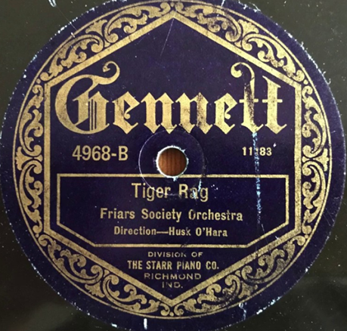

13. Cake Walking Babies (From Home) (Williams-Smith-Troy) 3:17
B5 The Red Onion Jazz Babies: Louis Armstrong-co; Charlie Irvis-tb; Sidney Bechet-cl, ss;
Lil Armstrong-p; Buddy Christian-bjo; Alberta Hunter, Clarence Todd-voc.
New York, December 23, 1924.
78rpm Gennett 5627/9248-A. LP Folkways FJ 2803 (1951).

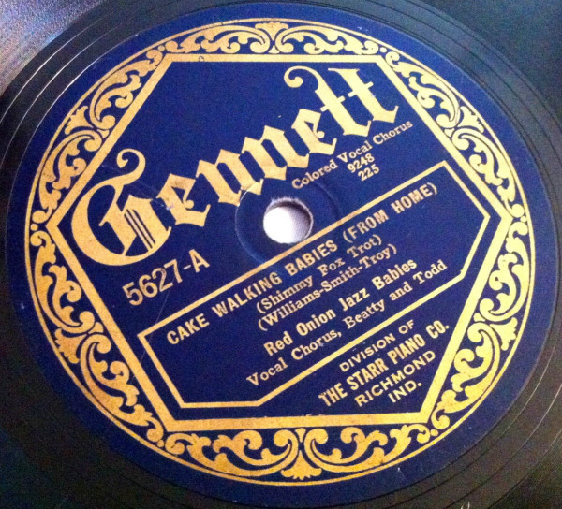

14. Hea’ Me Talkin’ to Ya (Lilian Hardin) 3:05
B6 Johnny Dodds and His Orchestra: Natty Dominique-co; Honore Dutrey-tb; Johnny
Dodds-cl; Lil Armstrong-p; Bill Johnson-b; Baby Dodds-dr.
Chicago, February 7, 1929
78rpm Victor 38541/48798-4. LP Folkways FJ 2803 (1951).

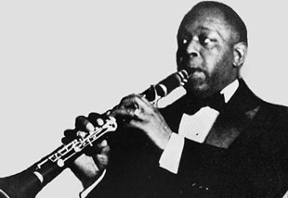

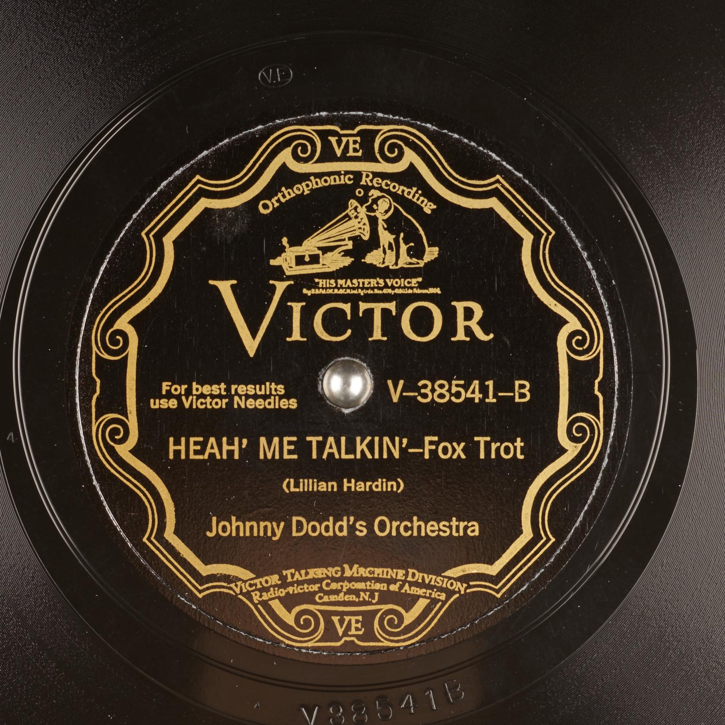

15. Mournful Serenade (Chimes Blues) (King Oliver) 3:19
B7 Jelly Roll Morton Quartet: Geechie Fields-tb; Omer Simeon-cl; Jelly Roll Morton-p;
Tommy Benford-dr.
New York, June 11, 1928.
78rpm Victor 38024/45624-1. LP Folkways FJ 2803 (1951).

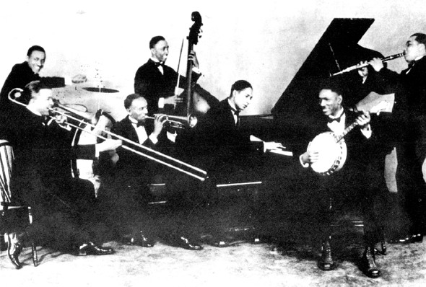

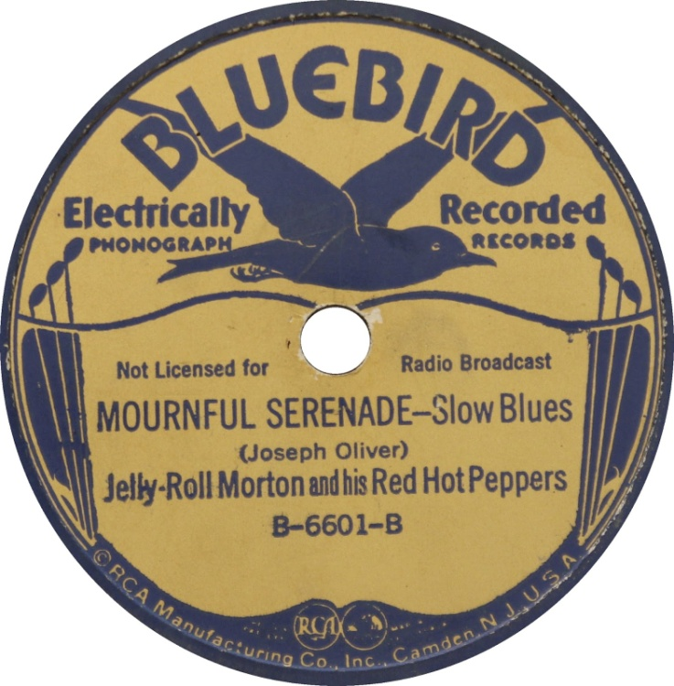

16. Livery Stable Blues (Dominick J. LaRocca) 3:06
17. Dixieland Jass Band One-Step (ODJB) 2:35
Original Dixieland Jazz Band: Nick LaRocca-co; Eddie Edwards-tb; Larry Shields-cl; Henry Ragas-p; Tony Sbarbaro (Spargo)-dr.
New York, February 26, 1917.
78rpm Victor 18255/19331-1 and 19332-3. CD RCA ND90650 (1992).

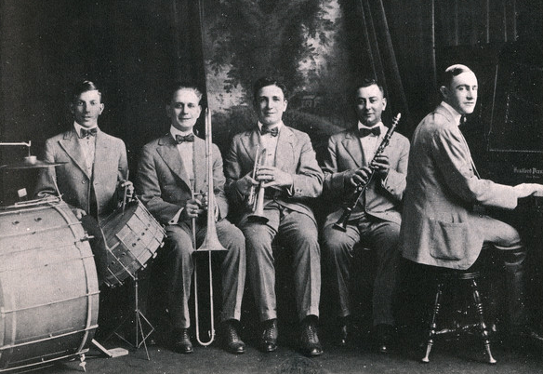

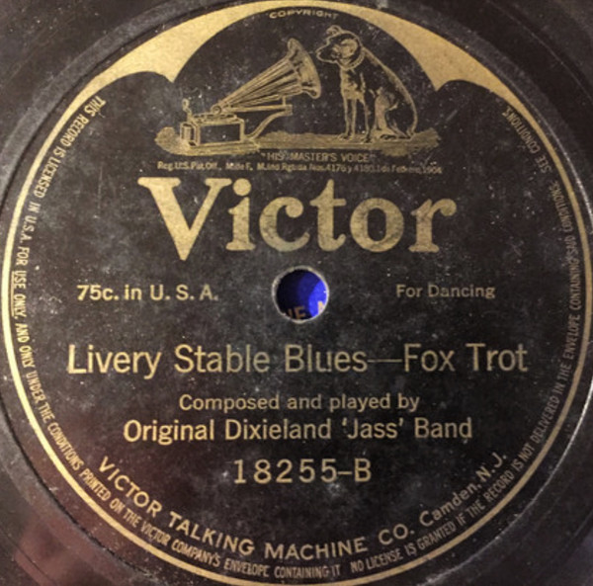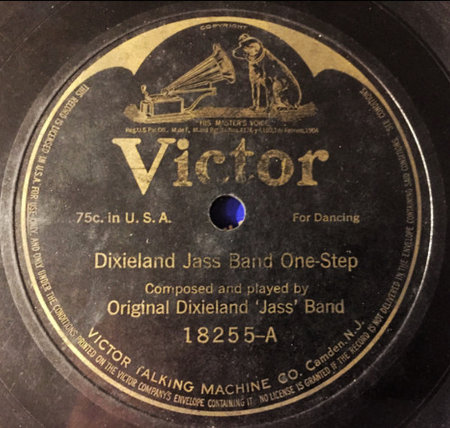

18. Ory’s Creole Trombone (Kid Ory) 3:11
Spikes’ Seven Pods of Pepper Orchestra (Ory’s Sunshine Orchestra): Mutt Carey-co;
Kid Ory-tb; Dink Johnson-cl; Fred Washington-p; Ed Garland-b; Ben Borders-dr.
Los Angeles, June 1922.
78rpm Nordskog 3009/matrix unknown. CD West Hill Radio Archives 6003 (2006).

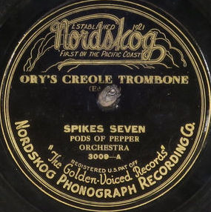

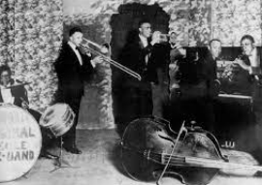

19. Shim-Me-Sha-Wabble (Spencer Williams) 2:55
New Orleans Rhythm Kings (formerly Friars Society Orchestra): Paul Mares-co; George
Brunies-tb; Leon Roppolo-cl; Mel Stitzel-p; Ben Pollack-dr.
Richmond, IN, March 12, 1923.
78rpm Gennett 5106/11354-B.

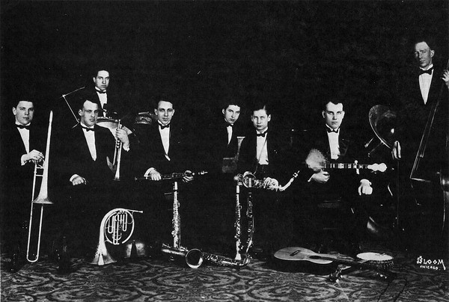

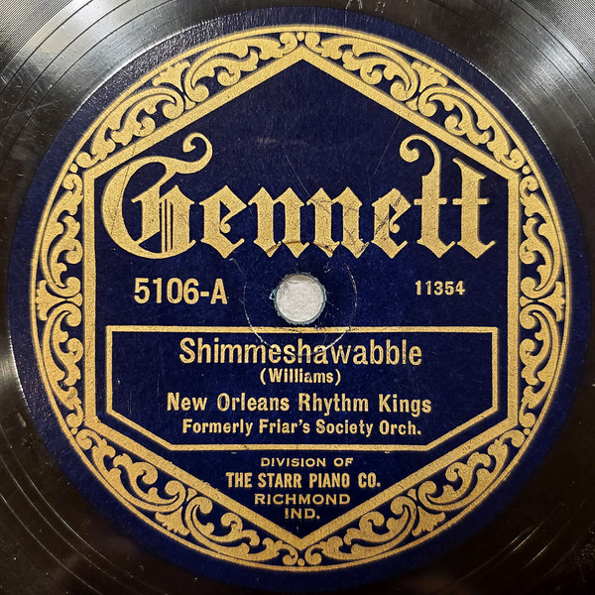

20. Hotter That That (Lilian Hardin Armstrong) 3:03
Louis Armstrong and His Hot Five: Louis Armstrong-co, voc; Kid Ory-tb; Johnny Dodds-cl; Lil Armstrong-p; Johnny St.Cyr-bjo; guest artist Lonnie Johnson-g.
Chicago, December 13, 1927.
78rpm OKeh 8535/82055-B. CD West Hill Radio Archives 6003 (2006).

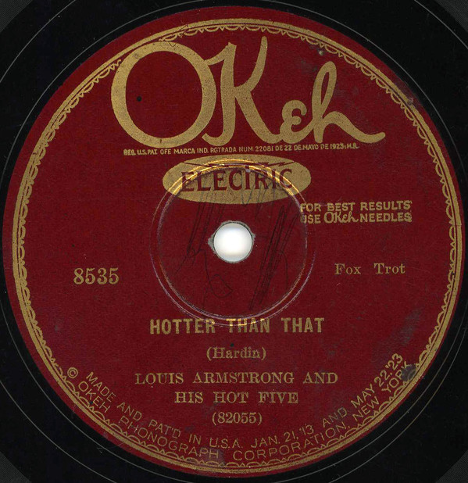

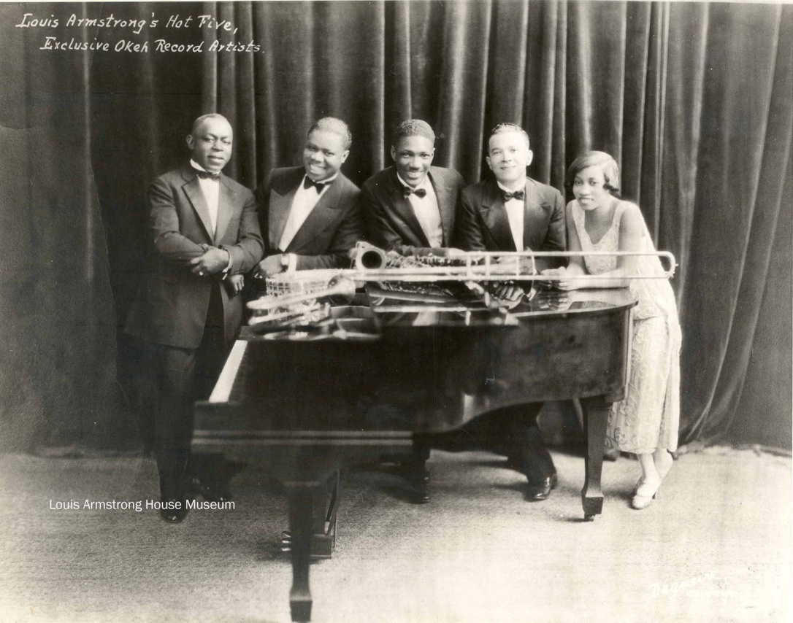

21. Singin’ the Blues (Jimmy McHugh) 3:02
Frankie Trumbauer and His Orchestra: Frankie Trumbauer-Cmel; Bix Beiderbecke-co;
Bill Rank-tb; Jimmy Dorsey-cl, as; Doc Ryker-as; Paul Mertz-p; Howdy Quicksell-bjo;
Eddie Lang-g; Chauncey Morehouse-dr.
New York, February 4, 1927.
78rpm OKeh 40772/80393-B.

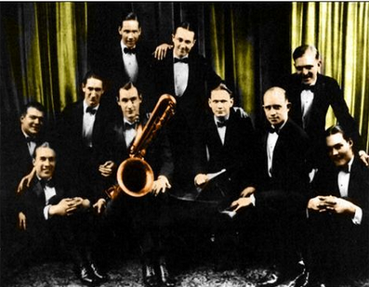

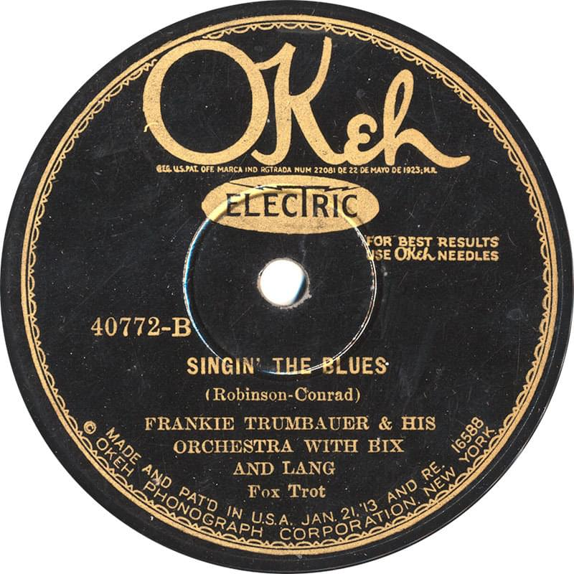

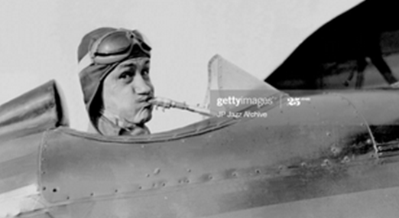

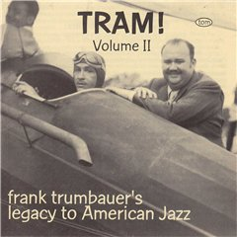

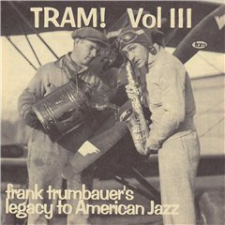

22. Meanest Blues (Phil Napoleon-Frank Signorelli) 3:15
Original Memphis Five: Phil Napoleon-tp; Charlie Panelli-tb; Jimmy Lytell-cl; Frank
Signorelli-p; Jack Roth-dr.
New York, October 1, 1924.
78rpm Victor 19480/30877-2.

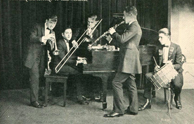

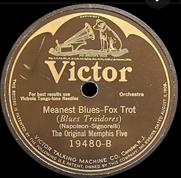

23. Indiana (James F. Hanley) 2:40
Red Nichols and his Five Pennies: Red Nichols, Leo McConville, Manny Klein-tp; Glenn
Miller-tb, arr; Jack Teagarden, Bill Trone or Herb Taylor-tb; Benny Goodman-cl, as, bs; Babe Russin-ts; Arthur Schutt-p; Carl Kress-g; Art Miller-b; Gene Krupa-dr.
New York, April 18, 1929.
78rpm Brunswick 4373/E-29708-A.

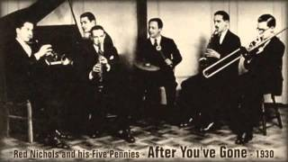

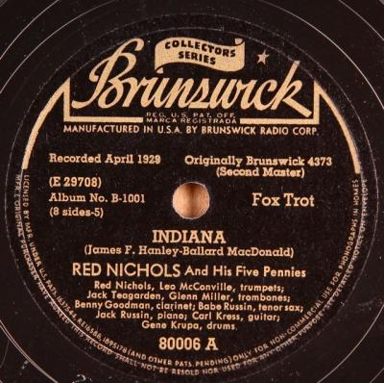

24. Doin’ Things (Joe Venuti) 2:43
Joe Venuti’s Blue Four: Joe Venuti-vio; Eddie Lang-g; Frank Signorelli-p.
New York, June 21, 1928.
78rpm Victor 21561/45812-3.

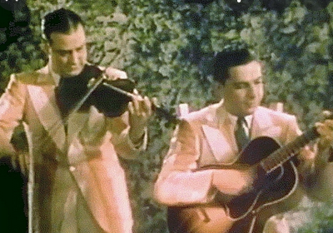

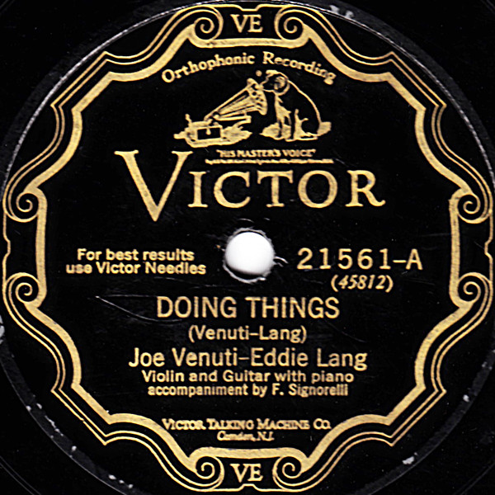

25. Makin’ Whoopee (Walter Donaldson-Gus Kahn) 3:14
Paul Whiteman and his Orchestra: Charlie Margulis, Harry Goldfield, Manny Klein, Eddie
Pinder-co; Boyce Cullen, Wilbur Hall, Bill Rank, Jack Fulton-tb; Chester Hazlett-cl, bcl, as;
Izzy Friedman-cl, ob; Red Mayer-bsn, Eh, picc; Frankie Trumbauer-cl, ss, as, Cmel, bsn;
Charles Strickfaden-ss, as, bs, ob; Kurt Dieterle, Mischa Russell, Matt Malneck, Mario Perry-
vio; Roy Bargy-p; Lennie Hayton-cel; Mike Pingitore-bjo; Min Leibrook-tu; Mike
Trafficante-b; George Marsh-dr (probable personnel); Bing Crosby-voc; Ferde Grofé-arr.
New York, December 22, 1928.
78rpm Columbia 1683-D/147540-7.

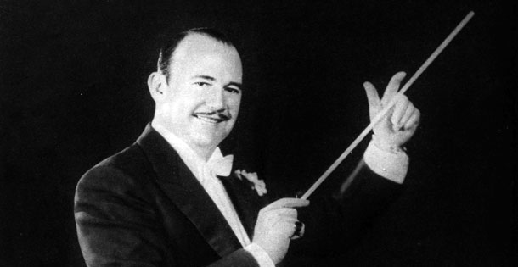

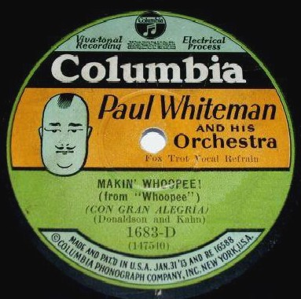

26. It Don’t Mean a Thing (Duke Ellington-Irving Mills) 3:08
Duke Ellington and his Orchestra: Arthur Whetsel, Freddy Jenkins, Cootie Williams-tp;
Joe Nanton, Lawrence Brown-tb; Juan Tizol-vtb; Johnny Hodges-cl, ss, as; Harry Carney-cl,
as, bs; Barney Bigard-cl, ts; Duke Ellington-p; Fred Guy-bjo; Wellman Braud-b; Sonny
Greer-dr; Ivie Anderson-voc.
New York, February 2, 1932.
78rpm Brunswick 6265/B-11204-A.

