11 JAZZ ROCK, FUSION… 16/78:54

00A On Green Dolphin Street (Bronislaw Kaper) 5:15
Stan Getz Quartet: Stan Getz-ts; Gary Burton-vib; Steve Swallow-b; Roy Haynes-dr.
Live at Salle Pleyel, Paris, November 13, 1966.
CD Verve 517 330-2.

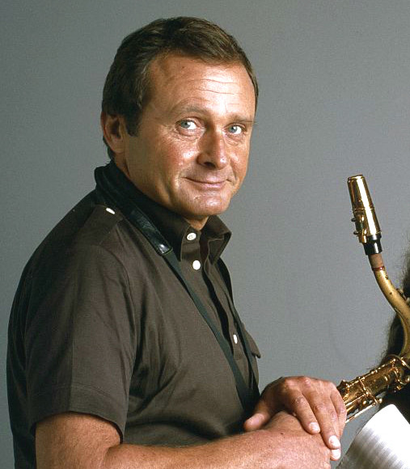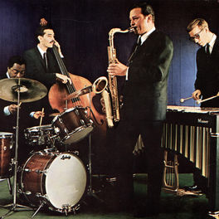
Stan Getz (1927 – 1991) & His Quartet (1964 – 1966)

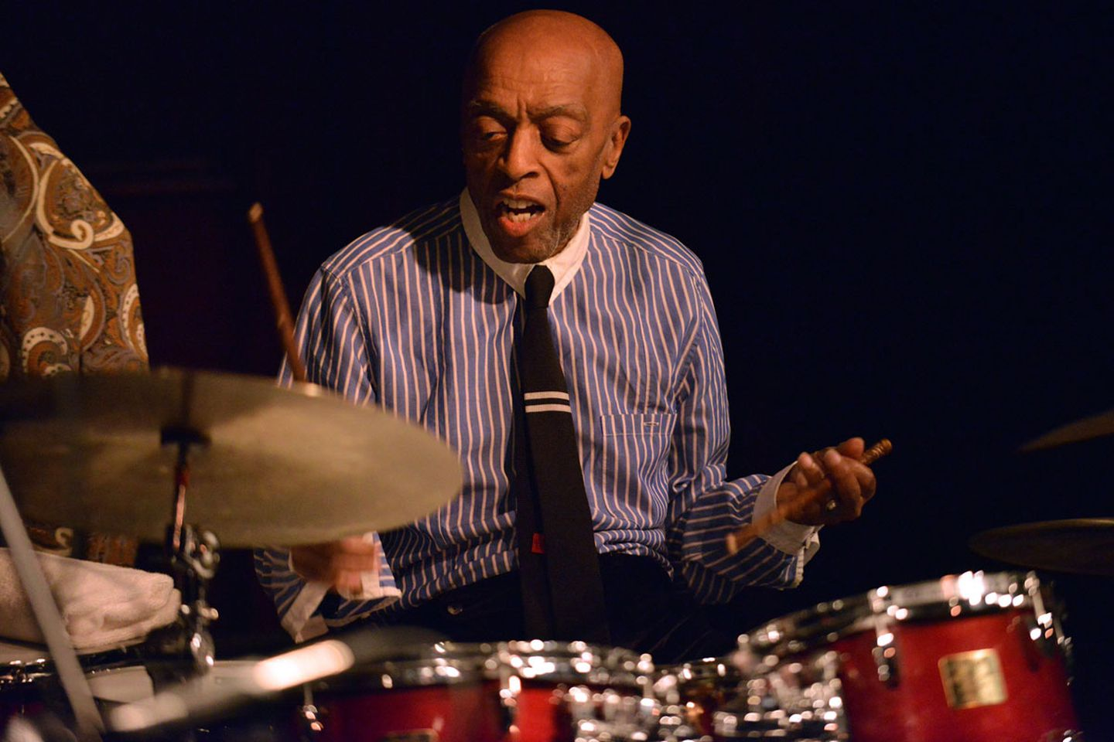
Roy Haynes (*1925) - photo 2013 = 88 years old

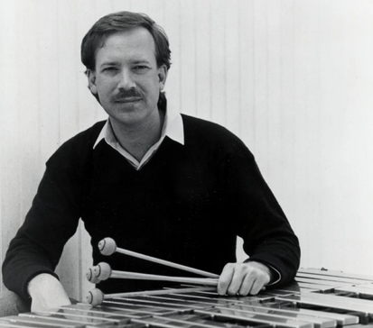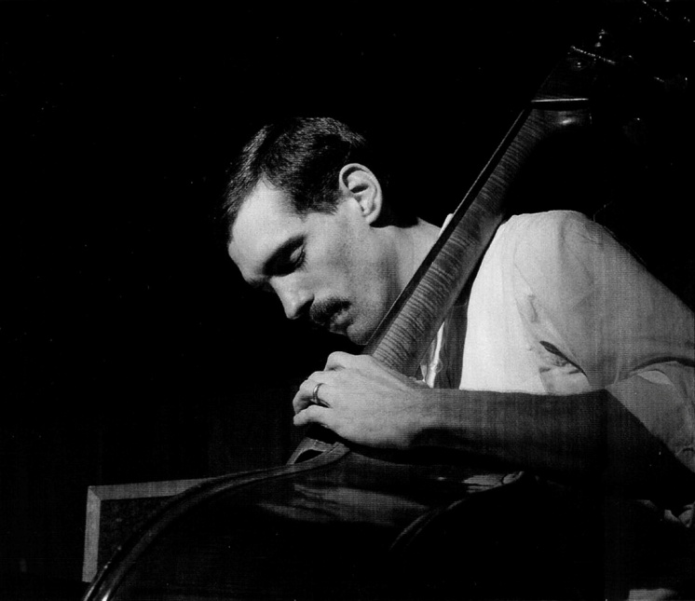
Gary Burton (*1943) Steve Swallow (*1940)

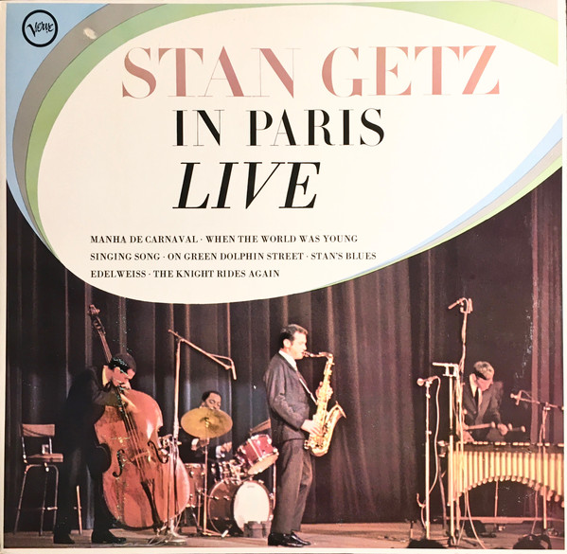

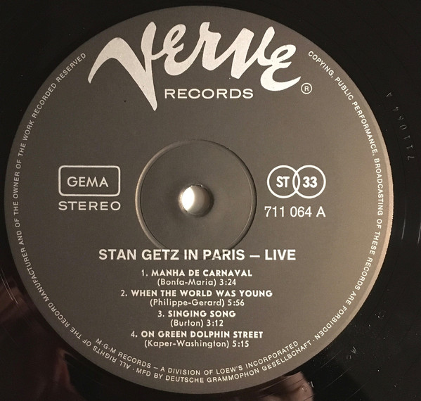

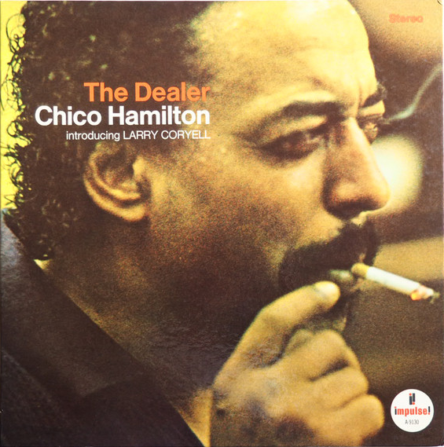

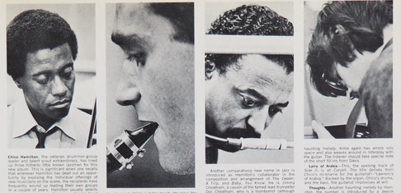
Richard Davis-bass Arnie Lawrence-alto Chico Hamilton-drums Larry Coryell-guit
Recorded September 18, 1966.

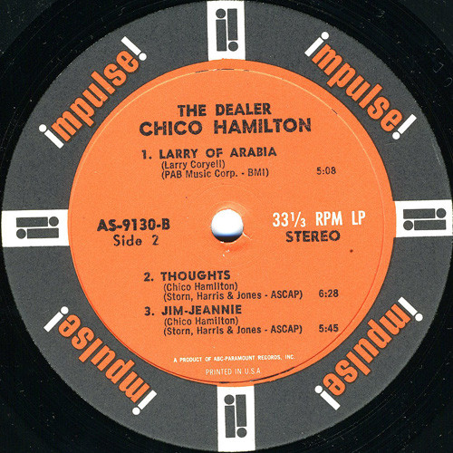

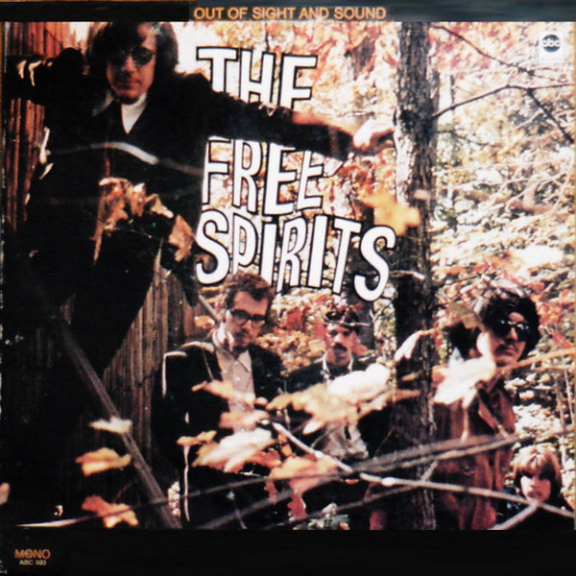

00B Cosmic Daddy Dancer (Larry Coryell-Columbus Baker) 2:30
The Free Spirits: Larry Coryell-lead g, lead voc, sitar; Columbus Baker-rhythm g, voc harmonies; Chris Hills-bg; Jim Pepper-ts, fl; Bob Moses-dr.
New Jersey, late 1966.
LP ABC(S) 593.

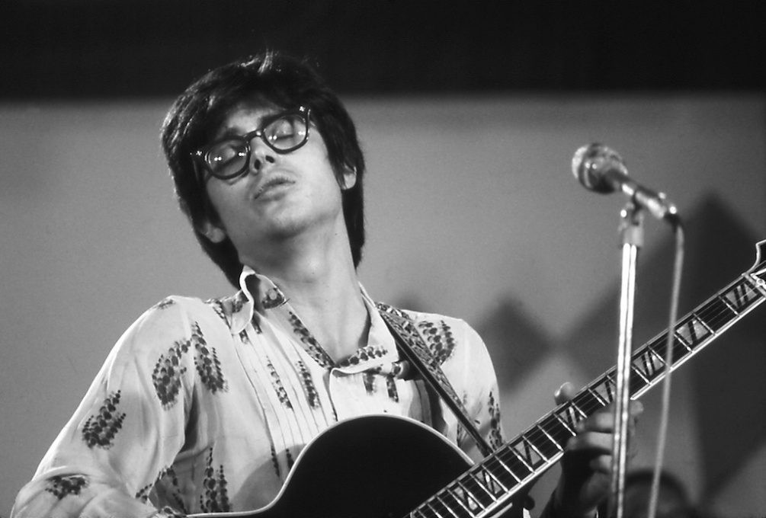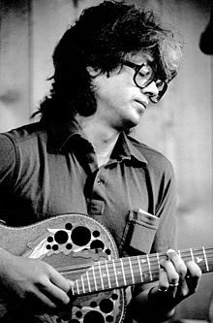
Larry Coryell (1943 – 2017)

The Free Spirits
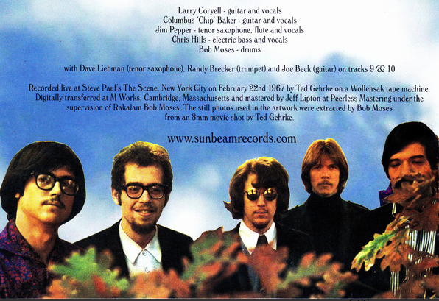

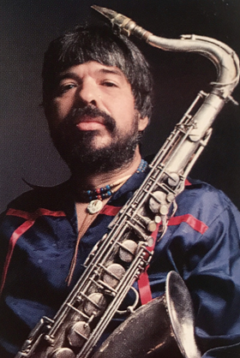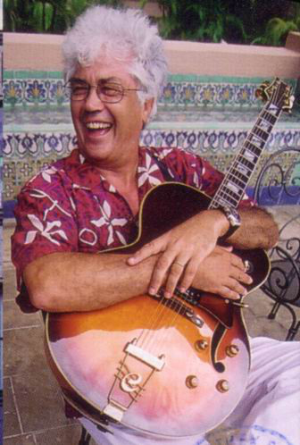
Jim Pepper (1941 – 1992) Larry Coryell

01 Ballet (Mike Gibbs) 4:55
Gary Burton Quartet: Gary Burton-vibes; Larry Coryell-g; Steve Swallow-b; Roy Haynes-dr.
New York, April 18, 1967.
LP RCA Victor LSP-3835.

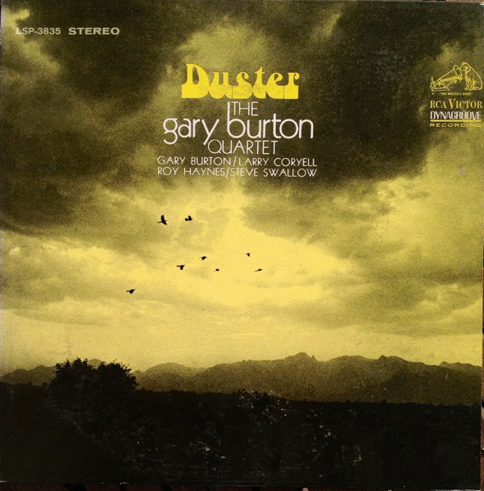

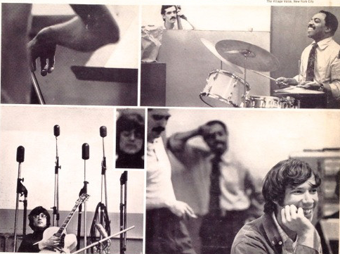

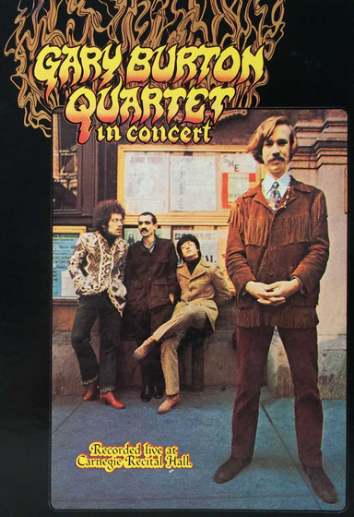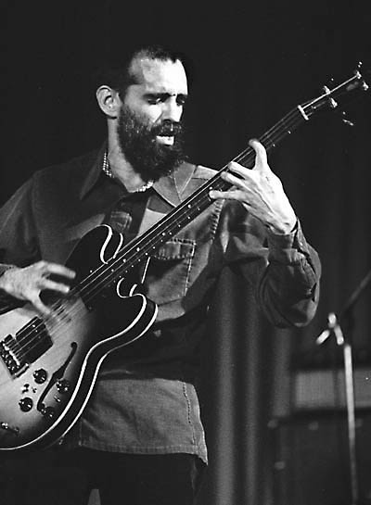

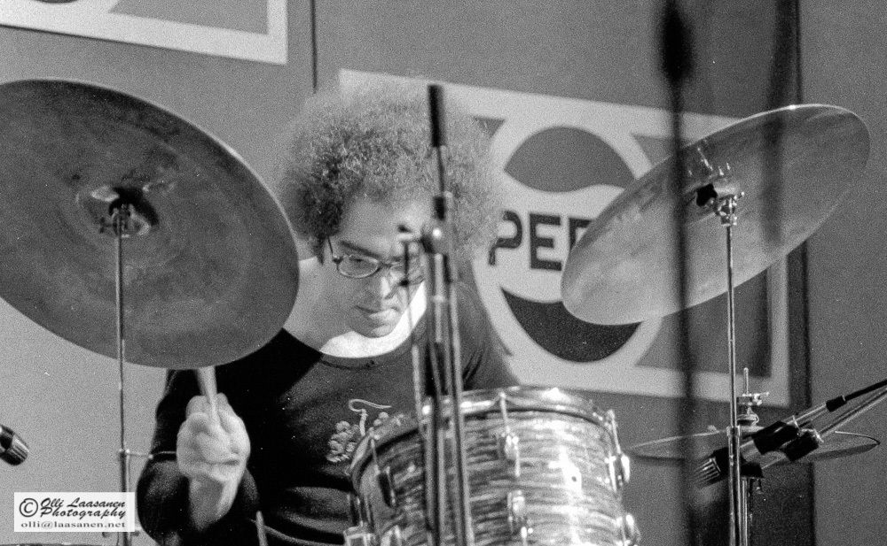
Bob Moses (*1948)

02 It’s All Becoming So Clear Now (Mike Mainieri) 5:25
Mike Mainieri-vib; Jeremy Steig-fl; Joe Beck-elg; Sam Brown-elg, acg; Warren Bernhardt-
p, org; Hal Gaylor-b; Chuck Rainey-elb; Donald MacDonald-dr.
Recorded 1968.
LP Solid State SS 18049.

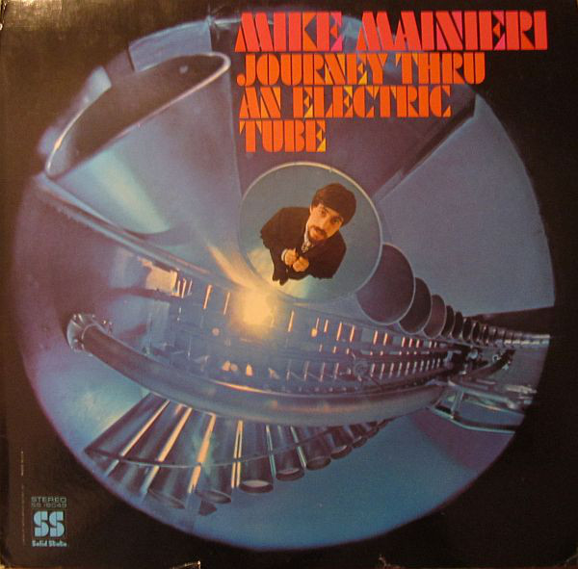

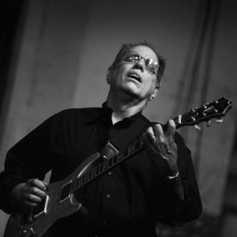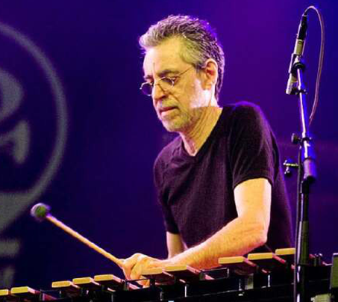
Joe Beck (1945 – 2008) Mike Mainieri (* 1938)

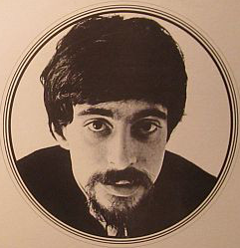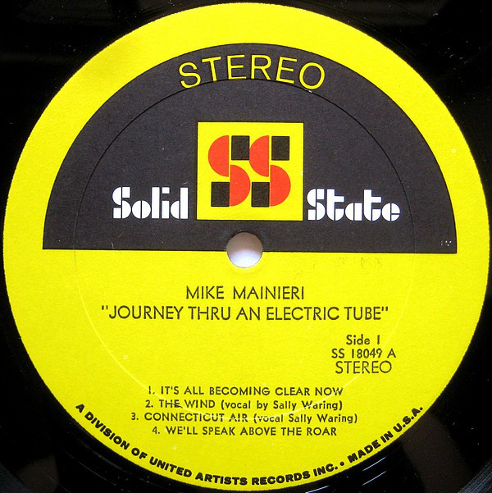

03 Little Church (Miles Davis) 3:17
Miles Davis-tp; Steve Grossman-ss; Chick Corea, Herbie Hancock-elp; Keith Jarrett-org;
John McLaughlin-g; Dave Holland-b, elb; Jack DeJohnette-dr; Airto Moreira-perc; Hermeto
Pascoal-dr, whistling, voc, elp.
New York, June 4, 1970.
CD Columbia C2K 65135.

Miles Davis: LIVE-EVIL
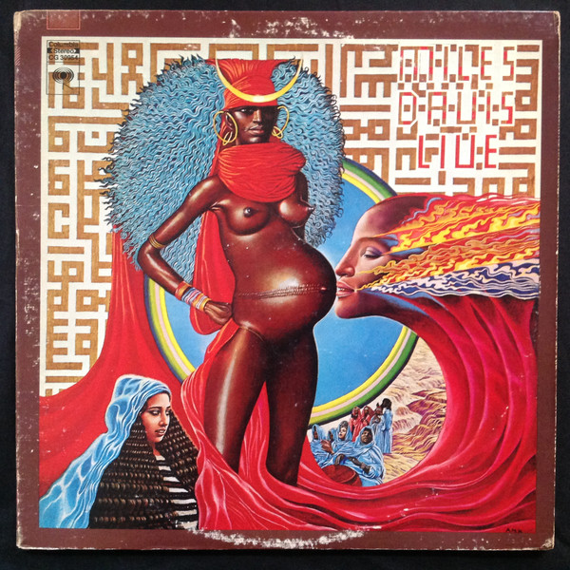

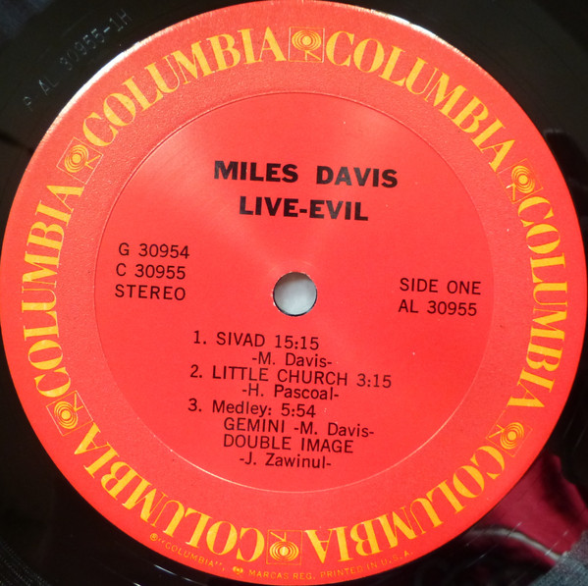

04 Medley: Gemini (Miles Davis)/Double Image (Joe Zawinul) 5:56
Miles Davis-tp; Wayne Shorter-ss; Joe Zawinul, Chick Corea-elp; John McLaughlin-g; Dave
Holland-b; Khalil Balakrishna-sitar; Billy Cobham, Jack DeJohnette-dr; Airto Moreira-perc.
New York, February 6, 1970.
CD Columbia C2K 65135.

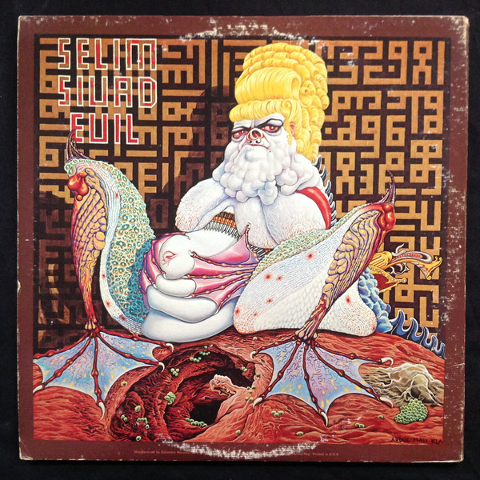

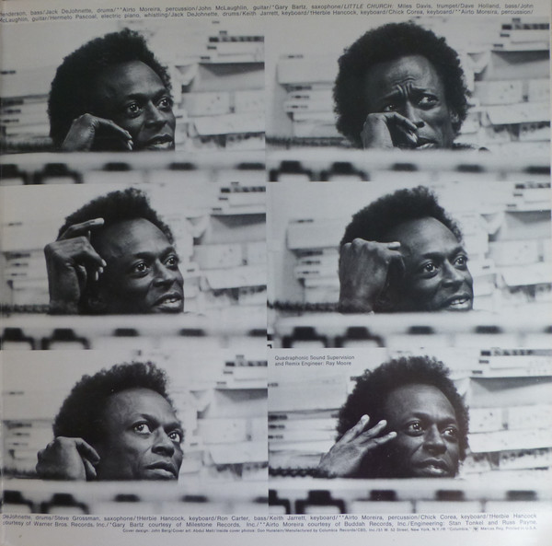

05 Milky Way (Wayne Shorter-Joe Zawinul) 2:33
Weather Report: Wayne Shorter-ss; Joe Zawinul-prepared acoustic piano.
06 Umbrellas (Miroslav Vitouš-W. Shorter-J. Zawinul) 3:26
Weather Report: Wayne Shorter-ss,ts; Miroslav Vitouš-b; Joe Zawinul-p,kb; Alphonse
Mouzon-dr; Airto Moreira-perc.
Columbia Studio B, New York City, February 22 & March 17, 1971.
LP Columbia KC 30661.

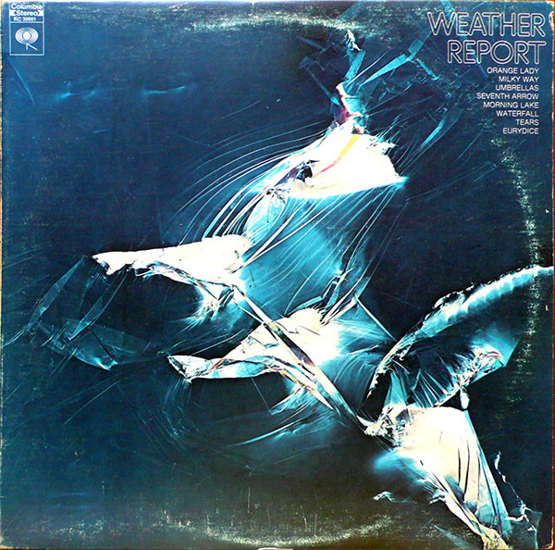

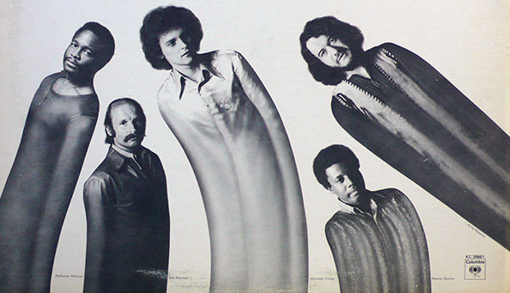

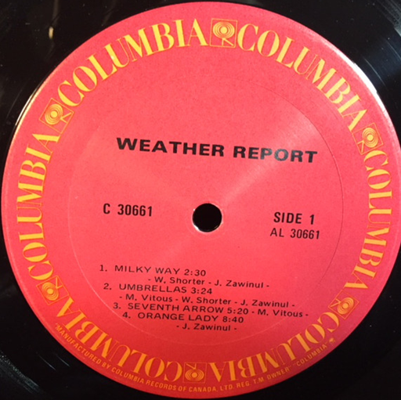

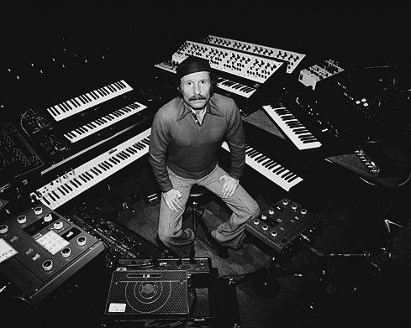

07 Birds of Fire (John McLaughlin) 5:39
Mahavishnu Orchestra: John McLaughlin-g; Jerry Goodman-vio; Jan Hammer-kb,Moog
syn; Rick Laird-b; Billy Cobham-dr.
CBS Studio, New York City & Trident Studios, London, August 1972.
LP Columbia KC 31996.

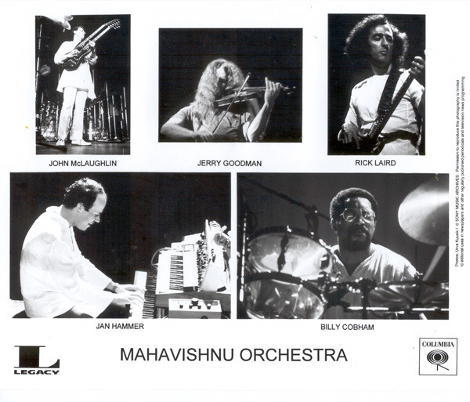

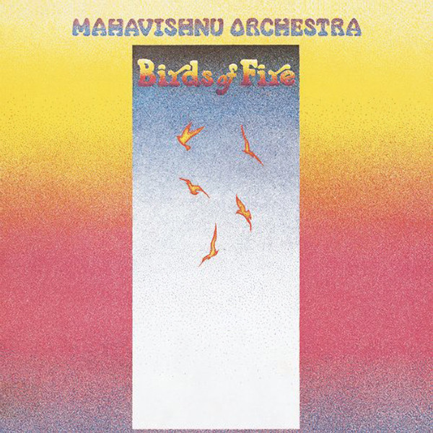

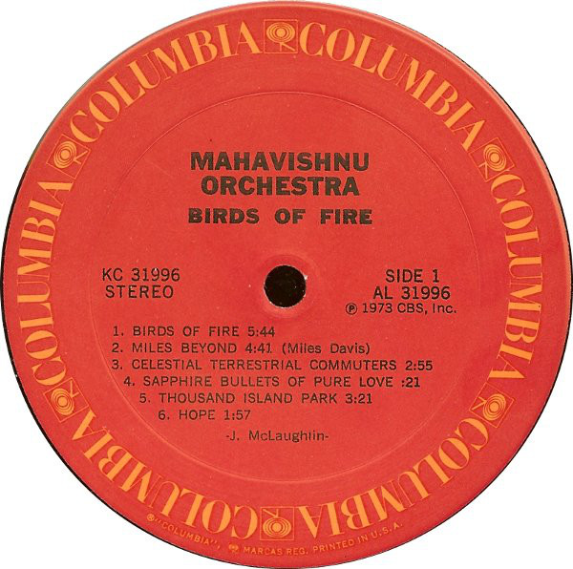

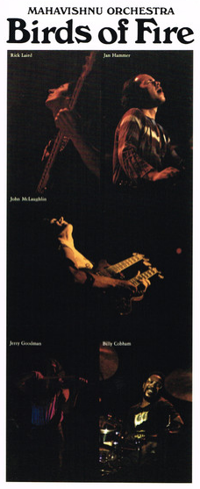

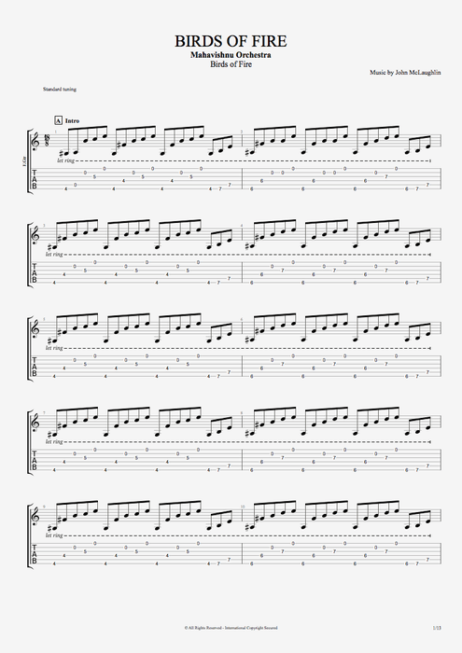

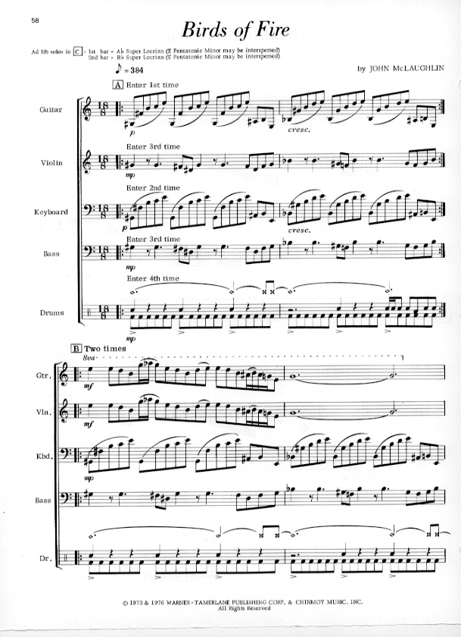

08 La Fiesta (Chick Corea) 7:49
Return to Forever: Joe Farrell-ss; Chick Corea-elp; Stanley Clarke-b; Airto Moreira-dr,perc;
Flora Purim-perc.
IBC Studios, London, February 2-3, 1972.
LP ECM 1022.

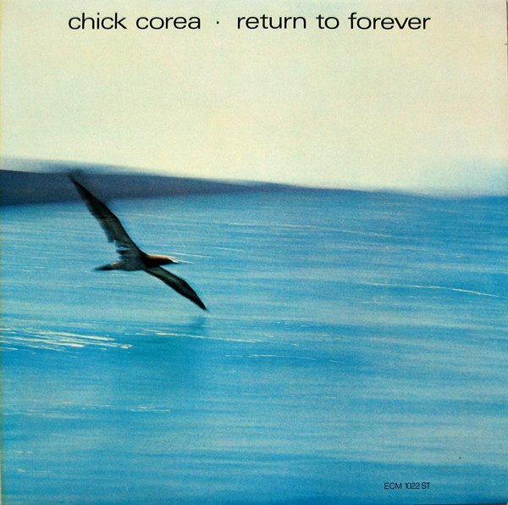

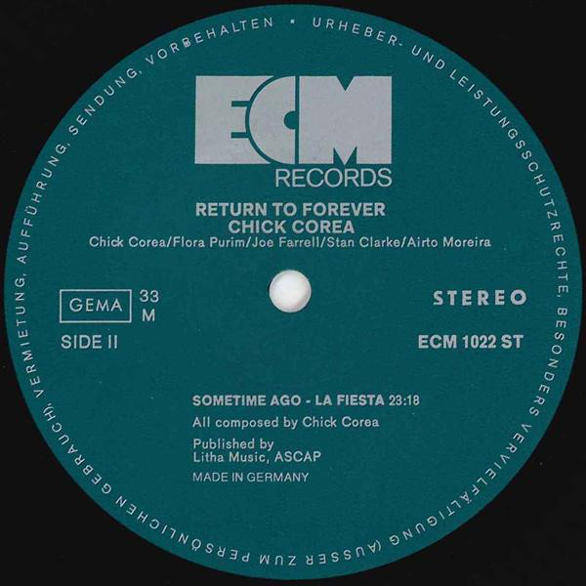

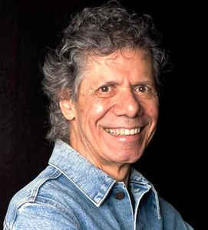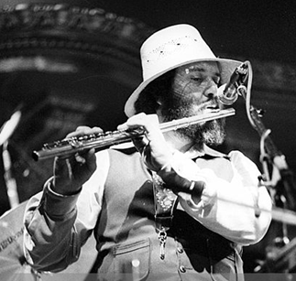

Chick Corea (1941 – 2021) Joe Farrell (1937 – 1986)

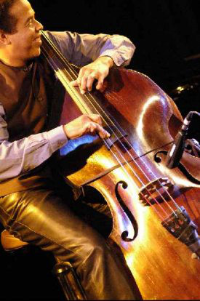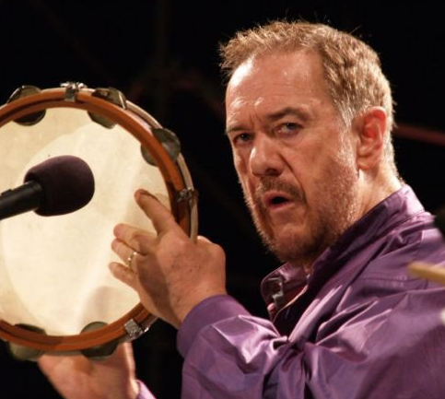

Stanley Clarke (*1951) Airto Guimorvan Moreira (*1941)

09 Grow Your Own (Keith Jarrett) 4:54
Gary Burton-vib; Keith Jarrett-p,elp,ss; Sam Brown-g; Steve Swallow-bg; Bill Goodwin-dr.
A&R Recording Studio, New York City, July 23, 1970.
LP Atlantic SD 1577.

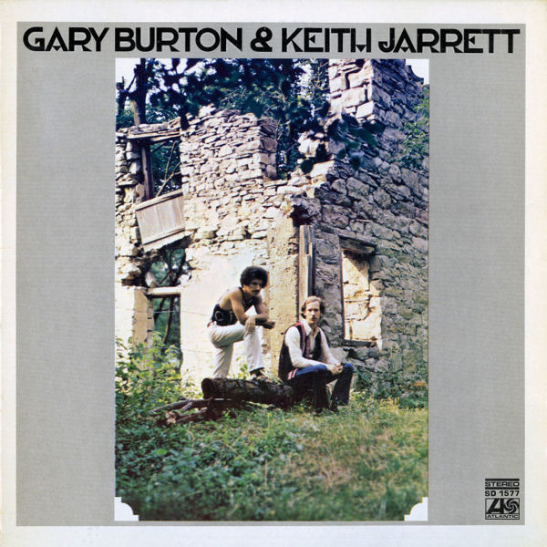

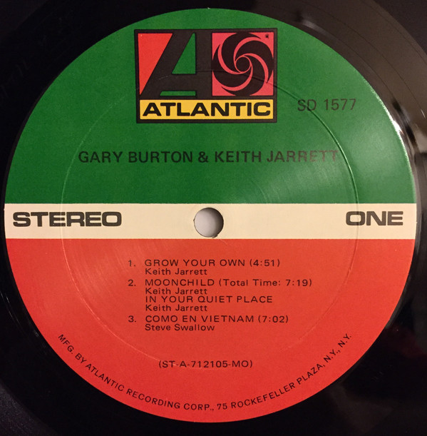

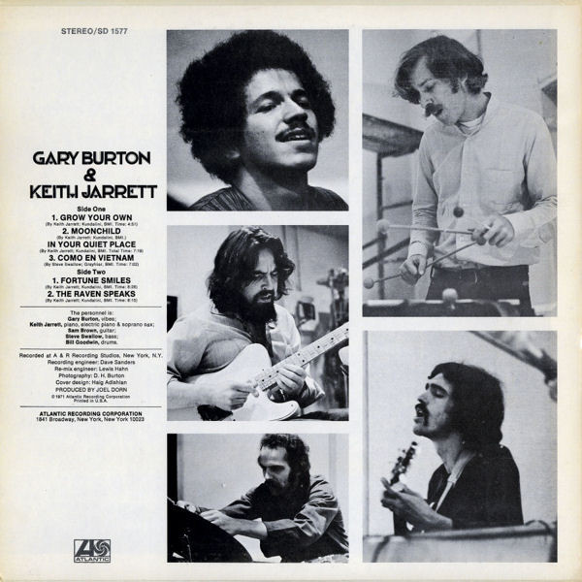

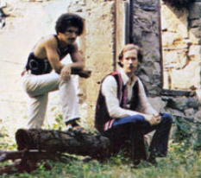

10 Hang Up Your Hang Ups (H. Hancock-P. Jackson-M. Ragin) 5:58
Mwandishi Herbie Hancock-Rhodes elp,Yamaha Electric Grand Piano,Arp Odyssey,Arp
String Ensemble,Hohner D6 Clavinet, Micro-Moog,Oberheim Polyphonic Synthesizer,
Echoplex, Countryman Phase Shifter,Cry Baby Wah Wah; Paul Jackson-elb; James Levi-dr;
Mwile Bennie Maupin-ss,ts,Lyricon; Kenneth Nash-perc; Ray Parker,Jr.-g; Wah Wah
Watson-g,Maestro Universal Synthesizer System, Maestro Sample & Hold,Voice Bag.
Newport Jazz Festival in New York, June 29, 1976.
LP Columbia 34688.

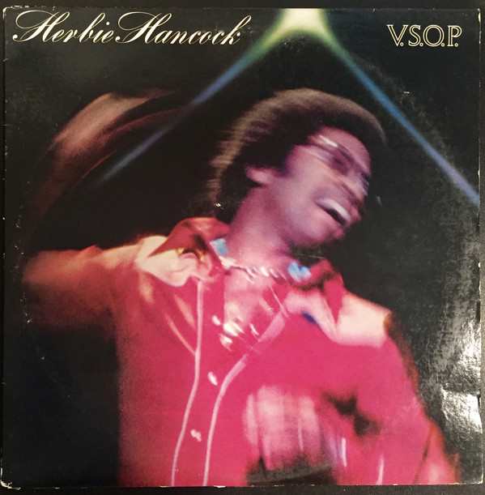

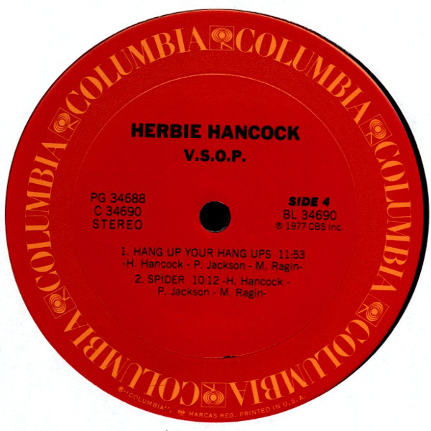

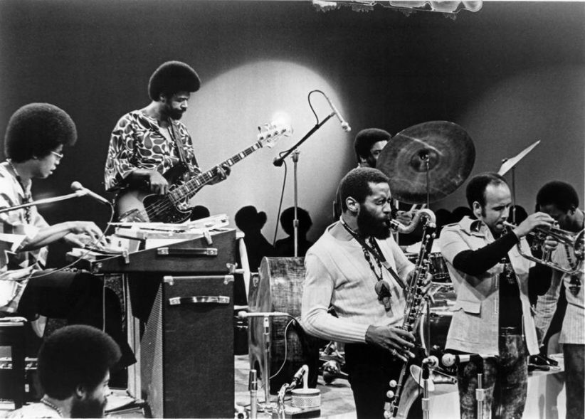

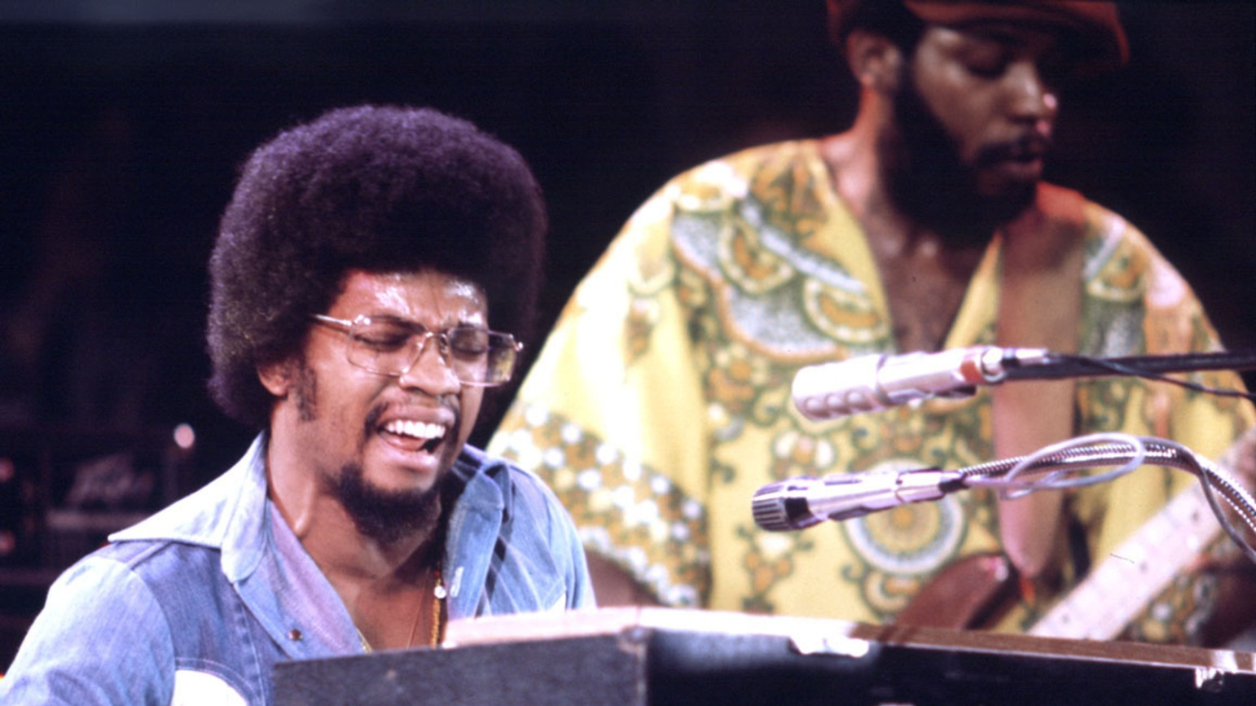

11 Gymnopédies 1 & 2 (Erik Satie/arr. Dick Halligan) 2:36
12 Spinning Wheel (David Clayton Thomas) 4:03
Blood, Sweat and Tears: Lew Soloff, Chuck Winfield-tp,fh; Jerry Hyman-tb,recorder; Fred
Lipsius-as,p; Dick Halligan-org,p,fl,tb,voc; Steve Katz-g,harm,voc; Jim Fielder-b; Bobby
Colomby-dr,perc,voc; David Clayton Thomas-voc.
CBS Studios, New York City, October 7-22, 1968.
LP Columbia CS 9720.

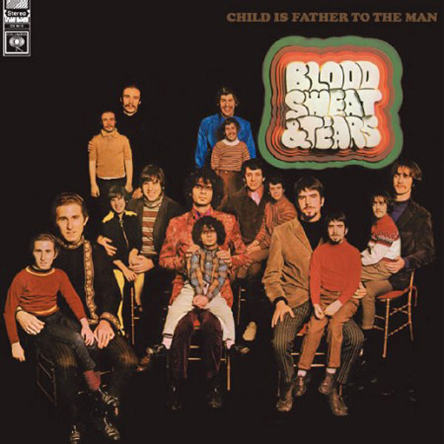
Released February 21, 1968

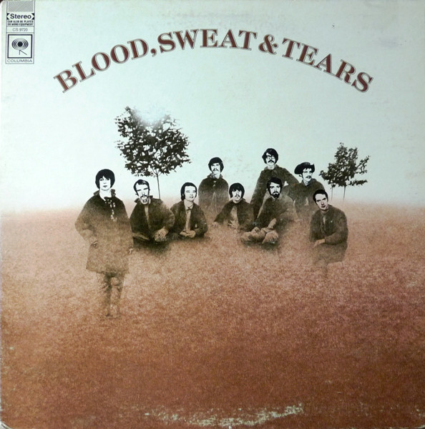
Released November 11, 1968
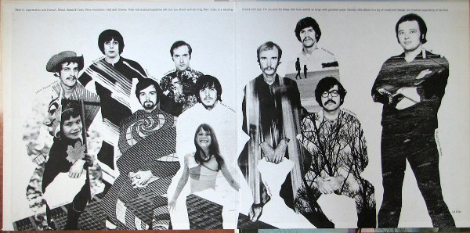

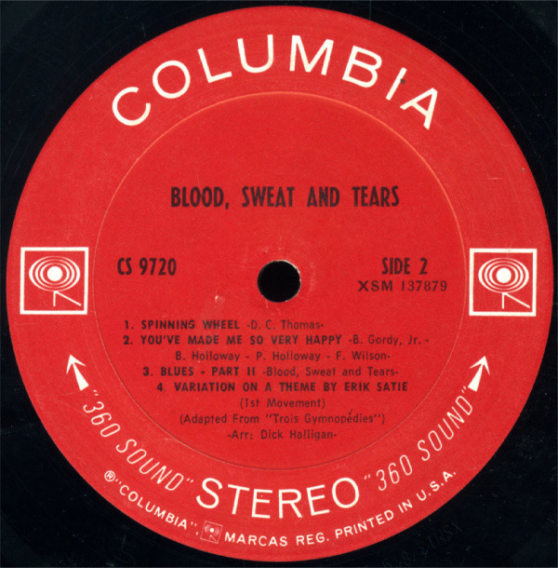

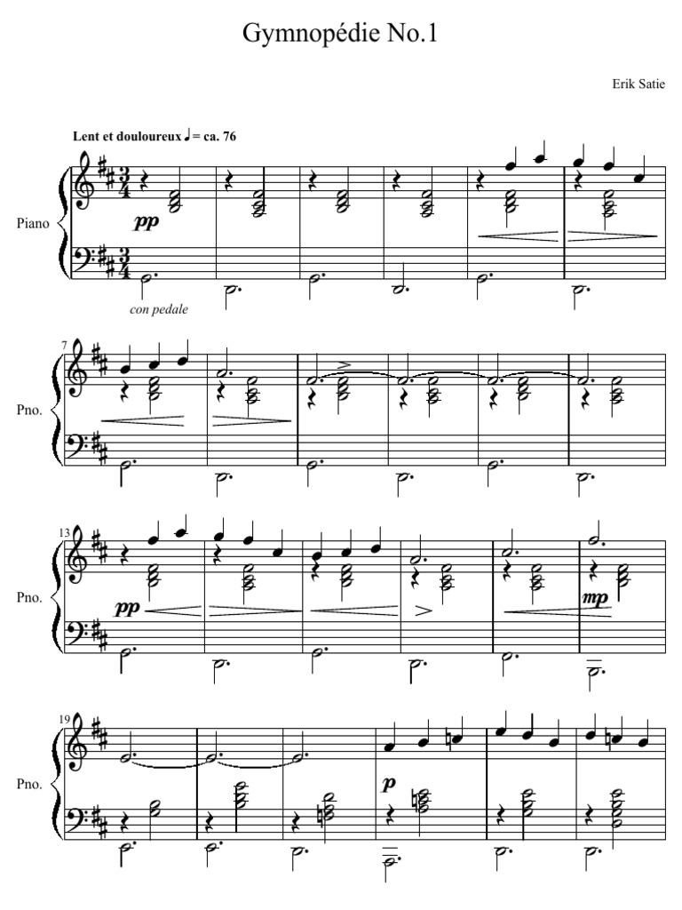

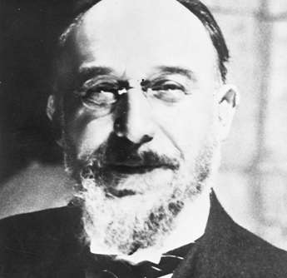
Erik Satie (1866 – 1925)

13 Thorn of a White Rose (Jan Hammer) 5:08
Elvin Jones Trio-dr; Jan Hammer-acp,elp,Moog syn; Gene Perla-acb,elb.
Red Gate Studio, Kent, NY, 1975.
LP Perla Music PMR-005.

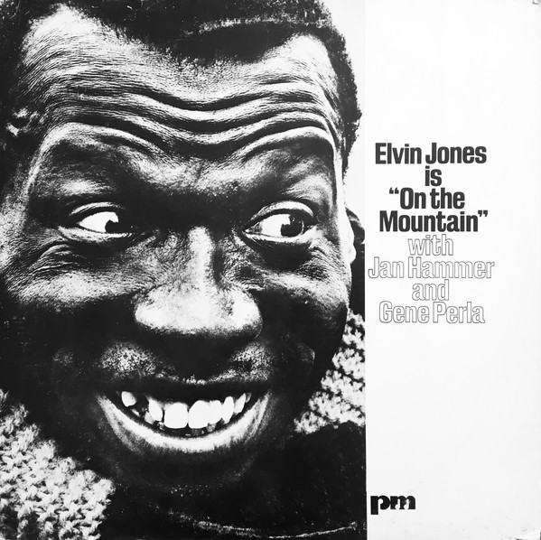

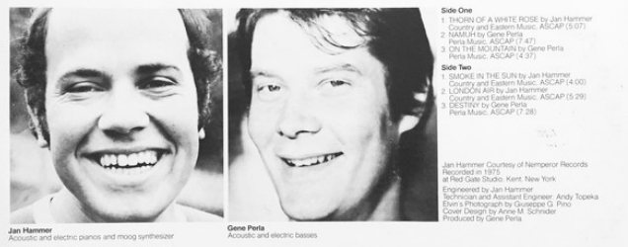

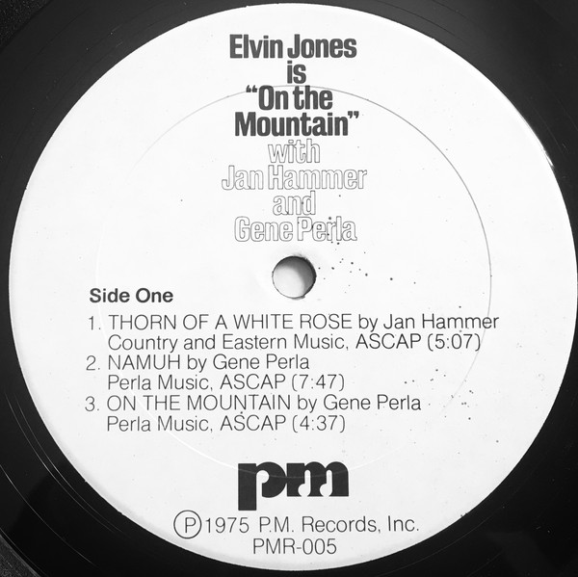

14 Is Once Enough? (Jean-Luc Ponty) 4:57
Jean-Luc Ponty-el.vio; Darryl Stuermer-g; Patrice Rushen-p,elp,syn; Tom Fowler-bg;
Norman Fearrington-dr,perc.
Cherokee Studios, Hollywood, CA, December 1975.
LP Atlantic SD 18163.

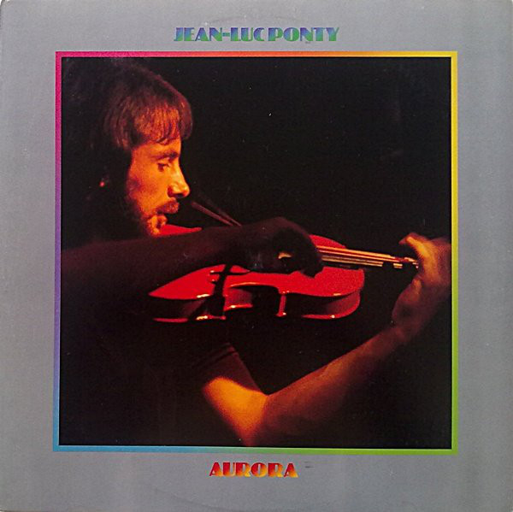

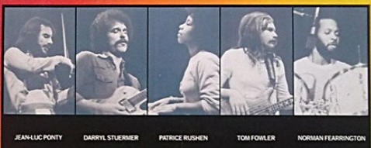

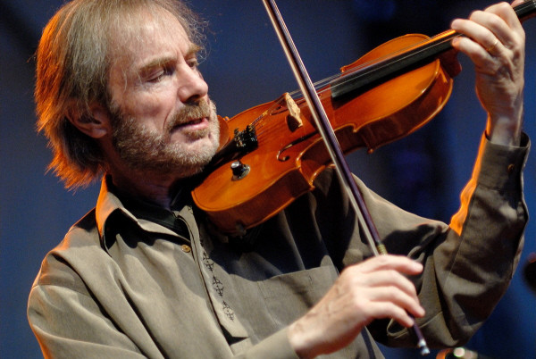

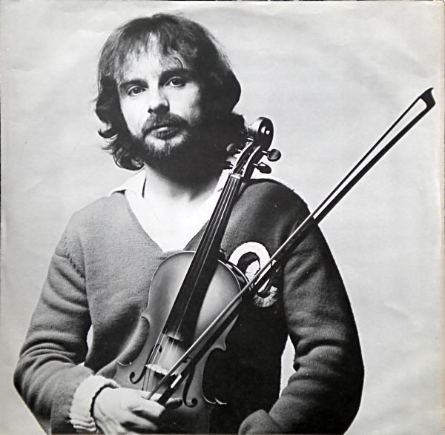

15 Czechoslovakia (Julie Driscoll) 6:25
16 All Blues (Miles Davis-Oscar Brown) 5:44
Julie Driscoll, Brian Auger & The Trinity: Julie Driscoll-voc,acg; Brian Auger-
org,p,elp,voc; David Ambrose-elb,acg,voc; Clive Thacker-dr,perc.
London, 1969.
LP Marmalade 608 005/6.

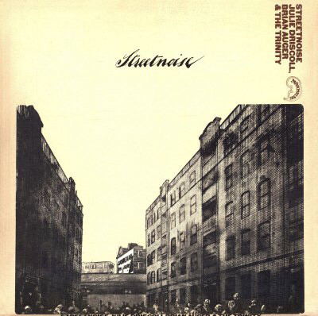

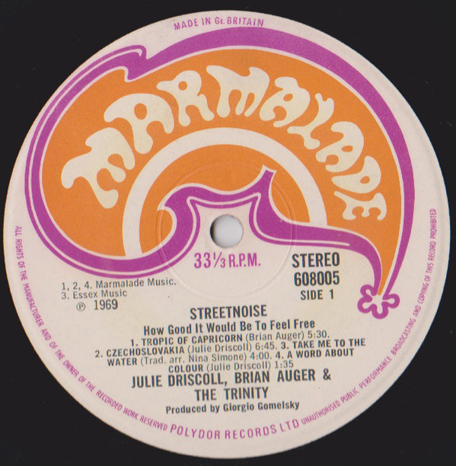

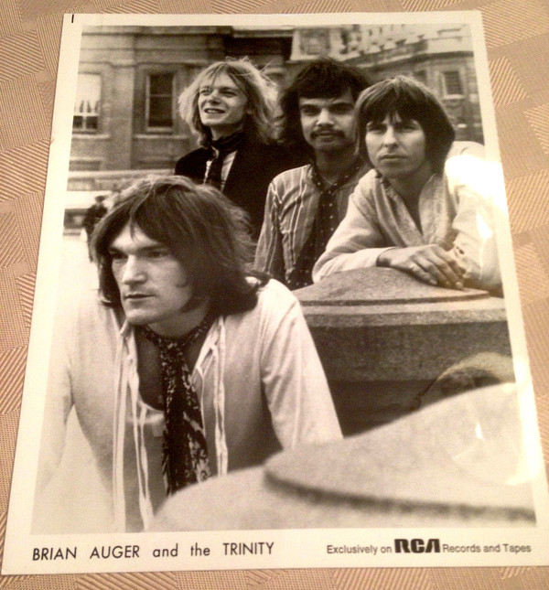

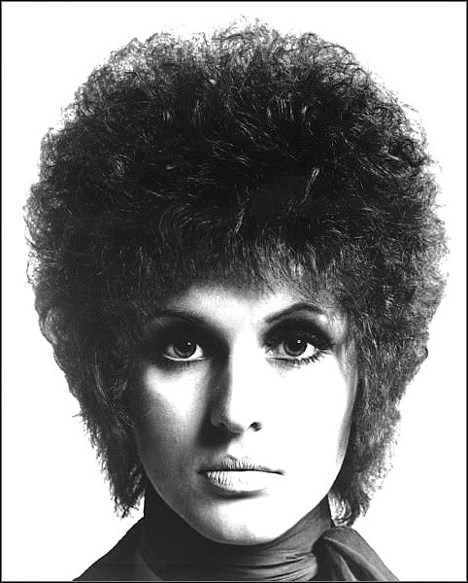
Julie Driscoll (Tippetts) (*1947)

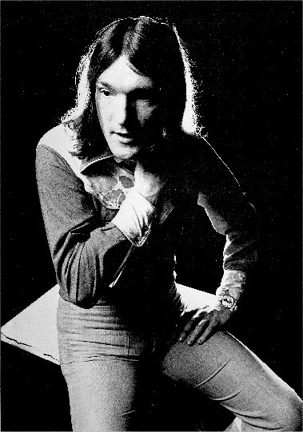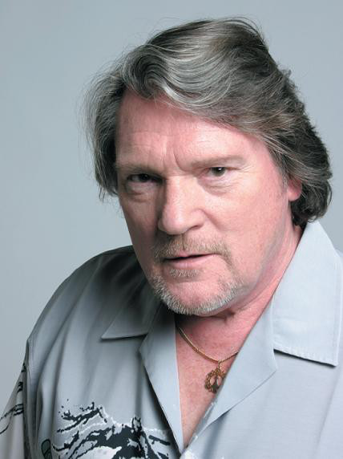
Brian Auger (*1939)

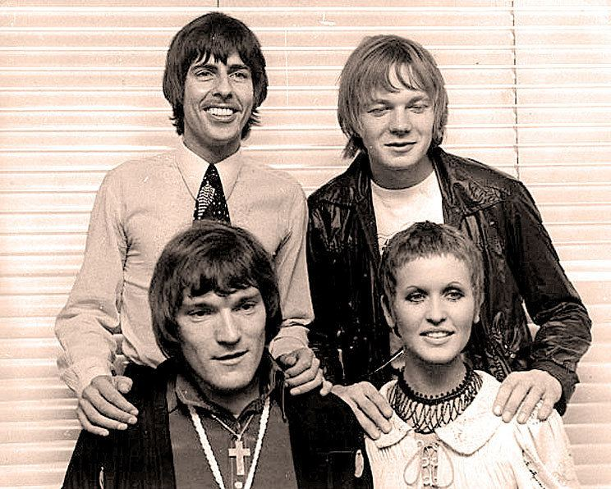
Brian Auger and the Trinity

