02 Jazz Legends – The South

Moses Asch
Moses ("Moe") Asch (December 2, 1905, Warsaw, Poland – October 19, 1986, New York City, USA) was one of the most important independent record producers of the 1940s.
He founded his first label, Asch Recordings, in 1938 and between 1941-1948 this label provided an outlet for some important material by folk artists including Leadbelly, Cisco Houston and Woody Guthrie.
In 1946 he launched the Disc label, which specialized in modern jazz.
In December 1949, Asch founded Folkways Records to specialize in folk and ethnic recordings. His masters and rights to the Folkways label were acquired by Smithsonian Folkways in 1987. In addition to producing records, Moe Asch possessed one of the world's finest and most eclectic collections of traditional and folk music as well as jazz.

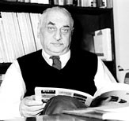

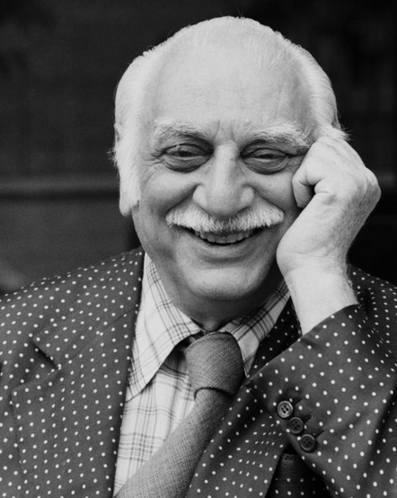
John Avery Lomax (September 23, 1867 – January 26, 1948) was an American teacher, a pioneering musicologist, and a folklorist who did much for the preservation of American folk music. He was the father of Alan Lomax, John Lomax Jr. and Bess Lomax Hawes, also distinguished collectors of folk music.

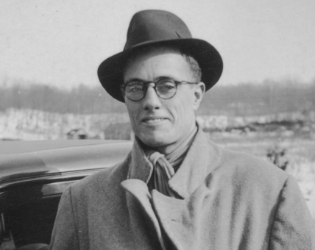

Alan Lomax (/ˈloʊmæks/; January 31, 1915 – July 19, 2002) was an American ethnomusicologist, best known for his numerous field recordings of folk music of the 20th century. He was also a musician himself, as well as a folklorist, archivist, writer, scholar, political activist, oral historian, and film-maker. Lomax produced recordings, concerts, and radio shows in the US and in England, which played an important role in preserving folk music traditions in both countries, and helped start both the American and British folk revivals of the 1940s, 1950s, and early 1960s. He collected material first with his father, folklorist and collector John Lomax, and later alone and with others, Lomax recorded thousands of songs and interviews for the Archive of American Folk Song, of which he was the director, at the Library of Congress on aluminum and acetate discs.
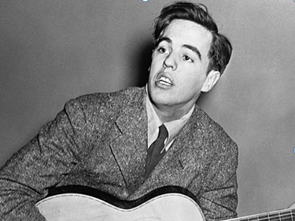

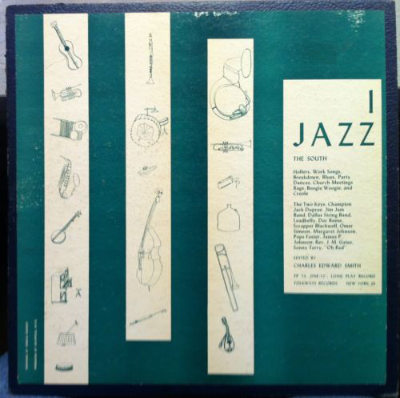

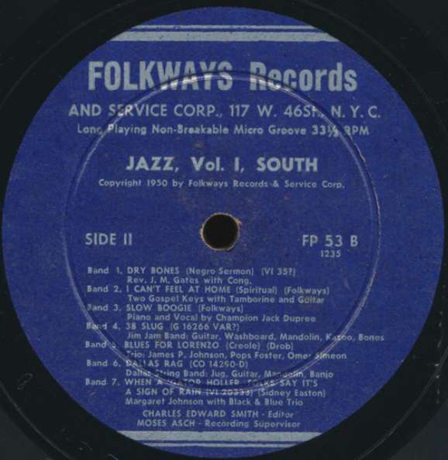
1950

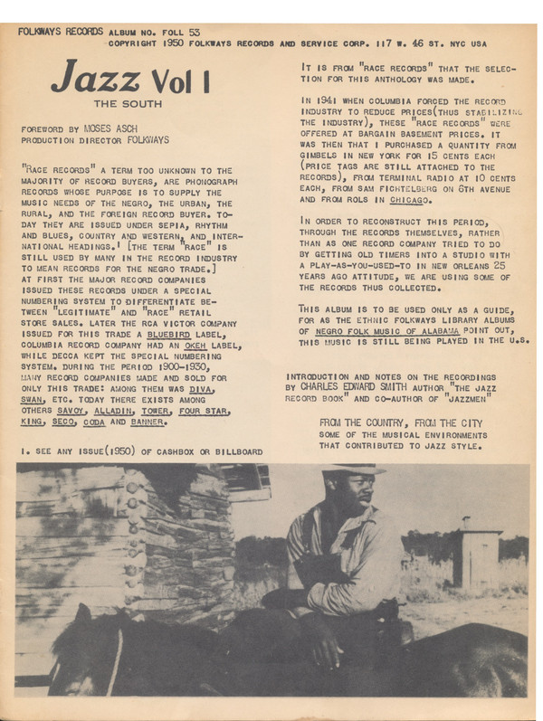

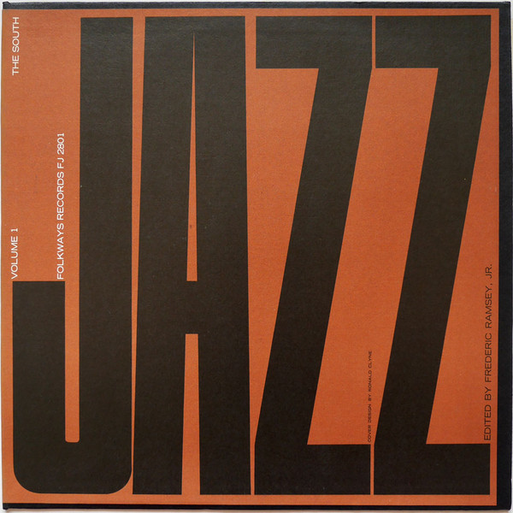

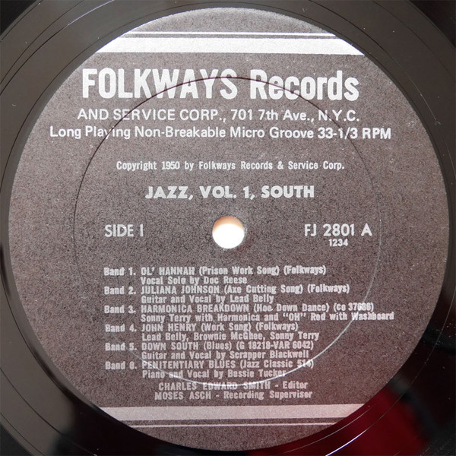
1950, 1958

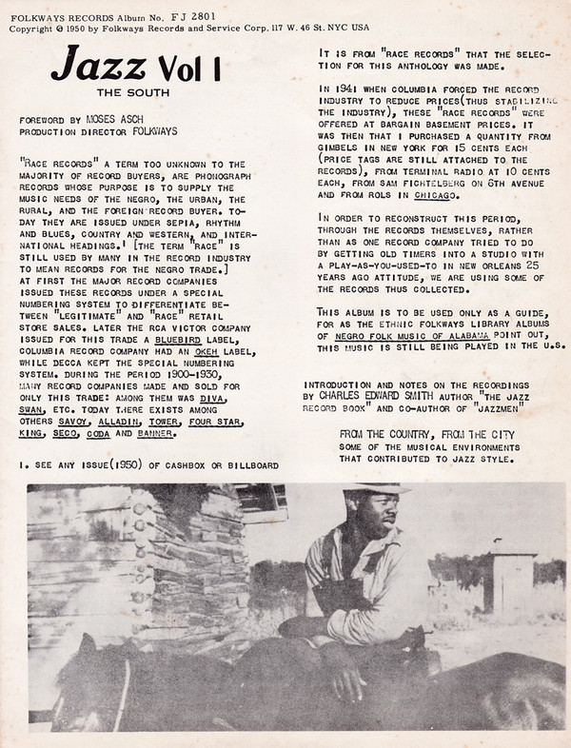
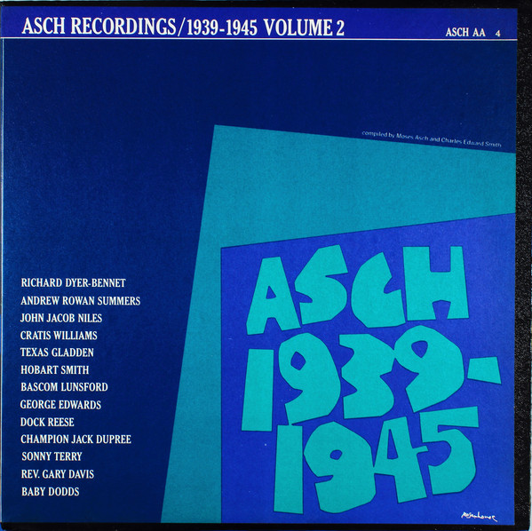

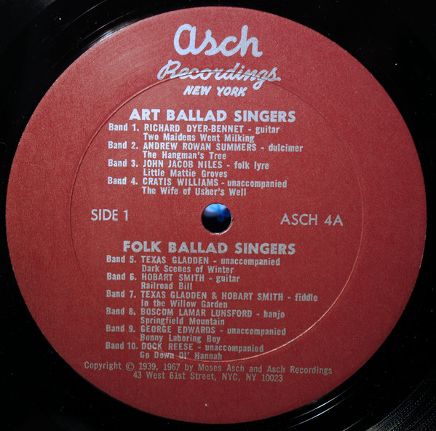
1967
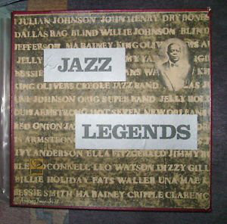

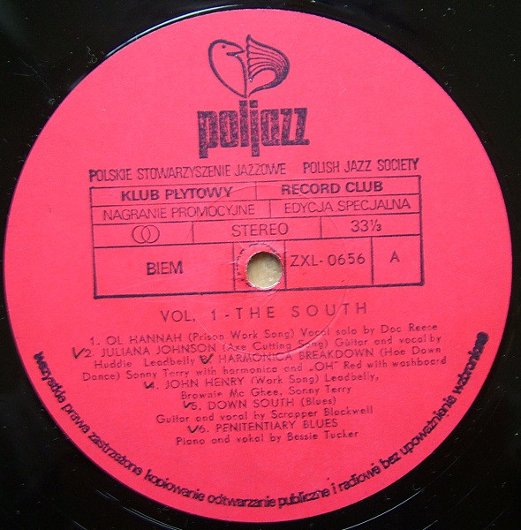
1979
A1. Ol’ Hannah (Field Holler/Prison Work Song) (as Go Down Ol’ Hannah) 4:52
01 Doc Reese-voc (or Dock Reese)
first issue unknown * LP Asch ASCH AA 3/4 (1967) Recorded by Moses Asch 1939-45

Doc Reese
African-American singer, who recorded "Go down old Hannah" for Asch/Folkways in the mid-1940s,
and again appeared at the Newport Folk Festival in 1964 (released on Vanguard).

Born 24 March 1924, Salem, VA, United States
Died 8 June 2012, Princeton, WV, United States
Member of The Heavenly Gospel Singers, The Starlight Gospel Singers

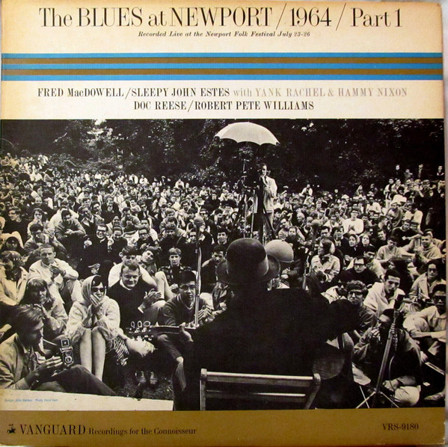

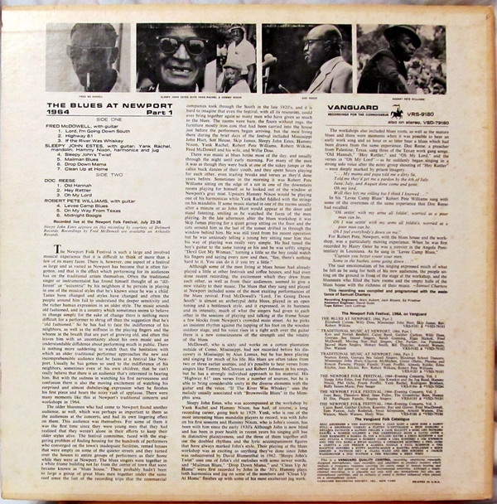

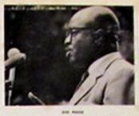

Doc Reese (1924 VA – 2012)

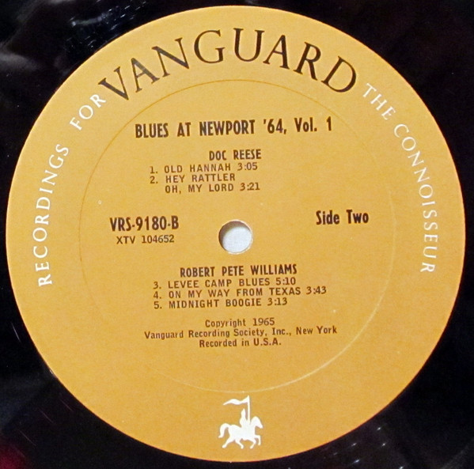

A2. Juliana Johnson (Axe Cutting Song) 1:05
02 Huddie „Leadbelly“ Ledbetter-g, voc
Recorded by Moses Asch, place and date unlisted (May-October, 1944?)
Disc 660 (3 shellacs), record 1: Disc 3001-A / Sc 275 (released 1943)

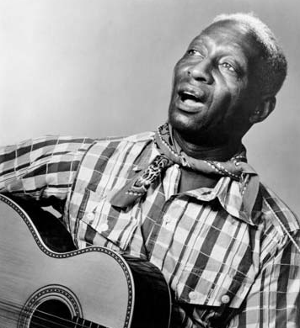

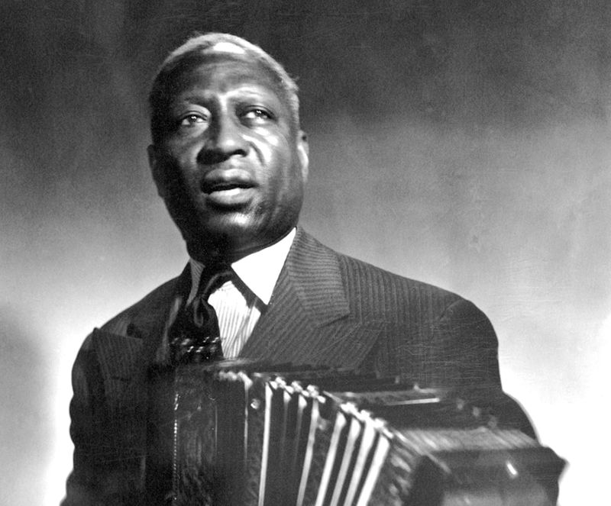

Leadbelly (aka Huddie Ledbetter) (1888 LA – 1949)

A3. Harmonica and Washboard Breakdown (Hoe Down Dance) 2:28
03 Sonny Terry-hca, „Oh“ Red (George Washington)- wb
New York City, March 5 (or 6?), 1940, recorded by Moses Asch
first issue Columbia 30064, 37686, OKeh 05538 / matrix number w26597A

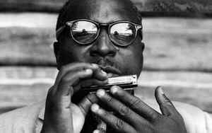

Sonny Terry (1911 GA – 1986)

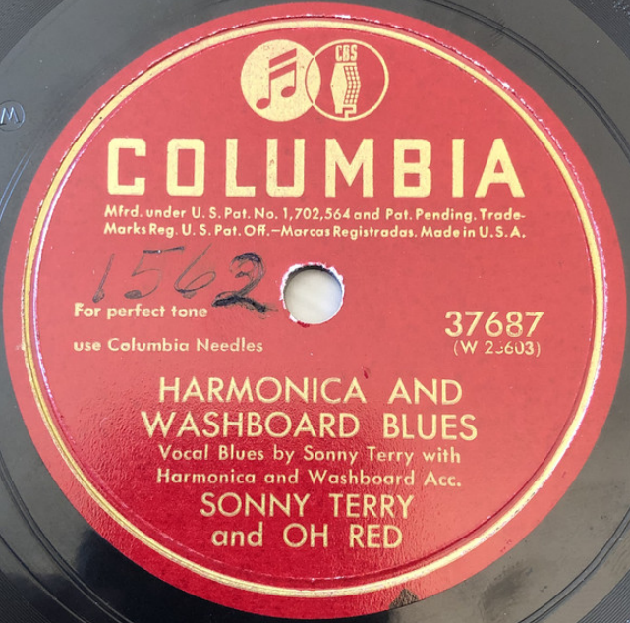

A4. John Henry (Work Song) 2:17
04 Leadbelly, Brownie McGhee, Sonny Terry
Recorded by Moses Asch, ca. 1941.

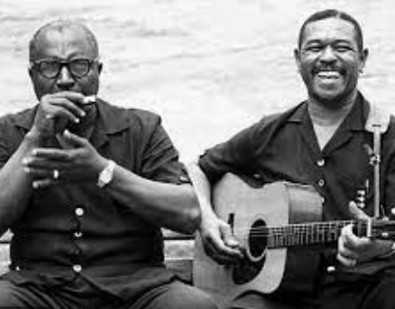

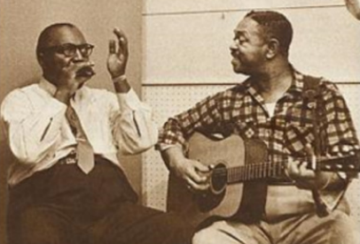

Sonny Terry & Brownie McGhee (1915 TN – 1996)

A5. Down South (Blues) 2:51
05 Scrapper Blackwell-g, voc
November 24, 1931, Richmond, Indiana
Varsity 6042 / USG-18218-D1, Champion 16452 /18218-…

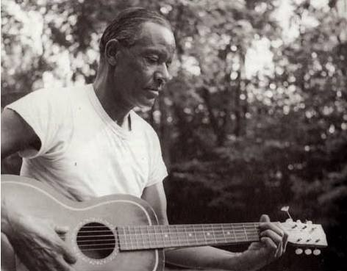

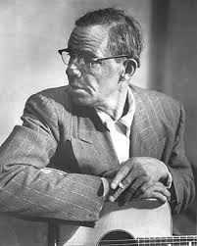

Scrapper Blackwell (1903 NC – 1962)

A6. Penitentiary Blues (Bessie Tucker) 3:10
06 Bessie Tucker-voc; K. D. Johnson-p.
Memphis, August 29, 1928
Victor 38526 / 45441-2 * Jazz Classics 514B, EP His Masters Voice 7EG 8085 (1955)

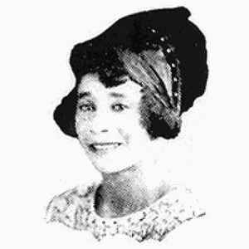

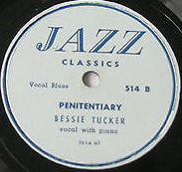

Bessie Tucker (c. 1906 TX – 1933)

B1. Dry Bones (in the Valley) (Negro Sermon) 3:34
07 Reverend J. M. Gates with Congregation
Chicago, December 1-2, 1926
Victor 35810 / 36480 * LP RST Records/Blue Documents BD-2104 [Rudolf Staeger, Wien],

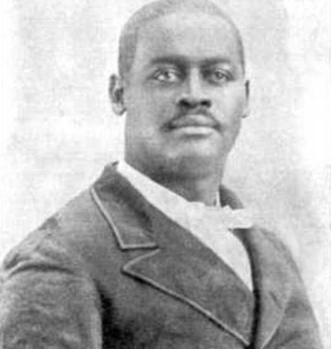

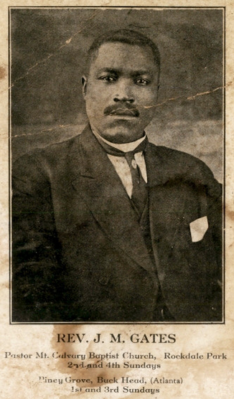

Reverend James M. Gates (1884 GA – 1945)

XY. When the Saints Go Marching In (Spiritual) 2:54
08 Wheat Street Female Quartet (personnel unknown; members of the Wheat St. Baptist Church)
Atlanta, GA, January 29, 1925
Columbia 14067 / 140298-1 * CD Document DOCD-5543 (1997)

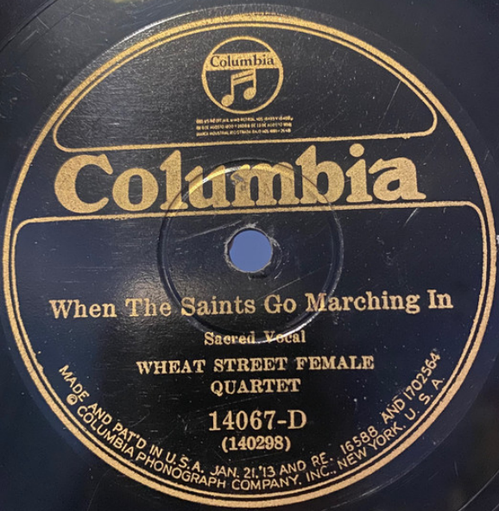

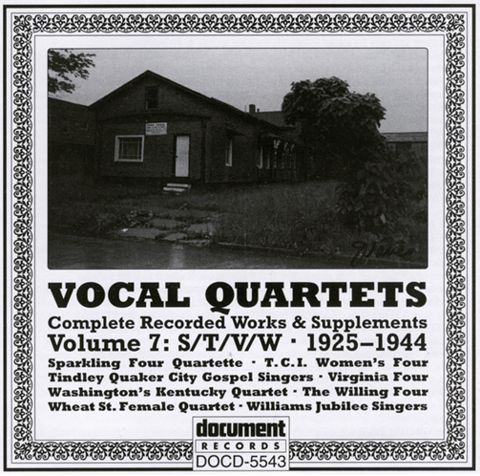

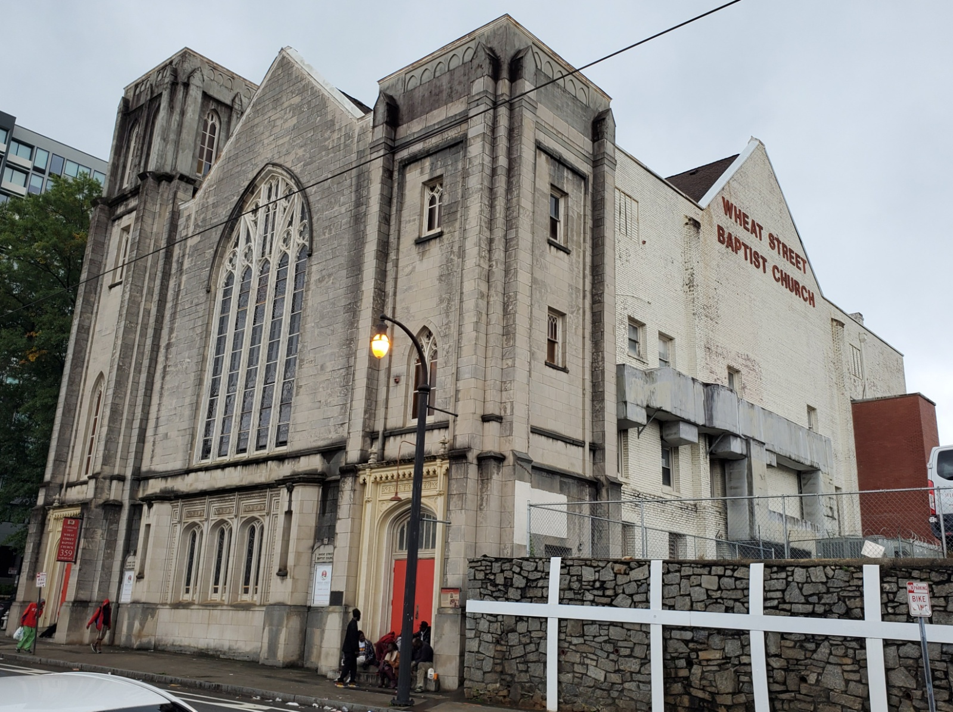

Wheat Street Baptist Church, Atlanta, GA (1869 / 1921)

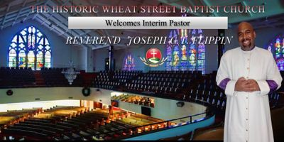

B2. I Can’t Feel at Home (in This World Any More) (Spiritual) 2:45
09 Two Gospel Keys: Mother Sally Jones-voc, tamb, Emma Daniels-voc, g
New York, late 1946
Recorded by Herb Abramson – Folkways FJ-2801 * CD Document DOCD-5221 (1993)

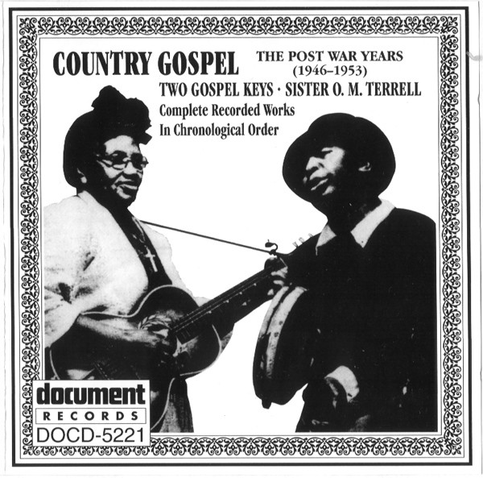

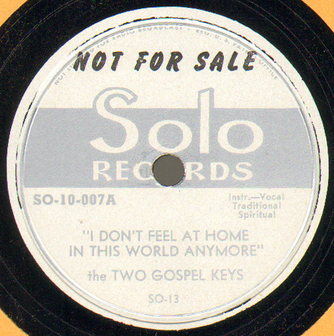

B3. Slow Boogie 2:19
10 Champion Jack Dupree-p, voc
Recorded by Moses Asch, 1943-44

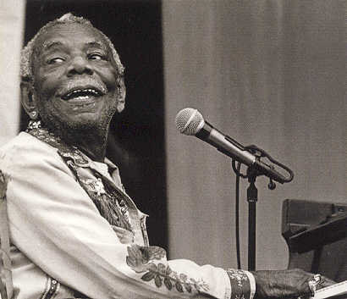

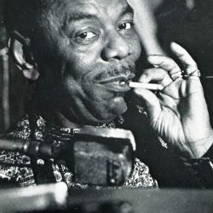

Champion Jack Dupree (1908/1910 NO – 1992)
Real Name: William Thomas Dupree

B4. 38 Slug 2:45
11 Jim Jam Band: unknown guitar, washboard, mandolin, kazoo, bones, vocals
matrix G 16266 VAR (test)

B5. Blues for Lorenzo [Lorenzo’s Blues] (Simeon-Foster) 2:29
12 Omer Simeon-cl, James P. Johnson-p, Pops Foster-b
New York, February 22, 1945
Disc Company of America/Tempo 6001 A / D 205 * CD Classics 1027

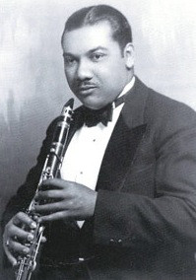

Omer Simeon (1902 NO – 1959 NY)

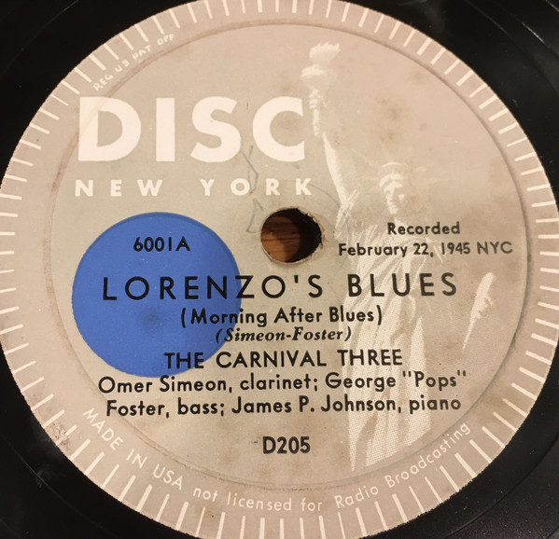

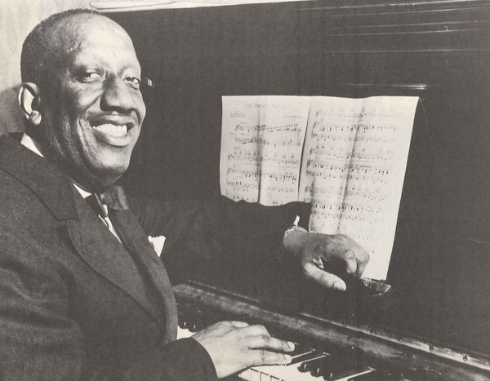

James P. Johnson (1894 NJ – 1955)

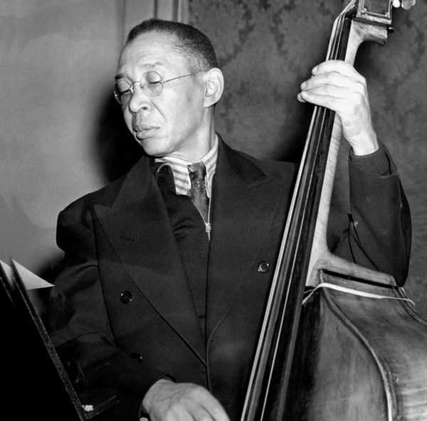

Pops Foster (1892 LA – 1969)

B6. Dallas Rag 2:48
13 Dallas String Band: Coley Jones-mandolin, voc; unknown-mandolin; ?Sam Harris-g; Marco
Washingon-b
Dallas, Tex., December 6, 1927
Columbia 14290-D / W145343 2-B-1 * LP Yazoo L-1045 (1974)

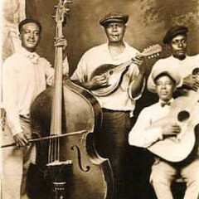

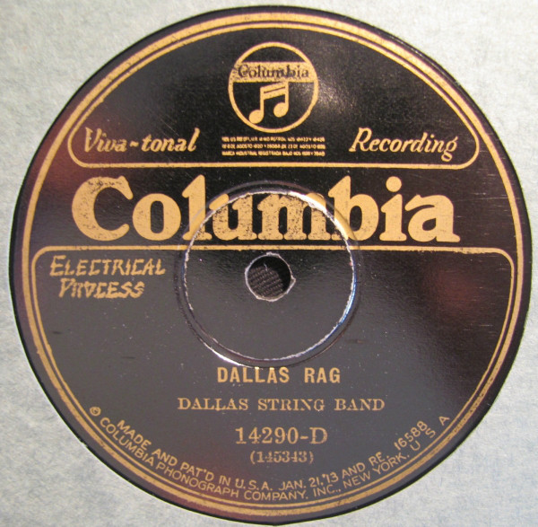

B7. When A’ Gator Hollers, Folks Say It’s a Sign of Rain (Sidney Easton) 2:45
14 Margaret Johnson-voc, with Black & Blue Trio: Tom Morris-co; Bob Fuller-cl; Mike Jackson-p
New York, October 20, 1926
Victor 20333AG / 36846-1 * LP RCA FPM1 7049 * CD Document DOCD-5436 (1996)

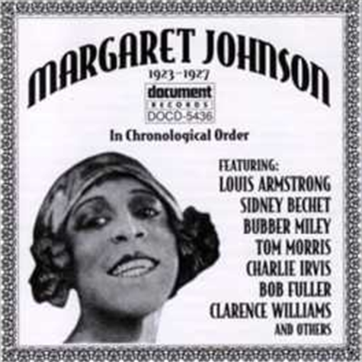

Margaret Johnson
Vaudeville blues singer, who recorded for OKeh and Victor 1923-1927.

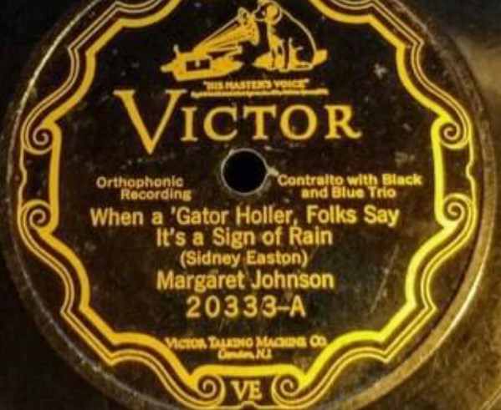

A1. Dark Was the Night, Cold Was the Ground 3:16
15 Blind Willie Johnson-voc, g
Dallas, December 3, 1927
Columbia 14303-D, Vocalion 03095 / W 145320-1 * Jazz Classics 512

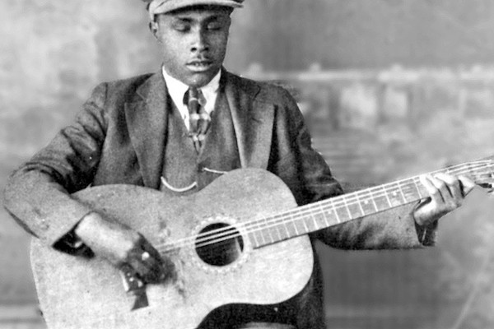

Blind Willie Johnson (1897 TX – 1945)

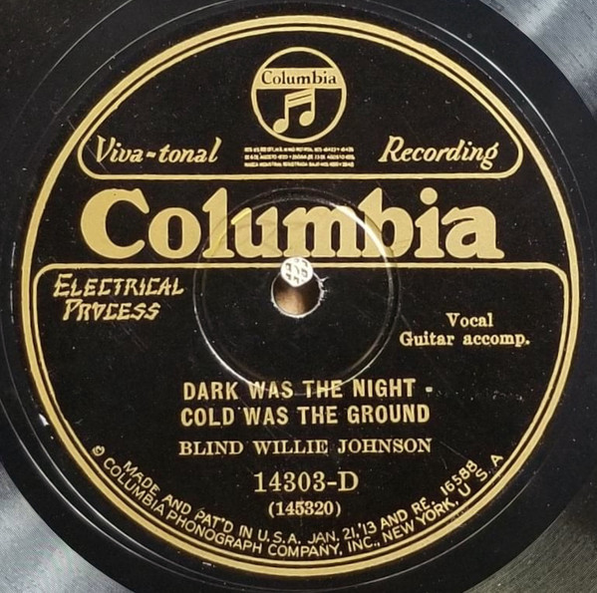

A2. Black Woman 1:22
16 Vera Hall-voc
Recorded 1948 by Frederic Ramsey Jr.

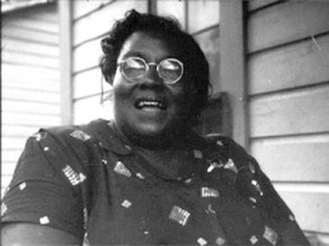

Vera Hall (1902 AL – 1964)
Real Name: Adele "Vera" Hall Ward

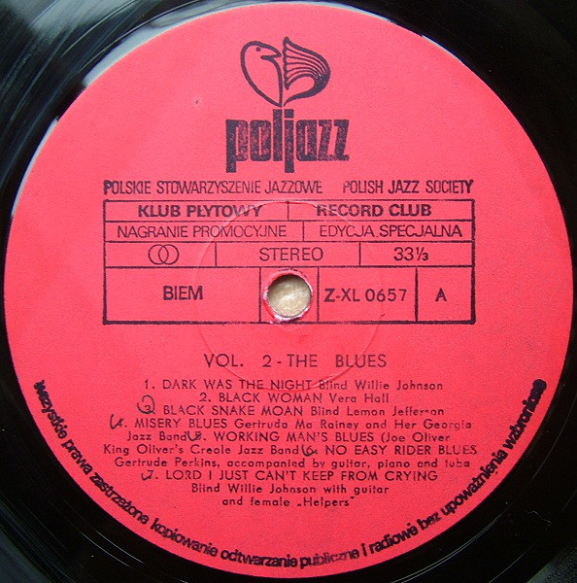

A3. Black Snake Moan (Jefferson) 2:48
17 Blind Lemon Jefferson-voc, g
Atlanta, GA, March 14, 1927 - Advertised in Chicago April 23, 1927
OKeh 8455-A / 80523-B * Jazz Classics 511A * CD Document DOCD-5018 (1991)

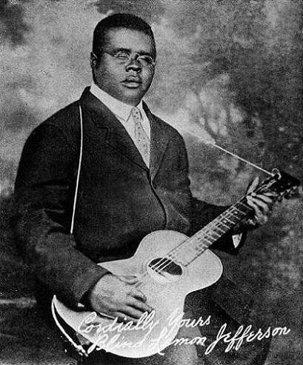

Blind Lemon Jefferson (1893 TX – 1929)

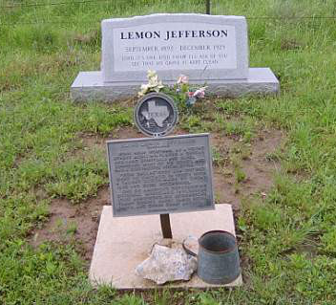

A4. Misery Blues (Gertrude Rainey) 2:35
18 Gertrude „Ma“ Rainey-voc, and Her Georgia Jazz Band: Shirley Clay-co; Kid Ory-tb;
?Hop Hopson-p; unknown-banjo and tuba.
Chicago, c. August 1927
Paramount 12508-B / 4707-1 * Jazz Classics L-52

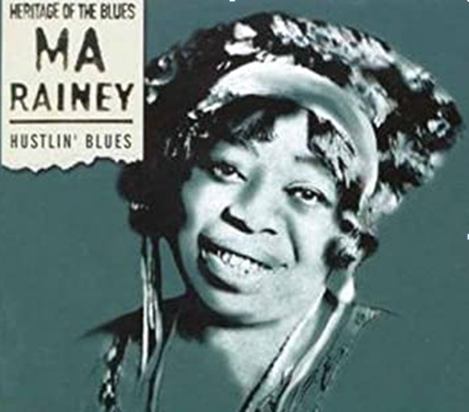

Gertrude „Ma“ Rainey (1886 GA – 1939)

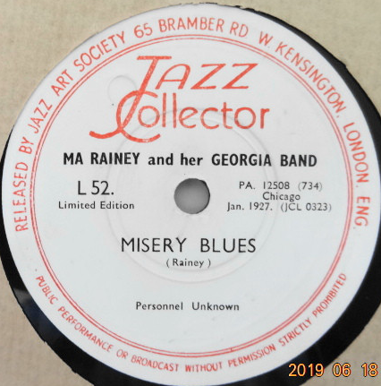

A5. Working Man’s Blues (Joe Oliver) 2:57
19 King Oliver’s Creole Jazz Band: Joe Oliver, Louis Armstrong-co; Honore Dutrey-tb;
Johnny Dodds-cl; Lil Armstrong-p; Johnny St. Cyr-bjo; Charlie Johnson-bass sax;
Baby Dodds-dr.
Chicago, c. October 26, 1923
OKeh 40034 / 8486-B * HJCA 7 * CD Masters of Jazz MJCD 2 (1991)

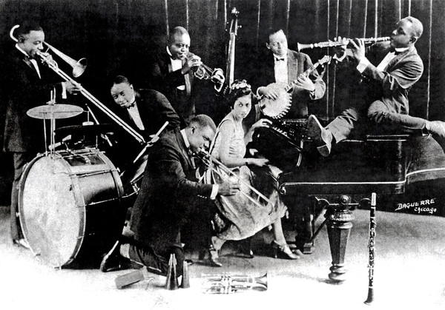

King Oliver’s Creole Jazz Band

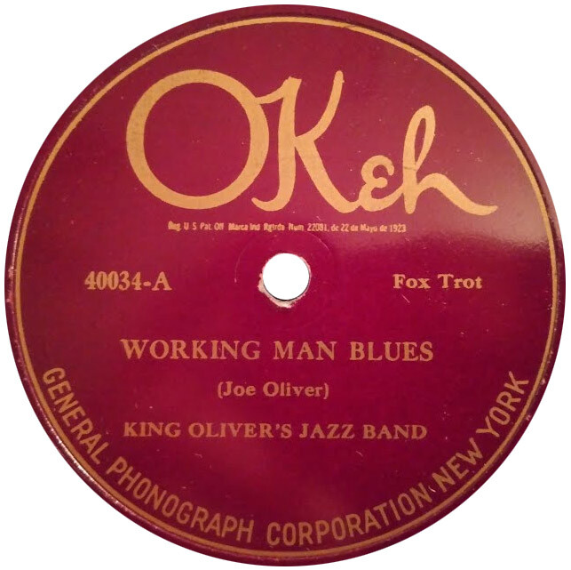

A6. No Easy Rider Blues (Burleson) 3:19
20 Gertrude Perkins-voc; Willie Tyson-p; unknown-g; Octave Gaspard-tu
Dallas, December 6, 1927
Columbia 14313-D / 145340-1

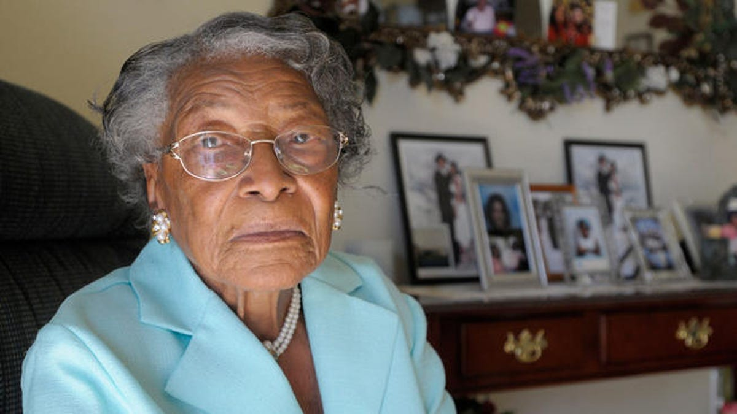

Rosa Parks, Recy Taylor and Gertrude Perkins Are Mothers of the Blues.
Blues singer, who recorded two titles for Columbia in Dallas, Texas, 1927.

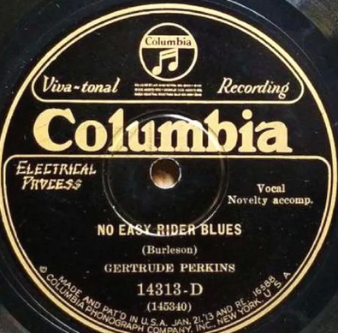

A7. Lord I Just Can’t Keep from Crying 3:00
21 Blind Willie Johnson-voc; with g & female „Helpers“
Dallas, December 5, 1928 - Released June 29, 1929
Columbia 14425-D / 147570 * CD Columbia 489892 2 (1998)

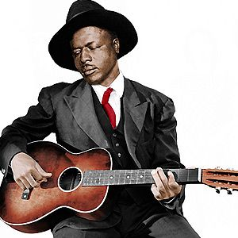

Blind Willie Johnson (1897 TX – 1945)

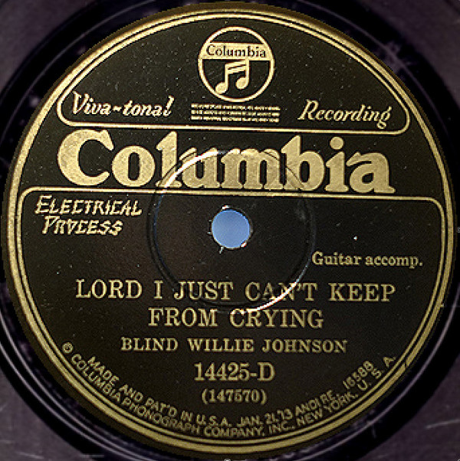

B1. How Long Blues (Ida Cox-Leroy Carr) 3:52
22 Jimmy Yancey-p solo
Chicago, December 1943
Session 12-003 / 117 * CD Document DOCD-5042 (2011)

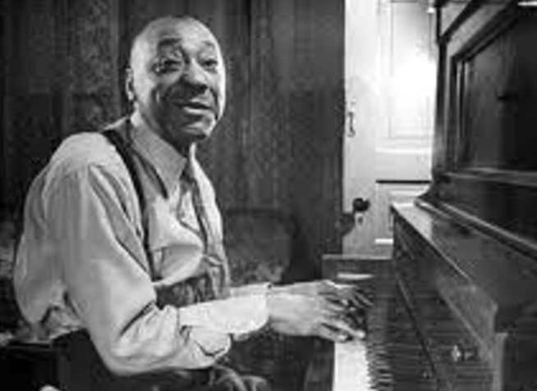

Jimmy Yancey (1898 IL – 1951)

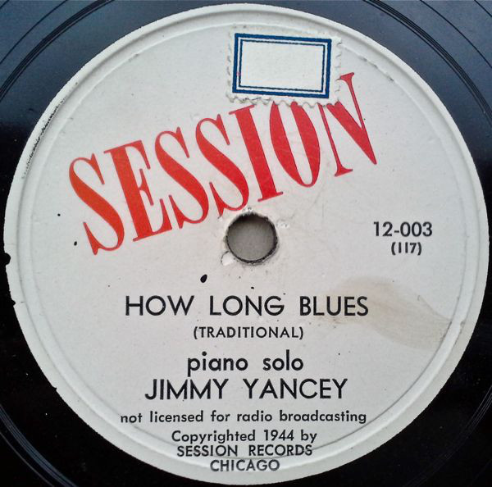

B2. Mr. Jelly Lord (Morton) 2:46
23 Jelly Roll Morton Trio: Morton-p; Johnny Dodds-cl; Baby Dodds-dr.
Oak Street Studio, Chicago, June 10, 1927
Victor 21064, Bluebird B 10258 / 38664-1

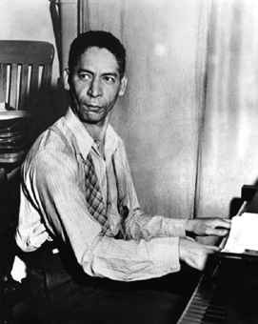

Jelly Roll Morton (1885/1890 NO – 1941)

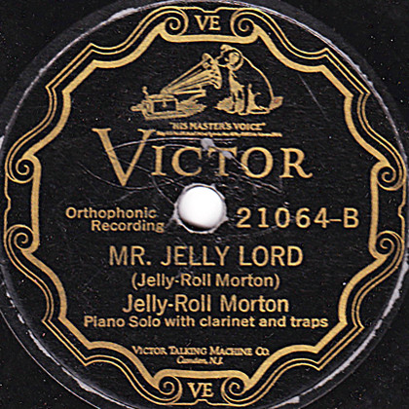

B3. Bridwell Blues (Welsh-Jones) 3:29
24 Nolan Welsh-voc; Louis Armstrong-co; Richard M. Jones-p
Chicago, June 16, 1926
OKeh 8372 / 9727-A * HJCA 36

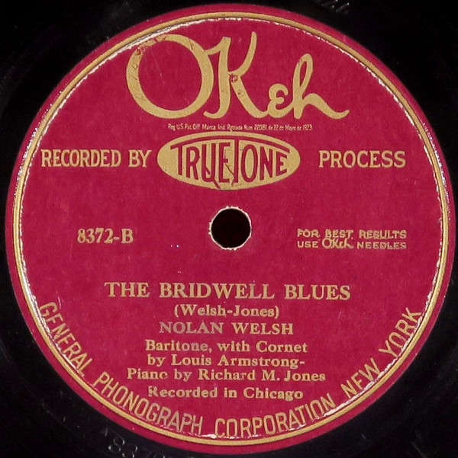

Nolan Welsh
Vocalist and pianist. He's mainly known to have recorded together with Louis Armstrong
"The Bridwell Blues" and the "St. Peter Blues" for Okeh on June 16, 1926.

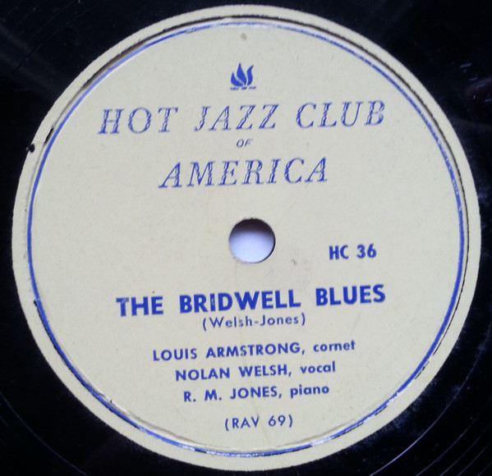

B4. Careless Love (W. C. Handy) 3:02
25 Original Tuxedo Jazz Orchestra: Oscar Celestin-co, dir; “Kid Shots” Madison-co; William
Ridgley-tb; Willard Thoumy-cl, as; unknown-ts; Manuel Manetta-p; John Marrero-bjo; Simon
Marrero-b; Abby Foster-dr, slide whistle
New Orleans, January 23, 1925
OKeh 8198 / 8907-A * Jazz Classics 510A

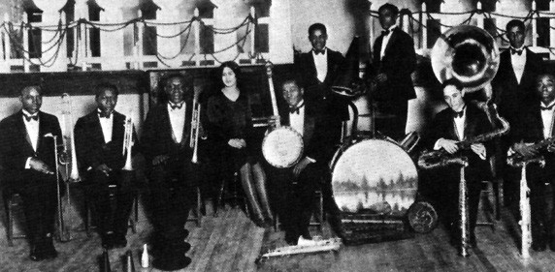

Original Tuxedo Jazz Orchestra

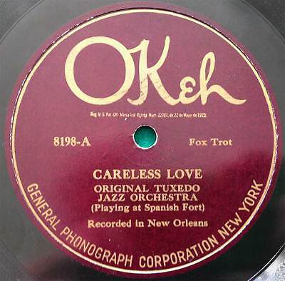

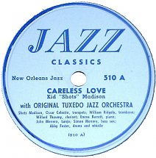

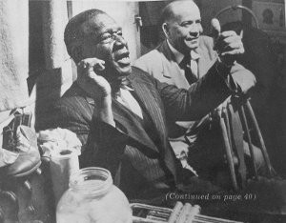

Oscar “Papa” Celestin (1884 LA – 1954 NO)

B5. Mean Old Red Bug Blues (Leo Wood) 3:09
26 Bessie Smith-voc, Porter Grainger-p, Lincoln Conaway-g
New York, September 27, 1927
Columbia 14250-D / 144796-3

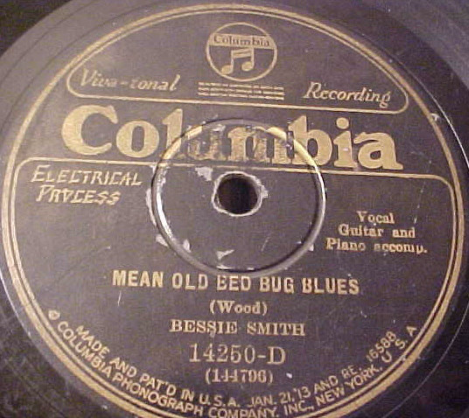

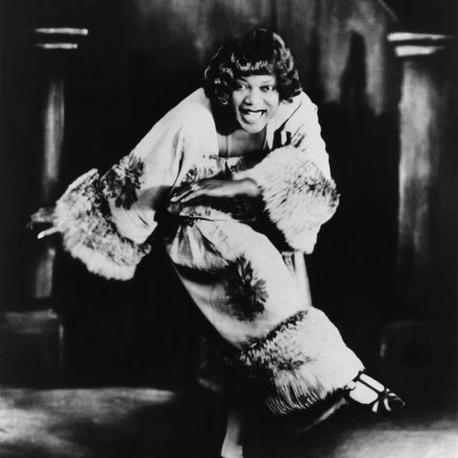

Bessie Smith - Empress of the Blues (1894 TN – 1937)

B6. I’m Not Rough (Armstrong) 2:54
27 Louis Armstrong and His Hot Five: Armstrong-voc, co; Kid Ory-tb; Johnny Dodds-cl; Lil
Armstrong-p; Johnny St. Cyr-bjo; Lonnie Johnson-g
Chicago, December 10, 1927
OKeh 8551 / 82040-B

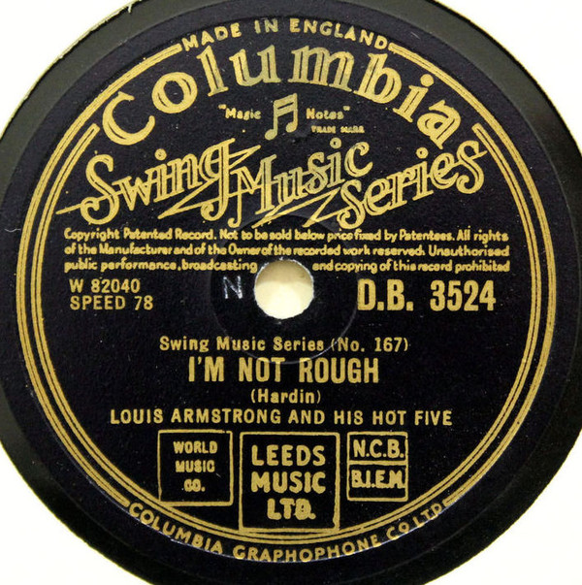

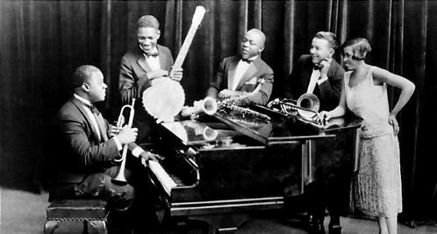

The first Hot Five sides, "Yes! I'm in the Barrel" composed by Armstrong, "My Heart" composed by Hardin Armstrong, and "Gut Bucket Blues" attributed to Armstrong, were recorded on November 12, 1925 with little rehearsal. The next session occurred on February 22, 1926…
The next highly successful session occurred in December 1927, producing the famous "Struttin' With Some Barbeque." In this session, Lonnie Johnson was added on guitar and vocals for the songs "I'm Not Rough," "Savoy Blues," and "Hotter Than That…"
In 1928, Armstrong revamped the recording band, replacing everyone but himself with members of the Carroll Dickerson Orchestra, in which Armstrong was playing: Fred Robinson on trombone, Jimmy Strong on clarinet and tenor saxophone, Earl Hines on piano, Mancy Carr (not "Cara" as has often been misprinted) on banjo, and Zutty Singleton on drums…
Thus, these sessions resulted in some of the most important masterpieces of early jazz, of which "West End Blues" (June 8, 1928) is arguably the best known. Other important recordings include "Basin Street Blues", "Tight Like This", "Saint James Infirmary", and "Weather Bird" (December 5, 1928). In the last named, only Armstrong and Hines are present, turning an old rag number into a tour-de-force duet.

