07 - SWING, BIG BANDY 2 23/73:07

1. Take the ‘A’ Train (Billy Strayhorn) 3:00
Duke Ellington Orchestra: Cootie Williams, William „Cat“ Anderson, Mercer Ellington,
Herbie Jones,-tp; Lawrence Brown, Buster Cooper-tb; Chuck Connors-btb; Jimmy Hamilton-
cl; Johnny Hodges, Russell Procope-as, cl; Paul Gonsalves-ts; Harry Carney-bs, cl; Duke
Ellington-p, arr, cond; John Lamb-b; Sam Woodyard-dr.
Hollywood, May 9, 1966.
LP RCA-Victor LSP 3576/TPA3-3927-3. CD RCA 09026-63386-2.

2. 9:20 Special (Harry Warren/arr. by Buster Harding) 3:07
Count Basie Orchestra: Buck Clayton, Ed Lewis, Harry „Sweets“ Edison, Al Killian-tp;
Dicky Wells, Ed Cuffee, Dan Minor-tb; Tab Smith-ss, as; Earl Warren-as; Don Byas, Buddy
Tate-ts; Jack Washington-bs; Count Basie-p, cond; Freddie Green-g; Walter Page-b; Jo
Jones-dr. Guest: Coleman Hawkins-ts. Buster Harding-arr.
Chicago, April 10, 1941.
OKeh 6244/C 3678-1. CD Columbia COL 461098 2.

3. One O’Clock Boogie (Count Basie-Jimmy Mundy) 3:24
Count Basie Orchestra: Ed Lewis, Emmett Berry, Snooky Young, Harry „Sweets“ Edison-
tp; Bill Johnson, Red Donnelly, George Matthews, Eli Robinson-tb; Preston Love, Rudy
Rutherford-as; Paul Gonsalves, Buddy Tate-ts; Jack Washington-bs; Count Basie-p, cond;
Freddie Green-g; Walter Page-b; Jo Jones-dr. Jimmy Mundy-arr.
New York, March 13, 1947.
Victor 20-2262/D7-VB-652-1. CD RCA ND 82292 (1990).

4. Li’l Darlin’ (Neal Hefti) 4:48
Count Basie Orchestra: Wendell Culley, Snooky Young, Thad Jones, Joe Newman-tp;
Henry Coker, Al Grey, Henry Powell-tb; Marshall Royal, Frank Wess-as; Eddie „Lockjaw“
Davis, Frank Foster-ts; Charlie Fowlkes-bs; Count Basie-p, cond; Freddie Green-g; Eddie
Jones-b; Sonny Payne-dr. Neal Hefti-arr.
New York City, October 21-22, 1957.
LP Roulette SR-52003. CD Roulette 7243 8 28635 2 6.

5. Let’s Dance (Gregogy Stone-Joseph Bonime-Fanny May Baldridge) 2:34
Benny Goodman Orchestra: Jimmy Maxwell, Ziggy Elman, Johnny Martel-tp; Red Ballard,
Vernon Brown, Ted Vesley-tb; Toots Mondello, Buff Estes-as; Bus Bassey, Jerry Jerome-ts;
Fletcher Henderson-p, arr; Charlie Christian-g; Artie Bernstein-b; Nick Fatool-dr; Benny
Goodman-cl, cond. George Bassman-arr.
New York, October 24, 1939.
Columbia 35301/WCO-26202-A. CD TIM 205378-205.

6. Good-Bye (Gordon Jenkins) 3:20
Benny Goodman Orchestra: Bunny Berigan, Nate Kazebier, Ralph Muzzillo-tp; Red
Ballard, Joe Harris-tb; Hymie Schertzer, Bill DePew-as; Arthur Rollini, Dick Clark-ts; Jess
Stacy-p; Allan Reuss-g; Harry Goodman-b; Gene Krupa-dr; Benny Goodman-cl, cond.
Gordon Jenkins-arr.
Hollywood, September 27, 1935.
Victor 25215/97016-1. CD TIM 205367-205.

7. Woodchopper’s Ball (Joe Bishop-Woody Herman) 3:13
Woody Herman Orchestra: Clarence Willard, Steady Nelson, Mac MacQuordale-tp; Neal
Reid-tb; Joe Bishop-fh, arr; Joe Estren Ray Hopfner-as; Saxie Mansfield, Pete Johns-ts; Tommy Linehan-p; Hy White-g; Walter Yoder-b; Frank Carlson-dr; Woody Herman-cl, cond.
Joe Bishop-arr.
New York, April 12, 1939.
Decca 2440/65379-A. CD History 20.1908-HI.

8. Four Or Five Times (Byron Gay / Marco Hellman) 3:04
Woody Herman Orchestra: Charles Peterson, Billie Rogers, George Seaberg, Cappy Lewis-
tp; Neal Reid, Tommy Farr, Walter Nims-tb; Edmund Constanza, Sam Rubinowich-as; Pete
Mondello, Mickey Folus-ts; Tommy Linehan-p; Hy White-g; Walter Yoder-b; Frank Carlson-
dr; Woody Herman-cl, cond, voc; unknown-arr.
Los Angeles, July 24, 1942.
Decca 18526/L-3123-A. CD History 20.1908-HI.

9. Four Brothers (Jimmy Giuffre) 3:15
Woody Herman Second Herd: Shorty Rogers, Ernie Royal, Stan Fishelson, Bernie Glow,
Markie Markowitz-tp; Earl Swope, Ollie Wilson-tb; Bob Swift-btb; Woody Herman-cl, as;
Sam Marowitz-as; Herbie Steward-as, ts; Stan Getz, Zoot Sims-ts; Serge Chaloff-bs; Fred
Otis-p; Gene Sargent-g; Walt Yoder-b; Don Lamond-dr. Jimmy Giuffre-arr.
Los Angeles, December 27, 1947.
Columbia 38304/HCO 3061-1A. CD Columbia 503280 2.

10. Indiana (James F. Hanley / Ballard MacDonald) 2:42
Harry James Orchestra: Harry James-tp, cond; Tommy Gonsoulin, Claude Bowen, Jack
Palmer-tp; Russell Brown, Truett Jones-tb; Dave Matthews, Claude Lakey-as; Drew Page,
Bill Luther-ts; Jack Gardner-p; Bryan Kent-g; Thurman Teague-b; Ralph Hawkins-dr;
unknown-arr.
New York, April 6, 1939.
Brunswick 8366/B-24347-C. CD History 20.1906-HI.

11. All Or Nothing at All (Arthur Altman / Jack Lawrence) 2:56
Harry James Orchestra: Harry James-tp, cond; Jack Schaeffer, Claude Bowen, Jack
Palmer-tp; Russell Brown, Truett Jones-tb; Dave Matthews, Claude Lakey-as; Drew Page,
Bill Luther-ts; Jack Gardner-p; Bryan Kent-g; Thurman Teague-b; Ralph Hawkins-dr; Frank
Sinatra-voc; Andy Gibson-arr.
New York, August 31, 1939.
Columbia 35587/25288-1. CD Masters of Jazz 35.

12. Ciribiribin (They’re So in Love) (Alberto Pestalozza / Jack Lawrence-Harry James) 2:25
Harry James Orchestra: Harry James-tp, cond; Jack Schaeffer, Claude Bowen, Jack
Palmer-tp; Truett Jones, Dalton Rizzotto, Bruce Squires-tb; Dave Matthews-as; Claude
Lakey-as, ts; Drew Page, Bill Luther-ts; Jack Gardner-p; Red Kent-g; Thurman Teague-b;
Michael Scrima-dr; Frank Sinatra-voc. Andy Gibson-arr.
Hollywood, November 8, 1939.
Columbia 35316/LA-2046-A. CD Masters of Jazz MJCD 35.

13. Drummin’ Man (Tiny Parham-Gene Krupa/arr. by Fred Norman) 3:02
Gene Krupa Orchestra: Corky Cornelius, Torg Halten, Nate Kazebier-tp; Al Sherman, Floyd
O’Brien, Dalton Rizzotto-tb; Bob Snyder, Clint Neagley-as; Sam Musiker, Sam Donahue-ts;
Milton Raskin-p; Ray Biondi-g; Biddy Bastien-b; Irene Daye-voc; Gene Krupa-dr, cond.
Fred Norman-arr.
Chicago, November 2, 1939.
Columbia 35324/WC-2824-A. CD Musica Jazz MJCD 1115 (1997).

14. I’ll Never Smile Again (Ruth Lowe/arr. by Fred Stulce) 3:10
Tommy Dorsey Orchestra: Bunny Berigan, Ray Linn, Jimmy Blake, John Dillard-tp; Les Jenkins, George Arus, Lowell Martin-tb; Johnny Mince-cl, as; Fred Stulce, Hymie Schertzer-as; Don Lodice, Paul Mason-ts; Joe Bushkin-p; Clark Yocum-g; Sid Weiss-b; Buddy Rich-dr; Frank Sinatra and The Pied Pipers-voc; Tommy Dorsey-tb, cond; unknown-arr.
New York City, May 23, 1940.
Victor 26628/BS 048942-4. CD Gallerie GALE 404.

15. Blue Skies (Irving Berlin/arr. by Sy Oliver) 3:14
Tommy Dorsey Orchestra: Ziggy Elman, Charlie Peterson, Ray Linn, Jimmy Blake-tp; George Arus, Les Jenkins, Lowell Martin-tb; Johnny Mince-cl, as; Fred Stulce, Heinie Beau-as; Don Lodice, Paul Mason-ts; Joe Bushkin-p; Clark Yocum-g; Sid Weiss-b; Buddy Rich-dr; Frank Sinatra-voc; Tommy Dorsey-tb, cond; unknown-arr.
New York, July 15, 1941.
Victor 27566/066923-1. CD Sony 096692.

16. Artistry Jumps (Stan Kenton) 2:37
Stan Kenton Orchestra: Buddy Childers, Ray Wetzel, John Anderson, Russ Burgher, Bob
Lymperis-tp; Freddie Zito, Jimmy Simms, Milt Kabak, Bart Varsalona-tb; Al Anthony,
Boots Mussulli-as; Vido Musso, Bob Cooper-ts; Bob Gioga-bs; Stan Kenton-p, arr, cond; Bob
Ahern-g; Eddie Safranski-b; Ralph Collier-dr.
October 30, 1945.
Capitol 229/778-3. CD History 20.1911-HI.

17. Taboo (Margarita Lecuona-Sidney Keith Russell-Al Stillman-Bob Russell-Francia Luban) 2:59
Stan Kenton Orchestra: Franck Beach, Chico Alvarez, Earl Collier-tp; Harry Forbes, Dick Cole-tb; Jack Ordean, Ted Romersa-as; Red Dorris, Hollis Bridwell-ts; Bob Gioga-bs; Ted
Repay-p; Al Costi-g; Howard Rumsey-b; Marvin George-dr; Stan Kenton-cond; unknown-arr.
Los Angeles, September 11, 1941.
Decca 4038/DLA-2751-A. CD History 20.1925-HI.

18. Tippin’ In (Bobby Smith) 3:21
Erskine Hawkins Orchestra: Erskine Hawkins, Bobby Johnson, Chuck Jones, Sammy Lowe,
Bill Moore-tp; Donald Cole, Dave James, Norman Green, Ed Sims-tb; Bobby Smith, Jimmy
Mitchelle-as; Aaron Maxwell, Julian Dash-ts; Haywood Henry-bs; Ace Harris-p; Leroy
Kirkland-g; Lee Stanfield-b; Kelly Martin-dr; unknown-arr.
New York, January 10, 1945.
Victor 20-1639/……… CD History 20.1914-HI.

19. Sophisticated Lady (Duke Ellington/arr. by William Russo) 3:15
Stan Kenton Orchestra: Buddy Childers, Maynard Ferguson (solo), Conte Candoli (muted
solo), Ruben McFall, Don Dennis-tp; Bob Burgess, Frank Rosolino, Keith Moon-tb; Bill
Russo-tb, arr; George Roberts-btb; Lee Konitz (solo), Vinnie Dean-as; Bill Holman, Richie
Kamuca-ts; Bob Gioga-bs;Stan Kenton-p, cond; Sal Salvador-g; Don Bagley-b; Stan Levey-dr.
Capitol Studios, Los Angeles, January 28, 1953.
Capitol EAP1/H426/11076. CD Mosaic 136.

20. Tuxedo Junction (William Johnson-Julian Dash-Erskine Hawkins-Buddy Feyne) 3:28
Glenn Miller Orchestra: R. D. McMickle, Clyde Hurley, Johnny Best, Legh Knowles-tp; Glenn Miller, Paul Tanner, Frank D’Anolfo, Tommy Mack-tb; Hal McIntyre, Wilbur Schwartz, Jimmy Abato-as; Tex Beneke, Al Klink-ts; J. C. MacGregor-p; Richard Fisher-g; Rowland Bundock-b; Maurice Purtill-dr. Jerry Gray-arr.
New York, February 5, 1940.
Bluebird B-10612/BS-046786-2A. CD RCA 90600.

21. Moonlight Serenade (Mitchell Parish-Glenn Miller) 3:22
Glenn Miller Orchestra: Dale McMickle, Bob Price, Legh Knowles-tp; Glenn Miller-tb, arr;, Al Mastren, Paul Tanner-tb; Hal McIntyre, Al Klink-as; Wilbur Schwartz-as, cl; Tex Benekets; Stanley Aronson-ts, as; Chummy MacGregor-p; Allan Reuss-g; Rolly Bundock-b; Frankie Carlson-dr.
New York, April 4, 1939.
Bluebird B-10214-B/BS-035701-1. CD RCA ND 90600 (1991).

22. Rhapsody in Blue (George Gershwin) 3:03
Glenn Miller Orchestra: Billy May, Steve Lipkins, Dale McMickle, Johnny Best-tp; Glenn Miller, Jimmy Priddy, Paul Tanner, Frank D’Annolfo-tb; Lloyd „Skippy“ Martin-as; Ernie Caceres-as, bs, cl; Wilbur Schwartz-cl, as; Tex Beneke, Al Klink-ts; Chummy MacGregor-p; Bobby Hackett-g; Doc Goldberg-b; Maurice Purtill-dr. Bill Finegan-arr.
Chicago, Thursday July 16, 1942.
Victor 20-1529-A/074748-1. CD RCA ND 90600 (1991).

23. Flyin’ Home (Benny Goodman-Lionel Hampton) 2:52
Charlie Barnet Orchestra: Johnny Owens, Billy May, Bobby Burnet, Lyman Vunk-tp; Don
Ruppersberg, Bill Robertson, Claude „Spud“ Murphy-tb; Charlie Barnet-ss, as, ts, cond; Gene Kinsey, Skippy Martin-as; James Lamare-as, bs; Kurt Bloom-ts; Bill Miller-p; Bus Etri-g; Phil Stevens-b; Cliff Leeman-dr; Skippy Martin-arr.
New York, May 8, 1940.
Bluebird B-10794/050620-1. CD History 20.1916-HI.

Total time 73:07

07 - SWING, BIG BANDY 2 23/73:07

1. Take the ‘A’ Train (Billy Strayhorn) 3:00
Duke Ellington Orchestra: Cootie Williams, William „Cat“ Anderson, Mercer Ellington,
Herbie Jones,-tp; Lawrence Brown, Buster Cooper-tb; Chuck Connors-btb; Jimmy Hamilton-
cl; Johnny Hodges, Russell Procope-as, cl; Paul Gonsalves-ts; Harry Carney-bs, cl; Duke
Ellington-p, arr, cond; John Lamb-b; Sam Woodyard-dr.
Hollywood, May 9, 1966.
LP RCA-Victor LSP 3576 / TPA3-3927-3. CD RCA 09026-63386-2.

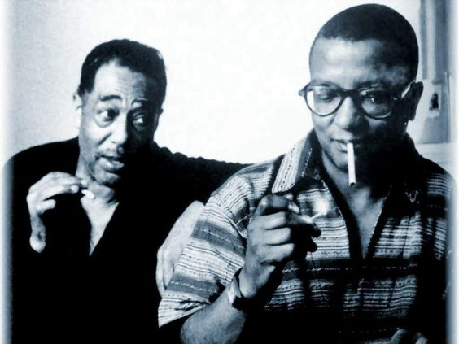
Duke Ellington (1899 – 1974) & Billy Strayhorn (1915 – 1967)

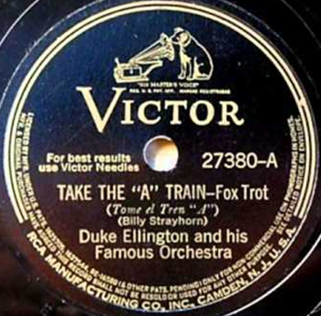
First issue - February 15, 1941

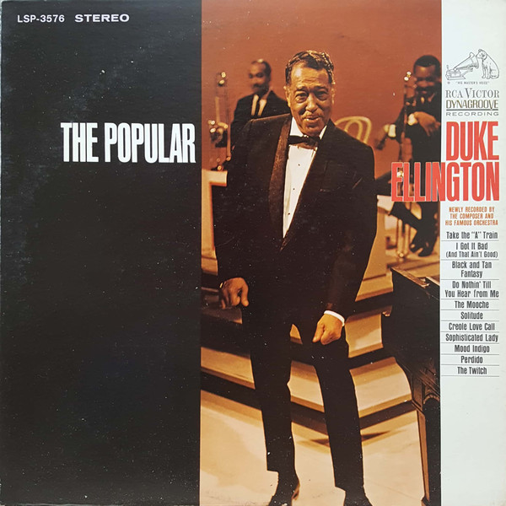

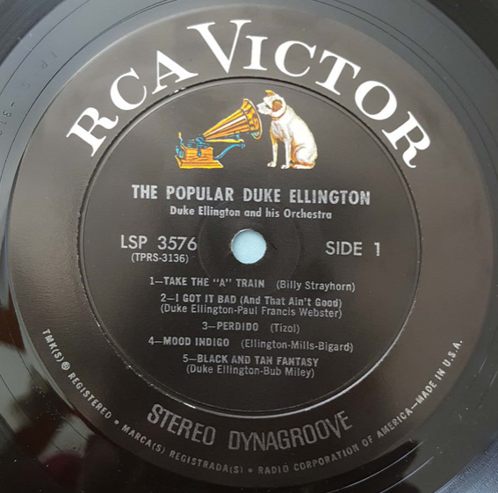
Definitive recording, May 9, 1966

2. 9:20 Special (Harry Warren/arr. by Buster Harding) 3:07
Count Basie Orchestra: Buck Clayton, Ed Lewis, Harry „Sweets“ Edison, Al Killian-tp;
Dicky Wells, Ed Cuffee, Dan Minor-tb; Tab Smith-ss, as; Earl Warren-as; Don Byas, Buddy
Tate-ts; Jack Washington-bs; Count Basie-p, cond; Freddie Green-g; Walter Page-b; Jo
Jones-dr. Guest: Coleman Hawkins-ts. Buster Harding-arr.
Chicago, April 10, 1941.
OKeh 6244 / C 3678-1. CD Columbia COL 461098 2.

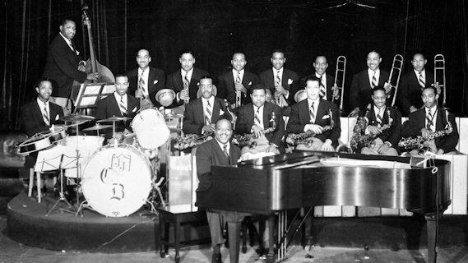
Count Basie (1904 – 1984) and His Orchestra (since 1936)

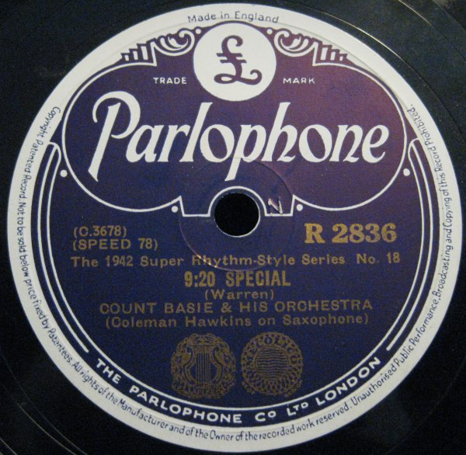

3. One O’Clock Boogie (Count Basie-Jimmy Mundy) 3:24
Count Basie Orchestra: Ed Lewis, Emmett Berry, Snooky Young, Harry „Sweets“ Edison-
tp; Bill Johnson, Red Donnelly, George Matthews, Eli Robinson-tb; Preston Love, Rudy
Rutherford-as; Paul Gonsalves, Buddy Tate-ts; Jack Washington-bs; Count Basie-p, cond;
Freddie Green-g; Walter Page-b; Jo Jones-dr. Jimmy Mundy-arr.
New York, March 13, 1947.
Victor 20-2262 / D7-VB-652-1. CD RCA ND 82292 (1990).

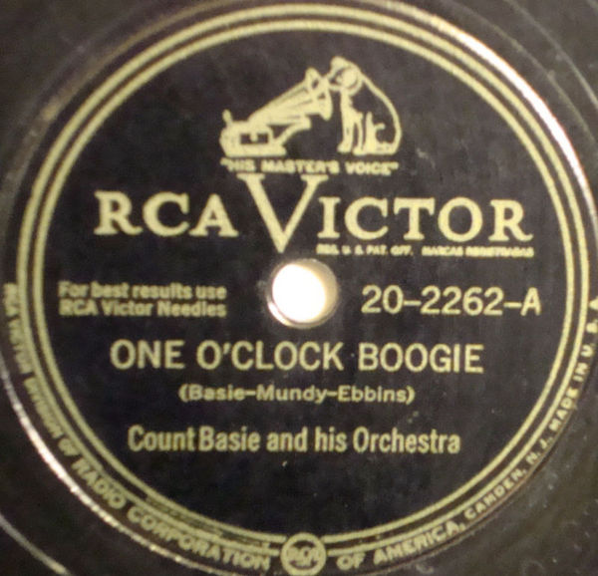

4. Li’l Darlin’ (Neal Hefti) 4:48
Count Basie Orchestra: Wendell Culley, Snooky Young, Thad Jones, Joe Newman-tp;
Henry Coker, Al Grey, Henry Powell-tb; Marshall Royal, Frank Wess-as; Eddie „Lockjaw“
Davis, Frank Foster-ts; Charlie Fowlkes-bs; Count Basie-p, cond; Freddie Green-g; Eddie
Jones-b; Sonny Payne-dr. Neal Hefti-arr.
New York City, October 21-22, 1957.
LP Roulette SR-52003 / 12470-8. CD Roulette 7243 8 28635 2 6.

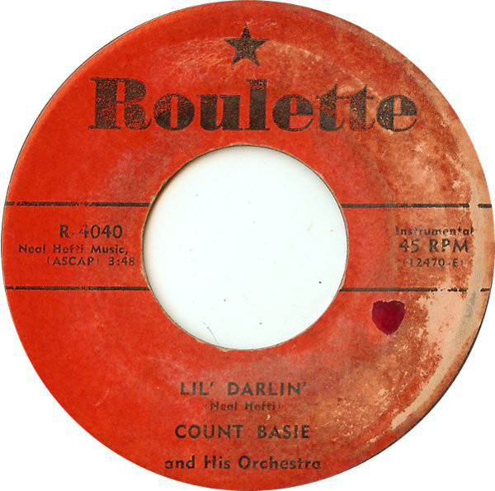

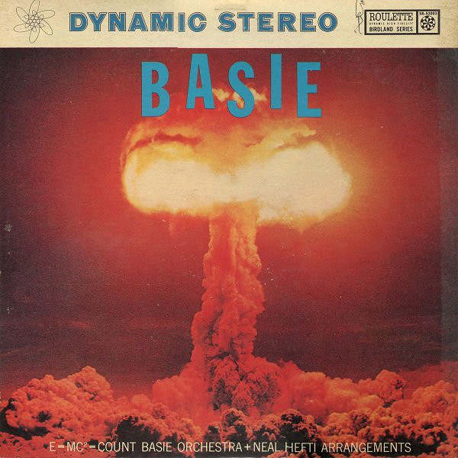

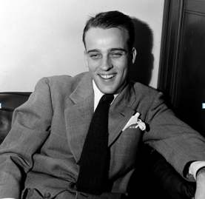
Neal Hefti (1922 – 2008)

5. Let’s Dance (Gregogy Stone-Joseph Bonime-Fanny May Baldridge/Carl M. v. Weber) 2:34
Benny Goodman Orchestra: Jimmy Maxwell, Ziggy Elman, Johnny Martel-tp; Red Ballard,
Vernon Brown, Ted Vesley-tb; Toots Mondello, Buff Estes-as; Bus Bassey, Jerry Jerome-ts;
Fletcher Henderson-p, arr; Charlie Christian-g; Artie Bernstein-b; Nick Fatool-dr; Benny
Goodman-cl, cond. George Bassman-arr. [based on Aufforderung zum Tanz, Op. 65, J. 260]
New York, October 24, 1939.
Columbia 35301 / WCO-26202-A. CD TIM 205378-205.

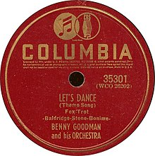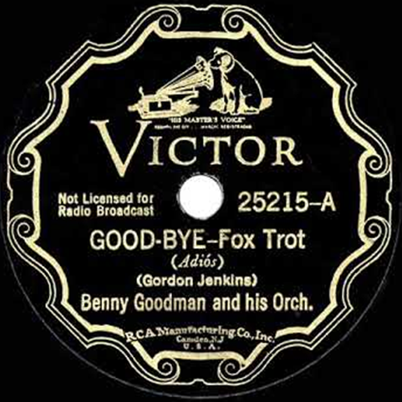

6. Good-Bye (Gordon Jenkins) 3:20
Benny Goodman Orchestra: Bunny Berigan, Nate Kazebier, Ralph Muzzillo-tp; Red
Ballard, Joe Harris-tb; Hymie Schertzer, Bill DePew-as; Arthur Rollini, Dick Clark-ts; Jess
Stacy-p; Allan Reuss-g; Harry Goodman-b; Gene Krupa-dr; Benny Goodman-cl, cond.
Gordon Jenkins-arr.
Hollywood, September 27, 1935.
Victor 25215 / 97016-1. CD TIM 205367-205.

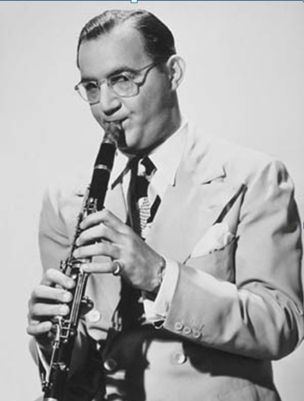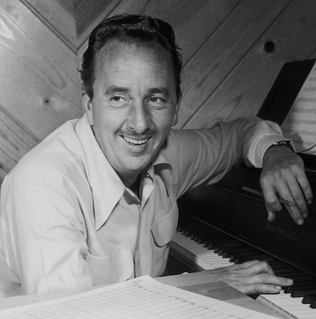
Benny Goodman (1909 – 1986) Gordon Jenkins (1910 – 1984)

7. Woodchopper’s Ball (Joe Bishop-Woody Herman) 3:13
Woody Herman Orchestra: Clarence Willard, Steady Nelson, Mac MacQuordale-tp; Neal
Reid-tb; Joe Bishop-fh, arr; Joe Estren Ray Hopfner-as; Saxie Mansfield, Pete Johns-ts; Tommy Linehan-p; Hy White-g; Walter Yoder-b; Frank Carlson-dr; Woody Herman-cl, cond.
Joe Bishop-arr.
New York, April 12, 1939.
Decca 2440 / 65379-A. CD History 20.1908-HI.

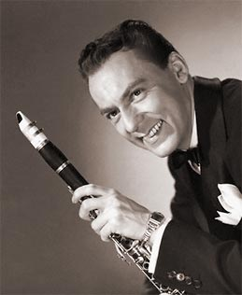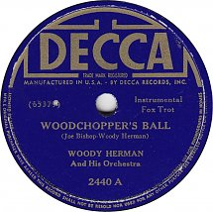
Woody Herman (1913 – 1987)

8. Four Or Five Times (Byron Gay / Marco Hellman) 3:04
Woody Herman Orchestra: Charles Peterson, Billie Rogers, George Seaberg, Cappy Lewis-
tp; Neal Reid, Tommy Farr, Walter Nims-tb; Edmund Constanza, Sam Rubinowich-as; Pete
Mondello, Mickey Folus-ts; Tommy Linehan-p; Hy White-g; Walter Yoder-b; Frank Carlson-
dr; Woody Herman-cl, cond, voc; unknown-arr.
Los Angeles, July 24, 1942.
Decca 18526 / L-3123-A. CD History 20.1908-HI.

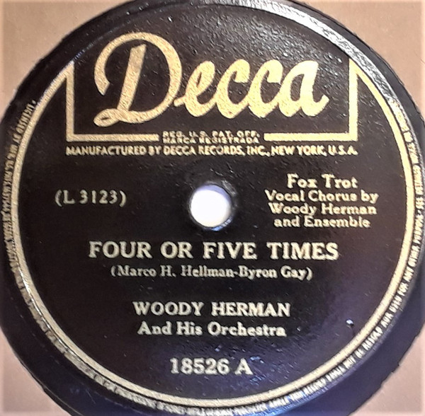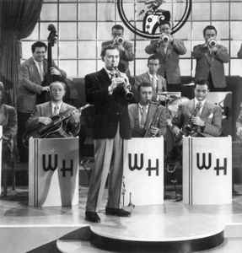

9. Four Brothers (Jimmy Giuffre) 3:15
Woody Herman Second Herd: Shorty Rogers, Ernie Royal, Stan Fishelson, Bernie Glow,
Markie Markowitz-tp; Earl Swope, Ollie Wilson-tb; Bob Swift-btb; Woody Herman-cl, as;
Sam Marowitz-as; Herbie Steward-as, ts; Stan Getz, Zoot Sims-ts; Serge Chaloff-bs; Fred
Otis-p; Gene Sargent-g; Walt Yoder-b; Don Lamond-dr. Jimmy Giuffre-arr.
Los Angeles, December 27, 1947.
Columbia 38304 / HCO 3061-1A. CD Columbia 503280 2.

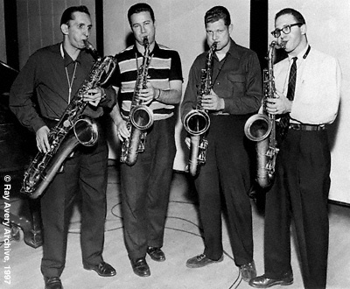

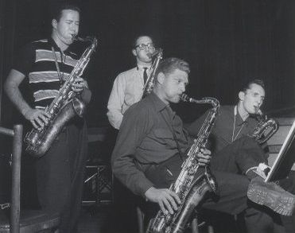
Four Brothers

10. Indiana (James F. Hanley / Ballard MacDonald) 2:42
Harry James Orchestra: Harry James-tp, cond; Tommy Gonsoulin, Claude Bowen, Jack
Palmer-tp; Russell Brown, Truett Jones-tb; Dave Matthews, Claude Lakey-as; Drew Page,
Bill Luther-ts; Jack Gardner-p; Bryan Kent-g; Thurman Teague-b; Ralph Hawkins-dr;
unknown-arr.
New York, April 6, 1939.
Brunswick 8366 / B-24347-C. CD History 20.1906-HI.

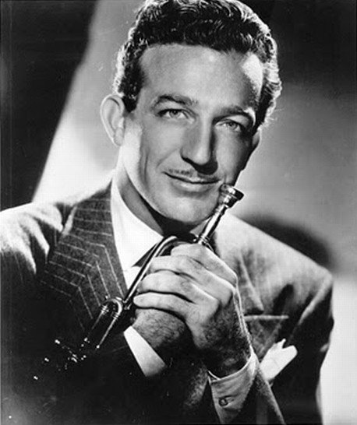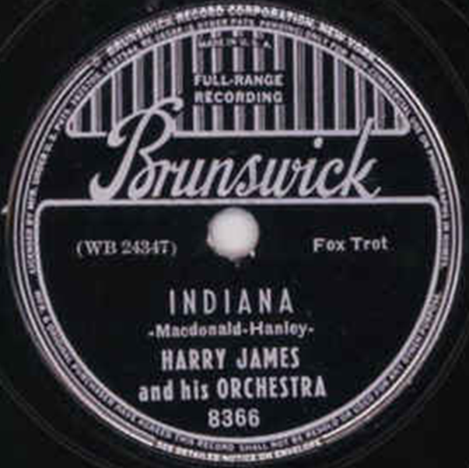
Harry James (1916 – 1983)

11. All Or Nothing at All (Arthur Altman / Jack Lawrence) 2:56
Harry James Orchestra: Harry James-tp, cond; Jack Schaeffer, Claude Bowen, Jack
Palmer-tp; Russell Brown, Truett Jones-tb; Dave Matthews, Claude Lakey-as; Drew Page,
Bill Luther-ts; Jack Gardner-p; Bryan Kent-g; Thurman Teague-b; Ralph Hawkins-dr; Frank
Sinatra-voc; Andy Gibson-arr.
New York, August 31, 1939.
Columbia 35587 / 25288-1. CD Masters of Jazz 35.

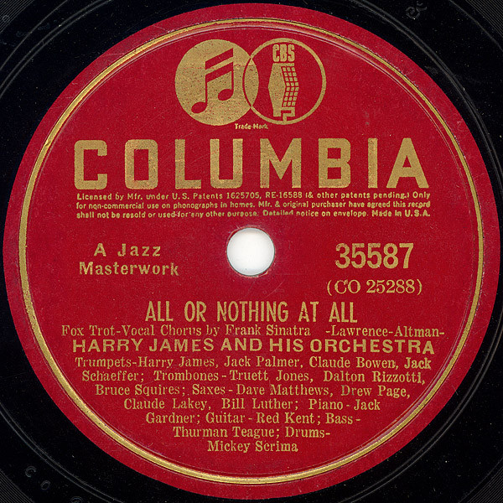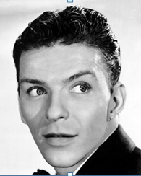
Frank Sinatra (1915 – 1998)

12. Ciribiribin (They’re So in Love) (Alberto Pestalozza / Jack Lawrence-Harry James) 2:25
Harry James Orchestra: Harry James-tp, cond; Jack Schaeffer, Claude Bowen, Jack
Palmer-tp; Truett Jones, Dalton Rizzotto, Bruce Squires-tb; Dave Matthews-as; Claude
Lakey-as, ts; Drew Page, Bill Luther-ts; Jack Gardner-p; Red Kent-g; Thurman Teague-b;
Michael Scrima-dr; Frank Sinatra-voc. Andy Gibson-arr.
Hollywood, November 8, 1939.
Columbia 35316 / LA-2046-A. CD Masters of Jazz MJCD 35.

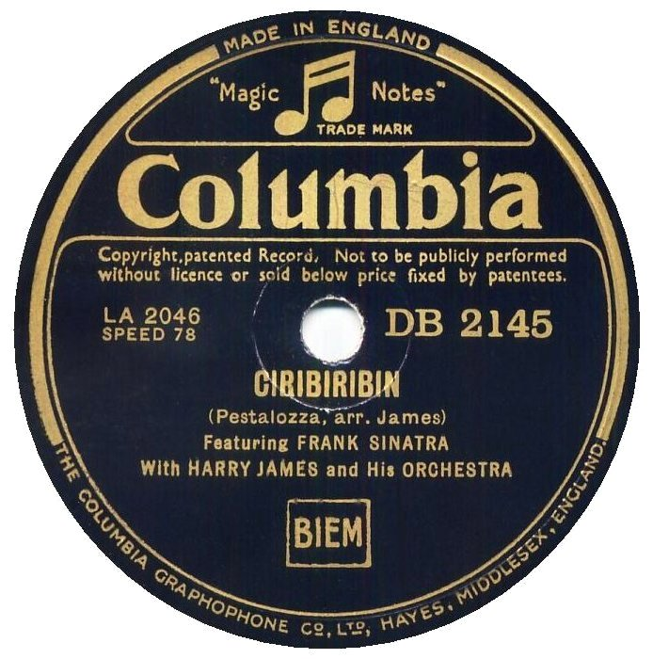

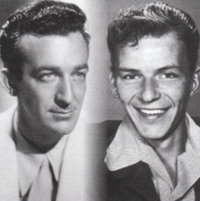

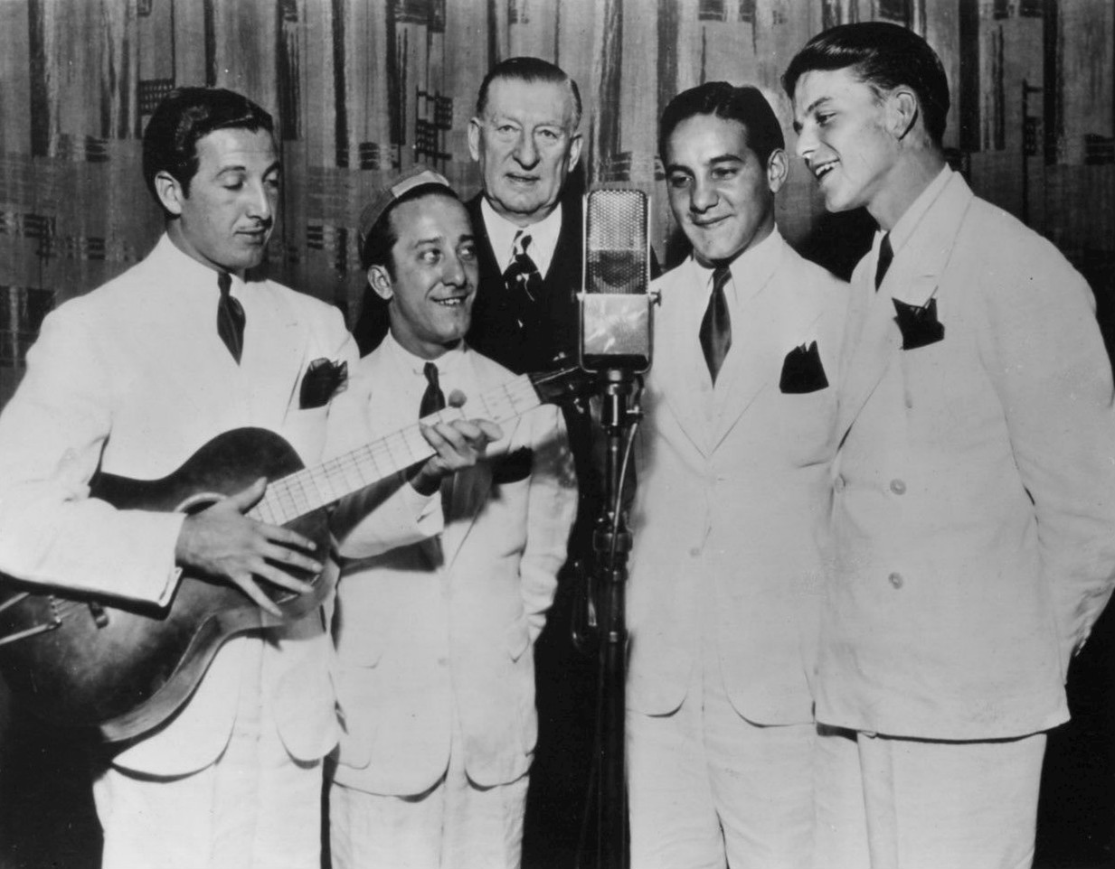
The Hoboken Four – September 8, 1935
Fred Tamburro, Jimmy Petrozelli, [Major Bowes], Patty Principi, Frank Sinatra

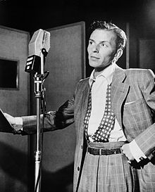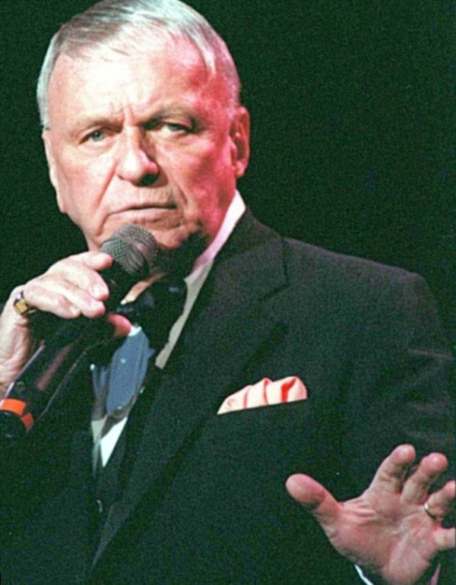

13. Drummin’ Man (Tiny Parham-Gene Krupa/arr. by Fred Norman) 3:02
Gene Krupa Orchestra: Corky Cornelius, Torg Halten, Nate Kazebier-tp; Al Sherman, Floyd
O’Brien, Dalton Rizzotto-tb; Bob Snyder, Clint Neagley-as; Sam Musiker, Sam Donahue-ts;
Milton Raskin-p; Ray Biondi-g; Biddy Bastien-b; Irene Daye-voc; Gene Krupa-dr, cond.
Fred Norman-arr.
Chicago, November 2, 1939.
Columbia 35324 / WC-2824-A. CD Musica Jazz MJCD 1115 (1997).

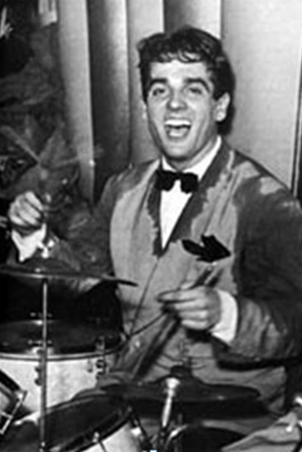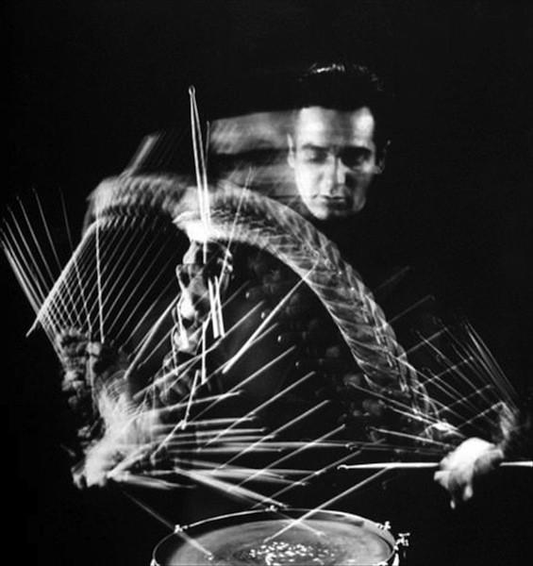
Gene Krupa (1909 – 1973)

14. I’ll Never Smile Again (Ruth Lowe/arr. by Fred Stulce) 3:10
Tommy Dorsey Orchestra: Bunny Berigan, Ray Linn, Jimmy Blake, John Dillard-tp; Les Jenkins, George Arus, Lowell Martin-tb; Johnny Mince-cl, as; Fred Stulce, Hymie Schertzer-as; Don Lodice, Paul Mason-ts; Joe Bushkin-p; Clark Yocum-g; Sid Weiss-b; Buddy Rich-dr; Frank Sinatra and The Pied Pipers-voc; Tommy Dorsey-tb, cond; unknown-arr.
New York City, May 23, 1940.
Victor 26628 / BS 048942-4. CD Gallerie GALE 404.

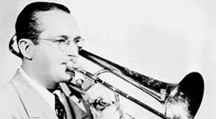
Tommy Dorsey (1905 – 1956)

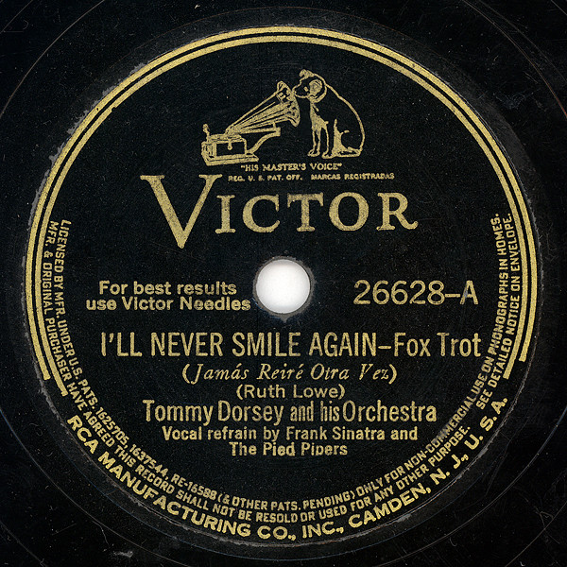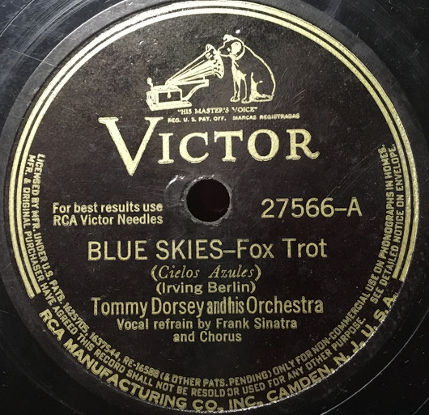

15. Blue Skies (Irving Berlin/arr. by Sy Oliver) 3:14
Tommy Dorsey Orchestra: Ziggy Elman, Charlie Peterson, Ray Linn, Jimmy Blake-tp; George Arus, Les Jenkins, Lowell Martin-tb; Johnny Mince-cl, as; Fred Stulce, Heinie Beau-as; Don Lodice, Paul Mason-ts; Joe Bushkin-p; Clark Yocum-g; Sid Weiss-b; Buddy Rich-dr; Frank Sinatra-voc; Tommy Dorsey-tb, cond; unknown-arr.
New York, July 15, 1941.
Victor 27566 / 066923-1. CD Sony 096692.

16. Artistry Jumps (Stan Kenton) 2:37
Stan Kenton Orchestra: Buddy Childers, Ray Wetzel, John Anderson, Russ Burgher, Bob
Lymperis-tp; Freddie Zito, Jimmy Simms, Milt Kabak, Bart Varsalona-tb; Al Anthony,
Boots Mussulli-as; Vido Musso, Bob Cooper-ts; Bob Gioga-bs; Stan Kenton-p, arr, cond; Bob
Ahern-g; Eddie Safranski-b; Ralph Collier-dr.
October 30, 1945.
Capitol 229 / 778-3. CD History 20.1911-HI.

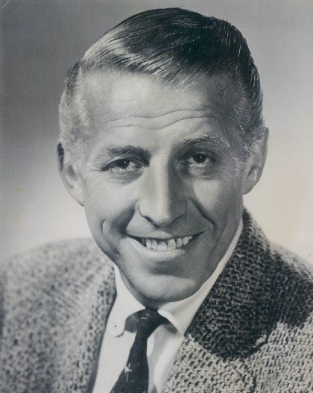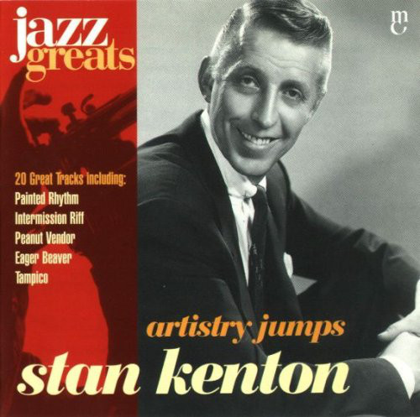
Stan Kenton (1911 – 1979)

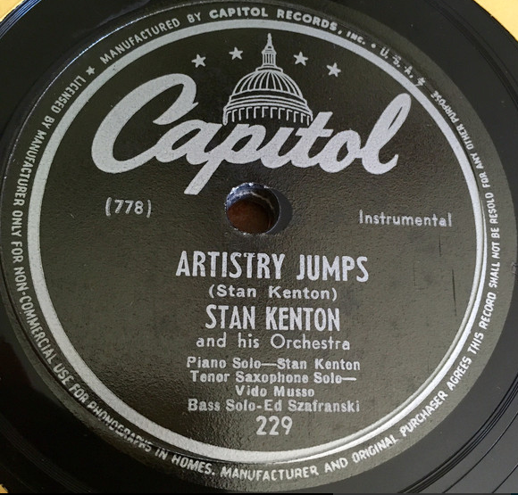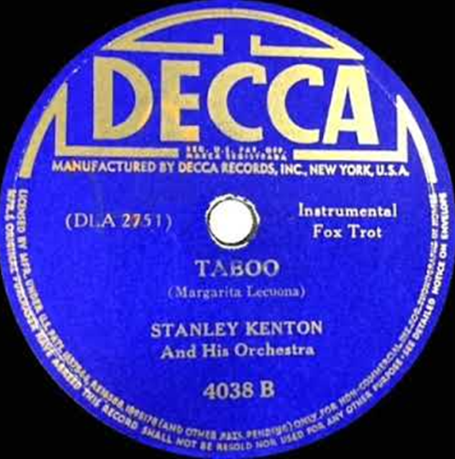

17. Taboo (Margarita Lecuona-Sidney Keith Russell-Al Stillman-Bob Russell-Francia Luban) 2:59
Stan Kenton Orchestra: Franck Beach, Chico Alvarez, Earl Collier-tp; Harry Forbes, Dick Cole-tb; Jack Ordean, Ted Romersa-as; Red Dorris, Hollis Bridwell-ts; Bob Gioga-bs; Ted
Repay-p; Al Costi-g; Howard Rumsey-b; Marvin George-dr; Stan Kenton-cond; unknown-arr.
Los Angeles, September 11, 1941.
Decca 4038 / DLA-2751-A. CD History 20.1925-HI.

18. Tippin’ In (Bobby Smith) 3:21
Erskine Hawkins Orchestra: Erskine Hawkins, Bobby Johnson, Chuck Jones, Sammy Lowe,
Bill Moore-tp; Donald Cole, Dave James, Norman Green, Ed Sims-tb; Bobby Smith, Jimmy
Mitchelle-as; Aaron Maxwell, Julian Dash-ts; Haywood Henry-bs; Ace Harris-p; Leroy
Kirkland-g; Lee Stanfield-b; Kelly Martin-dr; unknown-arr.
New York, January 10, 1945.
Victor 20-1639 / D5AB-300. CD History 20.1914-HI.

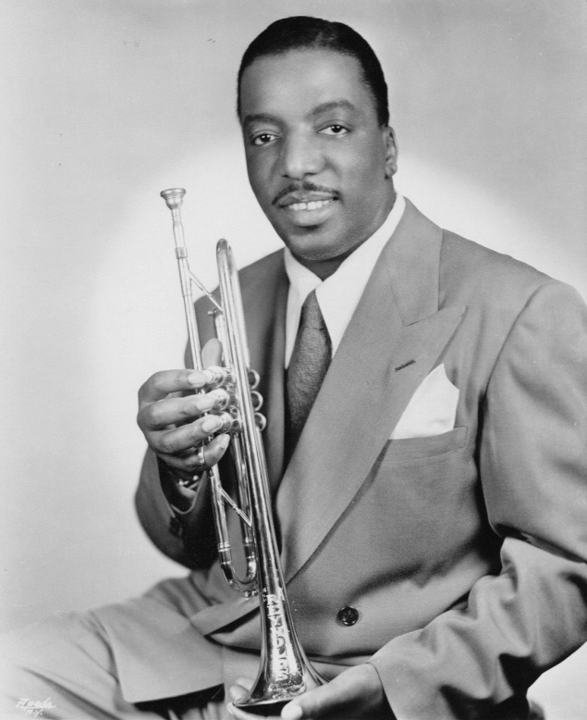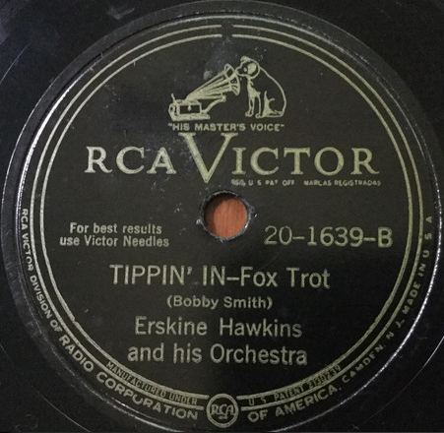
Erskine Hawkins (1914 – 1993)

19. Sophisticated Lady (Duke Ellington/arr. by William Russo) 3:15
Stan Kenton Orchestra: Buddy Childers, Maynard Ferguson (solo), Conte Candoli (muted
solo), Ruben McFall, Don Dennis-tp; Bob Burgess, Frank Rosolino, Keith Moon-tb; Bill
Russo-tb, arr; George Roberts-btb; Lee Konitz (solo), Vinnie Dean-as; Bill Holman, Richie
Kamuca-ts; Bob Gioga-bs;Stan Kenton-p, cond; Sal Salvador-g; Don Bagley-b; Stan Levey-dr.
Capitol Studios, Los Angeles, January 28, 1953.
Capitol EAP1 / H426/11076. CD Mosaic 136.

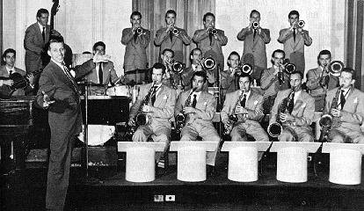

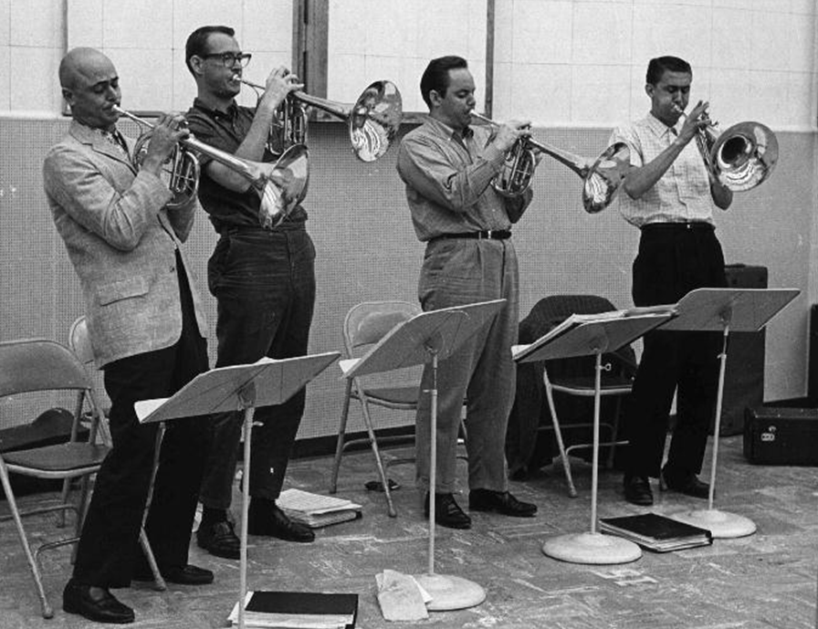
Mellophoniums

20. Tuxedo Junction (William Johnson-Julian Dash-Erskine Hawkins-Buddy Feyne) 3:28
Glenn Miller Orchestra: R. D. McMickle, Clyde Hurley, Johnny Best, Legh Knowles-tp; Glenn Miller, Paul Tanner, Frank D’Anolfo, Tommy Mack-tb; Hal McIntyre, Wilbur Schwartz, Jimmy Abato-as; Tex Beneke, Al Klink-ts; J. C. MacGregor-p; Richard Fisher-g; Rowland Bundock-b; Maurice Purtill-dr. Jerry Gray-arr.
New York, February 5, 1940.
Bluebird B-10612 / BS-046786-2A. CD RCA 90600.

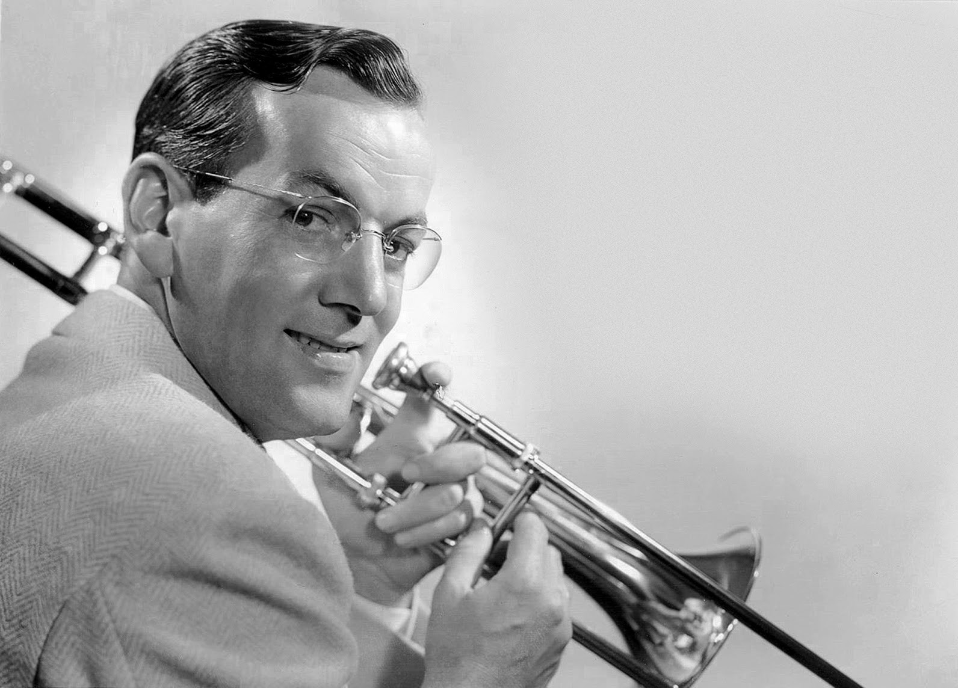
Glenn Miller (1904 – 1944)

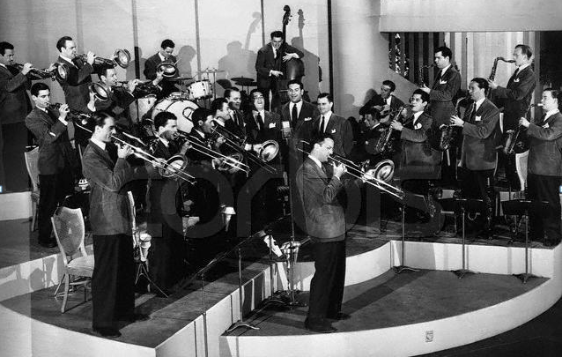

21. Moonlight Serenade (Mitchell Parish-Glenn Miller) 3:22
Glenn Miller Orchestra: Dale McMickle, Bob Price, Legh Knowles-tp; Glenn Miller-tb, arr;, Al Mastren, Paul Tanner-tb; Hal McIntyre, Al Klink-as; Wilbur Schwartz-as, cl; Tex Beneke-ts; Stanley Aronson-ts, as; Chummy MacGregor-p; Allan Reuss-g; Rolly Bundock-b; Frankie Carlson-dr.
New York, April 4, 1939.
Bluebird B-10214-B / BS-035701-1. CD RCA ND 90600 (1991).

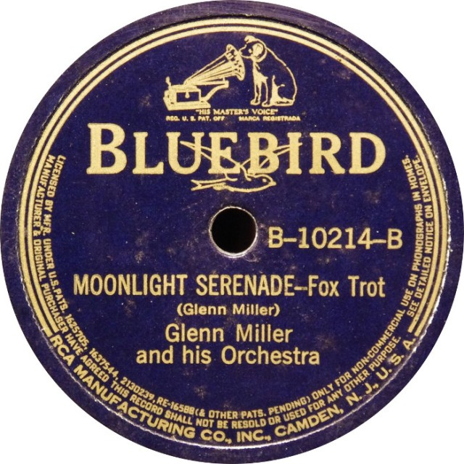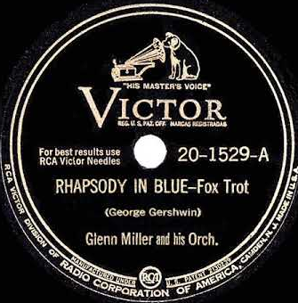

22. Rhapsody in Blue (George Gershwin) 3:03
Glenn Miller Orchestra: Billy May, Steve Lipkins, Dale McMickle, Johnny Best-tp; Glenn Miller, Jimmy Priddy, Paul Tanner, Frank D’Annolfo-tb; Lloyd „Skippy“ Martin-as; Ernie Caceres-as, bs, cl; Wilbur Schwartz-cl, as; Tex Beneke, Al Klink-ts; Chummy MacGregor-p; Bobby Hackett-g; Doc Goldberg-b; Maurice Purtill-dr. Bill Finegan-arr.
Chicago, Thursday July 16, 1942.
Victor 20-1529-A / 074748-1. CD RCA ND 90600 (1991).

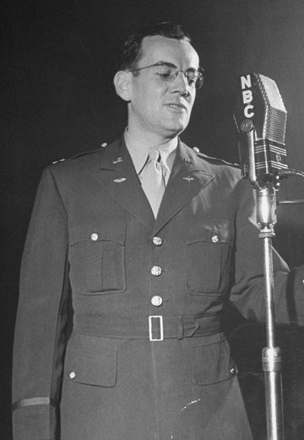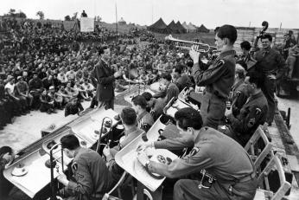

23. Flyin’ Home (Benny Goodman-Lionel Hampton) 2:52
Charlie Barnet Orchestra: Johnny Owens, Billy May, Bobby Burnet, Lyman Vunk-tp; Don
Ruppersberg, Bill Robertson, Claude „Spud“ Murphy-tb; Charlie Barnet-ss, as, ts, cond; Gene Kinsey, Skippy Martin-as; James Lamare-as, bs; Kurt Bloom-ts; Bill Miller-p; Bus Etri-g; Phil Stevens-b; Cliff Leeman-dr; Skippy Martin-arr.
New York, May 8, 1940.
Bluebird B-10794 / 050620-1. CD History 20.1916-HI.

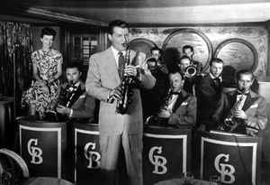

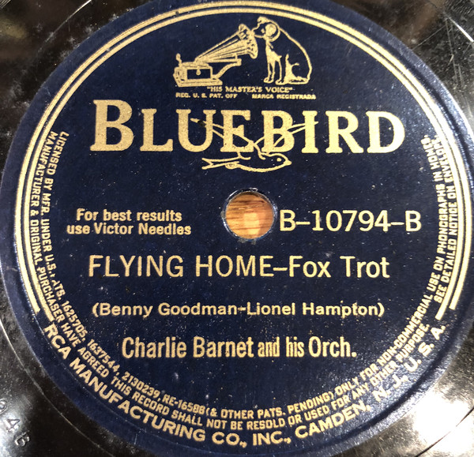

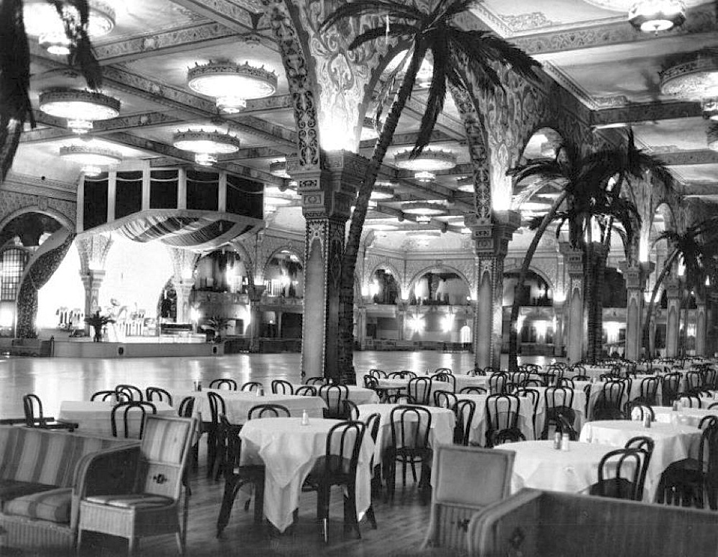

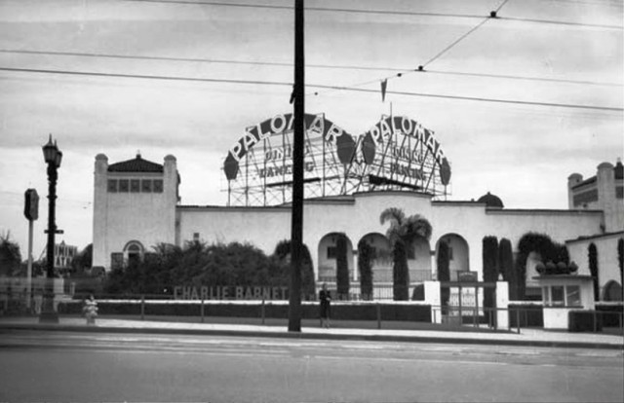

Palomar Ballroom, Vermont Avenue, Los Angeles
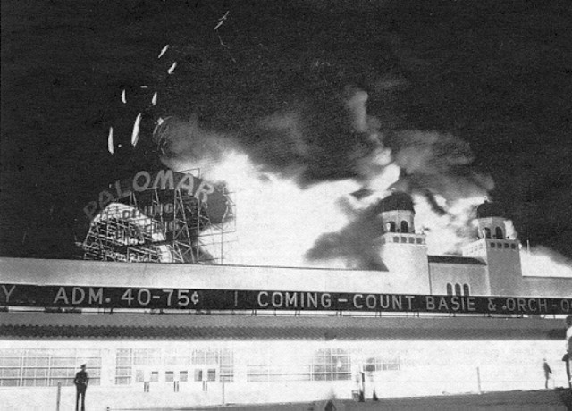

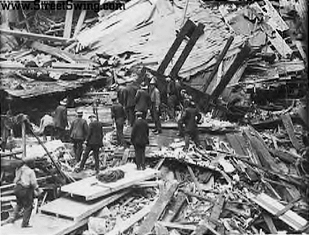

2. 10. 1939

varianta názvu | počet nahrávek | aranžér | nahráno poprvé
Artistry in Rhythm | 159 | Stan Kenton | 19401101
Artistry Jumps | 18 | Stan Kenton | 19451030
Artistry in Boogie | 5 | Pete Rugolo | 19460604
Artistry in Bolero | 14 | Pete Rugolo | 19460712
Artistry in Percussion | 14 | Pete Rugolo | 19460712
Artistry in Harlem Swing | 1 | Gene Roland | 19470101
Artistry in Tango | 4 | ??? | 19500000
Artistry in Blues | 1 | Stan Kenton | 19571010
Artistry in Bossa Nova | 1 | Stan Kenton | 19630417

Roku 1943 se základní, nejčastěji nahrávaná podoba skladby, Artistry in Rhythm, vyšplhala na 52. příčku.
1. května 1944 byl do amerických kin uveden krátkometrážní hudební film „Artistry in Rhythm“, v hlavních rolích byli Stan Kenton, zpěvačka Anita O’Day a zpěvák Gene Howard. Kentonův orchestr v něm hraje známé číslo ze svého repertoáru, skladbu „Eager Beaver“. Můžeme se domnívat, že zazní i znělka orchestru, „Artistry in Rhythm“. Trvání je 16 minut.

