08 BEBOP / COOL JAZZ / HARD BOP / WEST COAST

BEBOP

1 Ko-Ko (Charlie Parker) 2:56
Dizzy Gillespie-tp; Charlie Parker-as; Sadik Hakim-p; Curley Russell-b; Max Roach-dr.
New York, November 26, 1945.
first issue Savoy 597 / matrix number S5853-2
https://secondhandsongs.com/performance/161512

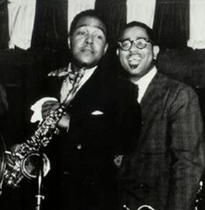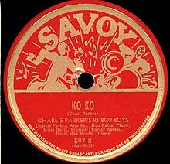

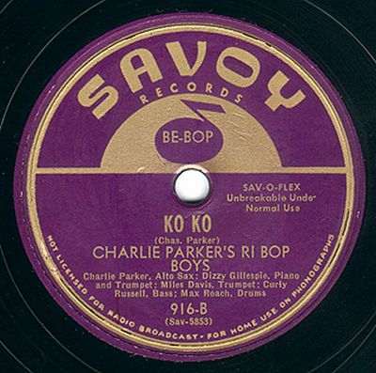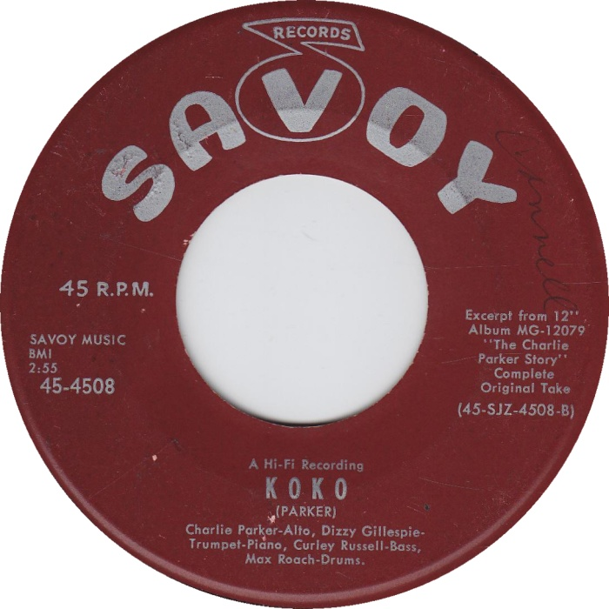

2 Billie’s Bounce (Charlie Parker) 3:10
Miles Davis-tp; Charlie Parker-as; Dizzy Gillespie-p; Curley Russell-b; Max Roach-dr.
New York, November 26, 1945.
Savoy 573 / S5850-5.
https://secondhandsongs.com/performance/106255

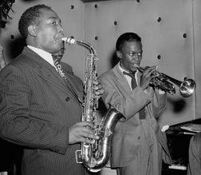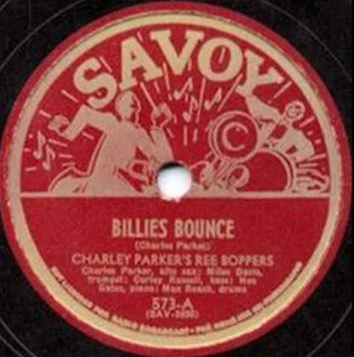

3 Evidence [aka Justice] (Thelonious Monk) 2:35
Thelonious Monk-p; Milt Jackson-vib; John Simmons-b; Shadow Wilson-dr.
New York, July 2, 1948.
Blue Note 549 / BN 328-0.
https://www.youtube.com/watch?v=Gw2OnHeq56U

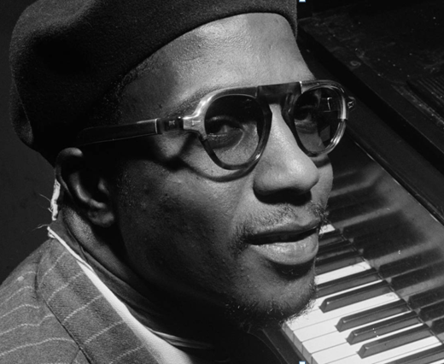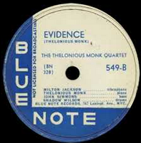

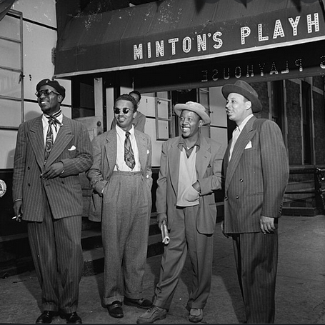
Thelonious Monk, Howard McGhee, Roy Eldridge, Teddy Hill

Henry Minton, a tenor saxophonist and the first black delegate to Local 802 of the musicians’ union, opened Minton’s Playhouse in 1938. Located on 118th street at Saint Nicholas Avenue in Harlem, adjacent to the Hotel Cecil, the Playhouse was a frequent temporary residence of musicians passing through New York. In 1940, Minton hired big band musician Teddy Hill to organize the music policy for his club and help improve a lagging business. Hill quickly made Kenny Clarke the band leader, giving him full artistic license. Clarke in turn brought trumpeter Joe Guy, bassist Nick Fenton, and local pianist at the time Thelonius Monk into the group. It was then that Minton’s history as the playground of New York jazz and the birthplace of bebop began.
Because of Minton’s connections to the union, musicians were able to experiment freely at the club without fear of being fined by the union delegate for playing without pay. Thus, musicians from nearby big band theaters like the Apollo and the Paramount made Minton’s their after hours hotspot (the club was open until 4am).

Clark Monroe opened the Uptown House in the 1930s at 198 West 134th St in Harlem.
From the late 1930s, the club presented swing jazz; Billie Holiday held a residence there for three months in 1937. In the early 1940s, the club became known for its jam sessions, where many of the players involved in the birth of bebop played together. Al Tinney led Monroe's house band, which included Max Roach, "Little" Benny Harris, George Treadwell, and Victor Coulsen. Charlie Parker was a featured soloist at the club in 1943.
An important live recording of Charlie Christian features a jam "session at Monroes".
Monroe moved the club to 52nd Street in 1943, and opened a second club, The Spotlite, in December 1944.
4 Up On Teddy’s Hill (Charlie Christian) 6:10
Joe Guy, Hot Lips Page-tp; Kermit Scott, Don Byas-ts; Thelonious Monk-p; Charlie
Christian-g; Nick Fenton-b; Kenny Clarke-dr.
Minton’s, New York, May 8, 1941.
CD: LaserLight 17032.
https://www.youtube.com/watch?v=I-sDu7yUyhM

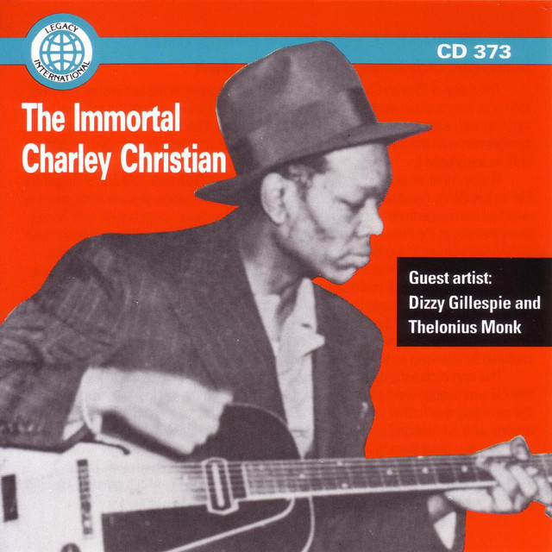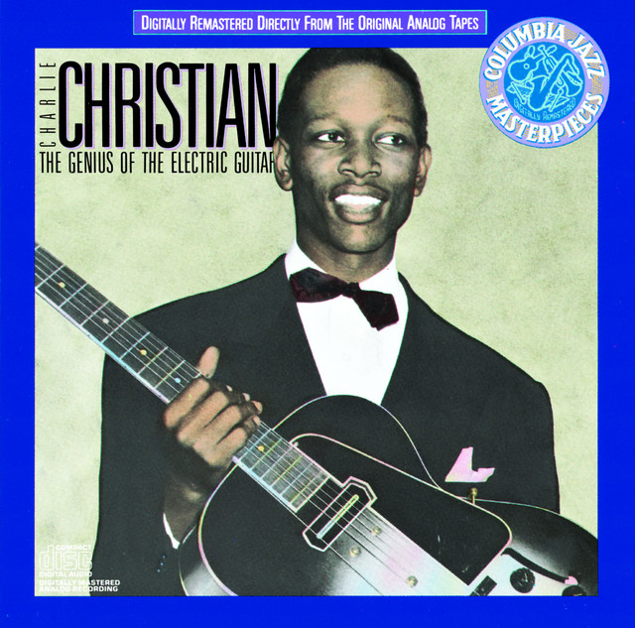

5 52nd Street Theme (Thelonious Monk) 3:17
Dizzy Gillespie-tp; Don Byas-ts; Milt Jackson-vib; Al Haig-p; Bill DeArango-g; Ray Brown-
b; J. C. Heard-dr.
New York, February 22, 1946.
Victor 40-1030 / PD6VB1682-2.
https://secondhandsongs.com/performance/73787

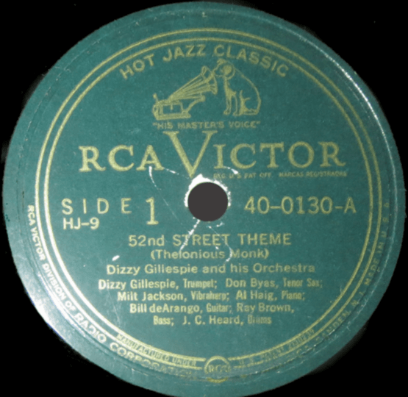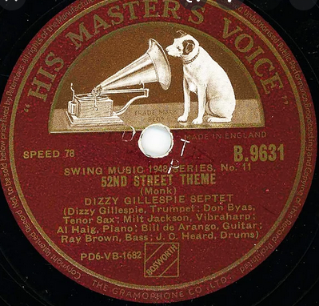

6 Minor Walk (Linton Garner-Dizzy Gillespie) 2:47
Dizzy Gillespie Big Band: Dizzy Gillespie, Elmon Wright, Dave Burns, Lamar Wright,
Ernest Bailey-tp; William Shepherd, Ted Kelly-tb; Howard Johnson, John Brown-as; Joe
Gayles, George Nicholas-ts; Cecil Payne-bs; John Lewis-p; Al McKibbon-b; Kenny Clarke-dr;
Chano Pozo-conga, bongos.
New York, December 30, 1947.
Victor 20-3186 / D7VB3094-1.
https://www.youtube.com/watch?v=3oZxZYoCSrw

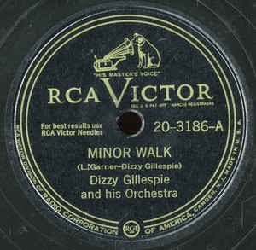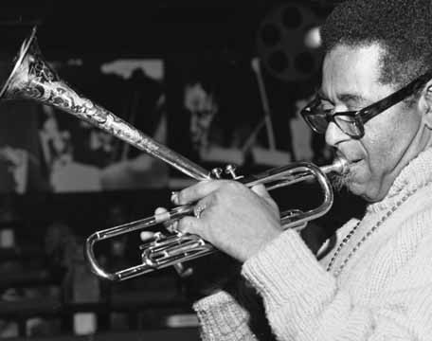

6a Cubana Be-Cubana Bop (Dizzy Gillespie-George Russell) 5:59
same personnel, George Russell-arr.
New York, December 22, 1947.
Victor 20-3145-A / D7VB2934-1 & Victor 20-3145-B / D7VB2935-1.
https://www.youtube.com/watch?v=dtCwaEK_TjA

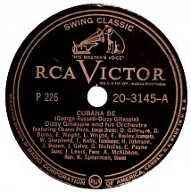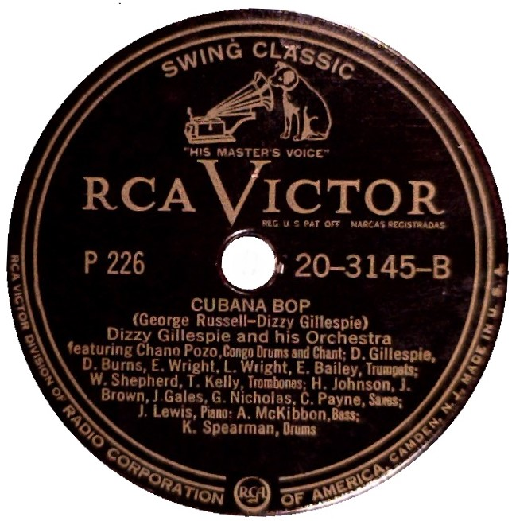

7 Bloomdido (Charlie Parker) 3:28
Dizzy Gillespie-tp; Charlie Parker-as; Thelonious Monk-p; Curly Russell-b; Buddy Rich-dr.
New York, June 6, 1950.
Clef MGC 512 / C410-4.
https://secondhandsongs.com/performance/631987

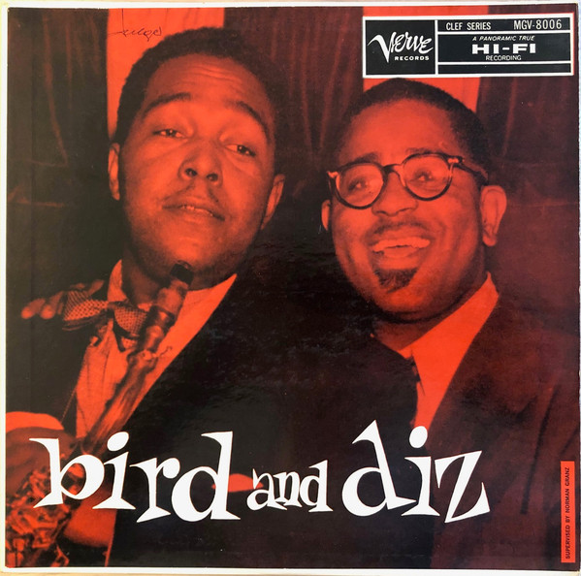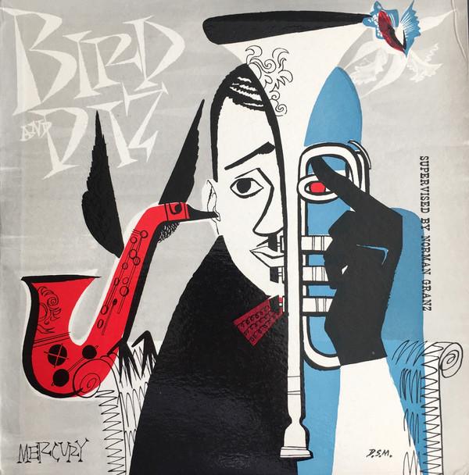

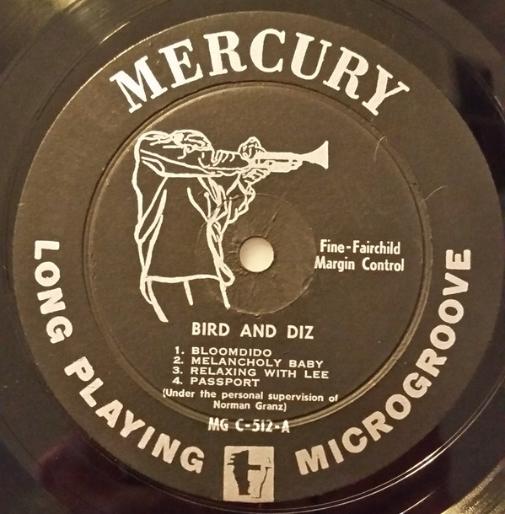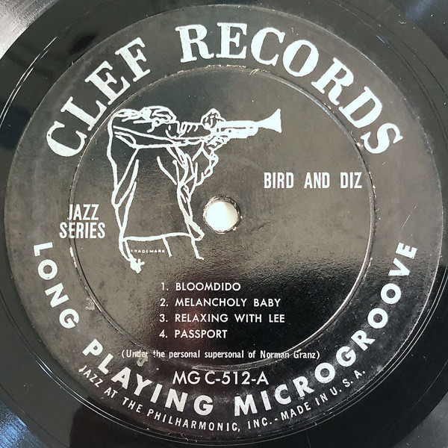

COOL JAZZ

8 Early Autumn (Ralph Burns) 3:09
Woody Herman Orchestra: Stan Fishelson, Bernie Glow, Red Rodney, Shorty Rogers, Ernie
Royal-tp; Earl Swope, Bill Harris, Bob Swift, Ollie Wilson-tb; Woody Herman- cl,as; Sam
Marowitz-as; Al Cohn, Stan Getz, Zoot Sims-ts; Serge Chaloff-bs; Lou Levy-p; Chubby
Jackson-b; Terry Gibbs-vib; Don Lamond-dr.
Los Angeles, December 30, 1948.
Capitol 57-616 / 3831-2.
https://secondhandsongs.com/performance/33478

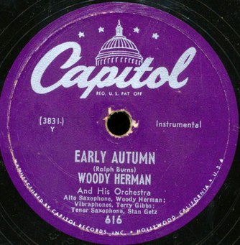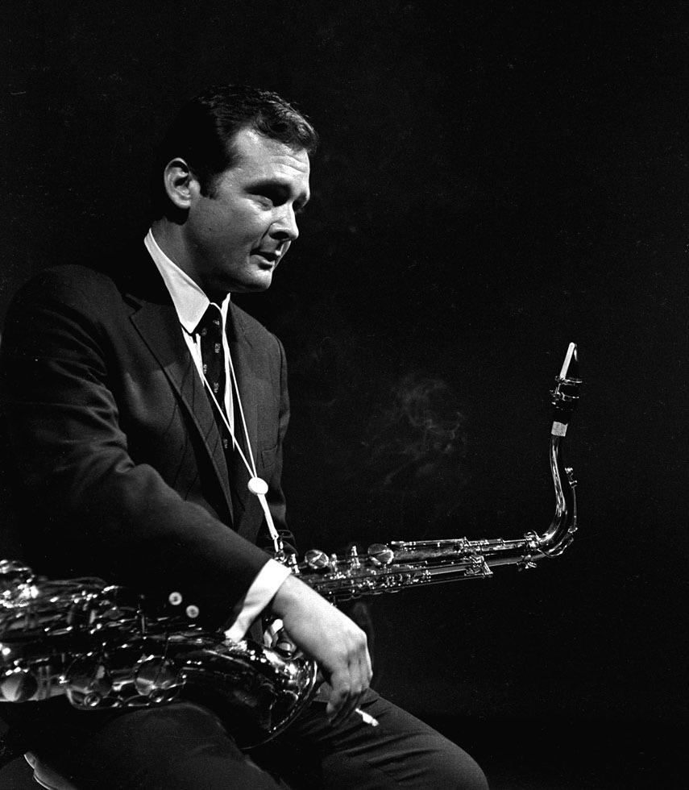
Stan Getz

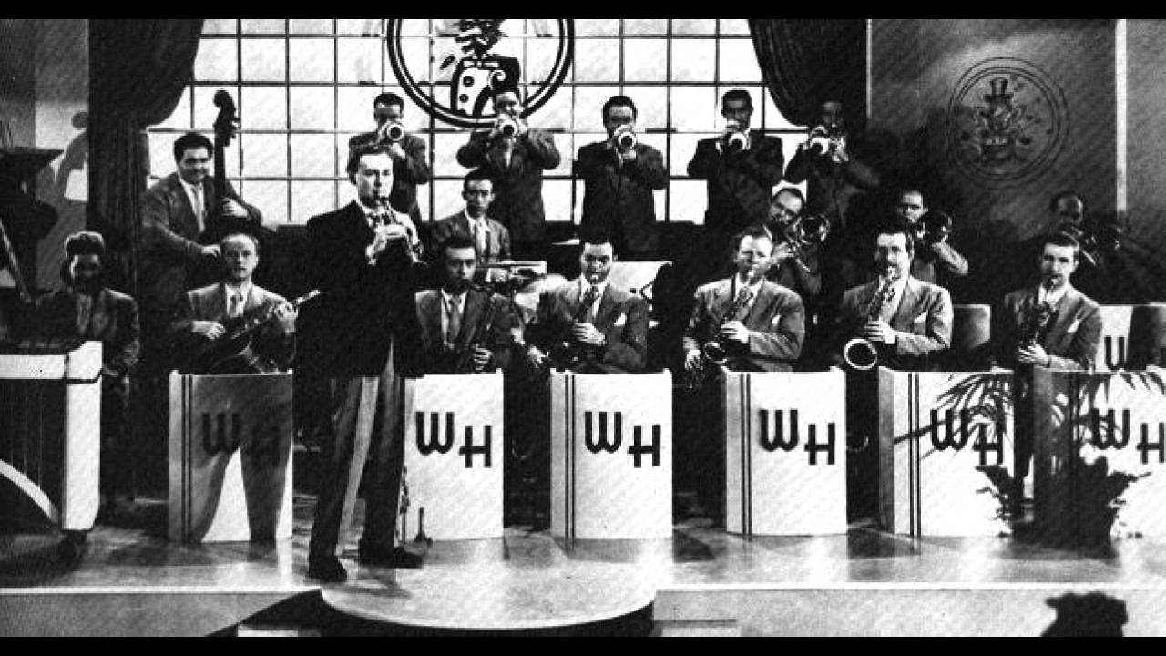

9 Four Brothers (Jimmy Giuffre) 3:18
Woody Herman Second Herd: Shorty Rogers, Ernie Royal, Stan Fishelson, Bernie Glow,
Markie Markowitz-tp; Earl Swope, Ollie Wilson-tb; Bob Swift-btb; W.H.-cl,as; Sam
Marowitz-as; Herbie Steward-as,ts; Stan Getz, Zoot Sims-ts; Serge Chaloff-bs; Fred Otis-p;
Gene Sargent-g; Walt Yoder-b; Don Lamond-dr.
Los Angeles, December 24, 1947.
Columbia 38304 / HCO 3061-1.
https://secondhandsongs.com/performance/291726

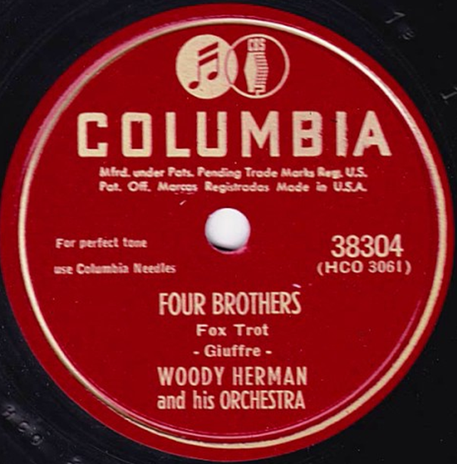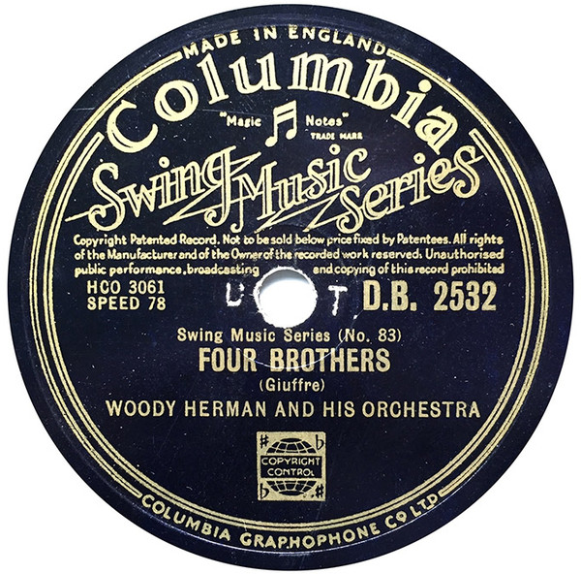

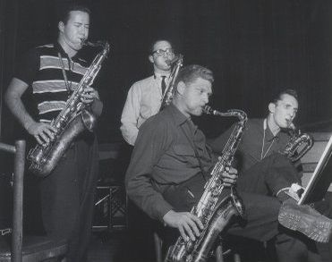

10 Where Or When (Richard Rodgers) 2:45
Claude Thornhill Orchestra: Rusty Dedrick, Conrad Gozzo, Bob Sprentall-tp; Tasso Harris, Bob Jenney-tb; Irving Fazola-cl; Dale Brown, George Paulson-cl, as; John Nelson, Hammond Russum-cl, ts; Ted Goddard- cl, bar; Claude Thornhill-p; Allen Hanlon-g; Harvey Sell-b; Gene Lemon-dr.
New York, May 21, 1941.
Columbia 36268 / CO 30533-1.
https://www.youtube.com/watch?v=vUBbxmwF1EQ

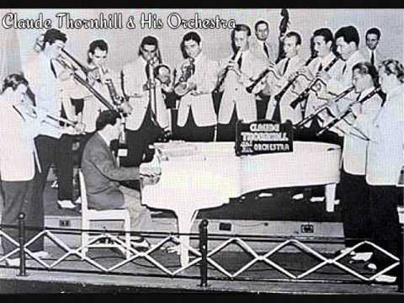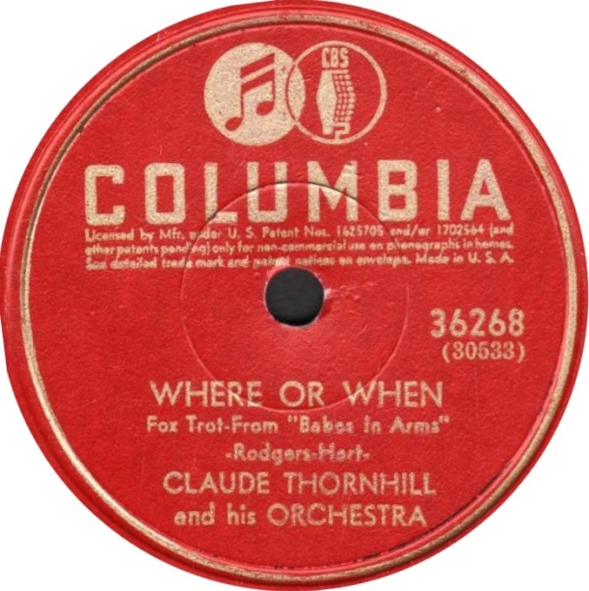

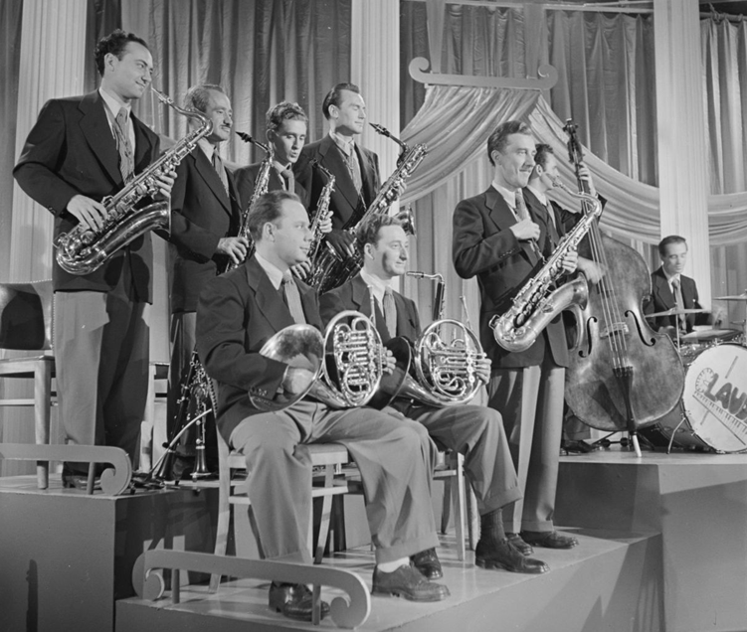

11 Godchild (George Wallington) 3:10
Claude Thornhill Orchestra: Johnny Napton, Johnny Carisi, Gene Roland-tp; Allan
Langstaff, Leon Cox-tb; Al Antonucci, Junior Collins-h; Danny Polo-cl,as; Lee Konitz-as;
Brew Moore, Jet Rollo-ts; Gerry Mulligan-bs,arr; C.T.-p; Joe Shulman-b; Bill Exiner-dr.
New York, October 1948.
Radio transcription/CD Hep 17.
https://www.youtube.com/watch?v=r70x1eF1quY

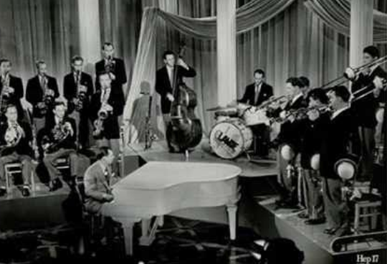

12 Godchild (Wallington) 3:11
Miles Davis Nonet [Capitol Orchestra]: Miles Davis-tp; Kai Winding-tb; Junior Collins-h;
Bill Barber-tu; Lee Konitz-as; Gerry Mulligan-bs,arr; Al Haig-p; Joe Shulman-b; Max
Roach-dr.
New York, January 21, 1949.
Capitol 57-60005 / 3397-2E.
https://secondhandsongs.com/performance/383903

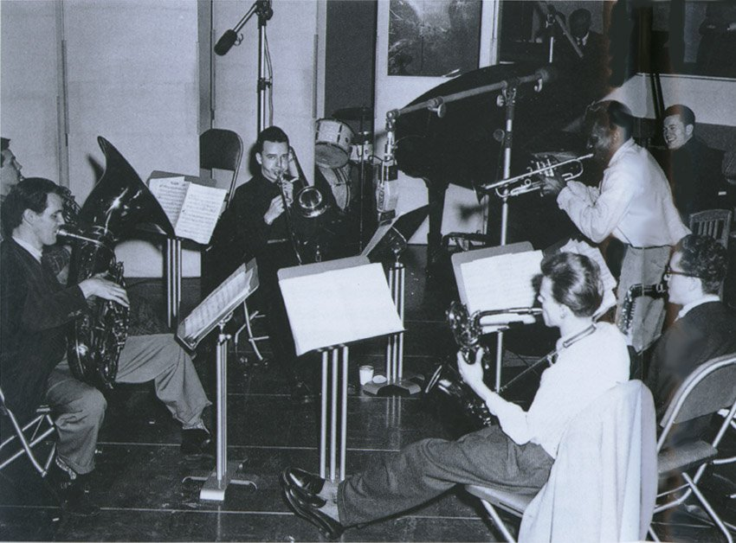

13 Godchild – live recording (Wallington) [fade out] 6:03
Miles Davis Nonet [Capitol Orchestra]: Miles Davis-tp; Mike Zwerin-h; Junior Collins-h;
Bill Barber-tu; Lee Konitz-as; Gerry Mulligan-bs,arr; John Lewis-p; Al McKibbon-b;
Max Roach-dr.
Royal Roost, New York, September 4, 1948.
Ozone 2.
https://www.youtube.com/watch?v=-WLt6DvyrX8

The Royal Roost was a jazz club located at 1580 Broadway in the Theater District of Manhattan in New York City.
Ralph Watkins originally opened the Royal Roost as a chicken restaurant.^{[1]} After a difficult start, Watkins was persuaded by Sid Torin (D.J. Symphony Sid) to try presenting modern jazz at the club. Beginning in 1948 the club began to showcase the likes of Charlie Parker, Dizzy Gillespie, Fats Navarro, Dexter Gordon, Tadd Dameron, and Max Roach. The presence of so many prominent bebop musicians performing at the Royal Roost led to the club being nicknamed "the Metropolitan Bopera House," a pun referencing the club's close proximity to the nearby Metropolitan Opera House.^{[2]} In 1949, a record label, Roost Records, was founded by Arthur Faden, Bill Faden, Monty Kay and Ralph Watkins, which recorded many of the musicians who performed at the club. In September 1948, Miles Davis debuted his nonet at the club, a project that would eventually give rise to the seminal cool jazz album Birth of the Cool. By the early 1950s, the jazz component of the Roost was moved to Watkins's new club, Bop City.

14 On a Planet (Lennie Tristano) 3:22
Lennie Tristano-p; Billy Bauer-g; John Levy-b.
New York, October 23, 1947.
Savoy MG12043 / T-1392.
https://www.youtube.com/watch?v=gRe-YDCiBto

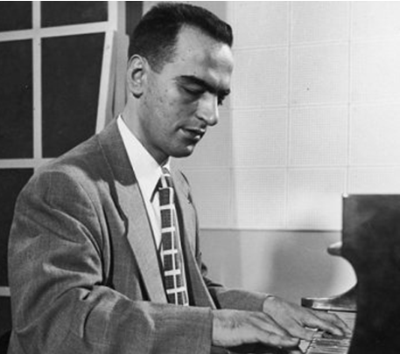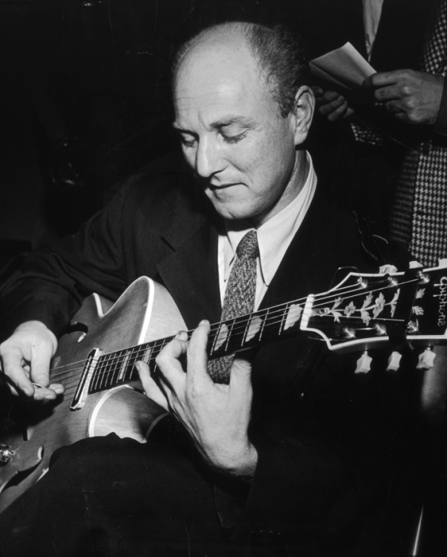

15 September in the Rain (Harry Warren) 3:14
George Shearing Quintet: George Shearing-p; Marjorie Hyams-vib; Chuck Wayne-g; John
Levy-b; Denzil Best-dr.
New York, February 17, 1949.
MGM 10426 / 49S86.
https://secondhandsongs.com/performance/74246

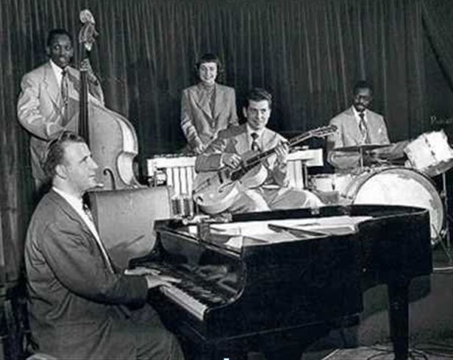

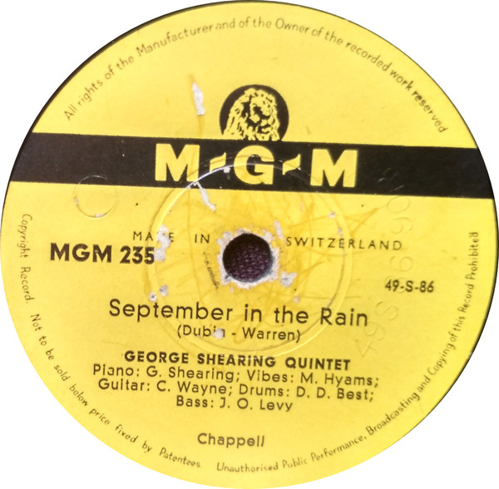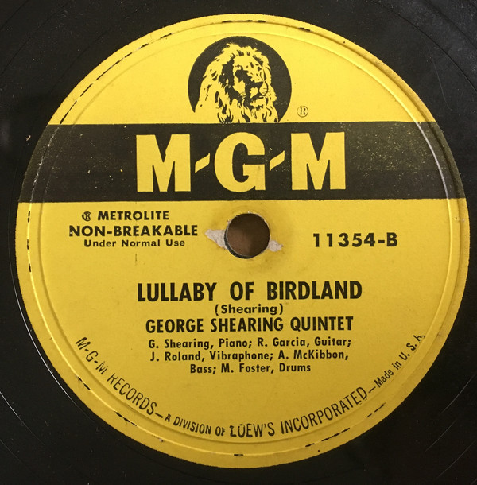

15a Lullaby of Birdland (George Shearing) 2:23
George Shearing Quintet: George Shearing-p; Joe Roland-vib; Dick Garcia-g; Al
McKibbon-b; Marquis Foster-dr.
New York, July 17, 1952.
MGM 11354 / 52S278-A.
https://www.youtube.com/watch?v=qNSxiLnJSVQ

15b Lullaby of Birdland (George Shearing) 2:26
Stan Getz Quintet: S.G.-ts; Duke Jordan-p; Jimmy Raney-g; Bill Crow-b; Frank Isola-dr
New York, December 19, 1952
Roost 562 / R 1146.
https://www.youtube.com/watch?v=8VKmnAdL8c0

15c Autumn Leaves (Joseph Kosma) 3:09
as above, matrix number R 1147.
https://www.youtube.com/watch?v=0PfJE9tHiGo

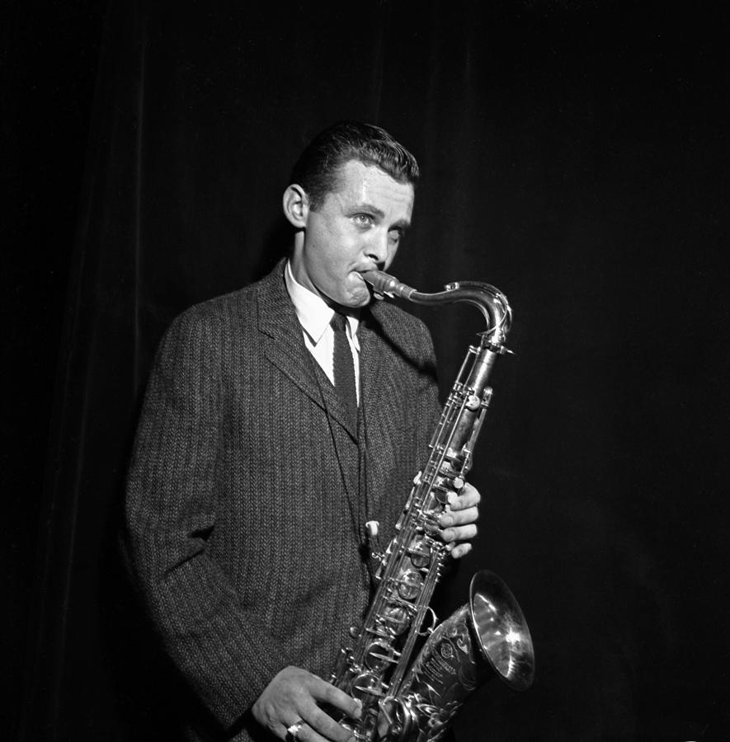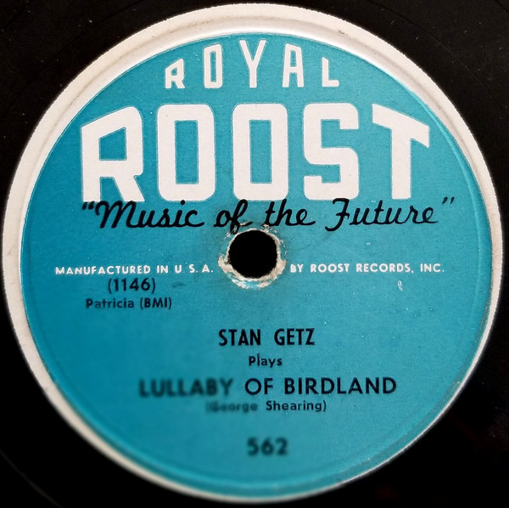

EAST COAST JAZZ / HARD BOP

16 Vendome (John Lewis) 3:14
Modern Jazz Quartet: Milt Jackson-vib; John Lewis-p; Percy Heath-b; Kenny Clarke-dr.
New York, December 22, 1952.
Prestige PRLP 160 / 405.
https://secondhandsongs.com/performance/407280

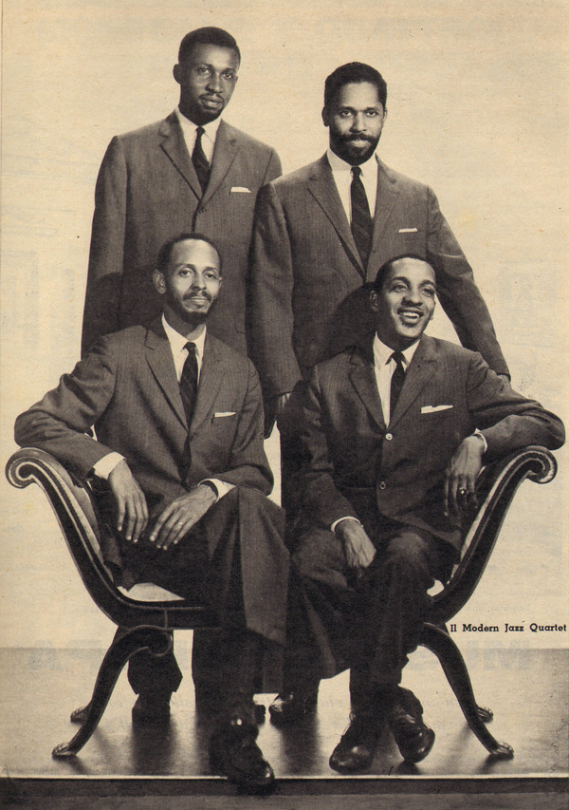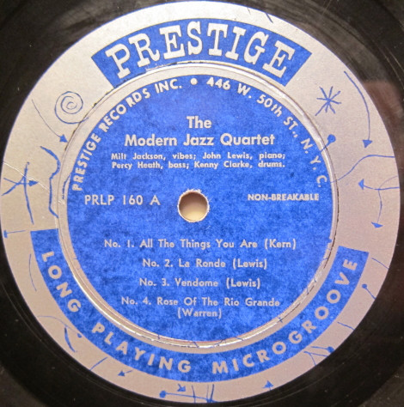

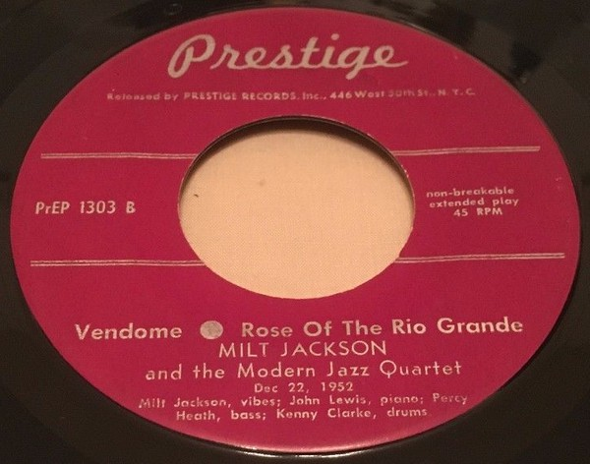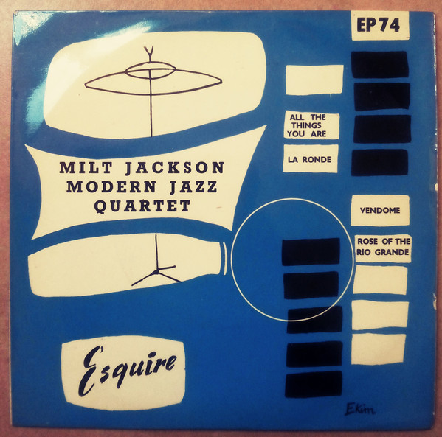

17 Room 608 (Horace Silver) 5:22
Horace Silver Quintet: Kenny Dorham-tp; Hank Mobley-ts; Horace Silver-p; Doug Watkins-
b; Art Blakey-dr.
Hackensack, NJ, November 13, 1953.
Blue Note 45-1631 / take 3.
https://www.youtube.com/watch?v=DuOwiu4K3OA

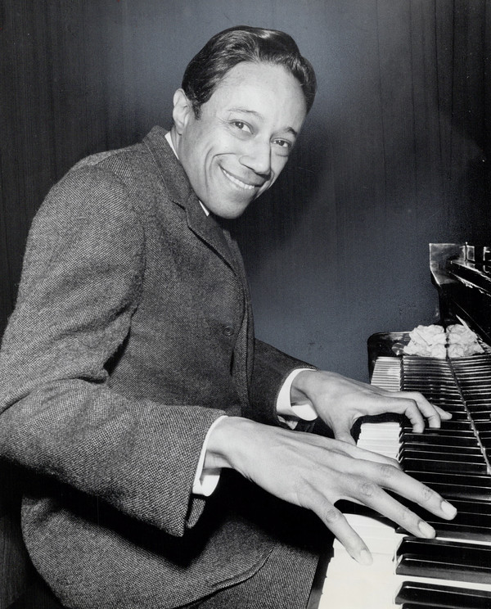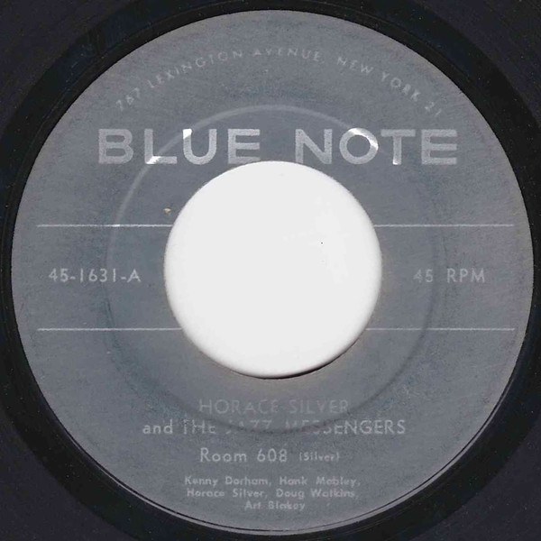

18 Daahoud (Clifford Brown) 4:04
Clifford Brown-Max Roach Quintet: C.B.-tp; Harold Land-ts; Richie Powell-p; George
Morrow-b; Max Roach-dr.
Los Angeles, August 6, 1954.
Mercury EP1-6075, MG 26043 / 10880.
https://www.youtube.com/watch?v=lv4EarQxGMo

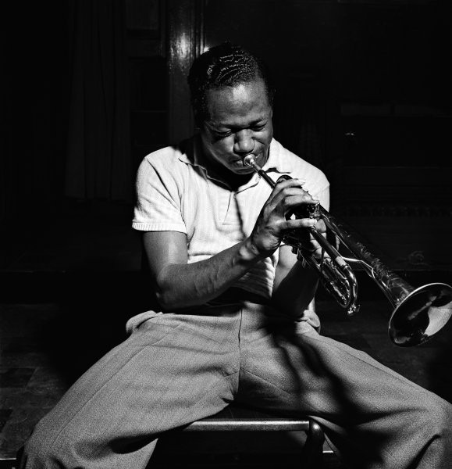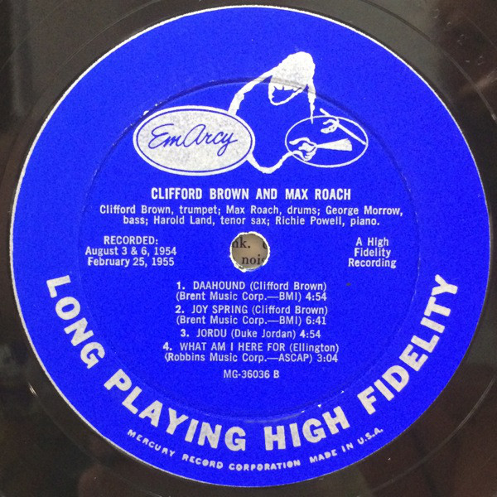

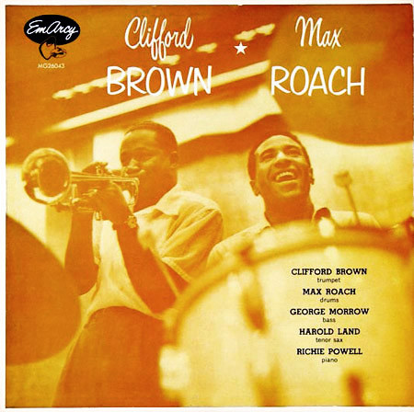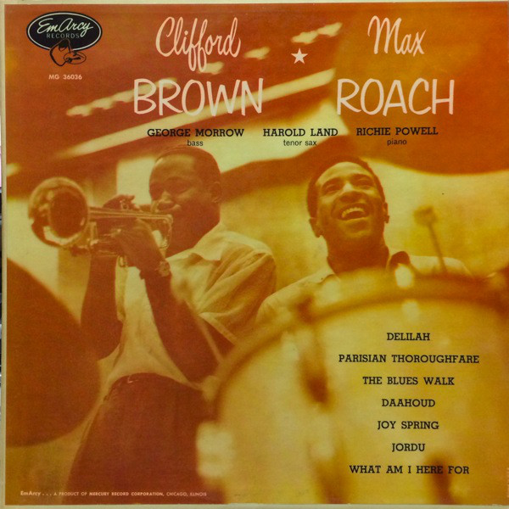

18a Daahoud (Clifford Brown) 4:13
Clifford Brown featuring Zoot Sims: C.B.-tp; Stu Williamson-vtb; Zoot Sims-ts; Bob
Gordon-bs; Russ Freeman-p; Joe Mondragon-b; Shelly Manne-dr; Jack Montrose-arr.
Los Angeles, July 12, 1954
Pacific Jazz PJLP 19 / matrix number unknown.
https://secondhandsongs.com/performance/214884

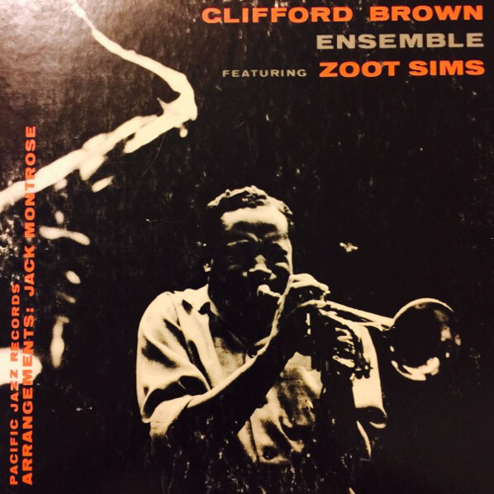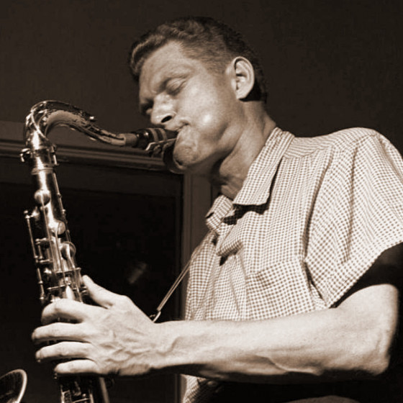

19 You Got It - live recording (Julian Adderley) 5:10
Cannonball Adderley Quintet: Nat Adderley-co; Julian Adderley-as; Bobby Timmons-p; Sam
Jones-b; Louis Hayes-dr.
San Francisco, October 18 & 20, 1959.
Riverside RLP 12-311, 1157 / matrix number unknown.
https://www.youtube.com/watch?v=4SMHmgZ5Os0

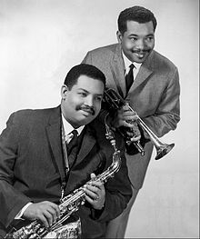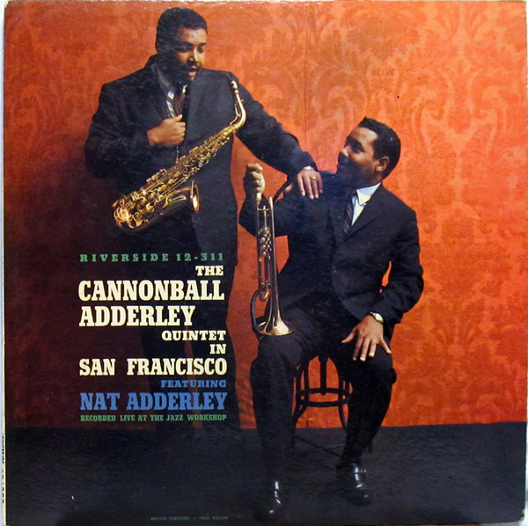

WEST COAST JAZZ

20 Bernie’s Tune (Bernie Miller) 2:55
Gerry Mulligan Quartet: Chet Baker-tp; G.M.-bs; Bobby Whitlock-b; Chico Hamilton-dr.
Los Angeles, August 16, 1952.
Pacific Jazz 601, PJLP-1 / 206.
https://secondhandsongs.com/performance/316919

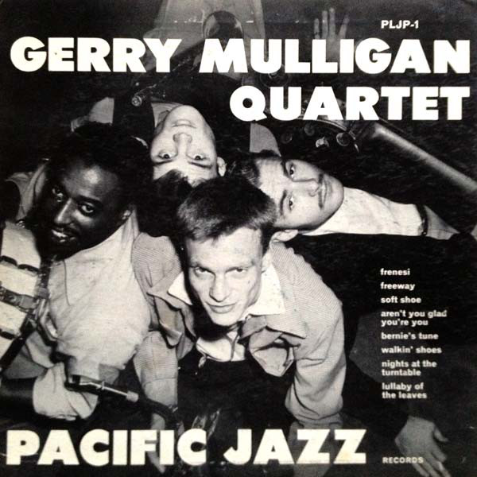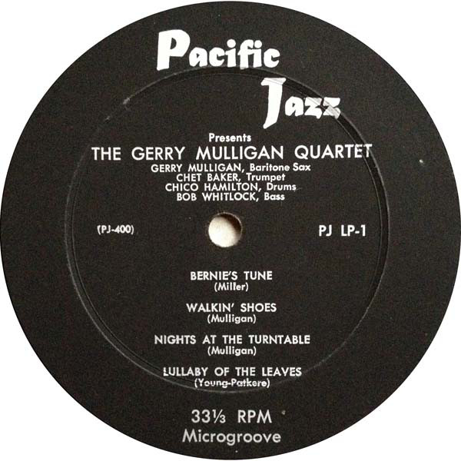

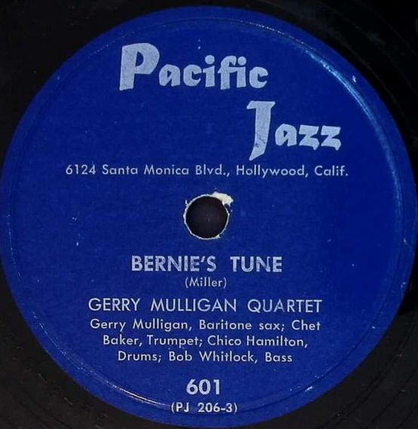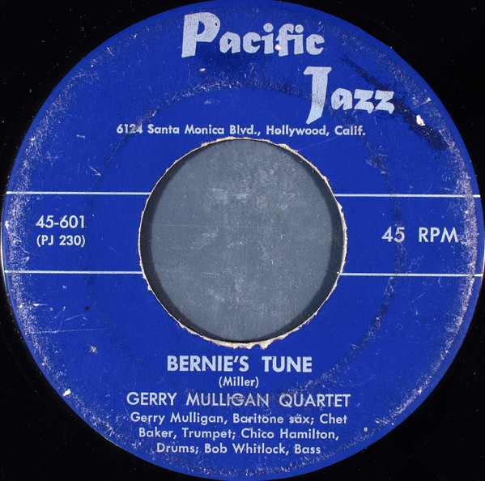

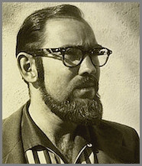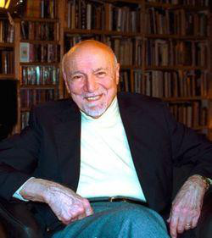
Richard Bock (1927 – 1988) Bob Weinstock (1928 – 2006)
Pacific Jazz Records (1952) Prestige Records (1949)

21 Walking Shoes (Gerry Mulligan) 3:12
same personnel
Los Angeles, October 15 – 16, 1952
Pacific Jazz 602 / 222.
https://www.youtube.com/watch?v=Lx-vsmRSDTw

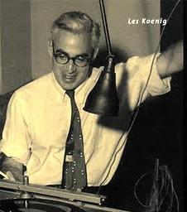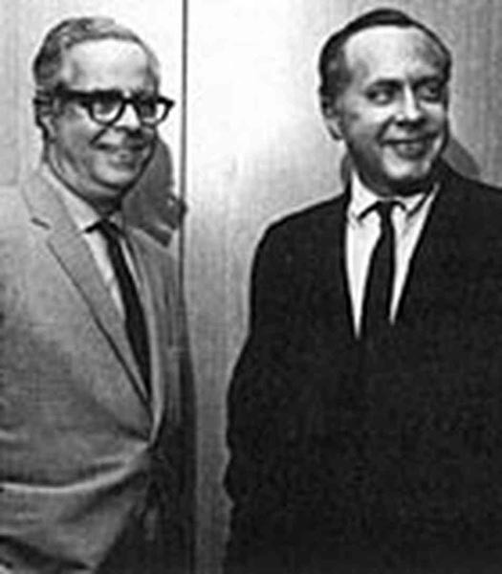
Lester Koenig (1918 – 1977) Blue Note Records (1939)
Contemporary Records (1951) Alfred Lion (1908-1987) & Francis Wolff (1907-1971)

21a Walking Shoes (Gerry Mulligan) 3:40
Gerry Mulligan Tentette: Chet Baker, Pete Candoli-tp; Gerry Mulligan-bs,p; Ray Siegel-tb;
Bob Enevoldsen-vtb; John Graas-Frh; Bud Shank-as; Don Davidson-bs; Joe Mondragon-b;
Chico Hamilton-dr.
Los Angeles, January 29, 1953.
Capitol EAP 1439, H-439, T 691 / 11117
https://secondhandsongs.com/performance/385395

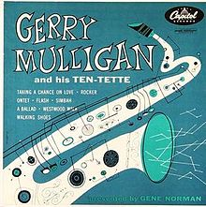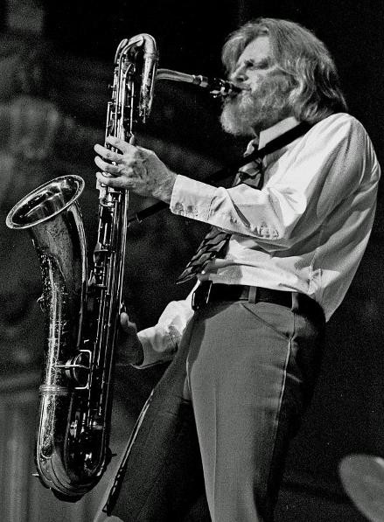

22 Didi (Shorty Rogers) 2:29
Shorty Rogers Giants: S.R.-tp; John Graas-h; Gene Englund-tb; Art Pepper-as; Jimmy
Giuffre-ts; Hampton Hawes-p; Don Bagley-b; Shelly Manne-dr.
Los Angeles, October 8, 1951.
Capitol 15765, EPP 2- 294 / 9118.
https://www.youtube.com/watch?v=vIMCDmquF2s

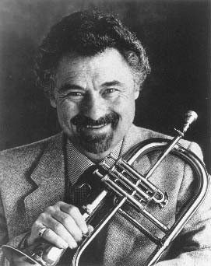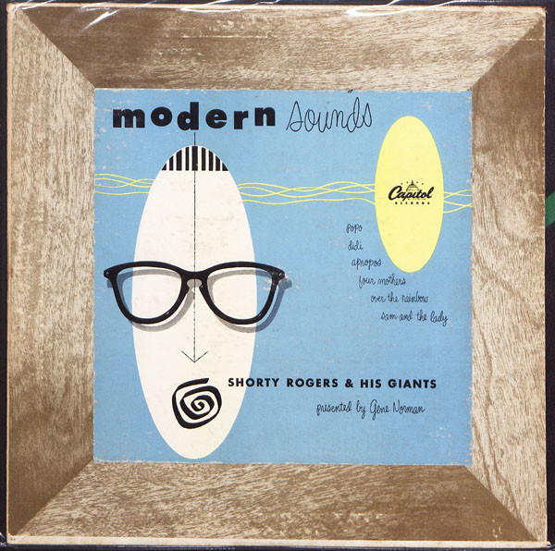

23 Take Five (Paul Desmond) 5:29
Dave Brubeck Quartet: Paul Desmond-as; D.B.-p; Joe Benjamin-b; Joe Morello-dr.
New York, July 1, 1959.
Columbia 4-41479, CS 8192 / CO 62578.
https://www.youtube.com/watch?v=vmDDOFXSgAs

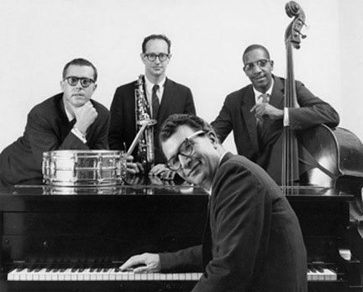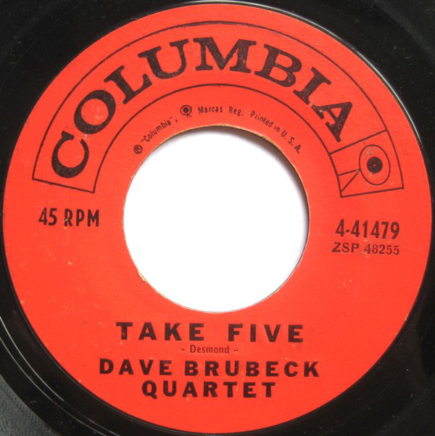

24 Blue Rondo a la Turk (Dave Brubeck) 6:46
Dave Brubeck Quartet: Paul Desmond-as; D.B.-p; Eugene Wright-b; Joe Morello-dr.
New York, August 18, 1959
Columbia 4-41479 / CO 62572.
https://www.youtube.com/watch?v=vKNZqM0d-xo

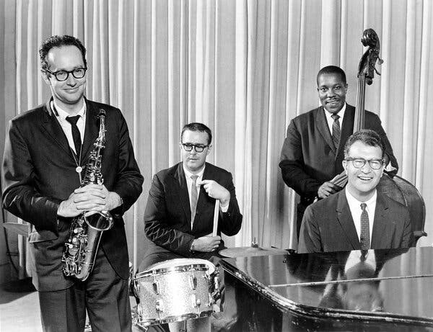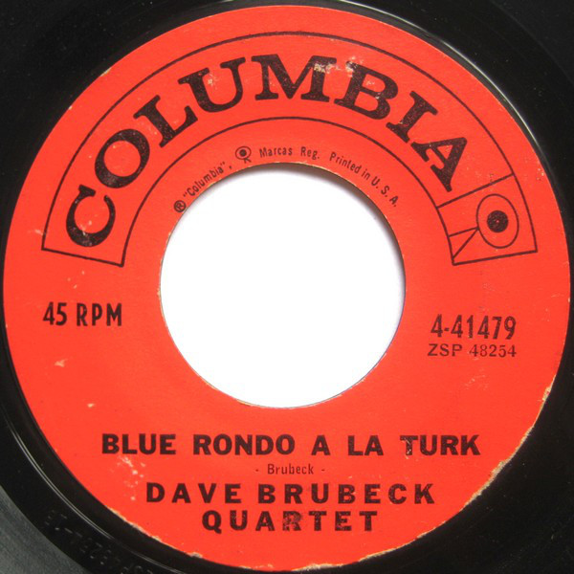

25 The Duke (Dave Brubeck) 2:50
Dave Brubeck Quartet: Paul Desmond-as; D.B.-p; Bob Bates-b; Joe Dodge-dr.
Live at Basin Street Club, New York, July 23, 1955
Columbia CL 699 / CO 52635.
https://www.youtube.com/watch?v=qUpCNgwPFXI

