Hauser, M. D., N. Chomsky & W. T. Fitch. The faculty of language. Science 298, 2002, s. 1569-1579. http://psych.colorado.edu/~kimlab/hauser.chomsky.fitch.science2002.pdf
Chomsky, N. & Gallego, Á. J. & Ott, D. Generative Grammar and the Faculty of Language: Insights, Questions, and Challenges. https://ling.auf.net/lingbuzz/003507
Chomsky, M. & Gallego, Á. J. The Faculty of Language*A biological object, a window into the mind, and a bridge across discipline. https://ling.auf.net/lingbuzz/004901
Jackendorf, R. What is the human language faculty? Two views https://ase.tufts.edu/cogstud/jackendoff/papers/humanlanguage.pdf
Clark, A. & Lappin, S. 2011. Linguistic Nativism and he Poverty of Stimulus. Wesr Sussex: Wiley – Blackwell. (když někdo bude chtít, dám k dispozici)

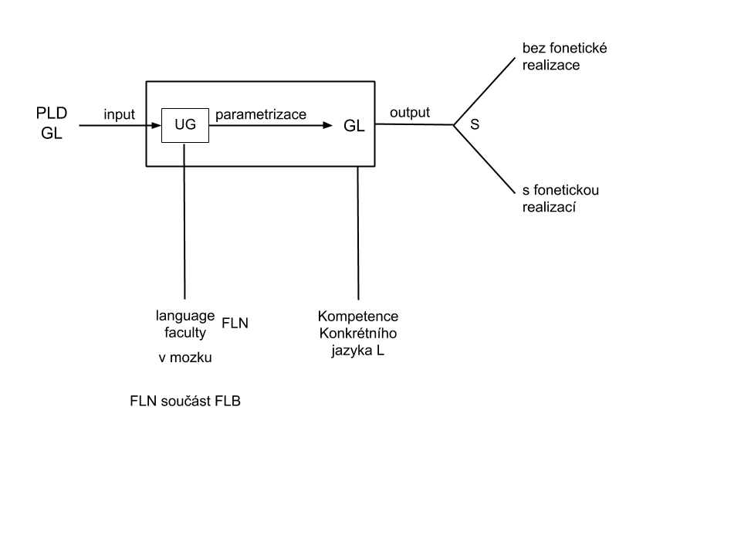
PLD = primary linguistics data (poverty of stimulus)
GL = jazyk L
UG = univerzální gramatika (vrozená, mají stejnou všichni, kdo se rodí rodičům, kteří jsou lidé)
FLN = narrow language faculty
FLB = broad language faculty

