MUNI 2022-2 – HAROLD ARLEN – 2 CD 2007

Over the Rainbow
1. Judy Garland 2:52
July 28, 1939.
first release Decca 2627 A, matrix number DLA 1840. CD: Recall 347.

Come Rain or Come Shine

2. Ella Fitzgerald-voc; Billy May Orchestra. 3:24
January 16, 1961.
LP Verve V6-4046-2. CD: Verve 589108.
3. The Hi-Lo’s & Boss Brass; Gene Puerling, Rob McConnell-arr. 3:04
June/September 1978.
LP: MPS 0068.217.
4. Alison Eastwood-voc; Ernie Watts-t; Alan Broadbent-p; Charlie Haden-b; 4:31
Larance Marable-dr.
Released 1997.
album Midnight in the Garden of Good and Evil. CD: Malpaso 46829.
5. Gerry Mulligan and the Concert Jazz Band; Gerry Mulligan-arr. 5:33
Live at Village Vanguard, New York, December 1960.
LP Verve V6-8396. CD: Verve 589488.

6. Harold Arlen 2:52
Waldorf Astoria, New York, May 16, 1969.
CD: Columbia 471640.

Stormy Weather

7. Ella Fitzgerald-voc; Billy May Orchestra. 5:18

January 14, 1961.
LP Verve V6-4046-2. CD: Verve 589108.
8. Ivie Anderson-Duke Ellington Orchestra 3:26
Hollywood, May 23, 1933 – soundtrack to the film „Bundle of Blues“.
Max MLP-1001. CD: Milan 252.
9. Lena Horne, Lou Bring Orchestra 3:23
December 15, 1941.
Victor 27819 / PBS-061977-1. CD: RCA 63692.
10. George Benson Quartet 2:19
March 15, 1966.
LP Columbia CL 2525 / CO 89384. CD: Columbia 502469.

Over the Rainbow

11. Ella Fitzgerald-voc; Billy May Orchestra. 4:18
January 15, 1961.
LP Verve V6-4046-2. CD: Verve 589108.
12. Sarah Vaughan with Kirk Stuart Trio. 5:16
live at Tivoli Gardens, Copenhagen, July 18-21, 1963.
LP Mercury 830721. CD: EmArcy 832788.
13. Four Freshmen 2:24
Recording date unknown. Released September 1954.
10”LP Capitol H 522

Blues in the Night

14. Ella Fitzgerald-voc; Billy May Orchestra. 7:12
January 14, 1961.
LP Verve V6-4046-2. CD: Verve 589108.
15. Johnny Mercer, Jo Stafford, The Pied Pipers, Paul Weston Orchestra. 3:15
Los Angeles, October 15 – November 12, 1943.
CD: Musica Jazz 1123.
16. Mel Tormé-voc; Dave Barbour-g; prob. Buddy Cole-p; unknown-b. 3:39
Los Angeles, 1947.
MacGregor transcription, LP Glendale GL 6007. CD: Musica Jazz 1123.
17. Mel Tormé-voc; Buddy Rich Big Band. 8: 09
New York, January 25, 1978.
LP Gryphon G-903. CD: Century CRDD 1100

Get Happy

18. Ella Fitzgerald-voc; Billy May Orchestra. 3:32

August 2, 1960.
LP Verve V6-4046-2. CD: Verve 589108.
19. Art Tatum-solo piano. 2:47
Los Angeles, February 22, 1940.
Decca 18050 / DLA 1939A. CD: Affinity 1035-3.

Get Happy / Happy Days Are Here Again
20. Judy Garland & Barbra Streisand in TV show. 2:24
October 6, 1963.
CD: Columbia 471640.
20 / 79:39

C D 2

It’s Only a Paper Moon

1. Ella Fitzgerald-voc; Billy May Orchestra. 3:40

August 1, 1960
LP Verve V6-4046-2. CD: Verve 589108.
2. Nat King Cole-p, voc; Oscar Moore-g; Johnny Miller-b. 2:58
December 15, 1943.
Capitol 20012 / 141-4. CD: Capitol 33571.
3. Oscar Peterson-voc, p; Herb Ellis-g; Ray Brown-b. 2:33
October 28, 1965.
LP Limelight LM 82029, LS 86029. CD: Verve 557468.
4. Rosemary Clooney-voc; John Pizzarelli-g, voc; Warren Vache-co; Scott 3:27 Hamilton-ts; John Oddo-p, arr; David Finck-b; Joe Cocuzzo-dr.
New York City, September 14-17, 1992.
Concord Jazz LP CJ-537, CD CCD-4537. CD: Recall 252.
5. Herbie Hancock-p; Bobby Hutcherson-vib; Pierre Michelot-b; Billy Higgins-dr. 7:45
early July 1985.
Blue Note BT 85135. CD: CDP 7 46397 2.

That Old Black Magic

6. Ella Fitzgerald-voc; Billy May Orchestra. 4:12

January 14, 1961.
LP Verve V6-4046-2. CD: Verve 589108.
7. Glenn Miller and His Orchestra, Skip Nelson & The Modernaires-voc. 3:06
New York, July 14 or 15, 1942.
78 Victor 074740-1. CD: RCA ND 90600-2.
8. Spike Jones and His City Slickers, Carl Grayson-voc. 2:31
Los Angeles, September 10, 1945.
78 Victor 20-1895 / D5-VB-1127. CD: Proper 1119.
9. André Previn-p, with orchestra, John Williams-arr, cond. 2:05
Los Angeles, April 16, 1963.
LP Columbia CL 2158, CS 8958. LP: Harmony 11207

Out of This World

10. Ella Fitzgerald-voc; Billy May Orchestra. 2:44

January 16, 1961.
LP Verve V6-4046-2. CD: Verve 589108.
11. Gerry Mulligan & The Concert Jazz Band, Bill Holman-arr. 3:50
New York, May 31-June 3, 1960.
CD: Mosaic MD4-221. Previously unreleased.
12.Steve Khan-g; Ron Carter-b; Al Foster-dr. 7:02
New York City, January 19-20, 1991.
CD Polydor 849563.
13. Norma Winstone-voc; John Taylor-p; Tony Coe-cl. 5:58
Rainbow Studio, Oslo, Norway, July 1986.
LP: ECM 1337, CD: ECM 831107.
14. John Coltrane-ts; McCoy Tyner-p; Jimmy Garrison-b; Elvin Jones-dr. 14:06
New York, June 19, 1962.
LP Impulse! A(S) 21 / 10980. CD: Impulse! 8-280.

14 / 65:58

MUNI 2022-2 – HAROLD ARLEN – 2 CD 2007

https://secondhandsongs.com/performance/5316
XXtra. Judy Garland (June 10, 1922 – June 22, 1969)
The Wizard of Oz – premiere August 10, 1939

USA | 10 August 1939 | (Green Bay, Wisconsin) (premiere)
USA | 11 August 1939 | (Appleton, Wisconsin)
USA | 11 August 1939 | (Cape Cod, Massachusetts)
USA | 11 August 1939 | (Kenosha, Wisconsin)
USA | 12 August 1939 | (Oconomowoc, Wisconsin) (premiere)
USA | 13 August 1939 | (Racine, Wisconsin)
USA | 13 August 1939 | (Sheboygan, Wisconsin)
Greece | 15 August 1939
USA | 15 August 1939 | (Hollywood, California)
USA | 15 August 1939 | (Philadelphia, Pennsylvania)
USA | 17 August 1939 | (New York City, New York)

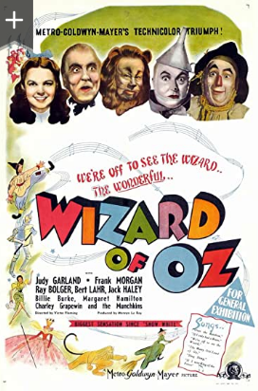

Over the Rainbow
1. Judy Garland 2:52
July 28, 1939.
first release 78 Decca 2627 A, matrix number DLA 1840. CD: Recall 347.

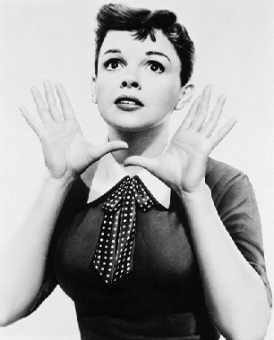
Judy Garland (1922 – 1969)

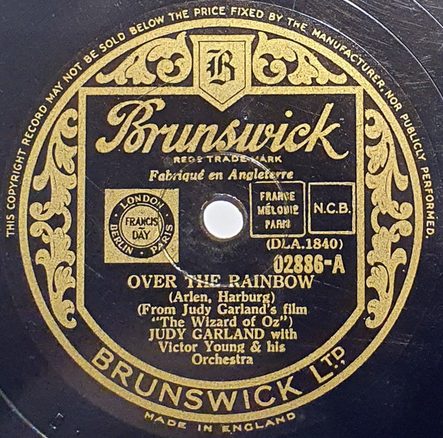

Come Rain or Come Shine

2. Ella Fitzgerald-voc; Billy May Orchestra. 3:24
Los Angeles, January 16, 1961.
LP Verve V6-4046-2. CD: Verve 589108.

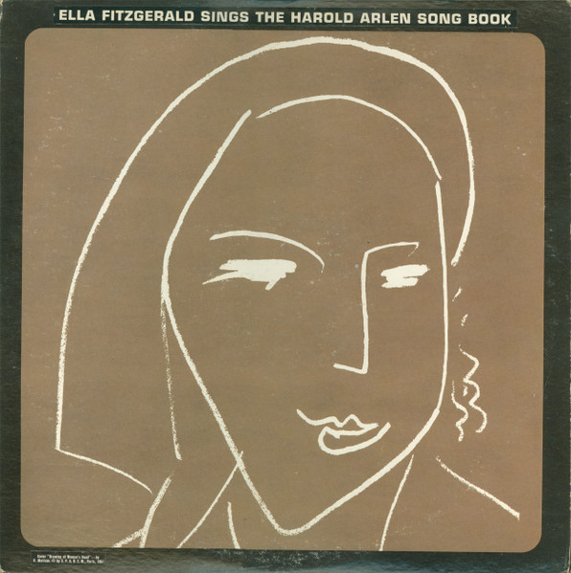

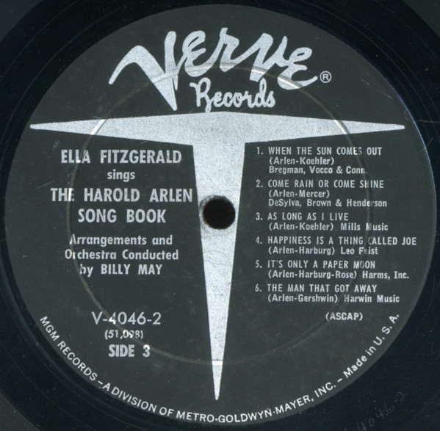

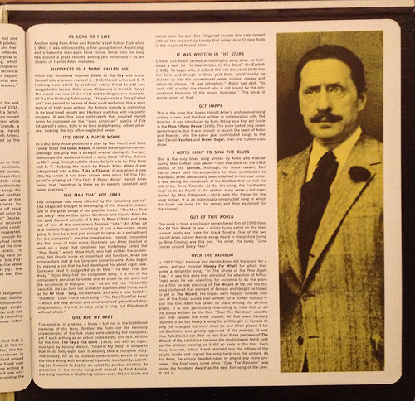

1984 release
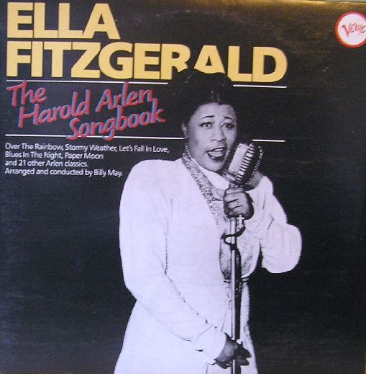

3. The Hi-Lo’s & Boss Brass; Gene Puerling, Rob McConnell-arr. 3:04
June/September 1978.
LP: MPS 0068.217.

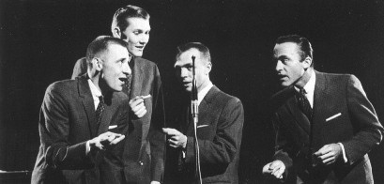

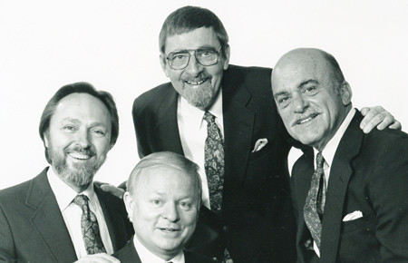

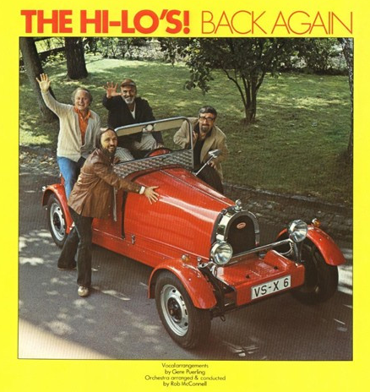

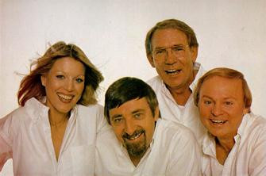
The Singers Unlimited

4. Alison Eastwood-voc; Ernie Watts-t; Alan Broadbent-p; Charlie Haden-b; 4:31
Larance Marable-dr.
Released 1997.
album Midnight in the Garden of Good and Evil. CD: Malpaso 46829.

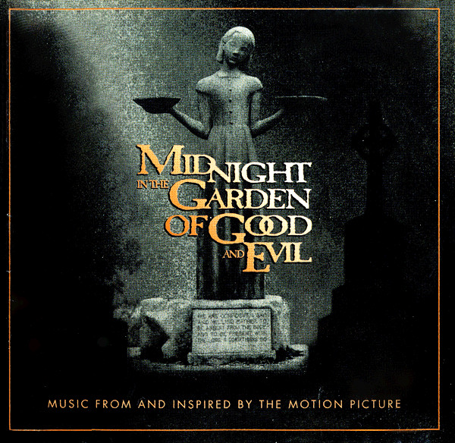

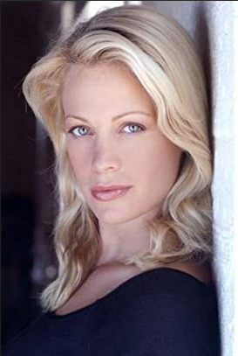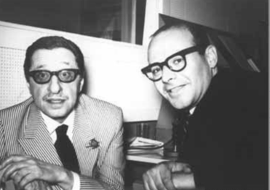
Alison Eastwood (*1972) Harold Arlen (1905–1986), Johnny Mercer (1909–1976) –
5. Gerry Mulligan and the Concert Jazz Band; Gerry Mulligan-arr. 5:33
Live at Village Vanguard, New York, December 1960.
LP Verve V6-8396. CD: Verve 589488.

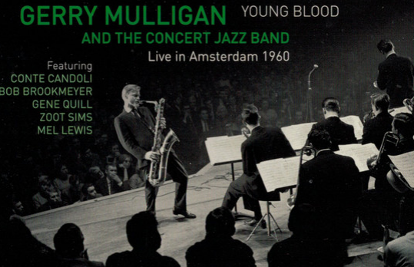

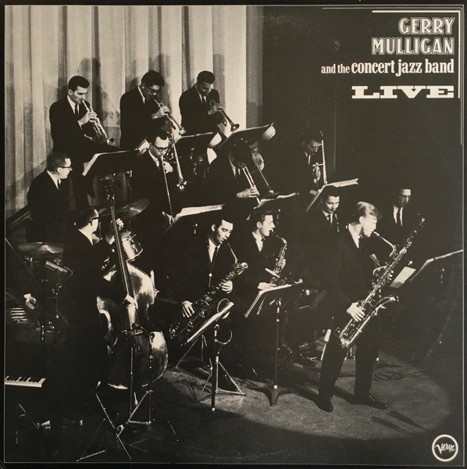
Gerry Mulligan (1927 – 1996)

6. Harold Arlen 2:52
Waldorf Astoria, New York, May 16, 1969.
CD: Columbia 471640.

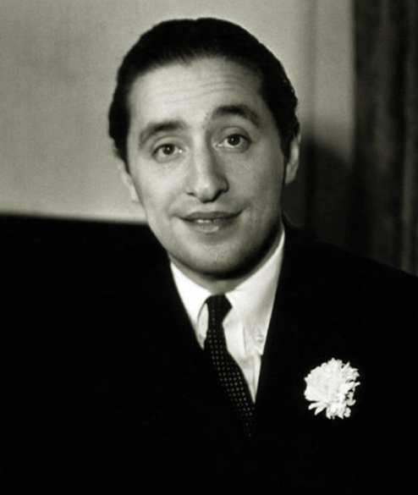

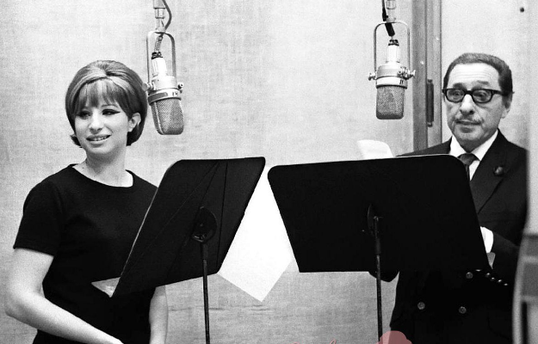
Barbra Streisand (*1942) & Harold Arlen

Stormy Weather

7. Ella Fitzgerald-voc; Billy May Orchestra. 5:18

Los Angeles, January 14, 1961.
LP Verve V6-4046-2. CD: Verve 589108.

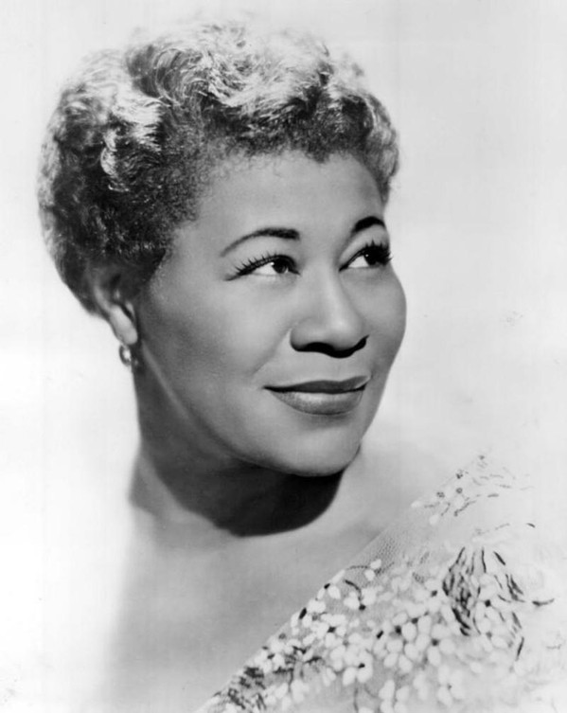

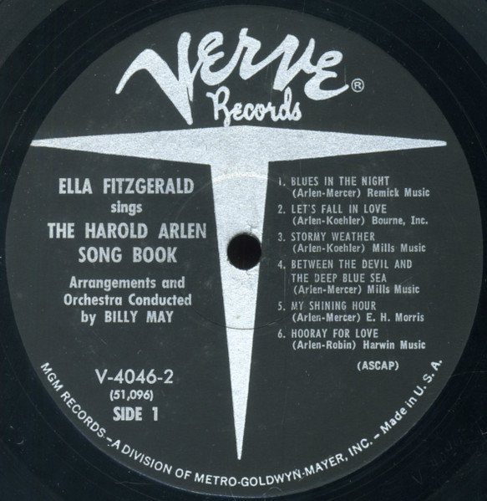

8. Ivie Anderson-Duke Ellington Orchestra 3:26
Hollywood, May 23, 1933 – soundtrack to the film „Bundle of Blues“.
Max MLP-1001. CD: Milan 252.

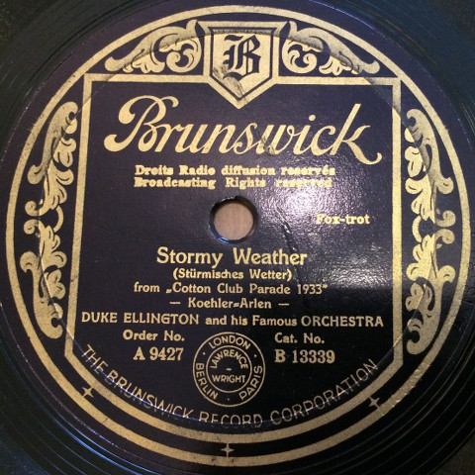

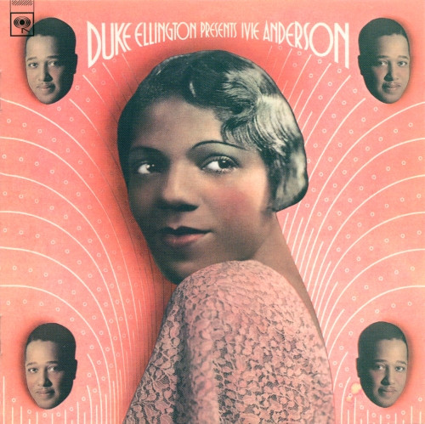

9. Lena Horne, Lou Bring Orchestra 3:23
December 15, 1941.
Victor 27819 / PBS-061977-1. CD: RCA 63692.

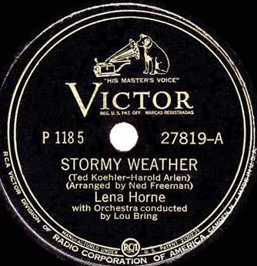

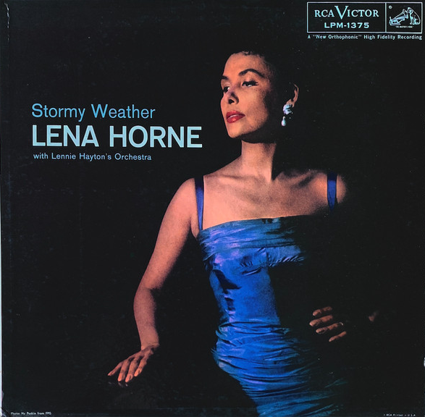

10. George Benson Quartet 2:19
March 15, 1966.
LP Columbia CL 2525 / CO 89384. CD: Columbia 502469.

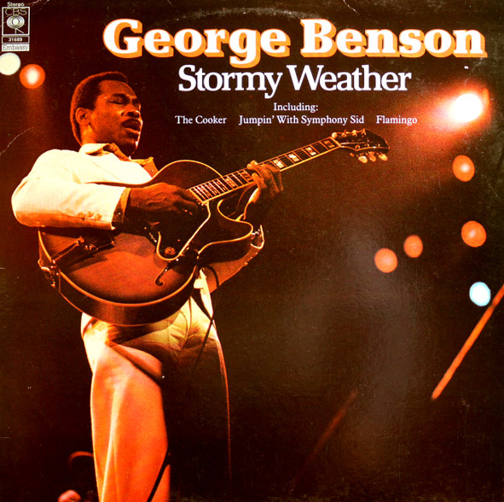

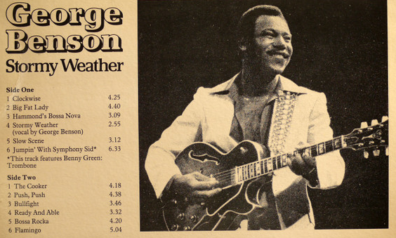

Over the Rainbow

11. Ella Fitzgerald-voc; Billy May Orchestra. 4:18
Los Angeles, January 15, 1961.
LP Verve V6-4046-2. CD: Verve 589108.

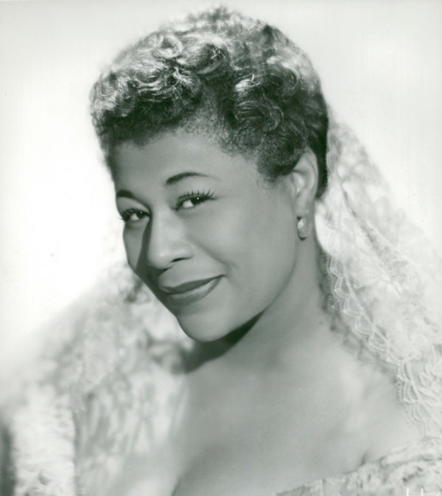

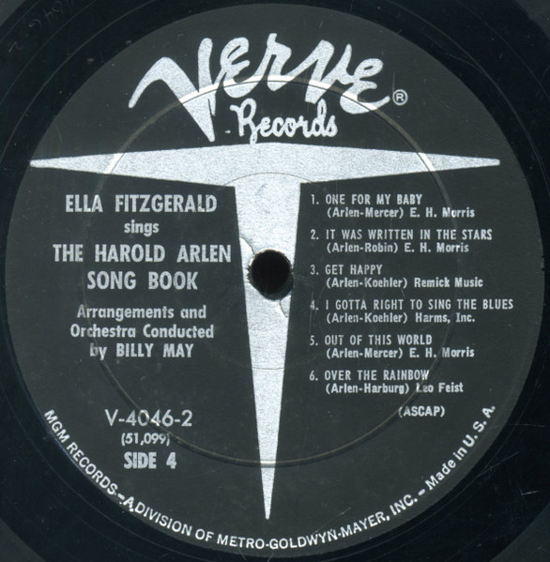

12. Sarah Vaughan with Kirk Stuart Trio. 5:16
live at Tivoli Gardens, Copenhagen, July 18-21, 1963.
LP Mercury 830721. CD: EmArcy 832788.

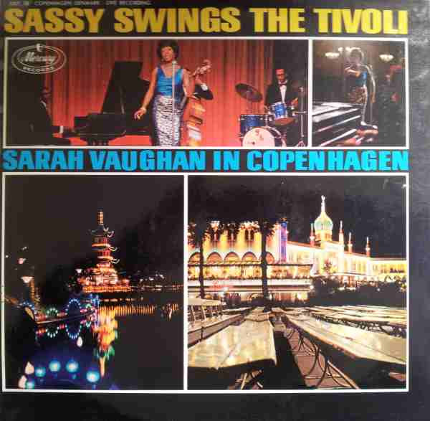

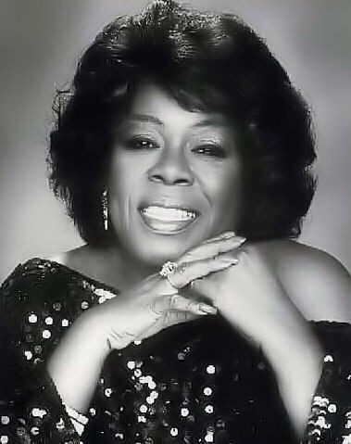
Sarah „Sassy“ Vaughan (1924 – 1990)

13. Four Freshmen 2:24
Recording date unknown. Released September 1954.
10”LP Capitol H 522

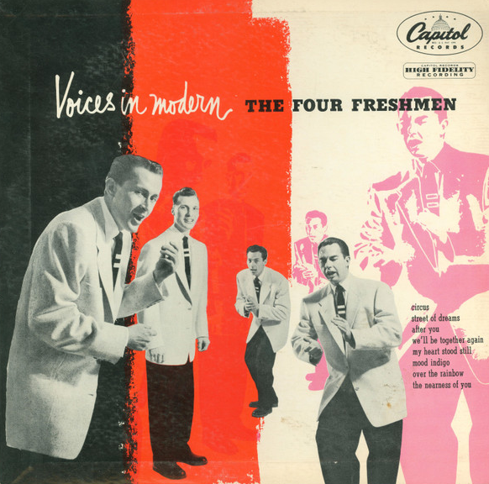

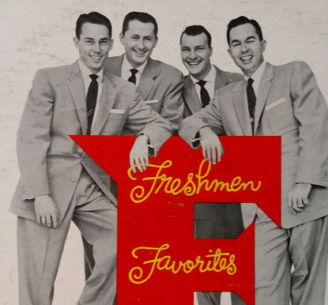

Blues in the Night

14. Ella Fitzgerald-voc; Billy May Orchestra. 7:12
Los Angeles, January 14, 1961.
LP Verve V6-4046-2. CD: Verve 589108.- OPENER

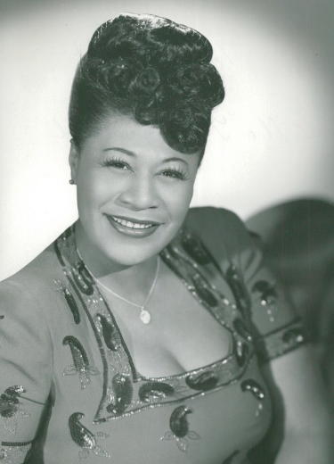

15. Johnny Mercer, Jo Stafford, The Pied Pipers, Paul Weston Orchestra. 3:15
Los Angeles, October 15 – November 12, 1943. Released May 1944.
78 Capitol 10001 / 84. CD: Musica Jazz 1123.

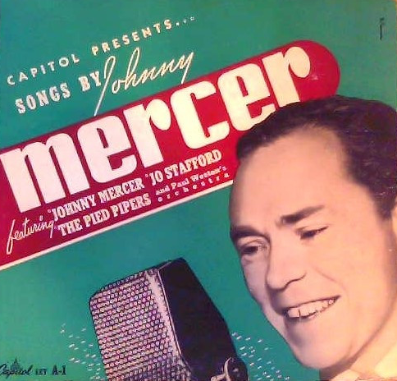

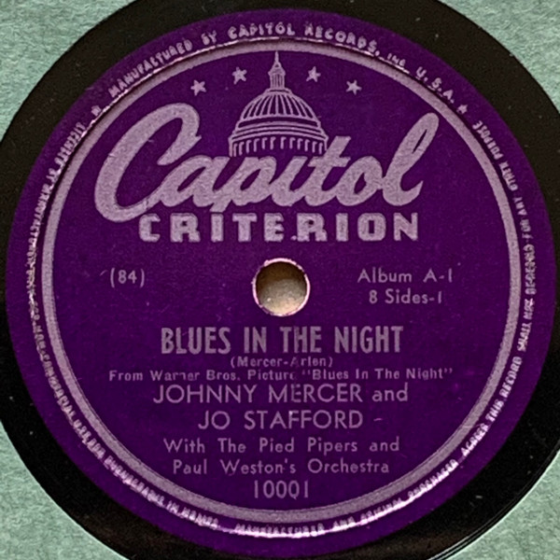

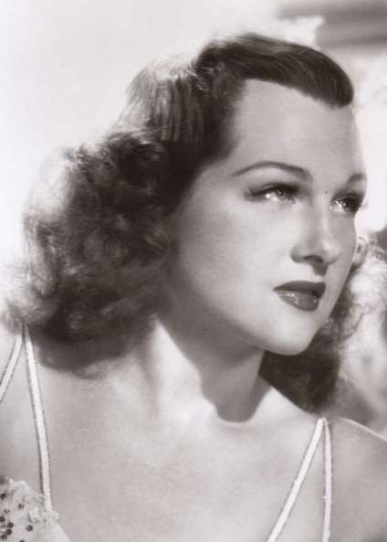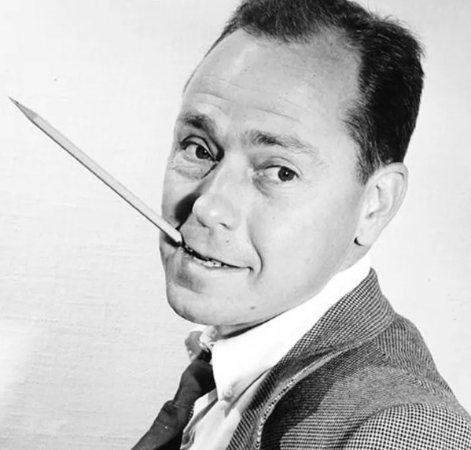
Jo Stafford (1917 – 2008) Johnny Mercer (1909 – 1976)

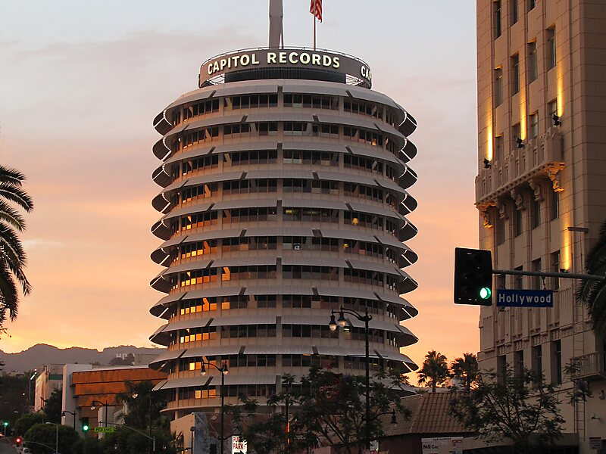

16. Mel Tormé-voc; Dave Barbour-g; prob. Buddy Cole-p; unknown-b. 3:39
Los Angeles, 1947.
MacGregor transcription, LP Glendale GL 6018. CD: Musica Jazz 1123.
Material licensed from the "C.P. MacGregor Library"; © and Ⓟ 1979 Legend Records Inc.

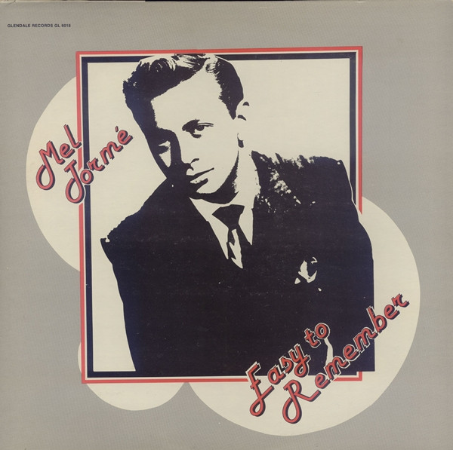

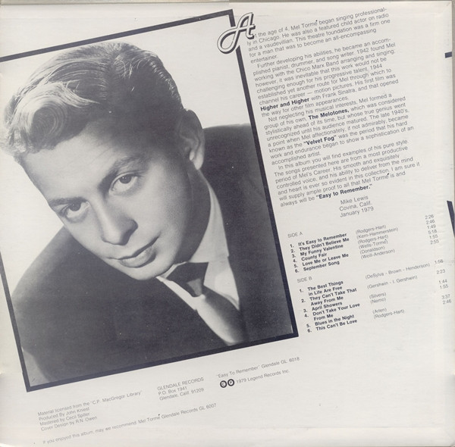

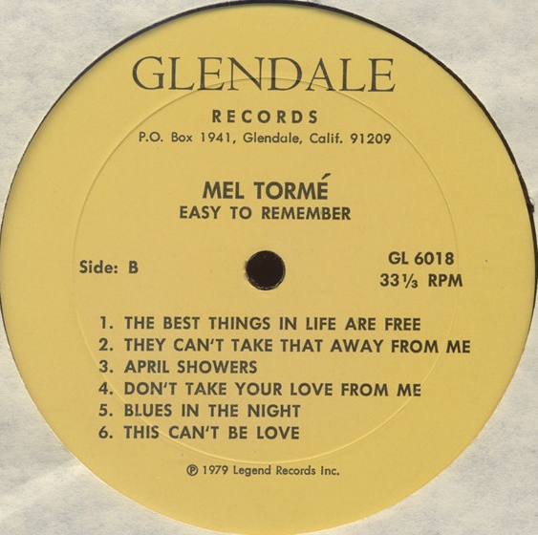

17. Mel Tormé-voc; Buddy Rich Big Band. 8: 09
New York, January 25, 1978.
LP Gryphon G-903. CD: Century CRDD 1100

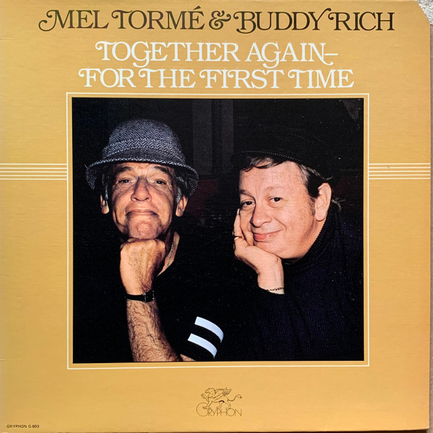

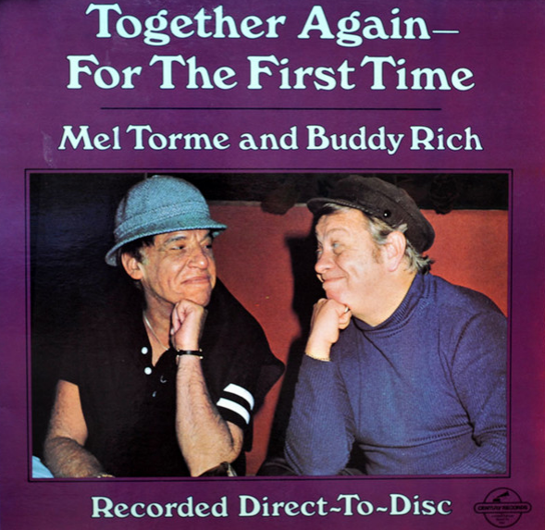

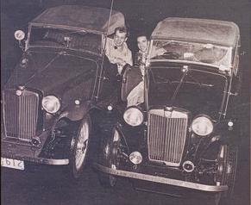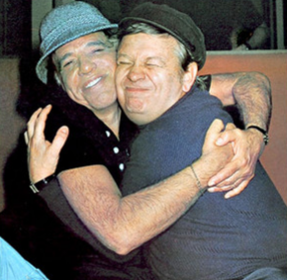

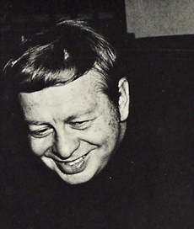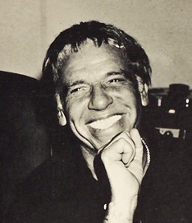
Mel Tormé (1925 – 1999) Buddy Rich (1917 – 1987)

Get Happy

18. Ella Fitzgerald-voc; Billy May Orchestra. 3:32

Los Angeles, August 2, 1960.
LP Verve V6-4046-2. CD: Verve 589108.

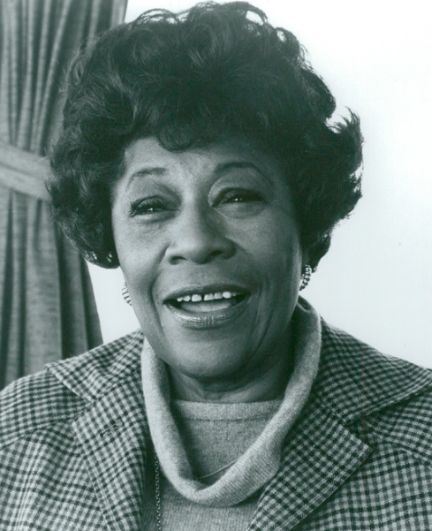

19. Art Tatum-solo piano. 2:47
Los Angeles, February 22, 1940.
Decca 18050 / DLA 1939A. CD: Affinity 1035-3.

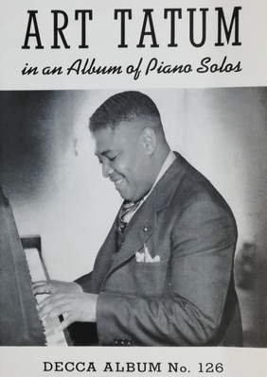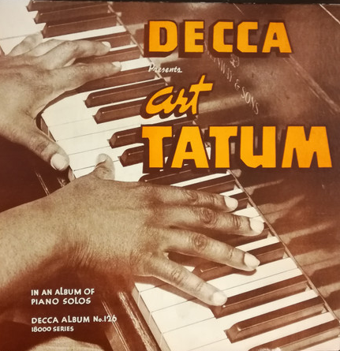
Art Tatum (1909 – 1956)

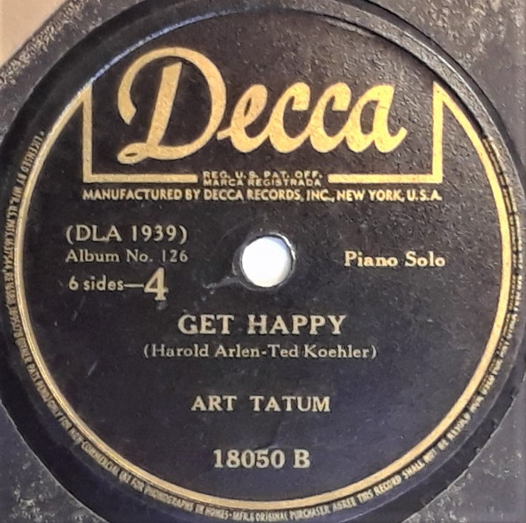

Get Happy / Happy Days Are Here Again
20. Judy Garland & Barbra Streisand in TV show. 2:24
October 6, 1963.
CD: Columbia 471640.

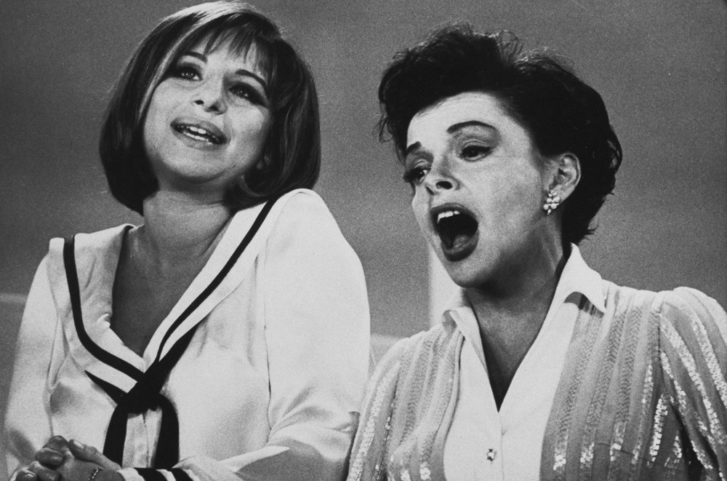

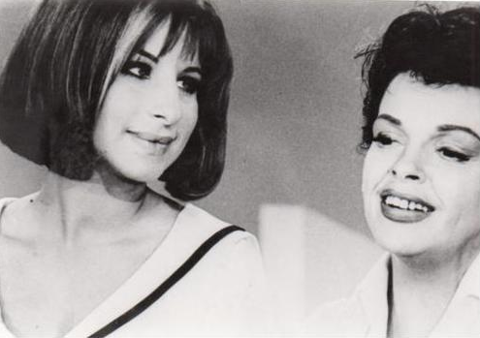
Barbra Streisand (* 1942) & Judy Garland (1922 – 1969)

C D 2

It’s Only a Paper Moon

1. Ella Fitzgerald-voc; Billy May Orchestra. 3:40

Los Angeles, August 1, 1960
LP Verve V6-4046-2. CD: Verve 589108.

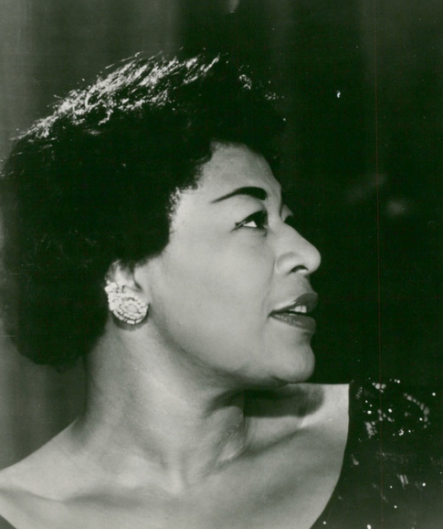

2. Nat King Cole-p, voc; Oscar Moore-g; Johnny Miller-b. 2:58
December 15, 1943.
Capitol 20012 / 141-4. CD: Capitol 33571.

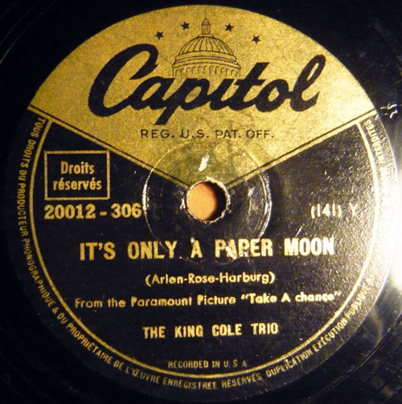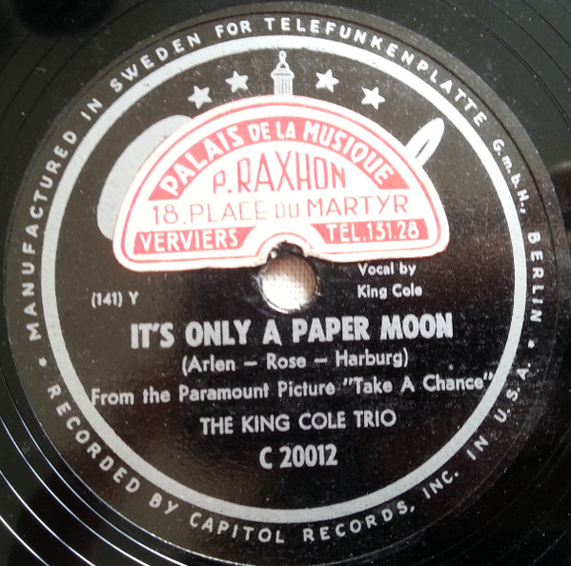
France Sweden

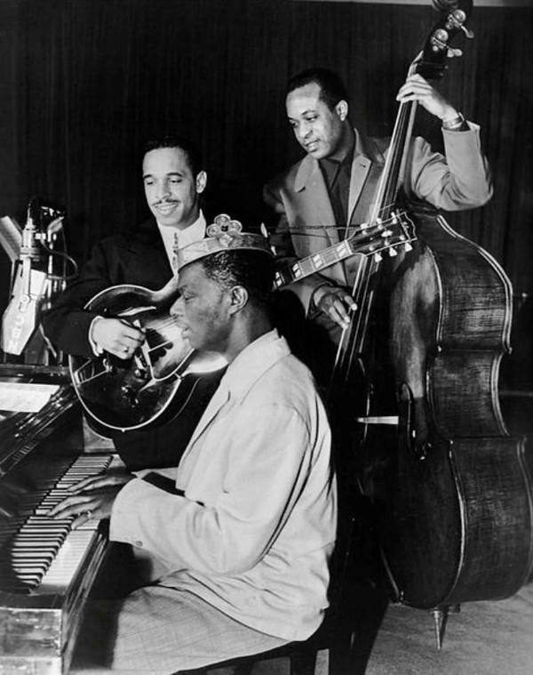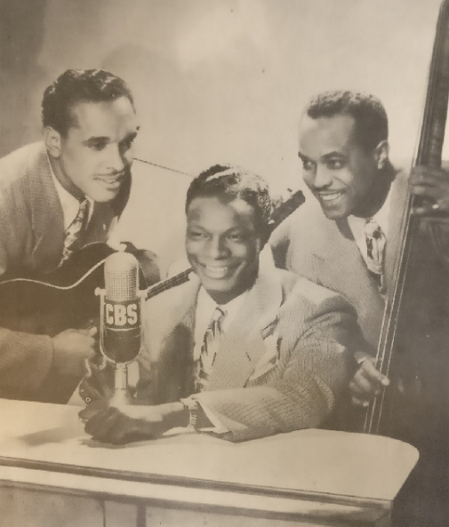
NAT KING COLE TRIO
Nat Cole-piano – Oscar Moore-guitar – Johnny Miller-bass
(1919 – 1965) (1916 – 1981) (1915 – 1988)

3. Oscar Peterson-voc, p; Herb Ellis-g; Ray Brown-b. 2:33
October 28, 1965.
LP Limelight LM 82029, LS 86029. CD: Verve 557468.

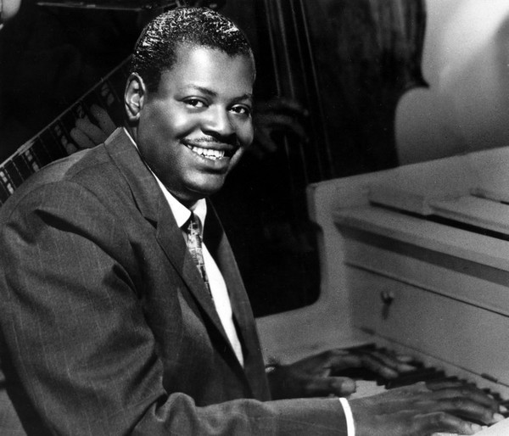

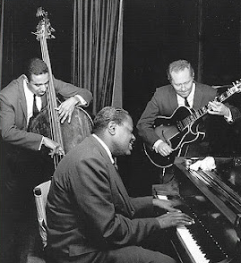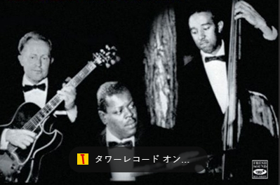
OSCAR PETERSON TRIO
Oscar Peterson-piano - Herb Ellis-guitar - Ray Brown-bass
(1925 – 2007) (1921 – 2010) (1926 – 2002)

4. Rosemary Clooney-voc; John Pizzarelli-g, voc; Warren Vache-co; Scott 3:27 Hamilton-ts; John Oddo-p, arr; David Finck-b; Joe Cocuzzo-dr.
New York City, September 14-17, 1992.
Concord Jazz LP CJ-537, CD CCD-4537. CD: Recall 252.

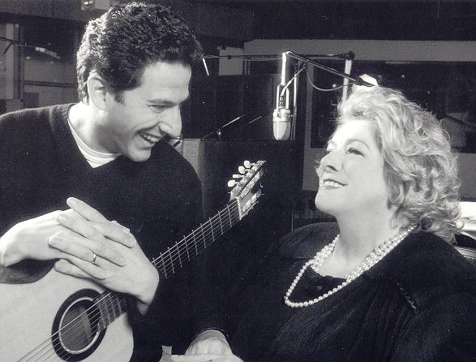

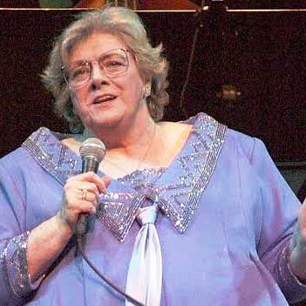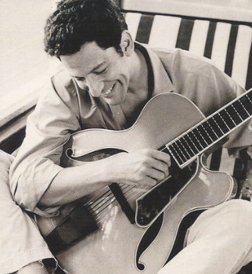
Rosemary Clooney (1928 – 2002) John Pizzarelli (* 1960)
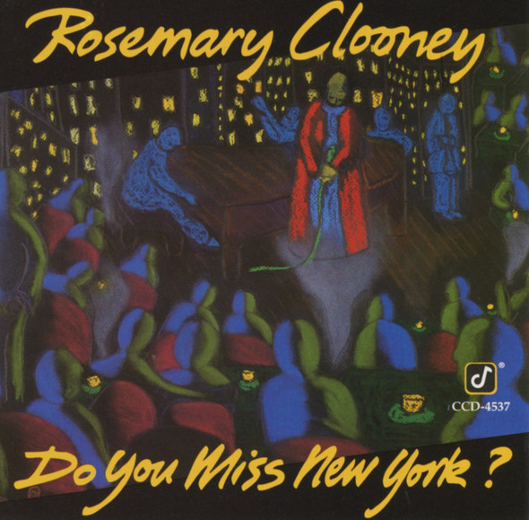

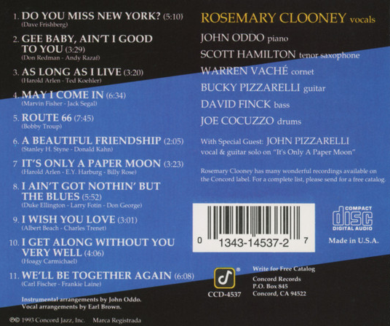

5. Herbie Hancock-p; Bobby Hutcherson-vib; Pierre Michelot-b; Billy Higgins-dr. 7:45
early July 1985.
Blue Note BT 85135. CD: CDP 7 46397 2.

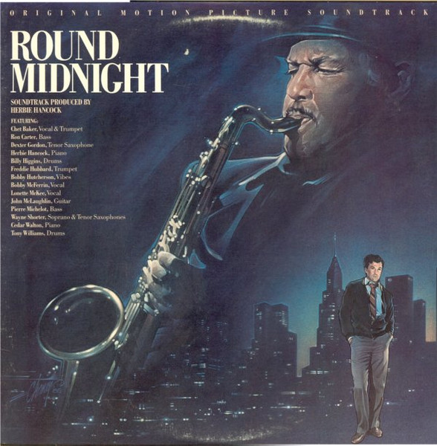

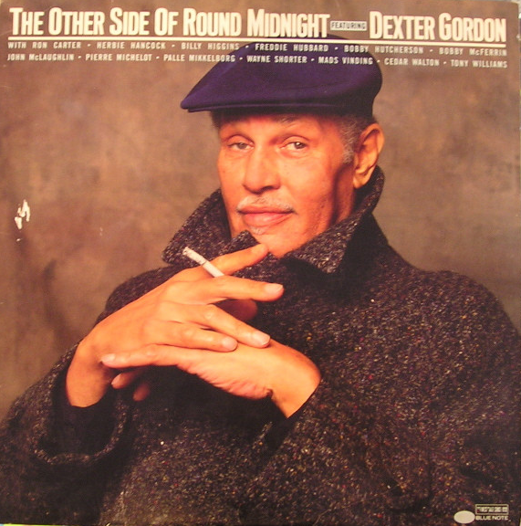

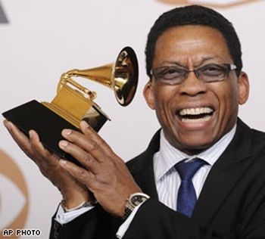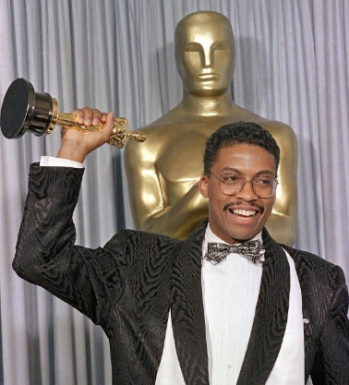
Herbie Hancock (* 1940)

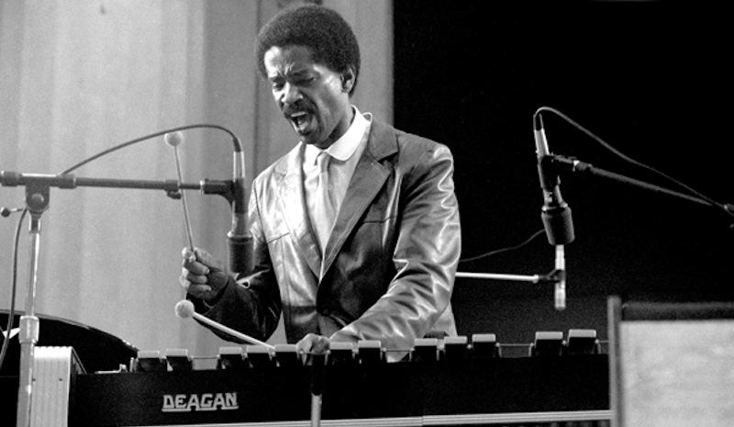
Bobby Hutcherson (1941 – 2016)

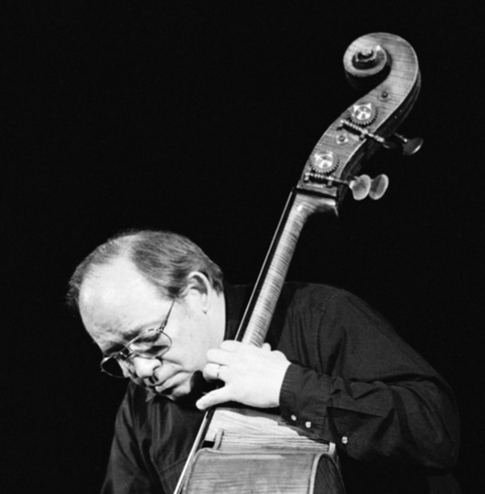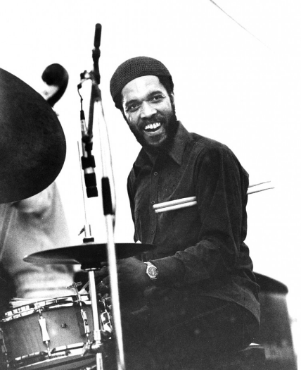
Pierre Michelot (1928 – 2005) Billy Higgins (1936 – 2001)

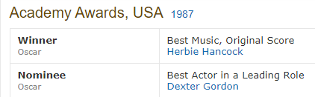

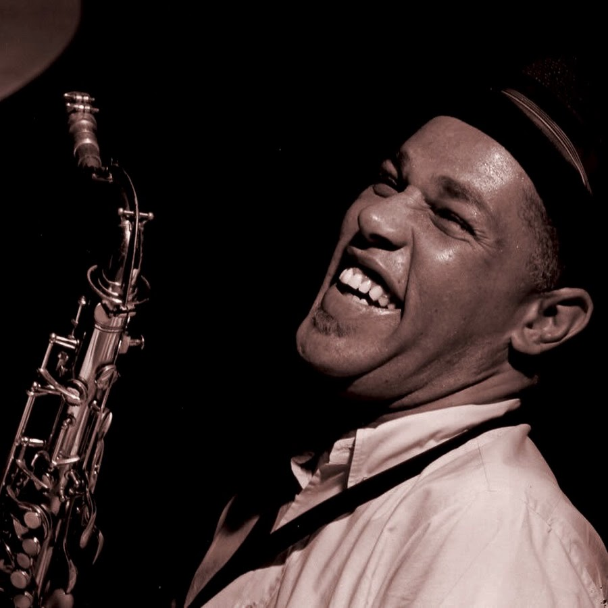

That Old Black Magic

6. Ella Fitzgerald-voc; Billy May Orchestra. 4:12

Los Angeles, January 14, 1961.
LP Verve V6-4046-2. CD: Verve 589108.

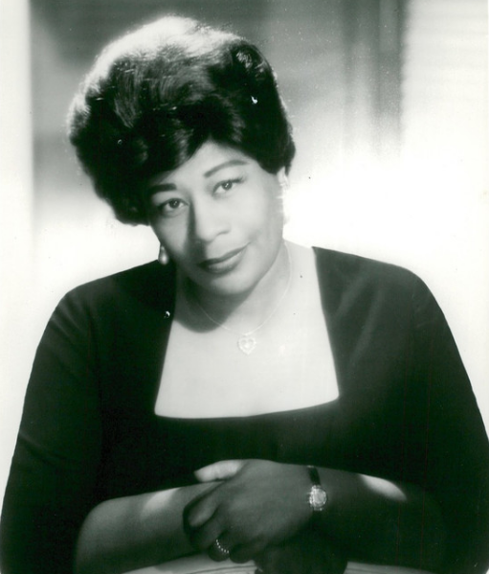

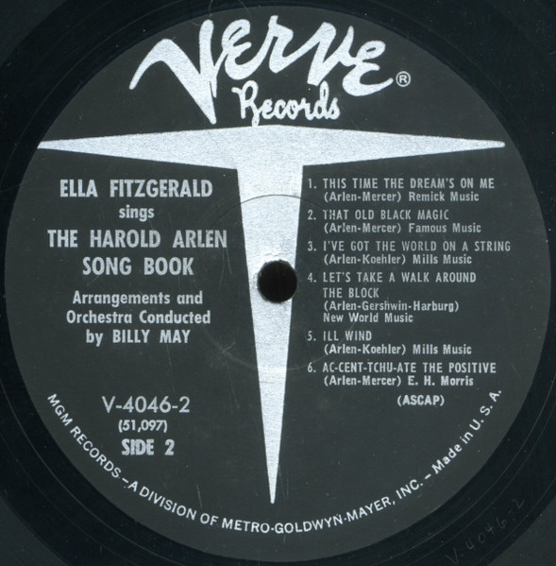

7. Glenn Miller and His Orchestra, Skip Nelson & The Modernaires-voc. 3:06
New York, July 14 or 15, 1942.
78 Victor 20-1523-A. CD: RCA ND 90600-2.

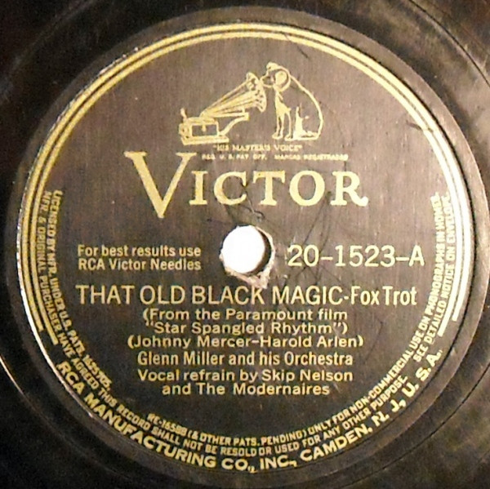

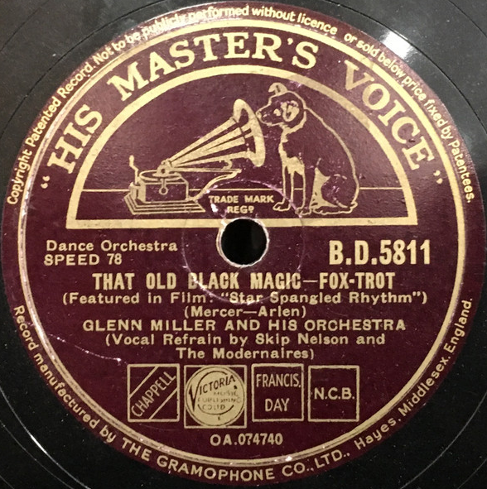

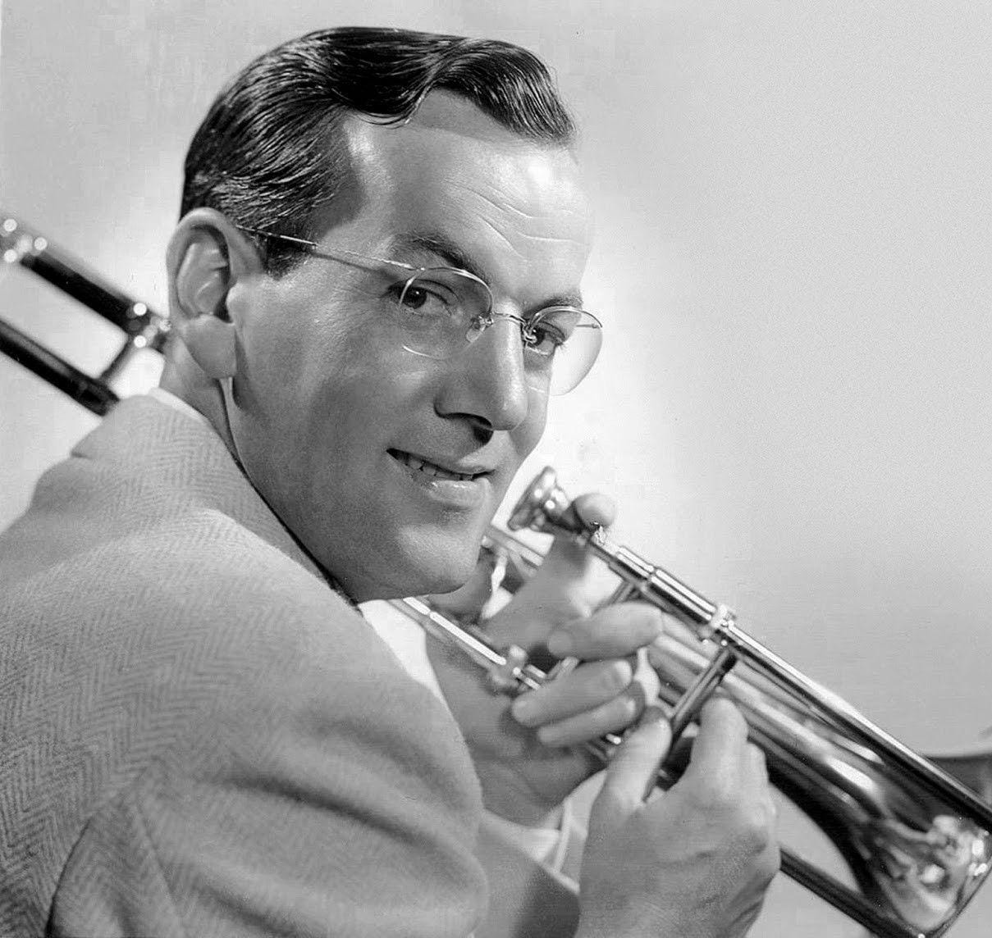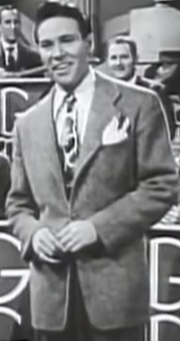
Glenn Miller (1904 – 1944) Skip Nelson (1920-1974)
(Scipione Mirabella)

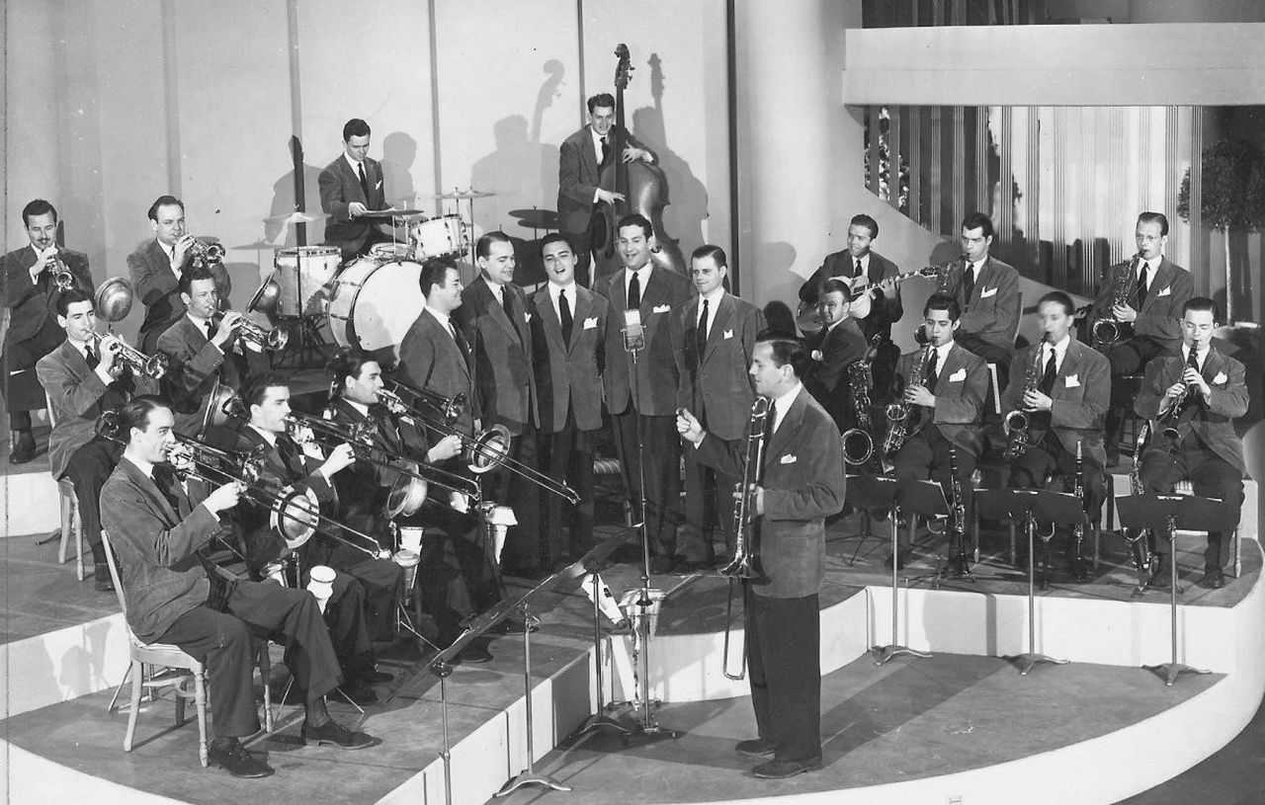

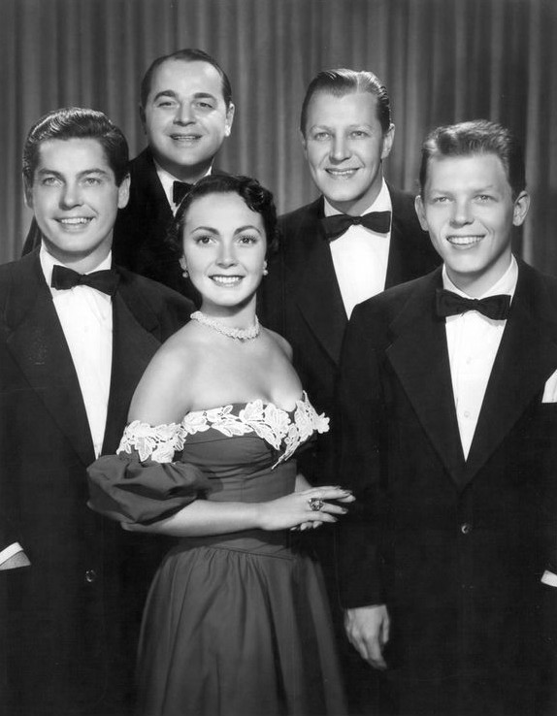
The Modernaires
Hal Dickinson, Chuck Goldstein, Bill Conway, Ralph Brewster & Paula Kelly (Mrs. Hal Dickenson)
(1913 – 1970) (???? – 1974) (1913 – 1991) (1914 – 1990) ,(1919 – 1992)

8. Spike Jones and His City Slickers, Carl Grayson-voc. 2:31
Los Angeles, September 10, 1945.
78 Victor 20-1895 / D5-VB-1127. CD: Proper 1119.

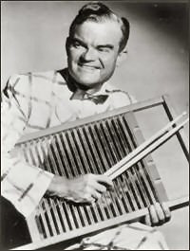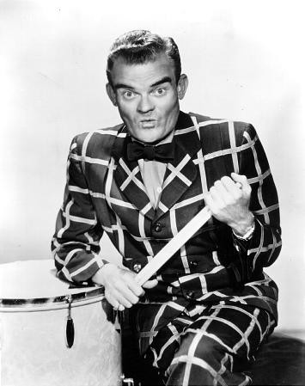
Spike Jones (1911 – 1965)…

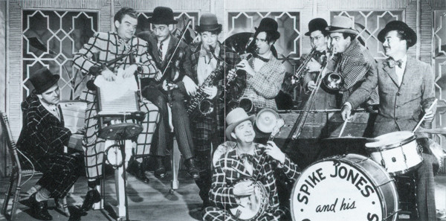
…and His City Slickers

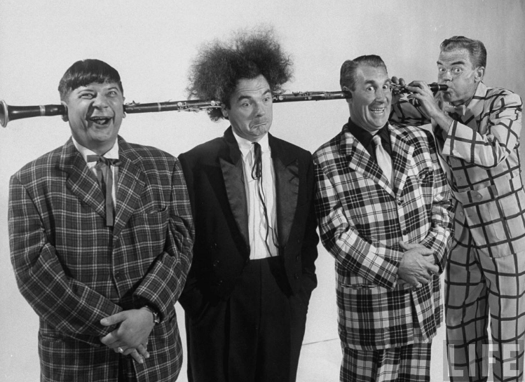

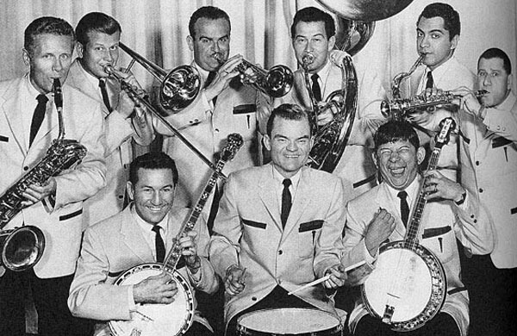

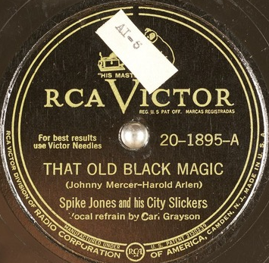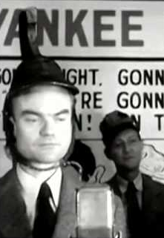
That Old Black Magic & Carl Grayson (1908 – 1958)

9. André Previn-p, with orchestra, John Williams-arr, cond. 2:05
Los Angeles, April 16, 1963.
LP Columbia CL 2158, CS 8958. LP: Harmony 11207

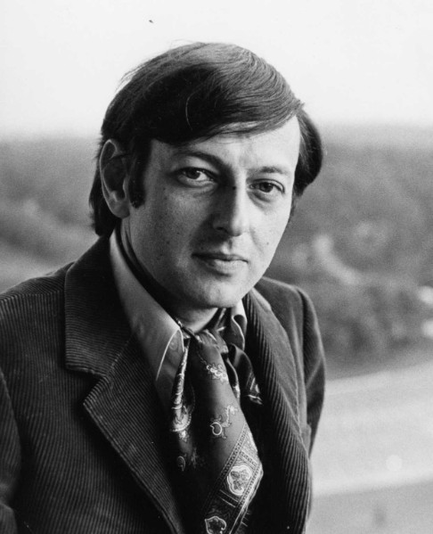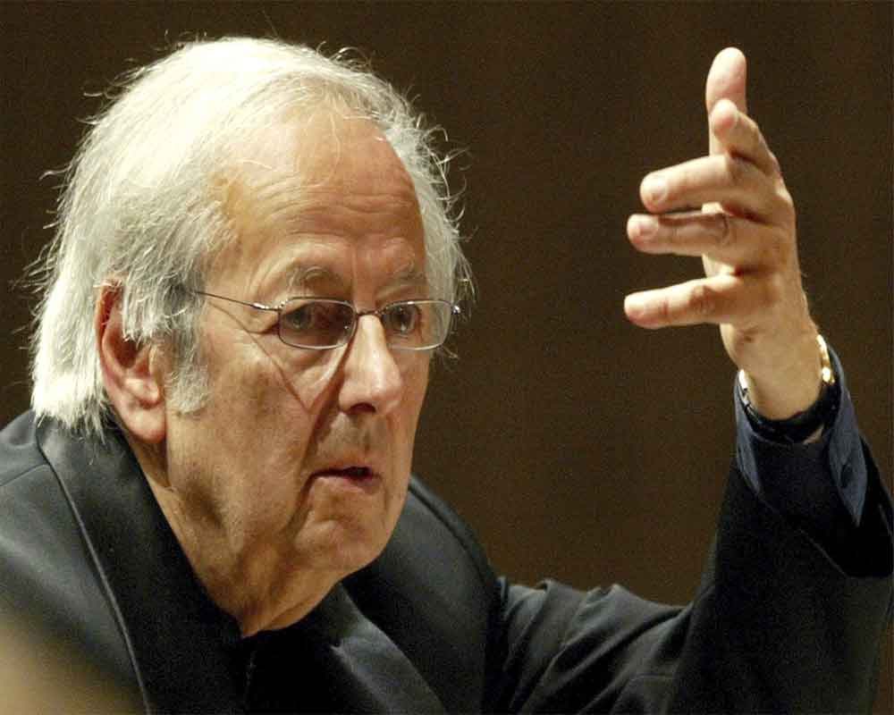
André Previn [Andreas Ludwig Priwin] (1929 – 2019)
4 x Oscar, 10 x Grammy

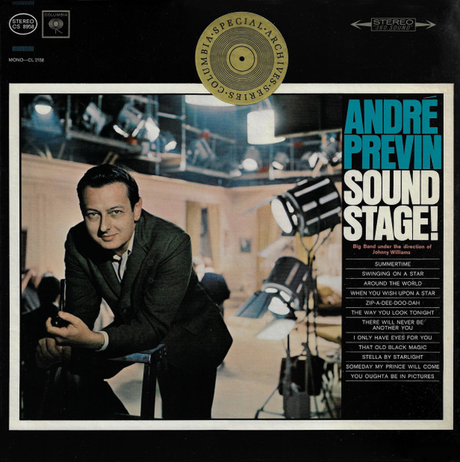

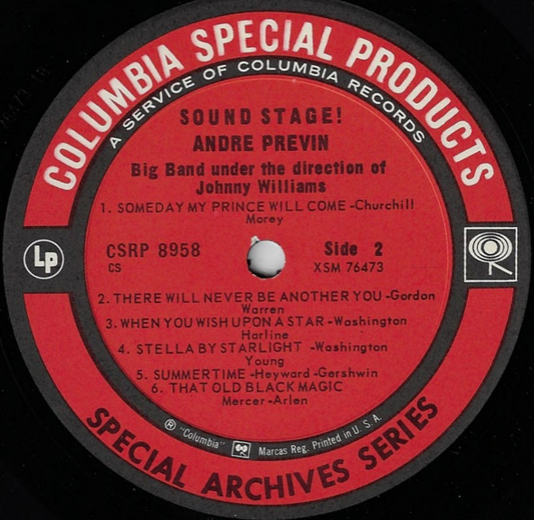

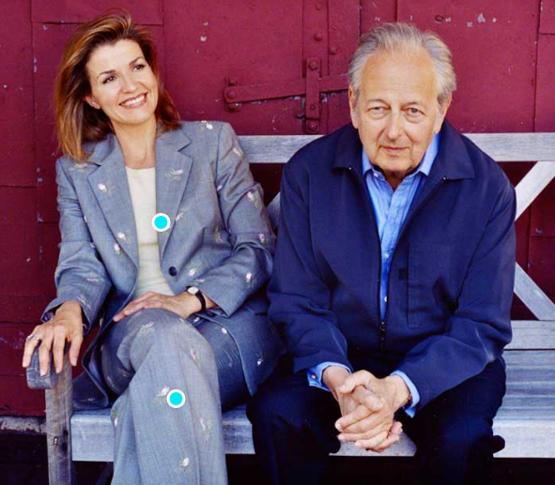
Anne Sophie Mutter (* 1963) & André Previn (1929 – 2019)

Out of This World

10. Ella Fitzgerald-voc; Billy May Orchestra. 2:44

Los Angeles, January 16, 1961.
LP Verve V6-4046-2. CD: Verve 589108.

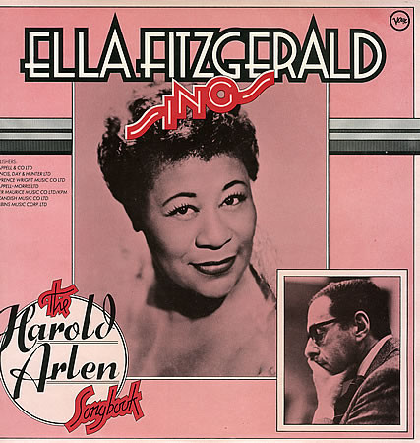

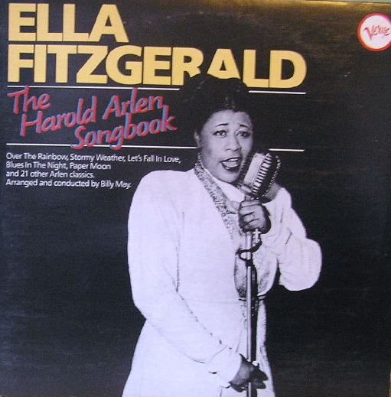

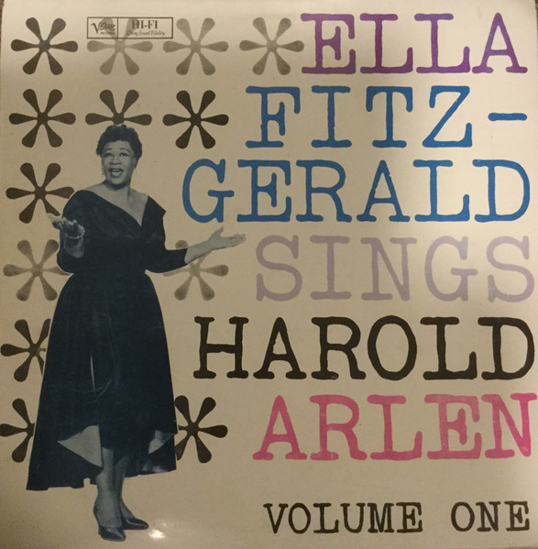

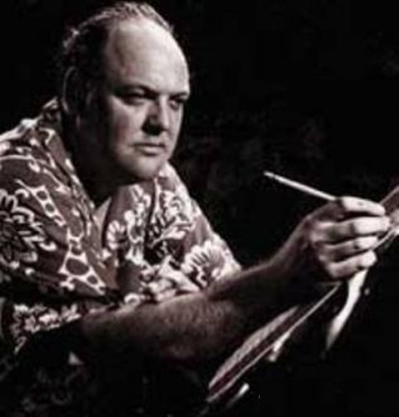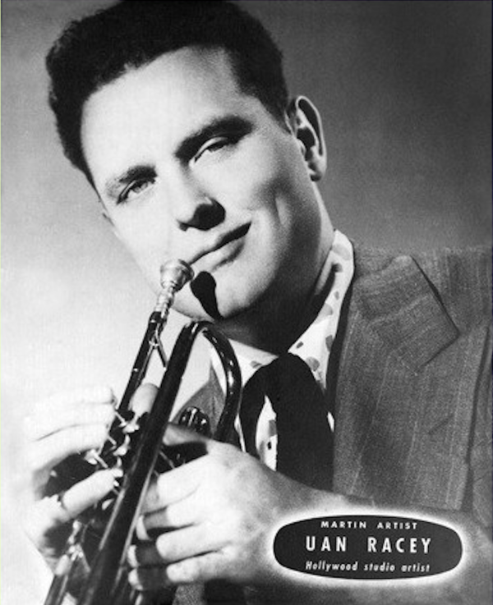
Billy May (2016 – 2004)

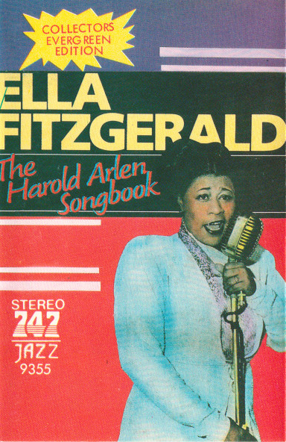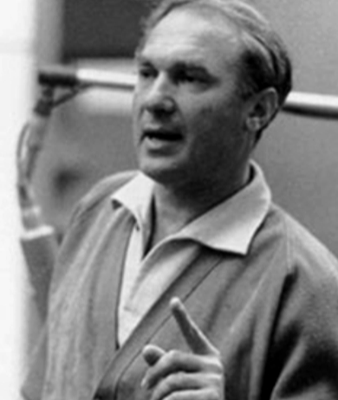
Ella Fitzgerald (1917 – 1996) Norman Granz (1918 – 2001)
8 Song Books Charlie Parker, Dizzy Gillespie, Oscar
Cole Porter – Rodgers & Hart Peterson, Stan Getz, Art Tatum, Billie
Duke Ellington – Gershwins Holiday, Count Basie, Buddy Rich,
Irving Berlin – Harold Arlen Ella & Louis, Ella & Louis Again,
Jerome Kern – Johnny Mercer Ella & Louis – Porgy & Bess….
Ella Fitzgerald with Rodgers & Hammerstein, Lerner & Loewe, Adler & Ross, Frank Loesser –
Ella Sings Broadway

11. Gerry Mulligan & The Concert Jazz Band, Bill Holman-arr. 3:50
New York, May 31-June 3, 1960.
CD: Mosaic MD4-221. Previously unreleased.

12.Steve Khan-g; Ron Carter-b; Al Foster-dr. 7:02
New York City, January 19-20, 1991.
CD Polydor 849563.

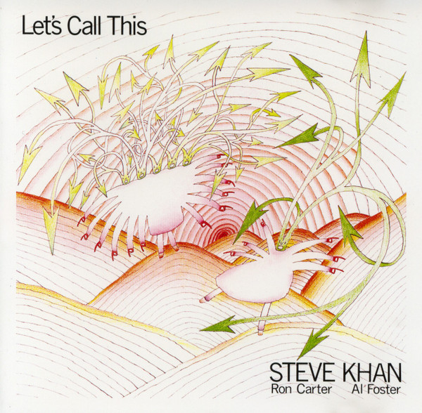

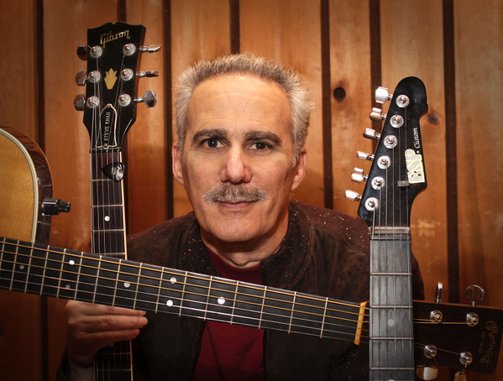
Steve Khan (* 1947)

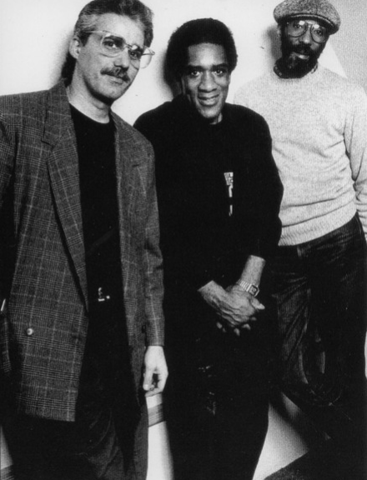
Steve Khan Al Foster Ron Carter
(* 1947) (* 1943) (* 1937)

13. Norma Winstone-voc; John Taylor-p; Tony Coe-cl. 5:58
Rainbow Studio, Oslo, Norway, July 1986.
LP: ECM 1337, CD: ECM 831107.

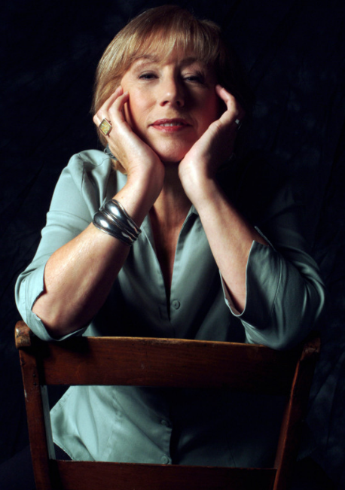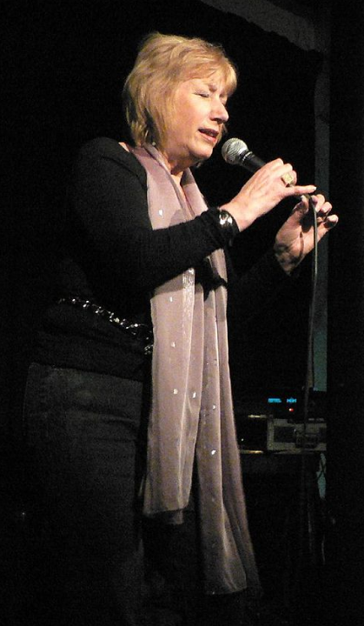
Norma Winstone (* 1941)

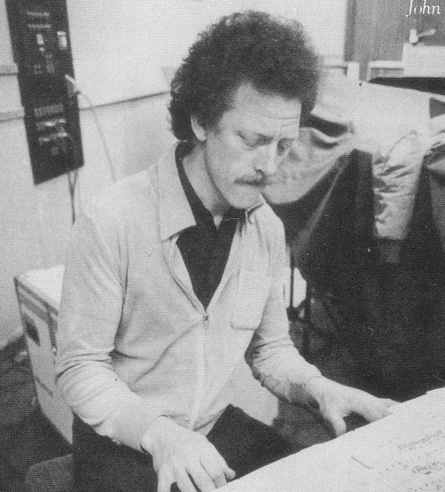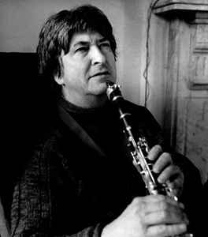
John Taylor (1942 – 2015) Tony Coe (* 1934)

14. John Coltrane-ts; McCoy Tyner-p; Jimmy Garrison-b; Elvin Jones-dr. 14:06
New York, June 19, 1962.
LP Impulse! A(S) 21 / 10980. CD: Impulse! 8-280.

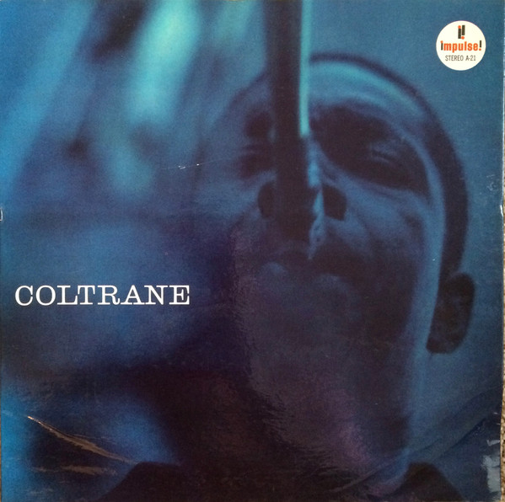

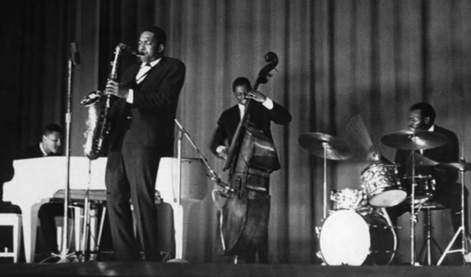
JOHN COLTRANE QUARTET

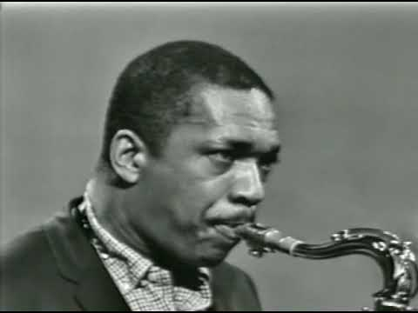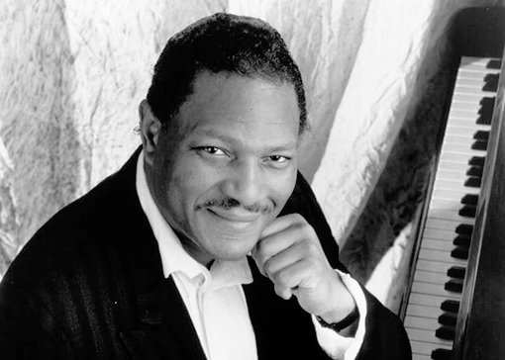
John Coltrane (1926 – 1967) McCoy Tyner (1938 – 2020)

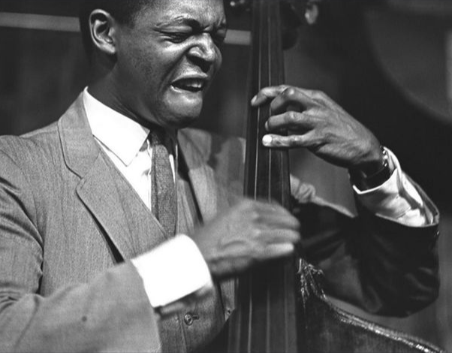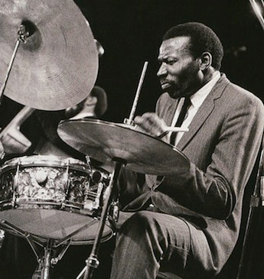
Jimmy Garrison (1933 – 1976) Elvin Jones (1927 – 2004)

