MUNI 2022-2 Gershwin (1)
C D 1

1. When You Want ‘Em, You Can’t Get ‘Em, When You’ve Got ‘Em, You Don’t Want ‘Em
(George Gershwin-Murray Roth) – September 1916 1:59
2. Swanee (George Gershwin/Irving Caesar) – February 1920 2:21

LADY, BE GOOD
3. Overture 5:57

Oh, Lady Be Good!
4. Jason Alexander, Ann Morrison, girls – August 12-14, 1992 3:49
5. Paul Whiteman Orchestra – April 1925 3:05
6. Michel Warlop, Stéphane Grappelly, Eddie South – September 1937 3:19
7. Artie Shaw and his Orchestra – January 22, 1939 (radio show) 3:09
8. Oscar Peterson Trio (Barney Kessel-Ray Brown) – December 4, 1952 3:49
9. Oscar Peterson Trio (Ray Brown-Ed Thigpen) – July-August, 1959 2:58
10. Ella Fitzgerald [studio] – January 8, 1959 4:02
11. Ella Fitzgerald [concert] – October 7, 1957 4:25
12. Gordon Family, Stuff Smith, Dizzy Gillespie – April 17, 1957 4:14

Fascinating Rhythm
13. Cliff Edwards [Ukulele Ike] – 1924 2:50
14. John Pizzarelli-voc, ukulele – OC 7:35
15. Mel Tormé – January 20, 1956 2:33
16. Ella Fitzgerald 3:25
17. Oscar Peterson Trio (Barney Kessel-Ray Brown) – December 4, 1952 2:56
18. Dave Grusin, Gary Burton (John Patitucci-Dave Weckl) – 1991 5:06

The Man I Love
19. Vaughn de Leath, Fred Rich and His Hotel Astor Orchestra – 1927 3:07
20. Rebecca Luker & Brent Barrett – 1990 6:06

MUNI 2022-2 Gershwin (1)
C D 2

The Man I Love
1. Billie Holiday – June 3, 1946 Carnegie Hall 3:05
2. Oscar Peterson Trio (Barney Kessel-Ray Brown) – December 4, 1952 3:30
3. Oscar Peterson Trio (Ray Brown-Ed Thigpen) – July-August, 1959 3:05
4. Ella Fitzgerald 3:54
5. Maureen McGovern – November 20, 1988 3:20

GIRL CRAZY
6. Overture
Embraceable You
7. David Carroll & Judy Blazer – 1990 3:53
8. David Carroll & Judy Blazer – 1990 1:58
9. Ella Fitzgerald – 1959 4:51
10. Charlie Parker – October 28, 1947 (Davis, Jordan, Potter, Roach) 3:21
11. Herbie Hancock – 1998 4:42

I Got Rhythm
12. Lorna Luft and choir [reprise] – 1990 1:31

But Not for Me
13. Judy Blazer – 1990 2:58
14. Judy Blazer & Frank Gorshin (comic reprise) – 1990 2:03
15. Helen Forrest & Harry James Orchestra – December 30, 1941 3:03
16. Thad Jones-Mel Lewis Quartet – September 24, 1977 16:51

MUNI 2022-2 Gershwin (1)
C D 1

1. When You Want ‘Em, You Can’t Get ‘Em, When You’ve Got ‘Em, You Don’t Want ‘Em
(George Gershwin-Murray Roth) – September 1916 1:59

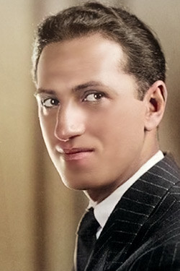
George Gershwin [Jacob Gershowitz] (1898 – 1937)

2. Swanee (George Gershwin/Irving Caesar) – February 1920 2:21

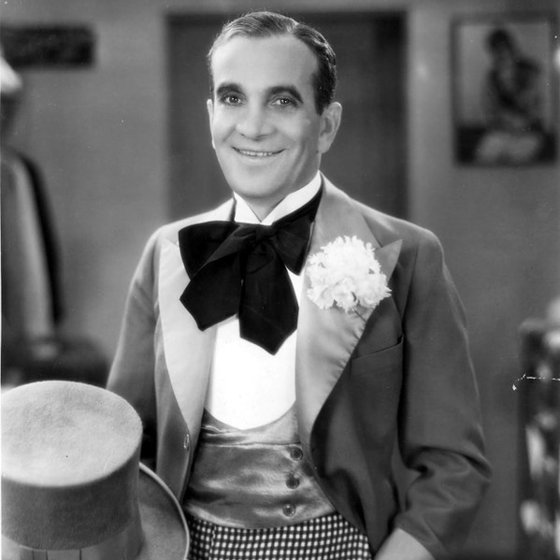
Al Jolson [Asa Yoelson] (1886 – 1950)
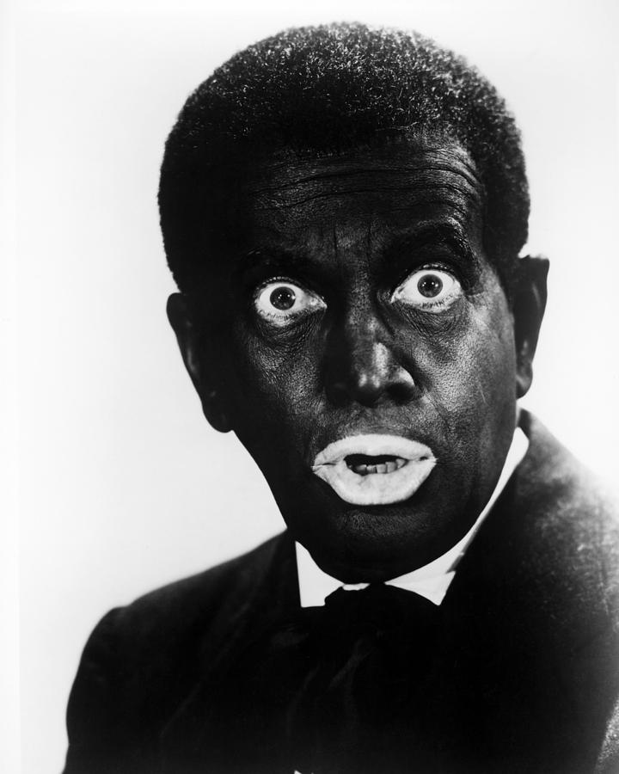

LADY, BE GOOD
3. Overture 5:57
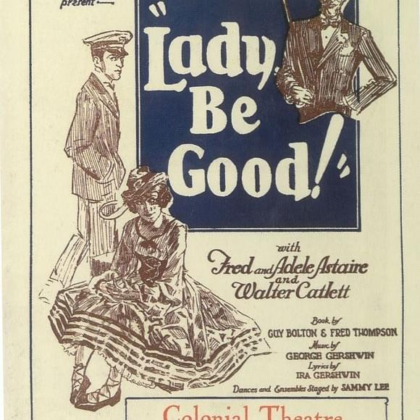
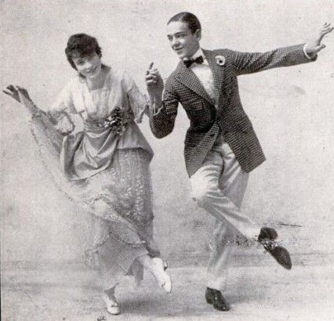
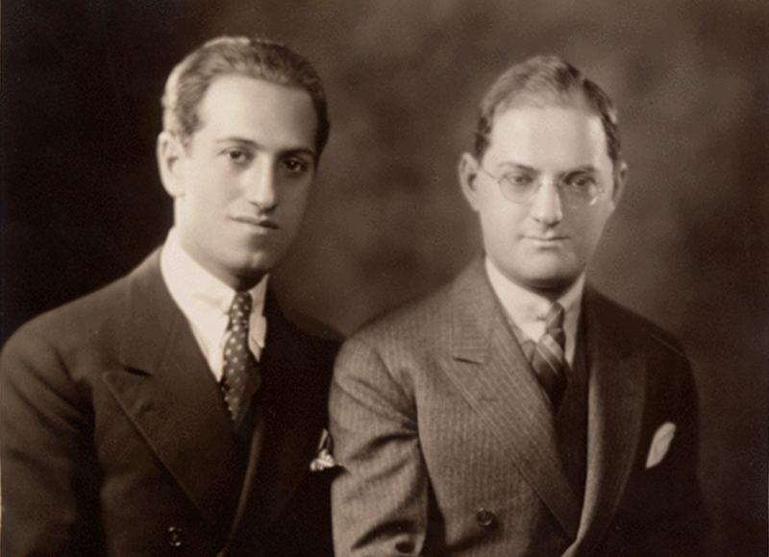
George & Ira Gershwin

Oh, Lady Be Good!
4. Jason Alexander, Ann Morrison, girls – August 12-14, 1992 3:49
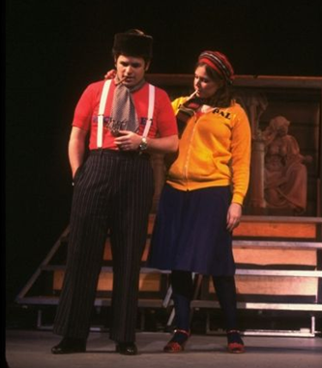

5. Paul Whiteman Orchestra – April 1925 3:05

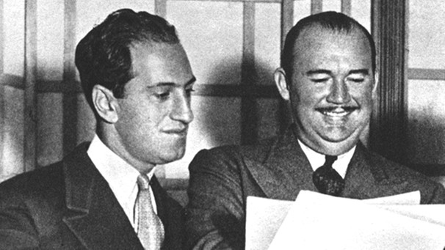

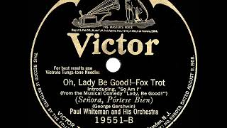

6. Michel Warlop, Stéphane Grappelly, Eddie South – September 1937 3:19
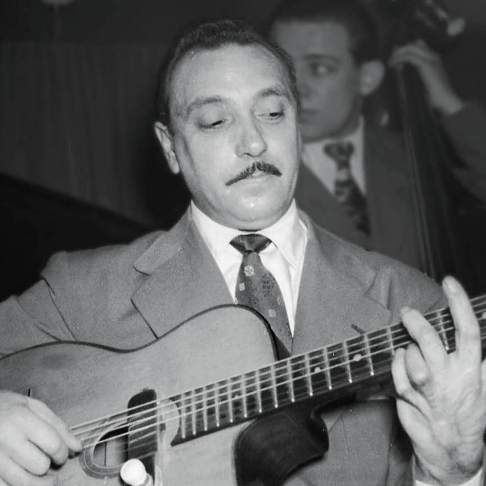
Django Reinhardt

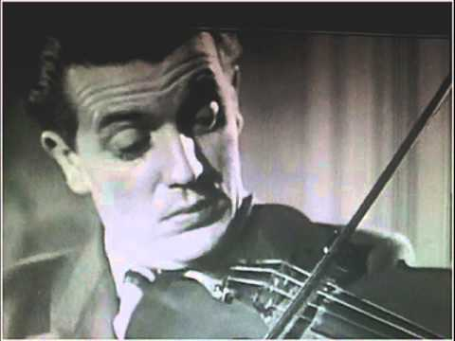
Michel Warlop
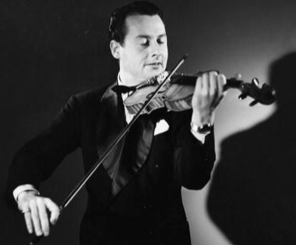
Stéphane Grappelly

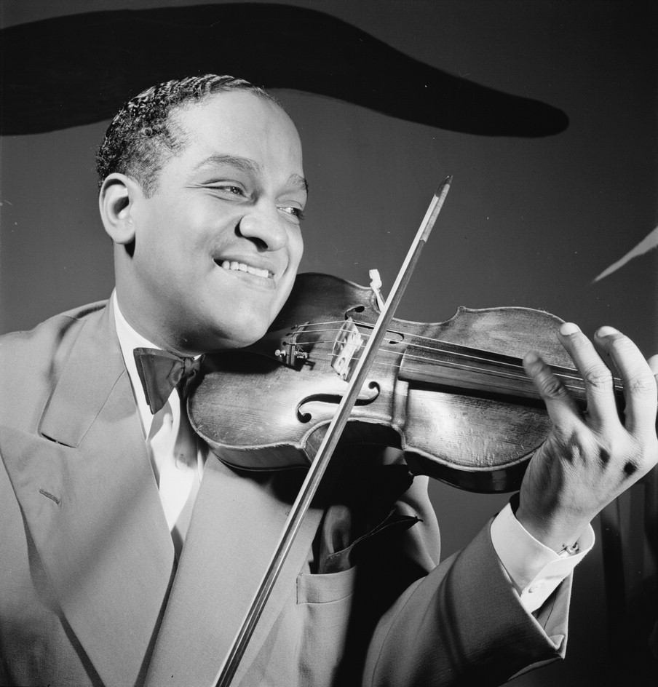
Eddie South

7. Artie Shaw and his Orchestra – January 22, 1939 (radio show) 3:09

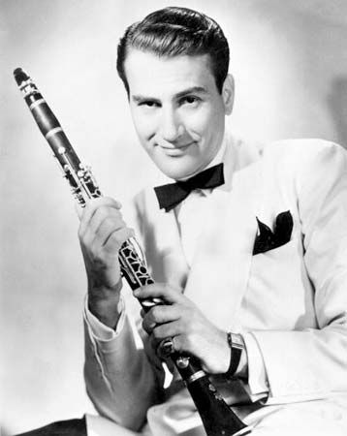
Artie Shaw

8. Oscar Peterson Trio (Barney Kessel-Ray Brown) – December 4, 1952 3:49

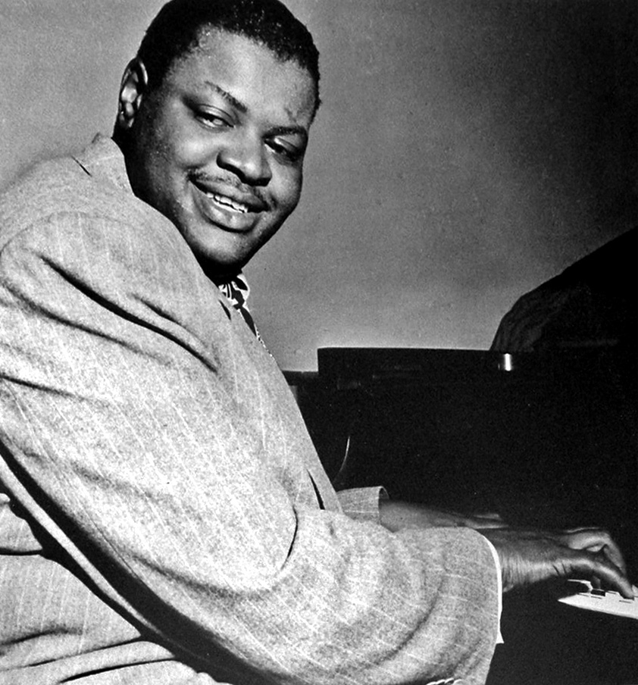
Oscar Peterson

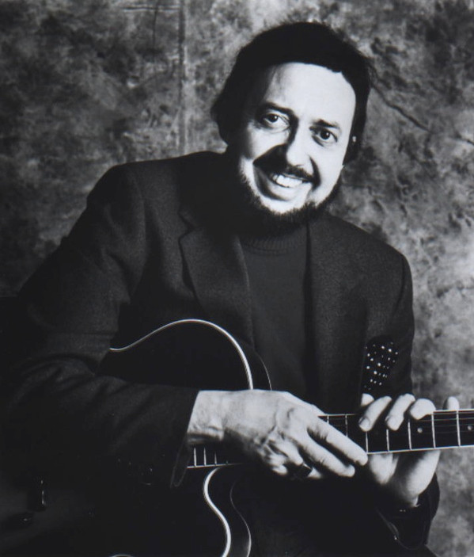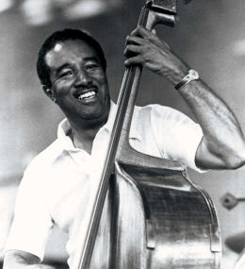
Barney Kessel Ray Brown

9. Oscar Peterson Trio (Ray Brown-Ed Thigpen) – July-August, 1959 2:58
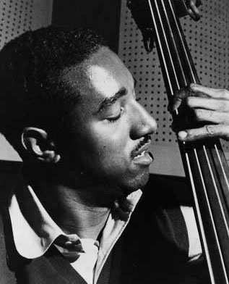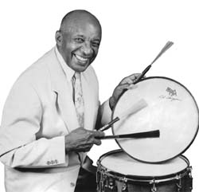
Ray Brown Ed Thigpen

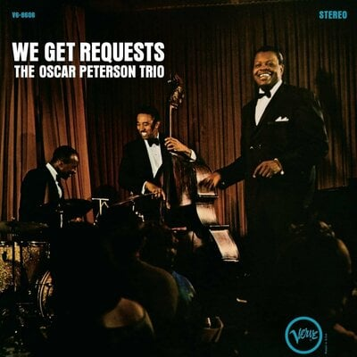

10. Ella Fitzgerald [studio] – January 8, 1959 4:02
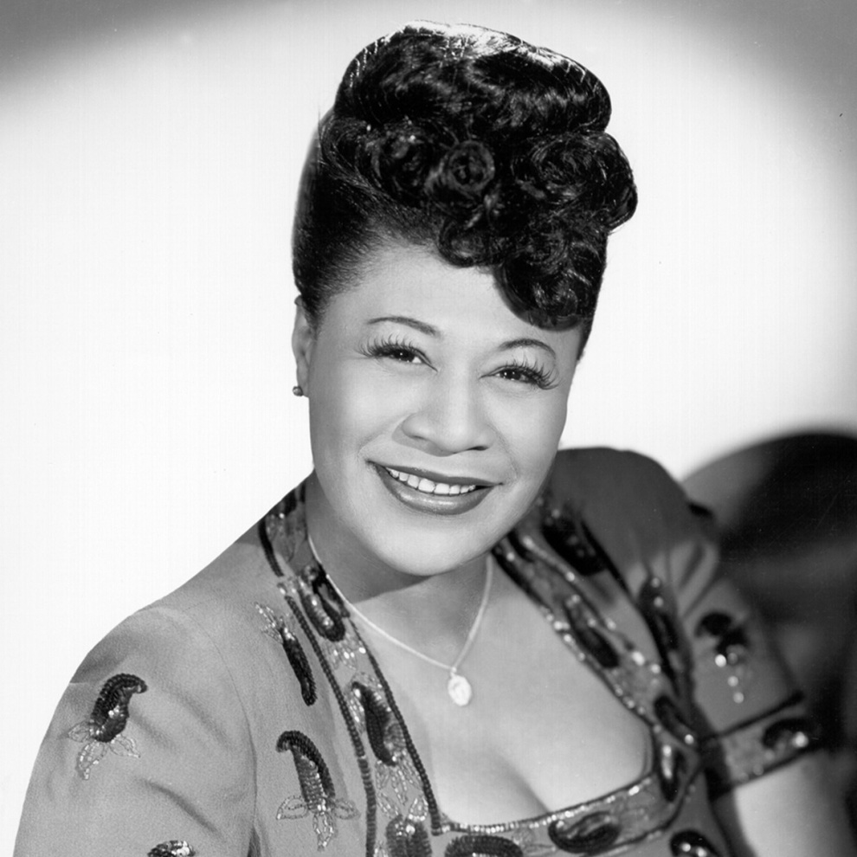

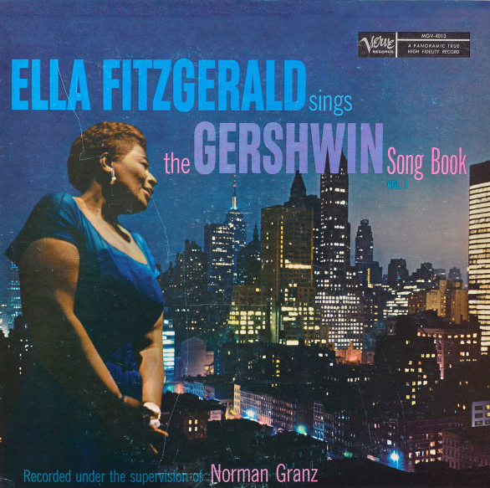

11. Ella Fitzgerald [concert] – October 7, 1957 4:25
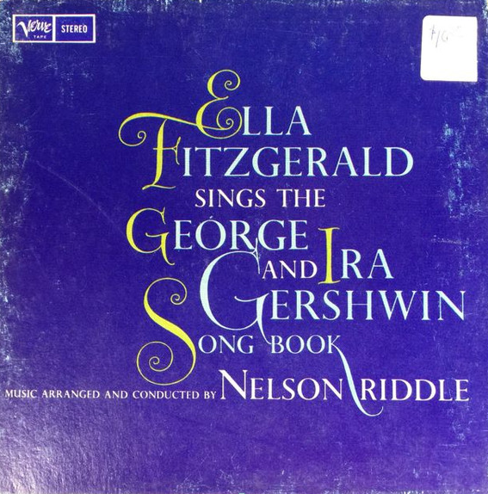
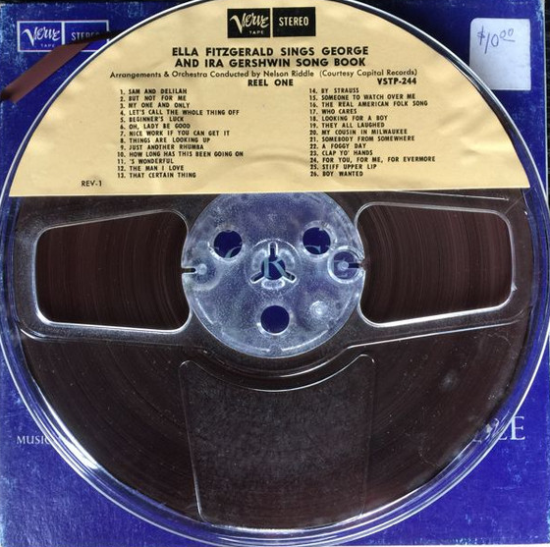

12. Gordon Family, Stuff Smith, Dizzy Gillespie – April 17, 1957 4:14

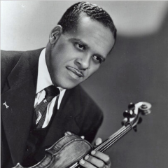
Stuff Smith

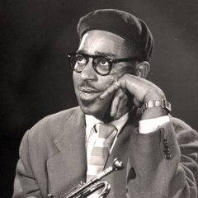
Dizzy Gillespie

Fascinating Rhythm
13. Cliff Edwards [Ukulele Ike] – 1924 2:50

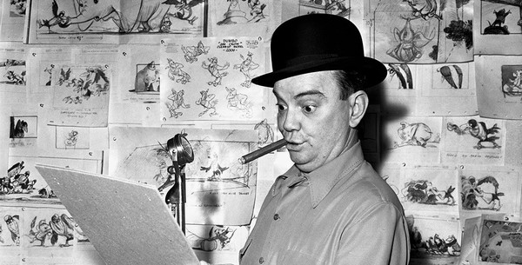

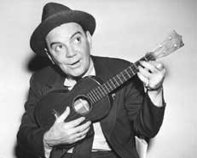
Cliff Edwards (Ukulele Ike)

14. John Pizzarelli-voc, ukulele – OC 7:35
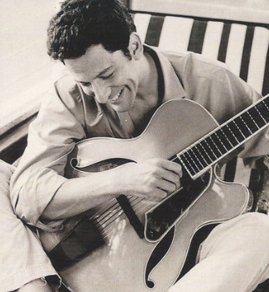
John Pizzarelli
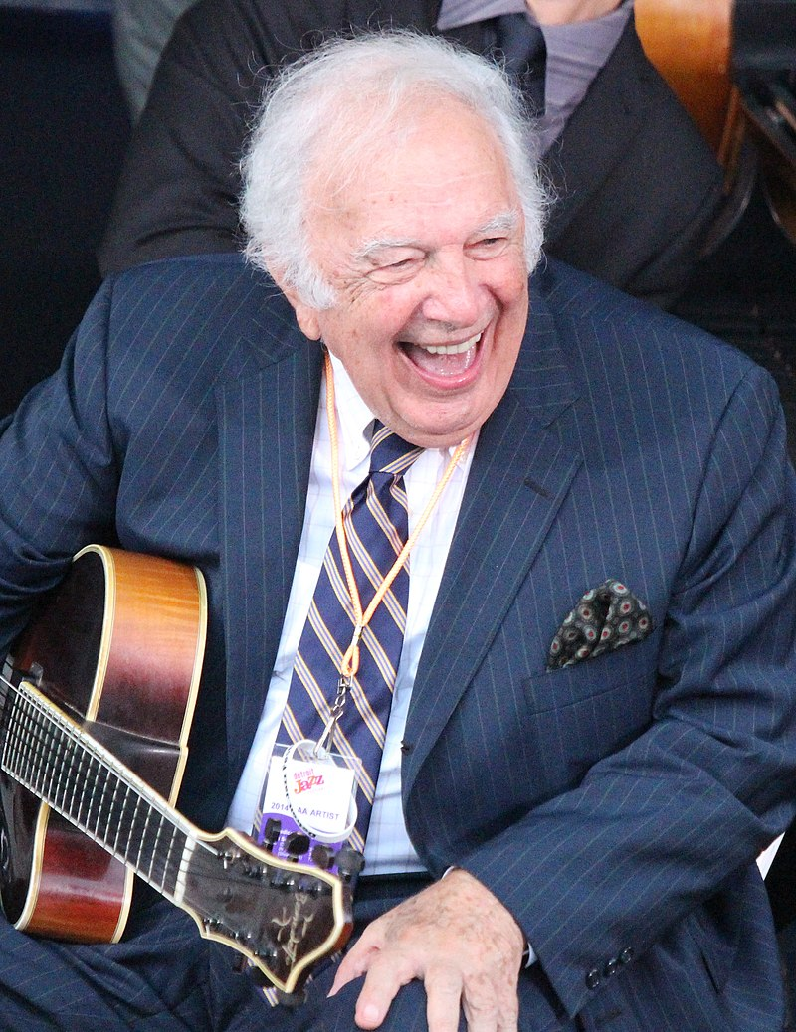
Bucky Pizzarelli

15. Mel Tormé – January 20, 1956 2:33
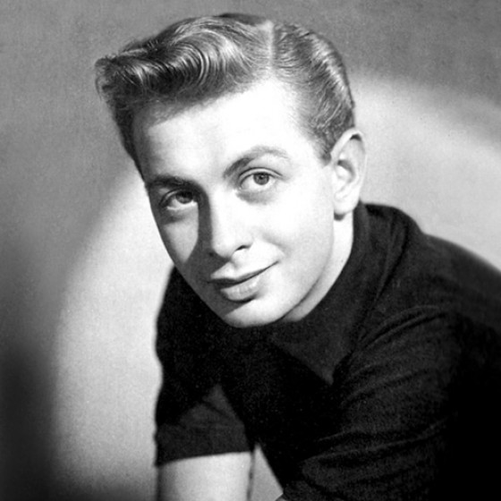
Mel Tormé
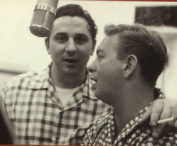
& Marty Paich
16. Ella Fitzgerald 3:25
17. Oscar Peterson Trio (Barney Kessel-Ray Brown) – December 4, 1952 2:56
18. Dave Grusin, Gary Burton (John Patitucci-Dave Weckl) – 1991 5:06
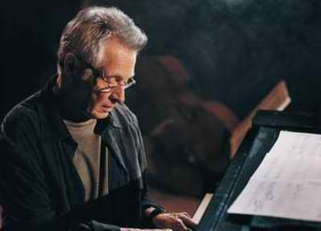
Dave Grusin
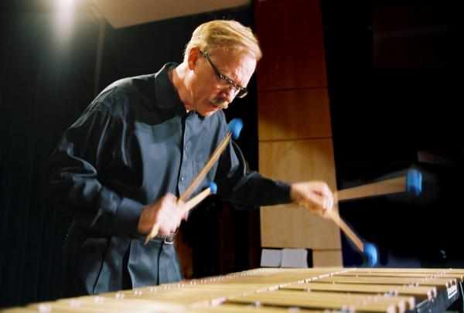
Gary Burton

The Man I Love
19. Vaughn de Leath, Fred Rich and His Hotel Astor Orchestra – 1927 3:07
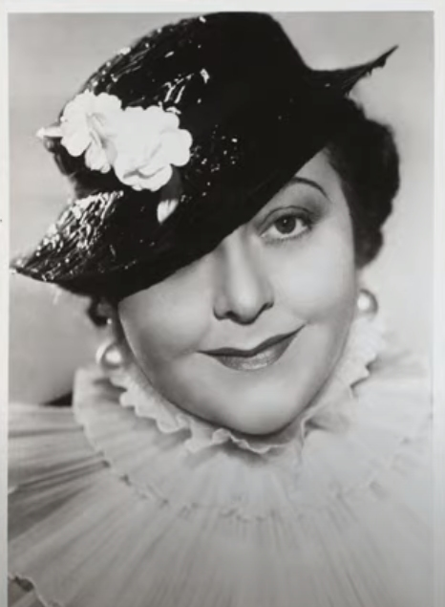
Vaughn de Leath
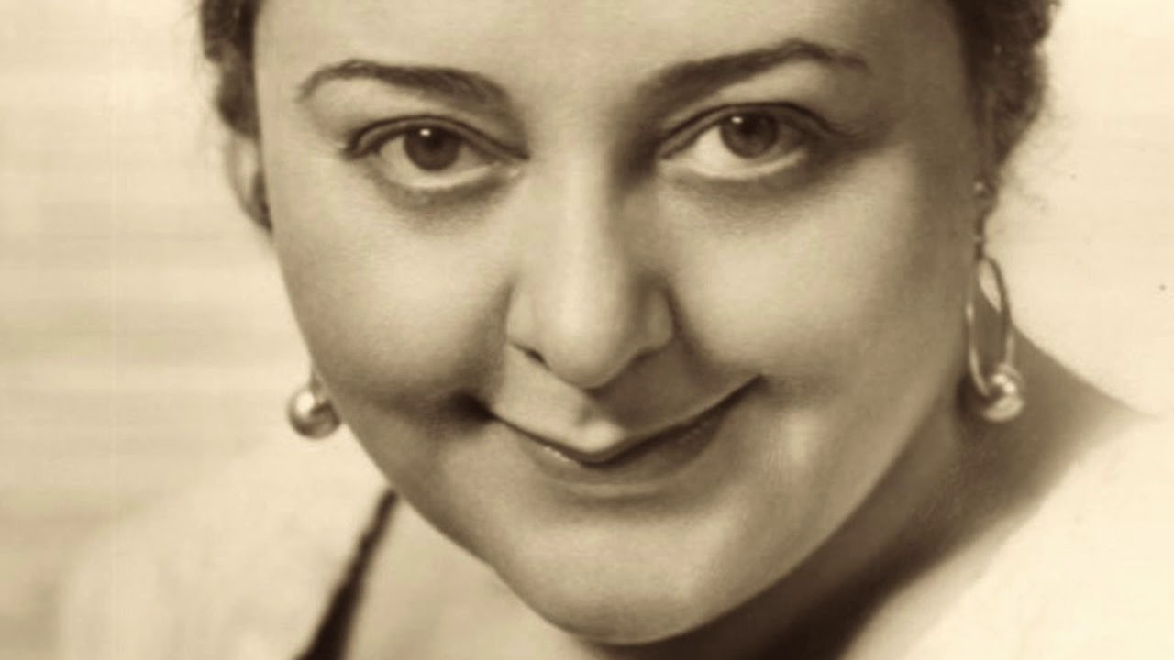

20. Rebecca Luker & Brent Barrett – 1990 6:06
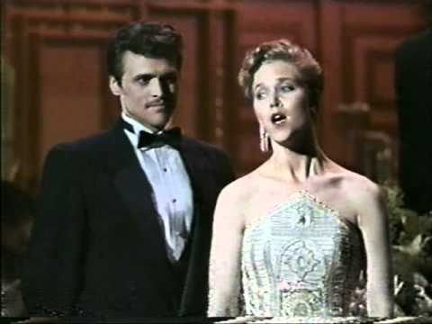
Rebecca Luker & Brent Barrett

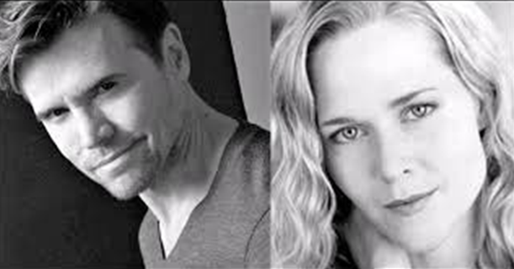

MUNI 2022-2 Gershwin (1)
C D 2

The Man I Love
1. Billie Holiday – June 3, 1946 Carnegie Hall 3:05
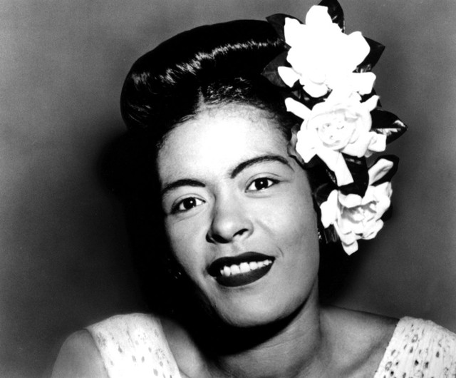
Billie Holiday

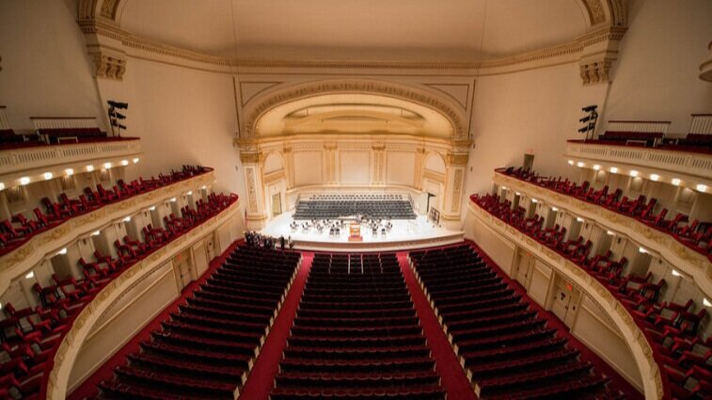
Carnegie Hall
2. Oscar Peterson Trio (Barney Kessel-Ray Brown) – December 4, 1952 3:30
3. Oscar Peterson Trio (Ray Brown-Ed Thigpen) – July-August, 1959 3:05

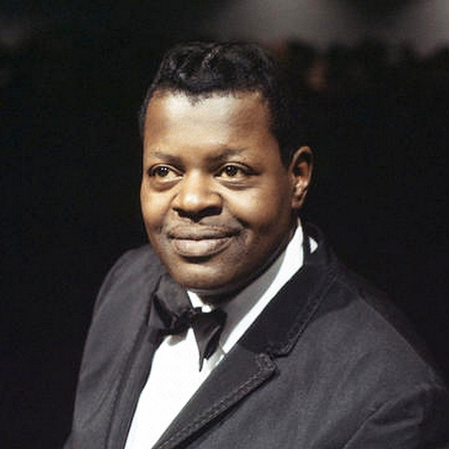

4. Ella Fitzgerald 3:54

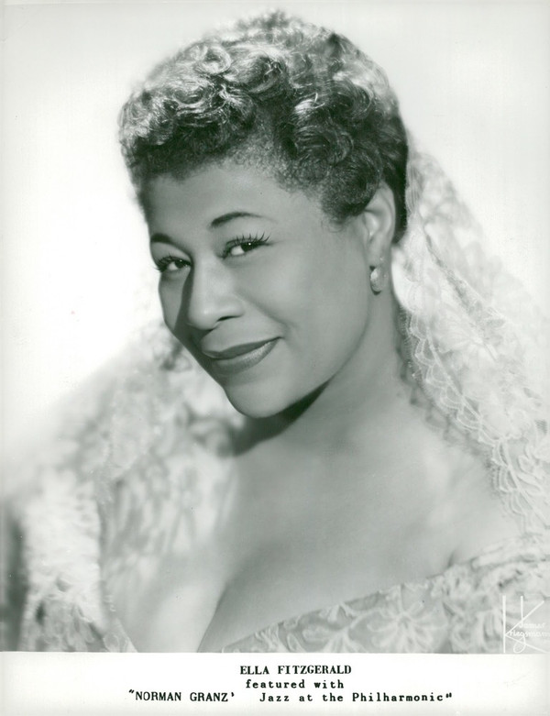

5. Maureen McGovern – November 20, 1988 3:20
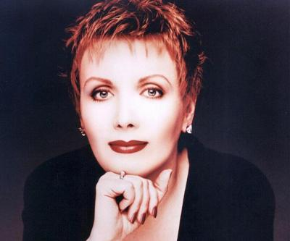

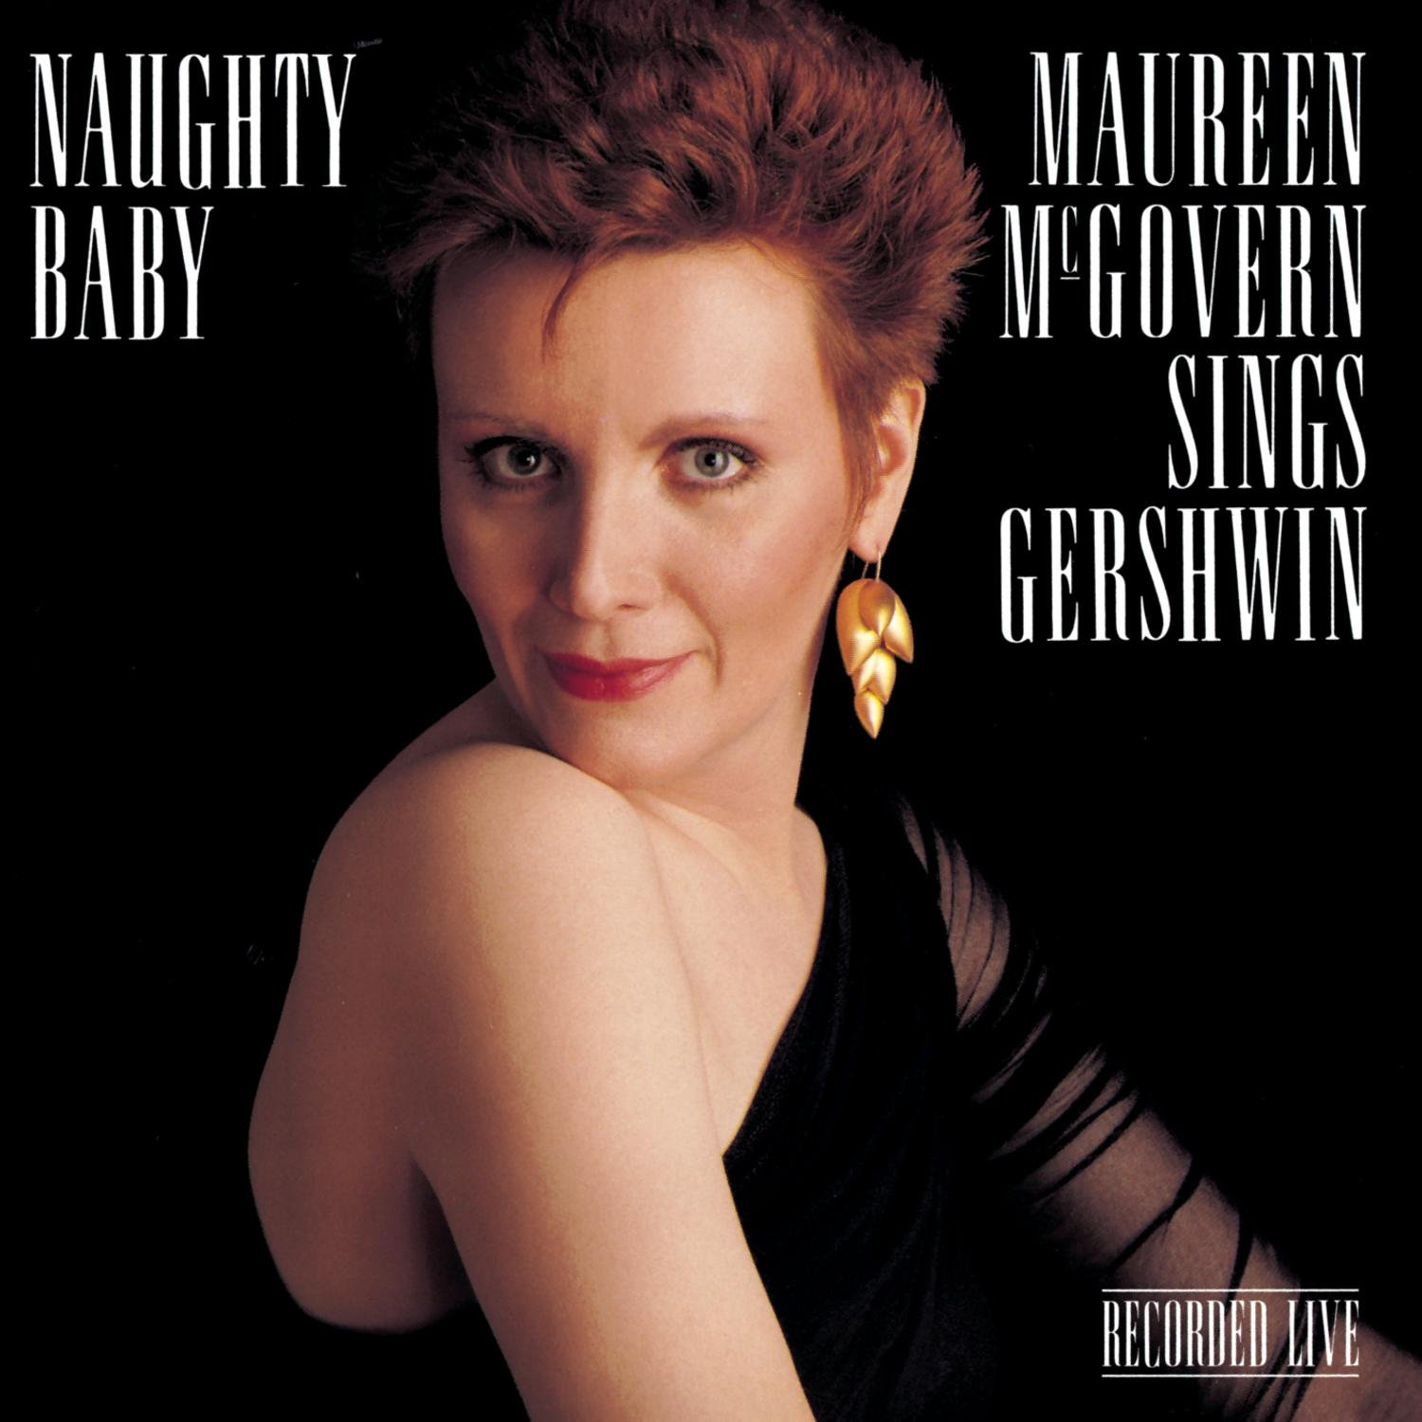

GIRL CRAZY
6. Overture
Embraceable You
7. David Carroll & Judy Blazer – 1990 3:53
8. David Carroll & Judy Blazer – 1990 1:58

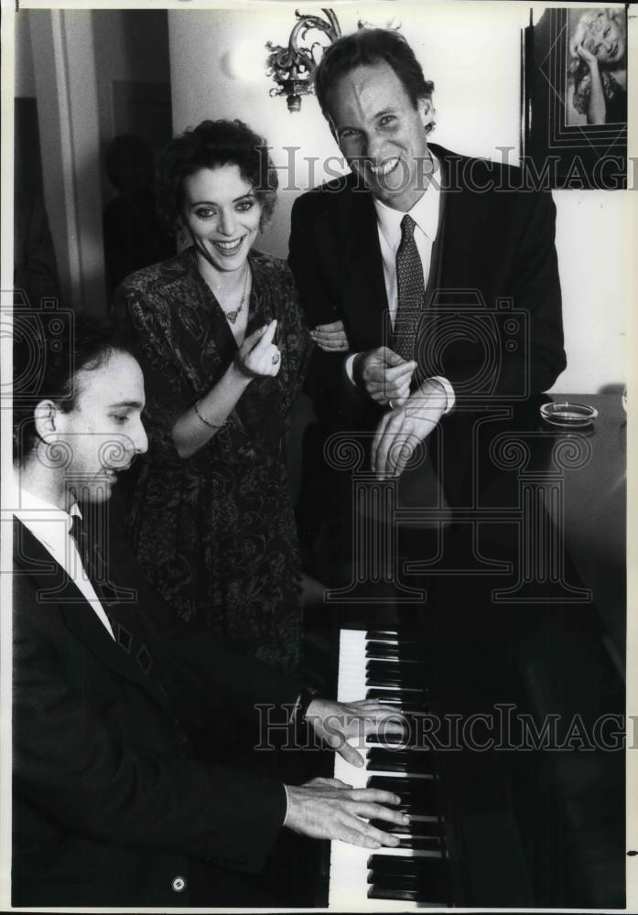
Tommy Krasker, Judy Blazer & David Carroll

9. Ella Fitzgerald – 1959 4:51

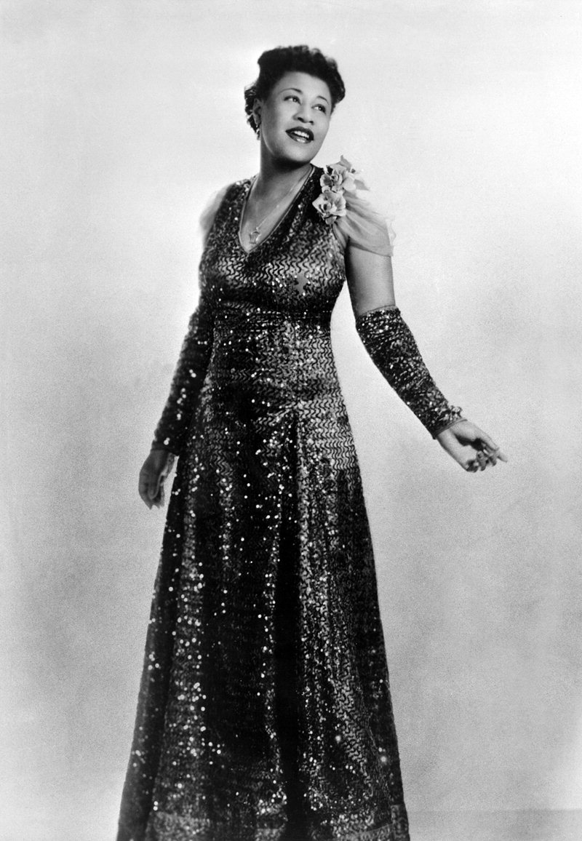

10. Charlie Parker – October 28, 1947 (Davis, Jordan, Potter, Roach) 3:21

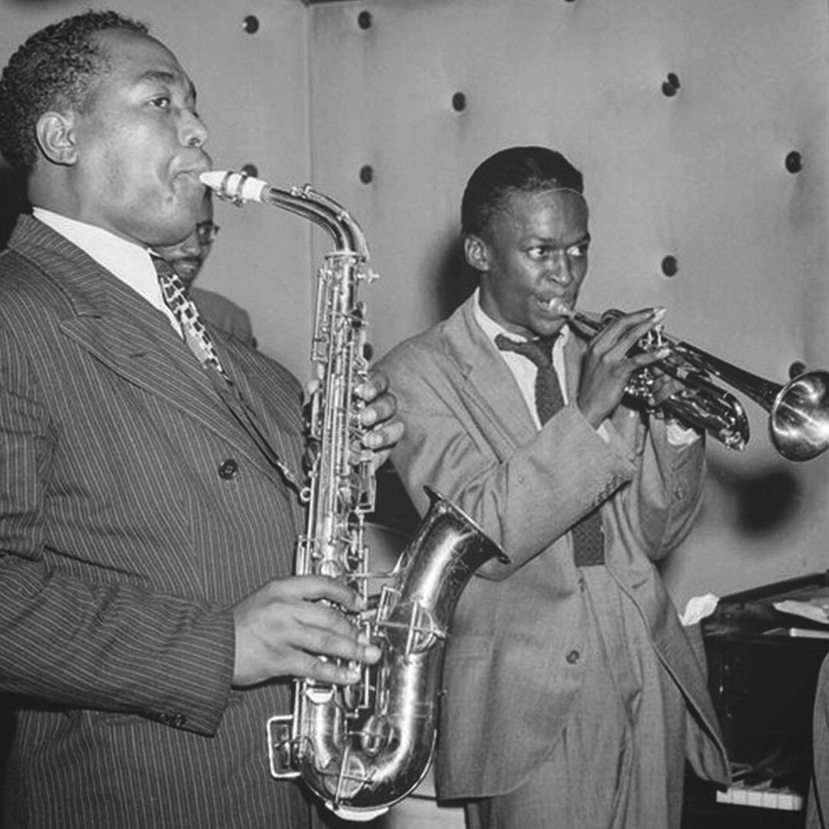
Charlie Parker & Miles Davis

11. Herbie Hancock – 1998 4:42

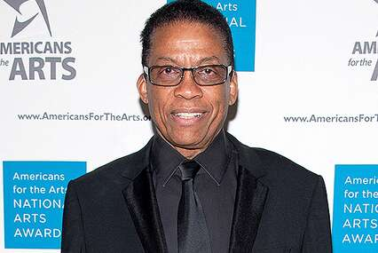

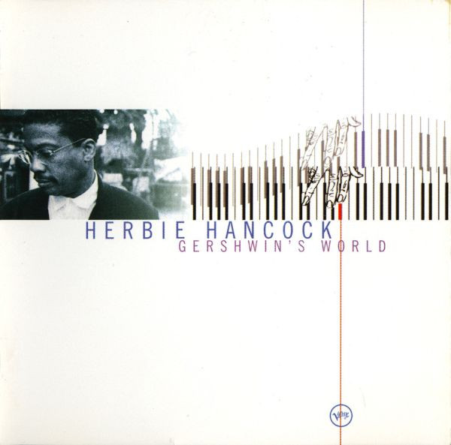

I Got Rhythm
12. Lorna Luft and choir [reprise] – 1990 1:31

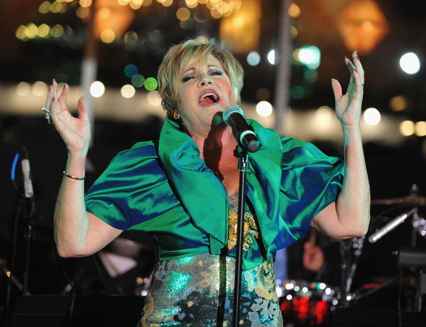
Lorna Luft
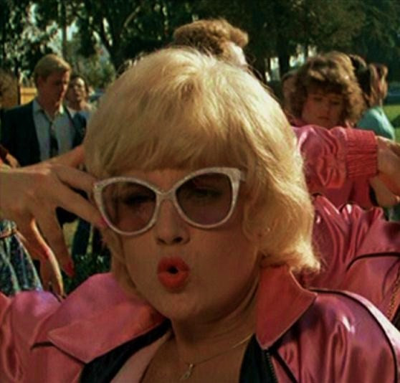

But Not for Me
13. Judy Blazer – 1990 2:58
14. Judy Blazer & Frank Gorshin (comic reprise) – 1990 2:03

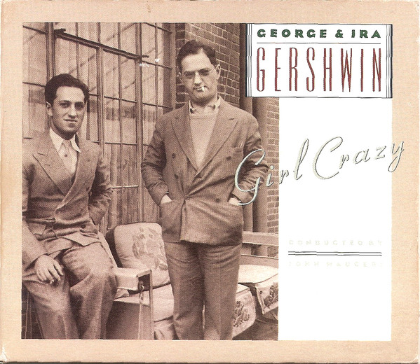
George & Ira Gershwin

15. Helen Forrest & Harry James Orchestra – December 30, 1941 3:03

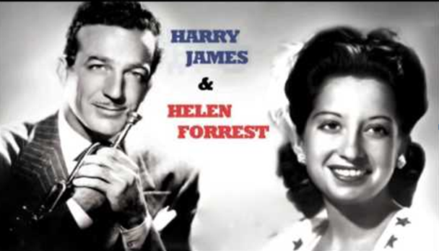

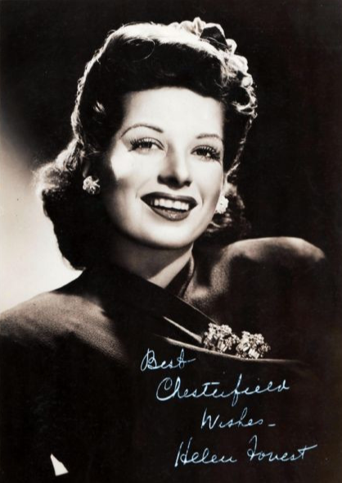

16. Thad Jones-Mel Lewis Quartet – September 24, 1977 16:51

