MUNI 20221107 - JEROME KERN foto

Jerome Kern
27. 1. 1885 New York – 11. 11. 1945 New York City

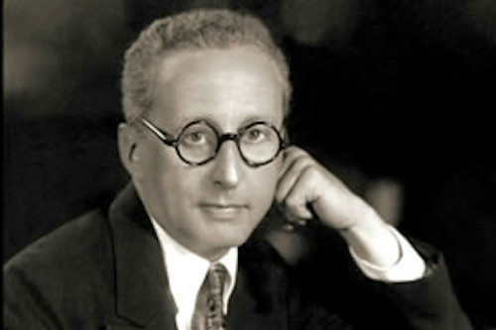

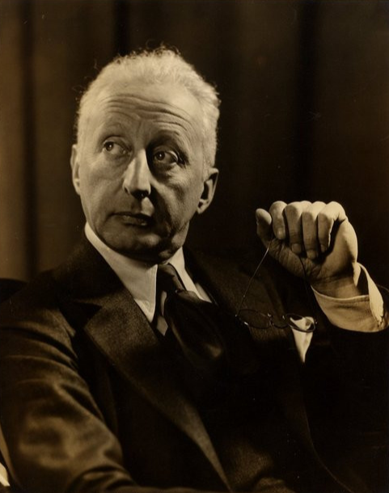

1. Ol’ Man River 3:17
Paul Whiteman and his Orchestra: Bix Beiderbecke, Bob Mayhew-co; Charlie Margulis, Henry
Busse-tp; Boyce Cullen, Wilbur Hall, Bill Rank, Jack Fulton-tb; Chester Hazlett-cl, as, bcl; Hal
McLean-cl, as; Frankie Trumbauer-Cmel; Charles Strickfaden-cl, ts; Jimmy Dorsey-cl, bs;
Harry Perrella-p; Kurt Dieterle, Mischa Russell, Mario Perry, Matty Malneck-vio; Mike
Pingitore-bjo; Tom Satterfield-celeste; Mike Trafficante-tu; Harold McDonald and unknown-dr;
Bing Crosby-voc; Bill Challis-arr; Paul Whiteman-cond.
New York, January 11, 1928.
78 Vic 21218, LP RCA 60001 (2).

Tom Lord Jazz Discography
41607-2 Ol' man river (bc vcl,bch arr) Vic 21218, Divergent 301, RCA "X"LVA1000, LPV584,
RCA (F)FXM1 7092, Phontastic (Swd)NOST7604, Joker (It)SM3563, Sunbeam Bix Vol. 7, Jonzo (E)JZ2, JZCD-2 [CD], IRD (It)101/9 [CD], BX Records BXCD4-6 [CD], Timeless (Du)CBC1-004 [CD], Bluebird 9678-2-R [CD], Masters of Jazz
(F)MJCD16 [CD], Memphis Archives MA7004 [CD],
Collector's Music 61 [CD], Classics (F)1208 [CD],
Vocalion (E)CDEA6129 [CD]
41607-3 Ol' man river (bc vcl,bh arr) BX Records BXCD13 [CD]

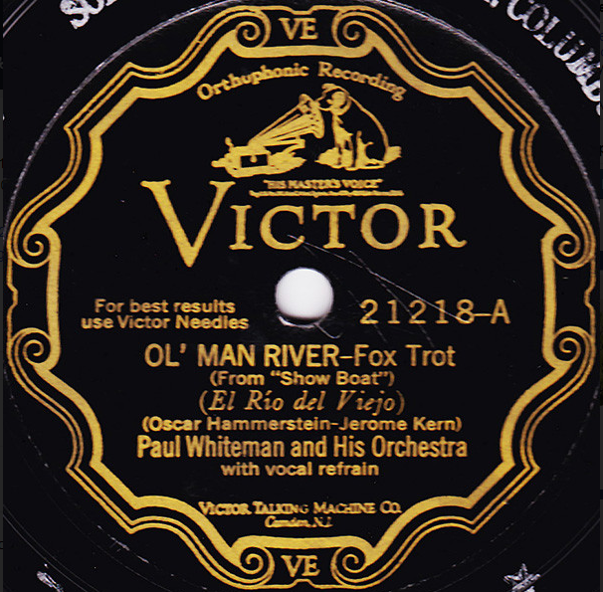

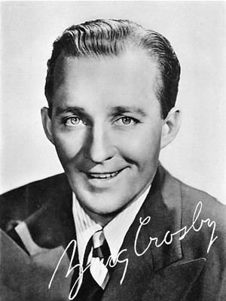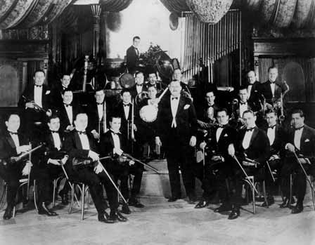
Bing Crosby (1903 – 1977) Paul Whiteman and His Orchestra

2. Ol’ Man River 4:09
Paul Whiteman & his Concert Orchestra with Paul Robeson-bass, Lambert Murphy-tenor &
mixed chorus; Mark Pingitore-banjo solo.
New York, March 1, 1928.
78 Victor 35912, CD ASV AJA 5170.

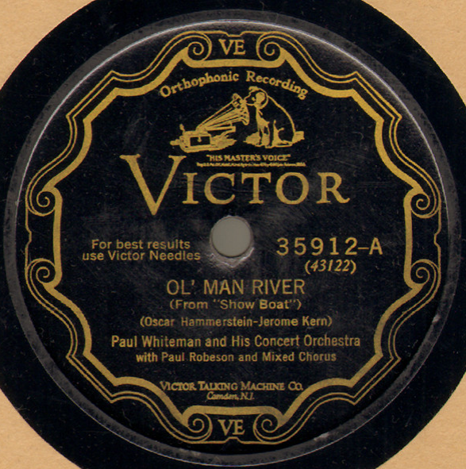

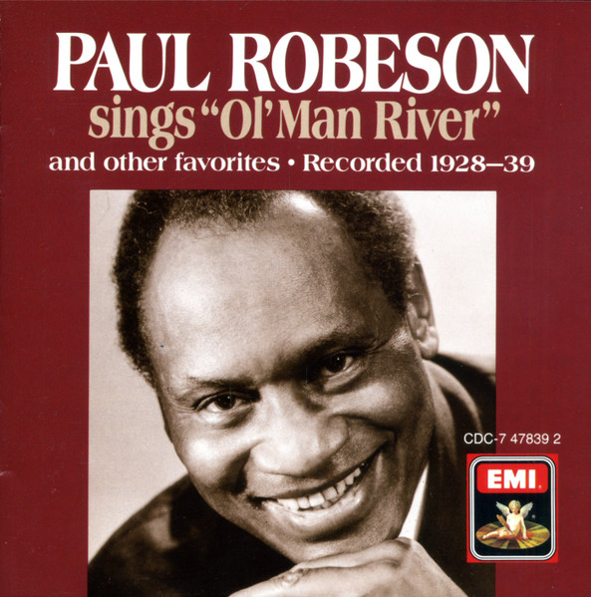

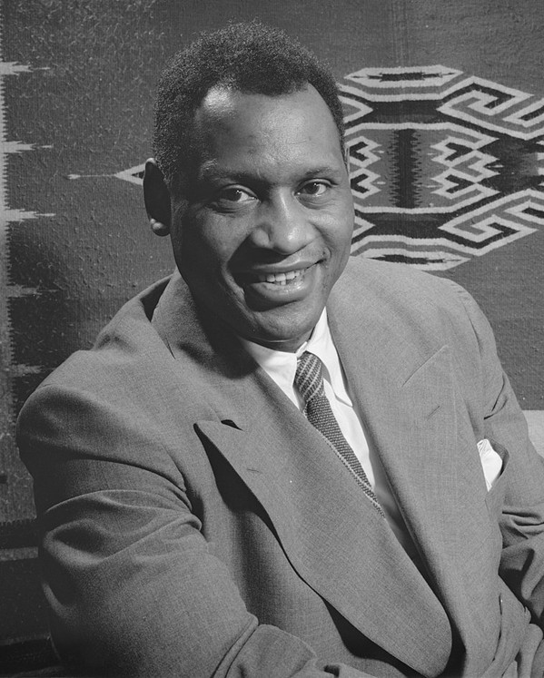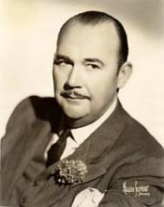
Paul Robeson (1898 – 1976) Paul Whiteman (1890 – 1967)

3. Ol’ Man River 7:07
Maynard Ferguson, Don Ellis, Chet Ferretti, Rick Kiefer-tp; Mike Zagarini (Zwerin), Charles
Greenlea-tb; Jimmy Ford-as; Joe Farrell, Willie Maiden-ts; Frank Hittner-bs; Jaki Byard-p;
Aubrey Tosin-b; Stu Martin-dr.
Recorded in New York, March 15-22, 1960.
LP Roulette R52047, R 52053.

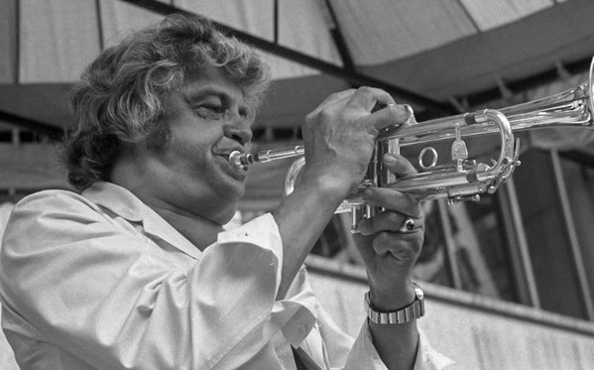
Maynard Ferguson (1928 – 2006)

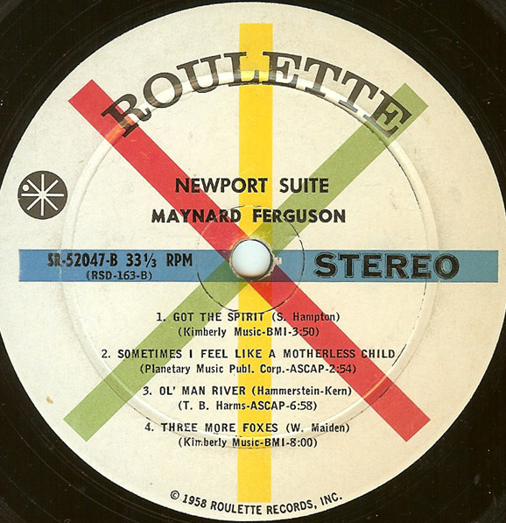

4. Ol’ Man River 2:38
Oscar Peterson Trio: Oscar Peterson-p; Ray Brown-b; Ed Thigpen-dr.
Chicago, July 21 – August 1, 1959
LP Verve MGV 2056

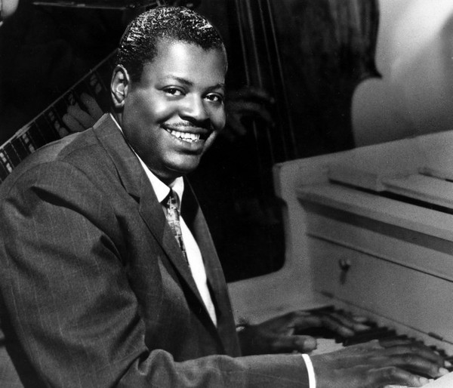
Oscar Peterson (1925 – 2007)

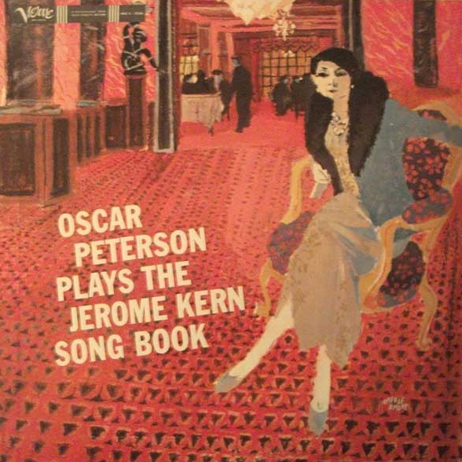

5. All the Things You Are 3:50
Margaret Whiting-voc; Bud Shank-as, fl; Russell Garcia Orchestra.
Los Angeles, January-February 1960
CD Verve 559 553-2.

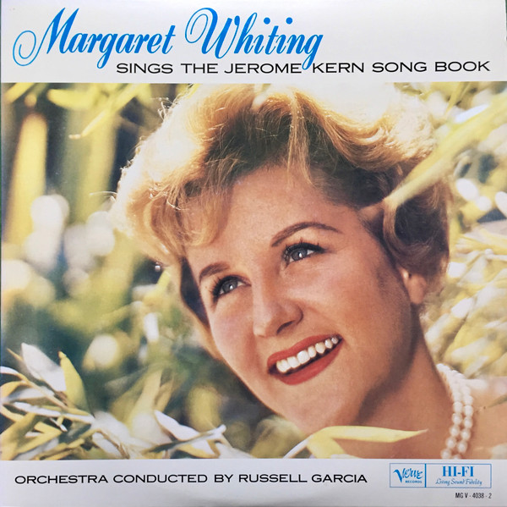

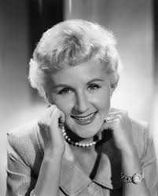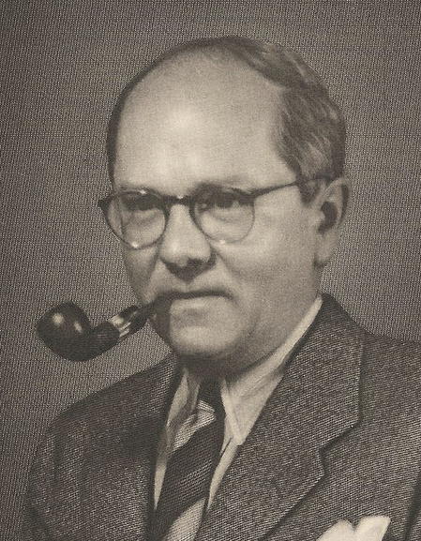
Margaret Whiting (1924 – 2011) Richard Whiting (1891 – 1938)

6. All the Things You Are 3:33
Barbra Streisand-voc; Ray Ellis-arr; studio orchestra conducted by David Shire.
CD Columbia COL 473698 2.

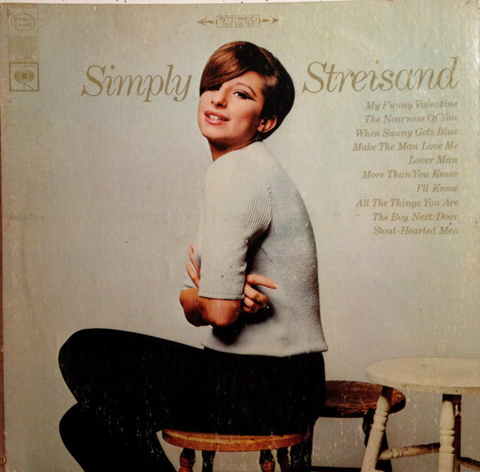
Barbra Streisand (* 1942)

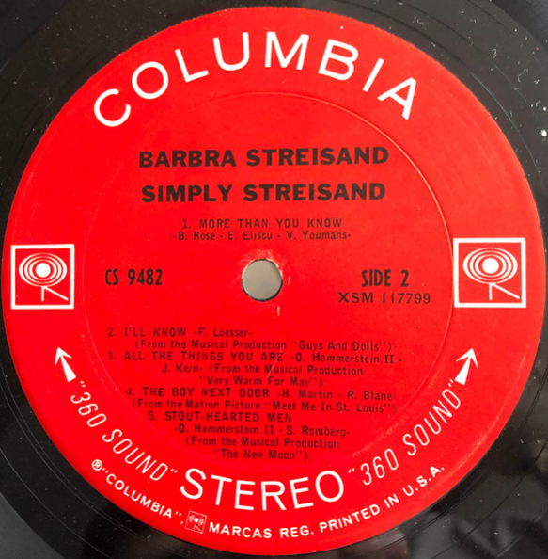

7. All the Things You Are 4:29
Joe Williams-voc; Thad Jones-tp; Eddie „Lockjaw“ Davis, Benny Golson-ts; John Collins-g;
Jerry Peters-kb; Norman Simmons-p; John Heard-b; Gerryck King-dr.
Los Angeles, June 29-30, 1985.
CD Delos 4004.

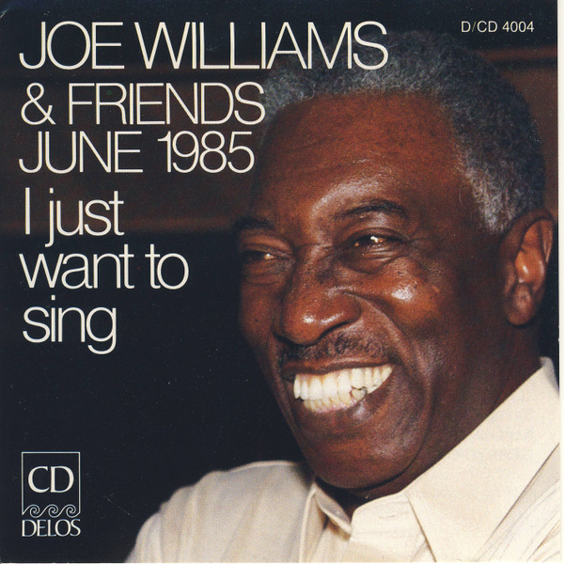
Joe Williams (1918 – 1999)

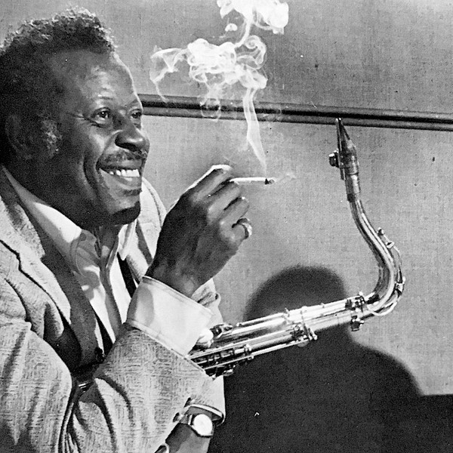
Eddie „Lockjaw“ Davis (1922 – 1986)

8. All the Things You Are 4:29
Hank Garland-g; Gary Burton-vib; Joe Benjamin-b; Joe Morello-dr.
Nashville, August 23, 1960.
CD Columbia 492532 2.

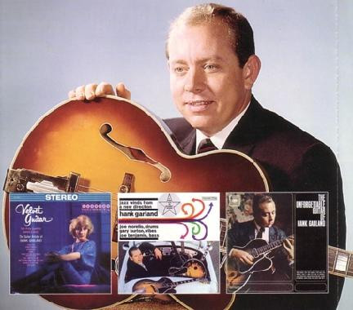
Hank Garland (1930 – 2004)

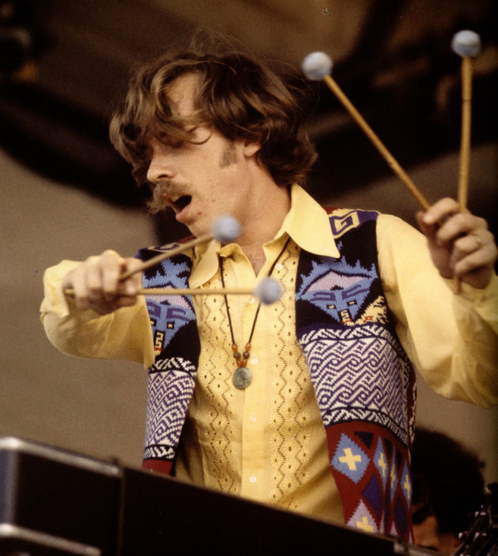
Gary Burton (* 1943)

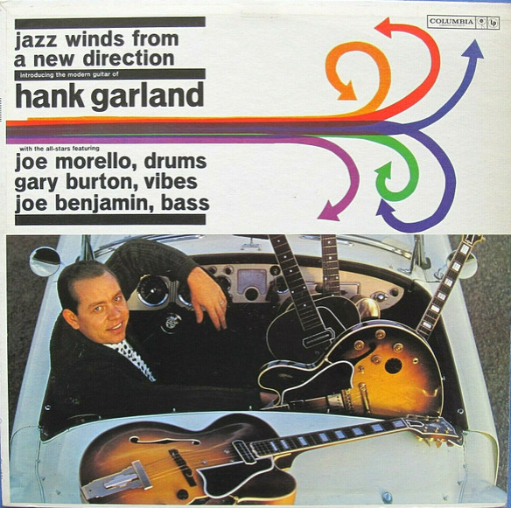

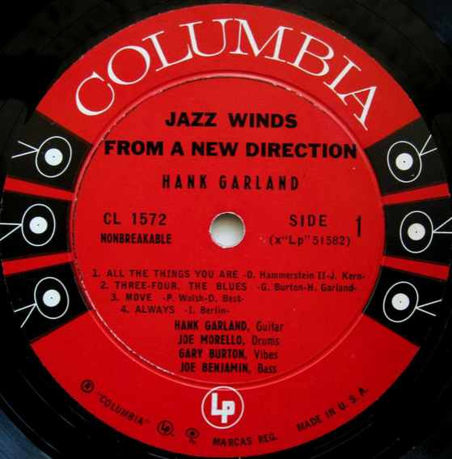

9. Are You All the Things? = All the Things You Are 5:06
Bill Evans-el. p; Eddie Gomez-b.
Fantasy Studios, Berkeley, CA, November 7-10, 1974. LP: Milestone 9475.

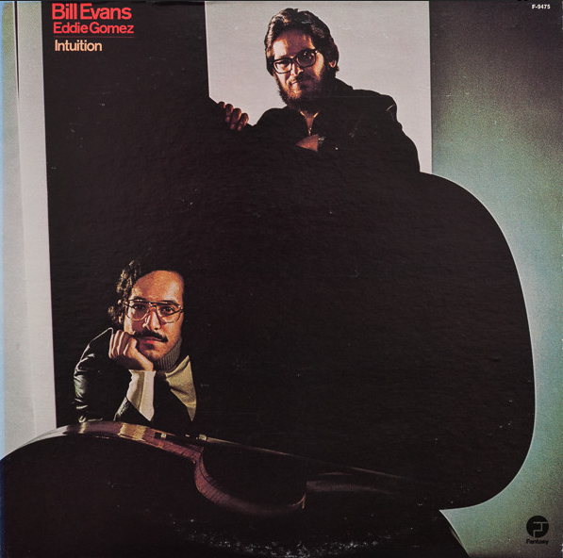
Eddie Gomez (* 1944) – Bill Evans (1929 – 1980)

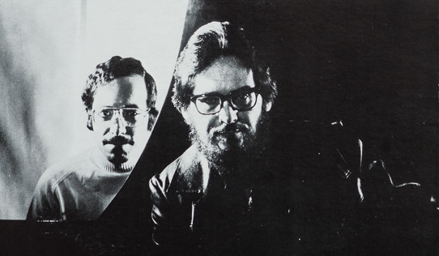

10. Yesterdays 2:52
Ella Fitzgerald-voc; Nelson Riddle Orchestra.
Los Angeles, January 6, 1963.
LP: Verve V6-4060. CD: Verve 0075021034754.

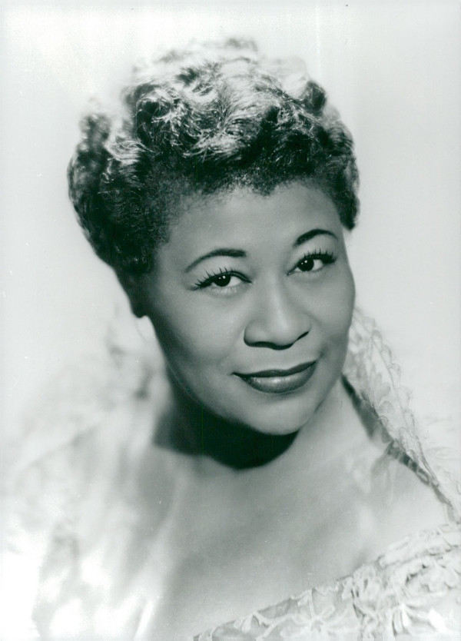

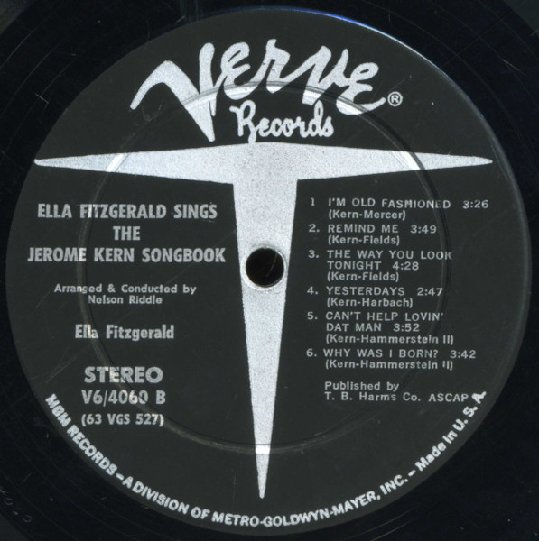

11. Yesterdays 2:58
The Hi-Lo’s

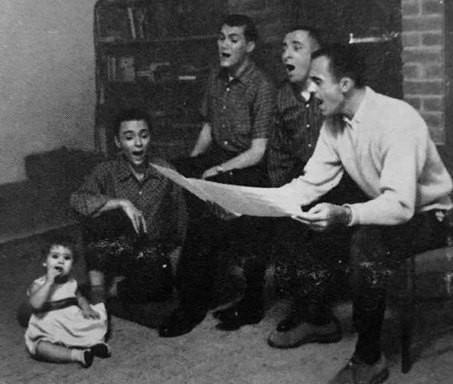

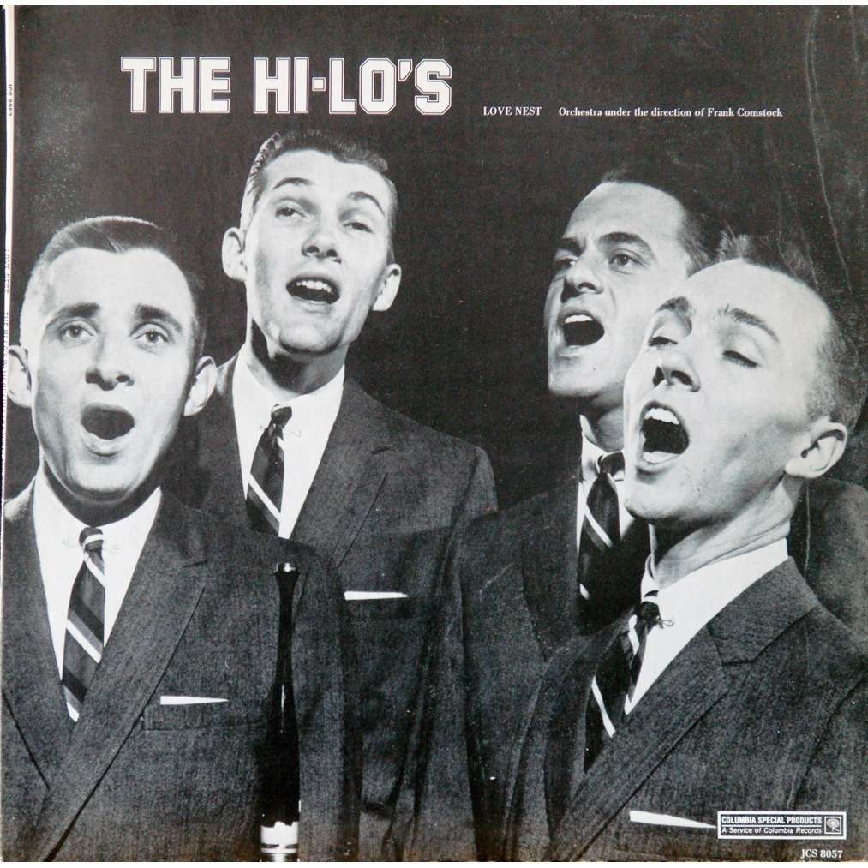

12. Yesterdays 5:12
Sonny Rollins & Coleman Hawkins-ts; Paul Bley-p; Bob Cranshaw-b; Roy McCurdy-dr.
New York, July 15, 1963.
LP RCA Victor LPM/LSP 2712.

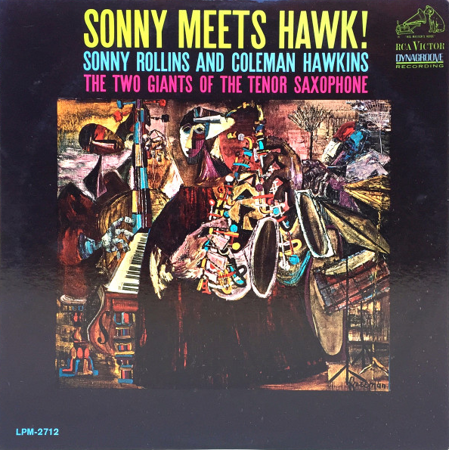

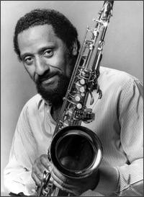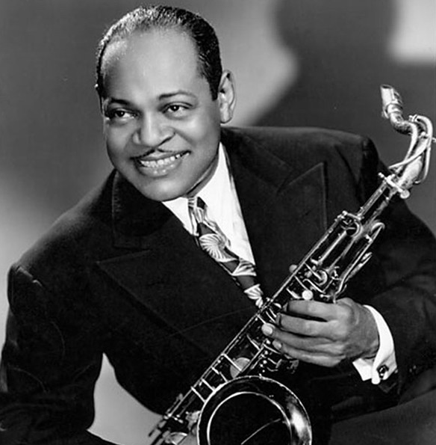
Sonny Rollins (* 1930) Coleman Hawkins (1904 – 1969)

13. Yesterdays 15:21
Miles Davis Quintet: Miles Davis-tp; Wayne Shorter-ts; Herbie Hancock-p; Ron Carter-b;
Tony Williams-dr.
Live at Chicago’s club Plugged Nickel, December 23, 1965.
LP CBS/Sony 25AP291, CD Columbia/Legacy CK 67377.

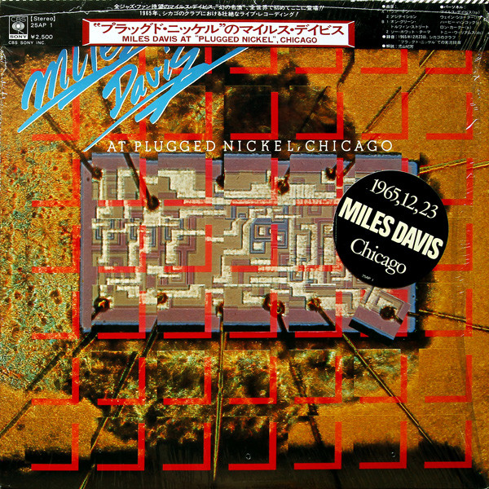
1 LP – 1976

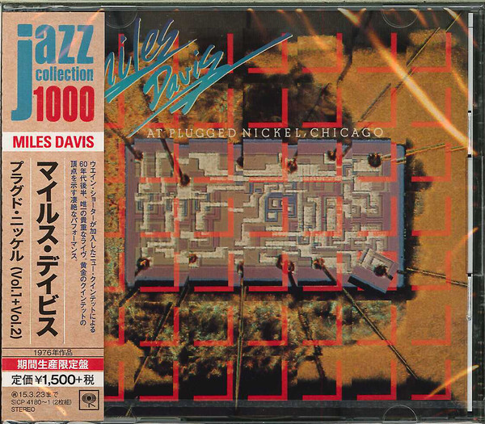
2 CD – 2014 (Yesterdays added)

The Second Miles Davis Quintet (1964 – 1968)

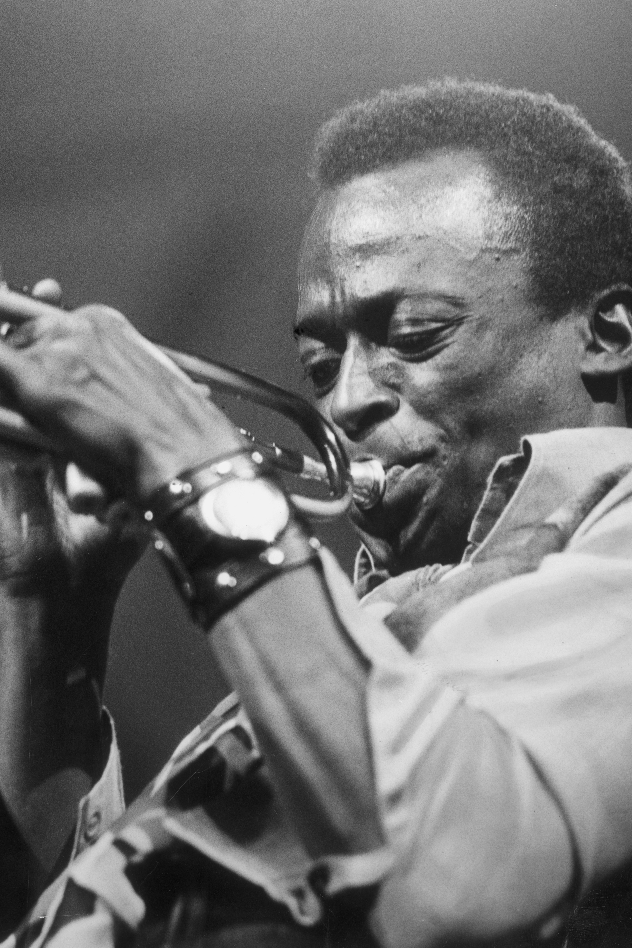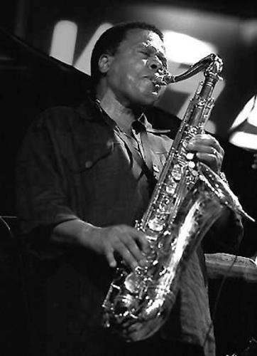
Miles Davis (1926 – 1991) Wayne Shorter (* 1933)

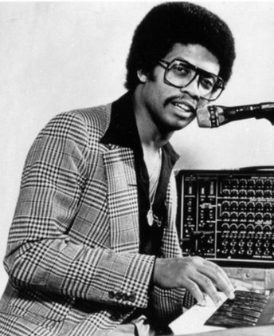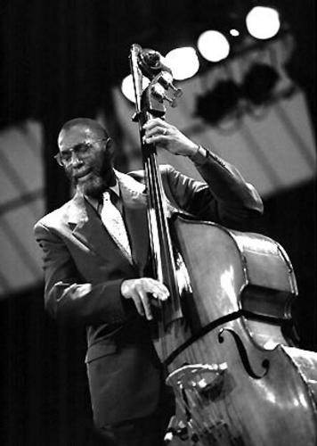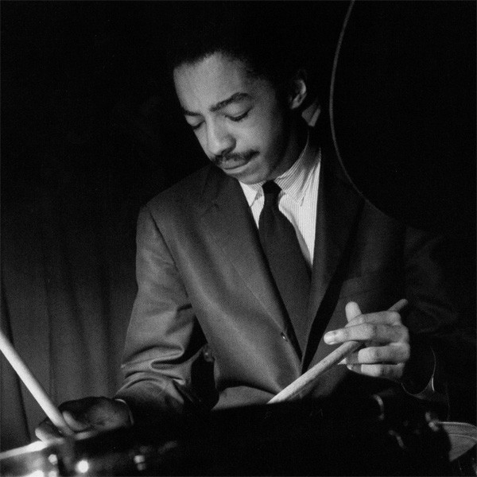
Herbie Hancock Ron Carter Tony Williams
(* 1940) (* 1937) (1945 – 1997)

14. Yesterdays 11:11
Howard Johnson & Gravity: Dave Bargeron-1st tu solo; Howard Johnson-BBb tu, 2nd solo;
Earl McIntyre, Joe Daley, Bob Stewart-tu; Raymond Chew-p; Bob Cranshaw-b; Kenwood
Dennard-dr.
New York 1996.
CD Verve/Motor 531 021-2.

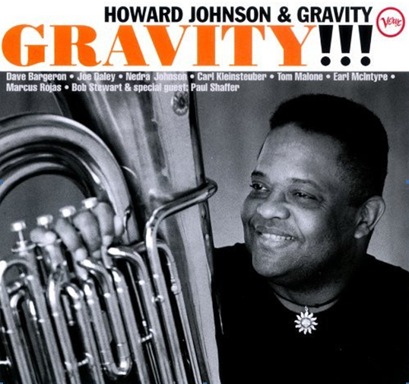

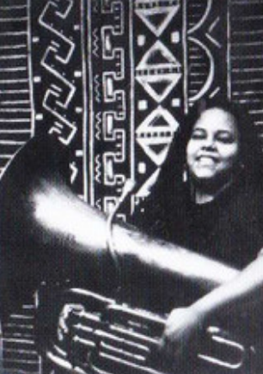 Nedra Johnson, daughter
C D 3

1. All the Things You Are 3:19
Ella Fitzgerald
2. All the Things You Are 7:47
Keith Jarrett Standard Trio: KJ-p; Gary Peacock-b; Jack DeJohnette-dr.
Power Station, New York City, January 11 – 12, 1983. CD: ECM 811 966-2.

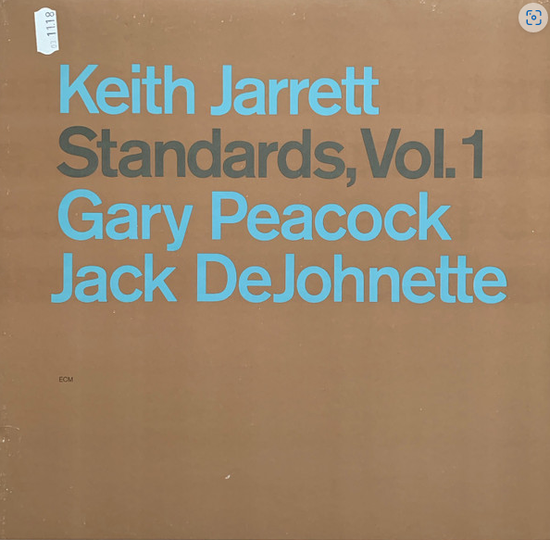

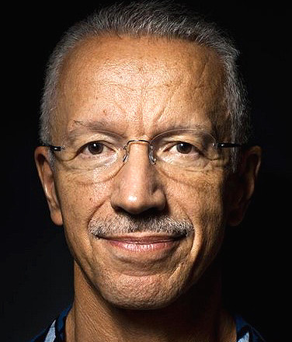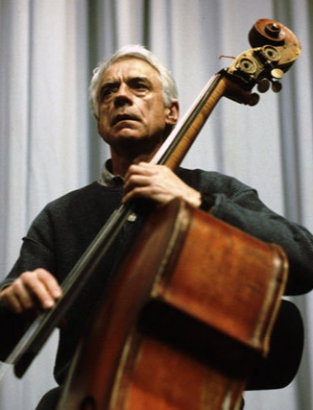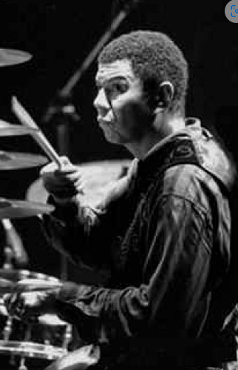
Keith Jarrett (* 1945) Gary Peacock (1935-2020) Jack DeJohnette (*1942)

3. Yesterdays
Ella Fitzgerald
4. Yesterdays
Standard Trio.
Live at Metropolitan Festival Hall, Tokyo. April 30, 2001. CD: ECM 2060.

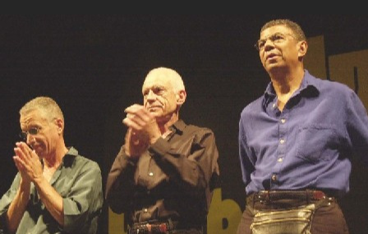
Keith Jarrett Gary Peacock Jack DeJohnette

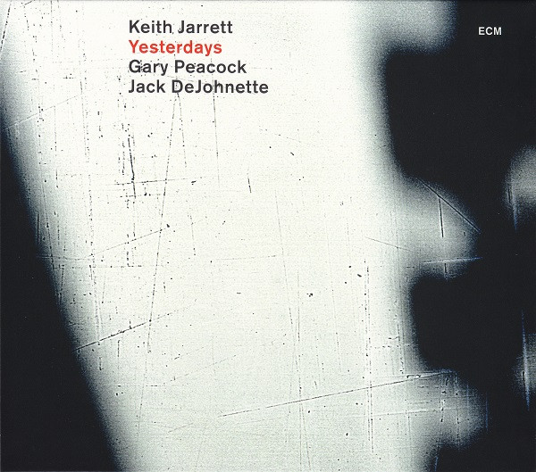

5. The Way You Look Tonight
Ella Fitzgerald
6. The Way You Look Tonight
Standard Trio.
The Palais des Congrès Studios de la Grande Armée, Paris, July 2, 1985.CD: ECM 1317

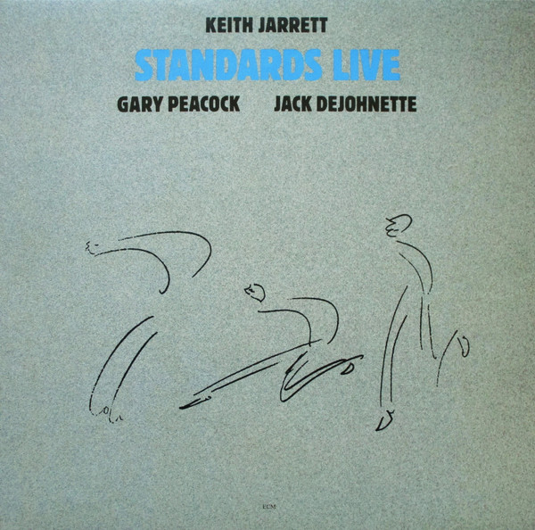

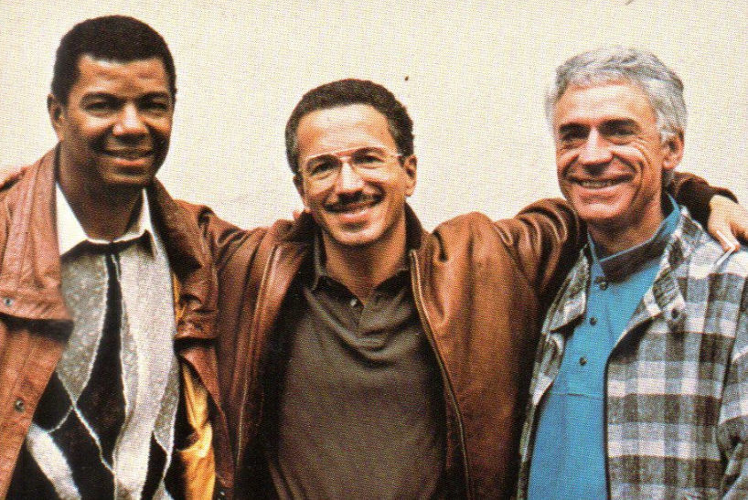

7. The Way You Look Tonight 3:23
Frank Sinatra-voc; Orchestra arranged and conducted by Nelson Riddle.
Los Angeles, January 27, 1964. LP: Reprise RS-5050.

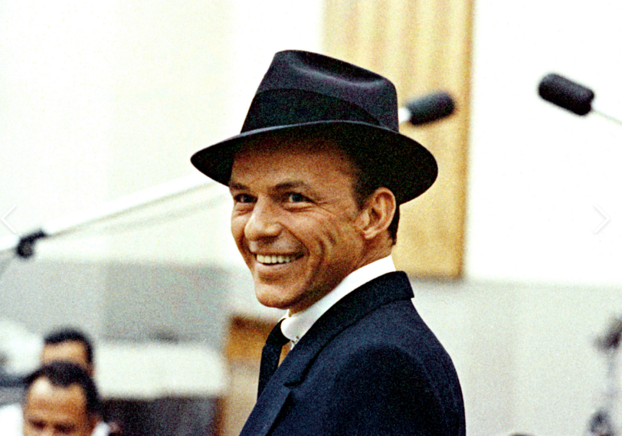
Frank Sinatra (1915 – 1998)

8. The Way You Look Tonight 4:02
Andy Williams-voc; Orchestra arranged and conducted by Robert Mersey.
Released 1962. LP Columbia CL 1879 / CS 8679.

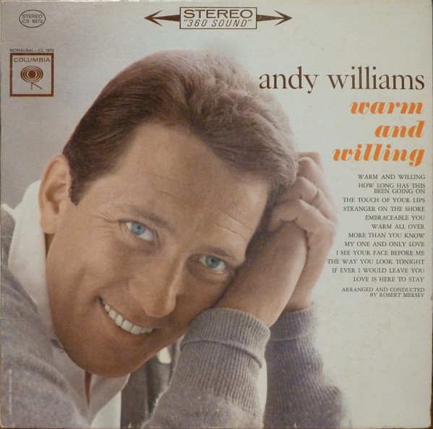
Andy Williams (1927 – 2012)

9. The Way You Look Tonight 3:23
Four Lads: Corrado “Connie” Codarini (1930-2010), John Bernard “Bernie” Toorish (*1931),
James F. “Jimmy” Arnold (1932-2004), Frank Busseri-voc; Claude Thornhill Orchestra, arranged
by Ray Ellis. Released 1956. LP: Columbia CL 912.

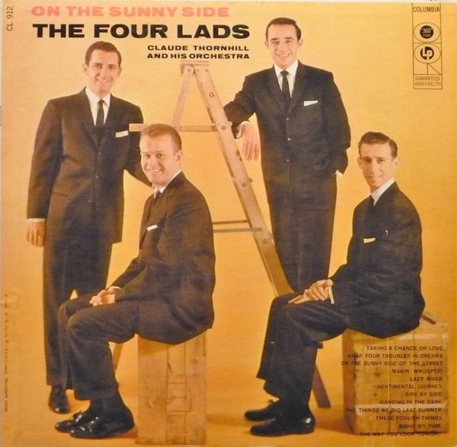

10. Smoke Gets in Your Eyes 3:57
Margaret Whiting-voc; Russell Garcia Orchestra. Los Angeles, January-February 1960.
LP: Verve MG V-4038-2 / VS-6142-2. CD: 559 553-2.

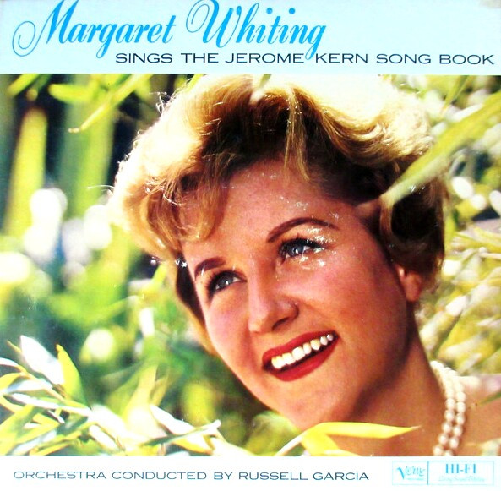
Margaret Whiting (1924 – 2011)

11. Smoke Gets in Your Eyes 2:36
Ray Conniff Orchestra and Choir. Released 1963. LP: Columbia CK 8950.

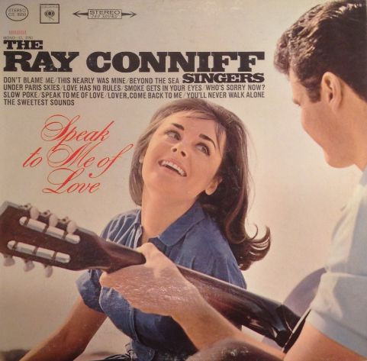

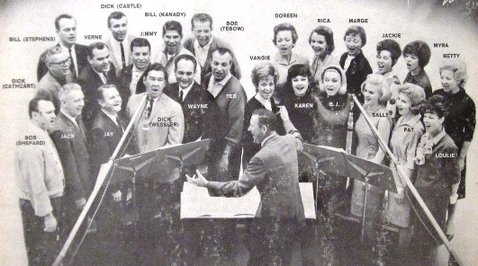

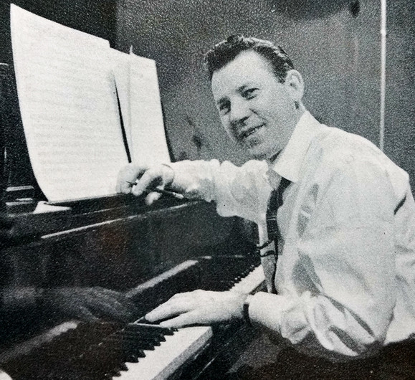
Ray Conniff (1916 – 2002)

12. Smoke Gets in Your Eyes 2:56
Nat King Cole Trio: Nat Cole-p; Oscar Moore-g; Johnny Miller-b. New York, October 30, 1946.
78: Capitol 10074. CD: Capitol Jazz CDP 7 98288 2.

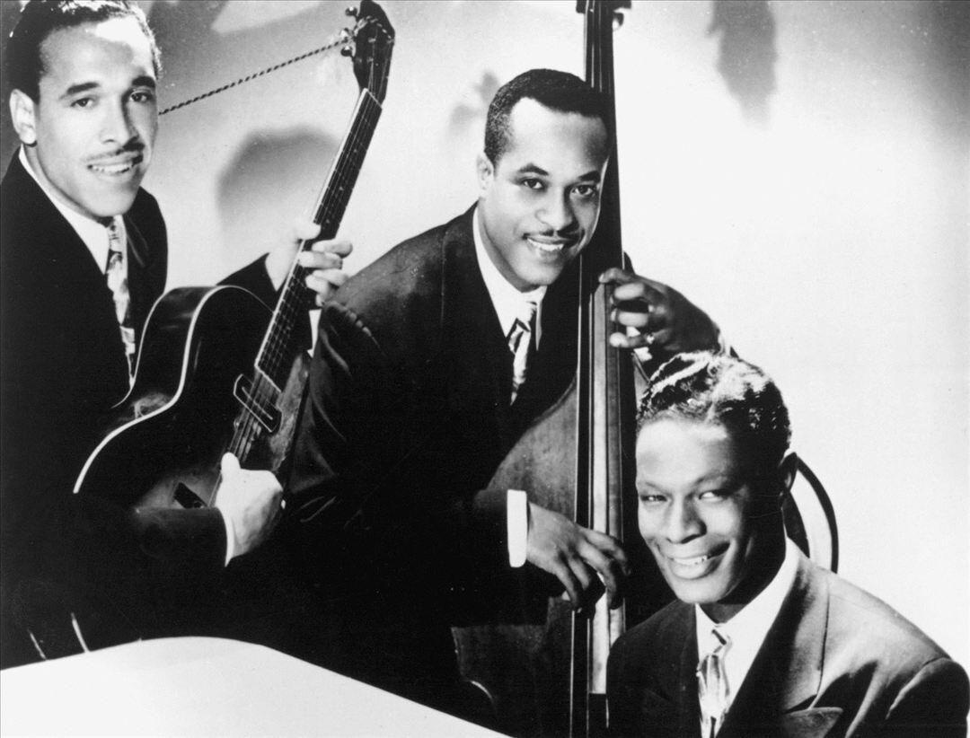

13. The Song Is You 2:00
Nancy Wilson-voc; Gerald Wilson Orchestra. Los Angeles, October 8 & 10, 1963.
LP: Capitol T 2012.

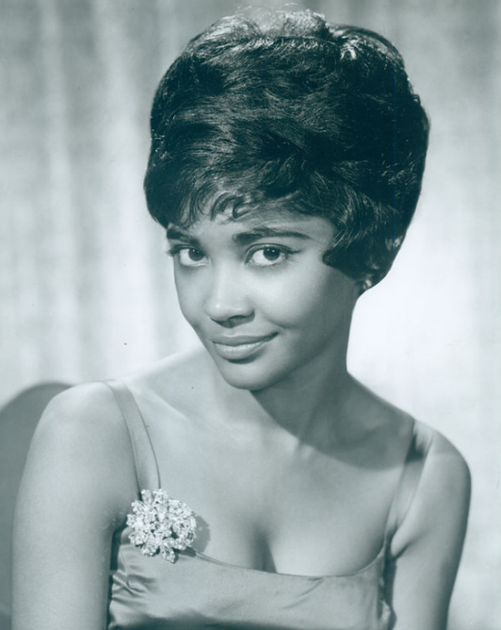

14. The Song Is You 3:22

Frank Sinatra-voc; Tommy Dorsey Orchestra. Hollywood, January 19, 1942. 78: Bluebird 11515.

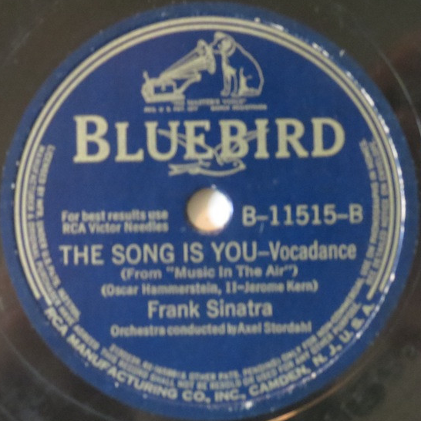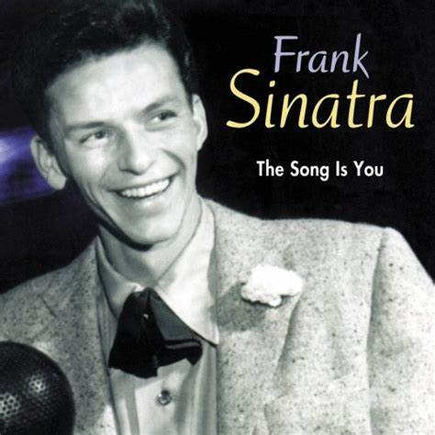

15. The Song Is You 3:49
Mel Tormé-voc; Rob McConnell and The Boss Brass. Toronto, Canada, May 1986.
LP: Concord Jazz CJ 306. CD: CCD-4306.

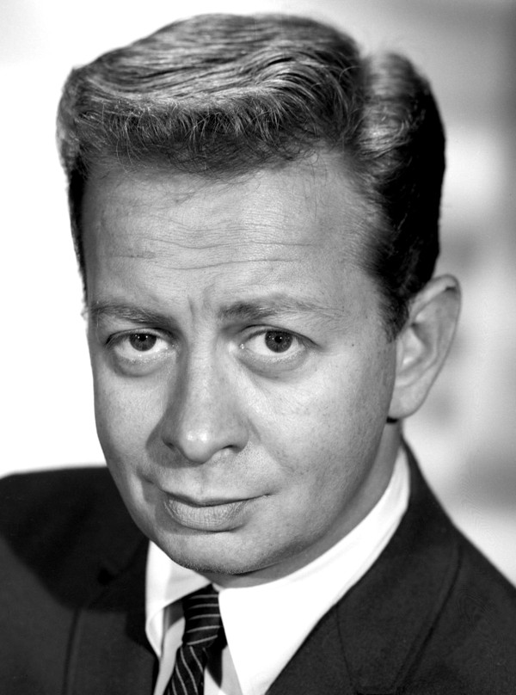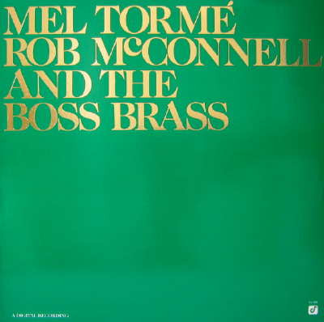
Mel Tormé (1925 – 1999)

16. I’m Old Fashioned 3:30
Ella Fitzgerald-voc; Nelson Riddle Orchestra. Los Angeles, January 6, 1963.
LP: Verve V6-4060. CD: Verve 0075021034754.

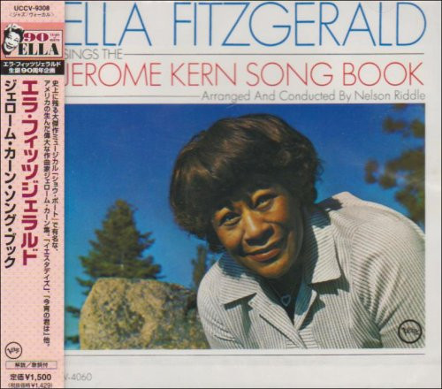
17. I’m Old Fashioned 3:06
Cassandra Wilson-voc; Mulgrew Miller-p; Lonnie Plaxico-b; Terri Lyne Carrington-dr.
New York, February 4 – 5, 1988. LP: JMT 834 419-1. CD: Verve 589 837-2.

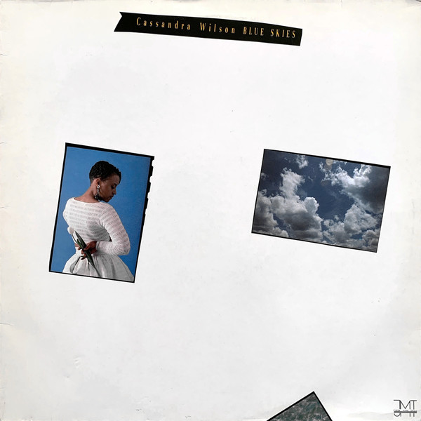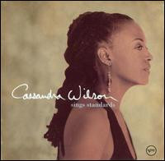
original 1988 LP compilation 2002 CD

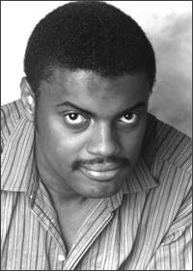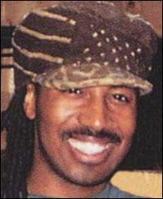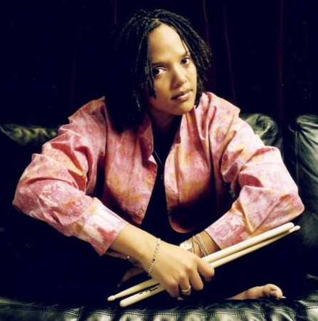
Mulgrew Miller (1955-2013) Lonnie Plaxico (* 1960) Terri Lyne Carrington (* 1965)

18. Long Ago and Far Away 2:50
Johnny Hartman-voc; Orchestra arranged and conducted by Rudy Traylor. New York, 1958.
LP: Roost SLP 2232. CD: CDP 7243 8 57456 2 1.

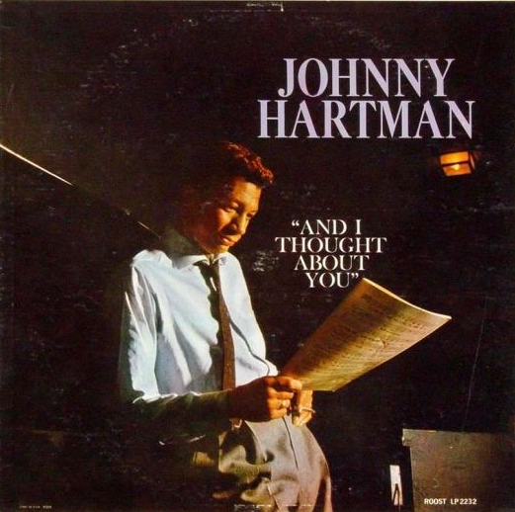

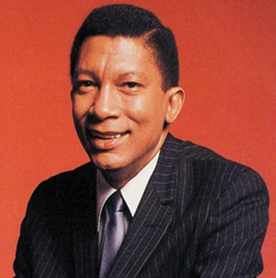
Johnny Hartman (1923 – 1983)

19. Long Ago and Far Away 2:28
The Hi/Lo’s:

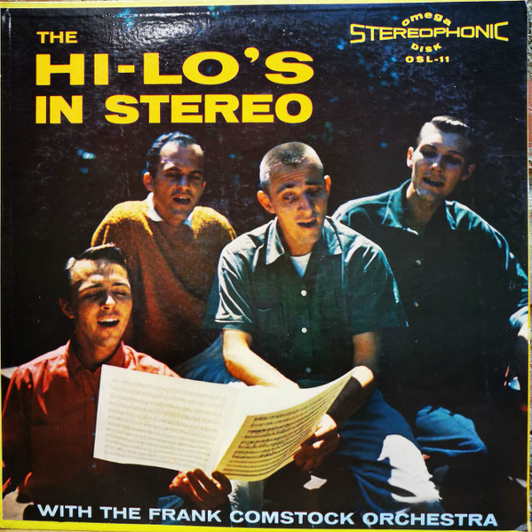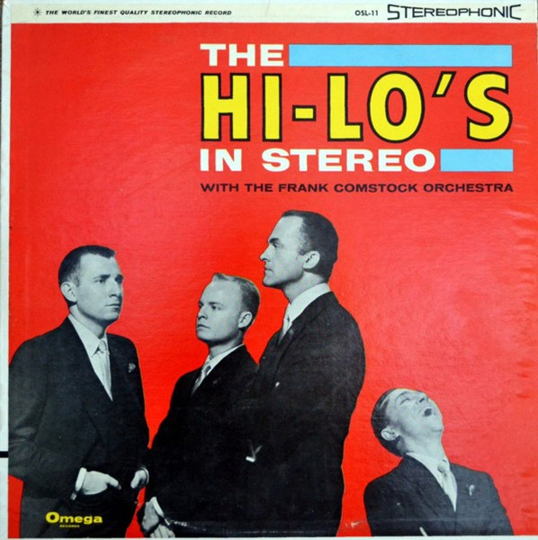

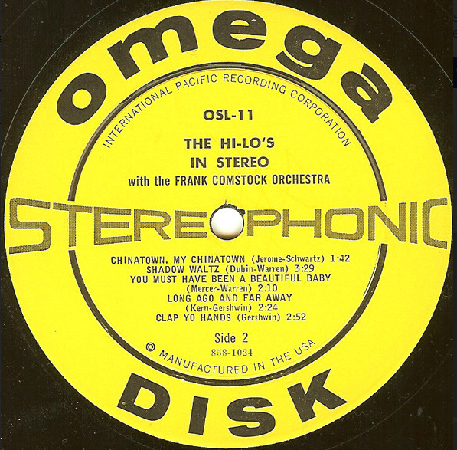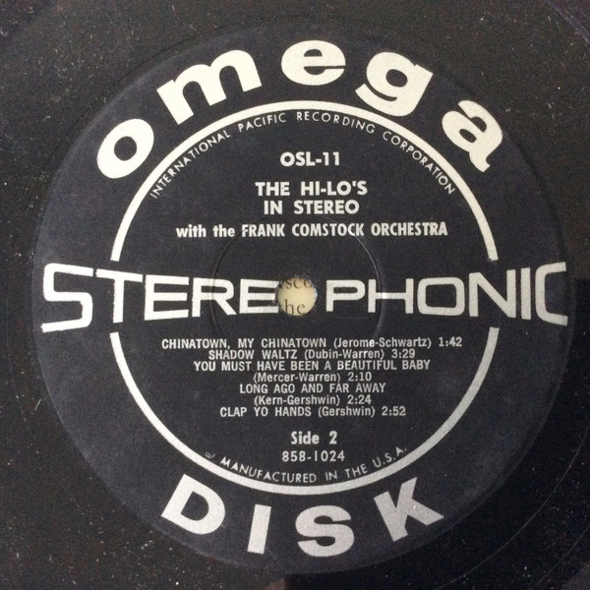

18. A Fine Romance 3:36
Ella Fitzgerald-voc; Nelson Riddle Orchestra. Los Angeles, January 5, 1963.
LP: Verve V6-4060. CD: Verve 0075021034754.

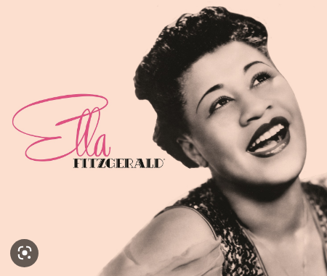

19. A Fine Romance 3:26
Stéphane Grappelli & Yehudi Menuhin-vio; Alan Clare-p; Ken Baldock-b; Tony Crombie-dr.
London, 1975.

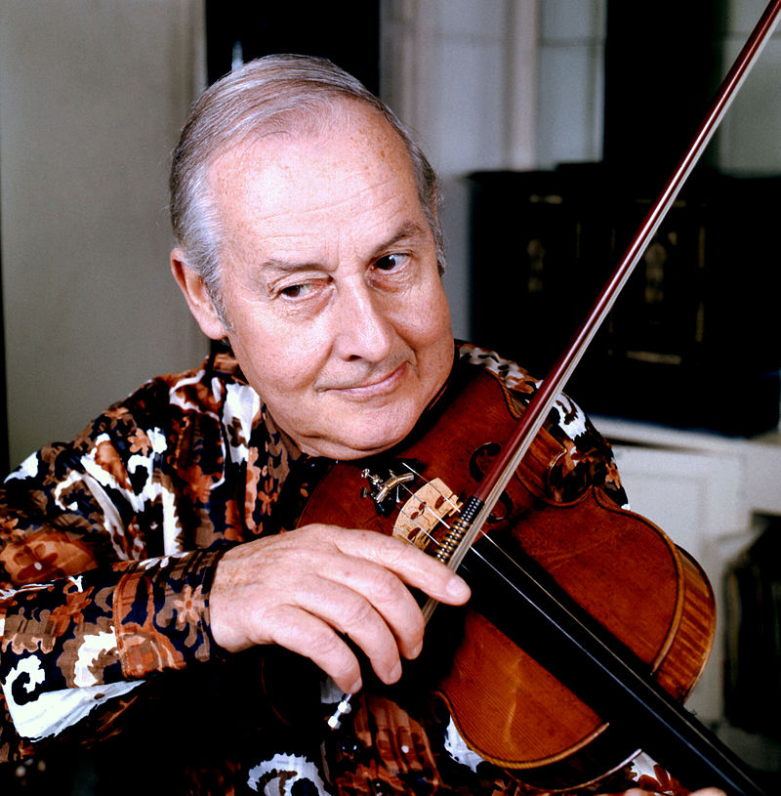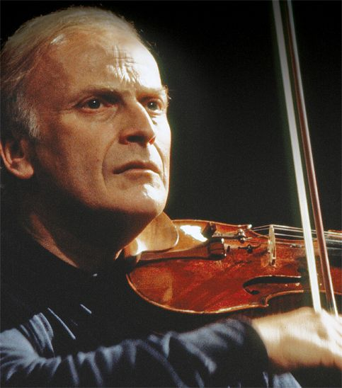
Stephane Grappelli (1908 – 1997) Yehudi Menuhin (1916 – 1999)

20. They Didn’t Believe Me 2:44
The Hi/Lo’s and All That Jazz / 24

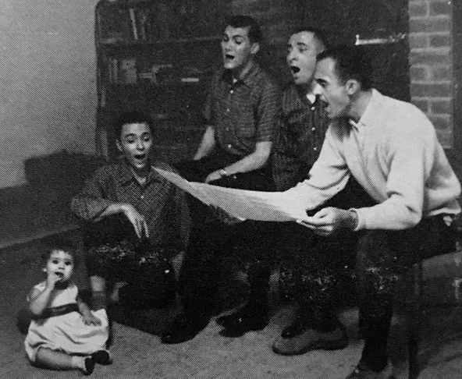

21. Pick Yourself Up
Grappelli-Menuhin 2:19

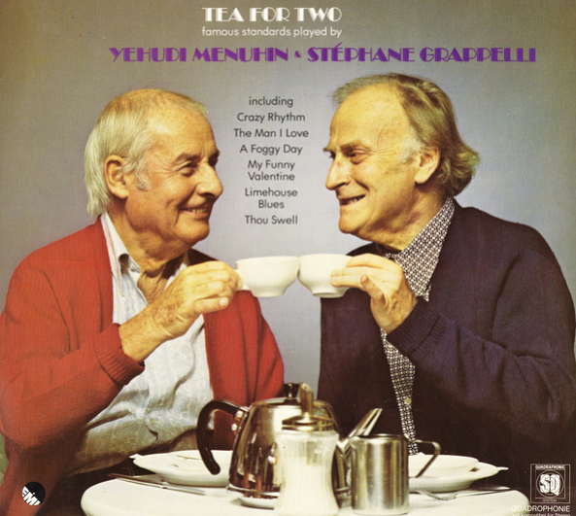

22. All the Things You Are 4:44
Gustav Brom Big Band, Matúš Jakabčic-arr . 1997 Opus.

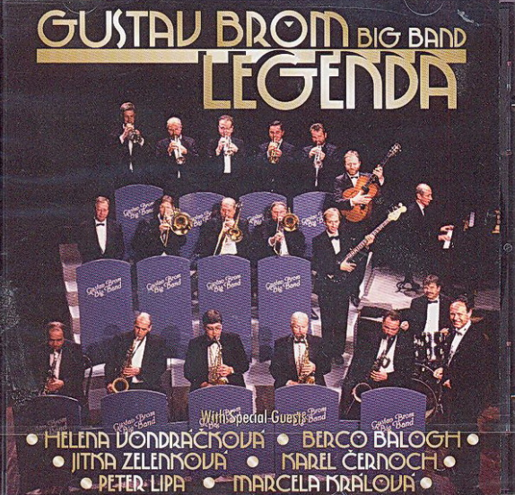

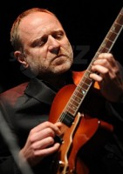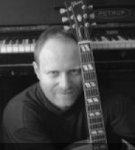
Matúš Jakabčic (* 1961)

