**Etymology map of Autumn / Fall:** What is VINTAGE?

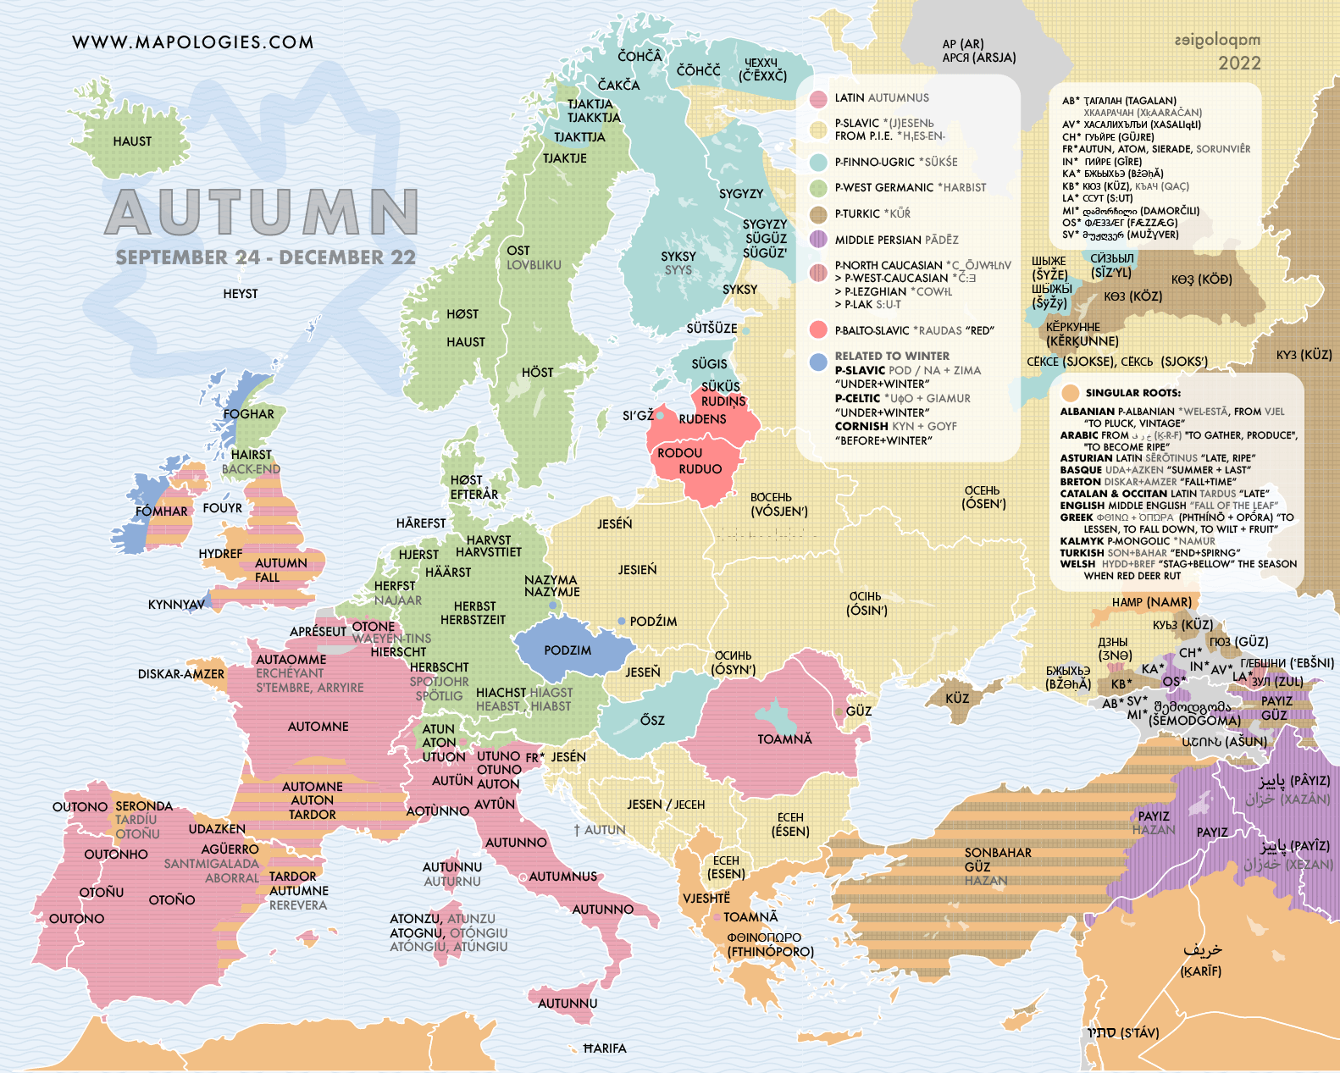

**Why is it a free day on Thursday?**

## St. Wenceslas Day in Czech Republic in 2023

## It is St. Wenceslas Day

This holiday is always celebrated on September 28th. It is the feast day of St. Wenceslas, the patron saint of Bohemia, and commemorates his death in 935.

Also known as 'Czech Statehood Day', it is a national holiday in the Czech Republic and has been a public holiday since 2000.