00a - JAZZ LEGENDS – THE SOUTH & THE BLUES 27 / 79:59

FOLKWAYS - LP 1 – THE SOUTH (FP 53 / 1950, FJ 2801 / 1958)

A1. Ol’ Hannah (Field Holler/Prison Work Song) (as Go Down Ol’ Hannah) 4:52
01 Doc Reese-voc (or Dock Reese; 1924 – 2012)
first issue unknown * LP Asch ASCH AA 3/4 (1967) Recorded by Moses Asch 1939-45
(Side 3 titled ART BALLAD SINGERS and FOLK BALLAD SINGERS)

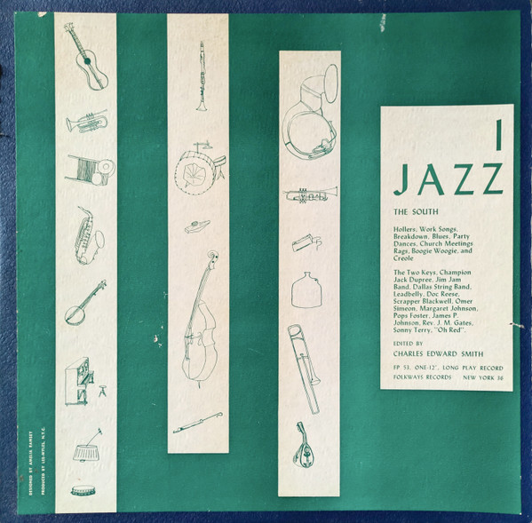

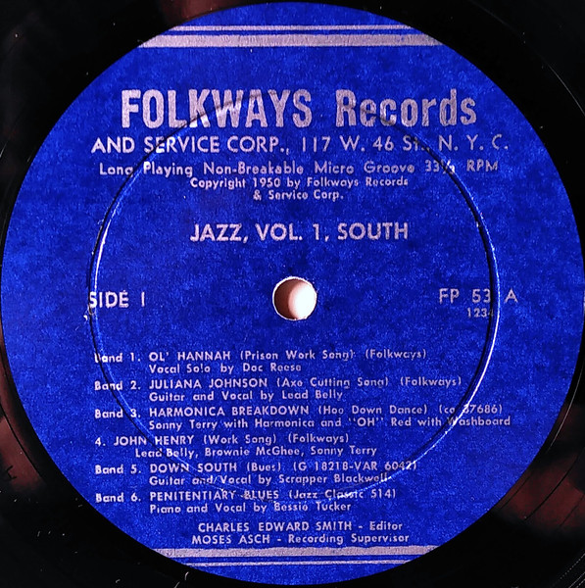

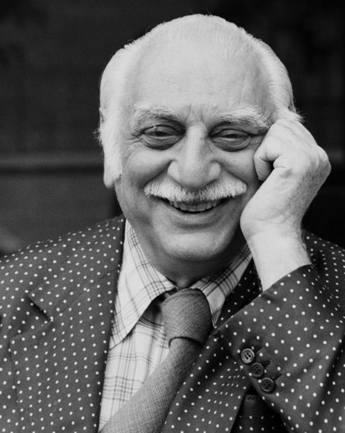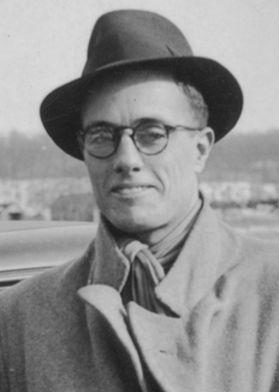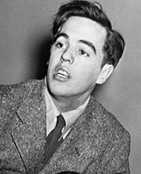
Moses Asch (1905-1986) John Lomax (1867-1948) Alan Lomax (1915-2002)

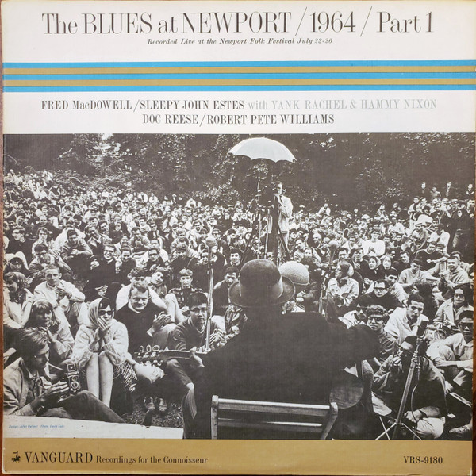

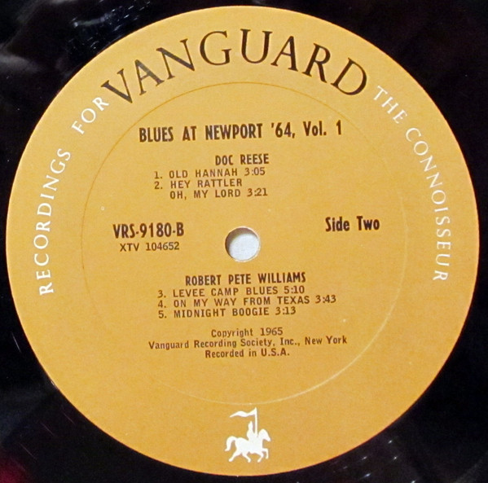

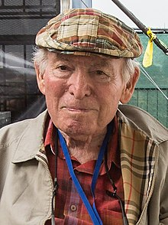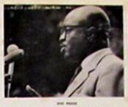
George Wein (1925-2021) ? Doc Reese (1924 – 2012)

A2. Juliana Johnson (Axe Cutting Song) 1:05
02 Huddie „Leadbelly“ Ledbetter-g, voc
1) Recorded by Moses Asch, place and date unlisted (May-October, 1944?)
Disc 660 (3 shellacs), record 1: Disc 3001-A / Sc 275 (released 1943)
2) Washington, DC, June 22, 1937 (as Julie Ann Johnson)
first issue unknown * LP Document DLP 608-B / 998-A-2

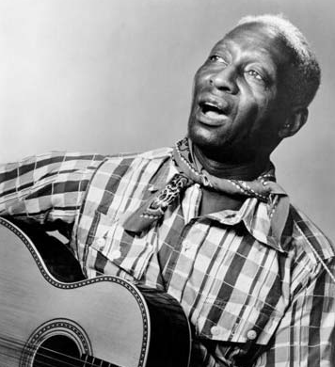

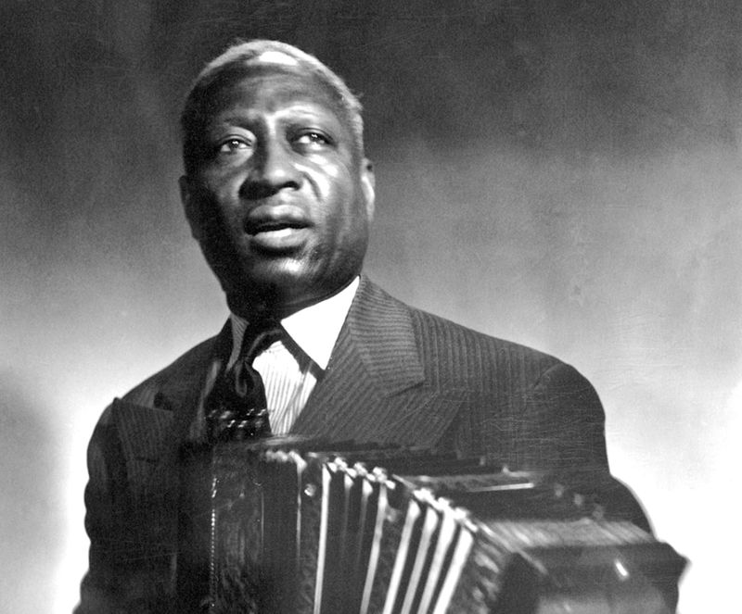
Leadbelly (aka Huddie Ledbetter) (1888 – 1949)

A3. Harmonica and Washboard Breakdown (Hoe Down Dance) 2:28
03 Sonny Terry-hca, „Oh“ Red (George Washington)- wb
New York City, March 5 (or 6?), 1940, recorded by Moses Asch
first issue Columbia 30064, 37686, OKeh 05538 / matrix number w26597A
* LP Document DLP 536 (1988), also Roots RL-321

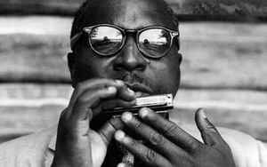
Sonny Terry (1911 – 1986)

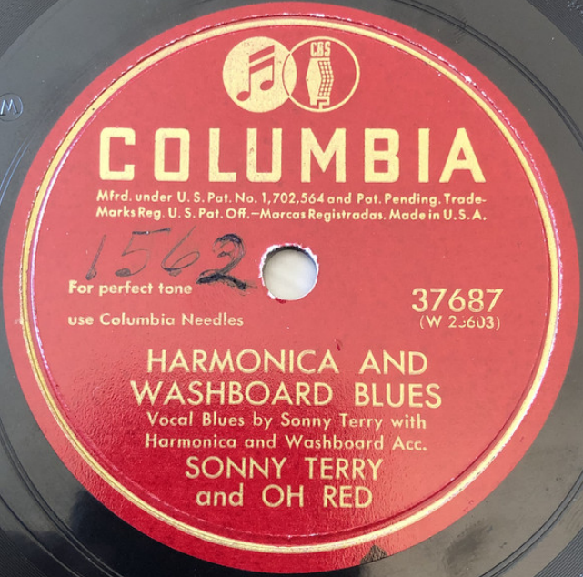

A4. John Henry (Work Song) 2:17
04 Leadbelly, Brownie McGhee, Sonny Terry
Recorded by Moses Asch, ca. 1941.

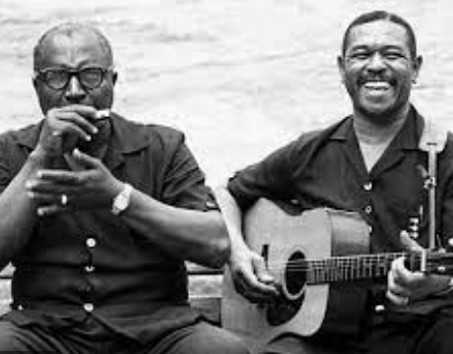

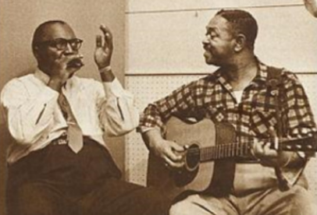
Sonny Terry & Brownie McGhee (1915 – 1996)

A5. Down South (Blues) 2:51
05 Scrapper Blackwell-g, voc
November 24, 1931, Richmond, Indiana
Varsity 6042 / USG-18218-D1, Champion 16452 /18218-… * CD Document Records ‎
DOCD-6029 (1992)

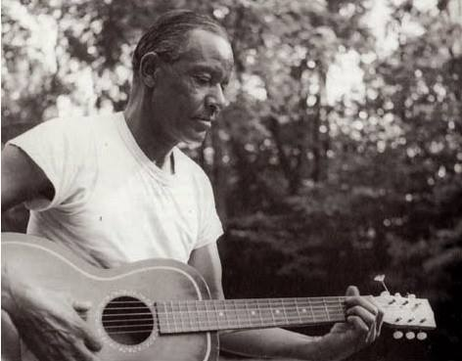

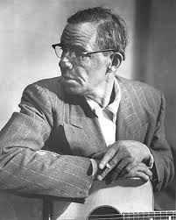
Scrapper Blackwell (1903 – 1962)

A6. Penitentiary Blues (Bessie Tucker) 3:10
06 Bessie Tucker-voc; K. D. Johnson-p.
Memphis, August 29, 1928
Victor 38526 / 45441-2 * Jazz Classics 514B, EP His Masters Voice 7EG 8085 (1955)

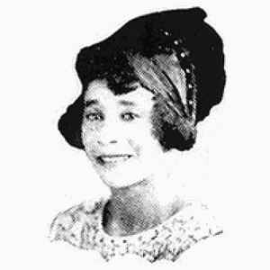

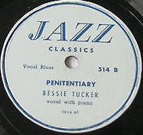
Bessie Tucker (c. 1906 – 1933)

B1. Dry Bones (in the Valley) (Negro Sermon) 3:34
07 Rev. J. M. Gates with Congregation
Chicago, December 1-2, 1926
Victor 35810 / 36480 * LP RST Records/Blue Documents BD-2104 [Rudolf Staeger, Wien],
CD Document DOCD-5442 (1996)

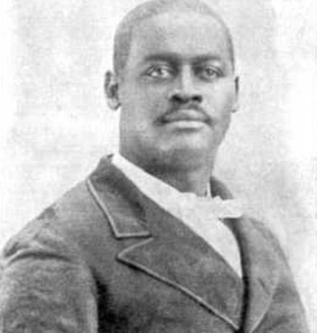

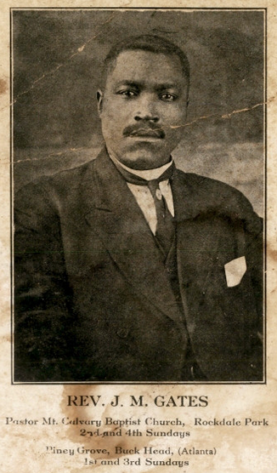
Reverend James M. Gates (1884 – 1945)

XY. When the Saints Go Marching In (Spiritual) 2:54
08 Wheat Street Female Quartet (personnel unknown; members of the Wheat St. Baptist Church)
Atlanta, GA, January 29, 1925
Columbia 14067 / 140298-1 * CD Document DOCD-5543 (1997)

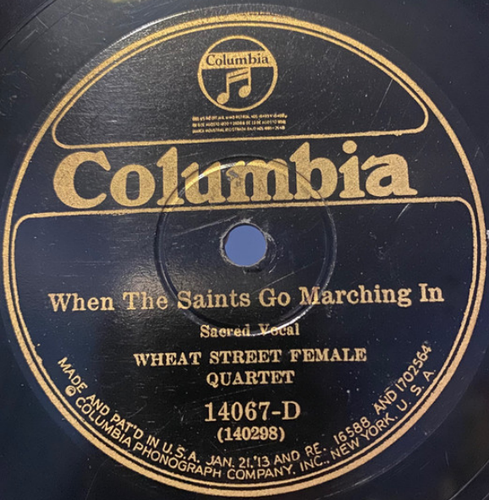

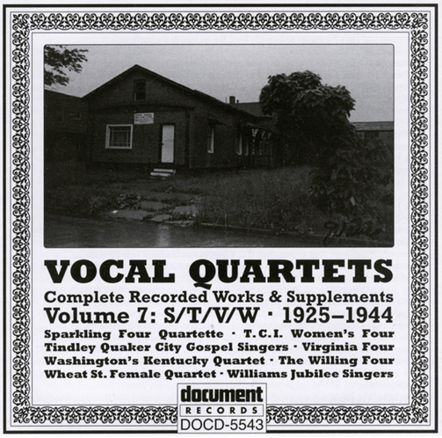

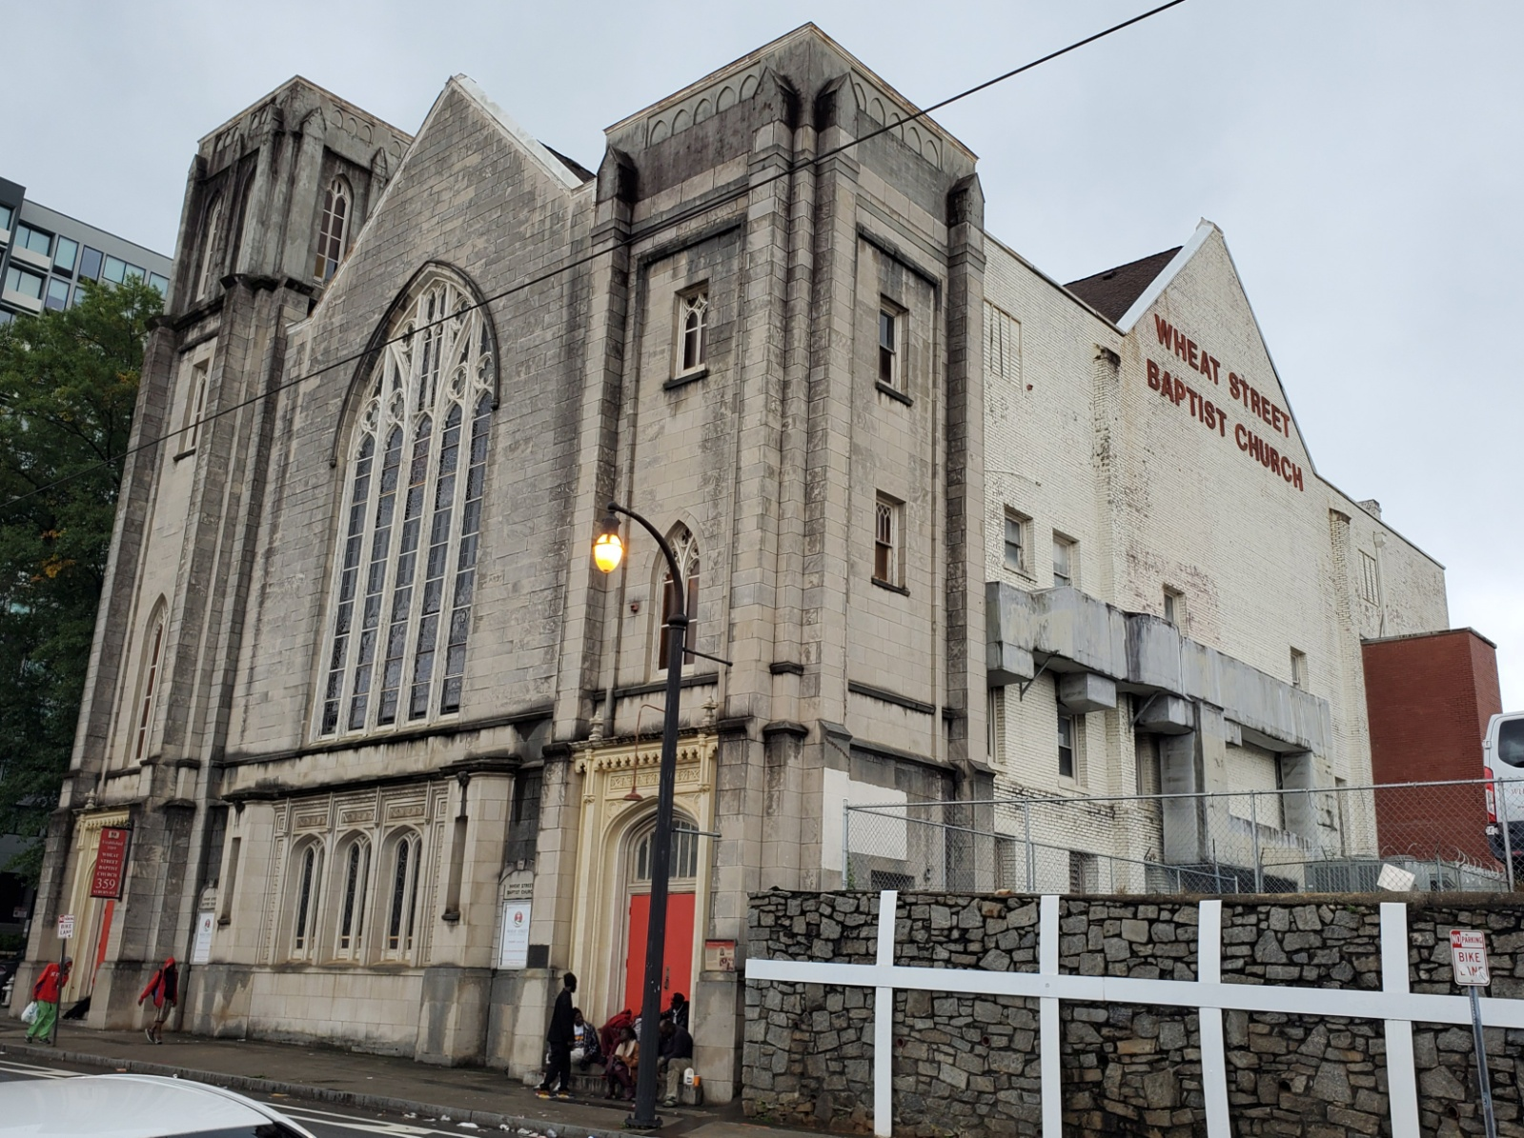
Wheat Street Baptist Church, Atlanta, GA (1869 / 1921)

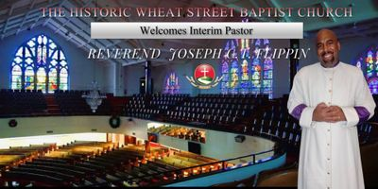

B2. I Can’t Feel at Home (in This World Any More) (Spiritual) 2:45
09 Two Gospel Keys: Mother Sally Jones-voc, tamb, Emma Daniels-voc, g
New York, late 1946
Recorded by Herb Abramson – Folkways FJ-2801 * CD Document DOCD-5221 (1993)

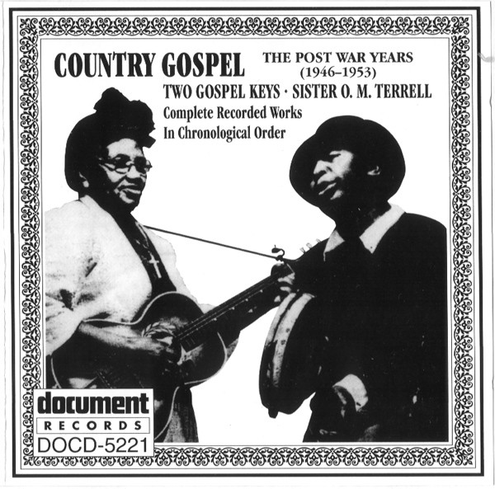

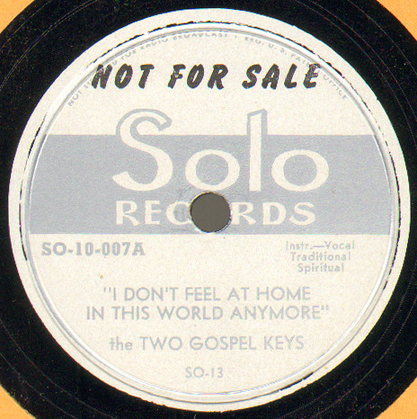

B3. Slow Boogie 2:19
10 Champion Jack Dupree-p, voc
Recorded by Moses Asch, 1943-44

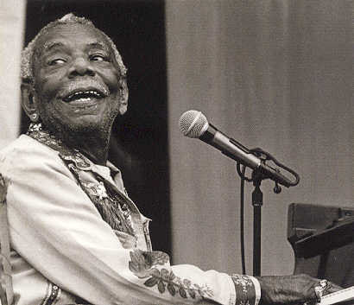

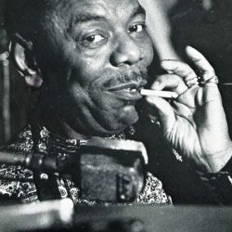
Champion Jack Dupree (1908/1910 – 1992)
Real Name: William Thomas Dupree

B4. 38 Slug 2:45
11 Jim Jam Band: unknown guitar, washboard, mandolin, kazoo, bones, vocals
matrix G 16266 VAR (test)

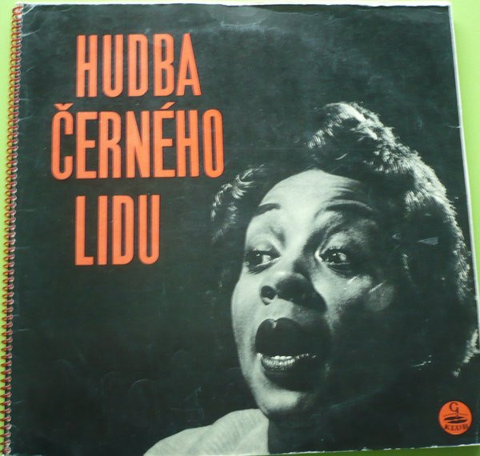

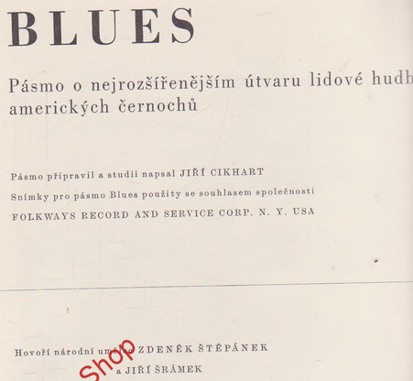

B5. Blues for Lorenzo [Lorenzo’s Blues] (Simeon-Foster) 2:29
12 Omer Simeon-cl, James P. Johnson-p, Pops Foster-b
New York, February 22, 1945
Disc Company of America/Tempo 6001 A / D 205 * CD Classics 1027

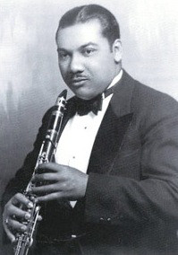
Omer Simeon (1902 – 1959)

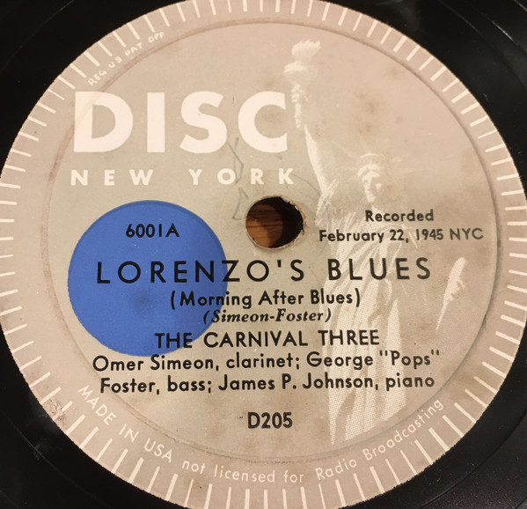
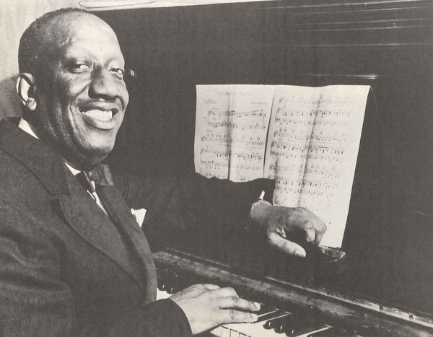
James P. Johnson (1894 – 1955)

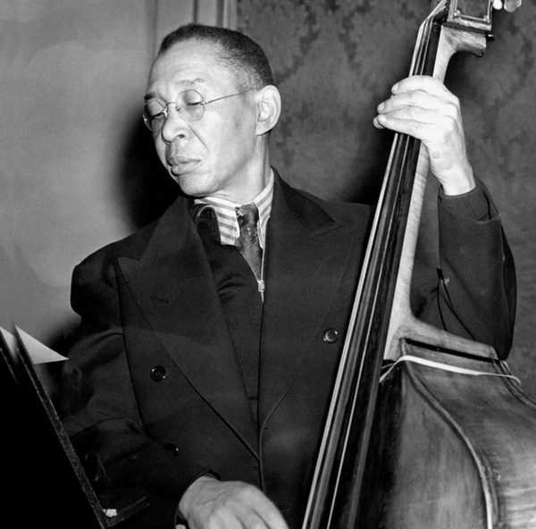
Pops Foster (1892 – 1969)

B6. Dallas Rag 2:48
13 Dallas String Band: Coley Jones-mandolin, voc; unknown-mandolin; ?Sam Harris-g; Marco
Washingon-b
Dallas, Tex., December 6, 1927
Columbia 14290-D / W145343 2-B-1 * LP Yazoo L-1045 (1974)

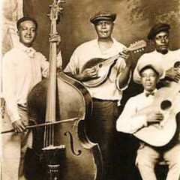

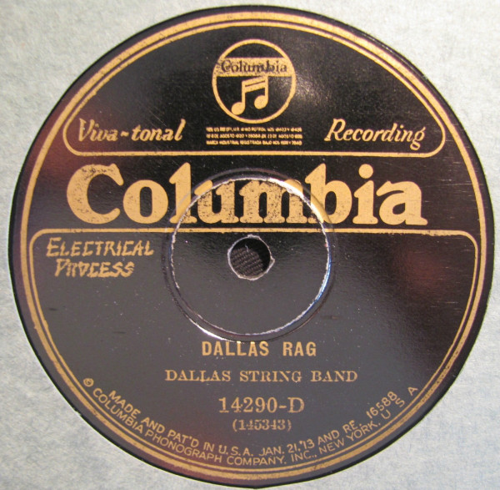

B7. When A’ Gator Hollers, Folks Say It’s a Sign of Rain (Sidney Easton) 2:45
14 Margaret Johnson-voc, with Black & Blue Trio: Tom Morris-co; Bob Fuller-cl; Mike Jackson-p
New York, October 20, 1926
Victor 20333AG / 36846-1 * LP RCA FPM1 7049 * CD Document DOCD-5436 (1996)

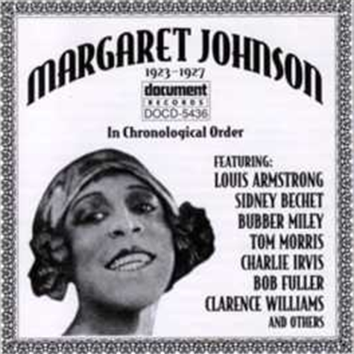
Margaret Johnson
Vaudeville blues singer, who recorded for OKeh and Victor 1923-1927.

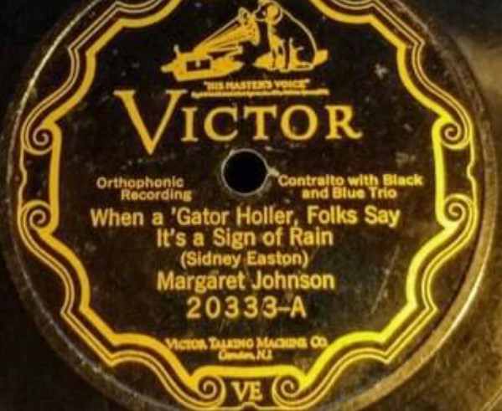

FOLKWAYS - LP 2 – THE BLUES (FP 55 / 1950, FJ 2802 / 1956)

A1. Dark Was the Night, Cold Was the Ground 3:16
15 Blind Willie Johnson-voc, g
Dallas, December 3, 1927
Columbia 14303-D, Vocalion 03095 / W 145320-1 * Jazz Classics 512

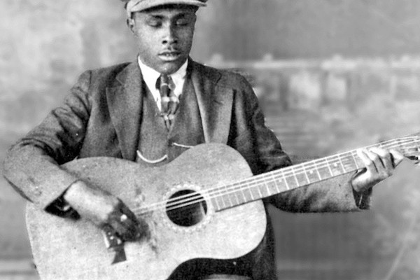
Blind Willie Johnson (1897 – 1945)

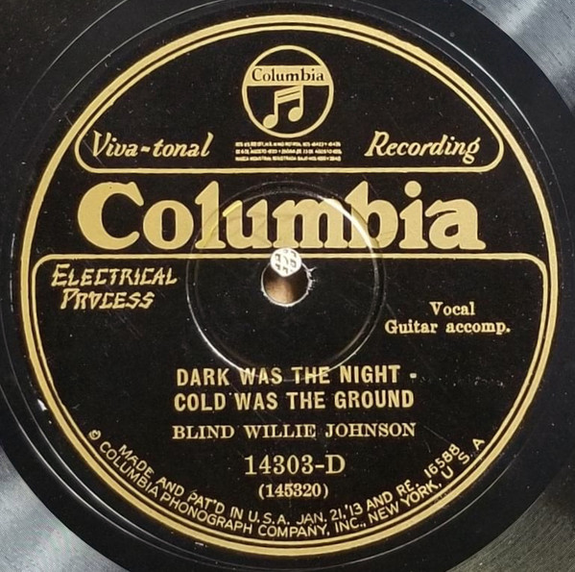

A2. Black Woman 1:22
16 Vera Hall-voc
Recorded 1948 by Frederic Ramsey Jr.

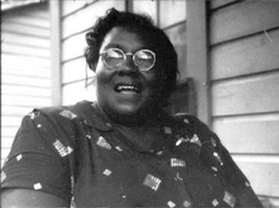
Vera Hall (1902 – 1964)
Real Name: Adele "Vera" Hall Ward

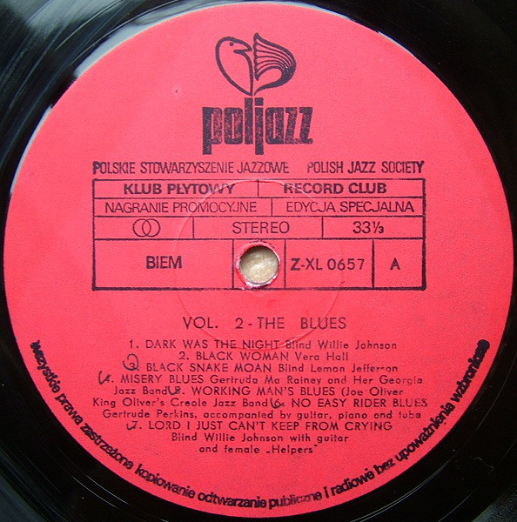

A3. Black Snake Moan (Jefferson) 2:48
17 Blind Lemon Jefferson-voc, g
Atlanta, GA, March 14, 1927 - Advertised in Chicago April 23, 1927
OKeh 8455-A / 80523-B * Jazz Classics 511A * CD Document DOCD-5018 (1991)

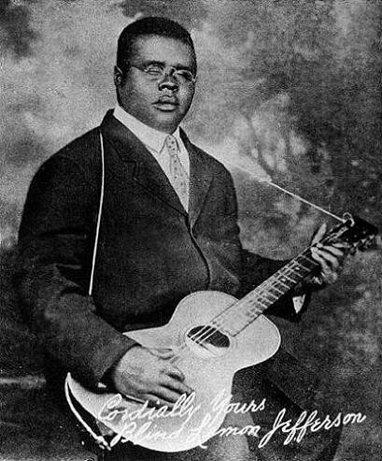
Blind Lemon Jefferson (1893 – 1929)

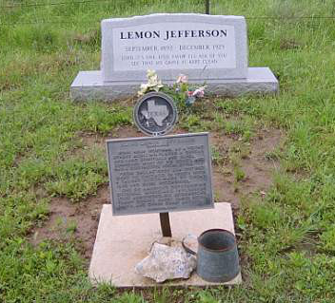

A4. Misery Blues (Gertrude Rainey) 2:35
18 Gertrude „Ma“ Rainey-voc, and Her Georgia Jazz Band: Shirley Clay-co; Kid Ory-tb;
?Hop Hopson-p; unknown-banjo and tuba.
Chicago, c. August 1927
Paramount 12508-B / 4707-1 * Jazz Classics L-52

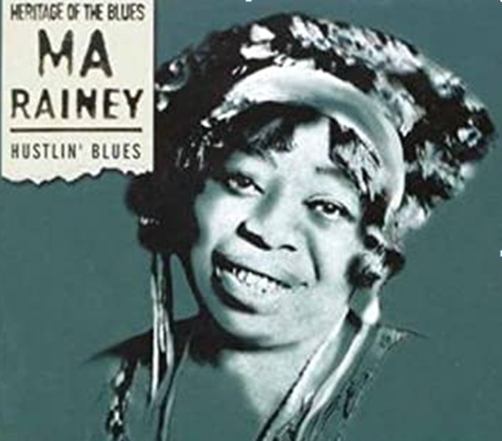
Gertrude „Ma“ Rainey (1886 GA – 1939)

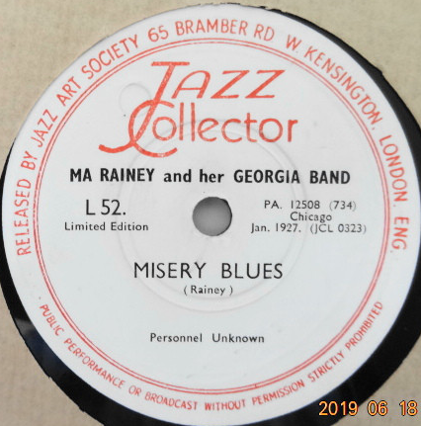

A5. Working Man’s Blues (Joe Oliver) 2:57
19 King Oliver’s Creole Jazz Band: Joe Oliver, Louis Armstrong-co; Honore Dutrey-tb;
Johnny Dodds-cl; Lil Armstrong-p; Johnny St. Cyr-bjo; Charlie Johnson-bass sax;
Baby Dodds-dr.
Chicago, c. October 26, 1923
OKeh 40034 / 8486-B * HJCA 7 * CD Masters of Jazz MJCD 2 (1991)

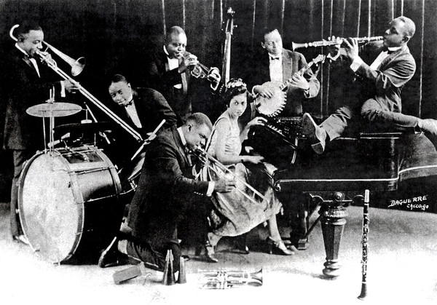
King Oliver’s Creole Jazz Band

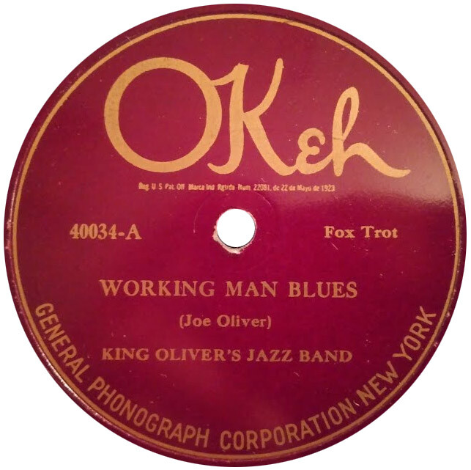

A6. No Easy Rider Blues (Burleson) 3:19
20 Gertrude Perkins-voc; Willie Tyson-p; unknown-g; Octave Gaspard-tu
Dallas, December 6, 1927
Columbia 14313-D / 145340-1

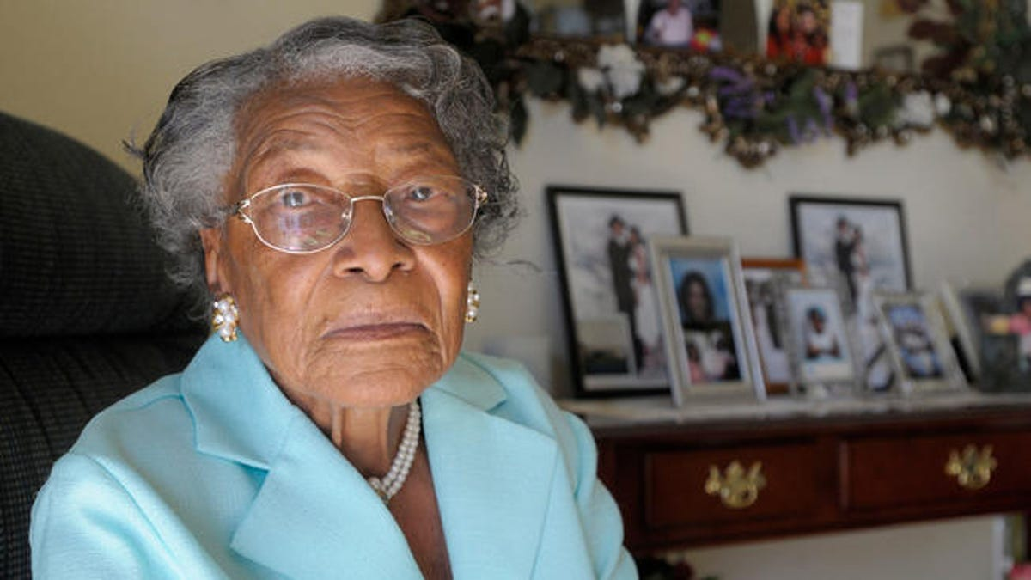
Rosa Parks, Recy Taylor and Gertrude Perkins Are Mothers of the Blues.
Blues singer, who recorded two titles for Columbia in Dallas, Texas, 1927.

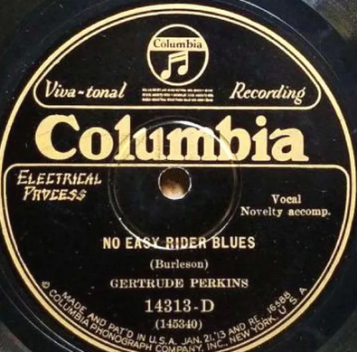

A7. Lord I Just Can’t Keep from Crying 3:00
21 Blind Willie Johnson-voc; with g & female „Helpers“
Dallas, December 5, 1928 - Released June 29, 1929
Columbia 14425-D / 147570 * CD Columbia 489892 2 (1998)

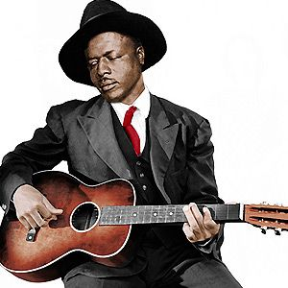
Blind Willie Johnson (1897 – 1945)

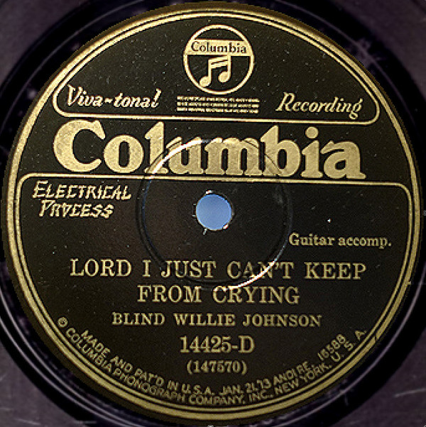

B1. How Long Blues (Ida Cox-Leroy Carr) 3:52
22 Jimmy Yancey-p solo
Chicago, December 1943
Session 12-003 / 117 * CD Document DOCD-5042 (2011)

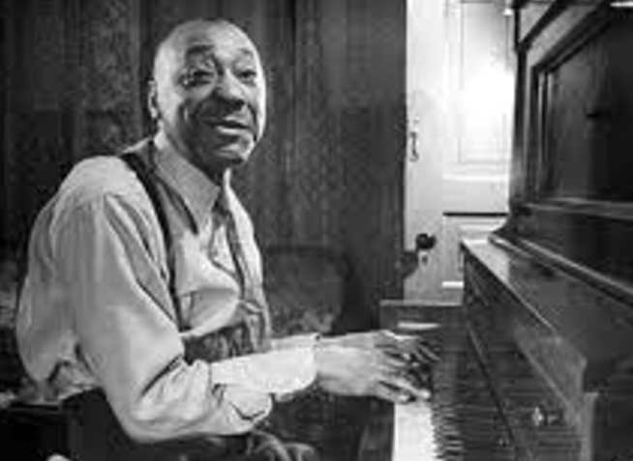
Jimmy Yancey (1898 – 1951)

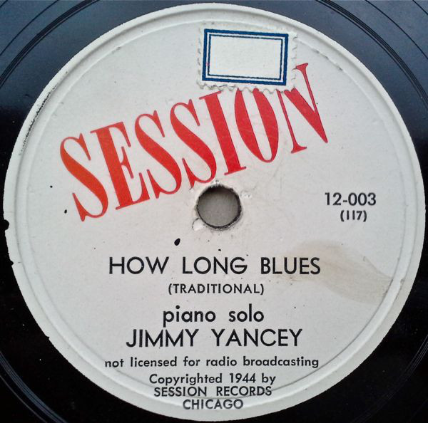

B2. Mr. Jelly Lord (Morton) 2:46
23 Jelly Roll Morton Trio: Morton-p; Johnny Dodds-cl; Baby Dodds-dr.
Oak Street Studio, Chicago, June 10, 1927
Victor 21064, Bluebird B 10258 / 38664-1

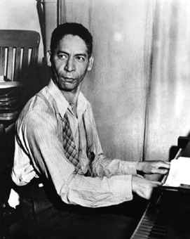
Jelly Roll Morton (1885/1890 – 1941)

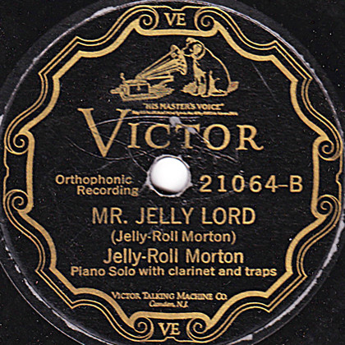

B3. Bridwell Blues (Welsh-Jones) 3:29
24 Nolan Welsh-voc; Louis Armstrong-co; Richard M. Jones-p
Chicago, June 16, 1926
OKeh 8372 / 9727-A * HJCA 36

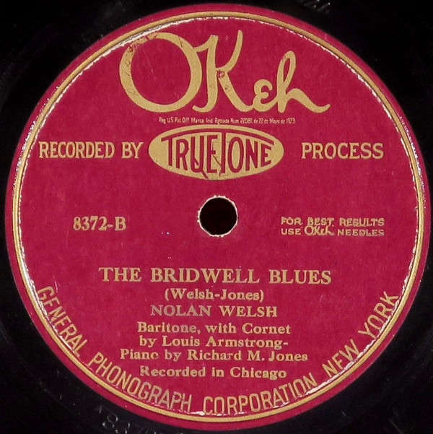
Nolan Welsh
Vocalist and pianist. He's mainly known to have recorded together with Louis Armstrong
"The Bridwell Blues" and the "St. Peter Blues" for Okeh on June 16, 1926.

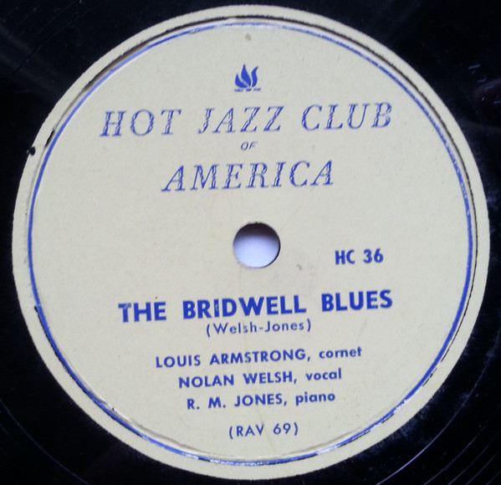

B4. Careless Love (W. C. Handy) 3:02
25 Original Tuxedo Jazz Orchestra: Oscar Celestin-co, dir; “Kid Shots” Madison-co; William
Ridgley-tb; Willard Thoumy-cl, as; unknown-ts; Manuel Manetta-p; John Marrero-bjo; Simon
Marrero-b; Abby Foster-dr, slide whistle
New Orleans, January 23, 1925
OKeh 8198 / 8907-A * Jazz Classics 510A

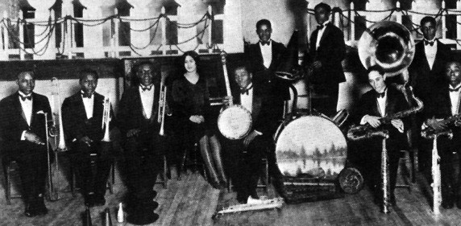
Original Tuxedo Jazz Orchestra

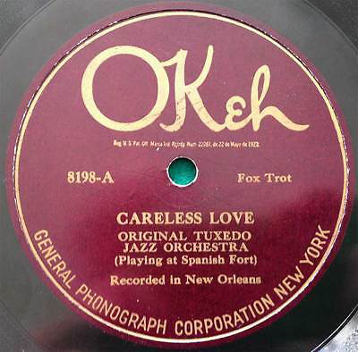

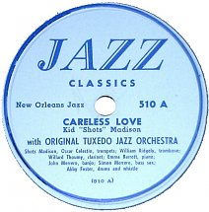

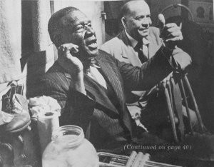
Oscar “Papa” Celestin (1884 – 1954)

B5. Mean Old Red Bug Blues (Leo Wood) 3:09
26 Bessie Smith-voc, Porter Grainger-p, Lincoln Conaway-g
New York, September 27, 1927
Columbia 14250-D / 144796-3

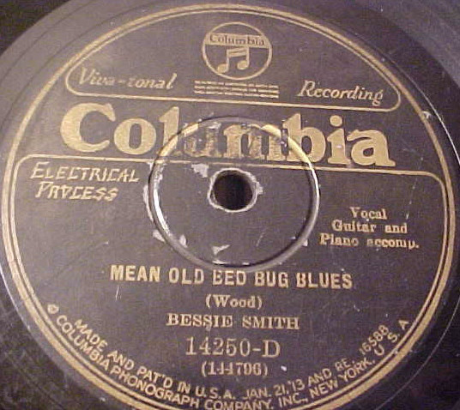

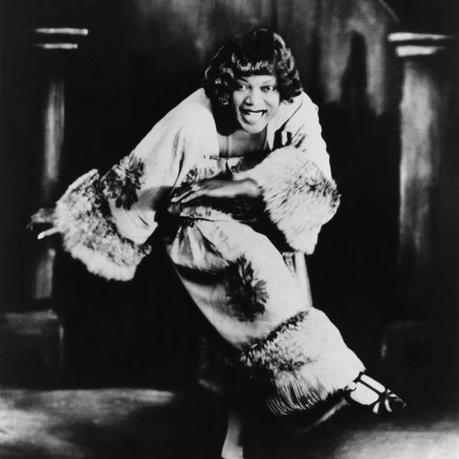
Bessie Smith - Empress of the Blues (1894 – 1937)

B6. I’m Not Rough (Armstrong) 2:54
27 Louis Armstrong and His Hot Five: Armstrong-voc, co; Kid Ory-tb; Johnny Dodds-cl; Lil
Armstrong-p; Johnny St. Cyr-bjo; Lonnie Johnson-g
Chicago, December 10, 1927
OKeh 8551 / 82040-B

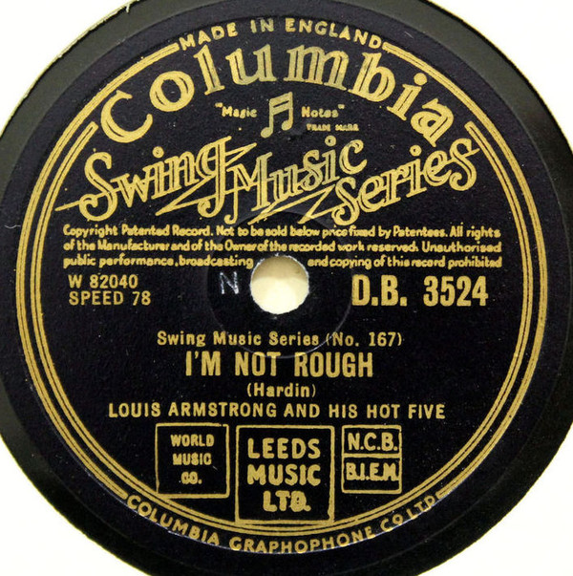

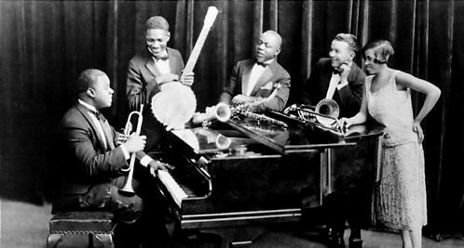
Total time 79:59
The first Hot Five sides, "Yes! I'm in the Barrel" composed by Armstrong, "My Heart" composed by Hardin Armstrong, and "Gut Bucket Blues" attributed to Armstrong, were recorded on November 12, 1925 with little rehearsal. The next session occurred on February 22, 1926…
The next highly successful session occurred in December 1927, producing the famous "Struttin' With Some Barbeque." In this session, Lonnie Johnson was added on guitar and vocals for the songs "I'm Not Rough," "Savoy Blues," and "Hotter Than That…"
In 1928, Armstrong revamped the recording band, replacing everyone but himself with members of the Carroll Dickerson Orchestra, in which Armstrong was playing: Fred Robinson on trombone, Jimmy Strong on clarinet and tenor saxophone, Earl Hines on piano, Mancy Carr (not "Cara" as has often been misprinted) on banjo, and Zutty Singleton on drums…
Thus, these sessions resulted in some of the most important masterpieces of early jazz, of which "West End Blues" (June 8, 1928) is arguably the best known. Other important recordings include "Basin Street Blues", "Tight Like This", "Saint James Infirmary", and "Weather Bird" (December 5, 1928). In the last named, only Armstrong and Hines are present, turning an old rag number into a tour-de-force duet.

