08+ COOL JAZZ 1+2 foto

1. Rhapsody in Blue (George Gershwin) 3:01
Glenn Miller Orchestra: Dále „Mickey“ McMickle, Steve Lipkins, John Best, Billy May-tp; Glenn
Miller, Paul Tanner, Jimmy Priddy, Frank D’Annolfo-tb; Skippy Martin-as; Wilbur Schwartz-cl, as;
Ernie Caceres-cl, as, bs; Tex Beneke, Al Klink-ts; Chummy MacGregor-p; Bobby Hackett-g, tp;
Bill Conway-g; Doc Goldberg-b; Maurice Purtill-dr; Bill Finegan-arr.
Chicago, July 16, 1942
first issue Victor 20-1529 / matrix number 074748-1 * CD RCA ND90600B (1991)

2. Minor Walk (Linton Garner-Dizzy Gillespie) 2:44
Dizzy Gillespie Orchestra: Dizzy Gillespie, Dave Burns, Elmon Wright, Benny Bailey, Lammar
Wright-tp; William Shepherd, Ted Kelly-tb; Howard Johnson, John Brown-as+ Joe Gayles,
George „Big Nick“ Nicholas-ts; Cecil Payne-bs; John Lewis-p; Al McKibbon-b; Kenny Clarke-
dr; Chano Pozo-bgo, cga; Linton Garner-arr.
New York, December 30, 1947
Victor 20-3186 / D7VB3094-1 * CD RCA 07863 66258 2 (1995)

3. Snowfall (Claude Thornhill) 2:37
Claude Thornhill Orchestra: probably Ed Zandy, Emil Terry, Louis Mucci-tp; Tak
Takvorian, Allan Langstaff-tb; Walt Weschler, Sandy Siegelstein-Frh; Danny Polo-cl, as; Lee
Konitz-as; Mickey Folus-ts, cl, bs; Mario Rollo-ts; Bill Bushey-bs; Claude Thornhill-p, arr;
Joe Shulman-b; Billy Exiner-dr.
New York City, September 25, 1947
Design DLP 50 * CD Hep 60 (1999)

4. Godchild (George Wallington) 3:11
Claude Thornhill Orchestra: Johnny Napton, Johnny Carisi, Gene Roland-tp; Allan Langstaff,
Leon Cox-tb; Al Antonucci, Addison „Junior“ Collins-Frh; Danny Polo-cl, as; Lee Konitz-as;
Milton „Brew“ Moore, Mario „Jet“ Rollo-ts; Gerry Mulligan-ts, bs, arr; Claude Thornhill-p;
Joe Shulman-b; Bill Exiner-dr.
New York, October 1948
CD Hep 17 / D9MM 2443 (1994 – previously unreleased radio transcription)

5. Godchild (George Wallington) 5:51
Miles Davis Nonet: Miles Davis-tp; Mike Zwerin-tb; Junior Collins-Frh; Bill Barber-tu; Lee
Konitz-as; Gerry Mulligan-bs, arr; John Lewis-p; Al McKibbon-b; Max Roach-dr.
Live from Royal Roost, New York, September 4, 1948
LP Ozone 2 * CD Capitol 7243 4 94550 2 3 (1998)

6. Godchild (George Wallington) 3:10
Miles Davis Nonet: Miles Davis-tp; Kai Winding-tb; Junior Collins-Frh; Bill Barber-tu; Lee
Konitz-as; Gerry Mulligan-bs, arr; Al Haig-p; Joe Shulman-b; Max Roach-dr.
New York, January 21, 1949
Capitol 57-60005 / 3397-2E * CD Capitol 7243 4 94550 2 3 (1998)

7. Woody Herman introduces the Word premiere of Ebony Concerto by Igor Stravinsky 0:37
8. Ebony Concerto (Part III) (Igor Stravinsky) 4:00
Woody Herman Orchestra: Sonny Berman, Pete Candoli, Conrad Gozzo, Marky Markowitz,
Shorty Rogers-tp; Bill Harris, Ed Kiefer, Ralph Pfeffner-tb; Woody Herman-cl; John LaPorta,
Sam Marowitz-as; Mickey Folus, Flip Phillips-ts; Sam Rubinowitch-bcl; Red Norvo-vib; Tony
Aless-p; Billy Bauer-g; Chubby Jackson-b; Don Lamond-dr; Guests: John Barrows-Frh; Abe
Rosen-harp; Walter Hendl-cond.
Live at Carnegie Hall, New York, March 25, 1946
previously unreleased * CD Verve 559 833-2 (1999)

9. Four Brothers (Jimmy Giuffre) 3:22
Woody Herman Second Herd: Shorty Rogers, Ernie Royal, Stan Fishelson, Bernie Glow,
Markie Markowitz-tp; Earl Swope, Ollie Wilson-tb; Bob Swift-btb; W.H.-cl,as; Sam
Marowitz-as; Herbie Steward-as,ts; Stan Getz, Zoot Sims-ts; Serge Chaloff-bs; Fred Otis-p;
Gene Sargent-g; Walt Yoder-b; Don Lamond-dr.
Los Angeles, December 24, 1947.
Columbia 38304 / HCO 3061 * CD Properbox 15 (????)

10. Early Autumn (Ralph Burns) 3:13
Woody Herman Orchestra: Ernie Royal, Bernie Glow, Stan Fishelson, Red Rodney, Shorty
Rogers-tp; Earl Swope, Bill Harris, Ollie Wilson, Bob Swift-tb; Woody Herman-cl, as;
Sam Marowitz-as; Al Cohn, Zoot Sims, Stan Getz-ts; Serge Chaloff-bs; Lou Levy-p; Terry
Gibbs-vib; Chubby Jackson-b; Don Lamond-dr; Ralph Burns-arr.
Los Angeles, December 30, 1948
Capitol 57-616 / 3831-2 * CD Properbox 15 (????)

11. Gone with the Wind (Herb Magidson Allie Wrubel) 2:57
Stan Getz Quartet: Stan Getz-ts; Al Haig-p; Tommy Potter-b; Roy Haynes-dr.
New York, May 17, 1950
Roost 516 / R 01030 * CD Roulette CDP 7 98144 2 (1991)

12. September in the Rain (Harry Warren) 3:16
George Shearing Quintet: George Shearing-p; Marjorie Hyams-vib; Chuck Wayne-g; John
Levy-b; Denzil Best-dr.
New York, February 17, 1949
MGM 10426 / 49S86 * CD Concord Jazz CCD2-2211-2(2004)

13. Lullaby of Birdland (George Shearing) 2:44
George Shearing Quintet: George Shearing-p; Joe Roland-vib; Dick Garcia-g; Al McKibbon-b;
Marquis Foster-dr.
New York, July 17, 1952
MGM 11354 / 52S278-A * CD Concord Jazz CCD2-2211-2 (2004)

14. Libra (Mary Lou Williams) 2:49
Mary Lou Williams-p solo.
New York, June 29, 1945
Asch 621-1 / zo9 * LP Folkways FJ 2809

15. On a Planet (Lennie Tristano) 3:22
Lennie Tristano Trio: Lennie Tristano-p; Billy Bauer-g; John Levy-b.
New York, October 23, 1947
Savoy MG 12043 / T 1392 * LP BYG 529607 (????)

16. G Minor Complex (Lennie Tristano) 3:54
Lennie Tristano-p solo. New York, autumn 1961
LP Atlantic 1357 / no matrix

Music for alto saxophone and strings (Bill Russo)
17. Part 1 4:29
18. Part 2 2:56
19. Part 3 2:38
Lee Konitz with Strings: Lee Konitz-as; string quartet (Gene Orloff and another-vio; unknown-
vla; Alan Shulman-vcl); Billy Bauer-g; Bill Russo-arr, cond.
New York, February 6, 1958
Verve MGV 8286 / 21920-1-2-3 * CD Verve 527 780-2 (96)

20. Darn That Dream (Jimmy Van Heusen) 1:55
Lee Konitz-Jimmy Giuffre Quintet: Lee Konitz, Hal McKusick-as; Ted Brown, Warne
Marsh-ts; Jimmy Giuffre-bs, arr.
New York, May 12 – 13, 1959
Verve MGV 8335 / 22837-28 * CD Verve 527 780-2 (96)

Ambiance (Marian McPartland)
Marian McPartland Trio: Marian McPartland-p; Michael Moore-b; Jimmy Madison-dr.
New York, July 1970
LP Halcyon HAL 103

21. Ambiance (Marian McPartland) 4:11
Marian McPartland Trio: Marian McPartland-p; Christian McBride-b; Jack DeJohnette-dr.
PBS Radio Broadcast, "Piano Jazz", New York, December 11, 1992
CD Jazz Alliance TJA-12018

22. Ambiance (Marian McPartland) 7:27
Thad Jones-Mel Lewis Jazz Orchestra: Thad Jones-fh, cond; Jim Bossy, Cecil Bridgewater,
Jon Faddis, Steve Furtado-tp; Billy Campbell, Quentin Jackson, Jimmy Knepper-tb; Cliff
Heather-btb; Jerry Dodgion-fl, ss, as; Ed Xiques-fl, cl, ss, as; Billy Harper-fl, ts; Ron
Bridgewater-cl, ts; Pepper Adams-b; Sir Roland Hanna-p; Buddy Lucas-hca, jawharp; George
Mraz-b; Mel Lewis-dr.
Philadelphia, June 1974
LP Philadelphia International X-598

23. Strýček (Karel Velebný) 3:41
Studio 5: Karel Velebný-vib; Vladimír Tomek-g; Luděk Hulan-b; Ivan Dominák-dr.
Studio Strahov, Praha, January 4, 1961
Supraphon DM 10107 * CD Indies Happy Trails MAM728-2 (2016)

23 / 79:19

mimo soutěž

Vendome (John Lewis) 3:14
Modern Jazz Quartet: Milt Jackson-vib; John Lewis-p; Percy Heath-b; Kenny Clarke-dr.
New York, December 22, 1952
Prestige 851 / 405 * CD Prestige 7711-2 (1984)

JAMU 2019-2 COOL JAZZ

S W I N G
1. Rhapsody in Blue (George Gershwin) 3:01
Glenn Miller Orchestra: Dále „Mickey“ McMickle, Steve Lipkins, John Best, Billy May-tp; Glenn
Miller, Paul Tanner, Jimmy Priddy, Frank D’Annolfo-tb; Skippy Martin-as; Wilbur Schwartz-cl, as;
Ernie Caceres-cl, as, bs; Tex Beneke, Al Klink-ts; Chummy MacGregor-p; Bobby Hackett-g, tp;
Bill Conway-g; Doc Goldberg-b; Maurice Purtill-dr; Bill Finegan-arr.
Chicago, July 16, 1942
first issue Victor 20-1529 / matrix number 074748-1 * CD RCA ND90600B (1991)

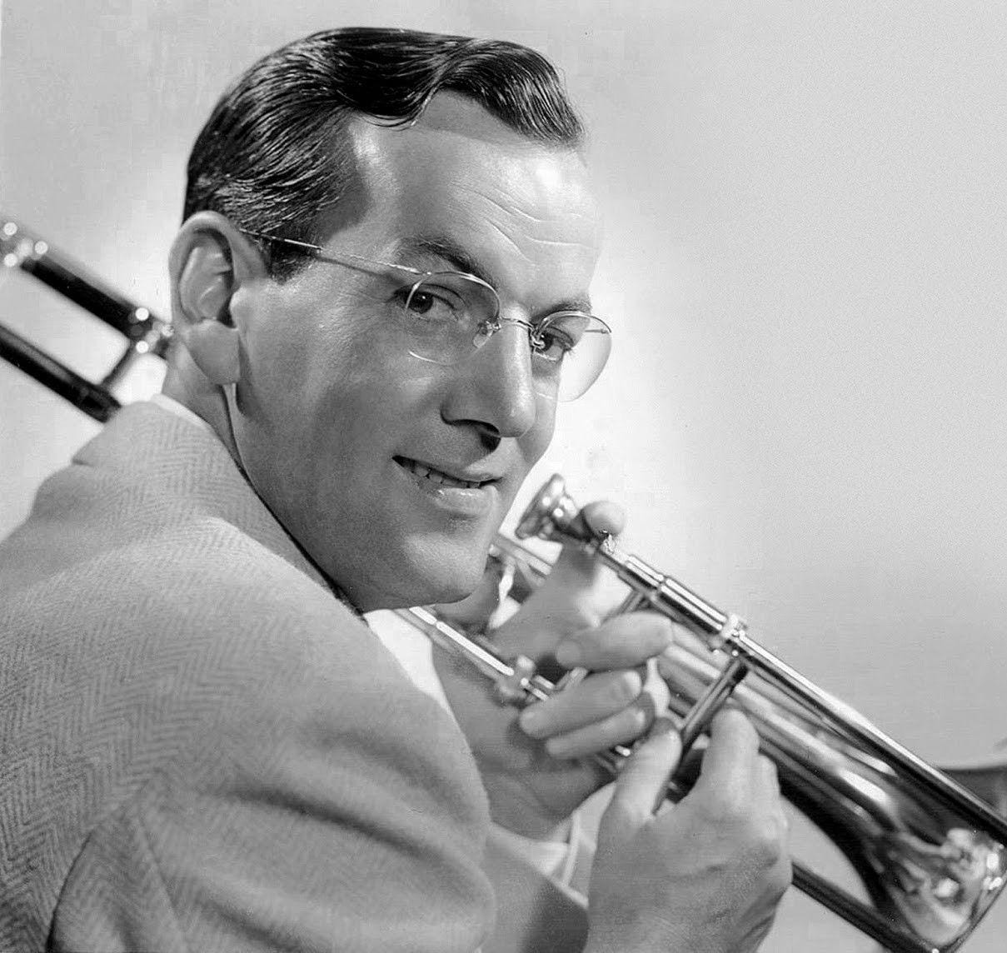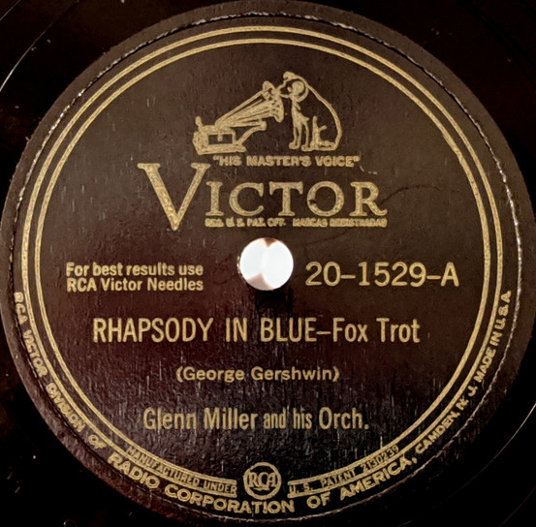
Glenn Miller (1904 – 1944) Recorded July 16, 1942

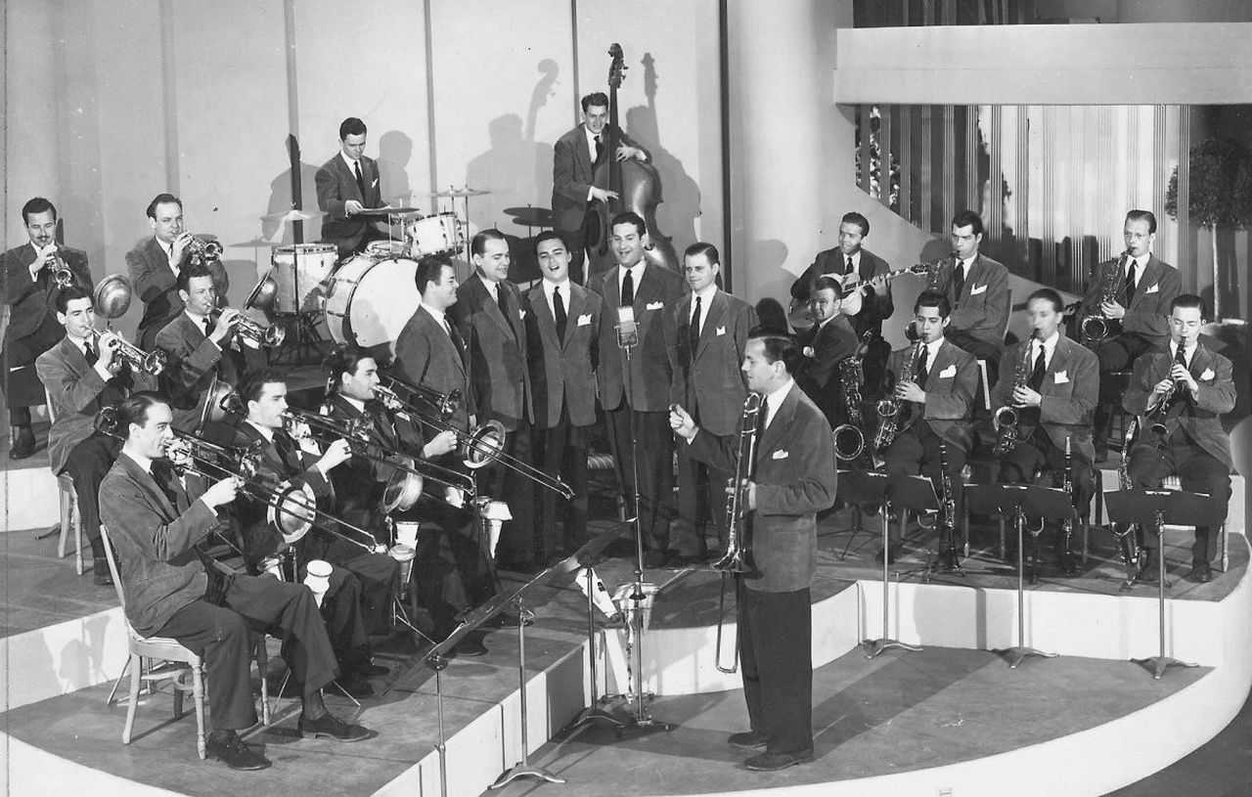

B E B O P
2. Minor Walk (Linton Garner-Dizzy Gillespie) 2:44
Dizzy Gillespie Orchestra: Dizzy Gillespie, Dave Burns, Elmon Wright, Benny Bailey, Lammar
Wright-tp; William Shepherd, Ted Kelly-tb; Howard Johnson, John Brown-as+ Joe Gayles,
George „Big Nick“ Nicholas-ts; Cecil Payne-bs; John Lewis-p; Al McKibbon-b; Kenny Clarke-
dr; Chano Pozo-bgo, cga; Linton Garner-arr.
New York, December 30, 1947
Victor 20-3186 / D7VB3094-1 * CD RCA 07863 66258 2 (1995)

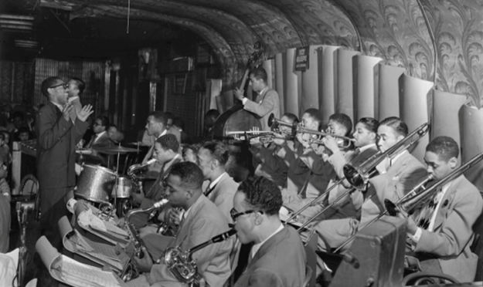

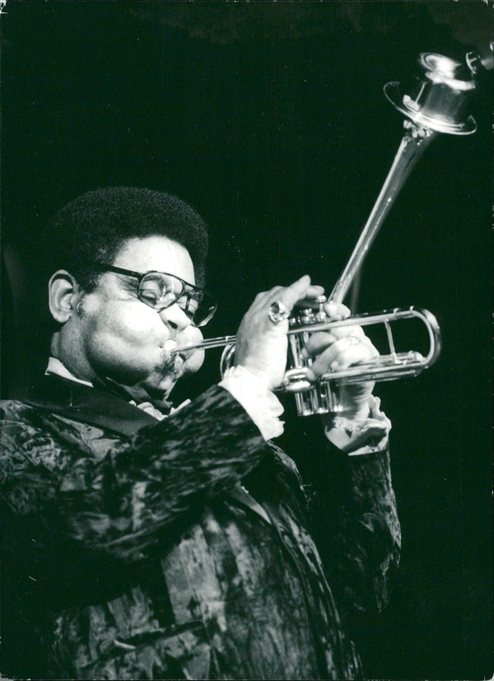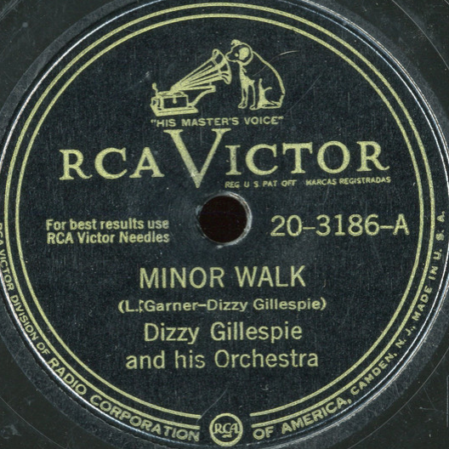
Dizzy Gillespie (1917 – 1993) Recorded December 30, 1947
C O O L J A Z Z
3. Snowfall (Claude Thornhill) 2:37
Claude Thornhill Orchestra: probably Ed Zandy, Emil Terry, Louis Mucci-tp; Tak
Takvorian, Allan Langstaff-tb; Walt Weschler, Sandy Siegelstein-Frh; Danny Polo-cl, as; Lee
Konitz-as; Mickey Folus-ts, cl, bs; Mario Rollo-ts; Bill Bushey-bs; Claude Thornhill-p, arr;
Joe Shulman-b; Billy Exiner-dr.
New York City, September 25, 1947
Design DLP 50 * CD Hep 60 (1999)

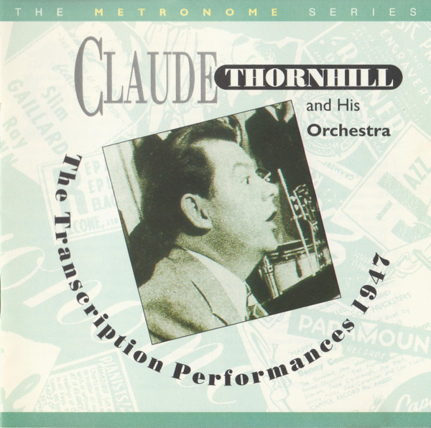
Claude Thornhill (1908 – 1965)

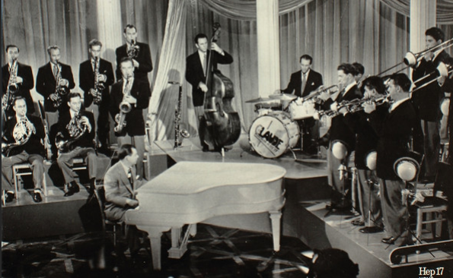

4. Godchild (George Wallington) 3:11
Claude Thornhill Orchestra: Johnny Napton, Johnny Carisi, Gene Roland-tp; Allan Langstaff,
Leon Cox-tb; Al Antonucci, Addison „Junior“ Collins-Frh; Danny Polo-cl, as; Lee Konitz-as;
Milton „Brew“ Moore, Mario „Jet“ Rollo-ts; Gerry Mulligan-ts, bs, arr; Claude Thornhill-p;
Joe Shulman-b; Bill Exiner-dr.
New York, October 1948
CD Hep 17 / D9MM 2443 (1994 – previously unreleased radio transcription)

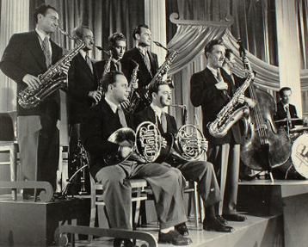

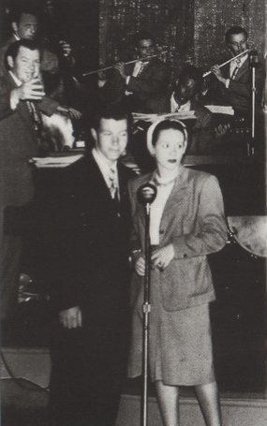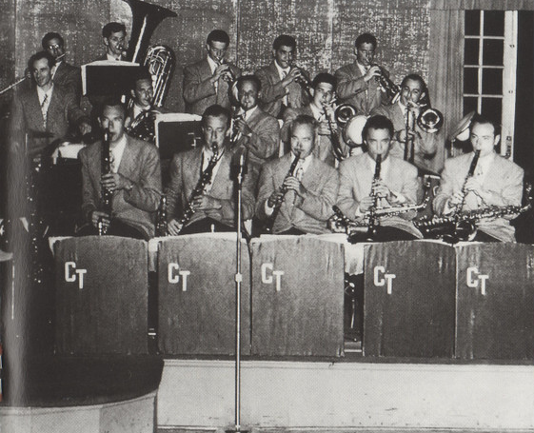

5. Godchild (George Wallington) 5:51
Miles Davis Nonet: Miles Davis-tp; Mike Zwerin-tb; Junior Collins-Frh; Bill Barber-tu; Lee
Konitz-as; Gerry Mulligan-bs, arr; John Lewis-p; Al McKibbon-b; Max Roach-dr.
Live from Royal Roost, New York, September 4, 1948
LP Ozone 2 * CD Capitol 7243 4 94550 2 3 (1998)

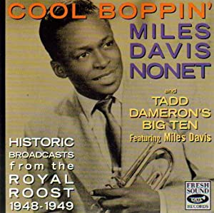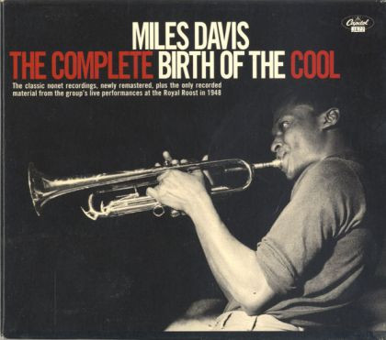

1998 definitive complete version
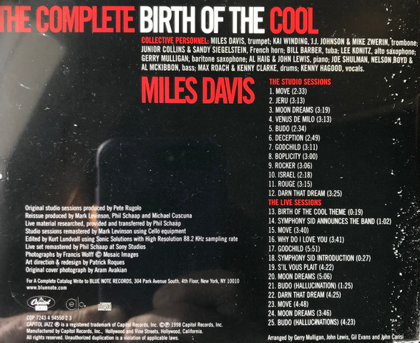

6. Godchild (George Wallington) 3:10
Miles Davis Nonet: Miles Davis-tp; Kai Winding-tb; Junior Collins-Frh; Bill Barber-tu; Lee
Konitz-as; Gerry Mulligan-bs, arr; Al Haig-p; Joe Shulman-b; Max Roach-dr.
New York, January 21, 1949
Capitol 57-60005 / 3397-2E * CD Capitol 7243 4 94550 2 3 (1998)

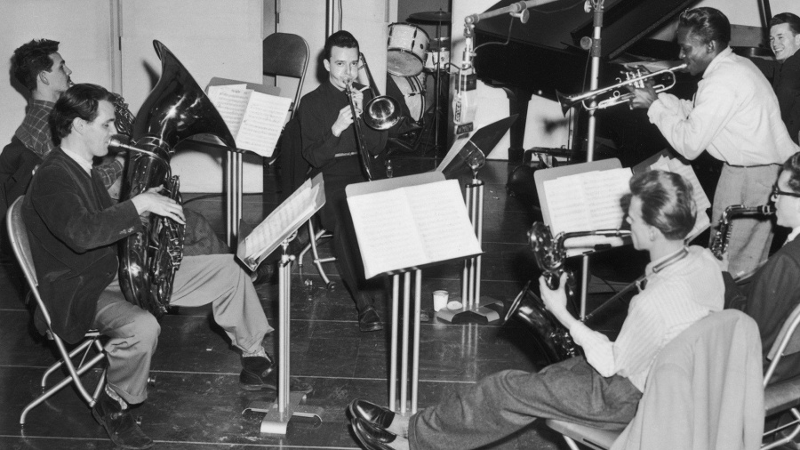

1957 release 1972 release
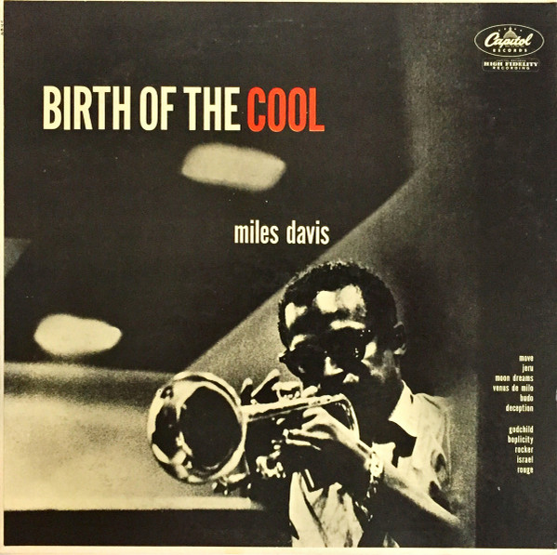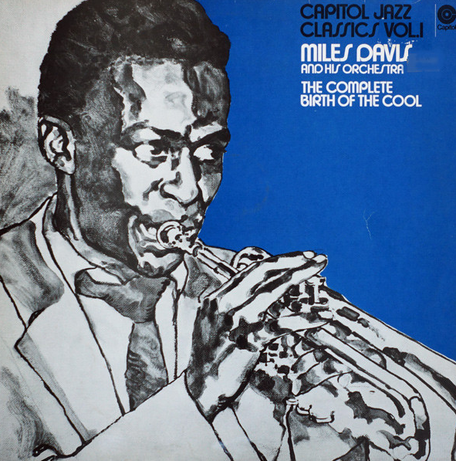

7. Woody Herman introduces the Word premiere of Ebony Concerto by Igor Stravinsky 0:37
8. Ebony Concerto (Part III) (Igor Stravinsky) 4:00
Woody Herman Orchestra: Sonny Berman, Pete Candoli, Conrad Gozzo, Marky Markowitz,
Shorty Rogers-tp; Bill Harris, Ed Kiefer, Ralph Pfeffner-tb; Woody Herman-cl; John LaPorta,
Sam Marowitz-as; Mickey Folus, Flip Phillips-ts; Sam Rubinowitch-bcl; Red Norvo-vib; Tony
Aless-p; Billy Bauer-g; Chubby Jackson-b; Don Lamond-dr; Guests: John Barrows-Frh; Abe
Rosen-harp; Walter Hendl-cond.
Live at Carnegie Hall, New York, March 25, 1946
previously unreleased * CD Verve 559 833-2 (1999)

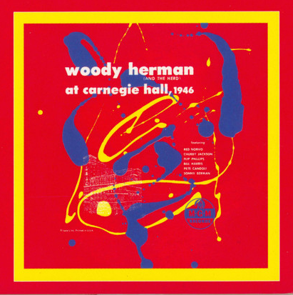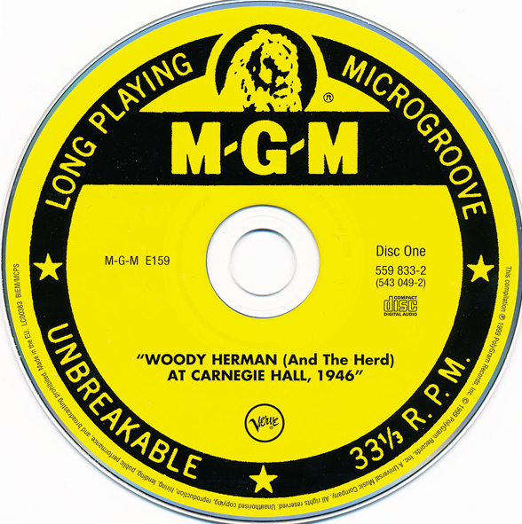

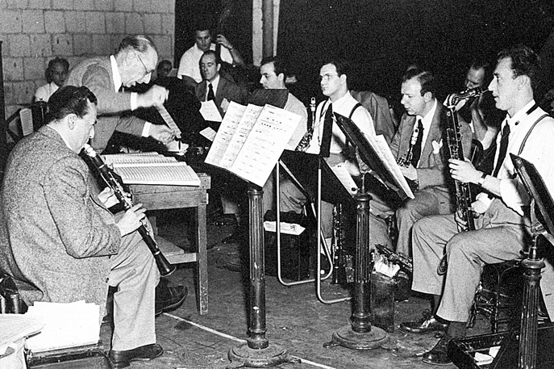

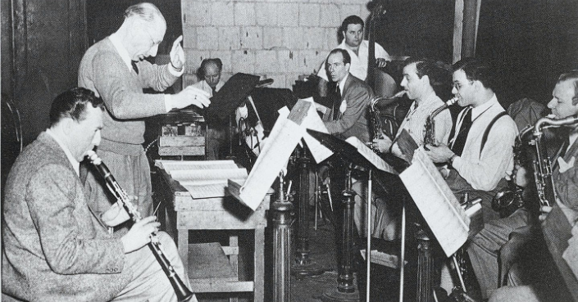
Woody Herman (1913 – 1987) & Igor Stravinskij (1882 – 1971)

1946 shellacs
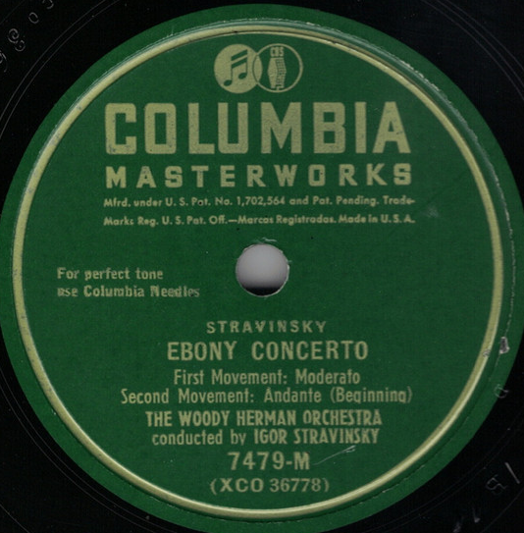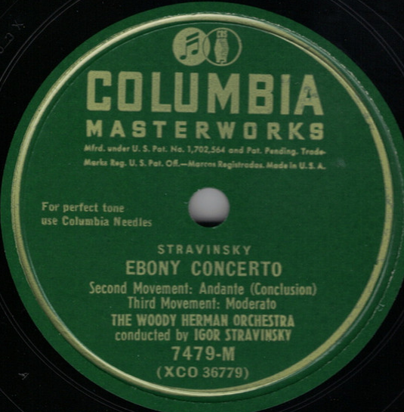

1958 stereo vinyl
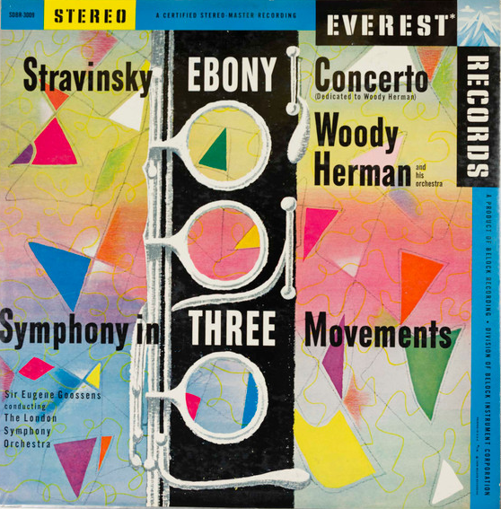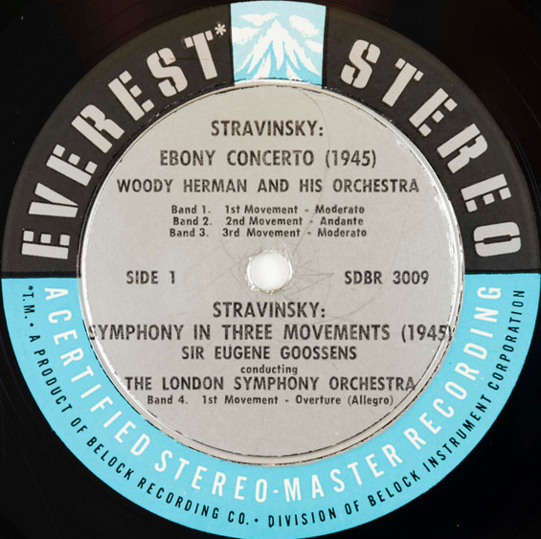

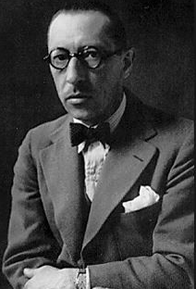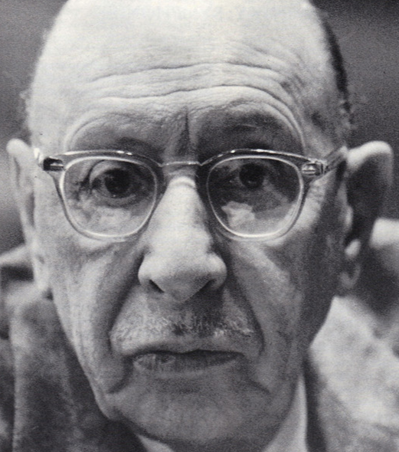

9. Four Brothers (Jimmy Giuffre) 3:22
Woody Herman Second Herd: Shorty Rogers, Ernie Royal, Stan Fishelson, Bernie Glow,
Markie Markowitz-tp; Earl Swope, Ollie Wilson-tb; Bob Swift-btb; W.H.-cl,as; Sam
Marowitz-as; Herbie Steward-as,ts; Stan Getz, Zoot Sims-ts; Serge Chaloff-bs; Fred Otis-p;
Gene Sargent-g; Walt Yoder-b; Don Lamond-dr.
Los Angeles, December 24, 1947.
Columbia 38304 / HCO 3061 * CD Properbox 15 (????)

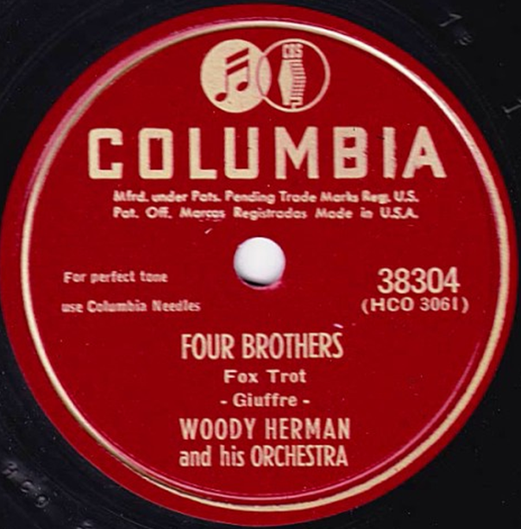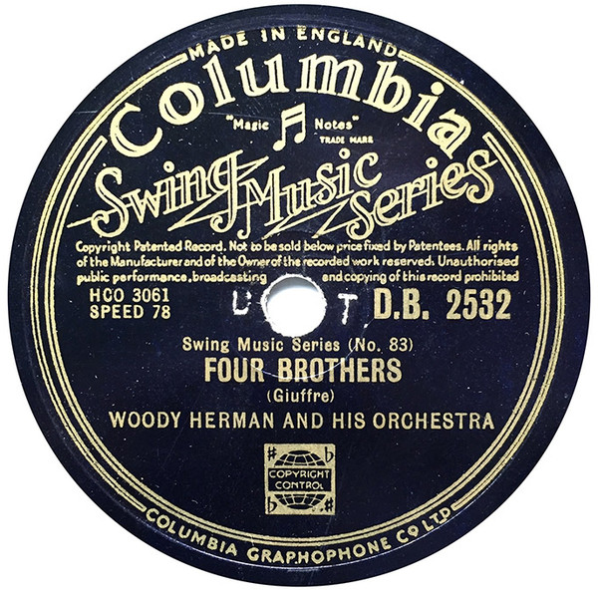

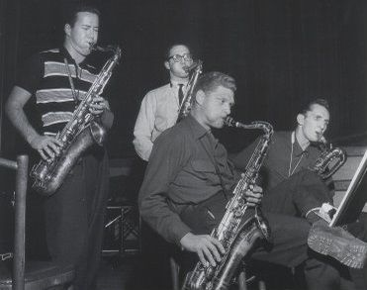

10. Early Autumn (Ralph Burns) 3:13
Woody Herman Orchestra: Ernie Royal, Bernie Glow, Stan Fishelson, Red Rodney, Shorty
Rogers-tp; Earl Swope, Bill Harris, Ollie Wilson, Bob Swift-tb; Woody Herman-cl, as;
Sam Marowitz-as; Al Cohn, Zoot Sims, Stan Getz-ts; Serge Chaloff-bs; Lou Levy-p; Terry
Gibbs-vib; Chubby Jackson-b; Don Lamond-dr; Ralph Burns-arr.
Los Angeles, December 30, 1948
Capitol 57-616 / 3831-2 * CD Properbox 15 (????)

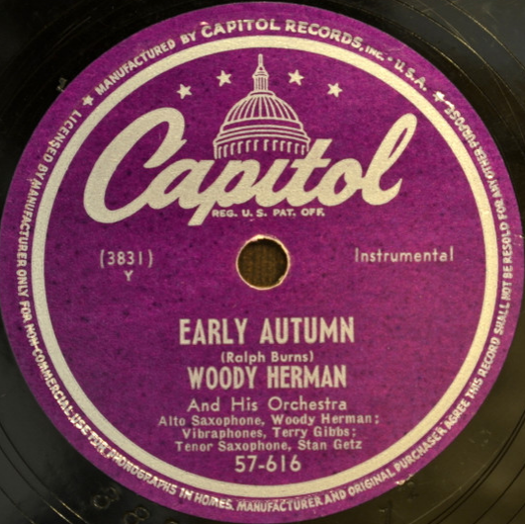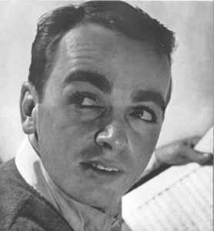
Ralph Burns (1922 – 2001)

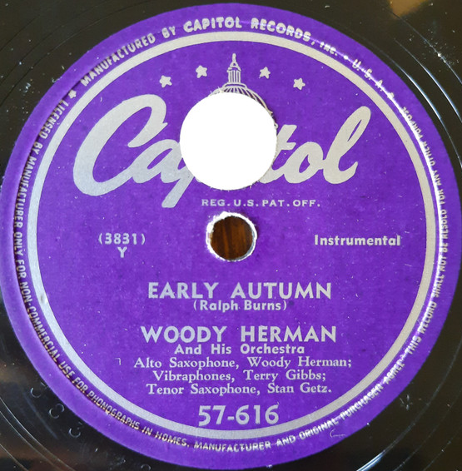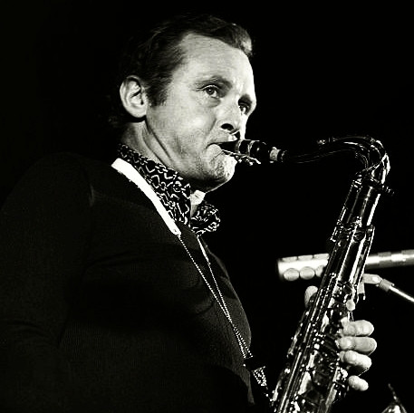
Stan Getz (1927 – 1991)

11. Gone with the Wind (Herb Magidson Allie Wrubel) 2:57
Stan Getz Quartet: Stan Getz-ts; Al Haig-p; Tommy Potter-b; Roy Haynes-dr.
New York, May 17, 1950
Roost 516 / R 01030 * CD Roulette CDP 7 98144 2 (1991)

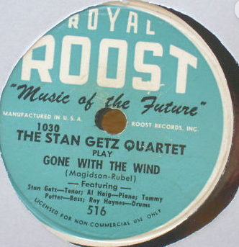

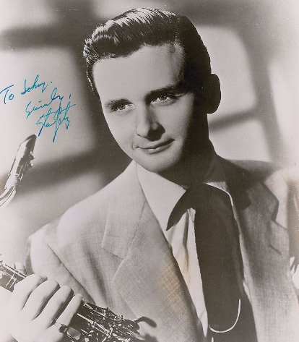

12. September in the Rain (Harry Warren) 3:16
George Shearing Quintet: George Shearing-p; Marjorie Hyams-vib; Chuck Wayne-g; John
Levy-b; Denzil Best-dr.
New York, February 17, 1949
MGM 10426 / 49S86 * CD Concord Jazz CCD2-2211-2(2004)

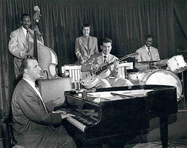

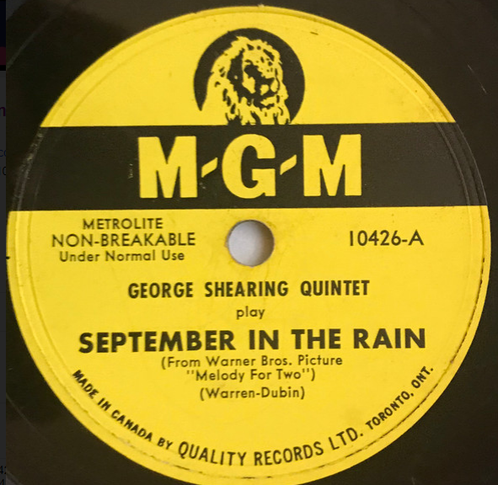

13. Lullaby of Birdland (George Shearing) 2:44
George Shearing Quintet: George Shearing-p; Joe Roland-vib; Dick Garcia-g; Al McKibbon-b;
Marquis Foster-dr.
New York, July 17, 1952
MGM 11354 / 52S278-A * CD Concord Jazz CCD2-2211-2 (2004)

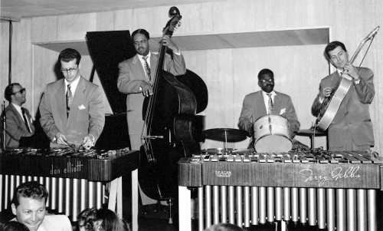

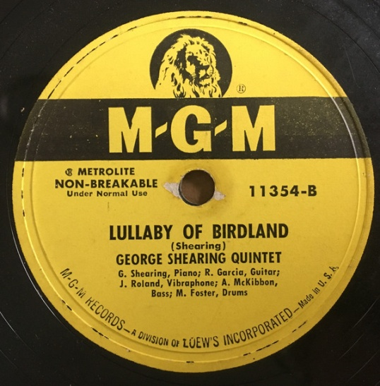

14. Libra (Mary Lou Williams) 2:49
Mary Lou Williams-p solo.
New York, June 29, 1945
Asch 621-1 / zo9 * LP Folkways FJ 2809

3 shellacs (1945) CD (re)issue (1995)
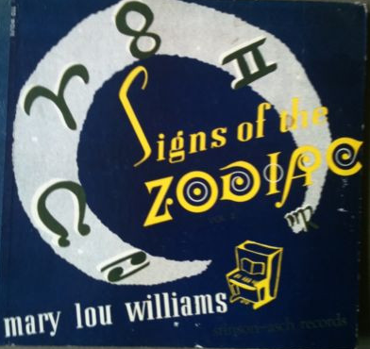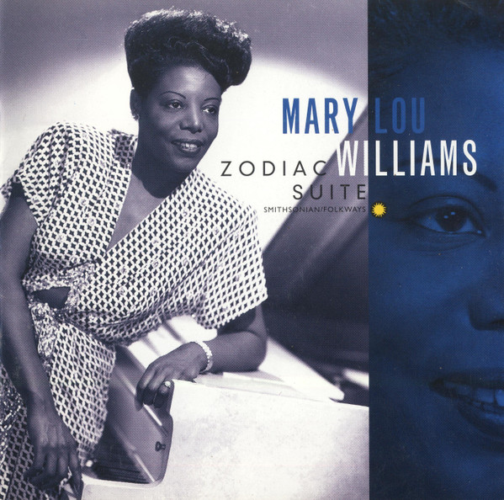
Mary Lou Williams (1910 – 1981)

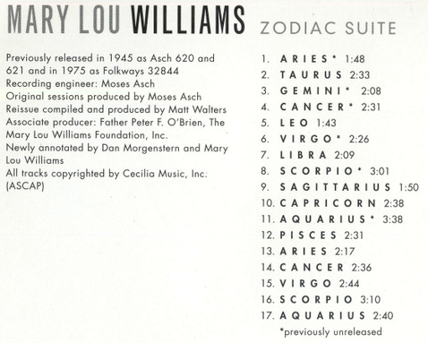

15. On a Planet (Lennie Tristano) 3:22
Lennie Tristano Trio: Lennie Tristano-p; Billy Bauer-g; John Levy-b.
New York, October 23, 1947
Savoy MG 12043 / T 1392 * LP BYG 529607 (????)

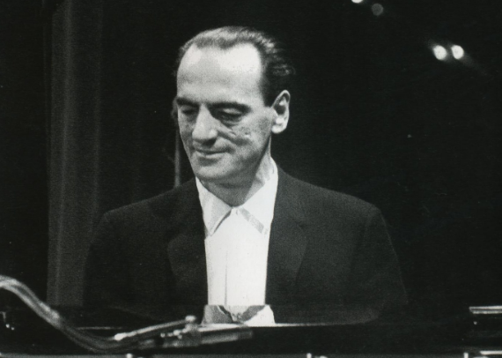

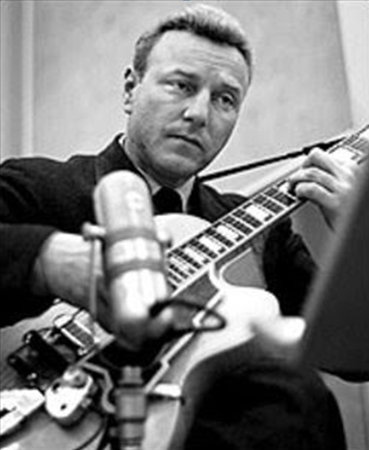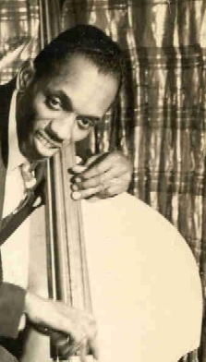
Billy Bauer (1915 – 2005) John Levy (1912 – 2012)

16. G Minor Complex (Lennie Tristano) 3:54
Lennie Tristano-p solo.
New York, autumn 1961
LP Atlantic 1357 / no matrix

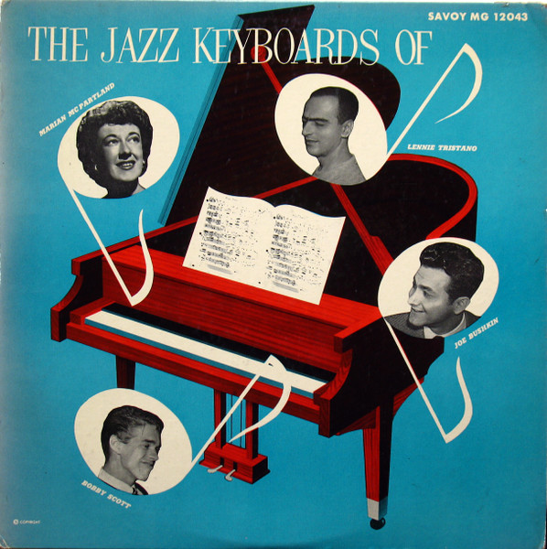

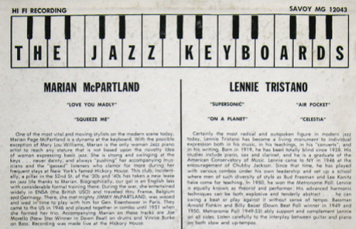
Marian McPartland (1918 – 2013) Lennie Tristano (1919 – 1978)

Music for alto saxophone and strings (Bill Russo)
17. Part 1 4:29
18. Part 2 2:56
19. Part 3 2:38
Lee Konitz with Strings: Lee Konitz-as; string quartet (Gene Orloff and another-vio; unknown-
vla; Alan Shulman-vcl); Billy Bauer-g; unknown bass and drums; Bill Russo-arr, cond.
New York, February 6, 1958
Verve MGV 8286 / 21920-1-2-3 * CD Verve 527 780-2 (96)

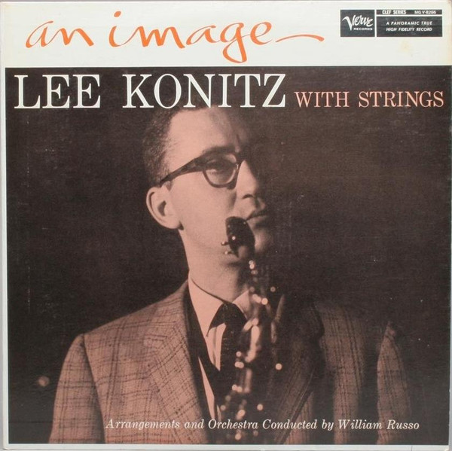

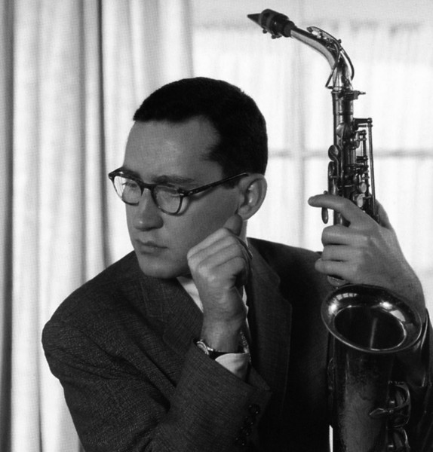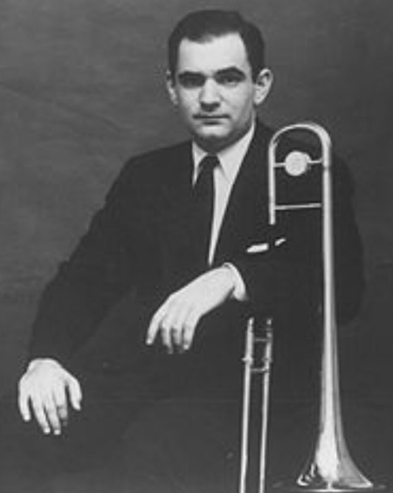
Lee Konitz (1927 – 2020) Bill Russo (1928 – 2003)
20. Darn That Dream (Jimmy Van Heusen) 1:55
Lee Konitz-Jimmy Giuffre Quintet: Lee Konitz, Hal McKusick-as; Ted Brown, Warne
Marsh-ts; Jimmy Giuffre-bs, arr.
New York, May 12 – 13, 1959
Verve MGV 8335 / 22837-28 * CD Verve 527 780-2 (96)

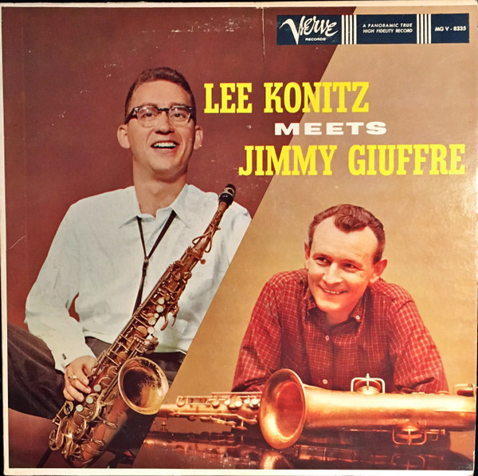
Lee Konitz & Jimmy Giuffre (1921 – 2008)

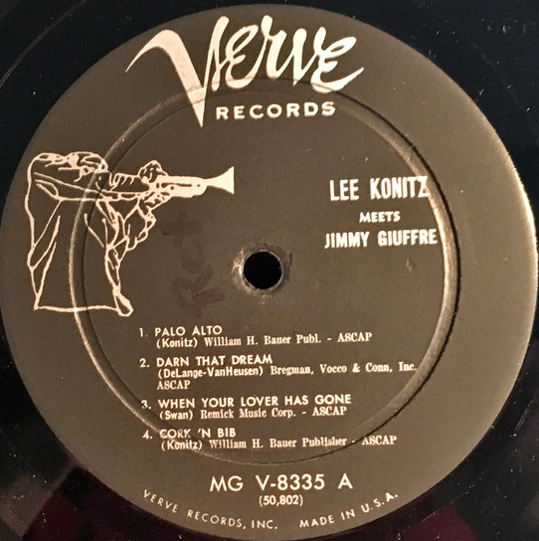

Ambiance (Marian McPartland)
Marian McPartland Trio: Marian McPartland-p; Michael Moore-b; Jimmy Madison-dr.
New York, July 1970
LP Halcyon HAL 103 (first recorded)

21. Ambiance (Marian McPartland) 4:11
Marian McPartland Trio: Marian McPartland-p; Christian McBride-b; Jack DeJohnette-dr.
PBS Radio Broadcast, "Piano Jazz", New York, December 11, 1992
CD Jazz Alliance TJA-12018

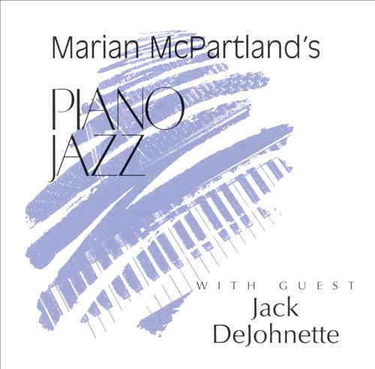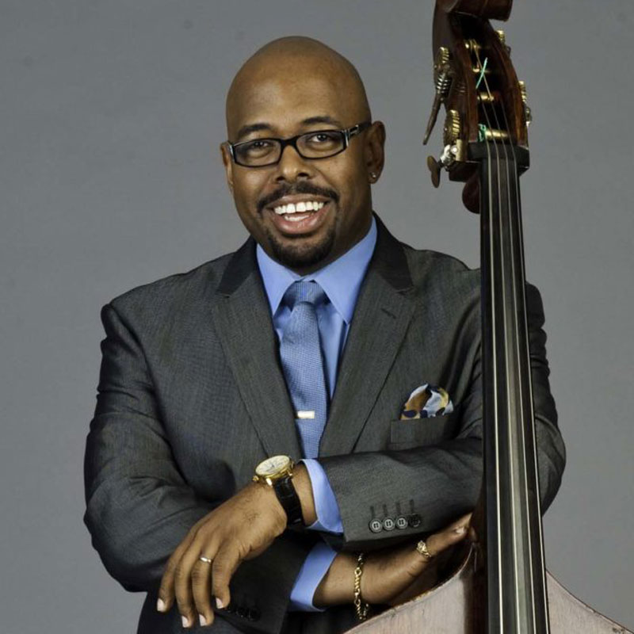
Christian McBride (*1972)

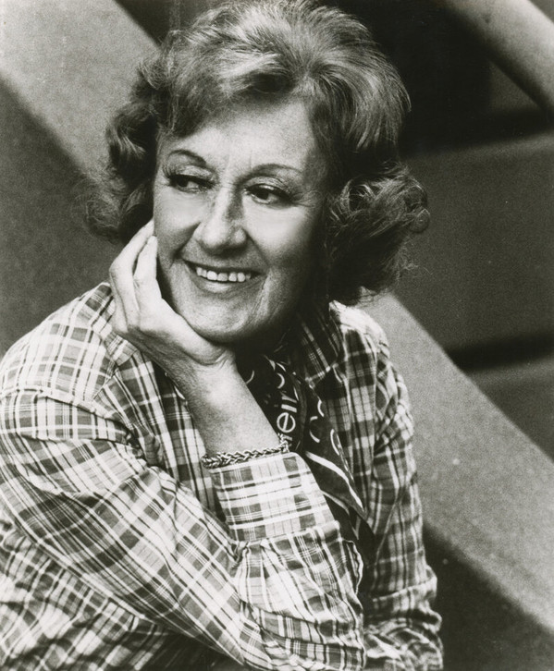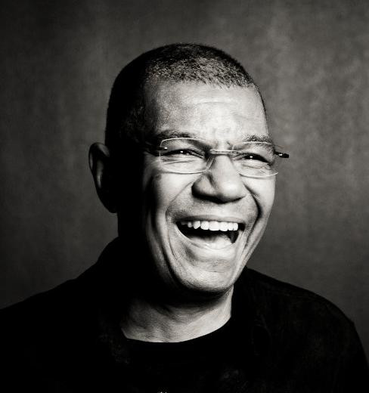
Marian McPartland (1918 – 2013) Jack DeJohnette (* 1942)

22. Ambiance (Marian McPartland) 7:27
Thad Jones-Mel Lewis Jazz Orchestra: Thad Jones-fh, cond; Jim Bossy, Cecil Bridgewater,
Jon Faddis, Steve Furtado-tp; Billy Campbell, Quentin Jackson, Jimmy Knepper-tb; Cliff
Heather-btb; Jerry Dodgion-fl, ss, as; Ed Xiques-fl, cl, ss, as; Billy Harper-fl, ts; Ron
Bridgewater-cl, ts; Pepper Adams-b; Sir Roland Hanna-p; Buddy Lucas-hca, jawharp; George
Mraz-b; Mel Lewis-dr.
Philadelphia, June 1974
LP Philadelphia International X-598

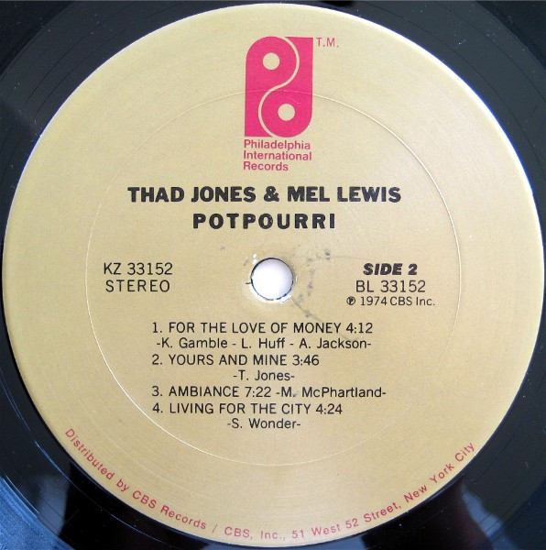

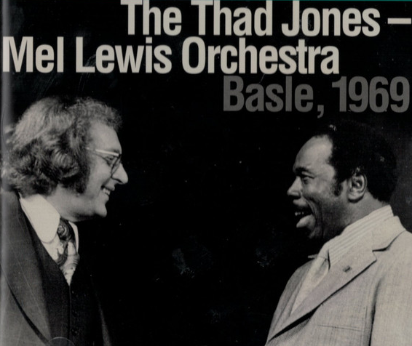
Mel Lewis (1929 – 1990) & Thad Jones (1923 – 1986)

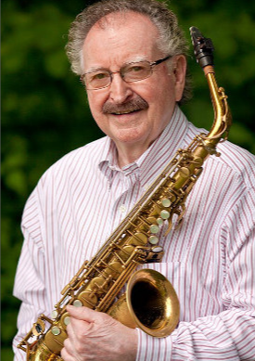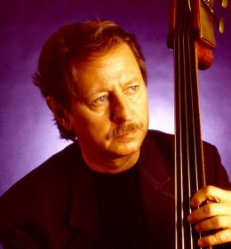
Jerry Dodgion (* 1932) George Mraz (1944 – 2021)

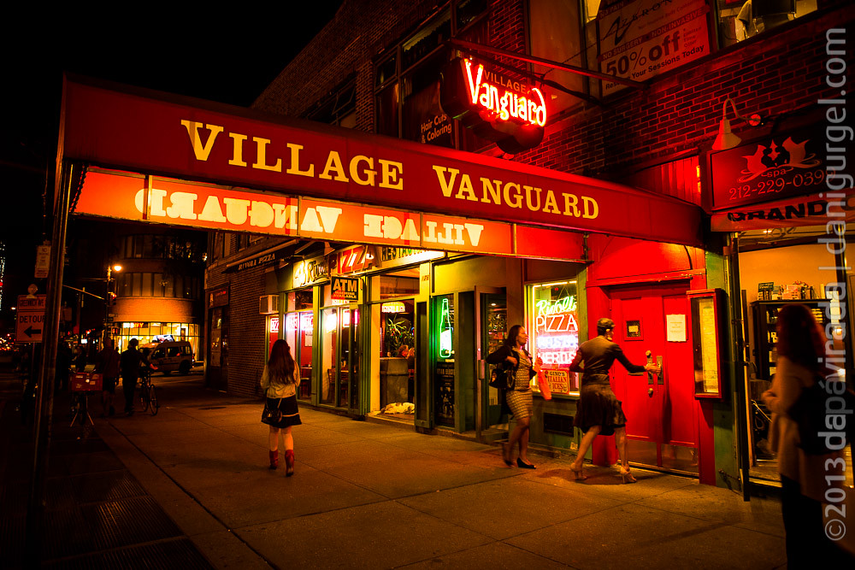
Nejslavnější jazzklub světa – Village Vanguard,
kde v únoru 1966 začínal big band, hrající zde dodnes každé pondělí!

Č E S K Ý C O O L J A Z Z
23. Strýček (Karel Velebný) 3:41
Studio 5: Karel Velebný-vib; Vladimír Tomek-g; Luděk Hulan-b; Ivan Dominák-dr.
Studio Strahov, Praha, January 4, 1961
Supraphon DM 10107 * CD Indies Happy Trails MAM728-2 (2016)

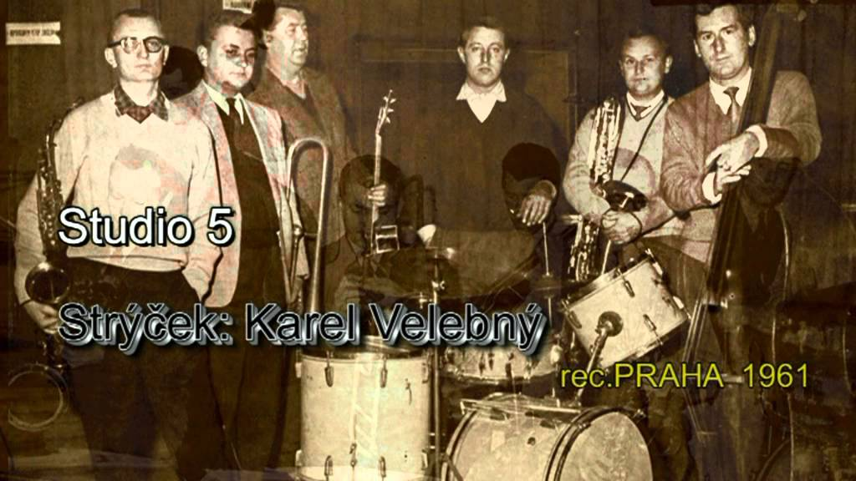
Zleva: Velebný, Hollitzer, Tomek, Dominák, Konopásek, Hulan

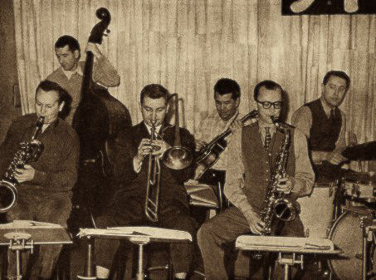
Zleva: Konopásek, Hulan, Hollitzer, Tomek, Velebný, Dominák

Malá LP deska, ale naše!
Český cool jazz

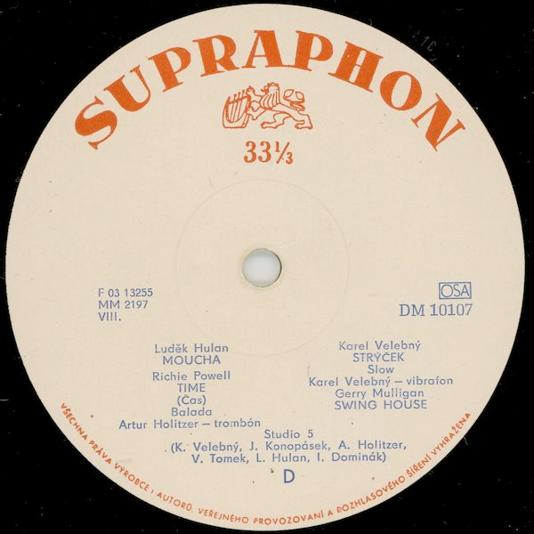

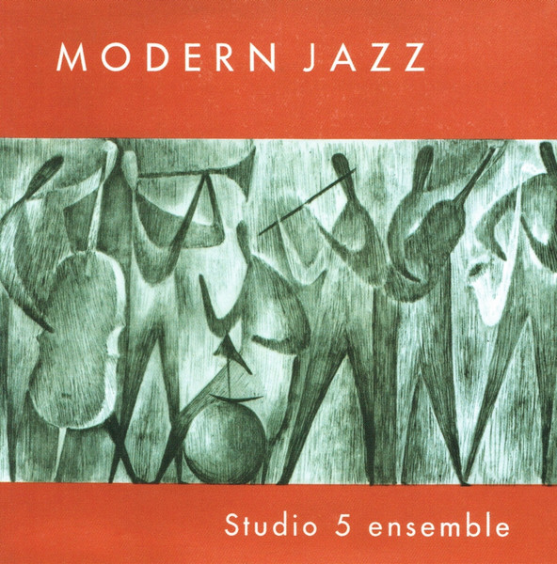
exportní obal, jaký jsme na našich pultech nepoznali

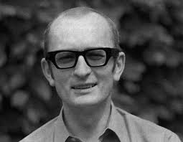
Karel Velebný kdysi…

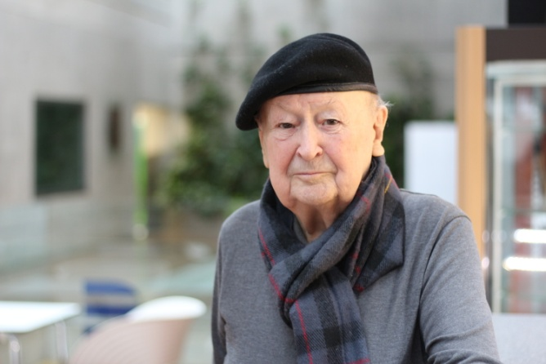
…Jan Konopásek před několika roky

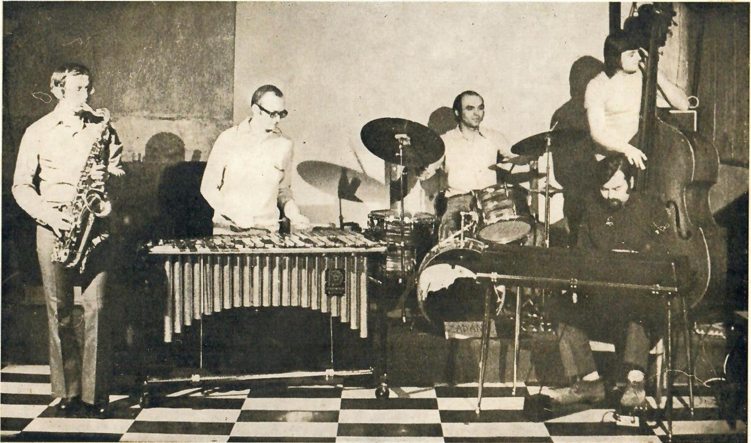
Jedno z pozdějších obsazení SHQ: Rudolf Ticháček, Karel Velebný, Josef Vejvoda, Petr Kořínek. Karel Růžička

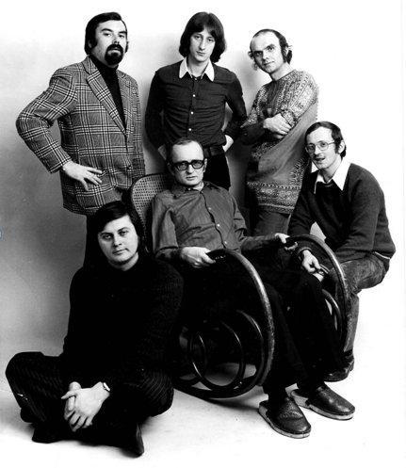
Malá obměna: nahoře Růžička, Jiří Tomek-perc, Vejvoda;
dole Kořínek, Velebný, Ticháček

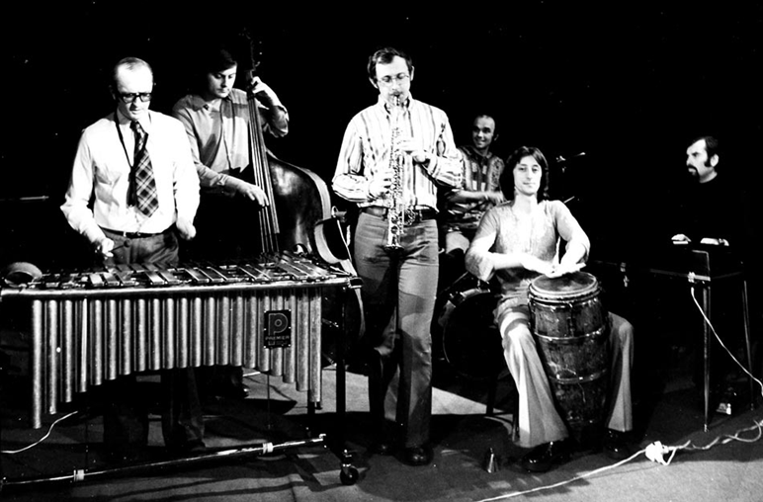
Titíž na pódiu

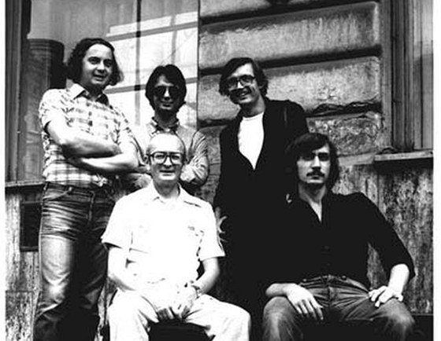
Poslední formace Velebného - Nahoře: František Uhlíř, Milan Vitoch,
Emil Viklický. Dole: Karel Velebný, Tony Viktora

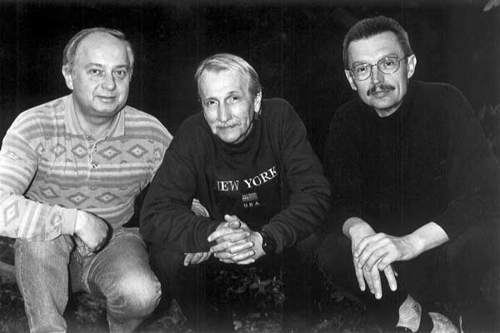

Poslední Velebného spoluhráči, Uhlíř a Viklický,
mezi nimi jeden dávný, Laco Tropp

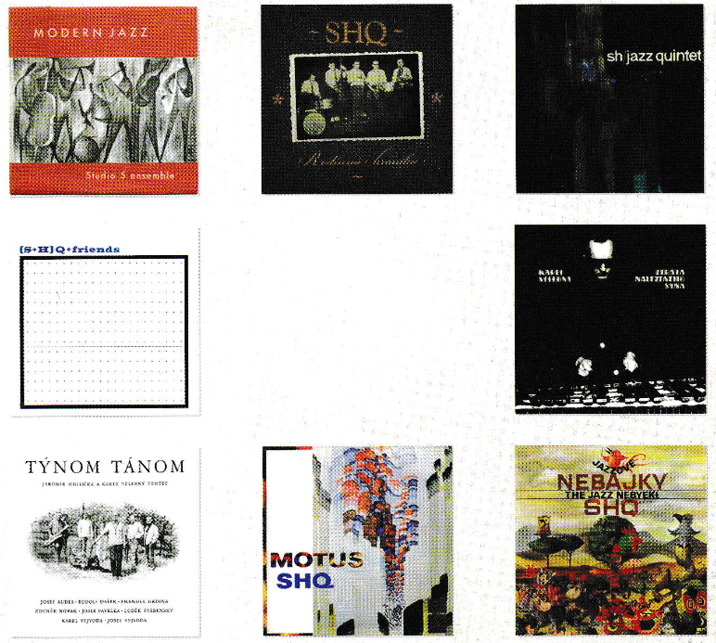

Luxusní reedice skupin Karla Velebného 1958 – 1972
na značce Indies Happy Trails, Brno

